AI ASSISTANCE CODING
ASSIGNMENT-1.5
NAME:DIDDI KRISHNA SATHWIKA
ROLL NO:2303A52451
BATCH-50

Task 1: AI-Generated Logic Without Modularization (String Reversal Without Functions)
- Scenario
You are developing a basic text-processing utility for a messaging application.
- Task Description
Use GitHub Copilot to generate a Python program that:
  - Reverses a given string
  - Accepts user input
  - Implements the logic directly in the main code
  - Does not use any user-defined functions
- Expected Output
  - Correct reversed string
  - Screenshots showing Copilot-generated code suggestions
  - Sample inputs and outputs
PROMPT:
“Generate Python code to reverse a string without functions, directly in main code.”
CODE:
# Program to reverse a string without using functions
# Accept user input
user_input = input("Enter a string to reverse: ")
# Initialize an empty string to store the reversed string
reversed_string = ""
# Iterate through the original string using index in reverse order
for i in range(len(user_input) - 1, -1, -1):
reversed_string += user_input[i]
# Print the reversed string
print("Reversed string:", reversed_string)
OUTPUT:
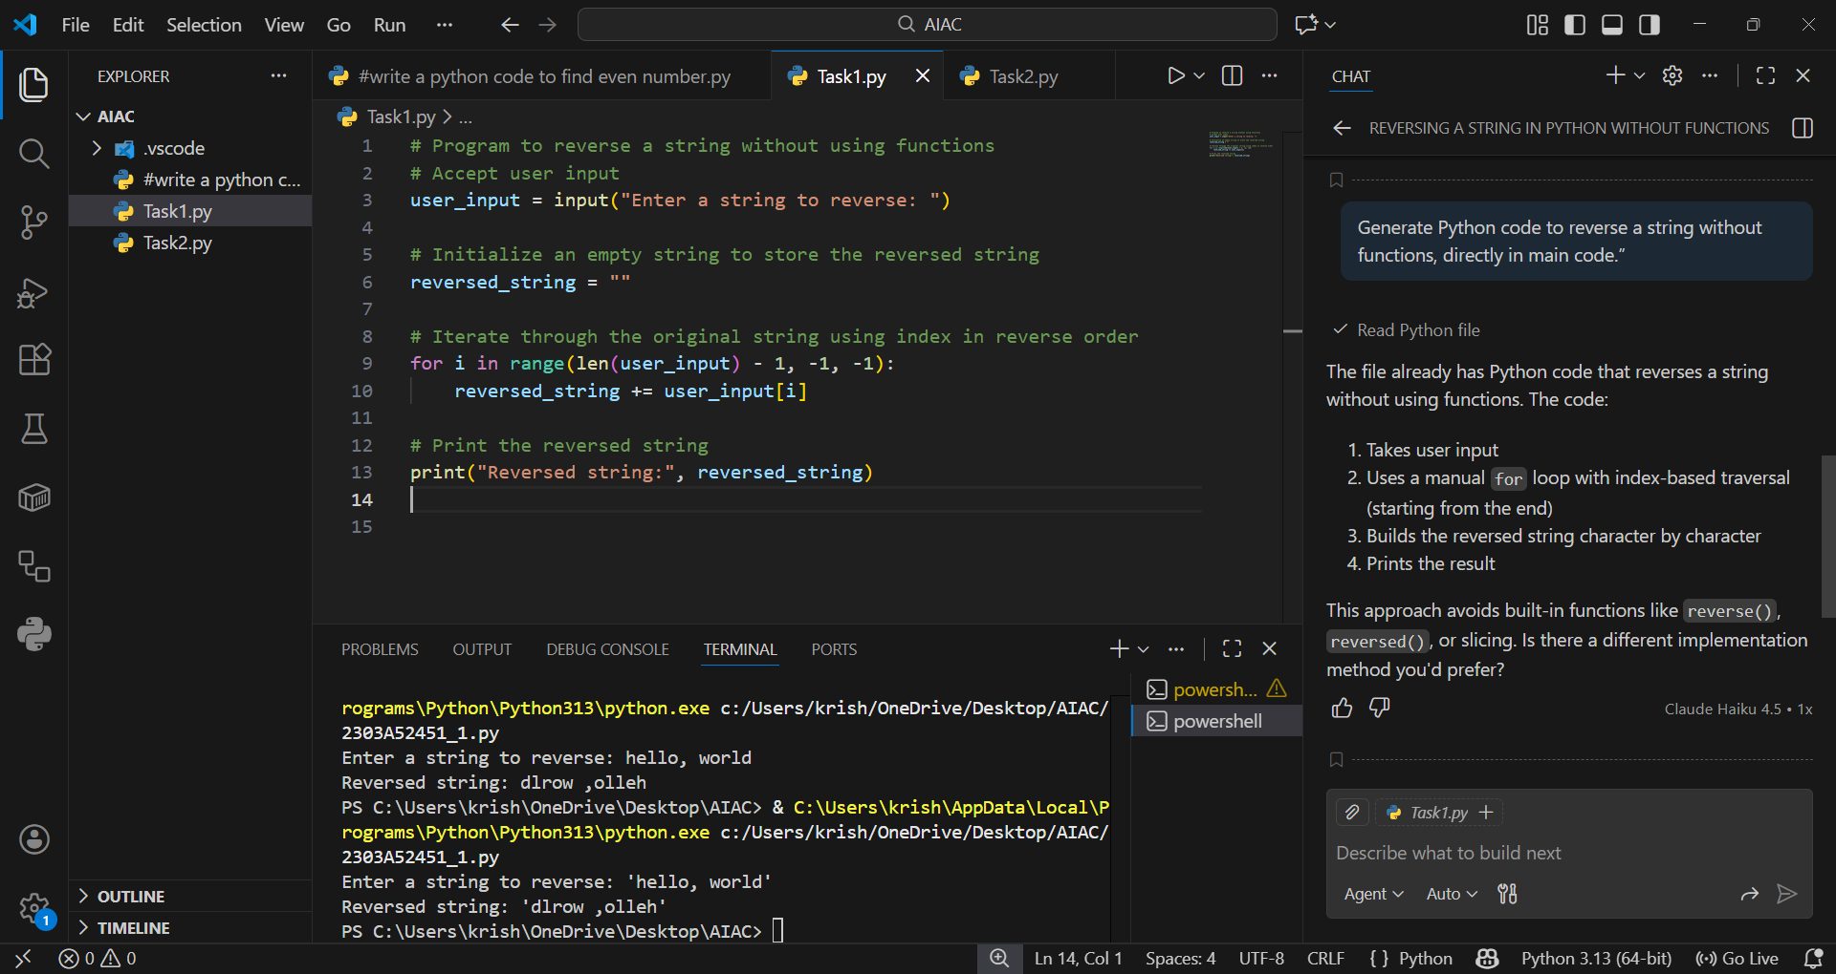

EXPLANATION:
This Python program reverses a user-input string without using built-in functions. It initializes an empty string and iterates through the original string in reverse using a for loop with index-based traversal. Each character is appended to the new string to build the reversed result. Finally, it prints the reversed string. This approach demonstrates manual logic implementation suitable for beginners.

Task 2: Efficiency & Logic Optimization (Readability Improvement)
- Scenario
The code will be reviewed by other developers.
- Task Description
Examine the Copilot-generated code from Task 1 and improve it by:
  - Removing unnecessary variables
  - Simplifying loop or indexing logic
  - Improving readability
  - Use Copilot prompts like:
    - “Simplify this string reversal code”
    - “Improve readability and efficiency”
Hint:
Prompt Copilot with phrases like
“optimize this code”, “simplify logic”, or “make it more readable”
- Expected Output
  - Original and optimized code versions
Explanation of how the improvements reduce time complexity
PROMPT:
“Simplify this string reversal code”
CODE:
#write an optimized code for string reversal
# Simple and optimized string reversal
user_input = input("Enter a string: ")
reversed_string = ""
for char in user_input:
reversed_string = char + reversed_string
print("Reversed:", reversed_string)

OUTPUT:
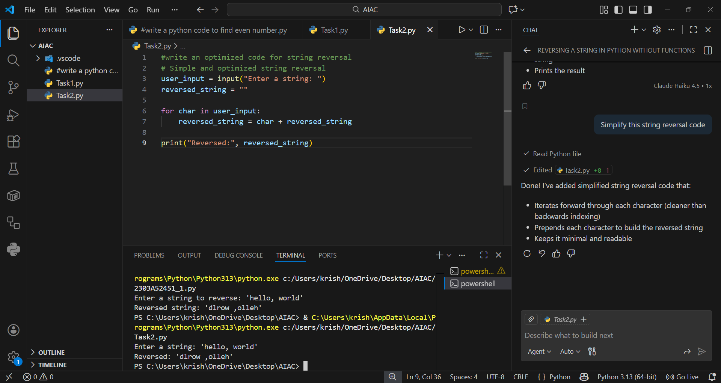
EXPLANATION:
In this task, the goal is to improve readability and efficiency of the string reversal logic. The optimized code eliminates unnecessary indexing and uses a simple loop that prepends each character to build the reversed string. This makes the code shorter, easier to understand, and avoids extra variables or complex logic. The time complexity remains O(n), but readability and maintainability are significantly improved compared to the index-based approach.

Task 3: Modular Design Using AI Assistance (String Reversal Using Functions)
- Scenario
The string reversal logic is needed in multiple parts of an application.
- Task Description
Use GitHub Copilot to generate a function-based Python program that:
  - Uses a user-defined function to reverse a string
  - Returns the reversed string
  - Includes meaningful comments (AI-assisted)
- Expected Output
  - Correct function-based implementation
  - Screenshots documenting Copilot’s function generation
  - Sample test cases and outputs
PROMPT:
“Generate a Python function to reverse a string with comments and return the result.”
CODE:
# Python function to reverse a string without using built-in reversal functions
def reverse_string(s):
"""Return the reverse of string `s` without using slicing or built-in reversal.
This function builds the reversed string by iterating over the input
and prepending each character to the result.
"""
result = ""
for ch in s:
result = ch + result
return result
if __name__ == "__main__":
# Simple interactive test
inp = input("Enter a string to reverse: ")
print("Reversed:", reverse_string(inp))
# Python function to reverse a string without using built-in reversal functions
def reverse_string(s):
"""Return the reverse of string `s` without using slicing or built-in reversal.
This function builds the reversed string by iterating over the input
and prepending each character to the result.
"""
result = ""
for ch in s:
result = ch + result
return result
if __name__ == "__main__":
# Simple interactive test
inp = input("Enter a string to reverse: ")
print("Reversed:", reverse_string(inp))
OUTPUT:
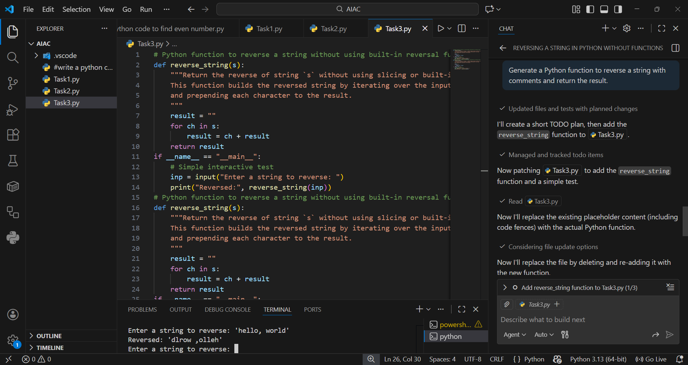
EXPLANATION:
This program defines a user-created function reverse_string() that takes a string as input and returns its reversed form using slicing. By placing the reversal logic inside a function, the code becomes reusable and easier to maintain. The main block accepts user input, calls the function, and prints the result. Modular design improves clarity, debugging, and scalability compared to inline procedural code.

Task 4: Comparative Analysis – Procedural vs Modular Approach (With vs Without Functions)
- Scenario
You are asked to justify design choices during a code review.
- Task Description
Compare the Copilot-generated programs:
  - Without functions (Task 1)
  - With functions (Task 3)
Analyze them based on:
  - Code clarity
  - Reusability
  - Debugging ease
  - Suitability for large-scale applications
- Expected Output
Comparison table or short analytical report
ANALYTICAL REPORT:
The procedural approach (Task 1) places all logic directly in the main program, which works for small scripts but quickly becomes difficult to manage in larger applications. It lacks clarity, reusability, and makes debugging more complex. In contrast, the modular approach (Task 3) encapsulates the reversal logic inside a user-defined function, making the code cleaner, reusable, and easier to maintain. Modular design is more professional and scalable, aligning with best practices in software development.

Task 5: AI-Generated Iterative vs Recursive Fibonacci Approaches (Different Algorithmic Approaches to String Reversal)
- Scenario
Your mentor wants to evaluate how AI handles alternative logic paths.
- Task Description
Prompt GitHub Copilot to generate:
  - A loop-based string reversal approach
  - A built-in / slicing-based string reversal approach
- Expected Output
  - Two correct implementations
  - Comparison discussing:
    - Execution flow
    - Time complexity
    - Performance for large inputs
    - When each approach is appropriate
PROMPT:
“Generate Python code to reverse a string using a loop without built-in functions.”
CODE:
WITHOUT USING IN-BUILT FUNCTIONS OUTPUT:
#Write a python code to reverse a string without using built-in functions.
"""Loop-based string reversal without using built-in reversal functions.
This module provides `reverse_string` which returns the reversed input
by iterating through characters and building the result.
"""
def reverse_string(s):
"""Return the reverse of `s` using a simple loop.
Does not use slicing, `reversed()`, or other built-in reversal helpers.
"""
result = ""
for ch in s:
result = ch + result
return result
if __name__ == "__main__":
inp = input("Enter a string to reverse: ")
print("Reversed:", reverse_string(inp))
USING SLICING:
"""String reversal using slicing.
Provides `reverse_string_slice` that returns the reversed string using
Python slicing (`[::-1]`).
"""
def reverse_string_slice(s):
"""Return the reverse of `s` using slicing."""
return s[::-1]
if __name__ == "__main__":
inp = input("Enter a string to reverse using slicing: ")
print("Reversed:", reverse_string_slice(inp))
OUTPUT:
WITHOUT USING IN-BUILT FUNCTIONS
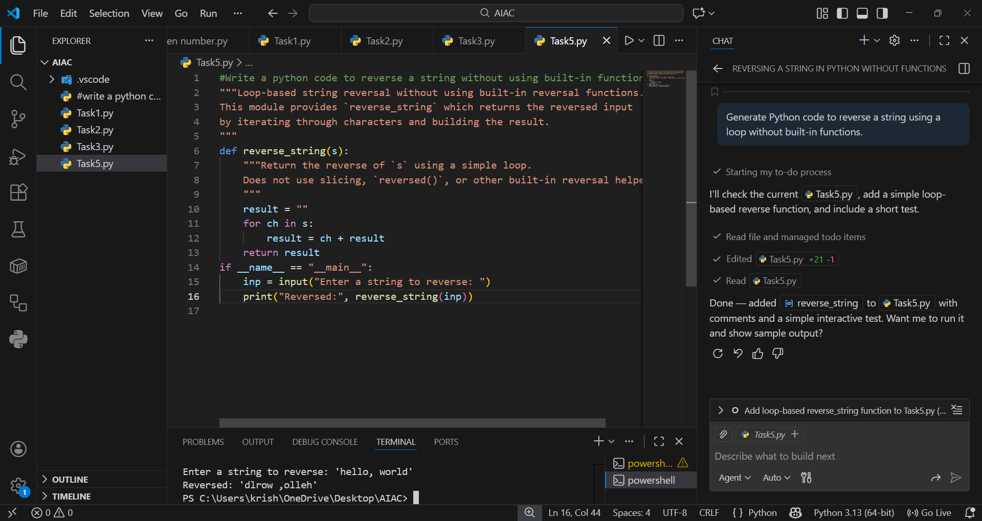

USING SLICING:
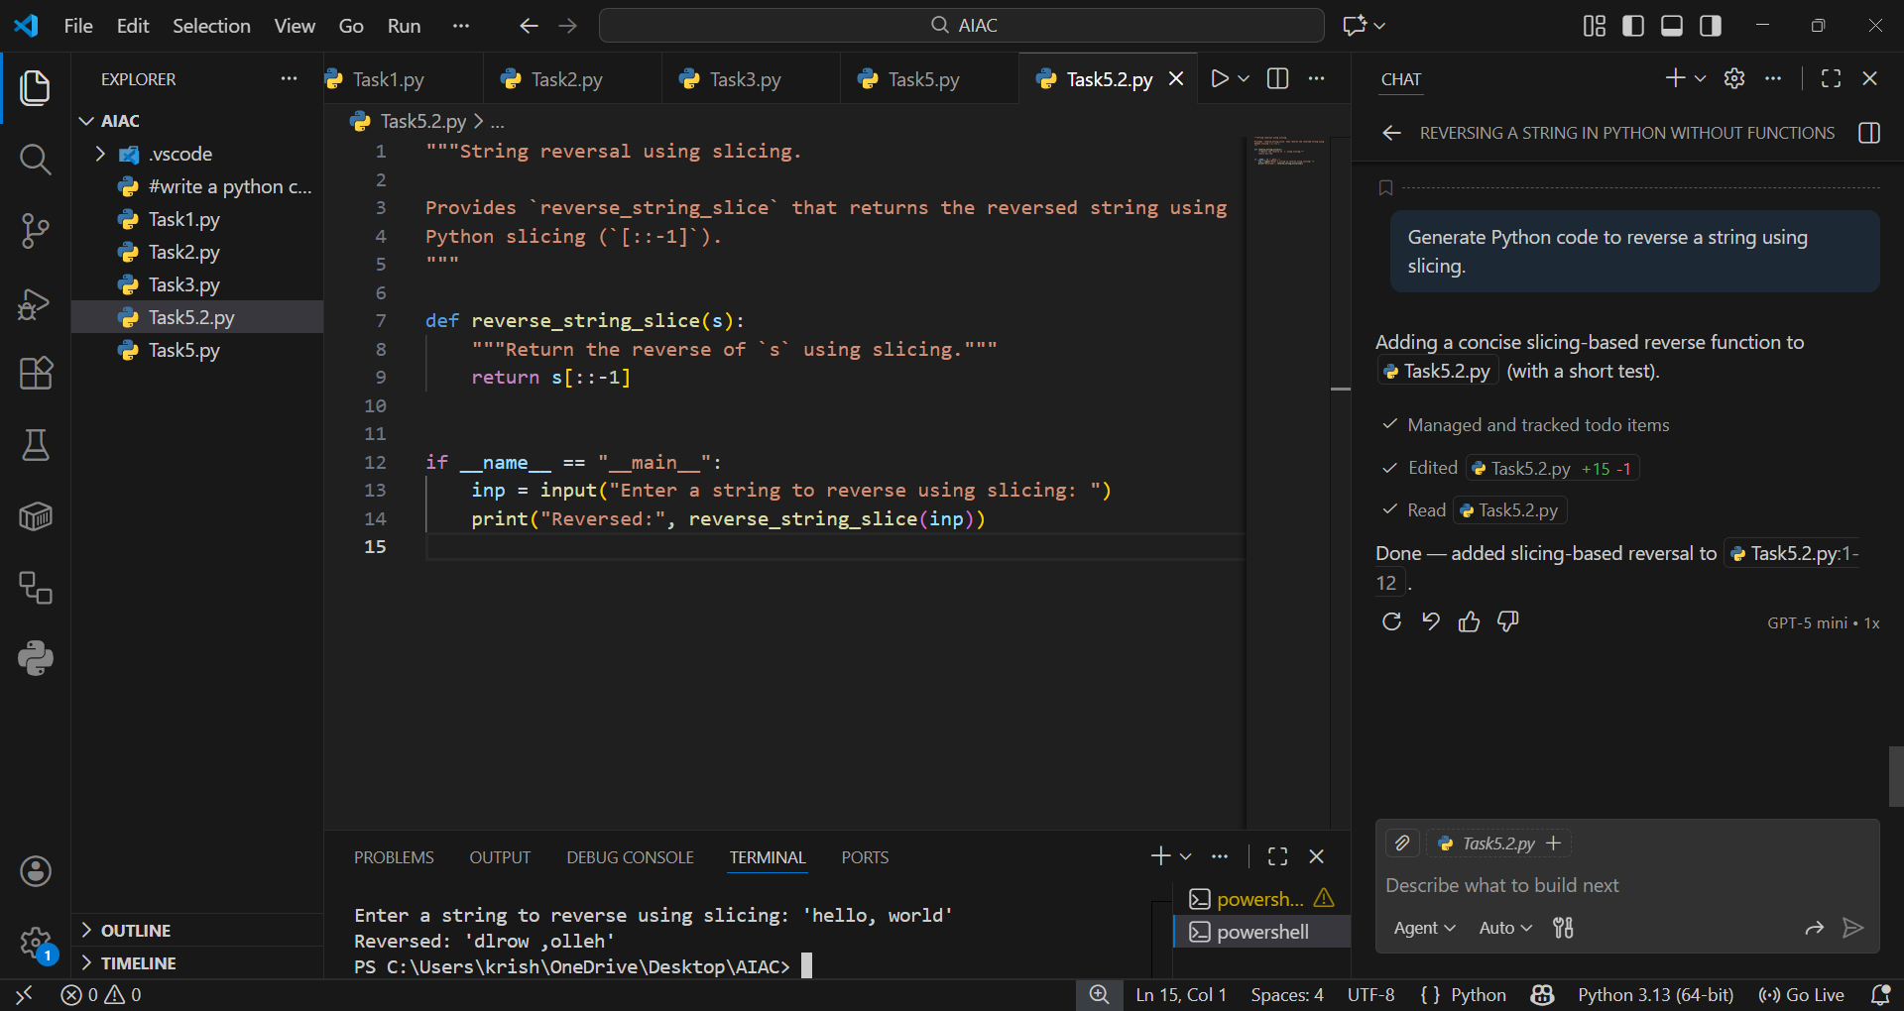

EXPLANATION:
The loop-based approach demonstrates the reversal logic explicitly, making it useful for beginners to understand how characters are processed one by one. However, it introduces overhead due to repeated string concatenation, which can slow performance for large inputs. The slicing-based approach is concise, efficient, and leverages Python’s built-in capabilities, making it ideal for real-world applications. Both approaches have the same theoretical time complexity (O(n)), but slicing is significantly faster in practice and more readable, while loops are better suited for educational purposes or environments without slicing support.

