AI ASSISTED CODING
ASSIGNMENT-6.3

NAME:DIDDI KRISHNA SATHWIKA
ROLL NO:2303A52451
BATCH-50

Task Description #1: Classes (Student Class)
Scenario
You are developing a simple student information management module.
Task
• Use an AI tool (GitHub Copilot / Cursor AI / Gemini) to complete a Student class.
• The class should include attributes such as name, roll number, and branch.
• Add a method display_details() to print student information.
• Execute the code and verify the output.
• Analyze the code generated by the AI tool for correctness and clarity.
Expected Output #1
• A Python class with a constructor (__init__) and a display_details() method.
• Sample object creation and output displayed on the console.
• Brief analysis of AI-generated code.

PROMPT:
“Write a Python class named Student with attributes name, roll_number, and branch. Add a method display_details() to print student information. Show sample object creation and output.”

CODE AND OUTPUT:
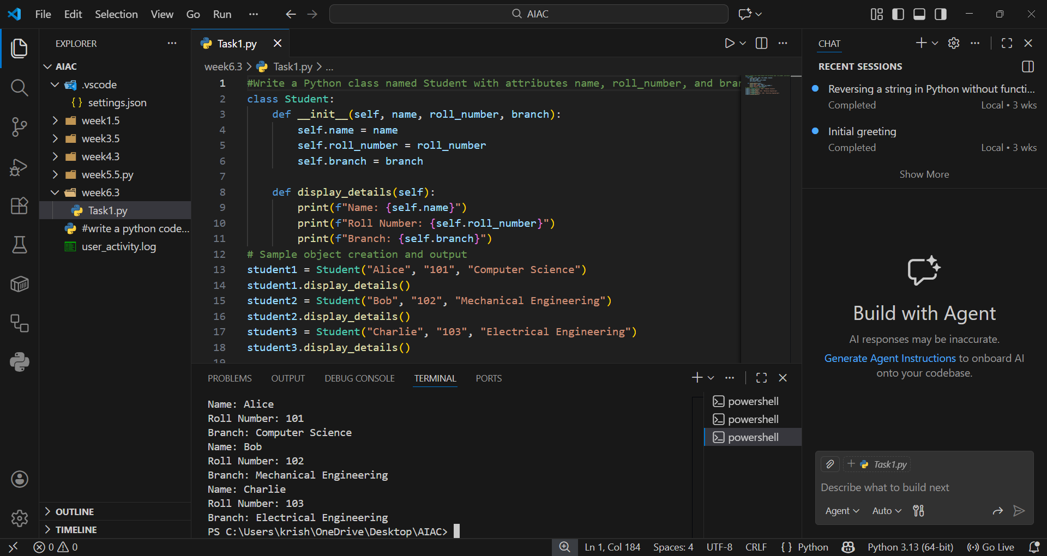

EXPLANATION:
This code defines a Student class with attributes like name, roll number, and branch.The __init__ method initializes these values when an object is created.The display_details() method prints the student’s information in a neat format.It demonstrates object-oriented programming basics in Python.

Task Description #2: Loops (Multiples of a Number)
Scenario
You are writing a utility function to display multiples of a given number.
Task
• Prompt the AI tool to generate a function that prints the first 10 multiples of a given number
using a loop.
• Analyze the generated loop logic.
• Ask the AI to generate the same functionality using another controlled looping structure (e.g.,
while instead of for).
Expected Output #2
• Correct loop-based Python implementation.
• Output showing the first 10 multiples of a number.
• Comparison and analysis of different looping approaches.

PROMPT:
“Generate a Python function that prints the first 10 multiples of a given number using a for loop. Then rewrite it using a while loop.”
CODE:
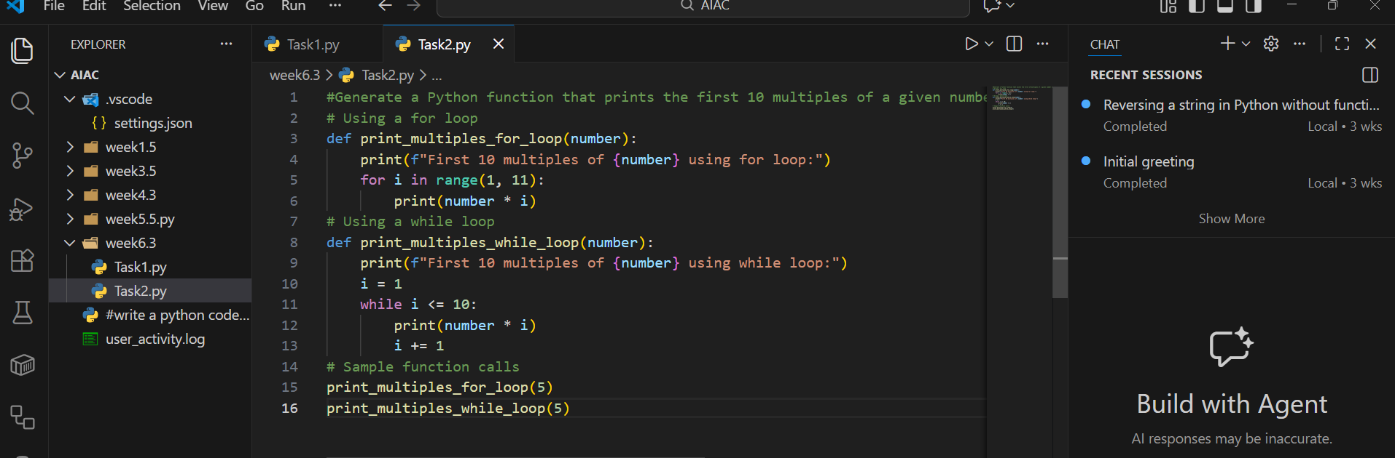

OUTPUT:
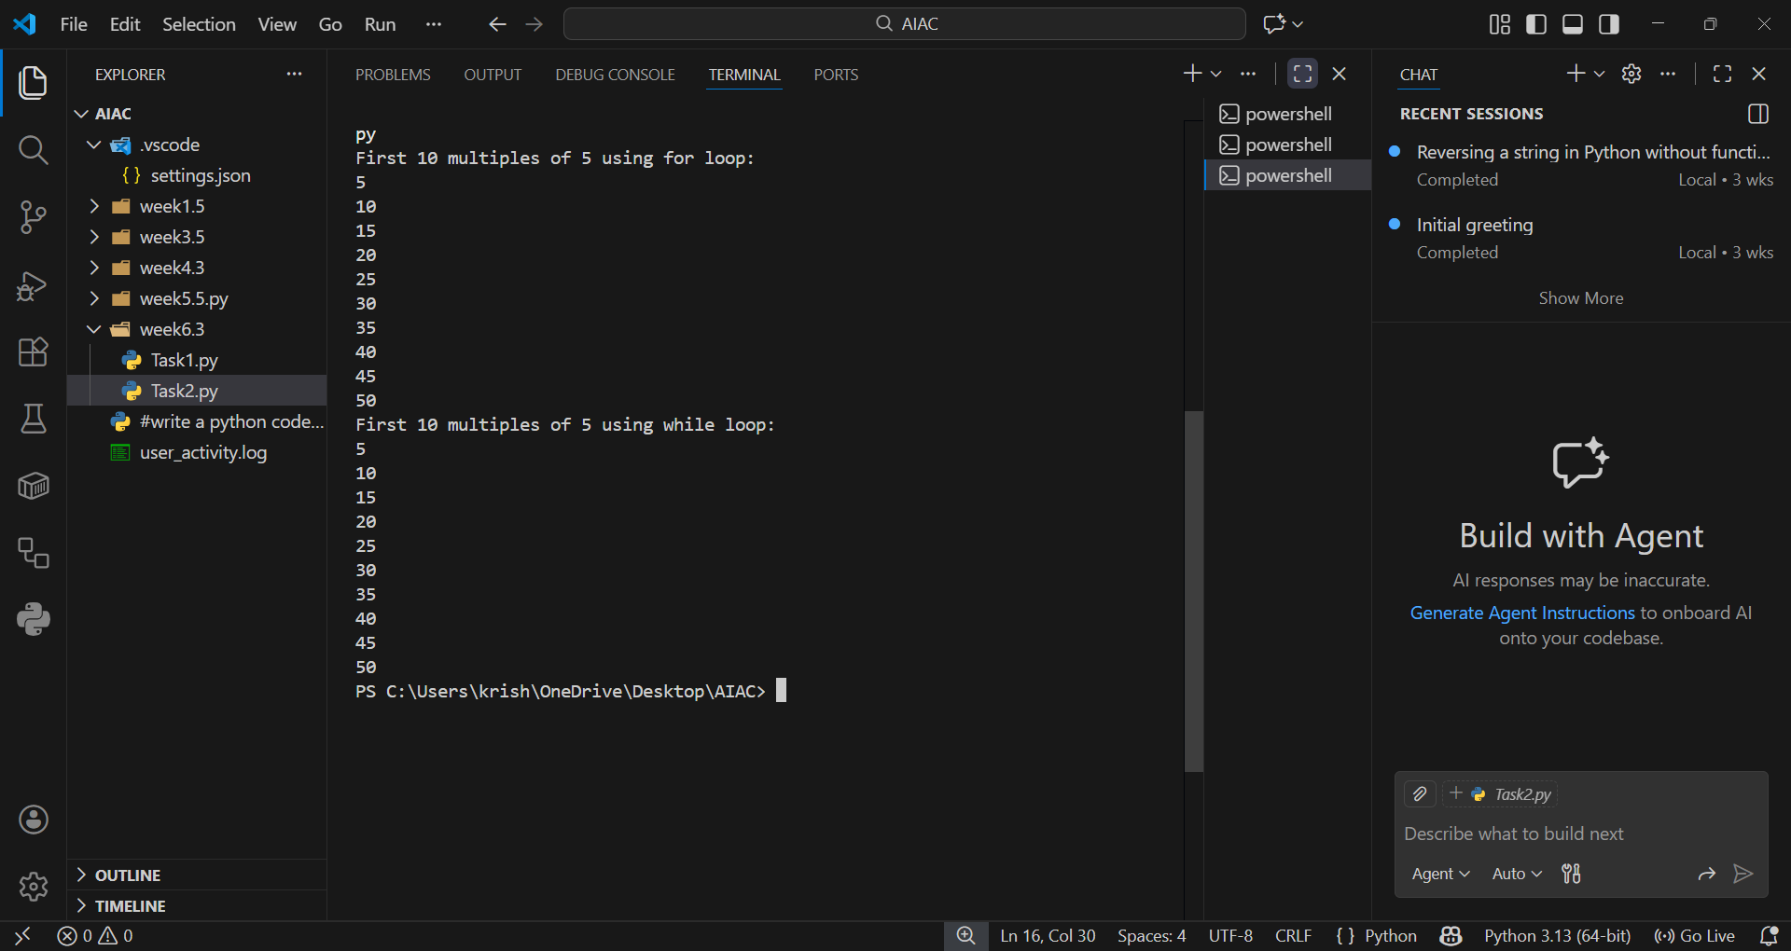

EXPLANATION:
The function uses a loop to print the first 10 multiples of a given number.
In the for loop version, iteration is fixed using range(1, 11).In the while loop version, a counter is incremented until it reaches 10.Both approaches produce the same output but differ in structure.

Task Description #3: Conditional Statements (Age Classification)
Scenario
You are building a basic classification system based on age.
Task
• Ask the AI tool to generate nested if-elif-else conditional statements to classify age groups
(e.g., child, teenager, adult, senior).
• Analyze the generated conditions and logic.
• Ask the AI to generate the same classification using alternative conditional structures (e.g.,
simplified conditions or dictionary-based logic).
Expected Output #3
• A Python function that classifies age into appropriate groups.
• Clear and correct conditional logic.
• Explanation of how the conditions work.

PROMPT:
“Write a Python function that classifies age into groups (child, teenager, adult, senior) using nested if-elif-else statements.Then show an alternative approach using dictionary-based logic.”

CODE:
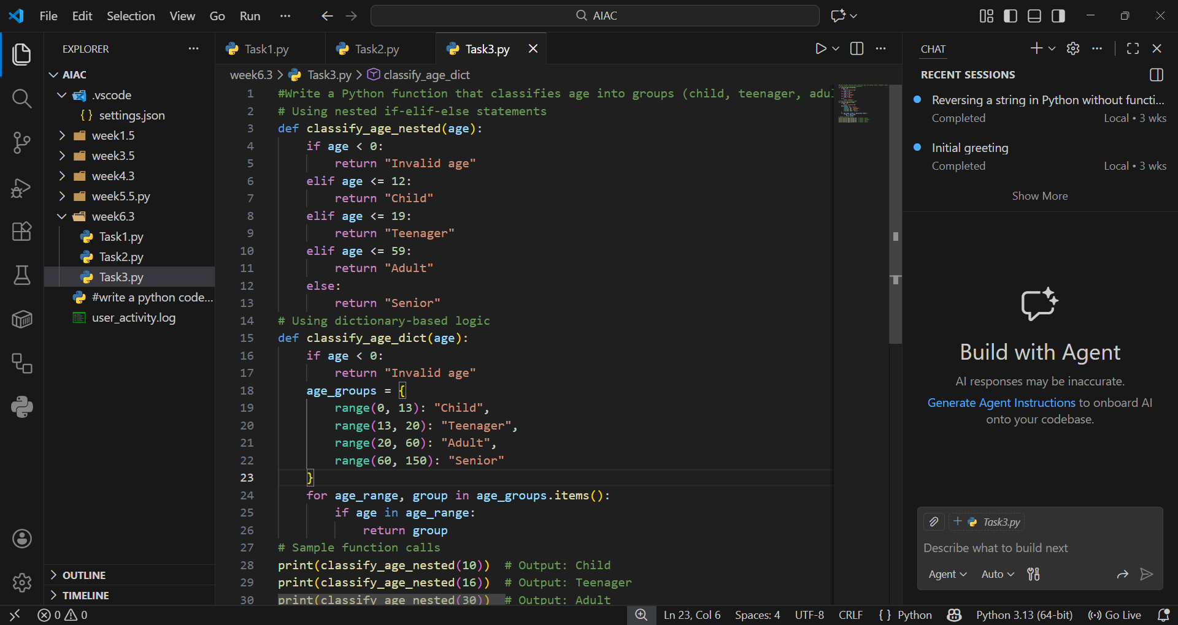

OUTPUT:
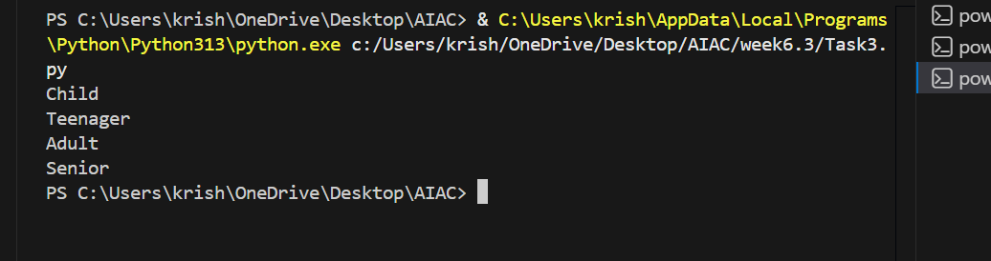

EXPLANATION:
This function classifies age into groups using if-elif-else conditions.It checks ranges step by step: child, teenager, adult, or senior.An alternative dictionary-based approach maps ranges to categories.Both methods ensure correct classification depending on the input age.

“Task Description #4: For and While Loops (Sum of First n Numbers)
Scenario
You need to calculate the sum of the first n natural numbers.
Task
• Use AI assistance to generate a sum_to_n() function using a for loop.
• Analyze the generated code.
• Ask the AI to suggest an alternative implementation using a while loop or a mathematical
formula.
Expected Output #4
• Python function to compute the sum of first n numbers.
• Correct output for sample inputs.
• Explanation and comparison of different approaches.

PROMPT:
“Write a python programme to calculate the sum of first n natural numbers using for loop.Then,perform same task using while loop or mathematical formula.”

CODE:
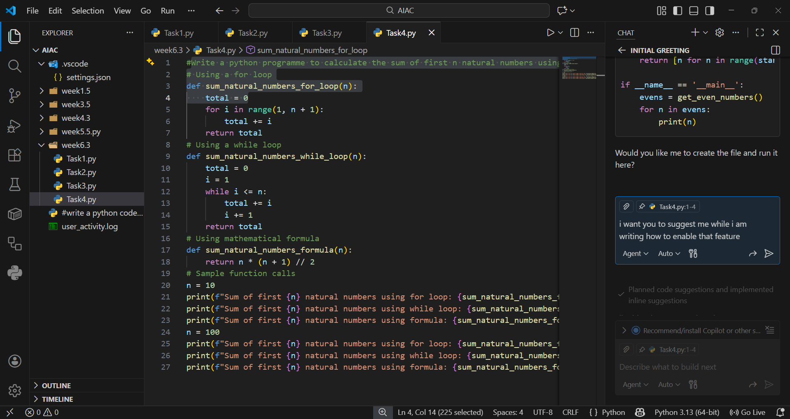

OUTPUT:
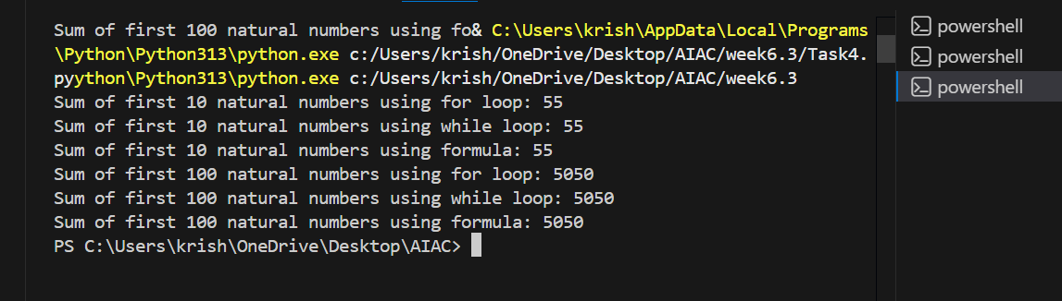

EXPLANTION:
The function calculates the sum of the first n natural numbers.The for loop adds numbers sequentially, while the while loop does the same with manual increments.A mathematical formula n(n+1)/2 provides the most efficient solution.All three approaches give the same result but vary in efficiency.

Task Description #5: Classes (Bank Account Class)
Scenario
You are designing a basic banking application.
Task
• Use AI tools to generate a Bank Account class with methods such as deposit(), withdraw(),
and check_balance().
• Analyze the AI-generated class structure and logic.
• Add meaningful comments and explain the working of the code.
Expected Output #5
• Complete Python Bank Account class.
• Demonstration of deposit and withdrawal operations with updated balance.
• Well-commented code with a clear explanation.

PROMPT:
“Write a Python class BankAccount with methods deposit(), withdraw(), and check_balance(). Demonstrate deposit and withdrawal operations with updated balance. Add comments explaining the code.”

CODE:
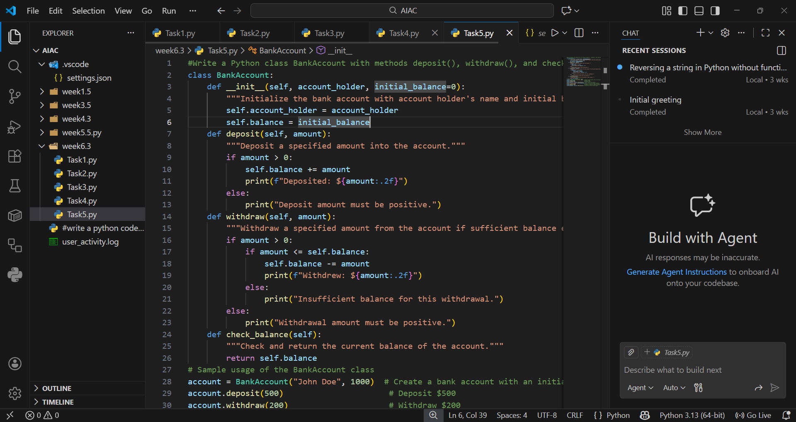

OUTPUT:
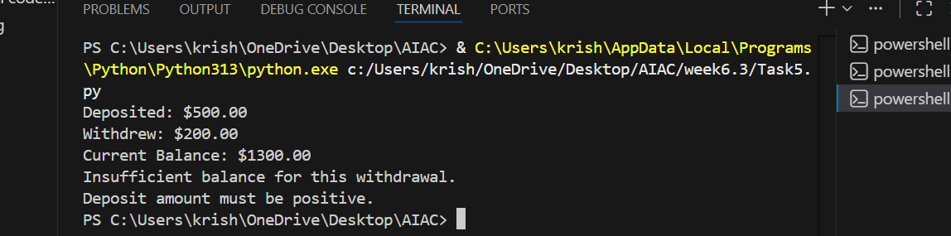

EXPLANATION:
This code defines a BankAccount class with deposit, withdraw, and balance methods.The constructor initializes account holder and balance.deposit() adds money, withdraw() deducts if funds are sufficient, and check_balance() displays the balance.It demonstrates encapsulation and basic banking operations in Python.

