AI ASSISTED CODING
ASSIGNMENT-10.3
NAME:DIDDI KRISHNA SATHWIKA
ROLL NO:2303A52451
BATCH:50
Problem Statement 1: AI-Assisted Bug Detection
Scenario: A junior developer wrote the following Python function to
calculate factorials:
def factorial(n):
result = 1
for i in range(1, n):
result = result * i
return result
Instructions:
1. Run the code and test it with factorial(5).
2. Use an AI assistant to:
o Identify the logical bug in the code.
o Explain why the bug occurs (e.g., off-by-one error).
o Provide a corrected version.
3. Compare the AI’s corrected code with your own manual fix.
4. Write a brief comparison: Did AI miss any edge cases (e.g.,
negative numbers, zero)?
Expected Output:
Corrected function should return 120 for factorial(5).
PROMPT:
“The following Python function is intended to calculate factorials but gives the wrong result. Identify the bug, explain why it occurs, and provide a corrected version. Also, check if edge cases like zero or negative inputs are handled.”

CODE AND OUTPUT:
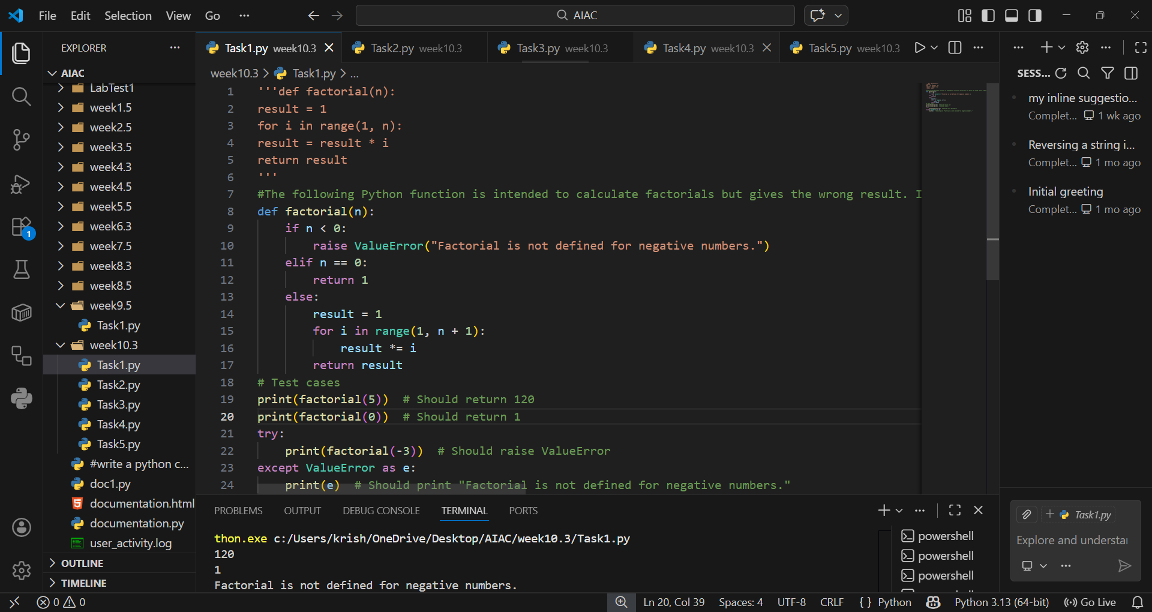

EXPLANATION:
This prompt explicitly asks the AI to detect the logical error (off-by-one in the loop), explain the reasoning, and fix it. It also ensures the AI considers edge cases beyond the immediate bug.

Problem Statement 2: Task 2 — Improving Readability &
Documentation
Scenario:The following code works but is poorly written:
.
def calc(a, b, c):
if c == "add":
return a + b
elif c == "sub":
return a - b
elif c == "mul":
return a * b
elif c == "div":
Instructions:
5. Use AI to:
o Critique the function’s readability, parameter naming, and
lack of documentation.
o Rewrite the function with:
1. Descriptive function and parameter names.
2. A complete docstring (description, parameters,
return value, examples).
3. Exception handling for division by zero.
4. Consideration of input validation.
6. Compare the original and AI-improved versions.
7. Test both with valid and invalid inputs (e.g., division by
zero, non-string operation).
Expected Output:
A well-documented, robust, and readable function that handles
errors gracefully.

PROMPT:
“Rewrite the following function to improve readability, naming, and documentation. Add a descriptive docstring, handle division by zero, validate inputs, and make the code more robust.”

CODE:
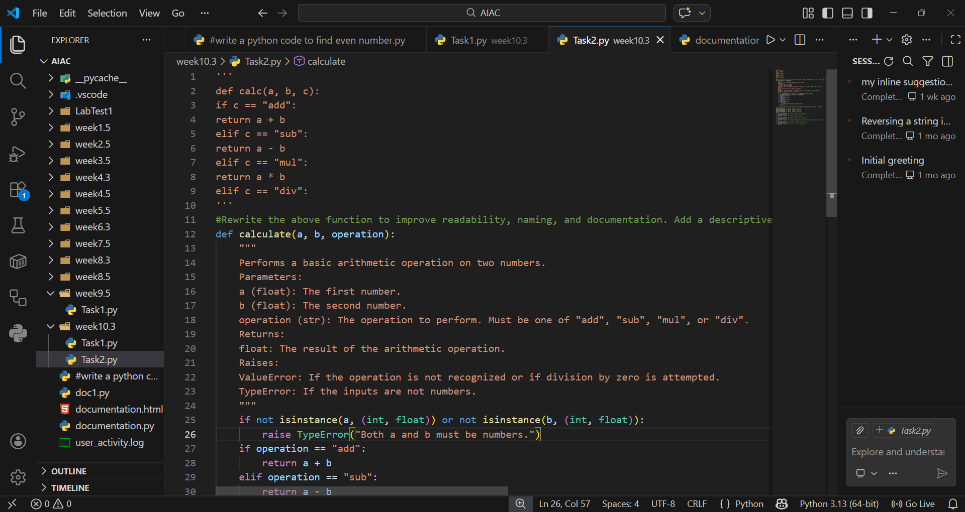
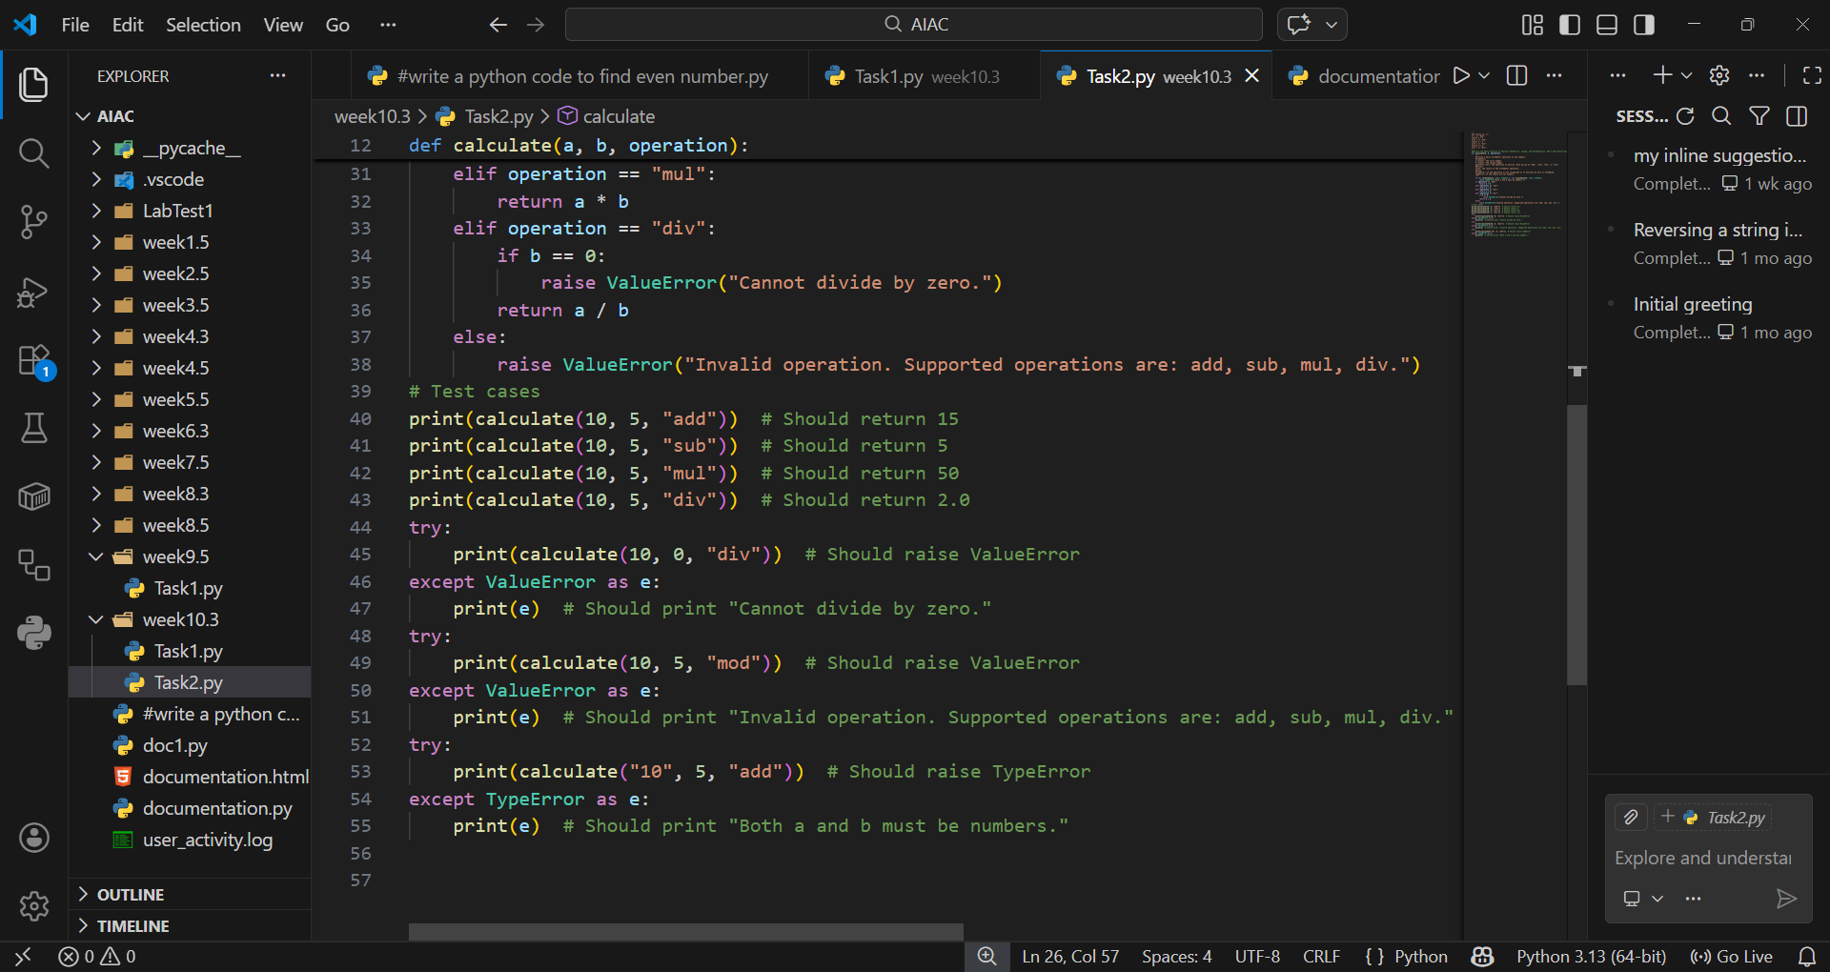
OUTPUT:
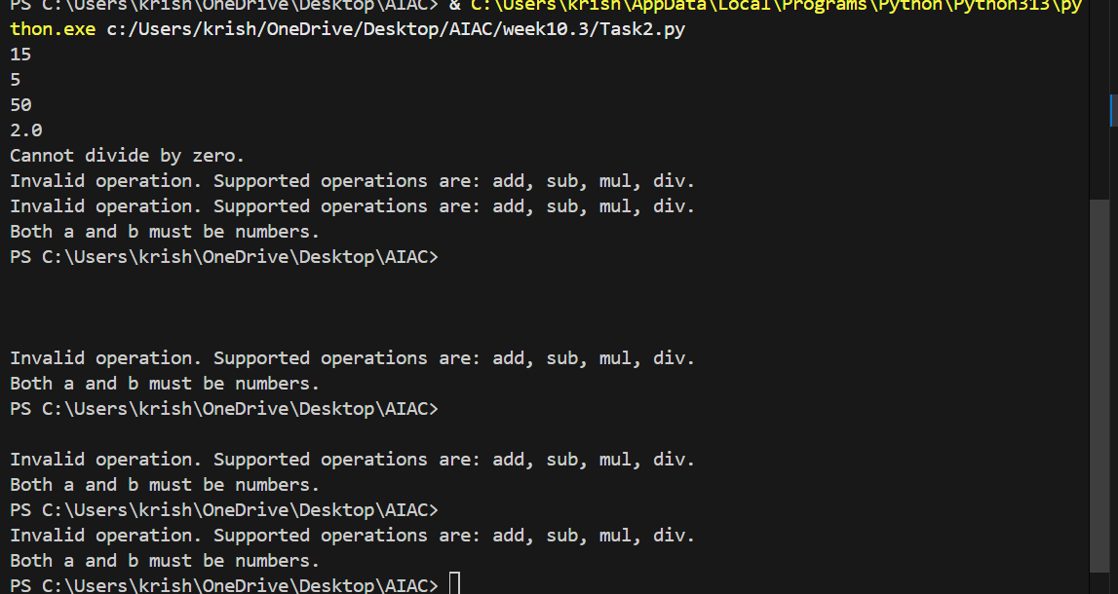
EXPLANATION:
This prompt guides the AI to critique the original code and produce a professional, well-documented version with error handling. It ensures the AI doesn’t just fix syntax but also improves clarity and usability.

Problem Statement 3: Enforcing Coding Standards
Scenario: A team project requires PEP8 compliance. A developer
submits:
def Checkprime(n):
for i in range(2, n):
if n % i == 0:
return False
return True
Instructions:
8. Verify the function works correctly for sample inputs.
9. Use an AI tool (e.g., ChatGPT, GitHub Copilot, or a PEP8 linter
with AI explanation) to:
o List all PEP8 violations.
o Refactor the code (function name, spacing, indentation,
naming).
10. Apply the AI-suggested changes and verify functionality is
preserved.
11. Write a short note on how automated AI reviews could streamline
code reviews in large teams.
Expected Output:
A PEP8-compliant version of the function, e.g.:
def check_prime(n):
for i in range(2, n):
if n % i == 0:
return False
return True
PROMPT:
“Analyze the above Python function for PEP8 violations. List all issues, then refactor the code to be fully PEP8-compliant while preserving functionality."
CODE:
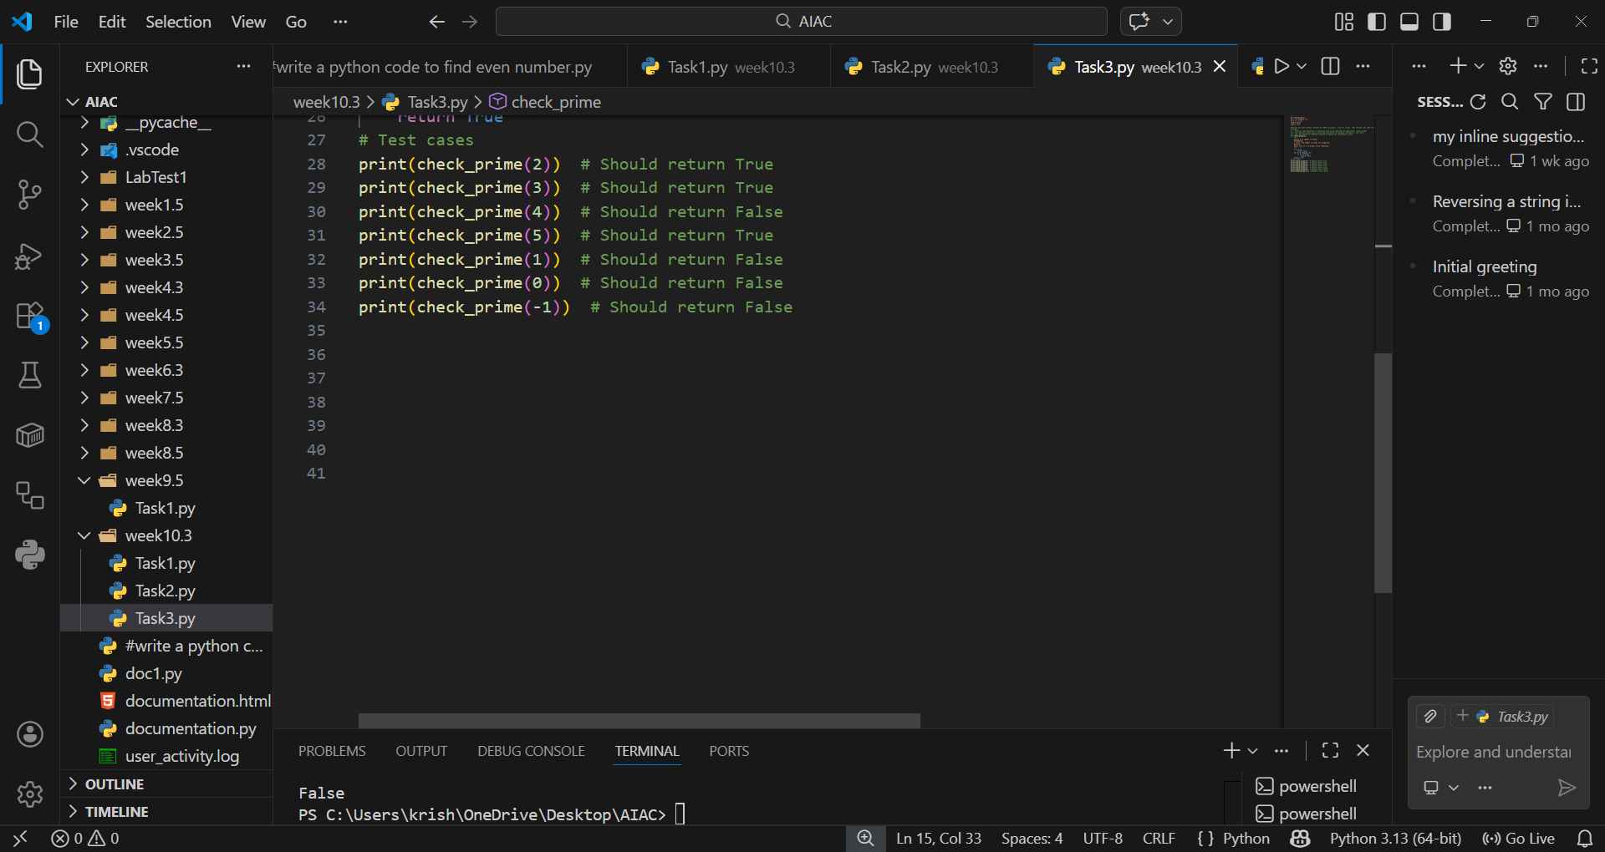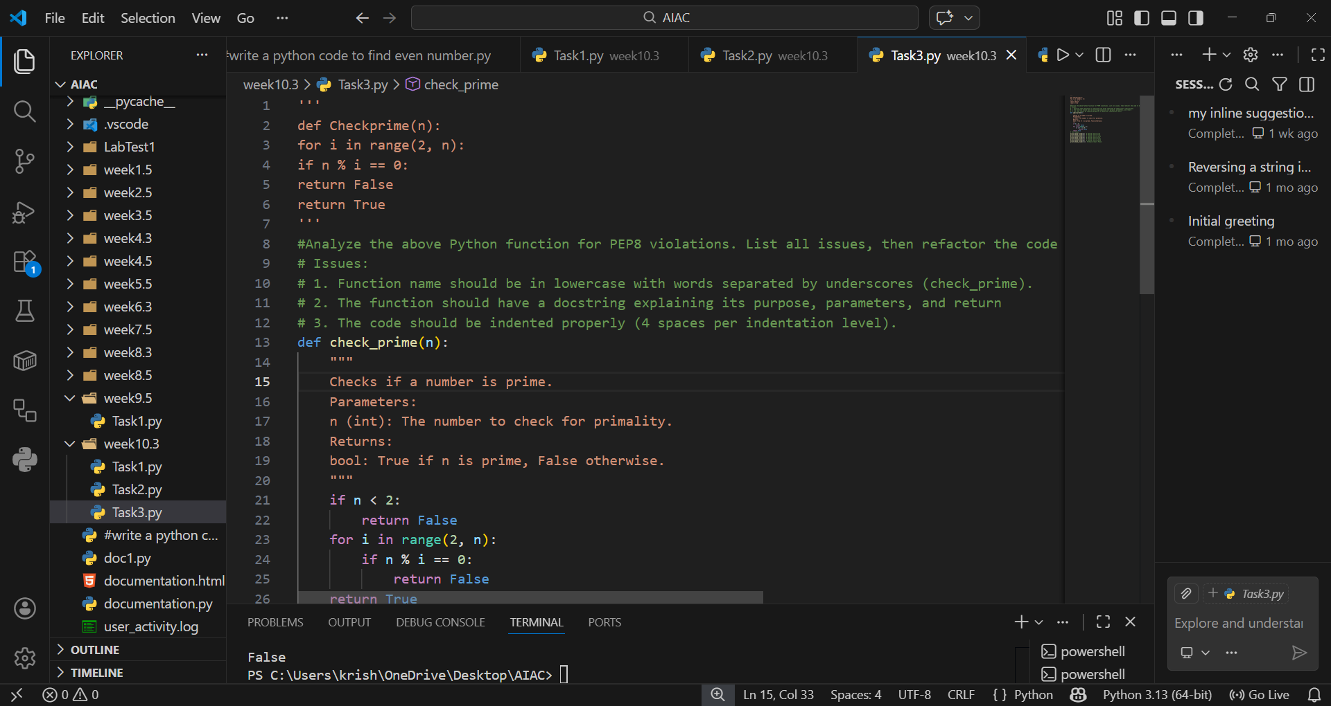
OUTPUT:
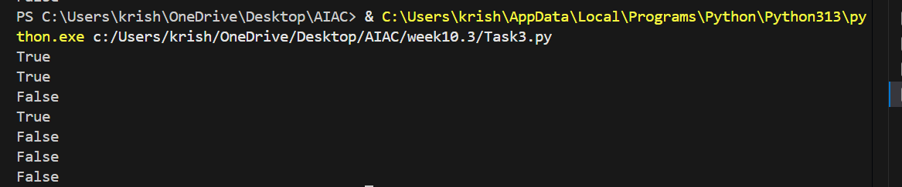

EXPLANATION:
This prompt ensures the AI acts like a linter, pointing out violations (naming, spacing, indentation) and then refactoring. It keeps the focus on compliance while maintaining correctness.

Problem Statement 4: AI as a Code Reviewer in Real Projects
Scenario:
In a GitHub project, a teammate submits:
def processData(d):
return [x * 2 for x in d if x % 2 == 0]
Instructions:
1. Manually review the function for:
o Readability and naming.
o Reusability and modularity.
o Edge cases (non-list input, empty list, non-integer
elements).
2. Use AI to generate a code review covering:
a. Better naming and function purpose clarity.
b. Input validation and type hints.
c. Suggestions for generalization (e.g., configurable
multiplier).
3. Refactor the function based on AI feedback.
4. Write a short reflection on whether AI should be a
standalone reviewer or an assistant.
Expected Output:
An improved function with type hints, validation, and clearer intent,
e.g.:
from typing import List, Union
def double_even_numbers(numbers: List[Union[int,
float]]) -> List[Union[int, float]]:
if not isinstance(numbers, list):
raise TypeError("Input must be a list")
return [num * 2 for num in numbers if isinstance(num,
(int, float)) and num % 2 == 0]
PROMPT:
“Review the above function for readability, naming, modularity, and edge cases. Suggest improvements with type hints, input validation, and generalization. Then refactor the function accordingly.”
CODE:
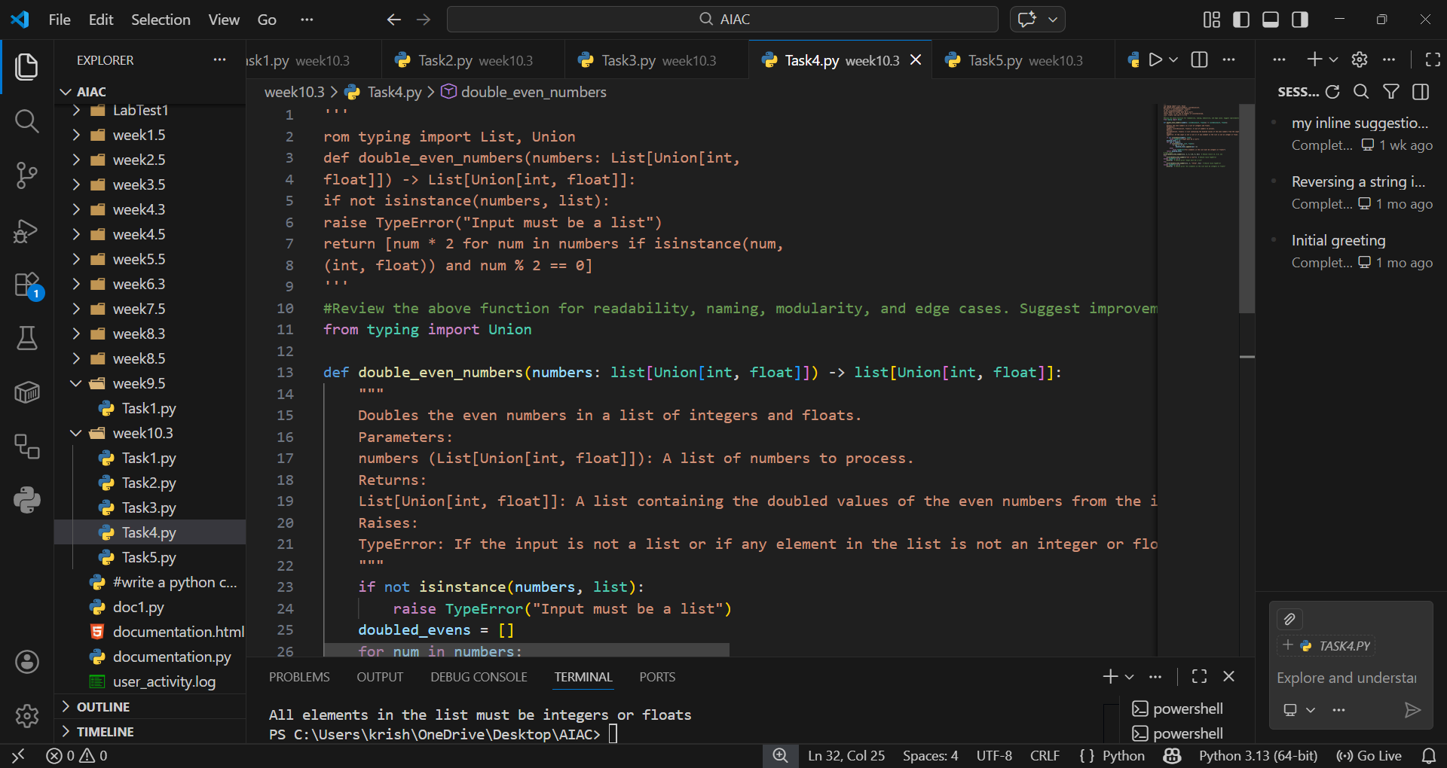
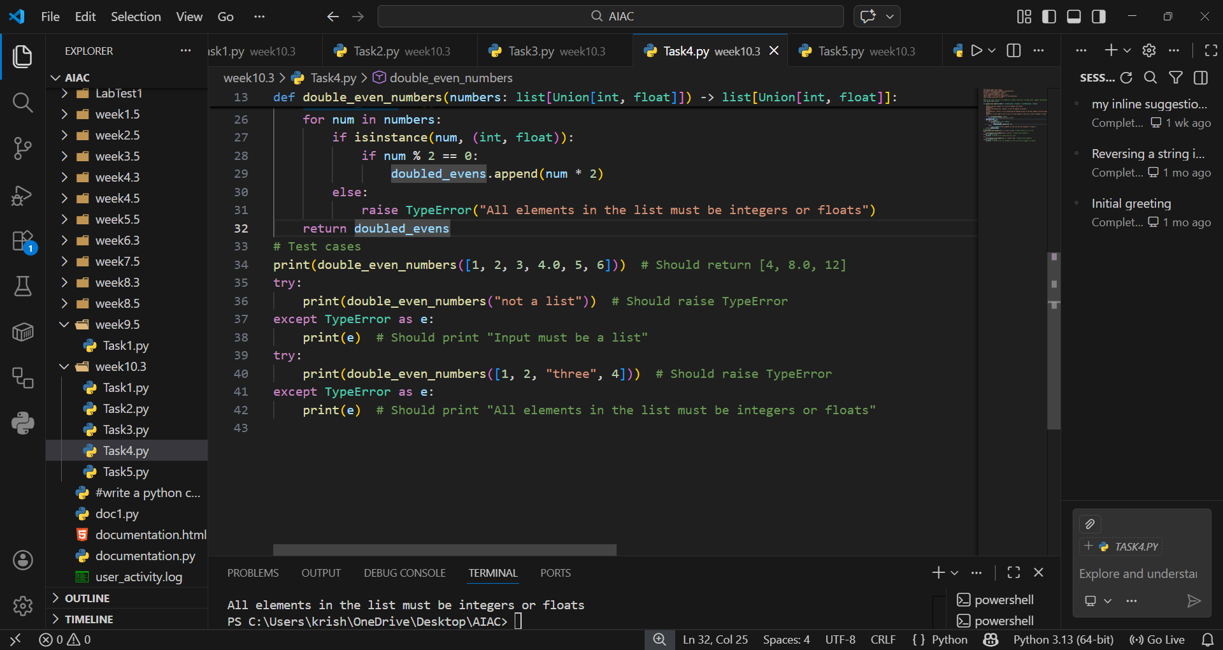

OUTPUT:
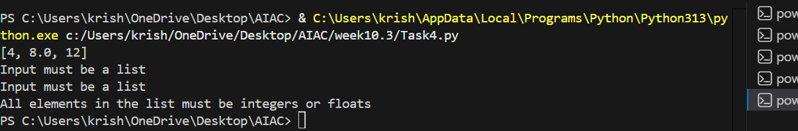
EXPLANATION:
This prompt positions the AI as a reviewer, not just a fixer. It ensures the AI provides critique, suggests enhancements, and produces a refactored version with clearer intent and robustness.

Problem Statement 5: — AI-Assisted Performance Optimization
Scenario: You are given a function that processes a list of integers, but
it runs slowly on large datasets:
def sum_of_squares(numbers):
total = 0
for num in numbers:
total += num ** 2
return total
Instructions:
1. Test the function with a large list (e.g., range(1000000)).
2. Use AI to:
o Analyze time complexity.
o Suggest performance improvements (e.g., using built-in
functions, vectorization with NumPy if applicable).
o Provide an optimized version.
3. Compare execution time before and after optimization.
4. Discuss trade-offs between readability and performance.
Expected Output:
An optimized function, such as:
def sum_of_squares_optimized(numbers):
return sum(x * x for x in numbers)
PROMPT:
“Analyze the time complexity of the above function. Suggest performance optimizations using Python built-ins or libraries like NumPy. Provide an optimized version and discuss trade-offs between readability and performance.”
CODE AND OUTPUT:
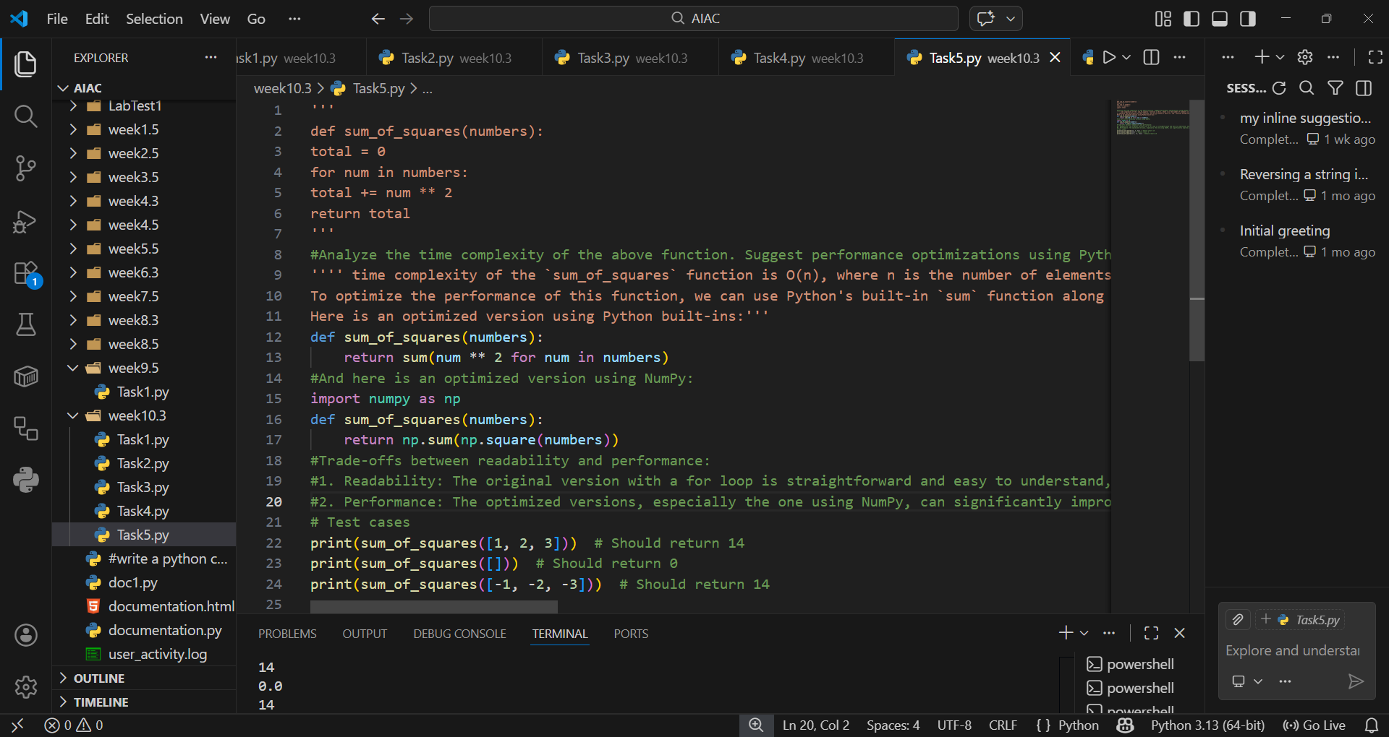
EXPLANATION:
This prompt ensures the AI evaluates efficiency, proposes alternatives, and explains trade-offs. It balances optimization with maintainability, which is crucial in real-world projects.

