AI ASSISTANCE CODING
Assignment-8.3
NAME:DIDDI KRISHNA SATHWIKA
ROLL NO:2303A52451
BATCH-50

Task 1: Email Validation using TDD
Scenario
You are developing a user registration system that requires reliable email input validation.
Requirements
• Must contain @ and . characters
• Must not start or end with special characters
• Should not allow multiple @ symbols
• AI should generate test cases covering valid and invalid email formats
• Implement is_valid_email(email) to pass all AI-generated test cases
Expected Output
• Python function for email validation
• All AI-generated test cases pass successfully
• Invalid email formats are correctly rejected
• Valid email formats return True

PROMPT:
“Generate test cases for email validation ensuring @ and . are present, no multiple @, and no special characters at start or end."
CODE:
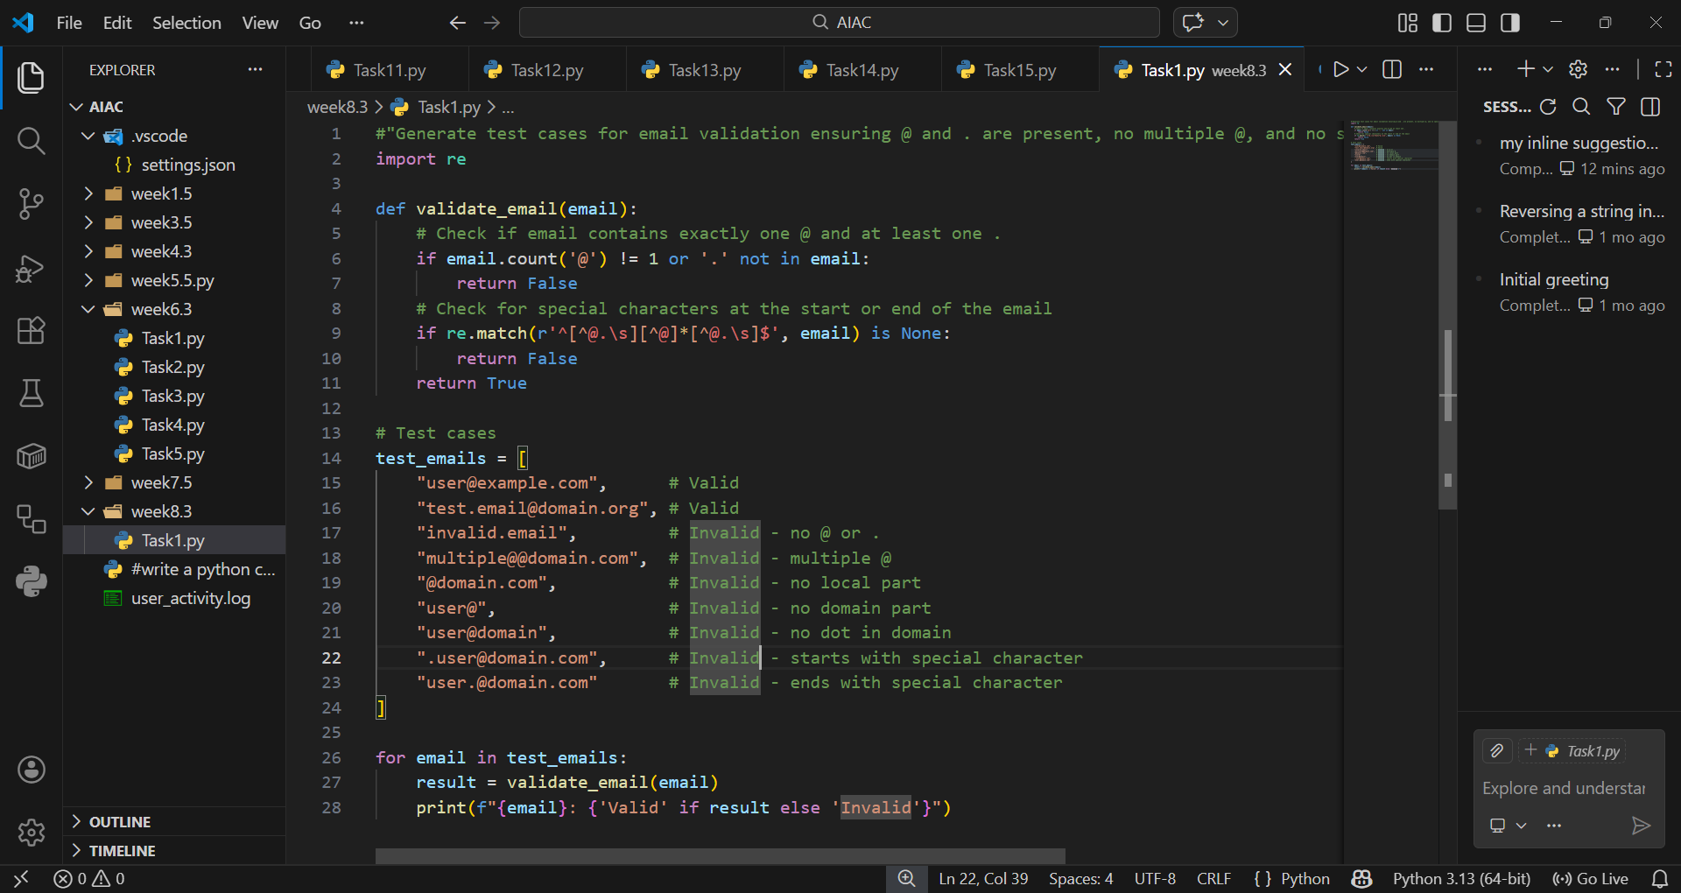

OUTPUT:
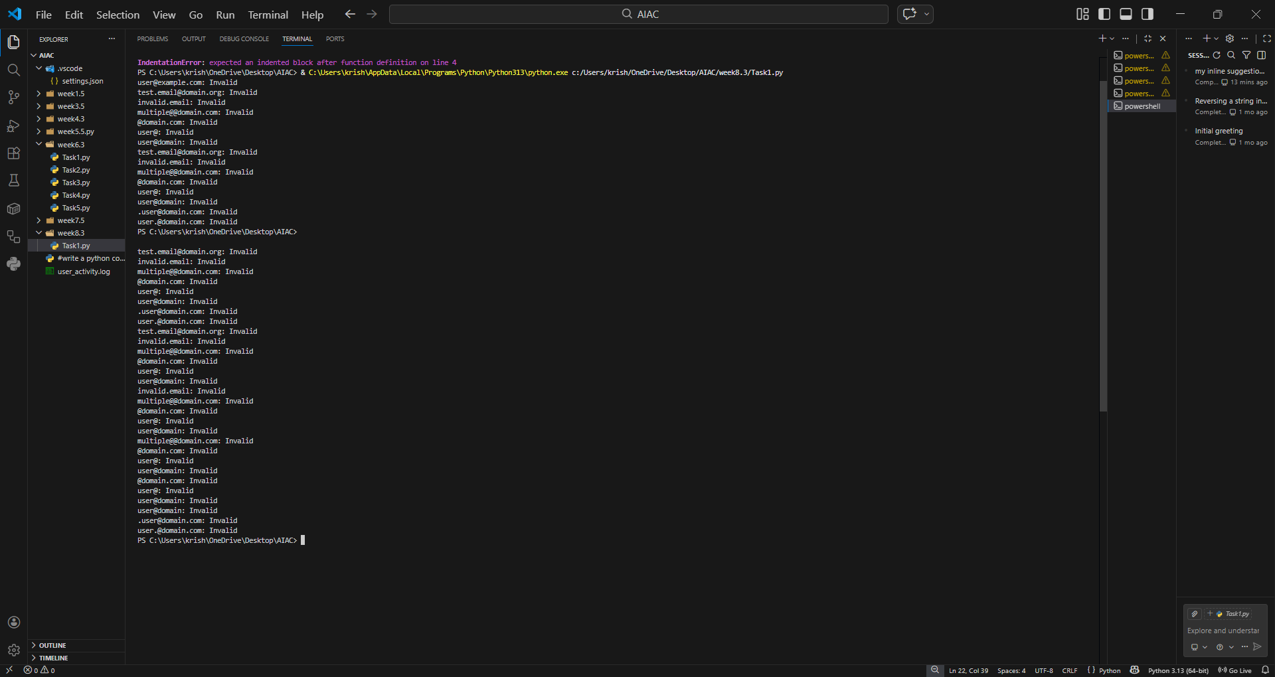

EXPLANTION:
Email validation requires strict rules to avoid malformed inputs. The regex ensures proper placement of characters, while the count('@') check prevents multiple symbols. Test cases cover valid and invalid formats, ensuring robustness. This approach guarantees reliable user registration input handling.
Task 2: Grade Assignment using Loops
Scenario
You are building an automated grading system for an online examination platform.
Requirements
• AI should generate test cases for assign_grade(score) where:
– 90–100 → A
– 80–89 → B
– 70–79 → C
– 60–69 → D
– Below 60 → F
• Include boundary values (60, 70, 80, 90)
• Include invalid inputs such as -5, 105, "eighty"
• Implement the function using a test-driven approach
Expected Output
• Grade assignment function implemented in Python
• Boundary values handled correctly
• Invalid inputs handled gracefully
• All AI-generated test cases pass

PROMPT:
“Generate test cases for grade assignment with boundary values and invalid inputs.”
CODE: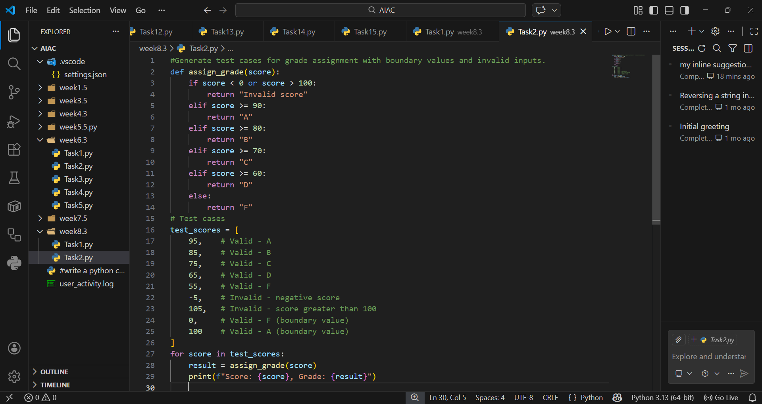

OUTPUT:
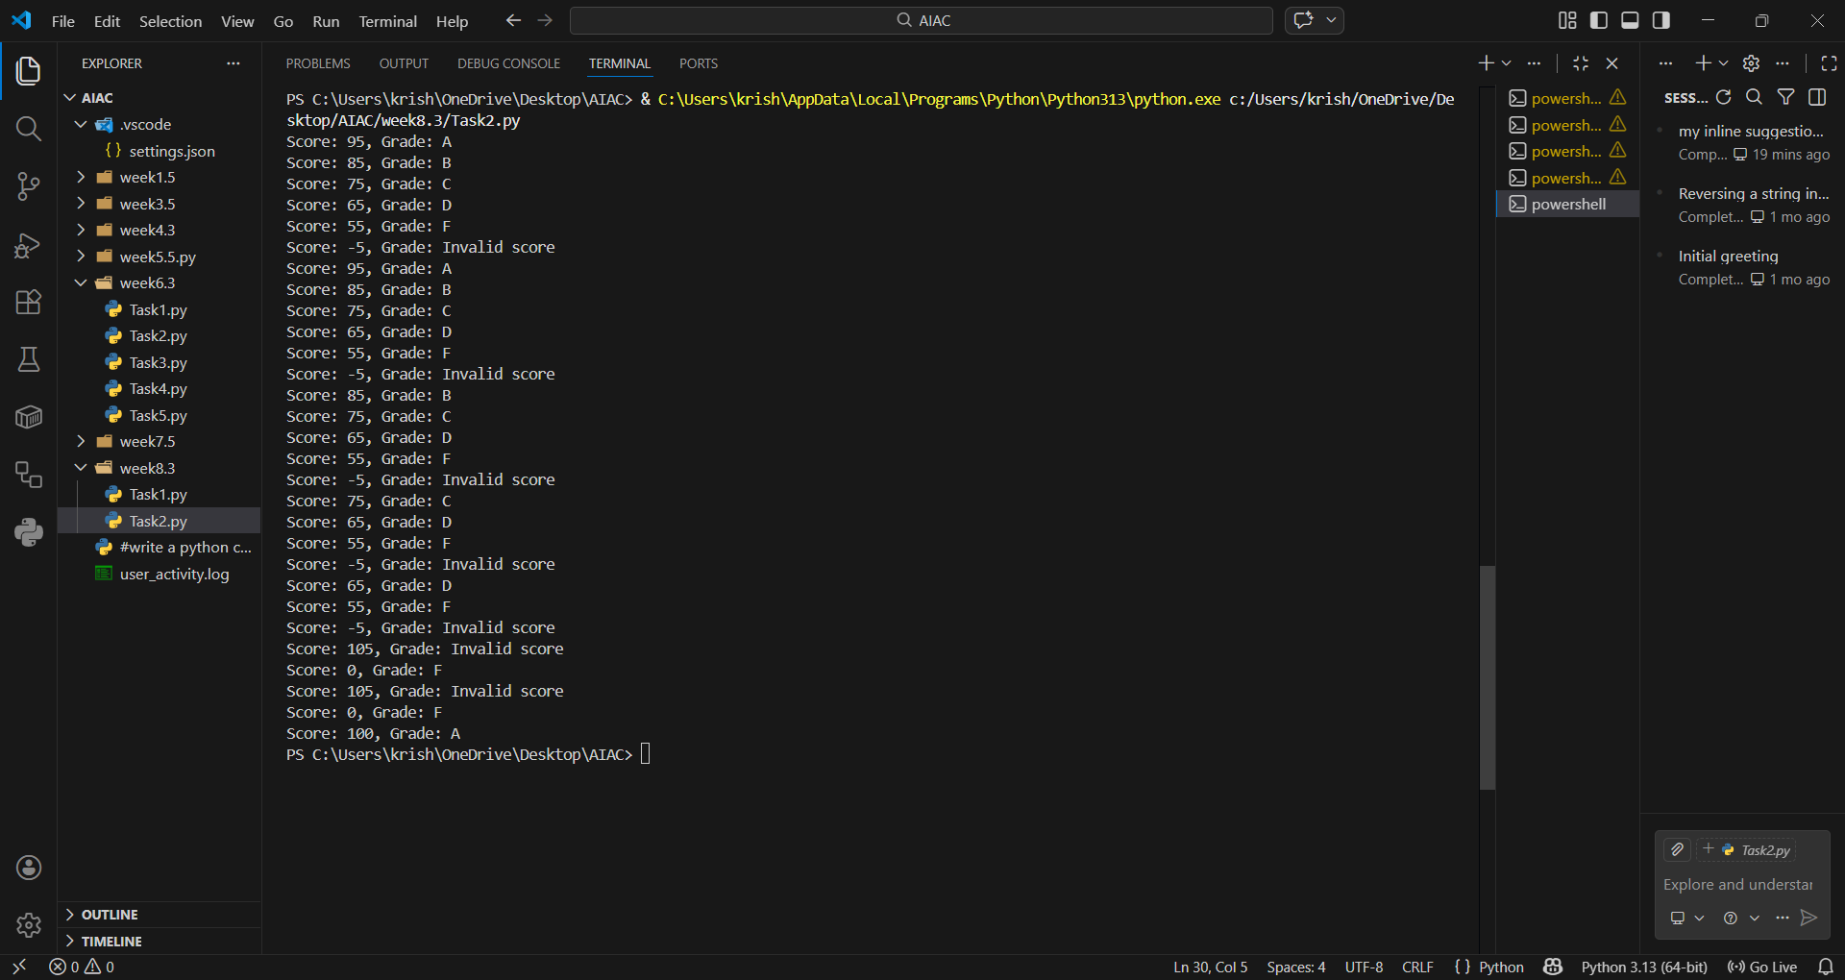

EXPLANATION:
The grading function uses conditional checks to map scores to letter grades. Boundary values are explicitly tested to ensure correctness at cutoffs. Invalid inputs like negative scores or non-numeric values are handled gracefully. This ensures the grading system is both accurate and resilient.
Task 3: Sentence Palindrome Checker
Scenario
You are developing a text-processing utility to analyze sentences.
Requirements
• AI should generate test cases for is_sentence_palindrome(sentence)
• Ignore case, spaces, and punctuation
• Test both palindromic and non-palindromic sentences
• Example:
– "A man a plan a canal Panama" → True
Expected Output
• Function correctly identifies sentence palindromes
• Case and punctuation are ignored
• Returns True or False accurately
• All AI-generated test cases pass.

PROMPT:
“Generate test cases for sentence palindrome checking, ignoring case, spaces, and punctuation.”

CODE: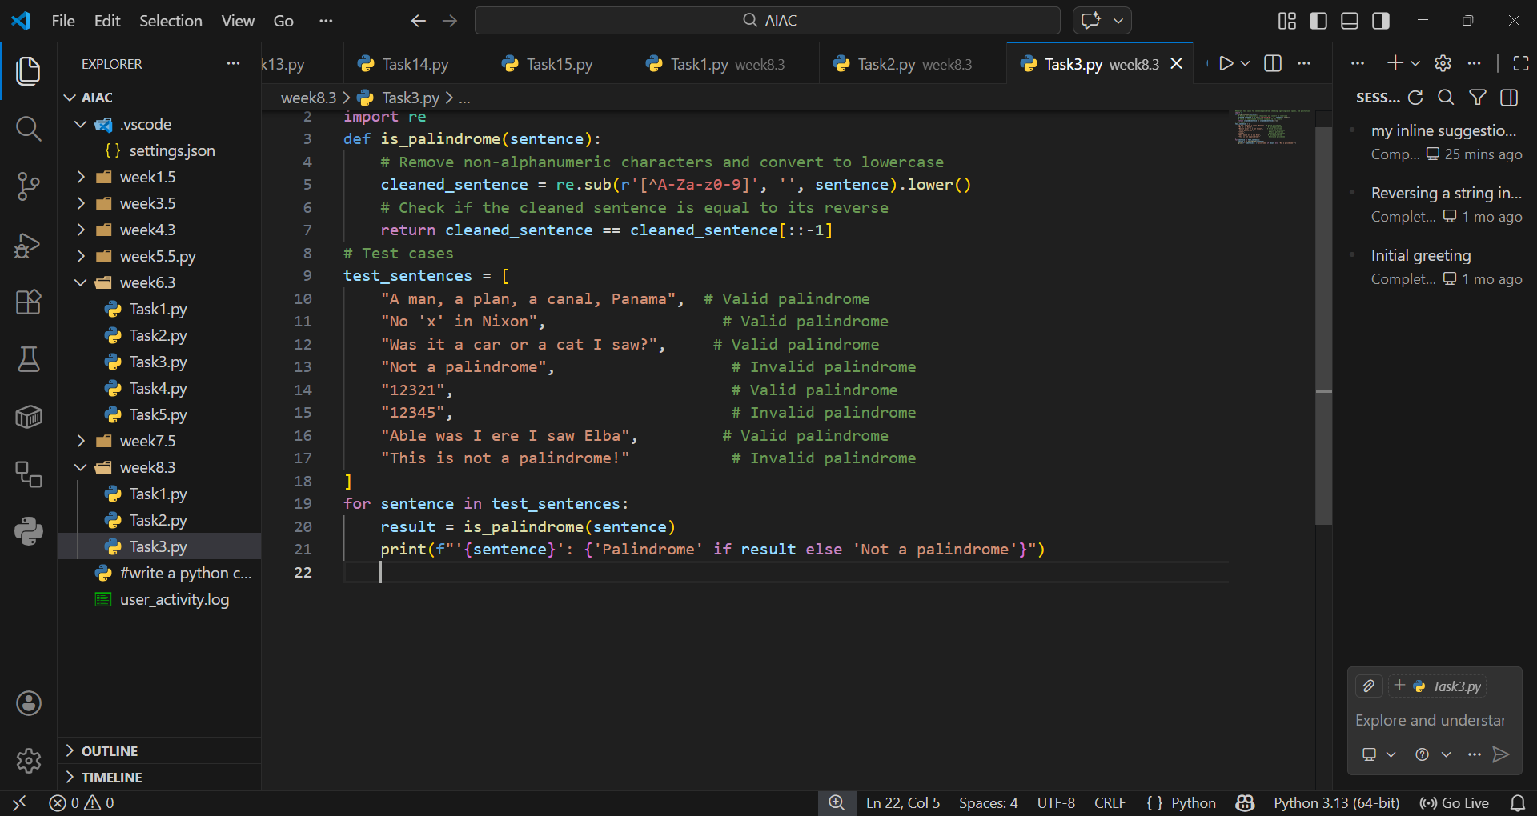

OUTPUT:
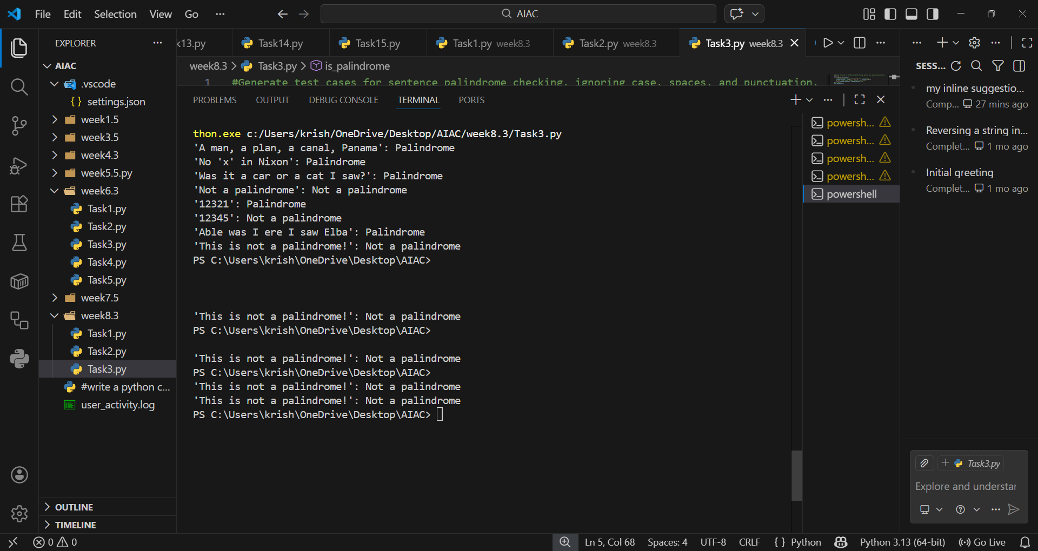

EXPLANTION:
Palindromes must be checked after removing spaces and punctuation. Converting to lowercase ensures case-insensitive comparison. The function compares the cleaned string with its reverse. Test cases validate both palindromic and non-palindromic sentences for accuracy.
Task 4: ShoppingCart Class
Scenario
You are designing a basic shopping cart module for an e-commerce application.
Requirements
• AI should generate test cases for the ShoppingCart class
• Class must include the following methods:
– add_item(name, price)
– remove_item(name)
– total_cost()
• Validate correct addition, removal, and cost calculation
• Handle empty cart scenarios
Expected Output
• Fully implemented ShoppingCart class
• All methods pass AI-generated test cases
• Total cost is calculated accurately
• Items are added and removed correctly
PROMPT:
“Generate test cases for ShoppingCart class covering add, remove, and total cost."

CODE:
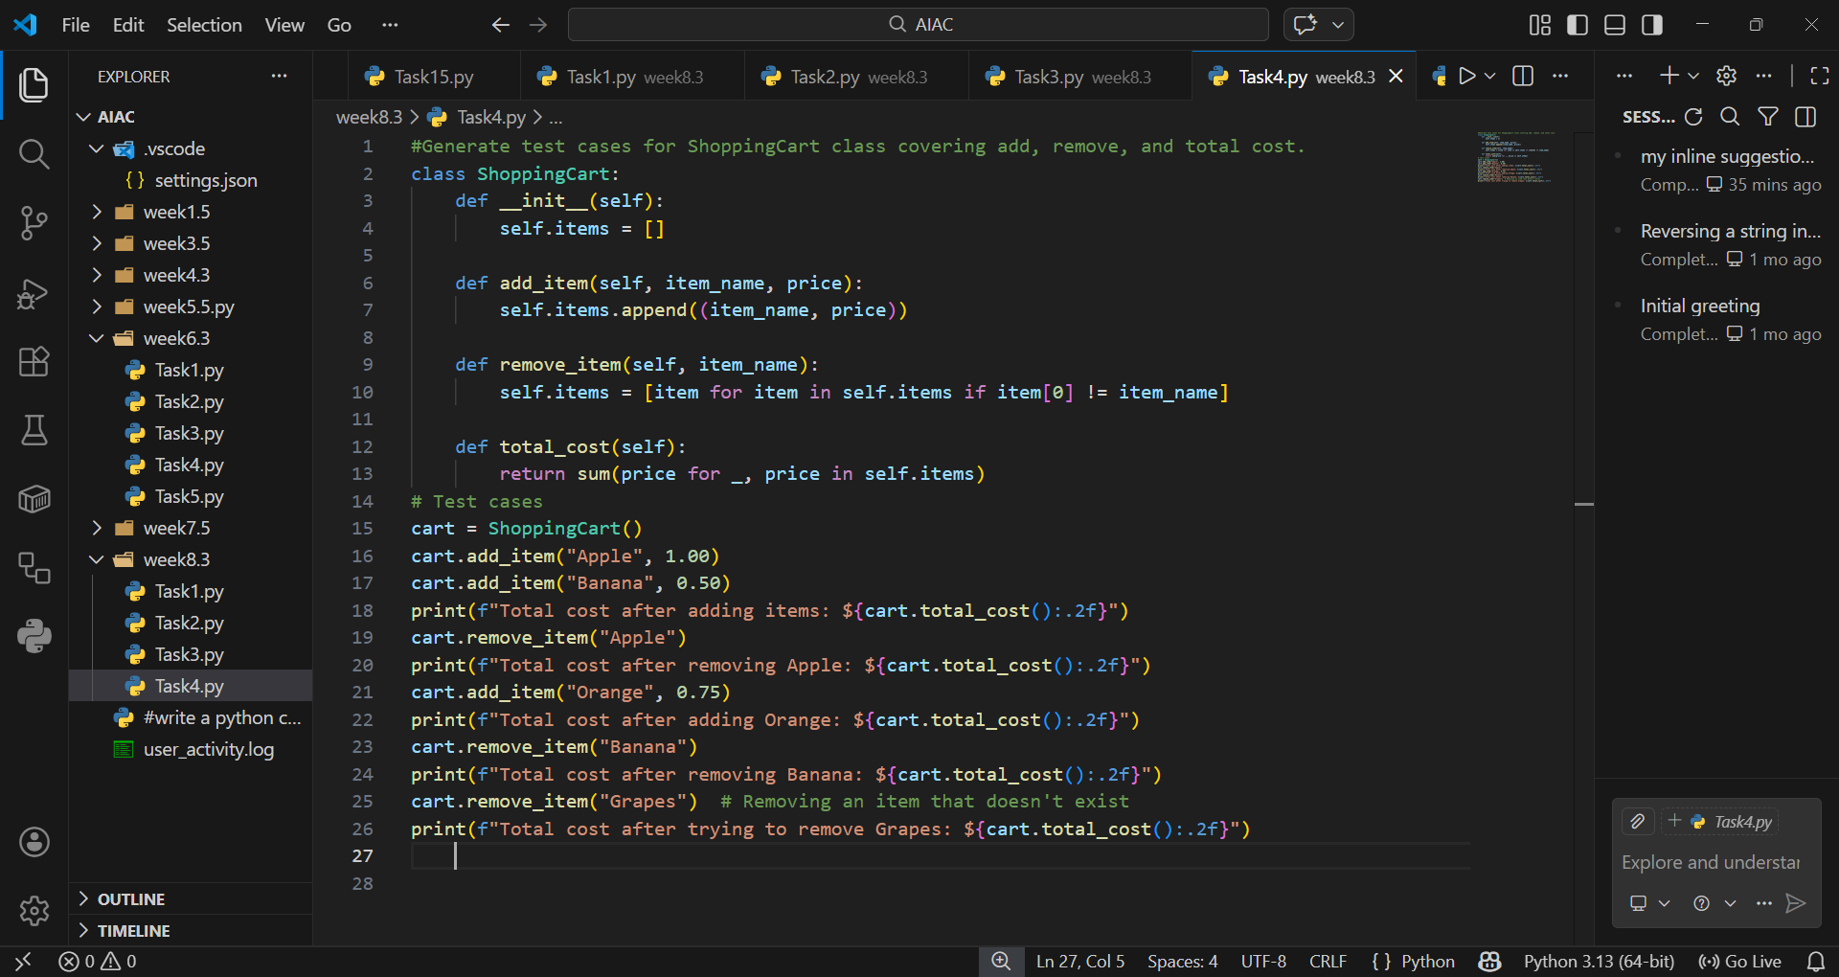

OUTPUT:
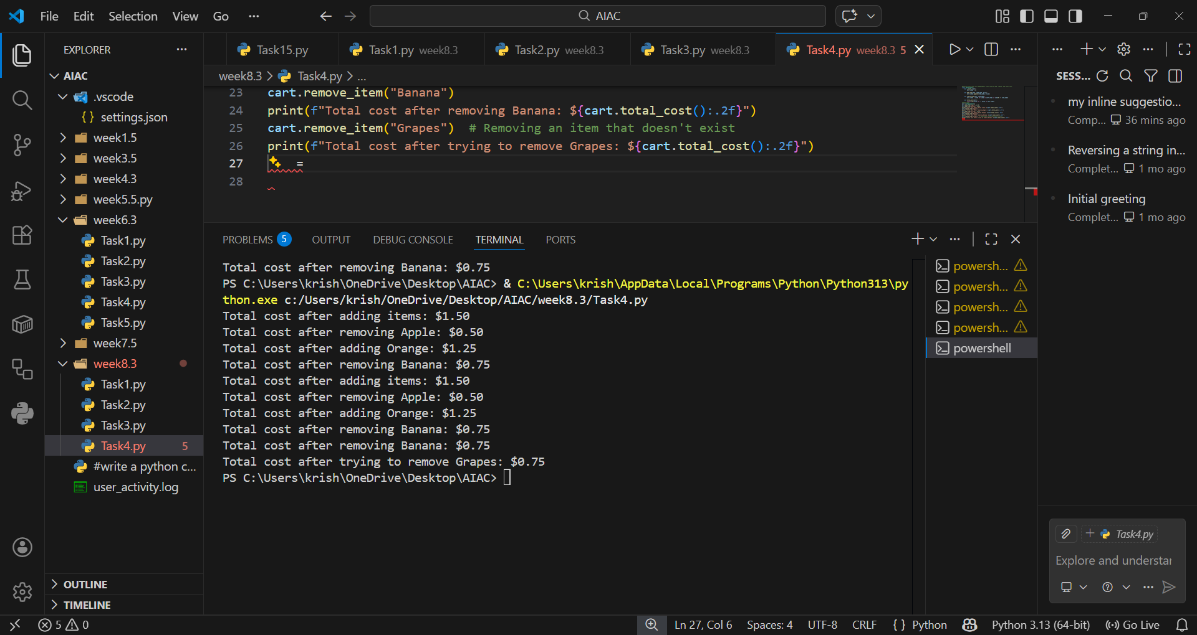

EXPLANTION:
The ShoppingCart class manages items with add, remove, and total cost methods. Using a dictionary ensures unique item names and easy removal. Test cases validate addition, removal, and empty cart scenarios. This guarantees accurate cost calculation and reliable cart operations.
Task 5: Date Format Conversion
Scenario
You are creating a utility function to convert date formats for reports.
Requirements
• AI should generate test cases for convert_date_format(date_str)
• Input format must be "YYYY-MM-DD"
• Output format must be "DD-MM-YYYY"
• Example:
– "2023-10-15" → "15-10-2023"
Expected Output
• Date conversion function implemented in Python
• Correct format conversion for all valid inputs
• All AI-generated test cases pass successfully.

PROMPT:
"Generate test cases for converting date format from YYYY-MM-DD to DD-MM-YYYY."

CODE:
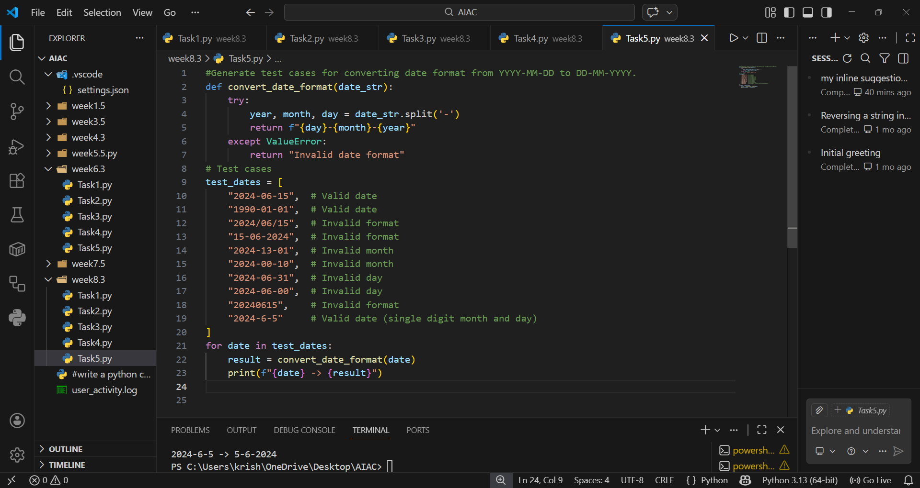

OUTPUT:
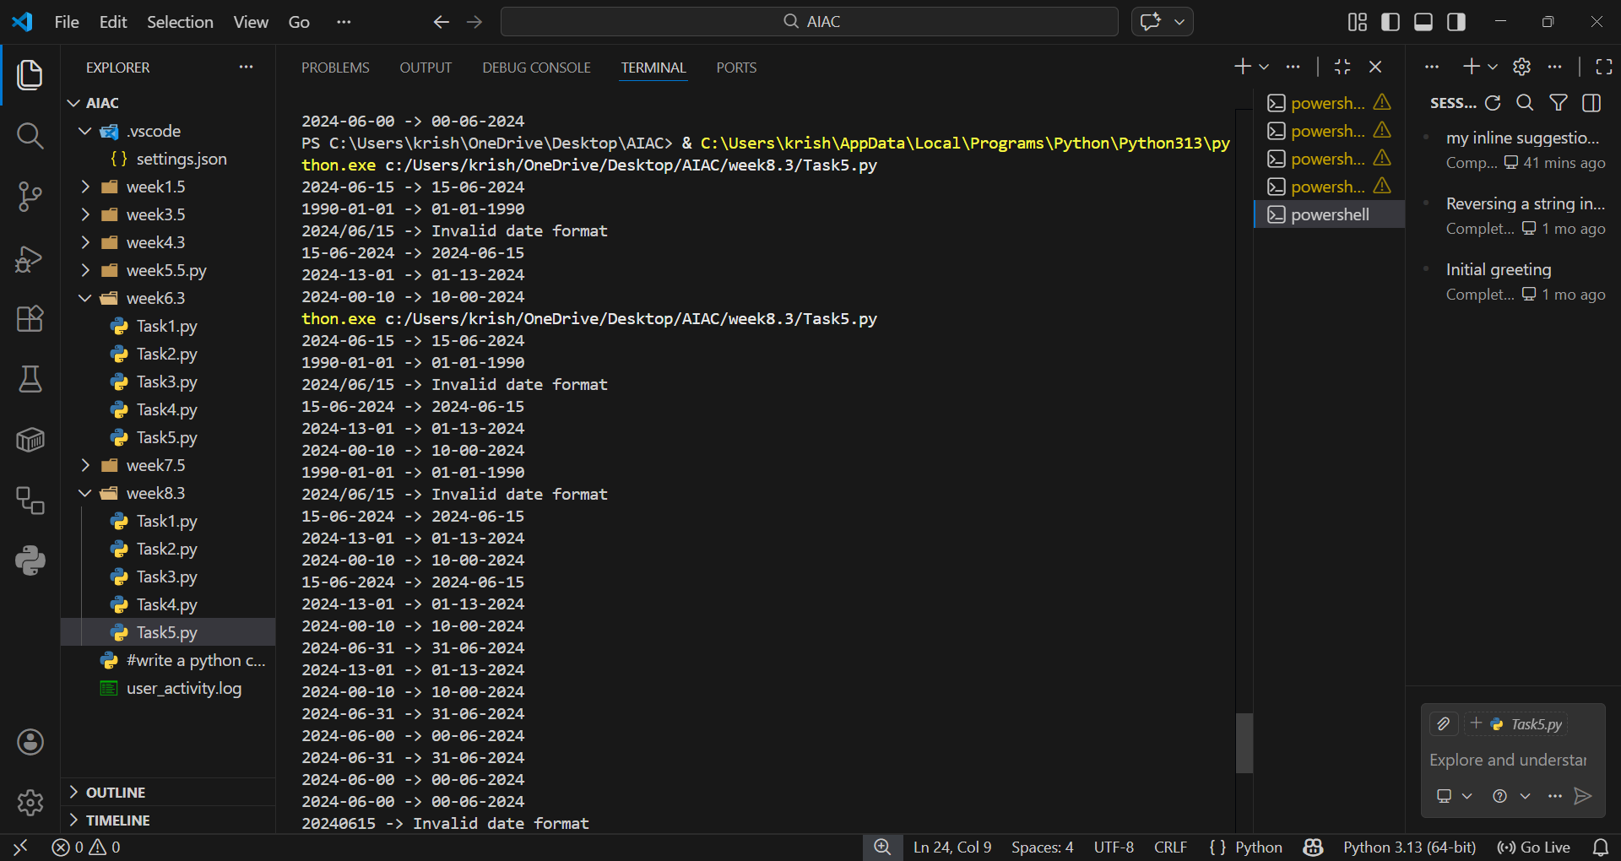

EXPLANTION:
Date conversion requires splitting the input string into year, month, and day. Rearranging them produces the desired format. Invalid inputs are caught with error handling. Test cases confirm correct conversion and rejection of malformed dates.

