Attn :

HRD Department

Regarding to your job offer, I encouraged myself to apply at your company. Since my skill and interest are in Human Resources ( HR ) & General Affair ( GA ), I would like to apply for the position available. And I would appreciate your consideration for my qualification.
I have completed my tertiary education in Soegijapranata Catholic of University at Semarang. My degrees are Bachelor of Psychology. I am able to operate personal computer with such as software as Microsoft Word, Microsoft Excel, and Microsoft Power Point.
Now, I worked at PT Jawamanis Rafinasi, which is a part of Wilmar Group since July 1st , 2011 until now. At this moment I am working as Human Resources & General Affairs Section Head
Enclosed is a copy my curriculum vitae. I would appreciate if you would consider my application here in and if I could meet you to discuss my qualification at earliest convenience.
Thank you for your consideration.

Sincerely yours,

Martinus Pri Hari Tomo

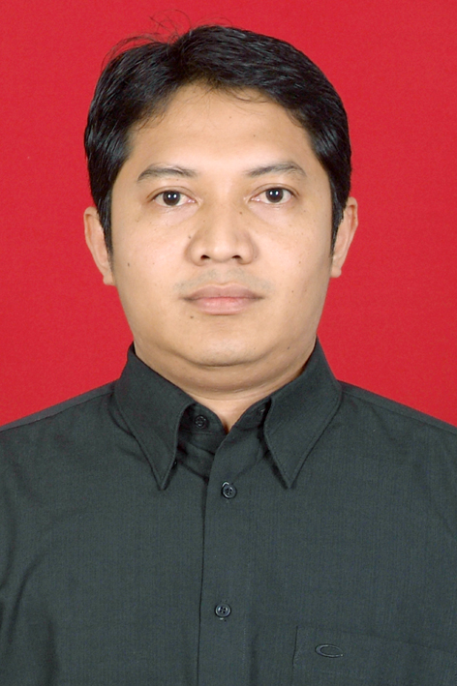
Martinus Pri Haritomo

Personal Data

Place, date of birth : Wonogiri, October 28, 1977
Sex : Male
Religion : Catholic
Ethnic : Javanese
Nationality : Indonesian
Marital Status : Married
Hobbies : Sport, Singing, Music, Traveling
Subjectivity : Hard working and enjoy in working as part of team or
independence and self motivation

Formal Education

- Psychology – Soegijapranata Catholic University at Semarang ( 1997 – 2002 )
- Regina Pacis High School at Surakarta ( 1993 – 1996 )
- Kanisius Junior High School at Wonogiri ( 1990 - 1993 )
- Kanisius Elementary School at Wonogiri ( 1984 – 1990 )

Ability

- Computer Literature ( MS Word, MS Excel, MS Power Point, Internet )
- SAP Program
- HRIS ( Human Resources Information System ) by Oracle
- ENABLON System
- Could communicate in English oral and written
- Able to working as part of team

Working Experience

August 01, 2015 – at present

PT. JAWAMANIS RAFINASI ( WILMAR Group)
About Company : Refinery Sugar Industry
Department : HR & Admin
Position : HR & Admin Section Head
Report to : Factory Manager
Duties :
- To Application SAP System & HRIS System
- Compensation & Benefit ( medical reimbursement, overtime, official travel for employee, BPJS, etc )
- Legal Permit
- Document Control at HR Department for ISO 9001 ; 2008, FSSC 22000 ; ISO 14001 ; SGP ( Social Guide Principle ) ; URSA ( Unilever Responsible Social Audit )
- Pest Control Inspection
- Internal Auditor for ISO 9001 ; 2008 & Housekeeping
- Interview in process recruitment for selected candidate

- Maintenance Asset ( vehicle, stationary, handy talky (HT), building, pc computer, AC, mess, furniture, etc)
- Cleaning service coordination
- Transportation employee coordination
- Administration ( ex. Processing billing payment from business partner, check invoice, etc )

July 01, 2011 – 30 September 2015

PT. DUTA SUGAR INTERNATIONAL ( WILMAR Group)
About Company : Refinery Sugar Industry
Department : HR & Admin
Position : HR & Admin Section Head
Report to : Factory Manager
Duties :
- To Application SAP System & HRIS System
- Compensation & Benefit ( medical reimbursement, overtime, official travel for employee, JAMSOSTEK, etc )
- Psycho Test ( TIU 5, WPT, IST, Wartegg test, Graphic test, DISC, Papi Costic, etc. )
- Document Control at HR Department for ISO 9001 ; 2008, FSSC 22000
- Pest Control Inspection
- Internal Auditor for ISO 9001 ; 2008 & Housekeeping
- Interview in process recruitment for selected candidate
- Maintenance Asset ( vehicle, stationary, handy talky (HT), building, pc computer, AC, etc)
- Cleaning service coordination
- Transportation employee coordination

- Manage of Canteen
- Administration ( ex. Processing billing payment from business partner, check invoice, etc )

February 02, 2009 – 30 Juni 2011

PT. DUTA SUGAR INTERNATIONAL ( Duta Anggada Group)
About Company : Refinery Sugar Industry
Department : HRD & GA
Position : HRD & GA Supervisor
Report to : HRD & GA Manager
Duties :
- Psycho Test ( TIU 5, WPT, IST, Wartegg test, Graphic test, DISC, Papi Costic, etc. )
- Interview in process recruitment for the client
- Maintenance Asset (vehicle, stationary, handy talky, pc computer, etc)
- Cleaning service coordination
- Transportation employee coordination
- Manage of Canteen
- Local purchasing
- Administration

October 06, 2003 – January 31, 2009

PT. MISAYA PROPERINDO ( Duta Pertiwi Tbk, Sinar Mas Group )
About Company : Developer
Department : HRD
Position : HRD Senior Staff
Report to : HRD Supervisor

Duties :
- Psycho Test
- Interview in process recruitment
- Processing Compensation and Benefit ( overtime, medical reimbursement, incentive, annual leave, absence, etc )
- Trainer
- Administration

January 15, 2002– September 28, 2002

BIRO KONSULTASI PSIKOLOGI ‘PERSONATA’ SEMARANG
About Company : Psychology Consultant for Recruitment and Training
Status : Job Training
Report to : Owner
Duties : Process recruitment for the client ( give psycho test and scoring test result )

June 2001 – June 2002

SOEGIJAPRANATA CATHOLIC UNIVERSITY AT SEMARANG
Position : Assistant of Student College at Psycho diagnostic IV ( Graphic Test )
Report to : Lecturer
Duties : Giving a theory, practicum, and scoring result of practicum

Training

- Human Resources Management – March 2006 by SLI ( Supreme Learning International )
- ISO 9001 ; 2008 by Neville Clarke
- FSSC 22000 ( PAS 220 ) by Wilmar Group
- QCC ( Quality Control Circle ) – October 2012 by Wilmar Learning Centre
- Internal Audit – October 2012 by Wilmar Learning Centre
- English Course by RC Consultant
- PROPER by Dinas Lingkungan Hidup
- Competency Base Human Resources Management ( CBHRM ) 2014 by Wilmar Group
- Property Concervatio & Pengenalan Bahaya by AAA Consultant
- Pest Control Awareness by Aardwolf Pest Management
- HACCP System for Implementation by Wilmar Group
- Penanggulangan Kebakaran by DAMKAR
- Penyakit Akibat Kerja ( PAK )

Sincerely yours,

Martinus Pri Hari Tomo

