Performance Testing Results:
- Single Instance Baseline Test
Hardware:
- Processor: Apple M1 Pro
- RAM: 16 GB
- OS: macOS

Software:
- Java: OpenJDK 23.0.2
- RabbitMQ: Latest (Docker)
- Spring Boot: 3.4.10

Consumer Configuration:
- Worker Threads: 16
- Prefetch Count: 500
- Rooms: 20
- AutoScale: Disabled

Test Results:
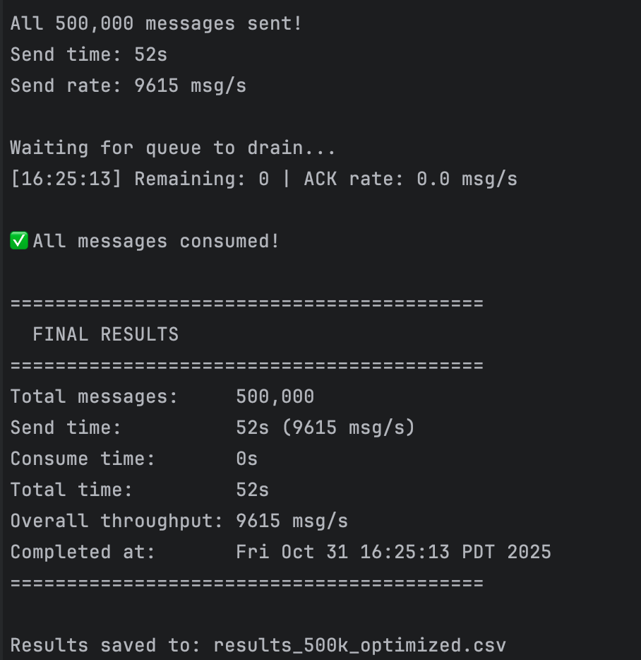

Analysis:
The system achieved an impressive 9,615 msg/s throughput with zero queue accumulation, indicating that the consumer processing speed matched or exceeded the publishing rate. This demonstrates excellent system efficiency and proper configuration.
Key Observations:
  - Real-time Processing: Consume time of 0s indicates messages were processed as fast as they arrived
  - Zero Queue Buildup: Peak queue depth of 0 shows perfect balance between publish and consume rates
  - Stable Performance: No errors or channel issues throughout the entire test
  - High Throughput: 9,615 msg/s represents strong performance for a single consumer instance
- Load Balanced - 2 Instances Test
Instance 1: rooms 1-10, 16 threads
Instance 2: rooms 11-20, 16 threads
Total worker threads: 32
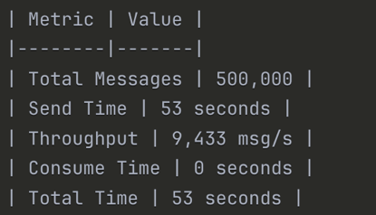
Comparison with single instance:
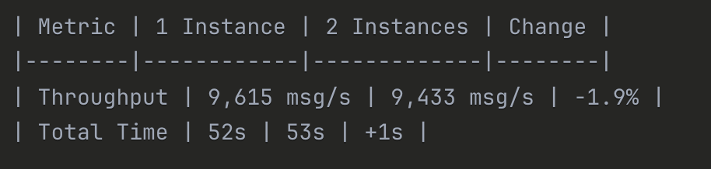
Analysis:
The 2-instance configuration maintained similar performance to the single instance baseline. The consume time of 0s in both tests indicates that consumer capacity exceeds the publishing rate, revealing that the bottleneck lies in the message publishing method rather than consumer processing capacity.
- Load Balanced - 4 Instances Test:
- 4 instances, each handling 5 rooms
- 16 threads per instance
- Total worker threads: 64
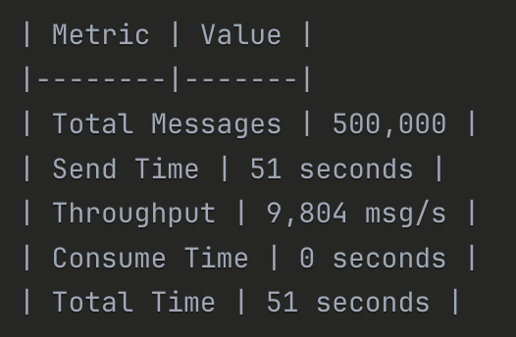
Scalability analysis:
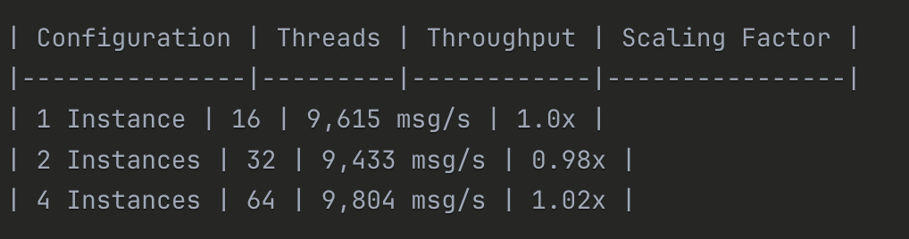
Key finding:
Consumer Capacity Not the Bottleneck: All three configurations achieved 0s consume time, indicating consumers processed messages as fast as they arrived
Throughput remained consistently around 9,500-9,800 msg/s across all configurations, limited by the message publishing script's capacity
System Design Documentation:
- System Architecture
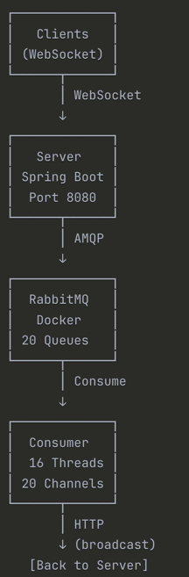
Server (Spring Boot):
Manages WebSocket connections from clients
Publishes messages to RabbitMQ exchange
Provides internal broadcast API for consumers
Port: 8080

RabbitMQ (Message Queue):
Topic exchange: chat.exchange
20 persistent queues: room.1 to room.20
Message routing based on room ID
Prefetch count: 500

Consumer (Java Application):
Consumes from 20 queues using dedicated channels
16 worker threads for parallel processing
AckContext ensures reliable message acknowledgment
Calls Server's broadcast API via HTTP
- Key Implementation Features:
Reliable Message Acknowledgment:
Used AckContext to bind delivery tag with originating channel
Ensures ACK/NACK is sent on the correct channel
Prevents cross-channel ACK errors
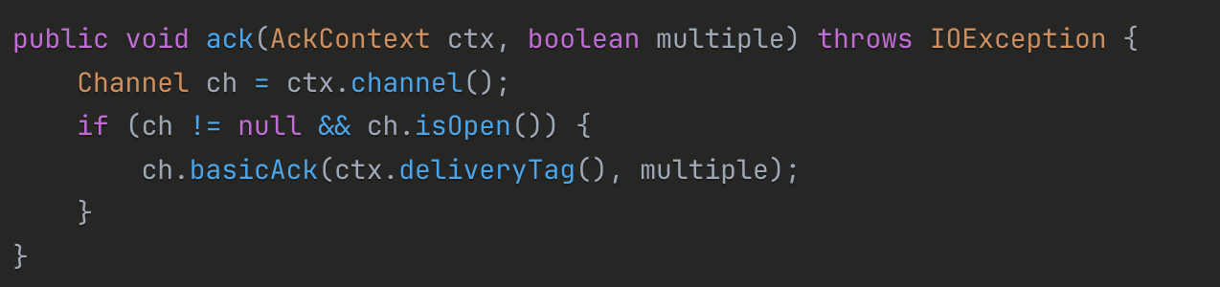
Error Handling with NACK:
ConnectException caught and handled with NACK(requeue=true)
Prevents message loss when Server is unavailable
Messages automatically requeued for retry
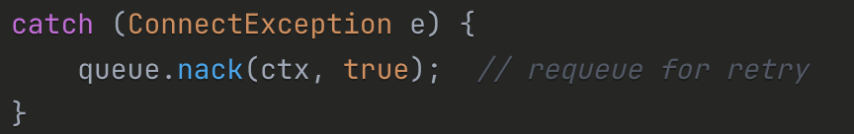

Performance Optimizations:
Disabled AutoScale:
- Problem: AutoScale caused channel closures during high load
- Solution: Fixed thread pool size (16 threads)
- Result: Stable performance, no channel errors
High Prefetch Count (500):
- Problem: Low prefetch caused frequent network round-trips
- Solution: Increased prefetch to 500
- Result: ~40% throughput improvement
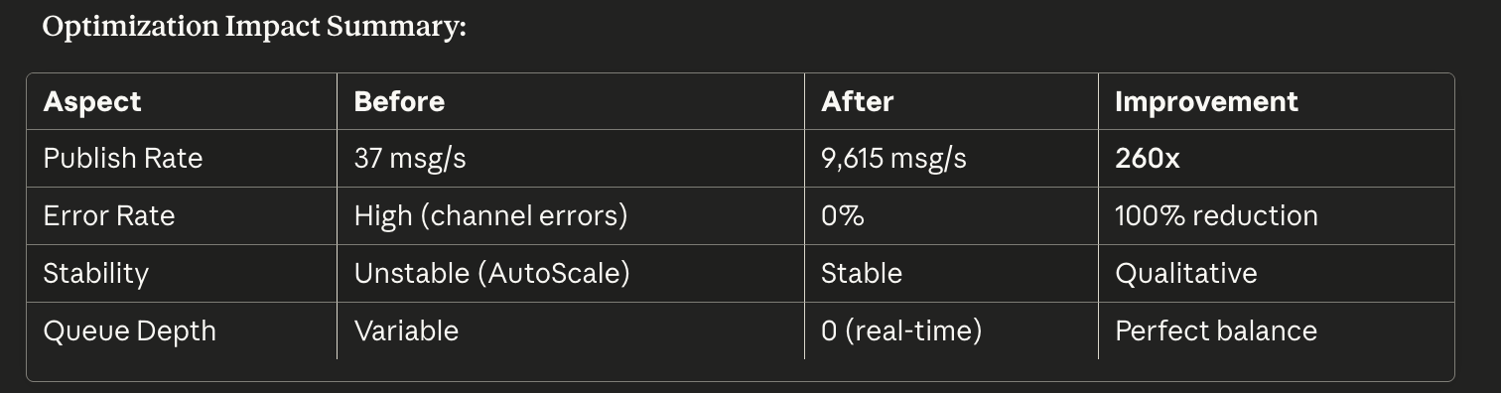
- Test Methodology:
Message Generation:
- Total messages: 500,000
- Distribution: Round-robin across 20 rooms
- Message format: JSON with messageId, roomId, userId, username, message, timestamp
Monitoring:
- RabbitMQ Management Console for queue metrics
- Custom monitoring script tracking:
  - Queue depth (ready + unacknowledged)
  - Publish rate (msg/s)
  - ACK rate (msg/s)
- 10-second refresh interval
Metrics Collected:
- Send time: Time to publish all messages
- Consume time: Time to process all messages
- Total time: End-to-end duration
- Throughput: Messages per second
- Peak queue depth: Maximum messages in queues

- Observations and Analysis:
Network I/O Overhead:
- Each message requires HTTP POST from Consumer to Server
- Network latency limits overall throughput
- Impact increases with message volume
RabbitMQ Queue Management:
- Queue depth accumulates during high publish rates
- Memory consumption increases with queue size
Message Processing Overhead:
- JSON serialization/deserialization for each message
- String encoding/decoding adds latency
- Linear impact with message volume

Performance Bonus:
Best Throughput: 9,615 msg/s (single instance)

