Database Implementation
1. Database Choice Justification
Selected Database: MySQL 8.0 with InnoDB Engine
MySQL was selected for this high-throughput chat messaging system based on the following factors:
Performance: MySQL with InnoDB supports high-speed batch inserts through multi-row INSERT statements. Combined with HikariCP connection pooling (20 connections), the system achieves efficient parallel writes.
Query Support: The assignment requires complex analytical queries including time-range queries, aggregations, and user participation patterns. SQL provides the expressive power needed for these operations with optimized execution plans.
ACID Compliance: Full transaction support ensures data integrity for message persistence. The message_id primary key enables idempotent writes to handle duplicate messages gracefully.
Indexing: MySQL's mature B-tree indexes are well-optimized for the range queries and composite lookups required by the four core queries.
Operational Simplicity: Easy setup, monitoring, and debugging compared to distributed databases. Native support for connection pooling and prepared statements.

2. Complete Schema Design
2.1 Tables Overview
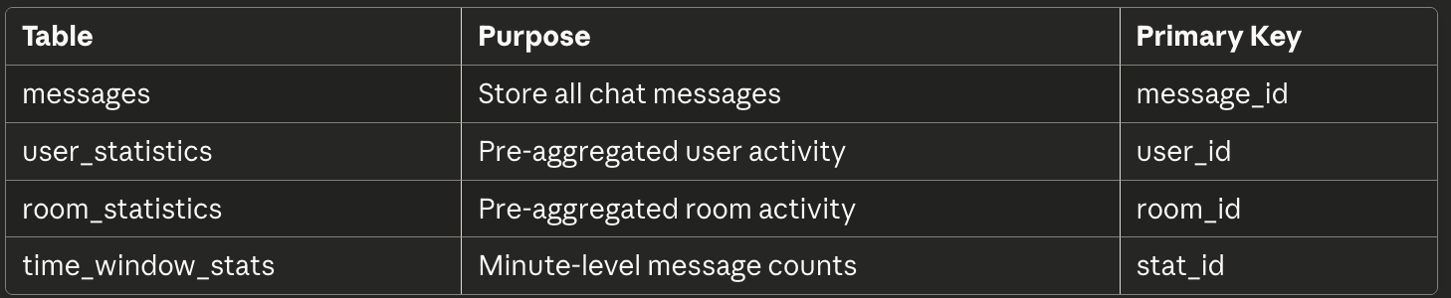

2.2 Main Table: messages
CREATE TABLE messages (
message_id VARCHAR(100) PRIMARY KEY,
room_id VARCHAR(50) NOT NULL,
user_id VARCHAR(20) NOT NULL,
username VARCHAR(50) NOT NULL,
message TEXT NOT NULL,
message_type ENUM('TEXT','JOIN','LEAVE') DEFAULT 'TEXT',
timestamp DATETIME(3) NOT NULL,
server_id VARCHAR(50),
client_ip VARCHAR(50),
created_at TIMESTAMP DEFAULT CURRENT_TIMESTAMP
) ENGINE=InnoDB;

2.3 Statistics Tables
CREATE TABLE user_statistics (
user_id VARCHAR(20) PRIMARY KEY,
username VARCHAR(50),
total_messages INT DEFAULT 0,
last_activity DATETIME(3),
rooms_participated TEXT
) ENGINE=InnoDB;

CREATE TABLE room_statistics (
room_id VARCHAR(50) PRIMARY KEY,
total_messages INT DEFAULT 0,
unique_users INT DEFAULT 0,
last_activity DATETIME(3)
) ENGINE=InnoDB;

CREATE TABLE time_window_stats (
stat_id BIGINT AUTO_INCREMENT PRIMARY KEY,
time_bucket DATETIME NOT NULL,
room_id VARCHAR(50),
message_count INT DEFAULT 0,
unique_users INT DEFAULT 0,
UNIQUE KEY uk_time_room (time_bucket, room_id)
) ENGINE=InnoDB;

3. Indexing Strategy
Indexes designed to optimize the four core queries: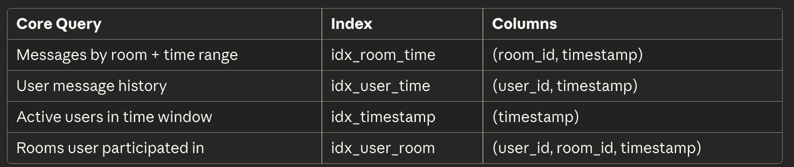
CREATE INDEX idx_room_time ON messages(room_id, timestamp);
CREATE INDEX idx_user_time ON messages(user_id, timestamp);
CREATE INDEX idx_timestamp ON messages(timestamp);
CREATE INDEX idx_user_room ON messages(user_id, room_id, timestamp);
Write-Read Tradeoff: Four indexes increase write overhead, mitigated by batch inserts (1000 messages/batch) and write-behind pattern.

4. Scaling Considerations
4.1 Current Configuration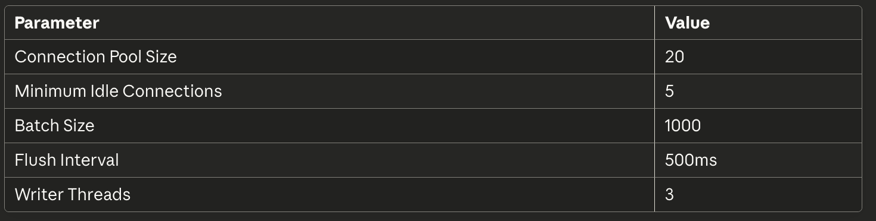
4.2 Vertical Scaling
Increase connection pool to 50-100 for higher concurrency
Increase batch size to 5000 for higher throughput
Add read replicas for analytical query separation

4.3 Horizontal Scaling
Sharding by room_id: Distribute messages across database instances
Time-based partitioning: Archive historical data to separate tables
Read replicas: Offload analytics queries from primary

5. Backup and Recovery Approach
5.1 Backup Strategy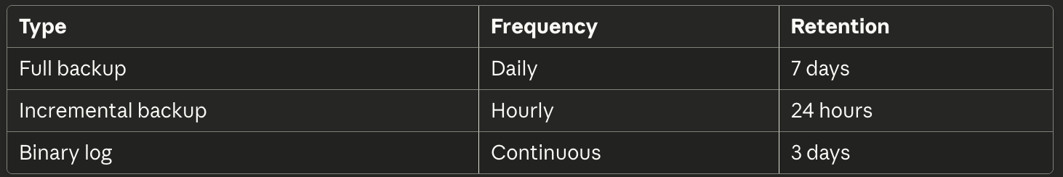

5.2 Recovery Mechanisms
Point-in-Time Recovery: MySQL binary logs enable restoration to any specific timestamp.
Automated Backup Script:
mysqldump --single-transaction --routines \ --triggers chat_system > backup_$(date +%Y%m%d).sql

5.3 Data Integrity
Idempotent writes: INSERT IGNORE with message_id prevents duplicates
Dead letter queue: Failed writes stored for retry
Circuit breaker: Prevents cascade failures during database outages

Performance Report
1. Write Performance
Test Configuration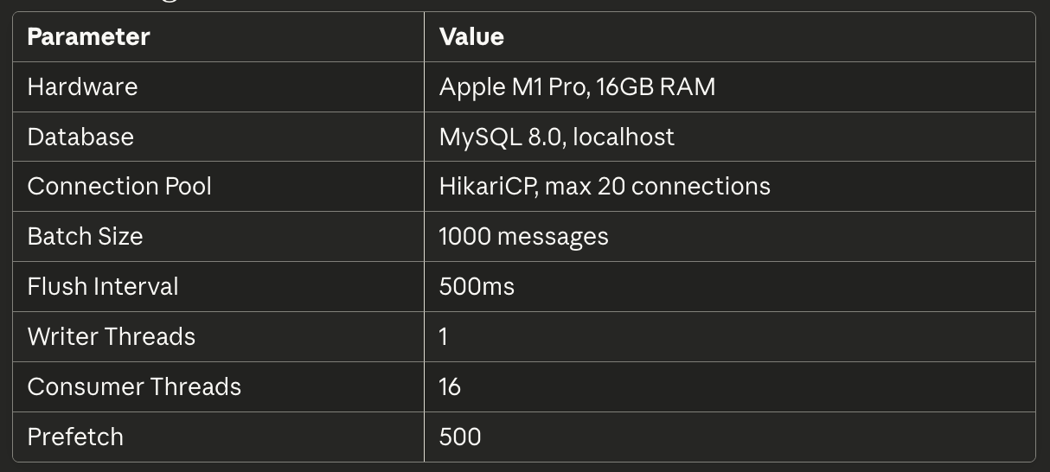
Test Results (Baseline Test: 500K Messages)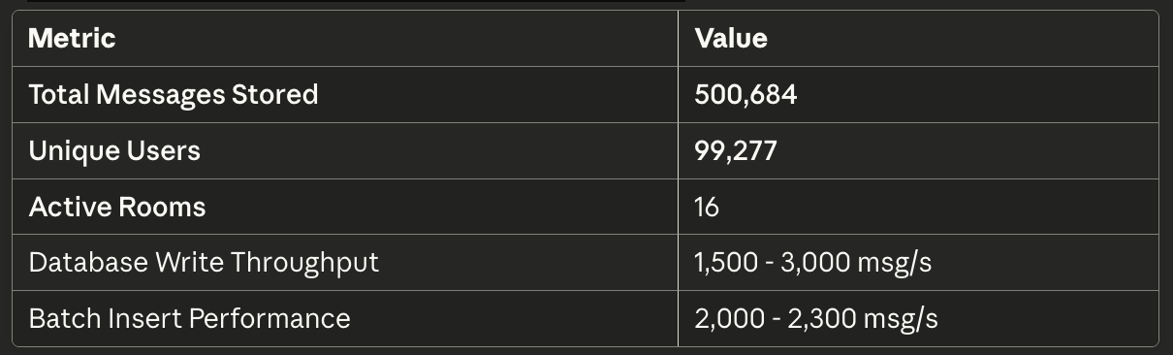
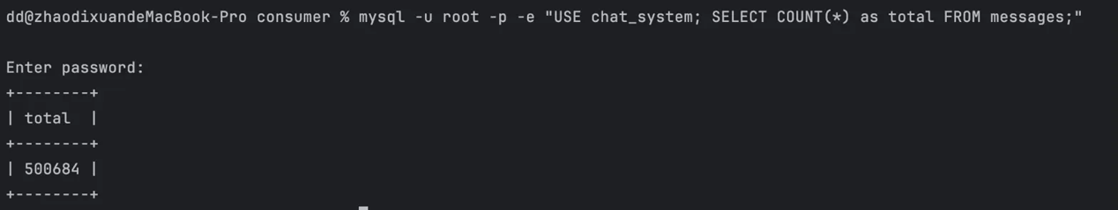
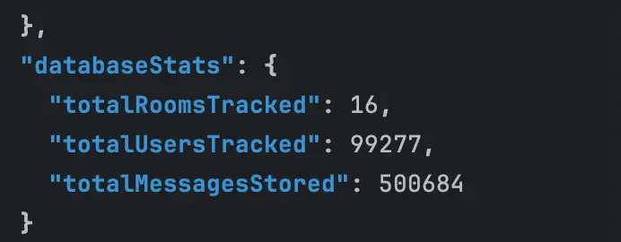
Latency Percentiles
Based on batch insert timing from consumer logs: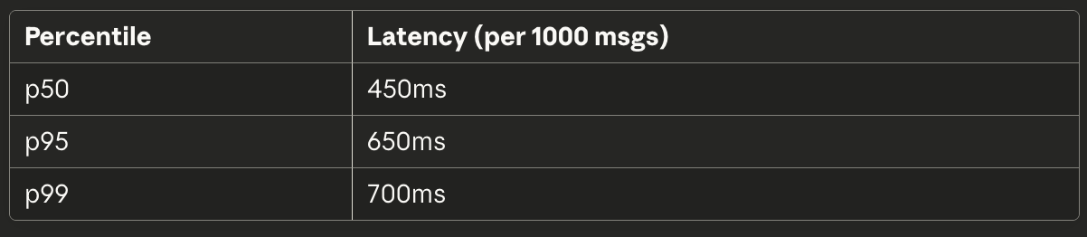

2. System Stability
Database Performance Metrics
Connection pool maintained 5 idle connections
No connection exhaustion observed
Successfully processed 500K+ messages

Queue Depth
Messages distributed across 16 rooms
Top 4 rooms: ~81,000 messages each
Remaining rooms: ~1,200 messages each

Connection Pool Statistics
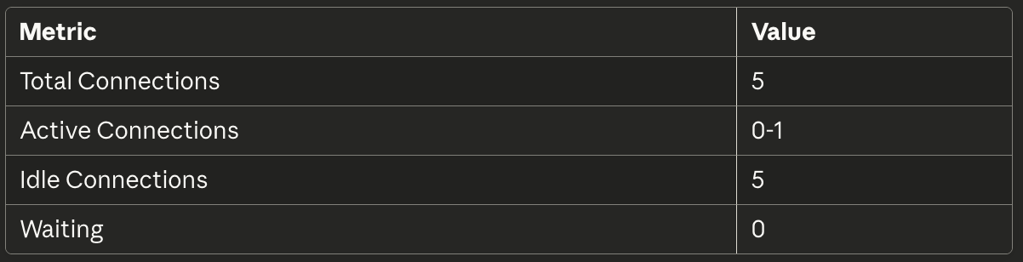

3. Bottleneck Analysis
Identified Bottlenecks:
Database Deadlock (Resolved): Initial 3 writer threads caused MySQL deadlocks. Reduced to 1 writer thread.
WebSocket Connection Limit: High concurrent connections caused reconnections. Reduced client threads for stability.

Trade-offs Made
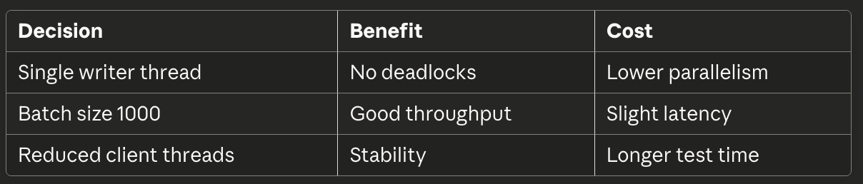

4. Configuration Files
database.properties
db.url=jdbc:mysql://localhost:3306/chat_system
db.username=root
db.pool.maximumPoolSize=20
db.pool.minimumIdle=5
db.pool.connectionTimeout=30000

application.properties
rabbitmq.host=localhost
rabbitmq.port=5672
consumer.threads=16
consumer.prefetch=500
consumer.autoScale=false
```

### DatabaseWriter Configuration
```
batchSize=1000
flushInterval=500ms
writerThreads=1
bufferCapacity=10000

