This folder contains sample data files from the Popane dataset to try the SignalBrowser toolbox.

It contains only data for the first 10 participants of study1

The original Popane data files can be found in the subfolder “OriginalFiles” . They have been reformatted using the Reformat.m Matlab script (in the same subfolder) so that they are readable by/compatible with BrowserSignal.m toolbox.

In particular, the reformatted file only retained the time, ECG, respiration and EDA data. The script also create a “Stimuli_Parameter.mat” file containing the beginning and end time, and the type of stimuli administered.

More information about the Popane dataset can be found in <https://data.psychosensing.psnc.pl/popane/index.html>

DATA DESCRIPTION (From the original Popane dataset)

Physiological activity is a fundamental element of emotional response along with subjective experience and a behavioral/expressive response (Mauss et al., 2005; Gross, 2015). Although the history of research on psychophysiological reactivity to emotions is almost 100 years old, the publicly available datasets covering this phenomenon are still limited. We present a publicly available dataset of psychophysiological responses to positive and negative emotions of 1157 healthy young adults, collected across seven studies. In our studies were continuously recorded affect and physiological activity during resting baseline and emotional responding. We recorded physiological responses using electrocardiography (EKG), impedance cardiography (ICG), electrodermal activity (EDA), and photoplethysmography (PPG, the blood pressure measures), respiratory and temperature sensors. In our studies, we elicited emotions with films, pictures, speech preparation, and expressive writing. We studied a wide range of positive and negative emotions, including amusement, anger, disgust, excitement, fear, gratitude, sadness, tenderness, and threat. In total, our data consists of approximately 725 hours of recordings. No single, consistent dataset of such magnitude - as Psychophysiology of Positive and Negative Emotions (POPANE) database - was ever before collected and shared publicly to make investigating psychophysiology of emotions common endeavor.

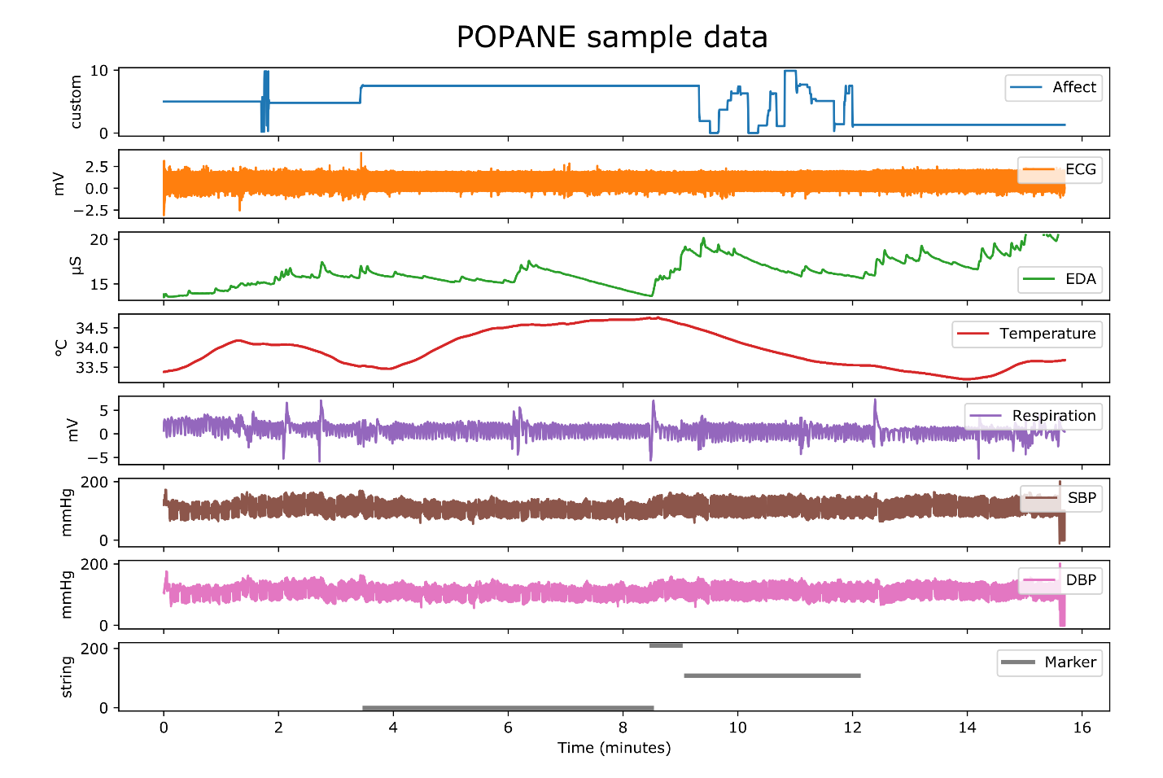

FILES

The data from seven studies are presented here, where for a given study (e.g. study1), there is a separate folder in which the data for the all participants are presented. For each participant there are several files, including, a) full recordings for laboratory visit (e.g. 123_All.csv); b) separate files for baseline (e.g. 123_Baseline.csv) and emotion elicitation (e.g. 123_Manipulation1.csv). Each file contains multiple psychophysiological channels e.g. valence, ECG, EDA, blood pressure measures, and a marker channel by which specific emotions can be recognized using metadata.xlsx.