TripSmart User Manual
A newcomer's guide to using the app

Every screen shown in this manual is a real screenshot of the app, not a mock-up. Field names, button labels and screen order match exactly what you will see when you open TripSmart yourself.

1. What is TripSmart?
TripSmart is a travel-weather app for Sri Lanka. It covers all 25 districts and gives you an hour-by-hour forecast for the next 24 hours, a 7-day outlook, the laws and etiquette that apply where you're standing, a way to compare two destinations before you decide where to go, live conditions reported by other travellers on the ground, and a personal travel journal to keep your own record of the trip.
The app is organized into five tabs along the bottom of the screen:
Tab | What it's for
Forecast | Your home screen — pick a district, see the current forecast
Local Guide | Laws, etiquette and safety advisories for a district
Route Intelligence | Compare two destinations, get smart re-routing suggestions
Ground Reports | Real-time conditions posted by other travellers, and posting your own
Profile | Your account, travel journal, notes, and settings

2. Getting Started
Most of the app — checking forecasts, reading laws, browsing ground reports — works without an account. You only need to sign up to compare destinations, post a ground report, or keep a travel journal.

2.1 Creating an account
- Open the Profile tab (bottom-right icon).
- Make sure Sign up is selected at the top of the card (Log in is the other option, for returning users).
- Fill in your full name, a username, your email, your country, and a password — or tap Continue with Google to skip the form entirely.
- Tap Create account.
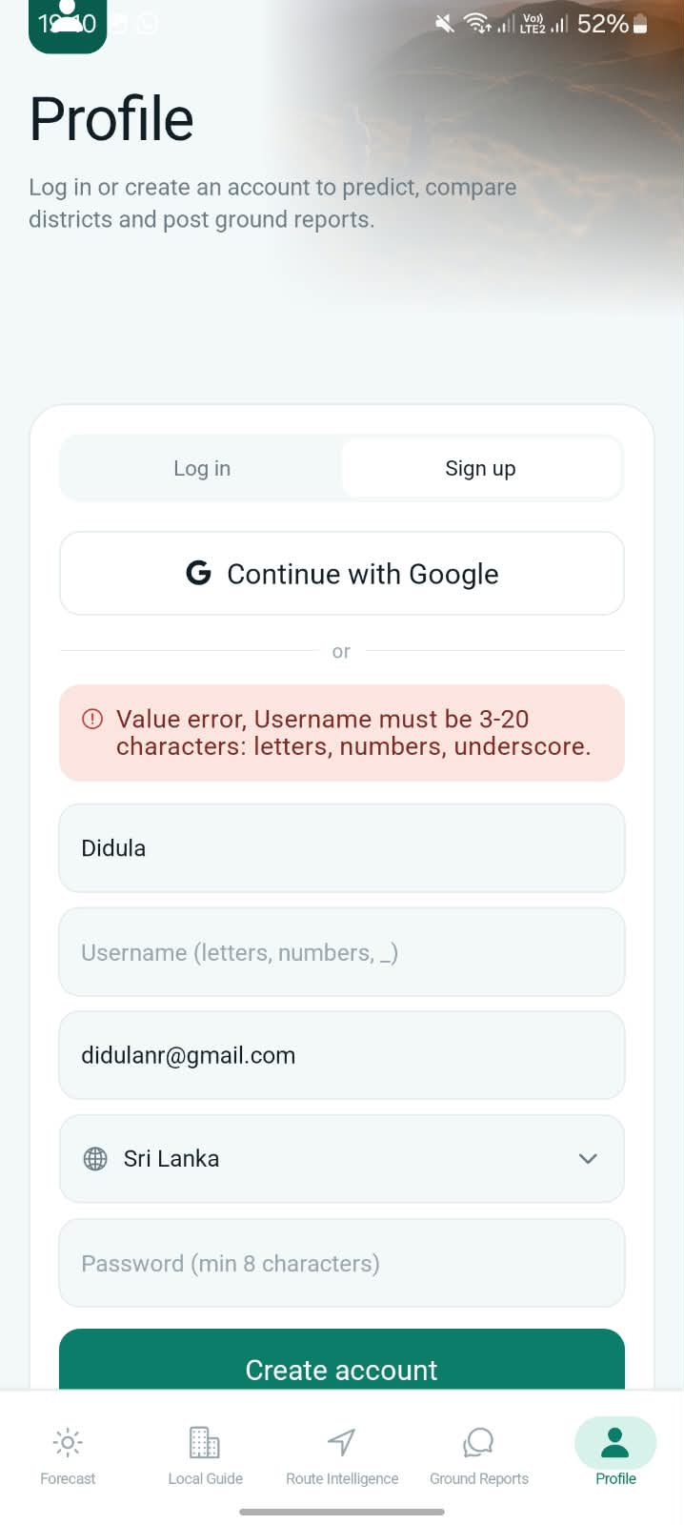
The Sign up form. Usernames must be 3–20 characters: letters, numbers, or underscores only.

TIP Your password needs at least 8 characters. The app tells you immediately if either field doesn't meet the rule, so you can fix it before submitting again.

2.2 Verifying your email
After Create account, TripSmart emails you a 6-digit code — this confirms the email address is really yours before your account is fully active.
- Check your email for a message from TripSmart.
- Enter the 6-digit code on the screen.
- Tap Verify & log in.
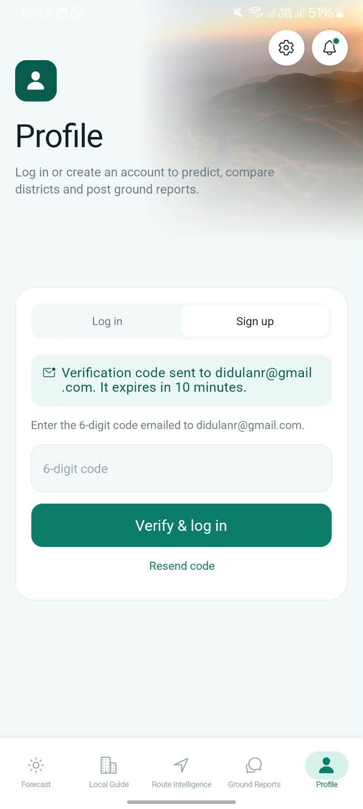
The verification screen. The code expires in 10 minutes — use Resend code if it runs out.

2.3 Logging in later
Once your account exists, switch the Profile tab to Log in instead of Sign up, and enter either your username or your email address along with your password. If you signed up with Google, use Continue with Google again instead.

3. The Forecast Tab
This is what opens first — your district's current weather and the model's 24-hour forecast.

3.1 Picking a location
Tap the district name at the top-left to switch districts, or tap anywhere on the map under Pick a location — the pin resolves to whichever district you tapped, and the forecast reloads for it automatically.
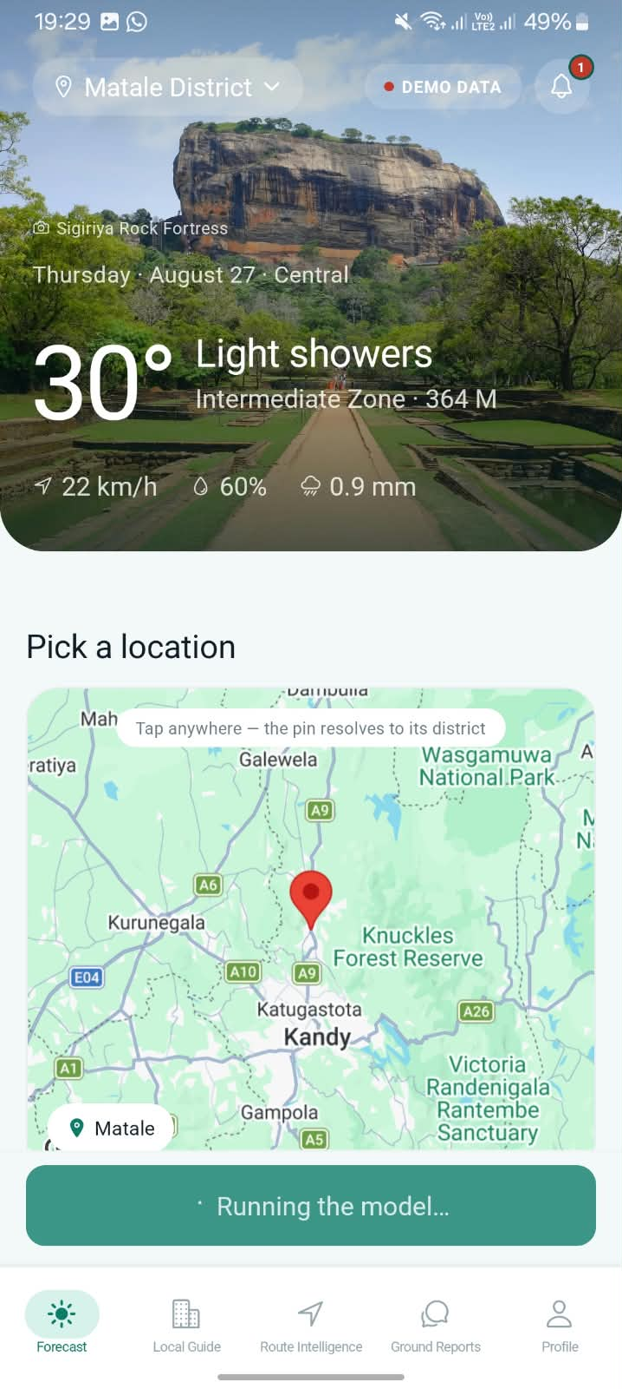
Picking Kandy from the map. “DEMO DATA” and “Running the model…” mean a fresh forecast is loading.

TIP DEMO DATA is a temporary placeholder shown only while the real forecast is being fetched, so the screen is never blank while you wait — it's replaced by the live figures within a few seconds.

3.2 Reading your forecast
Once loaded, the badge changes to LIVE and you get the real numbers: current temperature and sky condition, plus wind speed, humidity, and expected rainfall for that hour. The location name, elevation, and climate zone are shown under the hero photo.
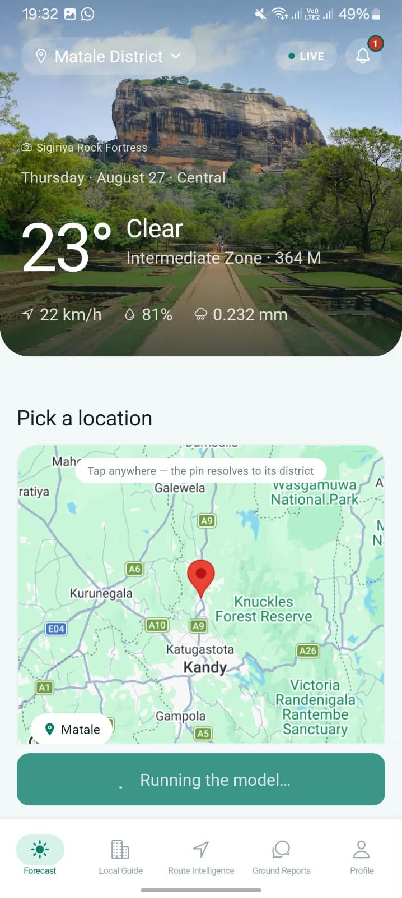
A completed forecast for Matale District — LIVE badge, 23°C and clear skies.

4. The Local Guide Tab
Every district has its own set of laws, cultural etiquette, and safety advisories — this tab surfaces the ones that apply to wherever you're filtering by, so you don't have to go looking for them.

4.1 Advisories and laws
- Tap Use my location to auto-detect your district, or use the Filtering by box to pick one manually.
- Scroll through Advisories for anything currently relevant (public holidays, local notices).
- Scroll further to Laws & guidelines for the full rule list — tap any rule to read it in full.
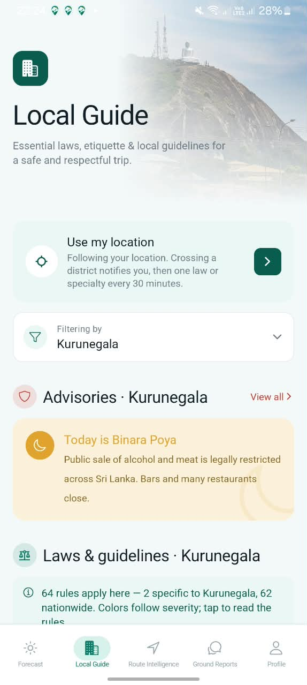
Local Guide for Kurunegala — a Poya day advisory (alcohol/meat sales restricted nationwide).

4.2 Reading severity by color
Advisories are color-coded by how serious they are — the app tells you this directly: “Colors follow severity; tap to read the rules.” A soft amber notice (like the Poya day above) is informational. A red notice is a hard restriction you should take seriously, for example a security zone:
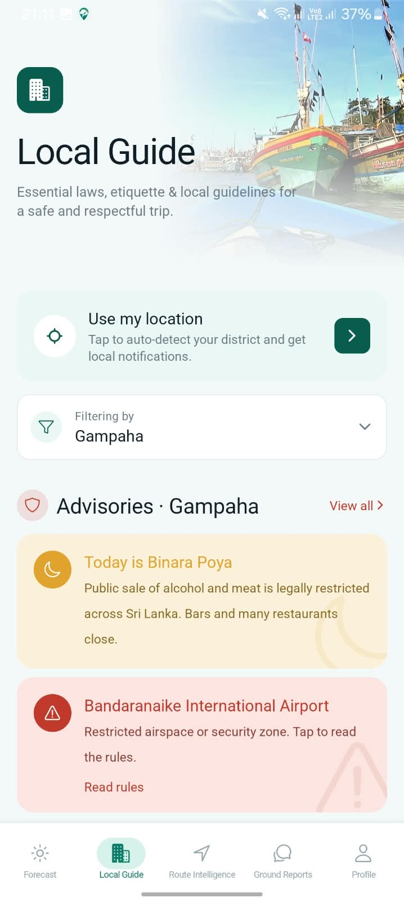
Local Guide for Gampaha — Bandaranaike International Airport's restricted airspace, flagged in red.

5. The Route Intelligence Tab
This is where you decide between two destinations, or find out if bad weather somewhere means you should reconsider your plan. Comparing districts requires being logged in.

5.1 Smart suggestions
When conditions are bad enough somewhere, the app proactively suggests a nearby alternative right at the top of this tab, with the reasoning shown plainly — how far away the alternative is and what its own forecast looks like.
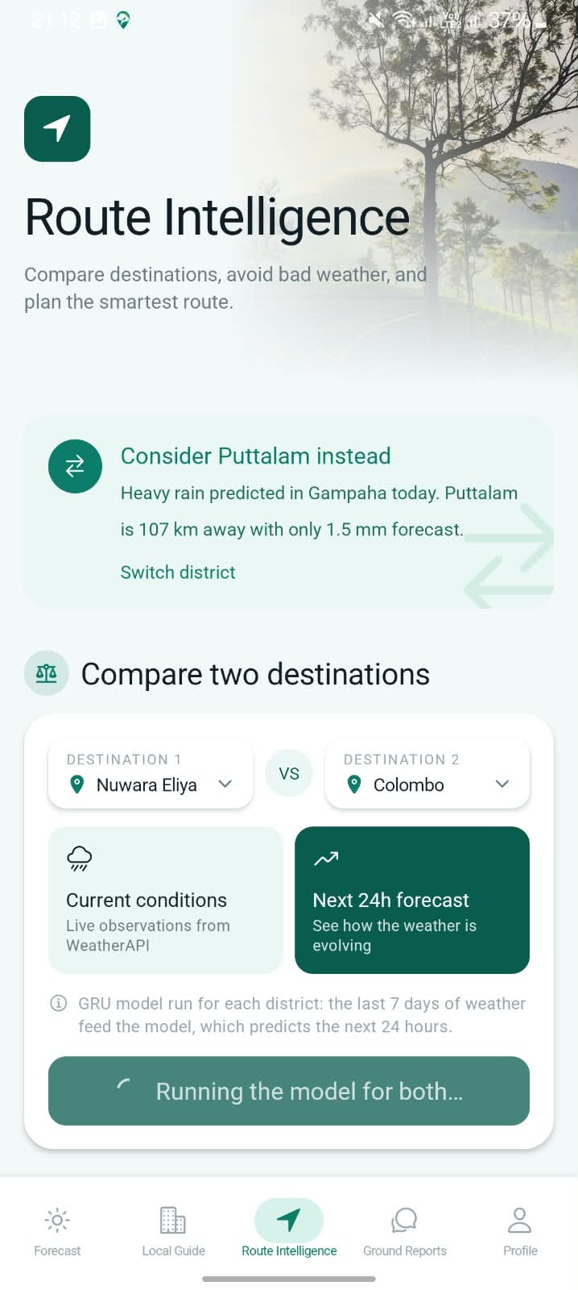
A live re-routing suggestion: heavy rain in Gampaha, Puttalam offered instead.

5.2 Comparing two destinations
- Pick Destination 1 and Destination 2 from the dropdowns.
- Choose Current conditions for a live, right-now snapshot, or Next 24h forecast to see how each place's weather is expected to evolve.
- Tap Compare districts.
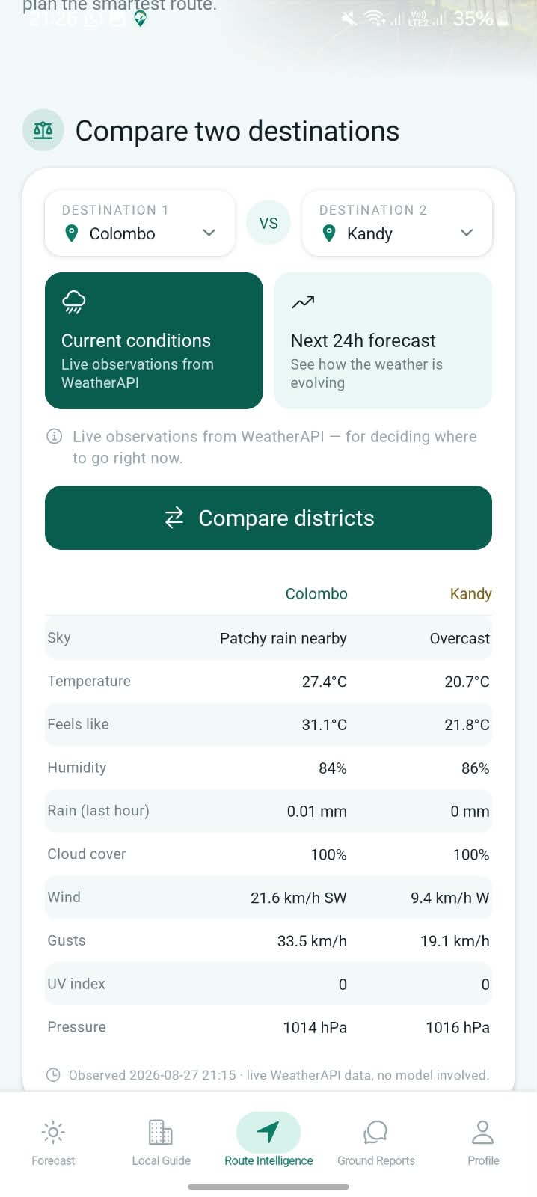
Current conditions: Colombo vs. Kandy, live WeatherAPI data side by side.

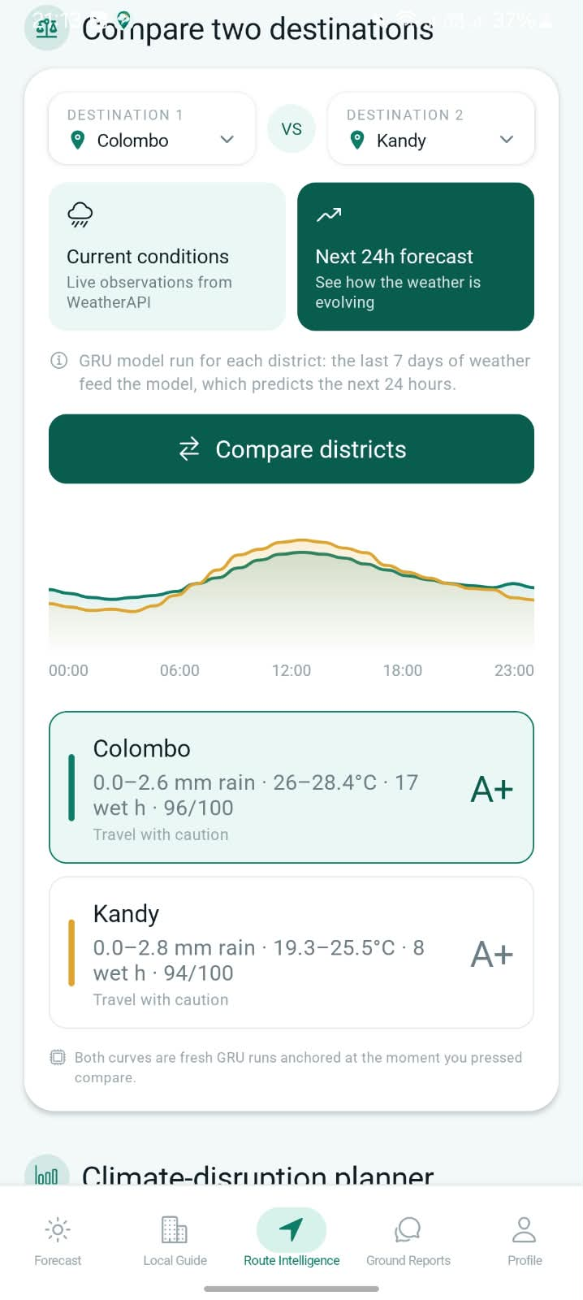
Next 24h forecast: a comparison chart plus an overall travel grade for each district.

TIP The letter grade (e.g. A+) is a quick-read summary of how travel-friendly the next 24 hours look — it accounts for both rain amount and how many hours are expected to be wet, not just a single number.

6. The Ground Reports Tab
Ground Reports are short, real-time updates posted by other travellers — trail conditions, closures, queues, anything worth knowing right now that a weather model can't tell you. Every report disappears automatically after 24 hours.

6.1 Browsing reports
Use Filtering by to narrow to one district, or Search reports for a keyword like “rain” or “closed”. Each report shows who posted it, where, and how long ago.
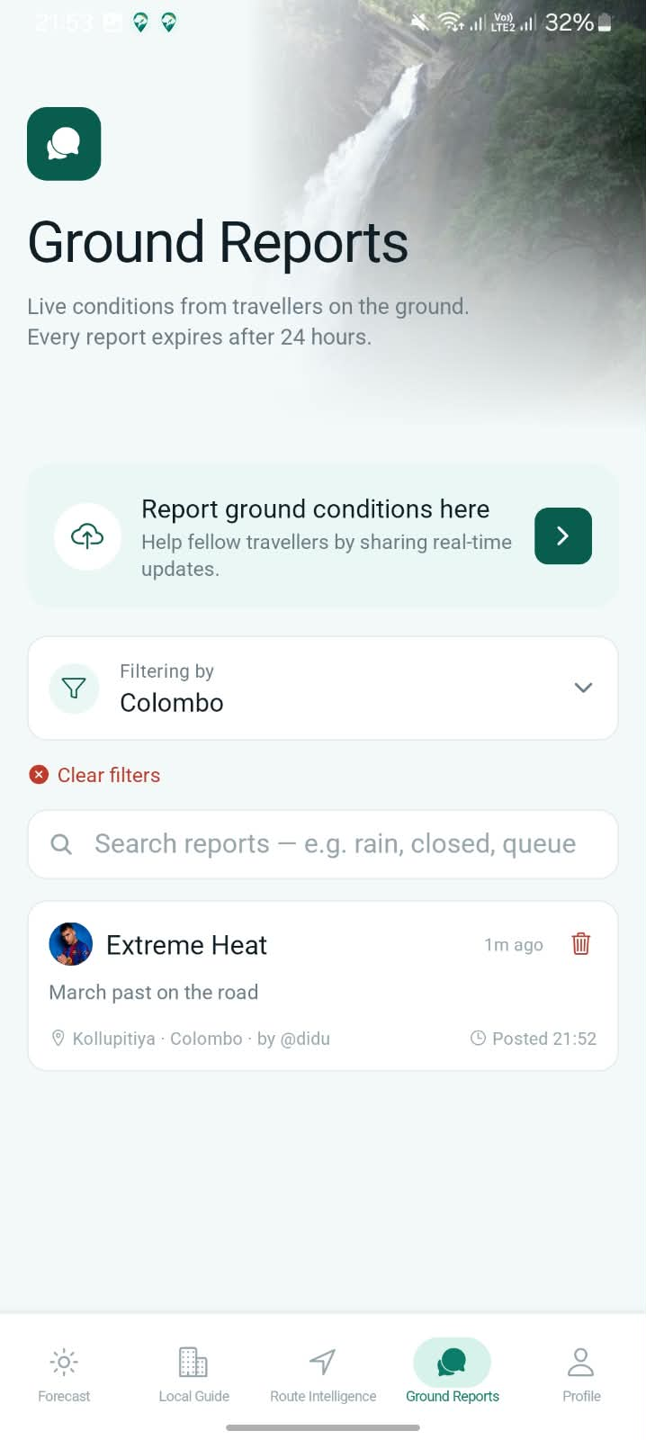
Ground Reports for Colombo, filtered — a live report posted a minute ago.

6.2 Posting a report
Posting requires being logged in (§2.1).
- Tap Report ground conditions here.
- Choose the District.
- Fill in Location (where exactly), a short Title (the main point), and the detail box below it.
- Tap Post report.
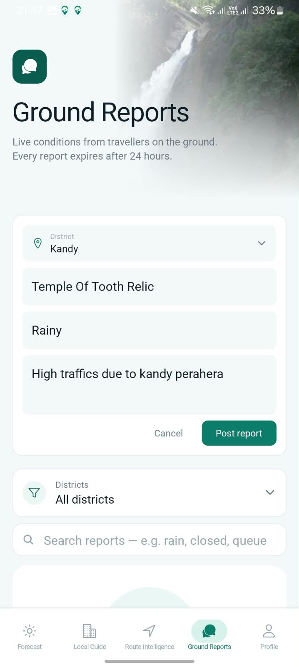
A report being drafted for Kandy — Temple of Tooth Relic, heavy Perahera-season traffic.

TIP Every other traveller currently watching that district gets a push notification the moment you post — your own device is excluded, so you won't be notified of your own report.

7. Profile and Travel Journal

7.1 Your profile
Once logged in, the Profile tab becomes your dashboard: places visited, notes written, and a running travel-points score, all calculated from your own journal — none of it is a server-tracked leaderboard, it's an honest reflection of what you've actually recorded.
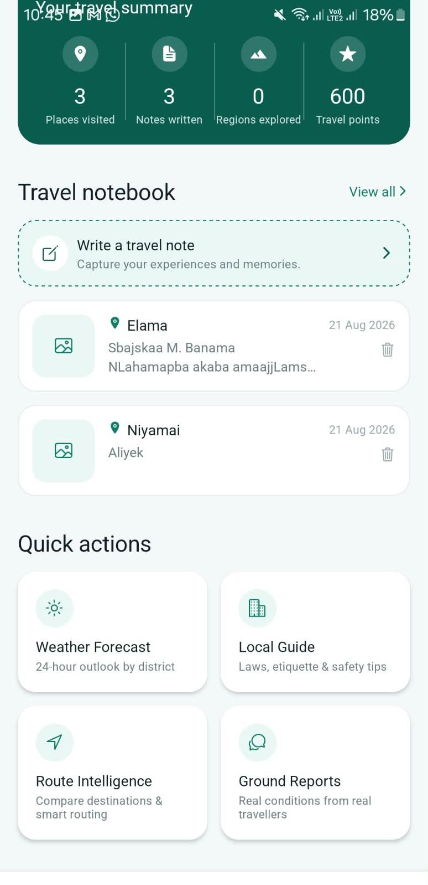
A logged-in profile — travel summary, notebook preview, and quick actions to every other tab.

TIP Tap the pencil icon next to your username on this screen any time you want to rename yourself — see §8 for the Settings screen this links to.

7.2 Your travel journal
Journals are organized into books of pages, so a longer trip can be split across multiple books. Tap Write a travel note from the Profile tab, or open an existing book to keep adding to it.

An empty journal page, ready to write — this book has room for up to 10 pages.

8. Settings
Reached via the gear icon on your Profile screen. Every control here does something real — nothing is a placeholder.
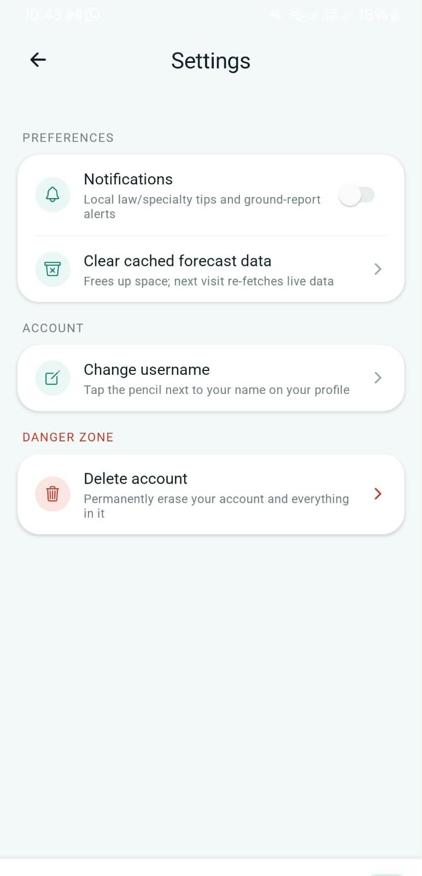
The Settings screen — Preferences, Account, and Danger Zone.

Setting | What it does
Notifications | Turns local law/specialty tips and ground-report alerts on or off
Clear cached forecast data | Frees up space; your next visit re-fetches live data instead of a saved copy
Change username | Points you to the pencil icon on your Profile screen (§7.1)
Delete account | Permanently erases your account, journal, and notes. Asks you to confirm before doing anything — this cannot be undone

TIP Deleting your account does not remove Ground Reports you've already posted — they simply stop showing as yours, and any still-live report of yours still expires after its normal 24 hours like every other report.

9. Quick Reference
A one-page summary of everything above, for once you already know the app and just need a reminder.
I want to… | Where
Check the weather for my district | Forecast tab → pick a district or tap the map
Know if something's legally restricted here | Local Guide tab → filter by district
Decide between two places to visit | Route Intelligence tab → Compare two destinations
See what other travellers are reporting right now | Ground Reports tab
Warn other travellers about something | Ground Reports tab → Report ground conditions here (login required)
Write down what I did today | Profile tab → Write a travel note
Change my username | Profile tab → pencil icon next to your name
Turn off notifications | Profile tab → gear icon → Settings
Delete my account | Profile tab → gear icon → Settings → Delete account

