# Vaadin Flow Checkliste (Stand 3.5.2024)

## Textfield

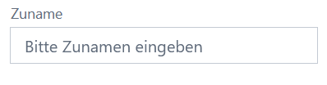

zuname = new TextField("Zuname");  
zuname.setWidth("300px");  
zuname.setPlaceholder("Bitte Zunamen eingeben");

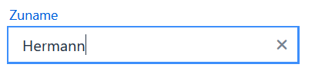

zuname.setClearButtonVisible(true);

## Button



Button button1 = new Button("Alle Eingabefelder leeren");

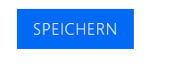

Button button2 = new Button("Speichern");  
button2.addThemeVariants(ButtonVariant.*LUMO_PRIMARY*);

## HorizontalLayout



HorizontalLayout buttons = new HorizontalLayout(button1, button2);

## Checkbox

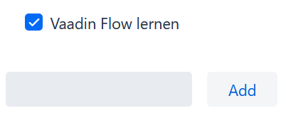

Checkbox checkbox = new Checkbox(taskField.getValue());

## Notification

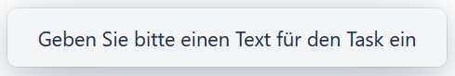

Notification.*show*("Geben Sie bitte einen Text für den Task ein");

## ClickListener (Button)

addButton.addClickListener(click -> {

Checkbox checkbox = new Checkbox(taskField.getValue());  
 todosList.add(checkbox);  
 taskField.clear();

}

);

## ClickShortcut (Button)

addButton.addClickShortcut(Key.*ENTER*);