GAME DEVELOPMENT LIFE CYCLE

Rickman Roedavan¹ , Naya Geovani²

¹Multimedia Engineering Technology Program, Faculty of Applied Science, Telkom University, Jl. Telekomunikasi No. 1, Bandung, West Java 40257, Indonesia
²Department of Entrepreneurship and Strategy, Lancaster University Management School, Lancaster University, Bailrigg, Lancaster, LA1 4YX, England, UnitedKingdom
Email: rikman@telkomuniversity.ac.id, s.g.putri@lancaster.ac.uk

ABSTRACT

The Game Development Life Cycle (GDLC) serves as a structured framework that guides the creation of digital games from conception to release and post-launch evaluation. However, there is no single standardized GDLC model universally adopted by the industry. This paper presents a comparative review of several prominent GDLC frameworks, including those proposed by Heather Chandler, Arnold Hendrick, Blitz Game Studio, and Doppler Interactive, as well as contemporary models from Agate Studio and Unity Guru. Additionally, the paper discusses several GDLC variations developed by the author, reflecting adaptive approaches used in educational and production contexts. Each GDLC model demonstrates distinct advantages and limitations depending on project scale, team structure, and development goals. The findings emphasize that effective game development requires selecting or adapting a GDLC model that best aligns with the specific needs, constraints, and creative objectives of the development environment. Keywords: Game Development Life Cycle, Conceptual Model

Introduction
The Game Development Life Cycle (GDLC) is a structured framework that outlines the processes involved in designing, developing, and delivering a video game. Similar to the Software Development Life Cycle (SDLC), GDLC provides a systematic approach that helps teams manage complexity, allocate resources, and ensure quality at each stage of production. However, unlike traditional software, games combine technical engineering with artistic creativity, requiring a development model that accommodates both iterative experimentation and creative vision.
In the modern gaming industry, structured development cycles are essential to manage the collaboration between multidisciplinary teams: programmers, designers, artists, writers, and testers. A well-defined GDLC ensures that each phase of production, from concept to post-launch support, operates cohesively. It allows studios to anticipate potential challenges such as feature creep, time constraints, or scope imbalance. Moreover, adopting a clear framework helps align stakeholders on milestones, ensuring the game’s creative intent is consistently realized within technical and financial limitations.
Over time, various studios and scholars have proposed different GDLC frameworks. Models by Heather Chandler, Arnold Hendrick, Blitz Game Studio, and Doppler Interactive emphasize different aspects such as pre-production planning, iterative prototyping, or post-release maintenance. More contemporary adaptations, like those from Agate Studio and Unity Guru, reflect modern workflows that integrate agile methodologies, live-ops strategies, and player-driven feedback loops. These models reveal that there is no single, universal GDLC; rather, each framework evolves to match the technological and organizational context of its creators.
The diversity of GDLC models highlights their adaptive nature. While some prioritize creative ideation and prototyping, others focus on scalability, monetization, or long-term content updates. Choosing the right GDLC depends on factors such as team size, budget, target platform, and game genre. For instance, indie developers often favor lightweight and iterative models, whereas AAA studios employ more rigid, milestone-based structures. This flexibility underscores the importance of tailoring GDLC frameworks to meet the unique demands of each project.
This paper aims to review and compare several influential GDLC frameworks to identify their strengths, weaknesses, and areas of applicability. It also introduces several GDLC variants developed by the author to address specific challenges in educational and production environments. By examining these models, the paper seeks to provide a clearer understanding of how different approaches to GDLC can enhance productivity, creativity, and project sustainability in the dynamic field of game development.

GDLC Comparison
The diversity of GDLC models reflects the wide range of approaches adopted by game studios and researchers to structure their production processes. Each GDLC framework represents a unique philosophy of development, emphasizing different priorities such as planning, creativity, iteration, or post-launch management. By comparing these various models, this section highlights how differences in workflow, team dynamics, and project goals influence the effectiveness and adaptability of each GDLC approach.

Heather Chandler’s GDLC
The Heather Chandler GDLC outlines a clear and structured approach to game development, consisting of four main stages: Pre-Production, Production, Testing, and Post-Production [1]. In this model, the process begins with pre-production, where ideas are conceptualized, the target audience is defined, and core gameplay elements are planned through design documentation and early prototypes. The production stage then transforms these concepts into a playable game, involving intensive collaboration between designers, programmers, artists, and sound engineers. Once key features are implemented, the testing phase ensures the game’s functionality, playability, and stability through iterative debugging and quality assurance. Finally, post-production focuses on polishing the final product, preparing marketing materials, and managing post-launch updates or patches. Chandler’s model as shown in Figure 1, emphasizes a cyclical workflow where feedback from each stage informs improvements in the next project, making it a reliable framework for both educational and professional game development environments.
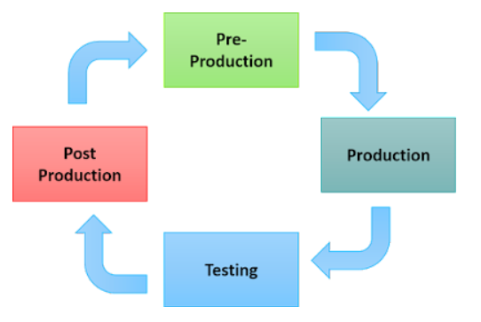
Figure 1. Heather Chandler’s GDLC

Arnold Hendrick’s GDLC
The Arnold Hendrick GDLC presents a linear and goal-oriented process for game development [2]. It begins with the Prototype stage, where core ideas and gameplay concepts are tested for feasibility. The Pre-Production phase focuses on detailed planning, including design, resources, and scheduling. During Production, the full game content, mechanics, graphics, and audio, is developed into a complete build. The Beta stage involves intensive testing and feedback to fix bugs and improve balance. Finally, the Live phase marks the release and maintenance period, where updates and player feedback are managed. Hendrick’s model as shown in Figure 2 emphasizes a structured flow suitable for large-scale projects that require clear milestones and quality control.
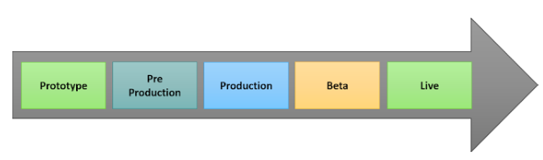
Figure 2. Arnold Hendrick’s GDLC

Doopler Interactive GDLC
The Doppler Interactive GDLC emphasizes an iterative and flexible workflow in game development [3]. It starts with the Design phase, where ideas and gameplay concepts are created. Then, the team moves to Develop/Re-Develop, building or improving features based on the design goals. The Evaluate phase follows, where feedback and testing results are reviewed often leading back to redesign or redevelopment if improvements are needed. After evaluation, the project enters the Test phase to ensure stability, performance, and user experience. Next, during Review Release, the game is refined and prepared for public launch. Finally, the Release phase marks the official publication of the game. The looping arrows in this model show its iterative nature, allowing continuous improvement before the final release making it ideal for agile and live-service game projects.
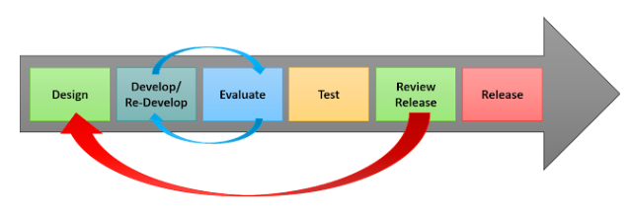
Figure 3. Doopler Interactive’s GDLC

Ridho Ramadhan’s GDLC
The Ridho Ramadhan GDLC model presents a structured and layered approach to game development that integrates both conceptual and production aspects [4]. It begins with Initiation, where the overall goals and motivations for the project are defined. This is followed by the Idea/Concept Design and Foundation phases, which establish the creative direction and technical groundwork for the game. The process then moves into Pre-Production and Production, where planning, asset creation, and implementation take place in iterative cycles supported by continuous Testing. Once the game reaches a stable state, it transitions into the Beta stage for broader evaluation before the final Release version is launched.
What makes Ridho Ramadhan’s GDLC notable is its layered representation showing how structure, formal detail, and refinement evolve alongside the alpha, beta, and release versions of the game. Figure 4 show that this model captures both academic clarity and practical workflow, making it easier to understand in research and classroom contexts. Consequently, the Ridho Ramadhan GDLC has become one of the most cited models in academic publications, not necessarily because it is the most advanced or widely used in industry, but because it has been formally documented in academic papersmaking it accessible and reliable for citation in scholarly works.
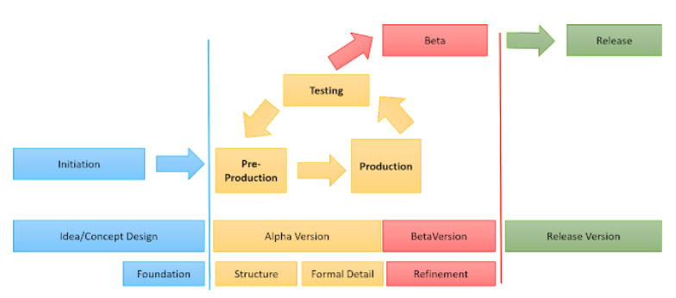
Figure 4. Ridho Ramadhan’s GDLC

Agate Studio GDLC
The Agate Studio GDLC introduces a more comprehensive and business-oriented framework for managing game development [5]. It begins with the Creation phase, which covers ideation, pitching, and feasibility studies to evaluate the project’s creative and financial viability. The process continues with Pre-Production, focusing on user research, prototyping, and iterative playtesting to validate gameplay and market potential before full-scale development. The Production phase then proceeds through detailed stages: Pre-Alpha, Alpha, and Beta with constant feedback from developer and user reviews. Afterward, the Product Launch phase is divided into Soft Launch and Grand Launch, ensuring market readiness and scalability. Finally, the Live-Ops phase maintains the game post-release through regular updates and feature enhancements.
This version of GDLC is more complex and multi-layered because it integrates not only creative and technical workflows but also organizational, financial, and business decision-making aspects. It involves multiple approval levels such as from directors, product managers, and quality control teams to ensure that each step aligns with company strategy and market expectations. As a result, the Agate Studio GDLC represents a professional-grade model suited for large studios where development decisions directly affect budgets, revenue, and long-term product sustainability.
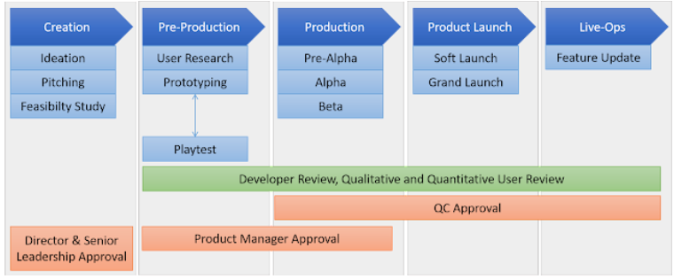
Figure 5. Agate Studio GDLC

Unity Guru GDLC
The Unity Tech Guru GDLC adopts a cyclical and holistic approach to game development, emphasizing continuous improvement and iteration [6]. The process starts from the Story/Idea stage, where the main concept and narrative direction are defined. It then moves to Conceptual Analysis and Game Planning, which involve assessing feasibility, setting design goals, and outlining gameplay mechanics. After that, Team Building ensures that the right mix of talent designers, programmers, and artists is assembled to execute the project.
Next, the Concept Design and Development stages translate ideas into playable prototypes and core gameplay systems. This is followed by Testing, where functionality, balance, and player experience are evaluated before proceeding to Pre-Production (Alpha/Beta) and Main Production, where the full game is refined and finalized. Finally, the cycle concludes with Sales & Marketing, focusing on promotion and distribution before looping back for updates or sequels.
This GDLC version highlights the cyclic and collaborative nature of modern game development, where creative, technical, and commercial processes are interconnected. It reflects a realistic workflow often used in studios that employ Unity as their primary engine balancing creative iteration with production efficiency and post-launch marketing strategies.
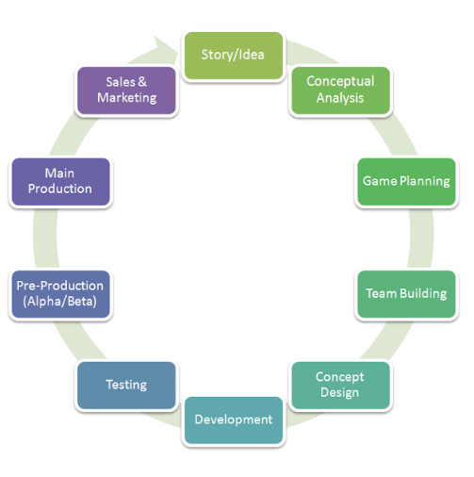
Figure 6. Unity Guru GDLC

Rickman Roedavan GDLC

The Rickman Roedavan GDLC consists of two distinct versions, each developed to address different needs in the game development ecosystem: Rapid Game Development (RGD) and the Serious Game Development Model (SGDM). The Rapid Game Development (RGD) version emphasizes speed, creativity, and adaptability. It is designed for short development cycles often used in game jams, prototypes, or student projects where the goal is to quickly transform ideas into playable experiences. This version focuses on iteration, agile teamwork, and immediate feedback, allowing developers to refine mechanics and visuals in compressed timeframes.

In contrast, the Serious Game Development Model (SGDM) version is intended for educational and training contexts, where games must integrate instructional design principles and measurable learning outcomes. SGDM follows a more structured process that aligns gameplay objectives with pedagogical goals, incorporating stages such as analysis, design, development, implementation, and evaluation (ADDIE-inspired).

Rapid Game Development Model (RGD)

The Rickman Roedavan – Rapid Game Development (RGD) model emphasizes speed, iteration, and cost efficiency in creating games [7]. Designed for academic projects and small teams, it streamlines development through three phases: Pre-Production, Production, and Product Launch. In Pre-Production, developers conduct Quick Ideation to rapidly generate and test core concepts. The Production phase involves cyclic processes of Prefabrication Development, Blueprint Integration, and Prototype Testing, enabling fast iteration and asset reuse. After validation, the project moves to Beta and Final Version Release under Product Launch, focusing on quick testing and polishing. The model also integrates cost considerations covering research, templates, and frameworks to maintain efficiency without sacrificing quality. Overall, RGD as shown in Figure 7 supports agile, iterative, and low-cost development, making it ideal for rapid prototyping and academic or experimental game projects.

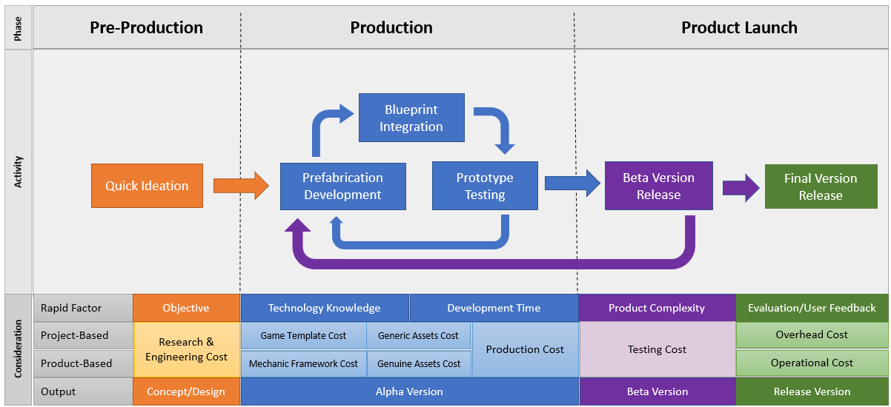
Figure 7. Rapid Game Development (RGD)

Serious Game Development Model (SGDM)

The Rickman Roedavan – Serious Game Development Model (SGDM) is a structured framework for developing educational and training games that combine learning and engagement. It consists of four phases Analysis, Production, Testing, and Release built on four learning foundations: Affective, Motivation, Cognitive, and Social/Cultural.

The process starts with Education Content Ideation, aligning learning goals with suitable game mechanics [8]. During Production, activities such as Tech & Art Development, Learning Mechanic, Assessment Mechanic, and Prototyping run iteratively to ensure educational and visual consistency. Afterward, Beta Testing evaluates learning outcomes and player engagement before the Final Version is released for sustained Game-Based Learning. Overall, SGDM as shown in Figure 8 integrates instructional design principles with gameplay, emphasizing motivation, cognition, and social interaction making it highly effective for academic and serious game projects.

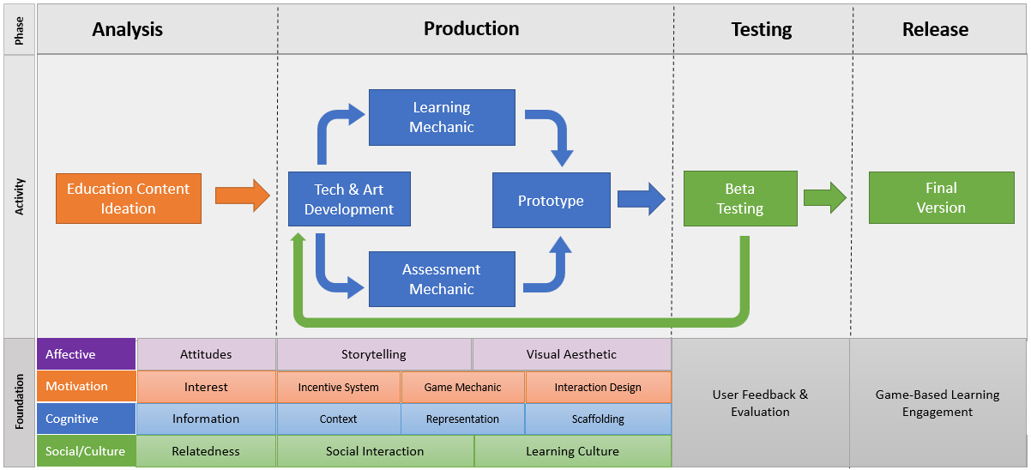
Figure 8. Serious Game Development Model (SGDM)

Result

This section presents a comparative overview of several well-known Game Development Life Cycle (GDLC) models. Each model represents a distinct approach to managing the complex process of game creation from concept and production to testing and release. The comparison highlights key characteristics, development focus, and typical application contexts. Additionally, two models developed by Rickman Roedavan Rapid Game Development (RGD) and Serious Game Development Model (SGDM are included to illustrate the integration of agile practices and educational design principles within academic and professional frameworks.

Table 1. GDLC Comparison
GDLC Version | Key Characteristics
Heather Chandler GDLC | Consists of four main stages: Pre-Production, Production, Testing, and Post-Production. Focuses on structured project management and milestone control. Commonly used in professional studios for its clear and sequential workflow.
Arnold Hendrick GDLC | Linear model with phases: Prototype, Pre-Production, Production, Beta, and Live. Emphasizes clear outputs at each stage, making it suitable for large projects with strict production control and budget oversight.
Doppler Interactive GDLC | Iterative and flexible model with cycles among Design, Develop/Re-Develop, and Evaluate, followed by Test, Review, and Release. Encourages agile methods and continuous improvement, ideal for live-service games.
Ridho Ramadhan GDLC | Structured academic model integrating Initiation, Pre-Production, Production, Testing, Beta, and Release. Widely cited in research due to formal documentation in academic papers, not necessarily industrial dominance.
Agate Studio GDLC | Comprehensive and business-driven model with phases from Creation to Live-Ops. Includes managerial approvals, quality control, and user research. Complex due to financial, organizational, and production interdependencies.
Unity Tech Guru GDLC | Cyclical process covering Story/Idea to Sales & Marketing. Highlights iterative collaboration among creative, technical, and marketing teams. Reflects Unity-based workflows emphasizing continuous feedback and scalability.
Rickman Roedavan Rapid Game Development (RGD) | Prioritizes speed, iteration, and low cost. Divided into Pre-Production, Production, and Product Launch with cyclic refinement between Prefabrication and Testing. Ideal for academic prototypes and agile projects.
Rickman Roedavan – Serious Game Development Model (SGDM) | Designed for educational and training games. Includes Analysis, Production, Testing, and Release phases, grounded on affective, motivational, cognitive, and social learning foundations. Ensures alignment between gameplay and learning goals.

The comparison of various Game Development Life Cycle (GDLC) models demonstrates that no single framework universally fits all game development contexts. Each model embodies a unique balance between structure, creativity, and adaptability ranging from the linear and milestone-driven approaches of Heather Chandler and Arnold Hendrick to the agile, iterative cycles of Doppler Interactive and Unity Tech Guru. Academic-oriented models such as Ridho Ramadhan’s GDLC and Rickman Roedavan’s SGDM highlight the importance of pedagogical integration and measurable learning outcomes, while studio-based frameworks like Agate Studio’s GDLC reveal the influence of financial and business considerations in large-scale production.

Meanwhile, the Rickman Roedavan RGD model offers a pragmatic solution for rapid prototyping and small academic projects that demand efficiency and agility. Ultimately, the effectiveness of a GDLC depends on how well it aligns with a project’s objectives, team structure, and resource constraints reinforcing the idea that successful game development is not defined by a single process, but by how creatively and strategically each process is applied.

Bibliography

- Chandler, H., Game Production Handbook, Sudbury: Jones and BartlettsPublishers, 2009.
- R. Roedavan, Y. Siradj, and S. Stefany, "Educational game scenario model based on imperative game goal typology," Journal of Games, Game Art, and Gamification, vol. 8, no. 1, pp. 18-23. 2023, Doi: https://doi.org/10.21512/jggag.v8i1.9497.
- P. Bambang, S. Salam, N. Che Pee, R. Roedavan, A. Prihatmanto, and A. Alomoush, "The 3D Dyscalculia Assessment Game Framework for Dyscalculia Identification," International Journal of Computing and Digital Systems, vol. 11, pp. 451-461, 2022, doi: 10.12785/ijcds/110137.
- Ramadan, R. & Widyani, Y., Game Development Life Cycle Guidelines,International Conference on Advanced Computer Science and InformationSystems, pp. 95-100, Sep 2013.
- Y Siradj, TW Liew, R Roedavan, SM Tan, B Pudjoatmodjo, MTI Khan, The Effects of Cognitive and Affective Trust in Pedagogical Agents on Flow and Technology Acceptance in a Digital Game-Based Learning Environment. 2025 14th International Conference on Educational and Information Technology
- R. Roedavan, B. P., and A. P. Sujana, “Multimedia Development Life Cycle (MDLC),” Feb. 2022. doi: 10.13140/RG.2.2.16273.92006.
- R. Roedavan, A. Pratondo, B. Pudjoatmodjo, and Y. Siradj, "Adaptation Atomic Design Method for Rapid Game Development Model," International Journal of Applied Information Technology (IJAIT), pp. 93-102. 2021
- R. Roedavan, B. Pudjoatmodjo, Y. Siradj, S. Salam, and B. Q. Hardianti, "Serious Game Development Model Based on the Game-Based Learning Foundation," Journal of ICT Research & Applications, vol. 15, no. 3, pp. 291-305, 2021, doi: 10.5614/itbj.ict.res.appl.2021.15.3.6.

