Practical instructions.

Getting materials
You first need to download the practical materials to your computer. They are in a repository on Github. A simple way to download this data is to install Git Bash (if on Windows), go to the folder where you want to download the materials, and open Git Bash there. You can open it in any folder by right clicking:
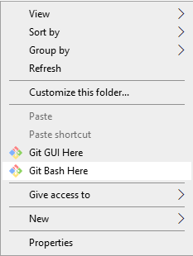

Then, simply type git clone “https://github.com/DieStok/PracticalEssentialsCourseUUSeptember212021.git”. This should work.

If that’s not for you, you can also go here and download all the files in a zip.

Working on the practical
The practical is self-paced and should be self-explanatory. It starts with k-means clustering and showing how it comes about, while showcasing the usage of the ggplot2 and gganimate libraries. Then, we discuss k-means and PCA in the context of dimensionality and noise. We then cover some hierarchical clustering. What follows is a part about Eigenfaces. This is the most non-essential, though quite interesting, part of the practical. Skip it if you are running low on time. We end with a comparison of PCA, t-SNE and UMAP on some data (where you are also required to watch videos about t-SNE and UMAP) and trying to recreate a paper figure subpanel from actual published RNAseq data.

Please go through the practical individually, but be sure to discuss, compare, and contrast with your neighbours. Please help others who might have had less exposure to R if you think you can. If there are any questions, please raise your hand and we will diligently come over to exterminate any and all questions.

Good luck!

