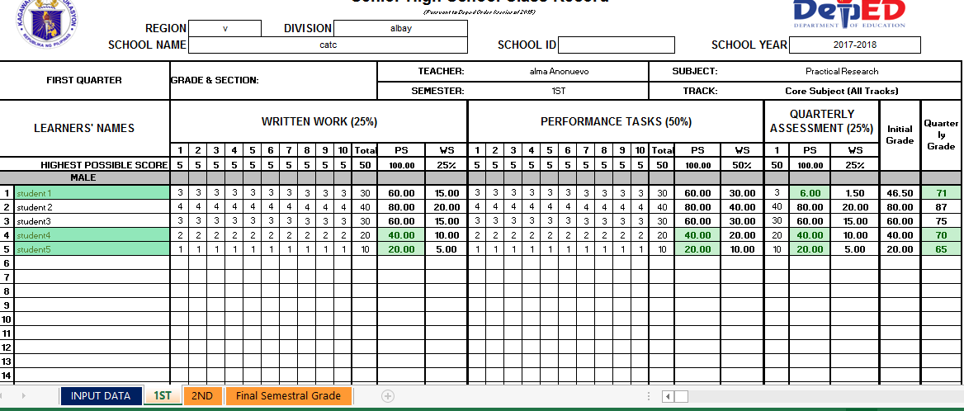

Written Work’s weighted Score+ Performance Task’s Weighted Score+ Quarterly Assessment Weighted Score

Written Work’s Percentage Score \* .25

Total raw score

(Ww total highest possible score ) \* 100

Total raw score

Learners raw Score

Sum of ww 1-10

QA total highest possible score

PT total highest possible score

Ww total highest possible score