PART 1 ER
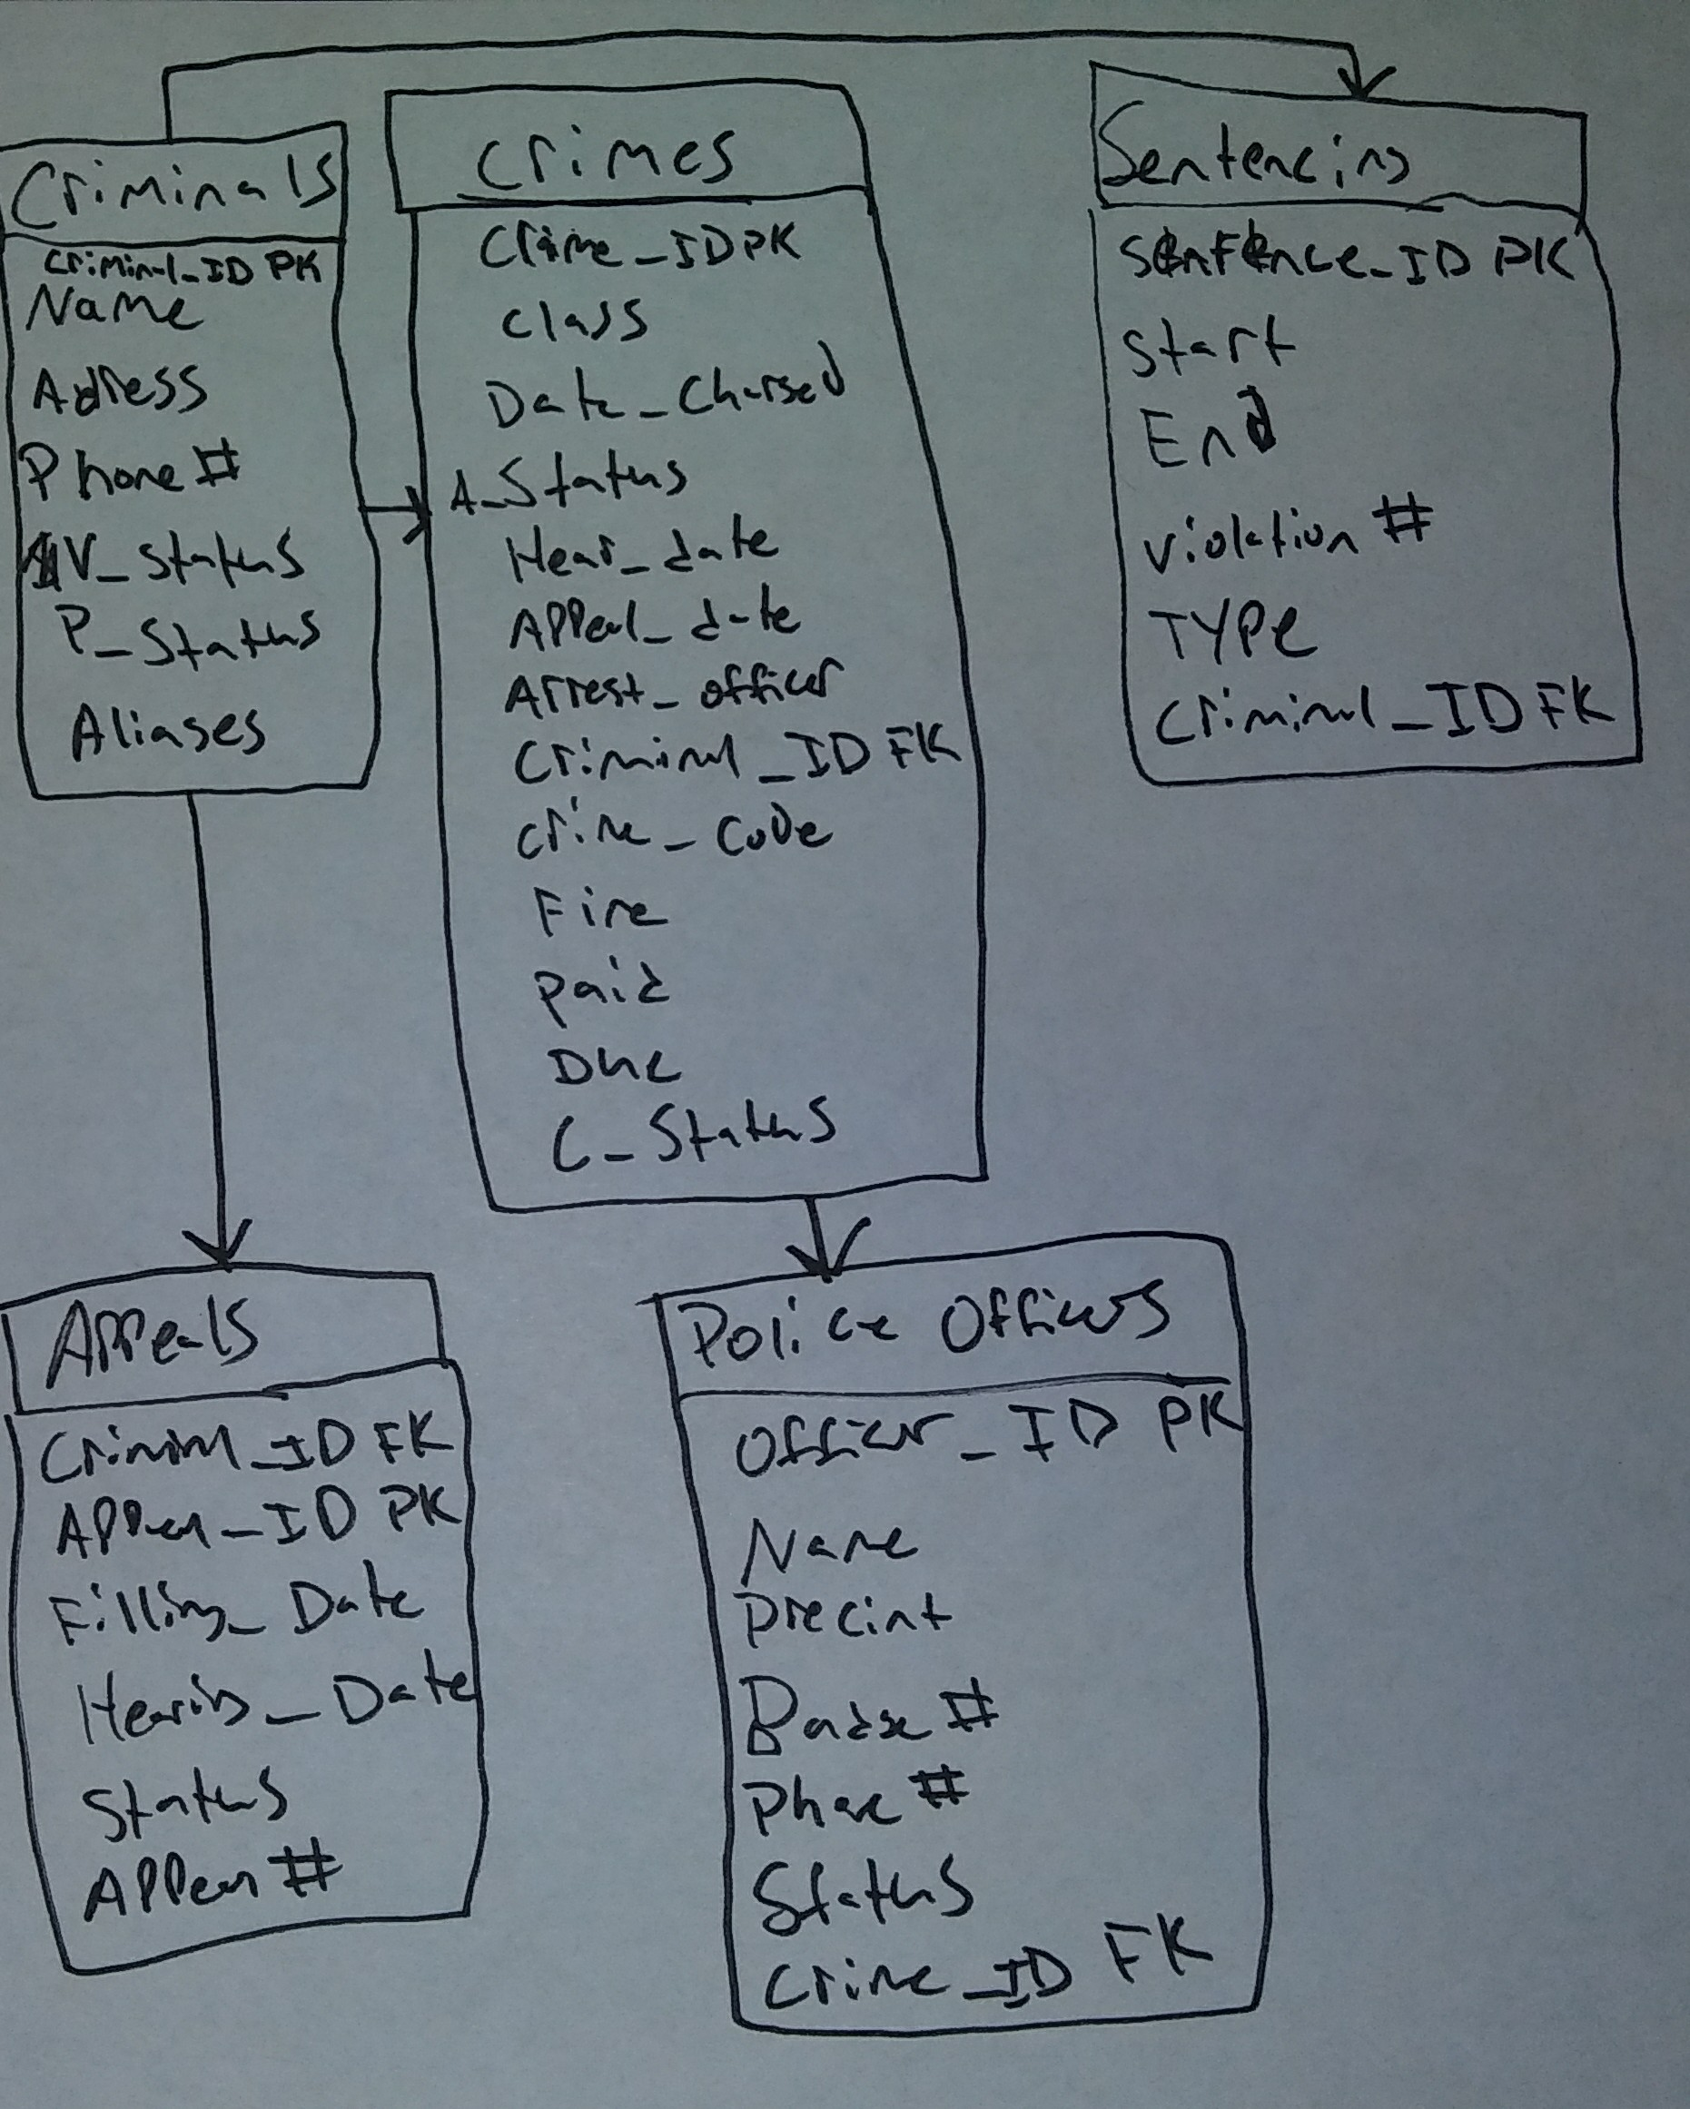

PART 2 SCRIPT
CREATE TABLE Aliases
(Alias_ID NUMBER(6), Criminal_ID NUMBER(6,0), Alias VARCHAR2(10));

CREATE TABLE Criminals
(Criminal_ID NUMBER(6,0), Last VARCHAR2(15), First VARCHAR2(10),
Street VARCHAR2(30), City VARCHAR2(20), State CHAR(2), Zip CHAR(5),
Phone CHAR(10), V_status CHAR(1) DEFAULT 'N', P_status CHAR(1) DEFAULT 'N');

CREATE TABLE Crimes
(Crime_ID NUMBER(9,0), Criminal_ID NUMBER(6,0), Classification CHAR(1),
Data_charged DATE, Status CHAR(2), Hearing_date DATE, Appeal_cut_date DATE);

CREATE TABLE Sentences
(Sentence_ID NUMBER(6), Criminal_ID NUMBER(6), Type CHAR(1), Prob_ID NUMBER(5),
Start_date DATE, End_date DATE, Violations NUMBER(3));

CREATE TABLE Prob_officers
(Prob_ID NUMBER(5), Last VARCHAR2(15), First VARCHAR2(10), Street VARCHAR2(30),
City VARCHAR2(20), State CHAR(2), Zip CHAR(5), Phone CHAR(10), Email VARCHAR(30),
Status CHAR(1) DEFAULT 'A');

CREATE TABLE Crime_charges
(Charge_ID NUMBER(10,0), Crime_ID NUMBER(9,0), Crime_code NUMBER(3,0),
Charge_status CHAR(2), Fine_amount NUMBER(7,2), Court_fee NUMBER(7,2),
Amount_paid NUMBER(7,2), Pay_due_date DATE);

CREATE TABLE Crime_officers
(Crime_ID NUMBER(9,0), Officer_ID NUMBER(8,0));

CREATE TABLE Officers
(Officer_ID NUMBER(8,0), Last VARCHAR2(15), First VARCHAR2(10), Precinct CHAR(4),
Badge VARCHAR2(14), Phone CHAR(10), Status CHAR(1) DEFAULT 'A');

CREATE TABLE Appeals
(Appeal_ID NUMBER(5), Crime_ID NUMBER(9,0), Filing_date DATE, Hearing_date DATE,
Status CHAR(1) DEFAULT 'P');

CREATE TABLE Crime_codes
(Crime_codes NUMBER(3,0), Code_description(30));

SECTION B
ALTER TABLE Crimes
MODIFY Classification DEFAULT 'U';

ALTER TABLE Crimes
ADD (Date_Recorded DATE DEFAULT SYSDATE);

ALTER TABLE Prob_officers
ADD (Pager# NUMBER(10));

ALTER TABLE Aliases
MODIFY (Alias VARCHAR2(20));

PART 3
Table Name | Column(s) | Contraint Type | Condition
Aliases | Alias | PK | -
Criminals | Criminal_ID | PK | -
Crimes | Crime_ID | PK | -
Sentences | Sentence_ID | PK | -
Officers | Officer_ID | PK | -
Crime_Codes | Crime_code | PK | -
Aliases | Criminal_ID | FK | Ref Criminals
Crimes | Criminal_ID | FK | Ref Criminals
Sentences | Criminal_ID | FK | Ref Criminals
Criminals | V_status | Check | Y or N
Criminals | P_status | Check | Y or N
Crimes | Classification | Check | F ,M, O, or U
Crimes | Status | Check | CL, CA, or IA
Sentences | Type | Check | J, H, or P
Prob_officers | Status | Check | A or I
Officers | Status | Check | A or I

DROP TABLE Appeals;
DROP TABLE Crime_officers;
DROP TABLE Crime_charges;

ALTER TABLE Aliases
ADD CONSTRAINT Aliases_id_pk PRIMARY KEY (Alias_ID);

ALTER TABLE Criminals
ADD CONSTRAINT Criminals_id_pk PRIMARY KEY (Criminal_ID);

ALTER TABLE Crimes
ADD CONSTRAINT Crimes_id_pk PRIMARY KEY (Crime_ID);

ALTER TABLE Sentences
ADD CONSTRAINT Sentences_id_pk PRIMARY KEY (Sentence_ID);

ALTER TABLE Officers
ADD CONSTRAINT Officers_id_pk PRIMARY KEY (Officer_ID);

ALTER TABLE Crime_codes
ADD CONSTRAINT Crime_codes_pk PRIMARY KEY (Crime_code);

ALTER TABLE Aliases
ADD CONSTRAINT Aliases_Criminal_fk FOREIGN KEY (Criminal_ID)
REFERENCES Criminals(Criminal_ID);

ALTER TABLE Crimes
ADD CONSTRAINT Crimes_Criminal_fk FOREIGN KEY (Criminal_ID)
REFERENCES Criminals(Criminal_ID);

ALTER TABLE Sentences
ADD CONSTRAINT Sentences_Criminal_fk FOREIGN KEY (Criminal_ID)
REFERENCES Criminals(Criminal_ID);

ALTER TABLE Criminals
ADD CONSTRAINT Criminals_Vstatus_ck CHECK (V_status IN('Y','N'));

ALTER TABLE Criminals
ADD CONSTRAINT Criminals_Pstatus_ck CHECK (P_status IN('Y','N'));

ALTER TABLE Crimes
ADD CONSTRAINT Classification_ck CHECK (Classification IN('F','M','O','U'));

ALTER TABLE Crimes
ADD CONSTRAINT Status_ck CHECK (Status IN('CL','CA','IA'));

ALTER TABLE Sentences
ADD CONSTRAINT Sentences_ck CHECK (Type IN('J','H','P'));

ALTER TABLE Prob_officers
ADD CONSTRAINT Prob_ck CHECK (Status IN('A','I'));

ALTER TABLE Officers
ADD CONSTRAINT Officers_ck CHECK (Status IN('A','I'));

CREATE TABLE Appeals
(Appeal_ID NUMBER(5) PRIMARY KEY, Crime_ID NUMBER(9,0) REFERENCES Crimes (Crime_ID), Filing_date DATE, Hearing_date DATE,
Status CHAR(1) DEFAULT 'P', CONSTRAINT Appeals_ck CHECK (Status IN('P','A','D')));

CREATE TABLE Crime_officers
(Crime_ID NUMBER(9,0) REFERENCES Crimes (Crime_ID),
Officer_ID NUMBER(8,0) PRIMARY KEY);

CREATE TABLE Crime_charges
(Charge_ID NUMBER(10,0) PRIMARY KEY, Crime_ID NUMBER(9,0) REFERENCES
Crimes (Crime_ID), Crime_code NUMBER(3,0), Charge_status CHAR(2),
Fine_amount NUMBER(7,2), Court_fee NUMBER(7,2),
Amount_paid NUMBER(7,2), Pay_due_date DATE,
CONSTRAINT Crime_charges_ck CHECK (Charge_status IN('PD','GL','NG')));

PART 4
1(a)
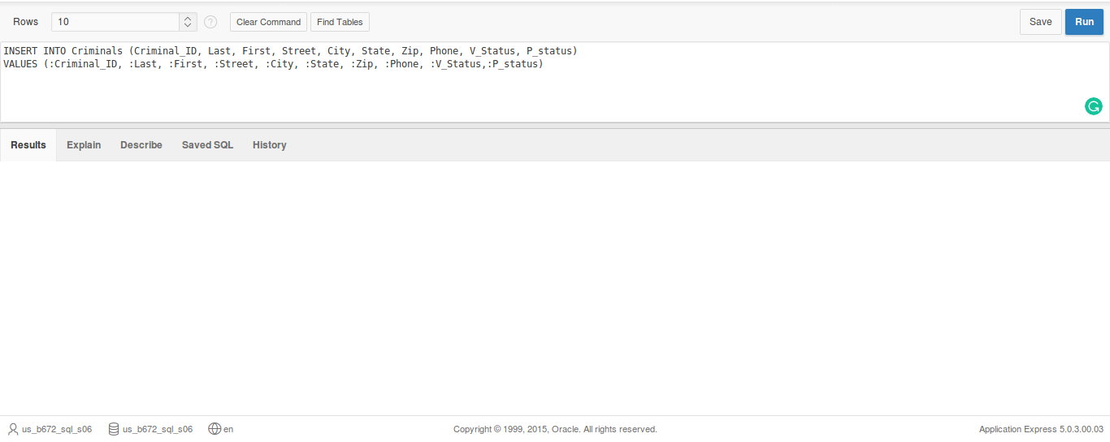

1(b) (Not sure why the default values didnt load.)
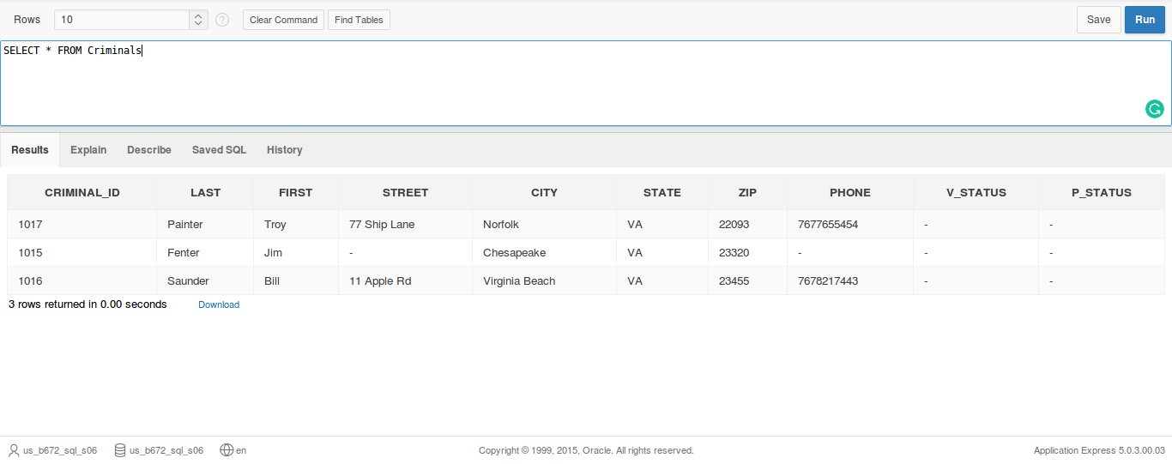

1(c-g)
ALTER TABLE Criminals
ADD (Mail_flag CHAR(1));

UPDATE Criminals
SET Mail_flag='Y';

UPDATE Criminals
SET Mail_flag='N' WHERE Street IS NULL;

UPDATE Criminals
SET Phone='7225659032' WHERE Criminal_ID=1016;

DELETE FROM Criminals
WHERE Criminal_ID=1017;

2(a)
INSERT INTO Crimes (Crime_ID, Criminal_ID, Classification, Date_charged, Status)
VALUES(100,1010,'M','15-JUL-09', 'PD');

Error: ORA-02290: check constraint (US_B672_SQL_S06.CRIMES_STATUS_CK) violated
Crime Status cannot be ‘PD’. Just CL, CA, or IA

2(b)
INSERT INTO Crimes (Crime_ID, Criminal_ID, Classification, Date_charged, Status)
VALUES(130,1016,'M', '15-JUL-09','PD');

Error: ORA-02290: check constraint (US_B672_SQL_S06.CRIMES_STATUS_CK) violated
Crime Status cannot be ‘PD’

2(c)
INSERT INTO Crimes (Crime_ID, Criminal_ID, Classification, Date_charged, Status)
VALUES(130,1016,'P', '15-JUL-09','CL');

Error: ORA-02290: check constraint (US_B672_SQL_S06.CRIMES_CLASS_CK) violated

Crime Class cannot be ‘P’

