Lab 5
1.
Add a new row in the ORDERS table with the following data: Order# = 1021, Customer# = 1009, and Order date = July 20, 2009.
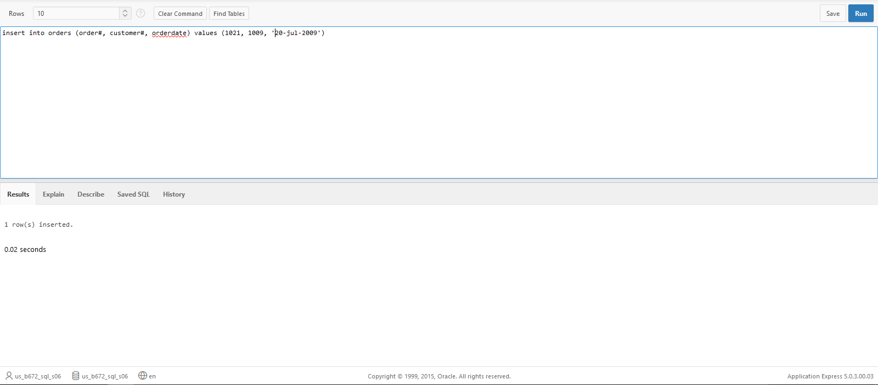
2. Modify the zip code on order 1017 to 33222.
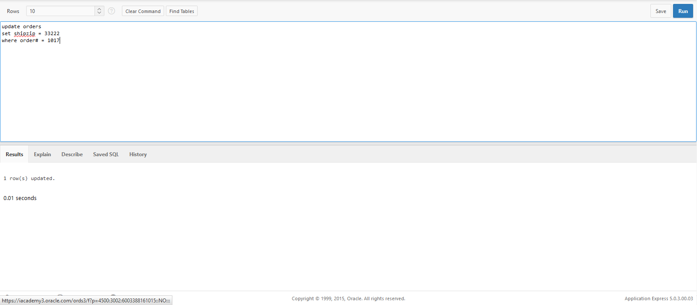

3. Save the changes permanently to the database.
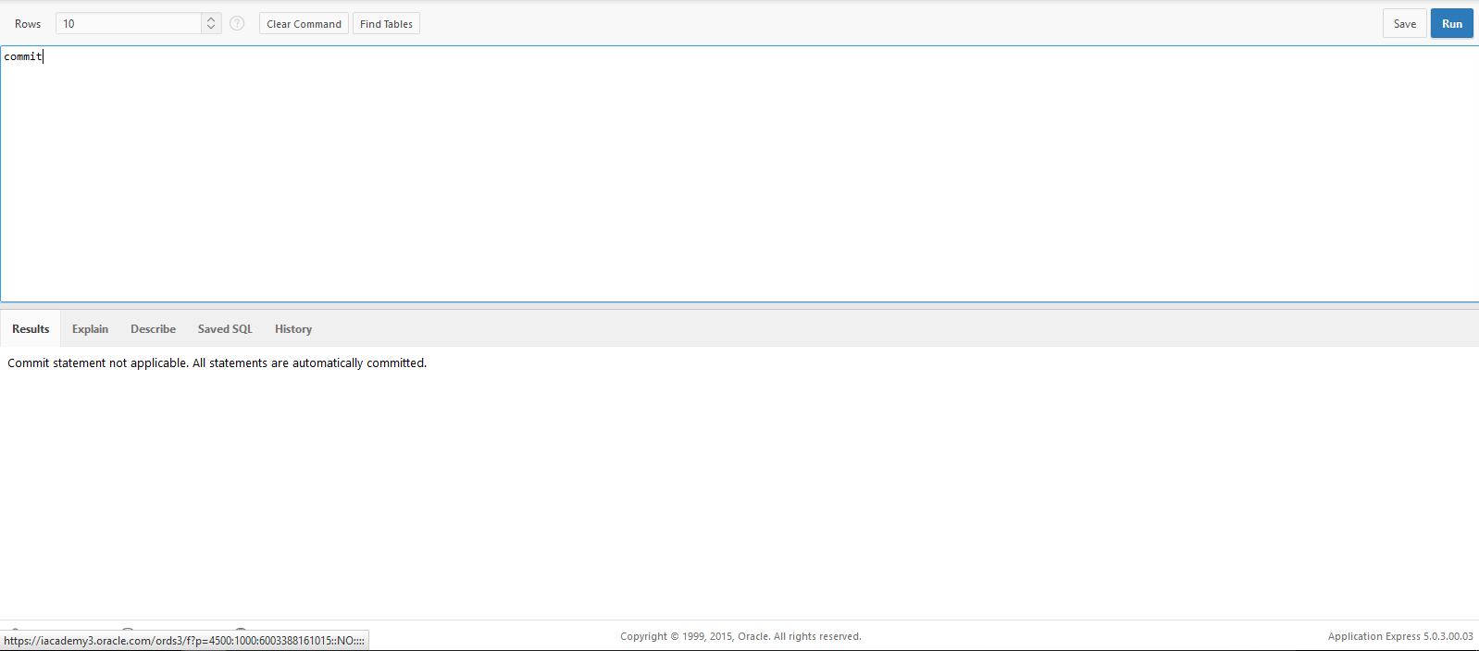
4. Add a new row in the ORDERS table with the following data: Order# = 1022, Customer# = 2000, and Order date = August 6, 2009. Describe the error raised and what caused the error.
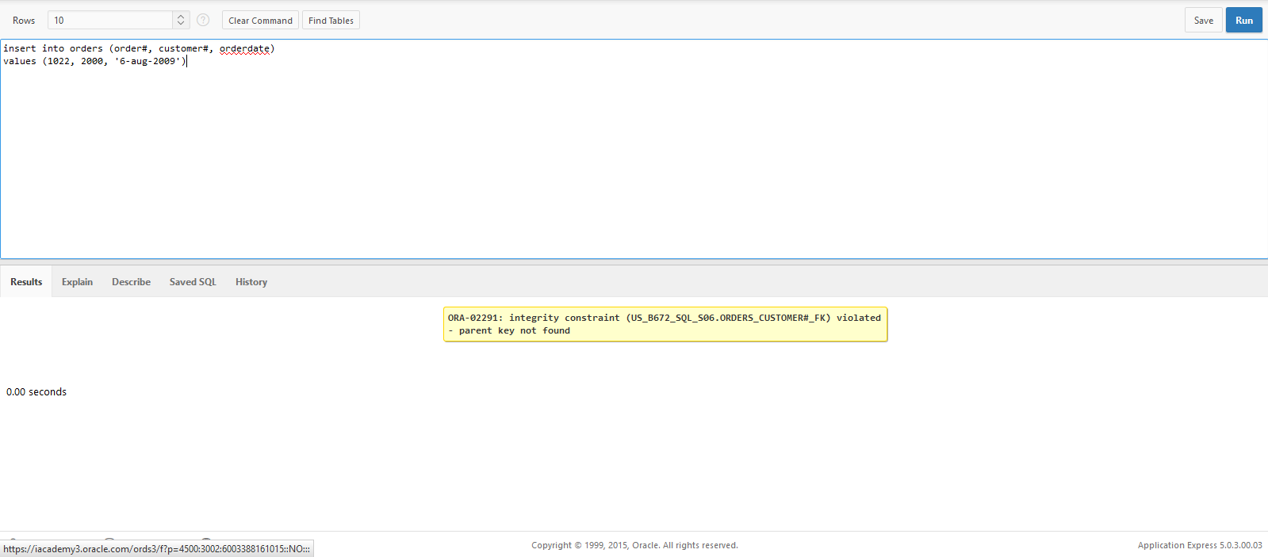
It caused an error because the customer# does not follow the database key

5. Add a new row in the ORDERS table with the following data: Order# = 1023 and Customer# = 1009. Describe the error raised and what caused the error.
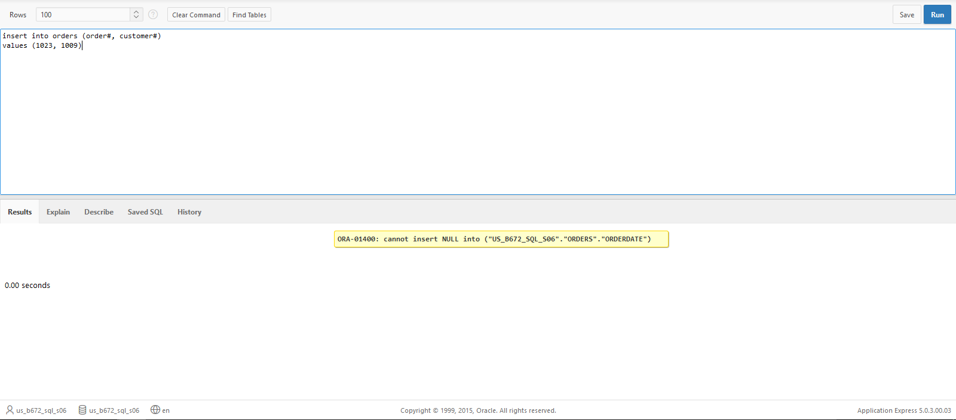
Tried to insert a value that would be considered NULL in a non-nullable value.
6. Create a script using substitution variables that allows a user to set a new cost amount for a book based on the ISBN.
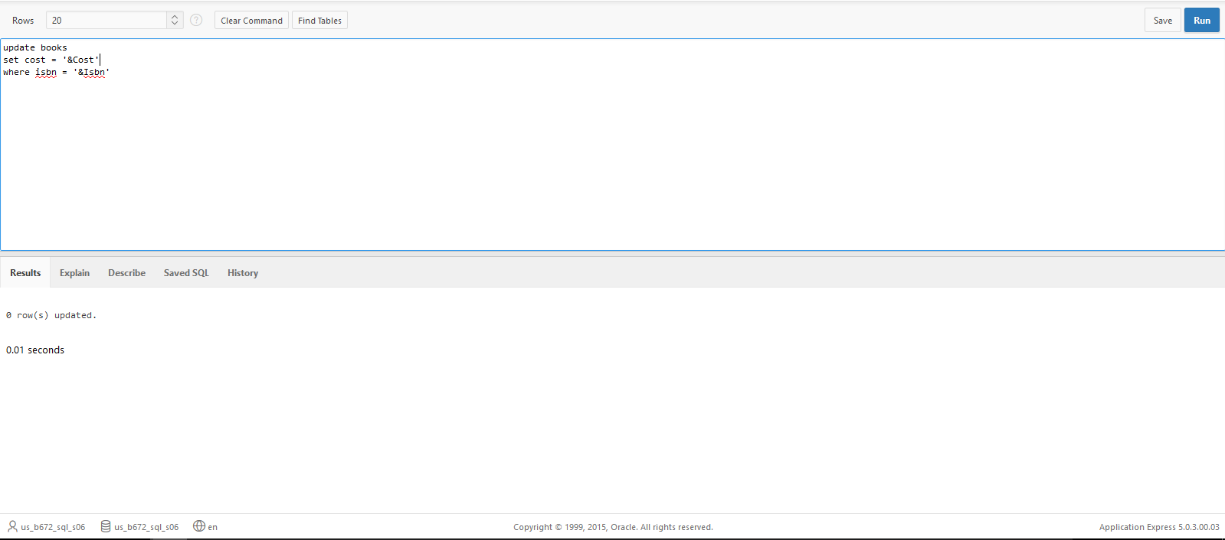

7. Execute the script and set the following values: isbn = 1059831198 and cost = $20.00.
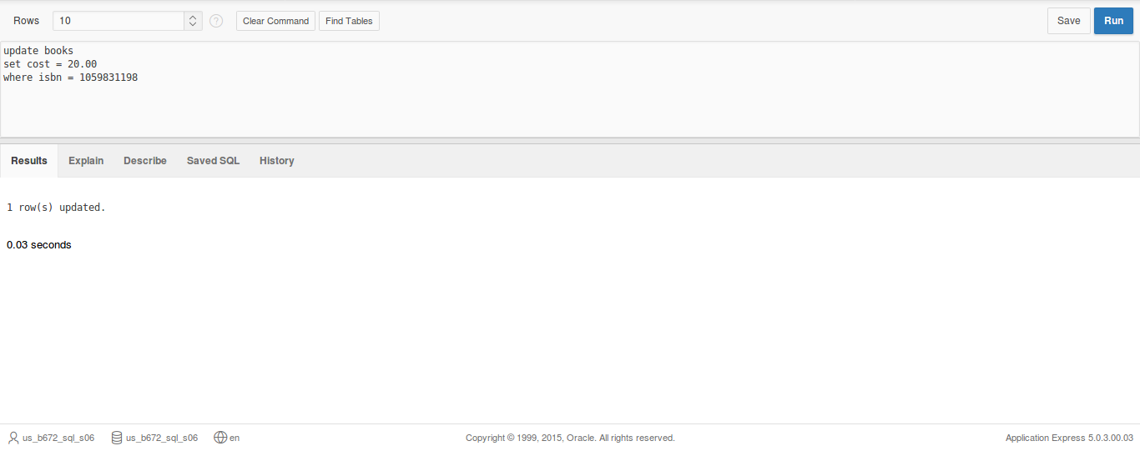
8. Execute a command that undoes the change in Step 7.
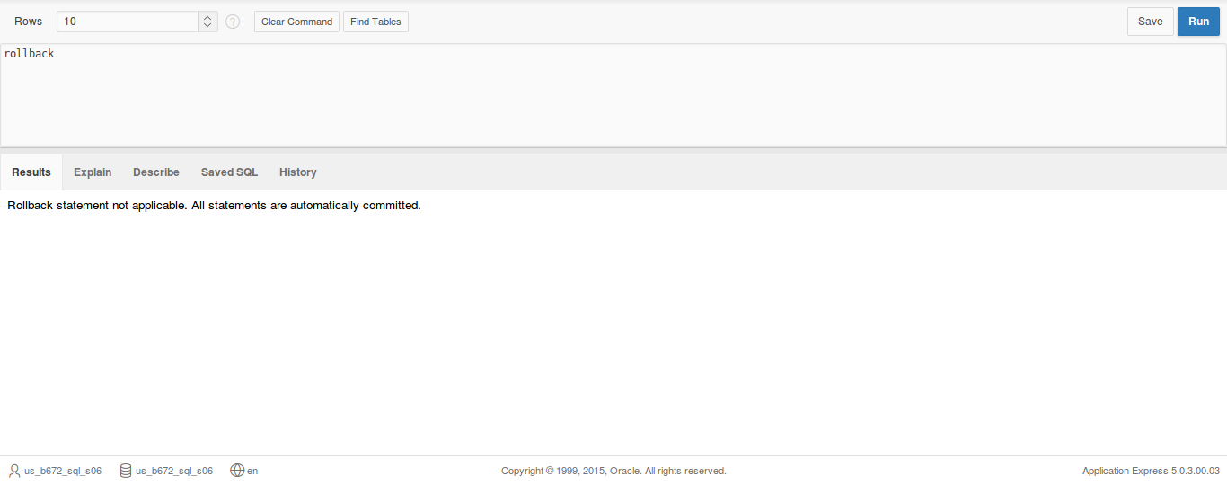

9. Delete Order# 1005. You need to address both the master order record and the related detail records.
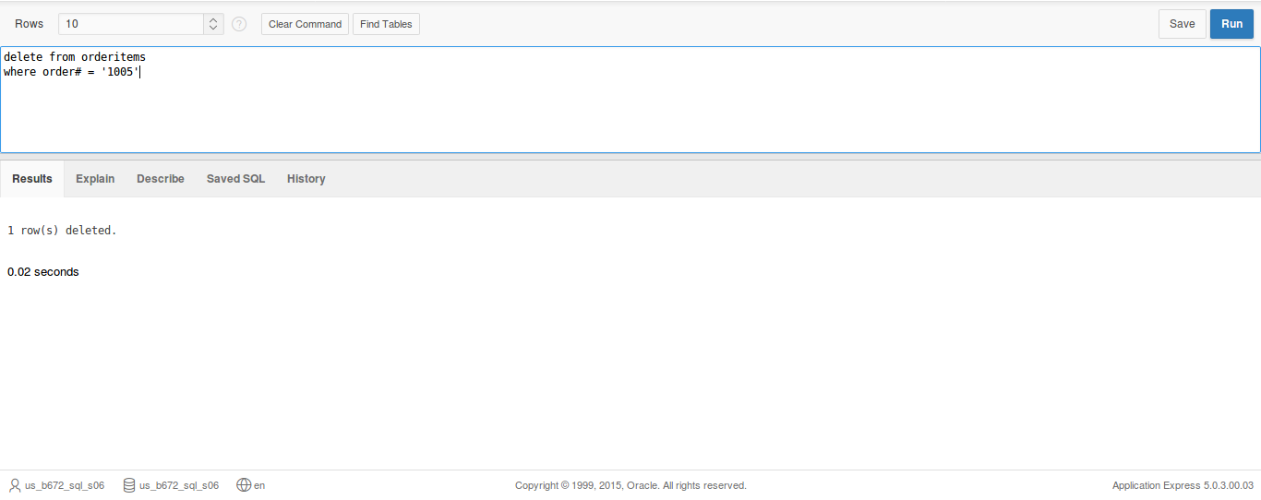
10.Execute a command that undoes the previous deletion.
