

**UNIVERSIDAD PRIVADA DE TACNA**

**FACULTAD DE INGENIERIA**

**Escuela Profesional de Ingeniería de Sistemas**

Lab 01 Análisis Exploratorio de Datos con R

Curso: Inteligencia de Negocios

Docente: Mag. Ing. Patrick Cuadros Quiroga

Integrantes

***Diego Manuel, Gorbeño Mamani (2018000354)***

**Tacna – Perú**

**2022**

**INFORME DE LABORATORIO U3–N°01**

## TEMA: Análisis Exploratorio de Datos con R

**PROCEDIMIENTO.**

**Paso 01.** Buscamos y abrimos anaconda.

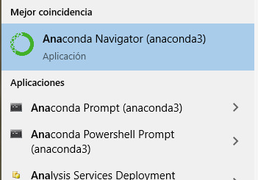

**Paso 02.** Ejecutamos Jupiter.

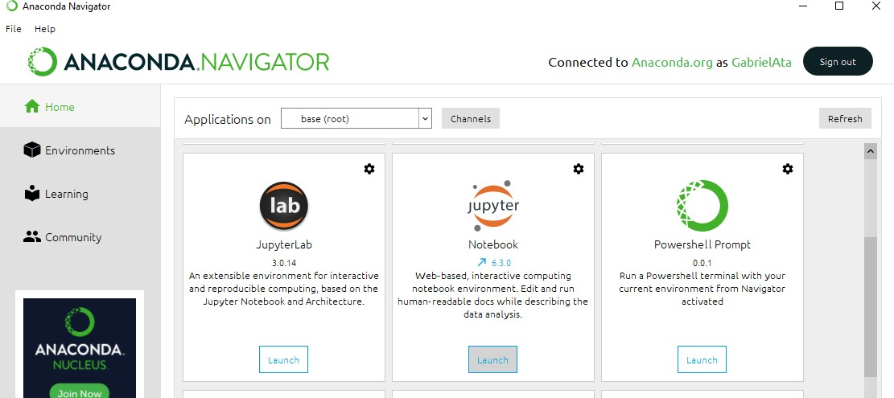

### **Paso 03.** Creamos un nuevo ambiente incluyendo R y Python.

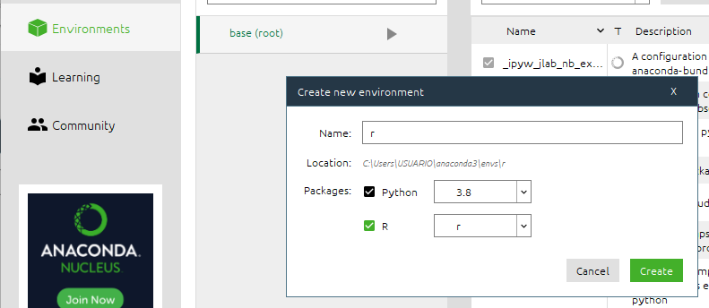

**Paso 04.** Abrimos el entorno con el paquete R usando la opción “Abrir con Jupyter Notebook”.

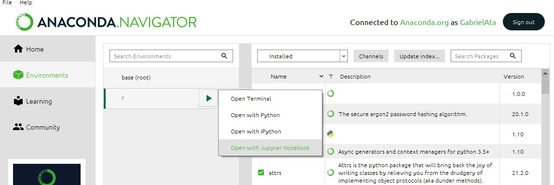

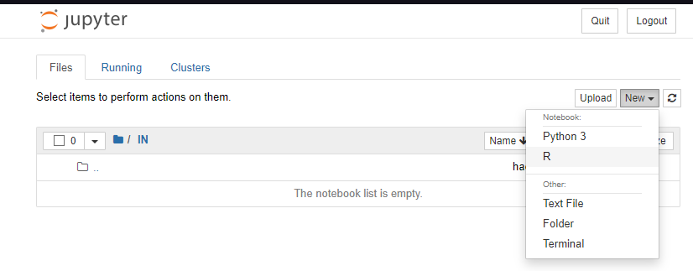**Paso 05.** Para crear un nuevo bloc de notas para el idioma R, en el menú Jupyter Notebook, seleccionamos Nuevo, luego seleccionaremos Folder para crear un directorio que pueda separar los archivos y finalmente dentro de la carpeta creada seleccionamos R.

**Paso 06.** Ingresamos un Nombre.

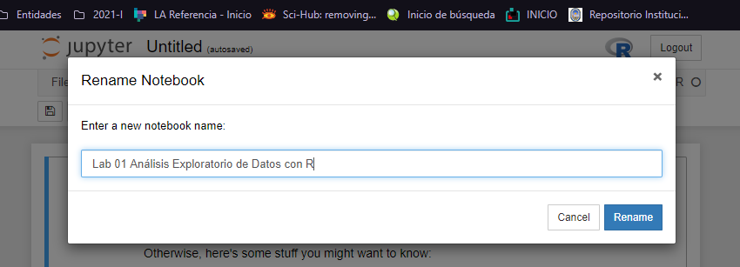

**Paso 07.** Comenzamos a codificar.

Getting started

#### Notebooks let you mix code, documentation and graphics. The following cell contains the traditional 'Hello, world’ getting. Click it, then execute it by pressing ShiR-Enter.

In [1]:

pnint(”Hello, vonld! ”}

##### [1] "He11a, world !"

We're working in R, so you might want to play with one of the build-in databases.

Let’s check out mtcars.

Fnr quancy

|  |  |  |  |  |  |  |  |  |  |  |  |  |
| --- | --- | --- | --- | --- | --- | --- | --- | --- | --- | --- | --- | --- |
| In [2]: | mtcars |  | | | | | | | | | | |
|  |  | mpg | cyl | disp | hp | drat | wt | qsec | as | am | gear | carb |
|  | M8zdaRX4 | 21.0 | 6 | 160.0 | 110 | 3.90 | 2.620 | 16.46 | 0 | 1 | 4 | 4 |
|  | M8zd8RX4W0g | 21.0 | 6 | 160.0 | 110 | 3.90 | 2.875 | 17.02 | 0 | 1 | 4 | 4 |
|  | oatsun710 | 22.8 | 4 | 108.0 | 93 | 3.85 | 2.320 | 18.61 | 1 | 1 | 4 | 1 |
|  | Homet4Dri›e | 21.4 | 6 | 256.0 | 110 | 3.08 | 3.215 | 19.44 | 1 | 0 | 3 | 1 |
|  | Homet5portabout | 18.7 | 8 | 360.0 | 175 | 3.15 | 3.440 | 17.02 | 0 | 0 | 3 | 2 |
|  | Valiant | 18.1 | 6 | 225.0 | 105 | 2.76 | 3.460 | 20.22 | 1 | 0 | 3 | 1 |
|  | Duster360 | 14.3 | 8 | 360.0 | 245 | 3.21 | 3.570 | 15.84 | 0 | 0 | 3 | 4 |
|  | M0rc240D | 24.4 | 4 | 146.7 | 62 | 3.69 | 3.190 | 20.00 | 1 | 0 | 4 | 2 |
|  | Merc230 | 22.8 | 4 | 140.8 | 95 | 3.92 | 3.150 | 22.90 | 1 | 0 | 4 | 2 |
|  | You can plot things: |  |  |  |  |  |  |  |  |  |  |  |

I n [4 ] : hist(mtcars$hp)

Hlstogram of mtcarsshp

10

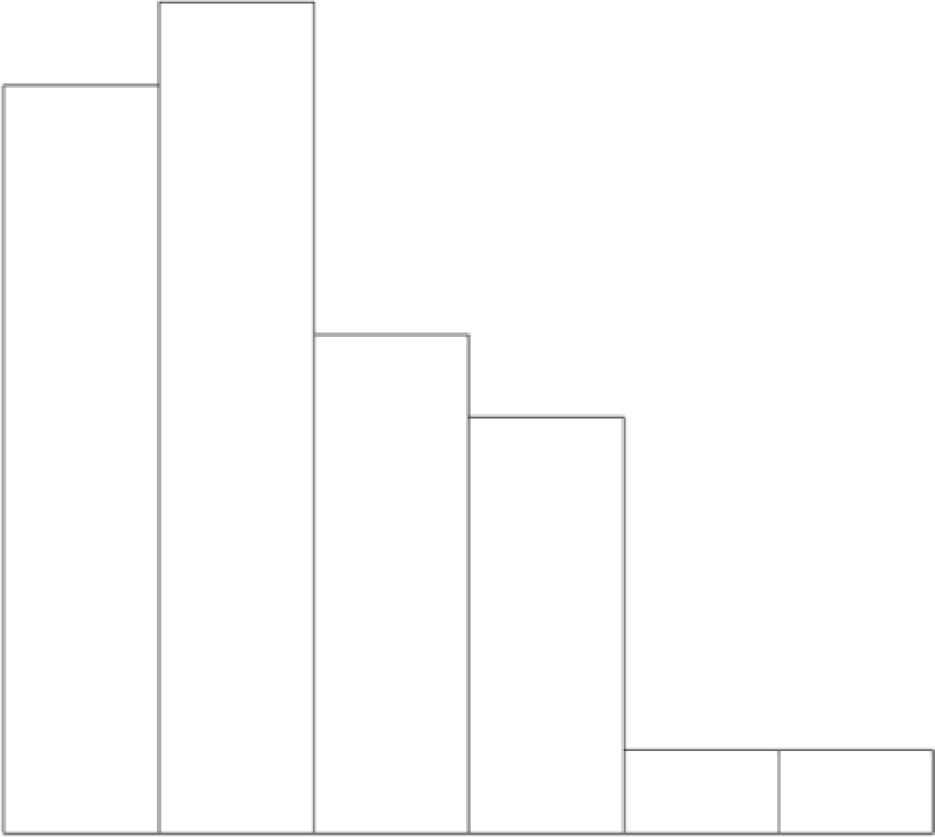

##### 50 100 150 200 250 500 350

mtcarsshp

Ir ’S]'

Ir ’O]:

library(ggplot2)

q plot (ntcans Sh p)

’stat bin(}’ using ’bins = 30’. Pick betten value with ’binwidth’.



-ir °Jr

nrlca rs $hp

plotly is another popular graphing library. Let's try it!

library(plotly) set.seed(100}

d <- diamonds[sample(nrov(diamonds), 1000), j plot_ly(d, x = carat, y = price, color = -carat,

size = -canat, text = paste(”Clarity: ”, canity})

Error in library(plotly): thene is no package called ’plotly’ Traceback:

1. library(plotly)

 library(ggplot2)

ggplot(diamonds, aes(x = canat, y = pnice, colon = clarity)) a geom point()

Registered S3 methods overwritten by ’ggplot2' : method from

[.Quosunes rlang

c.Quosures rlang pnint.quosures rlang

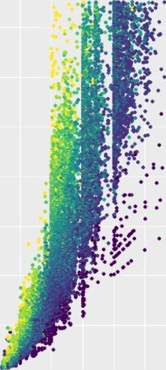

carat