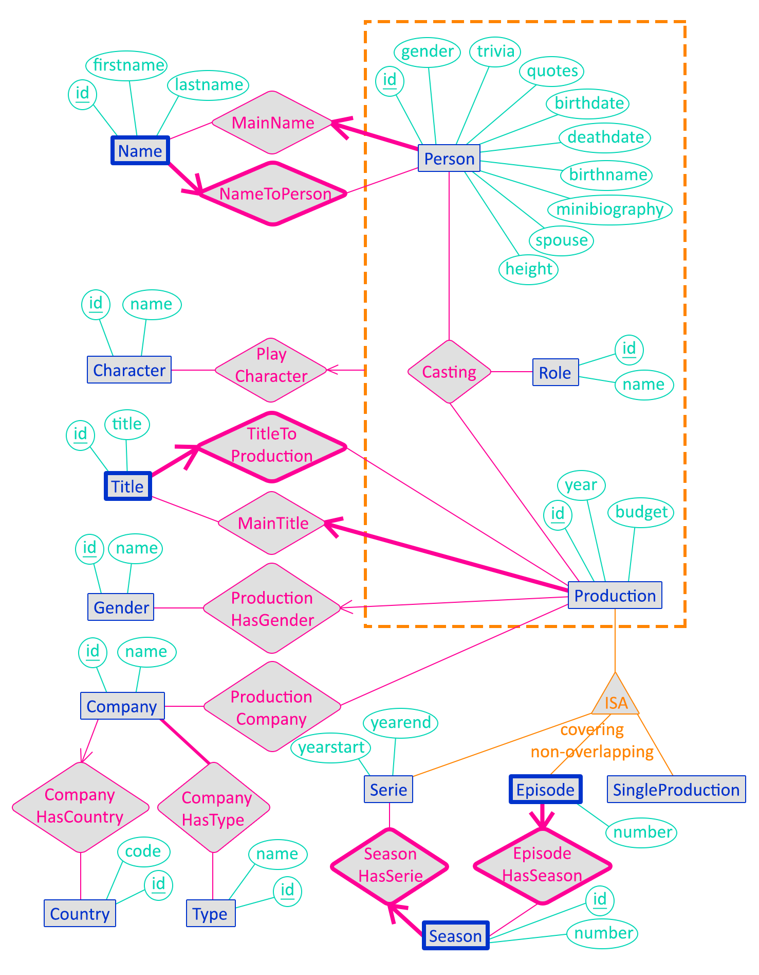

**Textual constraints :**

* MainName.Name must belong to MainName.Person through NameToPerson
* MainTitle.Title must belong to MainTitle.Production through TitleToProduction