**IMDB Project**

**Final report**

**0. Summary**

1. Introduction 3

1.1. Technologies 3

2. Conceptual design 5

2.1. Metadata and data analysis 5

2.2. Entity-Relationship schema (ER) 6

3. Logical design 9

3.1. Relational schema 9

3.2. DDL SQL code 12

4. Data import 18

4.1. Changes made in database schema 18

5. Web application 20

5.1. Search functionality 20

5.2. Main pages 24

5.3. Inserting, updating and deleting entities 27

6. Simple queries (milestone 2) 36

6.1. SQL code 36

6.2. Application dedicated page 39

7. Appendix A – Data import detailed report 41

7.1. Imported files 41

7.2. SQL DDL code before milestone 2 modification 45

8. Appendix B – Web application detailed 49

8.1. Major components 49

8.2. Main pages queries 50

8.3. Insert, update and delete procedures 54

# Introduction

The goal of this report is to present our work for the project due to EPFL’s CS-322 “Introduction to database systems” course. Realized application consists of a database designed and implemented on the basis of simple data files and short description given at the beginning of the project, coupled to a simple web application to manage and query this database. The stored data corresponds to some movies and series with simple relations such as actors, extracted from the *IMDB movies database[1]*.

## Technologies

As we had full choice about the tools and software we use for this project, here is a list of the main components we used and the reason of “why these and not others ?”.

### Database management system (DBMS)

We were offered to use some dedicated *Oracle[2]* server, internal to EPFL. The major inconvenient of this solution was that we won’t be able to work on this project in locations where no easy Internet access is provided, like trains, and we would become dependent of the availability of the server.

Instead, we chose to locally install and use *MySQL Community Edition[3]*, with the following argument about this choice.

* It is totally free and wide-used, essentially in the world of web applications, which kind of application we chosed to build (see [§1.1.2]) ;
* it comes with *MySQL Workbench[4]*, a powerful dedicated tool to model schemas, manage graphically the DBMS parameters, check queries are working and so on ;
* it is available on all major OS, which can be useful as we have different kinds of computers with different OS families installed.

More precisely, we use the following versions of the DBMS and tools.

* MySQL 5.6.23
* MySQL Workbench 6.2.4
* MySQL Utilities 1.5.3

### Graphical application development

We had full choice about the programming language and API technologies we want to use to develop the graphical application that has to come out as a result for this project.

As already having experience in such kind of development, we decided to create a web application based on the following servers and tools.

* *Apache[5]* 2.4.12, as the web server
* *PHP[6]* 5.5.0, as the server-side programming technology
* *jQuery[7]* 2.1.3, as the client-side programming framework
* *Twitter’s bootstrap[8]* 3.3.4, as the graphical enhancement framework

The application is strongly based on *AJAX requests[9]* to gather heavy data sets and execute long-running requests while informing user on the current progress status.

The development is enhanced by the ILARIA toolset, a powerful PHP framework developed by Jason Racine, one of our team’s member. This framework provides the following operations to speed up development.

* Full MVC (Model-View-Controller) paradigm
* Internal management and handling of asynchronous requests
* MySQL high-level abstraction layer to ease SQL commands building and management
* Enhanced security and errors protection

# Conceptual design

In this chapter, we analyse the data and metadata that are given at the start point of the project and mix them together into a Entity-Relational (ER) schema and a set of out-of-model constraints.

## Metadata and data analysis

Here we do a hypothesis-based analysis of parts of the data and their metadata (in fact, just column names) we were given. This will be used in [§2.2] to justify parts of the ER schema.

### “PERSON” and “ALTERNATIVE_NAME”

These 2 files are obviously linked by the fact that a person can have multiple alternative names, which is confirmed by the presence of the *“person_id”* field in *“ALTERNATIVE_NAME”*. In *“PERSON”* as well as in *“ALTERNATIVE_NAME”*, the *“name”* field seems to be always constructed in the same way, starting by the last name, followed by a comma, and then the first name(s). Sometimes, there is only one name without coma, suggesting it’s just the “main name”, let’s say last name. This field is to be split into 2 distinct fields “lastname” and “firstname” by parsing during the data import.

We also remark that the field *“gender”* in *“PERSON”* contains always values “m” and “f”, obviously describing if the person is a man or a woman. This is a candidate field to be exported as a separate entity set in ER schema.

### “PRODUCTION” and “ALTERNATIVE_TITLE”

These 2 files are also linked in a similar way as “PERSON” and “ALTERNATIVE_NAME” (see [§2.1.1]).

By digging into “PRODUCTION”, we see that there are 3 types of productions to consider.

* The single movies, that are registered once with all their informations ;
* the series, that are registered as a grouping element for episodes that they contain ;
* the episodes, linked to particular serie through the *“series_id”* field, and also registering a particular *“season_number”* and *“episode_number”* relative to the serie it belongs to.

This repartition of productions is a clear candidate to be modelled as a “ISA” hierarchy in the ER schema. More importantly, the *season* concept which is only present through the *“season_number”* field is a perfect candidate to be exported as a separate entity set in the ER schema, adding a level of hierarchy and thus helping to ensure consistency of the data.

The *“gender”* and “*kind*” fields of *“PRODUCTION”* are also good candidates for such export, as they contain highly-repeated values that cleary consist of a finite set of genders and kinds of movies, except for the “episode” and “tv_series” values of “*kind*” that are modelled through the “ISA” hierarchy.

### “COMPANY” and “PRODUCTION_COMPANY”

The *“COMPANY”* file contains listing of companies. By digging into it, we can rapidly show that the *“country_code”* field is highly-repeating, so it is a candidate to be exported in a separate entity set in the ER schema.

The *“PRODUCTION_COMPANY”* file acts as an associative relationship between *“PRODUCTION”* and *“COMPANY”*. By digging into it, we easily see that a company can be involved in multiple productions, and that a production needs the participation of multiple companies, thus giving a N:N relationship in the incoming ER schema, with a supplementary attribute for the type of company, that describes some sort of “role” the company played in the production (production company or distributor). This attribute is thus also a good candidate to be exported as a separate entity set to reduce redundancy.

### “PRODUCTION_CAST” and “CHARACTER”

The *“PRODUCTION_CAST”* file acts as an associative relationship between *“PRODUCTION”*, “PERSON” and *“CHARACTER”*, with a supplementary *“role”* value. This value is clearly repeating, making it a good candidate to be modelled as a separate entity set in the ER schema. By exploring the file, we also see that the *“production_id”*, *“person_id”* and *“role”* are always filled, thus always telling that a person participated in a production as a particular role. This is to be modelled as a ternary relationship set in the ER model. But because the *“character_id”* is not always filled, we need to be careful and think about modelling it as a second relationship set, linking the aggregation of our first relationship set to the entity set corresponding to the file *“CHARACTER”*.

Finally, the *“CHARACTER”* file is just a listing of the characters played in movies. By making a quick test with the search function of a basic text editor into *“PRODUCTION_CAST”*, it seems that some characters appears in multiple productions, either referenced by the exact same key or by having multiple instances of it in the *“CHARACTER”* file with slightly different names (e.g. “James Bond”, “James Bond 007”, “007 James Bond”, …). This will be hard to make this proper, but this is not the purpose of the first milestone of this project.

## Entity-Relationship schema (ER)

The conceptual design of the database is achieved using the same ER formalism as the one seen in course. The schema can be found on the next page, followed by a set of out-of-model constraints, these are constraints that apply to the data model to ensure its correctness, but that can’t be modelled by the chosen formalism (and more importantly, that any DBMS cannot ensure at all, it’s up to the applicative part to deal later with these problems).

### ER schema

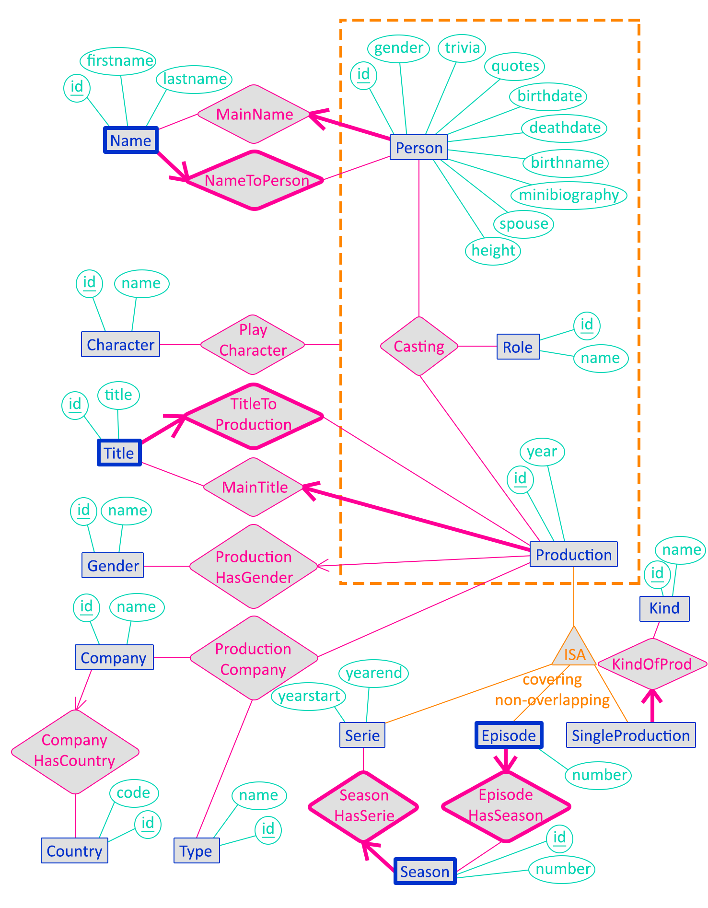

### Caption

**Blue** entity sets  
**Turquoise** attributes  
**Magenta** relationship sets  
**- - - - - - -** aggregation  
**_______** ISA hierarchy

### Out-of-model constraints

These are the constraints that cannot be modelled on the ER schema, and that will not be ensured by the DMBS but by the application.

1. For each instance of MainName, the referenced Name must belong to the referenced Person through an instance of NameToPerson ;
2. For each instance of MainTitle, the referenced Title must belong to the referenced Production through an instance of TitleToProduction.

### Account for design choices

Hereafter, we talk about the main design choices we did and some particularities of the method we used to design this database.

Name, MainName and NameToPerson

The entity set Name corresponds to the *“ALTERNATIVE_NAME”* file described in [§2.1.1]. We removed the “alternative” part because the main name, originally the field *“name”* in *“PERSON”*, is also modelled through this table. The NameToPerson relationship is the main link between Person and Name. This makes Name a *weak entity*, because a name has no sense without its owner. The MainName relationship is the cleanest way of ensuring that each Person has *exactly* one main name. This leads to the first out-of-model constraint defined in [§2.2.3].

Title, MainTitle and TitleToProduction

The entity set Title corresponds to the *“ALTERNATIVE_TITLE”* file described in [§2.1.2]. We removed the “alternative” part in a similar fashion as for Name, described above. The TitleToProduction relationship is the main link between Production and Title. This makes Title a *weak entity*, because a title has no sense without its owning production. The MainTitle relationship is the cleanest way of ensuring that each Production has *exactly* one main title. This leads to the second out-of-model constraint defined in [§2.2.3].

field gender of Person

We chosed to not export this field as a separate entity set, despite what was described in [§2.1.1], because this is a single letter which can be managed by the applicative part of the project. This alternative is more efficient than setting a foreign key and the indexes it involves just for a single character. Thus, searching for all women in the Person entity set is just searching through the indexed column gender for all ‘f’. If we did it with a separate entity set, we had to search through it for the ‘id’ of ‘f’ (let’s say, 1), then doing a similar search than before but for all ‘1’.

aggregation around Casting

We made Casting a 3-ary relationship, linked to Character through PlayCharacter, instead of making Casting a 4-ary, because not all instances of Casting are linked to a Character.

ISA architecture

As suggested in [§2.1.2], the best way to model the different kinds of productions is to use a ISA hierarchy. Here we chosed to separate “singles movies” into SingleProduction and apply a covering constraint on the ISA hierarchy, to make things clearer into the resulting database. We also modelled the “seasons” concept as a separate entity set, not part of the ISA hierarchy (because in the original *“PRODUCTION”* file the seasons are just discerned by numbers in a column, they do not have rows for them), so things are clearly hierarchized, thus making the future queries easier to build.

# Logical design

In this chapter, we translate the ER schema defined in [§2.2] into a purely relational schema, thus choosing data types (domains) for the attributes and determining whether relationship sets becomes foreign keys or associative tables. This schema is then implemented as a MySQL database.

## Relational schema

Here, we describe the relational schema in a textual form, then justify our main choices about the translation of the ER schema into this relational schema.

### Textual schema

This schema is given by alphabetic order of the relations names. Underlined attributes corresponds to the primary key for the corresponding table. Foreign keys are indicated under each relation description in green. Unicity constraints are indicated under each relation in blue. Attributes in bold are mandatory ones; ones not in bold can be omitted (NULL authorized).

***casting****(****id*: INT**, ***person_id*: INT**, ***production_id*: INT**, ***role_id*: INT**, *character_id*: INT)  
 *person_id* references *person.id*  
 *production_id* references *production.id* *role_id* references *role.id* *character_id* references *character.id* (*person_id*, *production_id*, *role_id*) must be unique

***character****(****id*: INT**, ***name*: VARCHAR(255)**)  
 (*name*) must be unique

***company***(***id*: INT**, ***name*: VARCHAR(255)**, *country_id*: INT)  
 *country_id* references *country.id* (*name*, *country_id*) must be unique

***country***(***id*: INT**, ***code*: VARCHAR(2)**)  
 (*code*) must be unique

***episode***(***id*: INT**, *number*: INT, ***season_id*: INT**)  
 *season_id* references *season.id  
 id references production.id* (part of the ISA hierarchy)  
 (*number*, *season_id*) must be unique

***gender***(***id*: INT**, ***name*: VARCHAR(255)**)  
 (*name*) must be unique

***kind***(***id*: INT**, ***name*: VARCHAR(255)**)  
 (name) must be unique

***name***(***id*: INT**, *firstname*: VARCHAR(255), ***lastname*: VARCHAR(255)**, ***person_id*: INT**)  
 *person_id* references *person.id* (*firstname*, *lastname*, *person_id*) must be unique

***person***(***id*: INT**, *gender*: VARCHAR(1), *trivia*: *TEXT*, *quotes*: TEXT, *birthdate*: DATE, *deathdate*: DATE, *birthname*: TEXT, *minibiography*: TEXT, *spouse*: VARCHAR(255), *height*: FLOAT, ***name_id*: INT**)  
 *name_id* references *name.id* (*name_id*) must be unique

***production***(***id*: INT**, *year*: INT, ***title_id*: INT**, *gender_id*: INT)  
 *title_id* references *title.id* *gender_id* references *gender.id* (*title_id*) must be unique

***productioncompany***(***id*: INT**, ***production_id*: INT**, ***company_id*: INT**, ***type_id*: INT**)  
 *production_id* references *production.id* *company_id* references *company.id  
 type_id* references *type.id* (*production_id*, *company_id, type_id*) must be unique

***role***(***id*: INT**, ***name*: VARCHAR(255)**)  
 (*name*) must be unique

***season***(***id*: INT**, *number*: INT, ***serie_id*: INT**)  
 *serie_id* references *serie.id* (*number*, *serie_id*) must be unique

***serie***(***id*: INT**, *yearstart*: INT, *yearend*: INT)  
 *id* references *production.id* (part of the ISA hierarchy)

***singleproduction***(***id*: INT**, ***kind_id*: INT**)  
 *id* references *production.id* (part of the ISA hierarchy)  
 kind_id references kind.id

***title***(***id*: INT**, ***title*: VARCHAR(255)**, ***production_id*: INT**)  
 *production_id* references *production.id* (*title*, *production_id*) must be unique

***type***(***id*: INT**, ***name*: VARCHAR(255)**)  
 (*name*) must be unique

### Account for translation choices

We made the following main choices when translating the conceptual schema into a relational one.

*casting* and its aggregation

The Casting relationship defined in the ER schema, and its aggregation used in the PlayCharacter relationship upon the Character entity, are translated to a single associative relation *casting* in the above relational schema, with the particularity that the *character_id* field can be NULL, meaning that no PlayCharacter instance exist for the given Casting instance. This seems more efficient to group them both in a single relation instead of having 2 different relations with more foreign keys to manage.

use of *id* fields in the associative relations

In the *casting* and *companytype* relations, an *id* field is always introduced, totally inexistent in the original data given as CSV files, declared as the primary keys for these relations. Thus, a unicity constraint is set over the foreign keys involved in the relation. It is generally admitted that it is better when designing a database to associate each relation a single, one-field primary key than composing complex primary keys with multiple fields, even if this seems more logical to do. The reason for that is that when we want to improve the database, adding more relations into it, it is easier having only one field to use as a foreign key to reference another relation than to have several fields to use as a foreign key.

data types

For all key fields (primary and obviously foreign), the data type is INT, which seems logical and non-controversing in most cases. In particular, all “id” fields given in the CSV data files are numerical, and for the primary keys that are to be generated during data import (those of associative relations that do not appear directly in CSV files) MySQL has a functionality called “AUTO_INCREMENT” that acts only on INT type and its variants (UNSIGNED, BIGINT, TINYINT, ...) We can work only with INT UNSIGNED, having possible values, as all given data files have at most 10’s of millions of entries.

Then, MySQL has special, dedicated data types for things like dates and years. In particular, by using the type DATE for data-like fields, it become easier in the queries to make calculations on those fields. When storing years, we originally used the YEAR data type, but as discussed in [§4.1.3], it was impossible to store pre-1900 values, so we changed it to INT to ensure everything is fine.

The textual fields are then divided into 3 groups.

* When the length can be arbitrarily long (biography, quotes, etc…) and no specific queries have to be executed on these fields, they are assigned the type TEXT, which can contain (theoretically) infinite texts, but for which indexation is hard to configure (because index must be specified on a maximum length, which cannot be infinite like the size of the corresponding field…) ;
* when the length is supposed to be quite limited (names, titles, etc…) and the fields appear to be used in specific queries of milestones 2 and 3, they are assigned the type VARCHAR(255), which can contain up to 255. It is then easy to put indexes on these fields. The exact value 255 is the more commonly used for such field, because it is quite large but is the larger number that can be encoded on 8 bits. As the length of a VARCHAR is stored with each instance of the corresponding attribute, 255 is thus the larger number of characters we can count without requiring adding a second metadata byte to count numbers >255 ;
* when the length is precisely known (1 for the gender of persons, 2 for country codes, …), the type VARCHAR(x) with x the precisely known length is assigned.

translation of the ISA hierarchy

We chosed to implement the ISA hierarchy described in the ER schema by keeping all entities involved into it (the parent as well as the children), linking them by their primary keys *id*. While it is a covering, non-overlapping ISA architecture, the parent entity set (Production) has its own attributes and is involved in external relationships, in which in particular ProductionCompany is of cardinality N:N, thus complicating things if we only keep the children relations.

### Unacknowledged constraints

In this relational schema, lots of constraints previously specified are not present, and thus need to be acknowledged here before writing down the SQL code to create tables.

* The 2 out-of-model constraints declared for ER schema in [§2.2.3], which will be implemented by the application as no database mechanism can ensure that ;
* all weak entities of the ER schema (Name, Title, Season, Episode) will be ensured *weak* in the SQL code through the “ON DELETE CASCADE” directives ;
* the non-overlapping property of the ISA architecture will have to be checked by the application.

## DDL SQL code

Hereafter is the SQL code that creates the tables and sets up the links (foreign keys) between them, compatible with the MySQL DBMS. The creation of the schema and database, as well as the management of the users and their rights to access database is not discussed here.

### MySQL DDL code

**-- 1. Create tables with unlinked columns, primary keys, unique indexes and simple indexes on future foreign keys**

CREATE TABLE `name` (

`id` INT UNSIGNED AUTO_INCREMENT,

`firstname` VARCHAR(255) CHARACTER SET utf8 COLLATE utf8_bin NULL,

`lastname` VARCHAR(255) CHARACTER SET utf8 COLLATE utf8_bin NOT NULL,

`person_id` INT UNSIGNED NOT NULL,

PRIMARY KEY (`id`),

UNIQUE KEY `un_first_last_person` (`firstname`, `lastname`, `person_id`)

);

CREATE TABLE `person` (

`id` INT UNSIGNED,

`gender` VARCHAR(1) NULL,

`trivia` TEXT NULL,

`quotes` TEXT NULL,

`birthdate` DATE NULL,

`deathdate` DATE NULL,

`birthname` TEXT NULL,

`minibiography` TEXT NULL,

`spouse` VARCHAR(255) NULL,

`height` FLOAT NULL,

`name_id` INT UNSIGNED NOT NULL,

PRIMARY KEY (`id`),

UNIQUE KEY `un_main_name` (`name_id`)

);

CREATE TABLE `role` (

`id` INT UNSIGNED AUTO_INCREMENT,

`name` VARCHAR(255) CHARACTER SET utf8 COLLATE utf8_bin NOT NULL,

PRIMARY KEY (`id`),

UNIQUE KEY `un_name` (`name`)

);

CREATE TABLE `character` (

`id` INT UNSIGNED,

`name` VARCHAR(255) CHARACTER SET utf8 COLLATE utf8_bin NOT NULL,

PRIMARY KEY (`id`),

UNIQUE KEY `un_name` (`name`)

);

CREATE TABLE `production` (

`id` INT UNSIGNED,

`year` INT UNSIGNED NULL,

`title_id` INT UNSIGNED NOT NULL,

`gender_id` INT UNSIGNED NULL,

PRIMARY KEY (`id`),

UNIQUE KEY `un_main_title` (`title_id`),

KEY `idx_gender` (`gender_id`)

);

CREATE TABLE `casting` (

`id` INT UNSIGNED AUTO_INCREMENT,

`person_id` INT UNSIGNED NOT NULL,

`production_id` INT UNSIGNED NOT NULL,

`role_id` INT UNSIGNED NOT NULL,

`character_id` INT UNSIGNED NULL,

PRIMARY KEY (`id`),

UNIQUE KEY `un_person_prod_role_character` (`person_id`, `production_id`, `role_id`,

`character_id`)

);

CREATE TABLE `title` (

`id` INT UNSIGNED AUTO_INCREMENT,

`title` VARCHAR(255) CHARACTER SET utf8 COLLATE utf8_bin NOT NULL,

`production_id` INT UNSIGNED NOT NULL,

PRIMARY KEY (`id`),

UNIQUE KEY `un_title_production` (`title`, `production_id`)

);

CREATE TABLE `gender` (

`id` INT UNSIGNED AUTO_INCREMENT,

`name` VARCHAR(255) CHARACTER SET utf8 COLLATE utf8_bin NOT NULL,

PRIMARY KEY (`id`),

UNIQUE KEY `un_name` (`name`)

);

CREATE TABLE `company` (

`id` INT UNSIGNED,

`name` VARCHAR(255) CHARACTER SET utf8 COLLATE utf8_bin NOT NULL,

`country_id` INT UNSIGNED NULL,

PRIMARY KEY (`id`),

UNIQUE KEY `un_name_country` (`name`, `country_id`)

);

CREATE TABLE `country` (

`id` INT UNSIGNED AUTO_INCREMENT,

`code` VARCHAR(10) CHARACTER SET utf8 COLLATE utf8_bin NOT NULL,

PRIMARY KEY (`id`),

UNIQUE KEY `un_code` (`code`)

);

CREATE TABLE `type` (

`id` INT UNSIGNED AUTO_INCREMENT,

`name` VARCHAR(255) CHARACTER SET utf8 COLLATE utf8_bin NOT NULL,

PRIMARY KEY (`id`),

UNIQUE KEY `un_name` (`name`)

);

CREATE TABLE `singleproduction` (

`id` INT UNSIGNED,

`kind_id` INT UNSIGNED NOT NULL,

PRIMARY KEY (`id`),

KEY `idx_kind` (`kind_id`)

);

CREATE TABLE `kind` (

`id` INT UNSIGNED AUTO_INCREMENT,

`name` VARCHAR(255) CHARACTER SET utf8 COLLATE utf8_bin NOT NULL,

PRIMARY KEY (`id`),

UNIQUE KEY `un_kind_name` (`name`)

);

CREATE TABLE `season` (

`id` INT UNSIGNED AUTO_INCREMENT,

`number` INT NULL,

`serie_id` INT UNSIGNED NOT NULL,

PRIMARY KEY (`id`),

UNIQUE KEY `un_serie_number` (`serie_id`, `number`)

);

CREATE TABLE `serie` (

`id` INT UNSIGNED,

`yearstart` INT UNSIGNED NULL,

`yearend` INT UNSIGNED NULL,

PRIMARY KEY (`id`)

);

CREATE TABLE `episode` (

`id` INT UNSIGNED,

`number` INT NULL,

`season_id` INT UNSIGNED NOT NULL,

PRIMARY KEY (`id`),

UNIQUE KEY `un_season_number` (`season_id`, `number`)

);

CREATE TABLE `productioncompany` (

`id` INT UNSIGNED,

`production_id` INT UNSIGNED NOT NULL,

`company_id` INT UNSIGNED NOT NULL,

`type_id` INT UNSIGNED NOT NULL,

PRIMARY KEY (`id`),

UNIQUE KEY `un_production_company` (`production_id`, `company_id`, `type_id`)

);

**-- 2. add all foreign keys constraints that are on schema**

ALTER TABLE `name`

ADD CONSTRAINT `fk_nametoperson` FOREIGN KEY (`person_id`) REFERENCES `person` (`id`)

ON DELETE CASCADE ON UPDATE CASCADE;

ALTER TABLE `person`

ADD CONSTRAINT `fk_mainname` FOREIGN KEY (`name_id`) REFERENCES `name` (`id`)

ON DELETE RESTRICT ON UPDATE CASCADE;

ALTER TABLE `production`

ADD CONSTRAINT `fk_maintitle` FOREIGN KEY (`title_id`) REFERENCES `title` (`id`)

ON DELETE RESTRICT ON UPDATE CASCADE,

ADD CONSTRAINT `fk_productionhasgender` FOREIGN KEY (`gender_id`)

REFERENCES `gender` (`id`) ON DELETE SET NULL ON UPDATE CASCADE;

ALTER TABLE `casting`

ADD CONSTRAINT `fk_casting_person` FOREIGN KEY (`person_id`) REFERENCES `person` (`id`)

ON DELETE CASCADE ON UPDATE CASCADE,

ADD CONSTRAINT `fk_casting_role` FOREIGN KEY (`role_id`) REFERENCES `role` (`id`)

ON DELETE RESTRICT ON UPDATE CASCADE,

ADD CONSTRAINT `fk_casting_production` FOREIGN KEY (`production_id`)

REFERENCES `production` (`id`) ON DELETE CASCADE ON UPDATE CASCADE,

ADD CONSTRAINT `fk_casting_character` FOREIGN KEY (`character_id`)

REFERENCES `character` (`id`) ON DELETE SET NULL ON UPDATE CASCADE;

ALTER TABLE `title`

ADD CONSTRAINT `fk_titletoproduction` FOREIGN KEY (`production_id`)

REFERENCES `production` (`id`) ON DELETE CASCADE ON UPDATE CASCADE;

ALTER TABLE `company`

ADD CONSTRAINT `fk_companyhascountry` FOREIGN KEY (`country_id`)

REFERENCES `country` (`id`) ON DELETE SET NULL ON UPDATE CASCADE;

ALTER TABLE `season`

ADD CONSTRAINT `fk_seasonhasserie` FOREIGN KEY (`serie_id`) REFERENCES `serie` (`id`)

ON DELETE CASCADE ON UPDATE CASCADE;

ALTER TABLE `episode`

ADD CONSTRAINT `fk_episodehasseason` FOREIGN KEY (`season_id`) REFERENCES `season` (`id`)

ON DELETE CASCADE ON UPDATE CASCADE;

ALTER TABLE `singleproduction`

ADD CONSTRAINT `fk_singleproduction_has_kind` FOREIGN KEY (`kind_id`)

REFERENCES `kind` (`id`) ON DELETE RESTRICT ON UPDATE CASCADE;

ALTER TABLE `productioncompany`

ADD CONSTRAINT `fk_productioncompany_production` FOREIGN KEY (`production_id`)

REFERENCES `production` (`id`) ON DELETE CASCADE ON UPDATE CASCADE,

ADD CONSTRAINT `fk_productioncompany_company` FOREIGN KEY (`company_id`)

REFERENCES `company` (`id`) ON DELETE CASCADE ON UPDATE CASCADE,

ADD CONSTRAINT `fk_productioncompany_type` FOREIGN KEY (`type_id`)

REFERENCES `type` (`id`) ON DELETE RESTRICT ON UPDATE CASCADE;

**-- 3. add foreign keys constraints relative to "ISA" architecture**

ALTER TABLE `serie`

ADD CONSTRAINT `fk_serie_isa_production` FOREIGN KEY (`id`) REFERENCES `production` (`id`)

ON DELETE CASCADE ON UPDATE CASCADE;

ALTER TABLE `episode`

ADD CONSTRAINT `fk_episode_isa_production` FOREIGN KEY (`id`)

REFERENCES `production` (`id`) ON DELETE CASCADE ON UPDATE CASCADE;

ALTER TABLE `singleproduction`

ADD CONSTRAINT `fk_singleproduction_isa_production` FOREIGN KEY (`id`)

REFERENCES `production` (`id`) ON DELETE CASCADE ON UPDATE CASCADE;

### Method for writing SQL DDL code

The above SQL code is highlighted by colours according to the following list.

Keywords keywords of the language, defining tables and constraints

Identificators names of tables, attributes, constraints, etc…  
 They are “backticks quoted”, as this is the way to ensure that if an identificator  
 accidentally (or voluntarily…) contain a keyword of MySQL, it will not be  
 interpreted as a keyword at all.

Data types MySQL data types for each attributes  
 They are set according to the relational schema (see [§3.1.1]). Keys (primary  
 and foreign) are defined as UNSIGNED to gain 1 bit, because keys are never  
 negative.

Null cond. These are constraints that specify whether a field can be set to NULL (no value)  
 or not. MySQL has a default value when it is not specified, but assuming  
 default values when building a script is always a bad idea, as default values  
 might change from a version to another. For “id” fields, it is not necessary to  
 specify “NOT NULL”, because it is a mandatory implication of the use of the  
 “PRIMARY KEY” clause.

ON … clauses These clauses specify what to do when a primary key referenced by a foreign  
 is updated or its corresponding row is deleted from the referenced table.

AUTO_INCREMENT clauses are set on primary keys of associative tables, as well as exported  
 tables that were originally redundant attributes, for which no data exist at all  
 in the given CSV data files.

The “ON UPDATE” clauses are always set to CASCADE as this enable us (DBA) to migrate the database to other servers with possible implications need on the numerical format of the keys with some ease of data update.  
The “ON DELETE” clauses are set according to the following method :

* If the foreign key is defined in a weak entity, referencing the weak relationship according to the ER schema, we use “ON DELETE CASCADE” because the weak entity cannot exist without the entity it is linked on, by definition ;
* if the foreign key is referencing a table that acts as a limited list of values (genders of productions, for example), we use “ON DELETE RESTRICT”, thus preventing the deletion of a value from the list when it is in use ;
* if the foreign key is defined for the purpose of an ISA hierarchy, we use “ON DELETE CASCADE”, as when the parent goes away, its children (representing other aspects of the same entity) must also go away ;
* when the foreign key can be set to NULL, we generally use “ON DELETE SET NULL”.

The creation of the foreign key constraints is entirely done separately at the end of the script for 2 major reasons.

* There are some circular relationships, that are a table A referencing a table B while the table B references the table A. As a foreign key cannot be created until the referenced table exist, at least one of the 2 foreign key in the case of a circular relationship must be created afterwards ;
* As for the above reason we need to create few foreign keys after corresponding tables have been created, it is then more readable to create them all after all tables have been created, otherwise we have lots of places to look at to find all foreign keys while reading the script.

The “UNIQUE KEY” clauses are created according to the relational schema (see [§3.1.1]).

For all fields that will be declared as foreign keys after the creation of the tables, and that are not already referenced in a “UNIQUE KEY” index, we create a simple “KEY” index during the table creation. We do that to ensure retro-compatibility of the script, because older versions of MySQL may not accept the creation of a foreign key if no index is defined on the corresponding field (for performance reasons[10]). Newer versions of MySQL automatically create this index if it does not exist, but by setting it explicitly we make our script compatible also with older versions.

### Extended note about AUTO_INCREMENT clauses

It is said above that the AUTO_INCREMENT clause is set on all primary keys of tables which represents associative relationships of the ER schema, and on tables that have been created to suppress redundancy from some attribute fields, because such keys does not exist at all in the given CSV data files. The AUTO_INCREMENT clause thus ensure that distinct, continuous values are assigned automatically at all rows of the considered table when these rows are added.

For all other *id* fields (primary keys), there is not AUTO_INCREMENT clause because the value will be entered to correspond to what is in the CSV data files. This is the best way to design the first version of the database so that import of all CSV data is easy to do in the next milestone.

This advantage will thus turn into an inconvenient when the database is ready, because when wanting to add a row (for example a production) through the application interface, we will have to manually enter a primary key, or at least implement the application such that it automatically find a non-used value for the primary key and use it immediately.

To correct the situation, we will use DDL commands of the following form AFTER the data have been imported (to be done concretely in milestone 2…), so that all primary key fields of the database are then controlled by a AUTO_INCREMENT clause, facilitating management of data through the application.

ALTER TABLE `table_name` CHANGE COLUMN `id` `id` INT UNSIGNED AUTO_INCREMENT;

The effect of such command on the primary key field *id* of the table *table_name* is to put on it a AUTO_INCREMENT controller, which starting value is automatically initialized to the current maximum value of the table plus one.

### Verification of the correctness of the script

After running the script to create all elements, we can use MySQL Workbench to generate[11] the corresponding visual relational schema in the MySQL formalism. The obtained schema is the following, visually confirming that everything seems right.

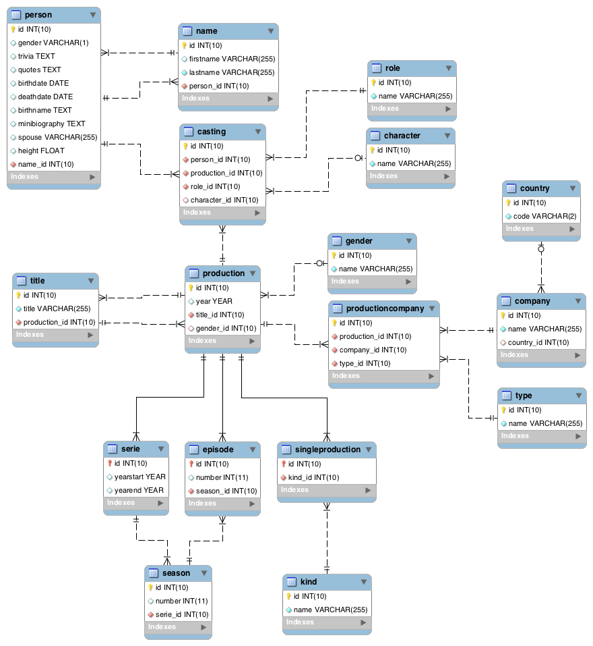

# Data import

The data are initially given in CSV format. To import them, we built some PHP scripts reading these CSV files, computing intermediate transformations (like exploding a single CSV line into multiple relations records) and issuing SQL DML commands.

The detailed report for data importation can be found in Appendix A [§7.1]. [n can be found in Appendix A (ortation can be found in Appendix A ([§

## Changes made in database schema

Some simple tests were done on small samples of each CSV file before any real import attempt, to detect most common error cases and build the scripts based on these observation. All these preliminary tests leaded to some database schema modifications and corrections, detailed below.

The modifications described below as executed during development are already implemented in the final DDL SQL code given in [§3.2]. To show the DDL SQL code as it was before these changes were applied, refer to Appendix A [§7.2].

### Data types for indexed texts

As created by default, the VARCHAR fields appearing in indexes in order to be “searchable” suffered from a problem. The lower/upper case was taken in consideration when searching, which is not what we wanted. The following script was run, adding a particular collation to the concerned fields, in order to fix this problem.

ALTER TABLE `name` CHANGE COLUMN `firstname`

`firstname` VARCHAR(255) CHARACTER SET utf8 COLLATE utf8_bin NULL;

ALTER TABLE `name` CHANGE COLUMN `lastname`

`lastname` VARCHAR(255) CHARACTER SET utf8 COLLATE utf8_bin NOT NULL;

ALTER TABLE `role` CHANGE COLUMN `name`

`name` VARCHAR(255) CHARACTER SET utf8 COLLATE utf8_bin NOT NULL;

ALTER TABLE `character` CHANGE COLUMN `name`

`name` VARCHAR(255) CHARACTER SET utf8 COLLATE utf8_bin NOT NULL;

ALTER TABLE `title` CHANGE COLUMN `title`

`title` VARCHAR(255) CHARACTER SET utf8 COLLATE utf8_bin NOT NULL;

ALTER TABLE `gender` CHANGE COLUMN `name`

`name` VARCHAR(255) CHARACTER SET utf8 COLLATE utf8_bin NOT NULL;

ALTER TABLE `company` CHANGE COLUMN `name`

`name` VARCHAR(255) CHARACTER SET utf8 COLLATE utf8_bin NOT NULL;

ALTER TABLE `country` CHANGE COLUMN `code`

`code` VARCHAR(2) CHARACTER SET utf8 COLLATE utf8_bin NOT NULL;

ALTER TABLE `type` CHANGE COLUMN `name`

`name` VARCHAR(255) CHARACTER SET utf8 COLLATE utf8_bin NOT NULL;

ALTER TABLE `kind` CHANGE COLUMN `name`

`name` VARCHAR(255) CHARACTER SET utf8 COLLATE utf8_bin NOT NULL;

### Length of country codes

By looking at the very first lines of the COMPANY.CSV file when designing database a few weeks ago, it seemed that all country codes were 2-characters long, ignoring the brackets. But slightly longer codes have been found by the automated inspection of this file before the import attempt, thus the size of this field has been enlarged to 10 by the following script.

ALTER TABLE `country` CHANGE COLUMN `code`

`code` VARCHAR(10) CHARACTER SET utf8 COLLATE utf8_bin NOT NULL;

### Handling of pre-1900 values in YEAR-typed fields

It appeared that some years of productions (both the field year of the production table, and the fields yearstart and yearend of the serie table) were before 1900, thus cannot be stored by the specific YEAR MySQL format previously defined for these fields. This format has been changed to simple INT UNSIGNED by the following script.

ALTER TABLE `production` CHANGE COLUMN `year`

`year` INT UNSIGNED NULL;

ALTER TABLE `serie` CHANGE COLUMN `yearstart`

`yearstart` INT UNSIGNED NULL;

ALTER TABLE `serie` CHANGE COLUMN `yearend`

`yearend` INT UNSIGNED NULL;

### Changed UNIQUE index in casting

By going through the casting table during inspection before import attempt, it was discovered that the same person could act as multiple characters in the same production. Thus, the unique key un_person_prod_role in the casting table was extended to the character_id field by the following script.

ALTER TABLE `casting` DROP INDEX `un_person_prod_role`;

ALTER TABLE `casting` ADD UNIQUE INDEX `un_person_prod_role_character`

(`person_id`,`production_id`,`role_id`,`character_id`);

# Web application

This chapter explains how the web application is built, what are the main queries used to make it work, and details the functionalities offered to the user.

In Appendix B [§8] can be found all detailed information that is not crucial to the project comprehension but that is still interesting and useful to understand the work we did to develop the application.

Major components offered by the ILARIA framework are described in Appendix B [§8.1].

## Search functionality

With a so large database to manage, the search functionality is considered as the core operation of the whole application. Thus it is designed to be as efficient as possible on a single laptop, reducing the primary search time over all “searchable areas” to a couple of seconds.

### Search queries

In this chapter we present with full details the search queries used.

**Productions**

The primary search query for finding productions is as follow (here we are searching for “hunger games”).

SELECT DISTINCT PR.`id`, TI_MAIN.`title`, PR.`year`, GE.`name` AS `gender`

FROM `production` PR

INNER JOIN (

SELECT TI.`id`, TI.`production_id` AS `prod_id`

FROM `title` TI

WHERE TI.`title` COLLATE UTF8_GENERAL_CI LIKE “%hunger games%”

) TI_SEARCH ON PR.`id` = TI_SEARCH.`prod_id`

INNER JOIN `title` TI_MAIN ON PR.`title_id` = TI_MAIN.`id`

LEFT JOIN `gender` GE ON PR.`gender_id` = GE.`id`

GROUP BY PR.`id`

ORDER BY PR.`year` DESC, TI_MAIN.`title` ASC;

By returning the production’s ID in the result, it is then possible to add a link on the graphical result lines, redirecting to the production’s main page. The search is done on all titles (main and alternative), but the resulting productions are displayed by their main titles only.

**Persons**

The primary search query for finding persons is as follow (here we are searching for “jennifer lawrence”).

SELECT DISTINCT PE.`id`, NA_MAIN.`lastname`, NA_MAIN.`firstname`, PE.`birthdate`, PE.`deathdate`

FROM `person` PE

INNER JOIN `name` NA_SEARCH ON PE.`id` = NA_SEARCH.`person_id`

INNER JOIN `name` NA_MAIN ON PE.`name_id` = NA_MAIN.`id`

WHERE (

NA_SEARCH.`lastname` COLLATE UTF8_GENERAL_CI LIKE "%jennifer%"

OR NA_SEARCH.`lastname` COLLATE UTF8_GENERAL_CI LIKE "%lawrence%"

) AND (

NA_SEARCH.`firstname` COLLATE UTF8_GENERAL_CI LIKE "%jennifer%"

OR NA_SEARCH.`firstname` COLLATE UTF8_GENERAL_CI LIKE "%lawrence%"

)

GROUP BY PE.`id`

ORDER BY NA_MAIN.`lastname` ASC, NA_MAIN.`firstname` ASC;

By returning the person’s ID in the result, it is then possible to add a link on the graphical result lines, redirecting to the person’s main page. The search is done on all names (main and alternative), but the resulting persons are displayed by their main names only.

In the above example, the original search text was “jennifer lawrence". In the live application, any input string is broken down by using space as separator, and a customized query is built dynamically, based on the above sample structure, adding a “OR” clause to each part of the main “AND” clause for every additional name. When only a single word is specified, the query is simplified to a simple OR between firstname and lastname on this single word.

**Characters**

The primary search query for finding characters is as follow (here we are searching for “everdeen").

SELECT DISTINCT CH.`id`, CH.`name`, COUNT(DISTINCT CA.`person_id`) AS `persons_count`, COUNT(DISTINCT CA.`production_id`) AS `productions_count`

FROM `character` CH

INNER JOIN `casting` CA ON CH.`id`=CA.`character_id`

WHERE CH.`name` COLLATE UTF8_GENERAL_CI LIKE "%everdeen%"

GROUP BY CH.`id`

ORDER BY CH.`id`;

When characters are found, we use their IDs on a button click to open a modal window showing a list of persons that played that character, retrieved by the following secondary search query. Here the ID is 2604958 corresponding to Katniss Everdeen.

SELECT DISTINCT PE.`id`, NA.`firstname`, NA.`lastname`

FROM `person` PE

INNER JOIN `name` NA ON PE.`name_id` = NA.`id`

INNER JOIN `casting` CA ON PE.`id` = CA.`person_id`

WHERE CA.`character_id` = 2604958;

In a similar way, we can open a modal window showing a list of productions in which this character appeared, retrieved by the following secondary search query.

SELECT DISTINCT PR.`id`, TI.`title`, PR.`year`

FROM `production` PR

INNER JOIN `title` TI ON PR.`title_id` = TI.`id`

INNER JOIN `casting` CA ON PR.`id` = CA.`production_id`

WHERE CA.`character_id` = 2604958;

The 2 above queries are returning person’s, respectively production’s ID, allowing us to put buttons on interface leading to the corresponding person’s or production’s main page.

**Companies**

The primary search query for finding companies is as follow (here we are searching for “lionsgate”).

SELECT DISTINCT COM.`id` AS `id`, COM.`name` AS `name`, COU.`code` AS `country`,

COUNT(DISTINCT PC_PROD.`production_id`) AS `produced_count`, COUNT(DISTINCT

PC_DIST.`production_id`) AS `distributed_count`

FROM `company` COM

LEFT JOIN `country` COU ON COM.`country_id` = COU.`id`

INNER JOIN `productioncompany` PC_PROD ON COM.`id` = PC_PROD.`company_id`

AND PC_PROD.`type_id` = (

SELECT `id` FROM `type` WHERE `name`="production companies"

)

INNER JOIN `productioncompany` PC_DIST ON COM.`id` = PC_DIST.`company_id`

AND PC_DIST.`type_id` = (

SELECT `id` FROM `type` WHERE `name`="distributors"

)

WHERE COM.`name` COLLATE UTF8_GENERAL_CI LIKE "%lionsgate%"

GROUP BY COM.`id`

ORDER BY COM.`name`;

When companies are found, we use their IDs on a button click to open a modal window showing a list of movies in which the company is involved as a production company, retrieved by the following secondary search query. Here the ID is 3293, corresponding to Lionsgate [us].

SELECT DISTINCT PR.`id` AS `id`, TI.`title` AS `title`, PR.`year` AS `year`

FROM `production` PR

INNER JOIN `title` TI ON PR.`title_id` = TI.`id`

INNER JOIN `productioncompany` PC ON PR.`id` = PC.`production_id`

INNER JOIN `type` TY ON PC.`type_id` = TY.`id`

WHERE TY.`name`="production companies"

AND PC.`company_id`=3293

ORDER BY PR.`year` DESC, TI.`title` ASC;

In the application, the same query is used a second time for a twin button, leading the the list of movies in which the company is involved as a distributor. The search parameter “production companies” is simply replaced by “distributors” in the above query.

**Genders**

The primary search query for finding genders of movies is as follow (here we are searching for “action”).

SELECT DISTINCT GE.`id` AS `id`, GE.`name` AS `name`, COUNT(DISTINCT PR.`id`) AS

`count_prod`

FROM `gender` GE

INNER JOIN `production` PR ON GE.`id` = PR.`gender_id`

WHERE GE.`name` COLLATE UTF8_GENERAL_CI LIKE "%action%"

GROUP BY GE.`id`

ORDER BY GE.`name`;

When genders are found, we use their IDs on a button click to open a modal window showing a list of movies having this gender, retrieved by the following secondary search query. Here the ID is 19, corresponding to action.

SELECT DISTINCT PR.`id` AS `id`, TI.`title` AS `title`, PR.`year` AS `year`

FROM `production` PR

INNER JOIN `title` TI ON PR.`title_id` = TI.`id`

INNER JOIN `gender` GE ON PR.`gender_id` = GE.`id`

WHERE GE.`id`=19

ORDER BY PR.`year` DESC, TI.`title` ASC;

### Graphical interface

The search form is composed of 2 parts.

* A “simple query” can be done, searching simultaneously through all the primary search queries presented above.
* An “advanced query” can be done, specifying which primary search queries must be launched.

This 2 parts are presented to the user in a collapsible accordion for better visual comprehension of the search possibilities.

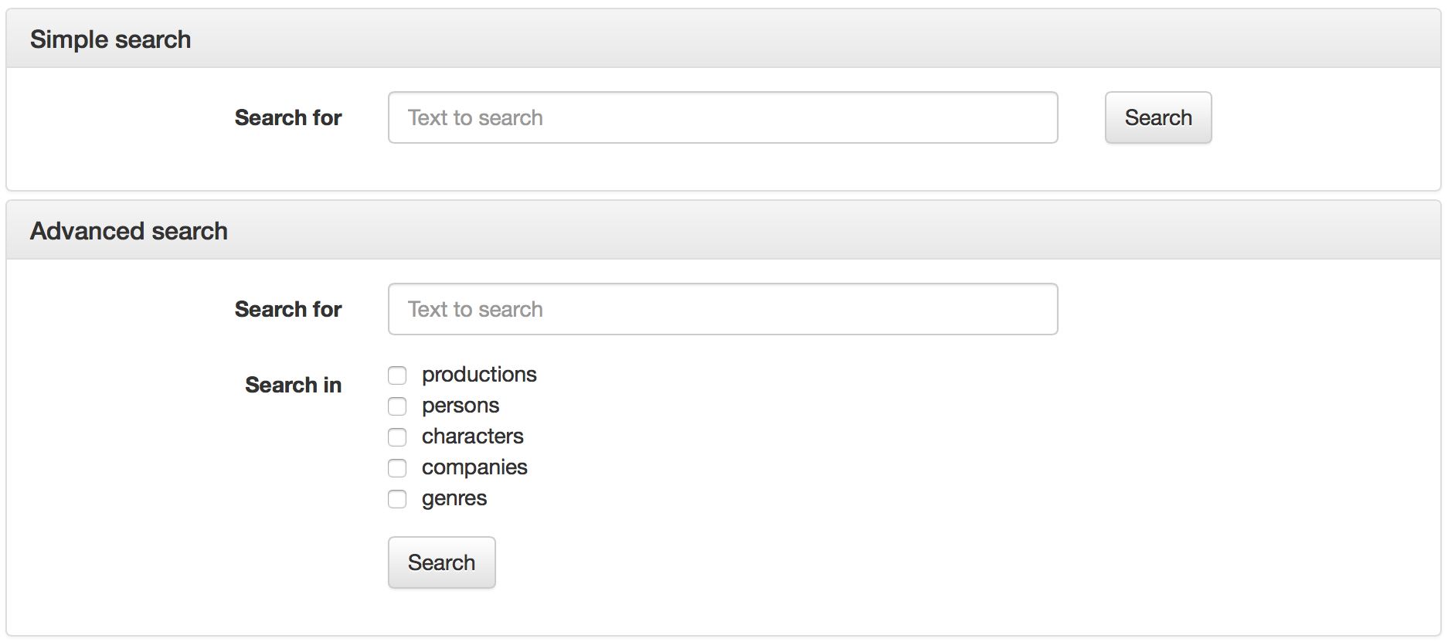

*The 2 search forms expanded for the purpose of this report*

When a simple search is done, a screen like the following is displayed.

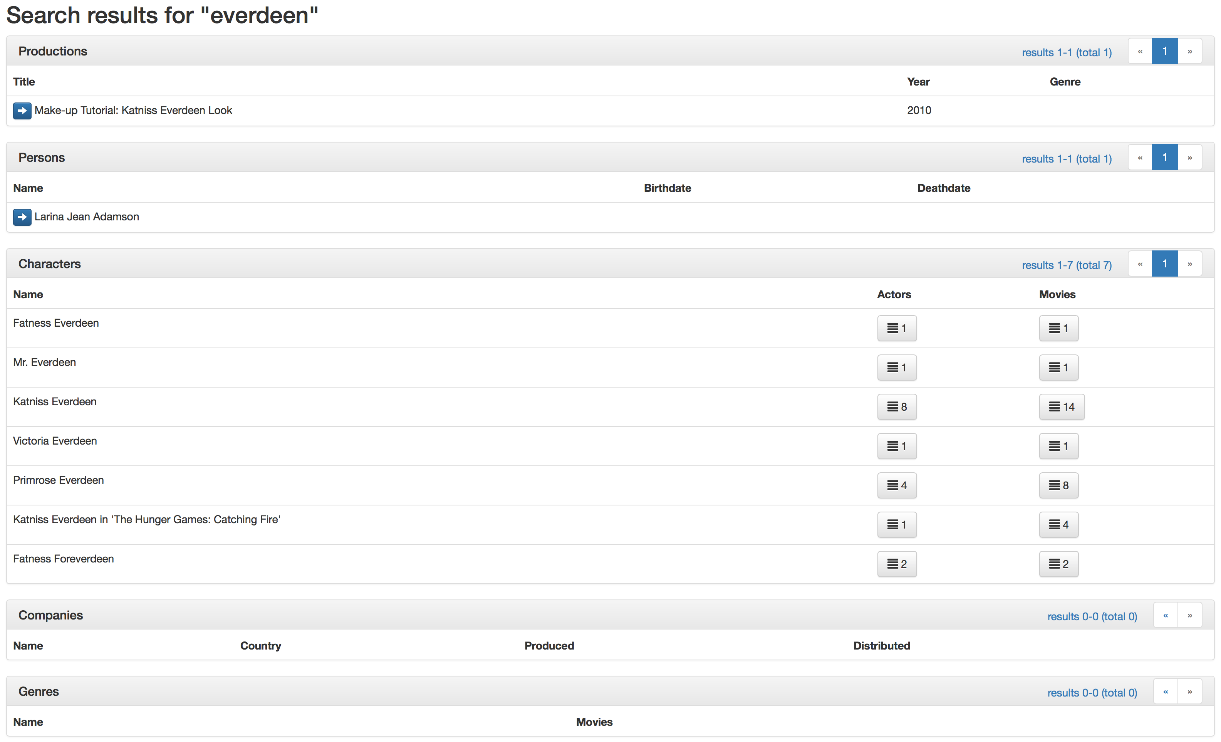

*A result screen sample for “everdeen"*

Each of the 5 result sections is an AJAX-loaded data array, linked to the corresponding primary search query.

In the case of an advanced search, only sections that are checked on the advanced form will be displayed on the result page and thus loaded by AJAX queries.

In the characters, companies and genres result arrays, grey buttons with counts (for actors and movies, in the case of characters as shown on above picture) are calling secondary search queries and loading the result in the modal window.

In the persons, productions and companies result arrays, blue buttons with arrows are redirecting to the main pages for these elements.

## Main pages

The application offers main pages for viewing the details of productions, persons and companies. Other entities don’t have dedicated main pages because the search functionality’s various modal windows are sufficient to accessing all their details efficiently and conveniently.

### Person’s main page

The following picture presents the main page of a person.

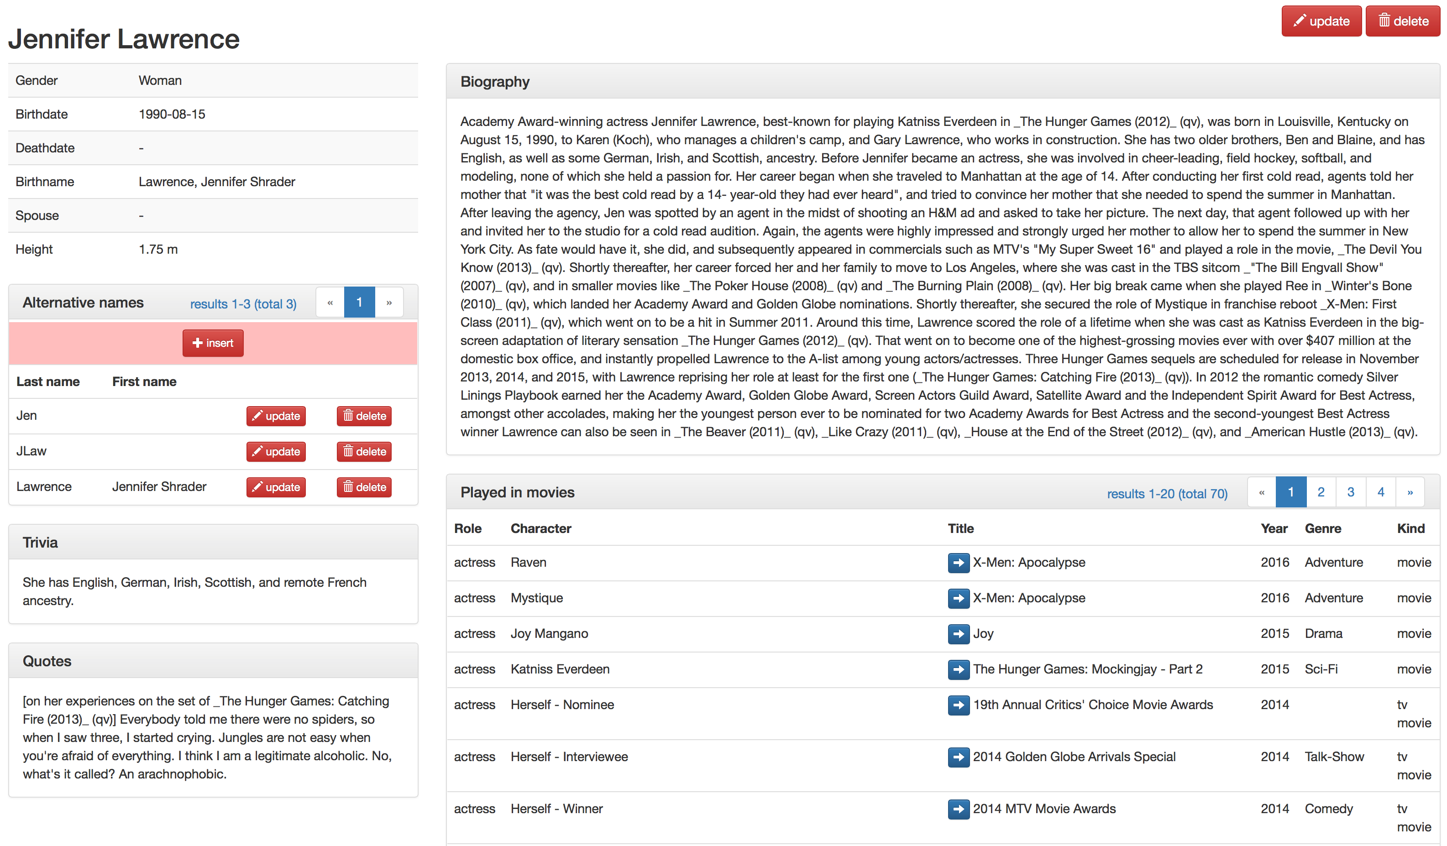

*Jennifer Lawrence’s main page, truncated vertically*

The above picture is truncated for practical reasons. The “Played in movies” is 20 elements long, with pagination visible in the upper right corner. A similar list, with the explicit title “Played in series” is present just below it, thus clearly separating these 2 kinds of elements. Episodes are implicitly included in the series, with modal windows to accessing corresponding lists.

The “Played in movies”, “Played in series” and “Alternative names” lists are AJAX-loaded, thus speeding up the main page loading and apparition of the main elements (name, birthdate, etc…).

Queries used to load this page’s data are given in Appendix B [§8.2.1].

### Production’s main page

The following picture presents the main page of a production.

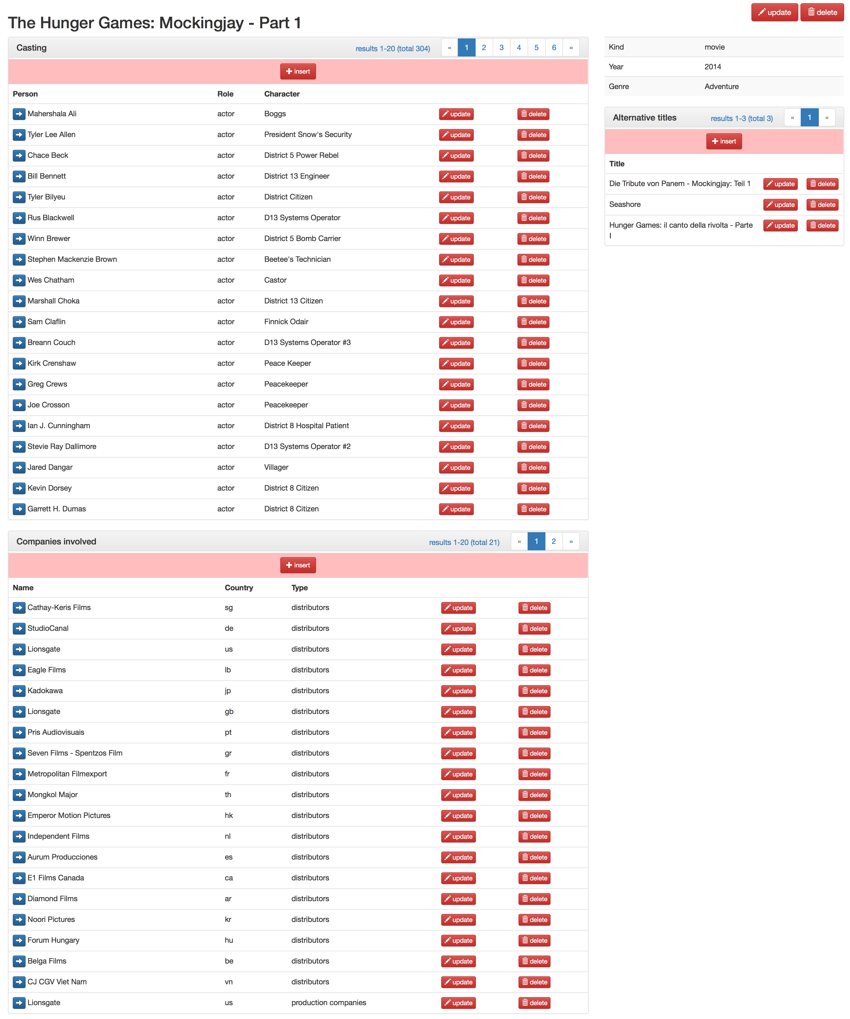

*The Hunger Game’s main page*

The “Casting”, “Companies involved” and “Alternative titles” data arrays are AJAX-loaded.

The above main page presents the graphical configuration of a singleproduction kind of production. In the case of an episode, the corresponding serie’s name, season and episode numbers would appear in the upper right general infos tab. In the case of a serie, a fourth AJAX-loaded list is added, with the list of seasons and buttons to load using AJAX the lists of episodes in a season in the modal window.

Queries used to load this page’s data are given in Appendix B [§8.2.2].

### Company’s main page

The following picture presents the main page of a company.

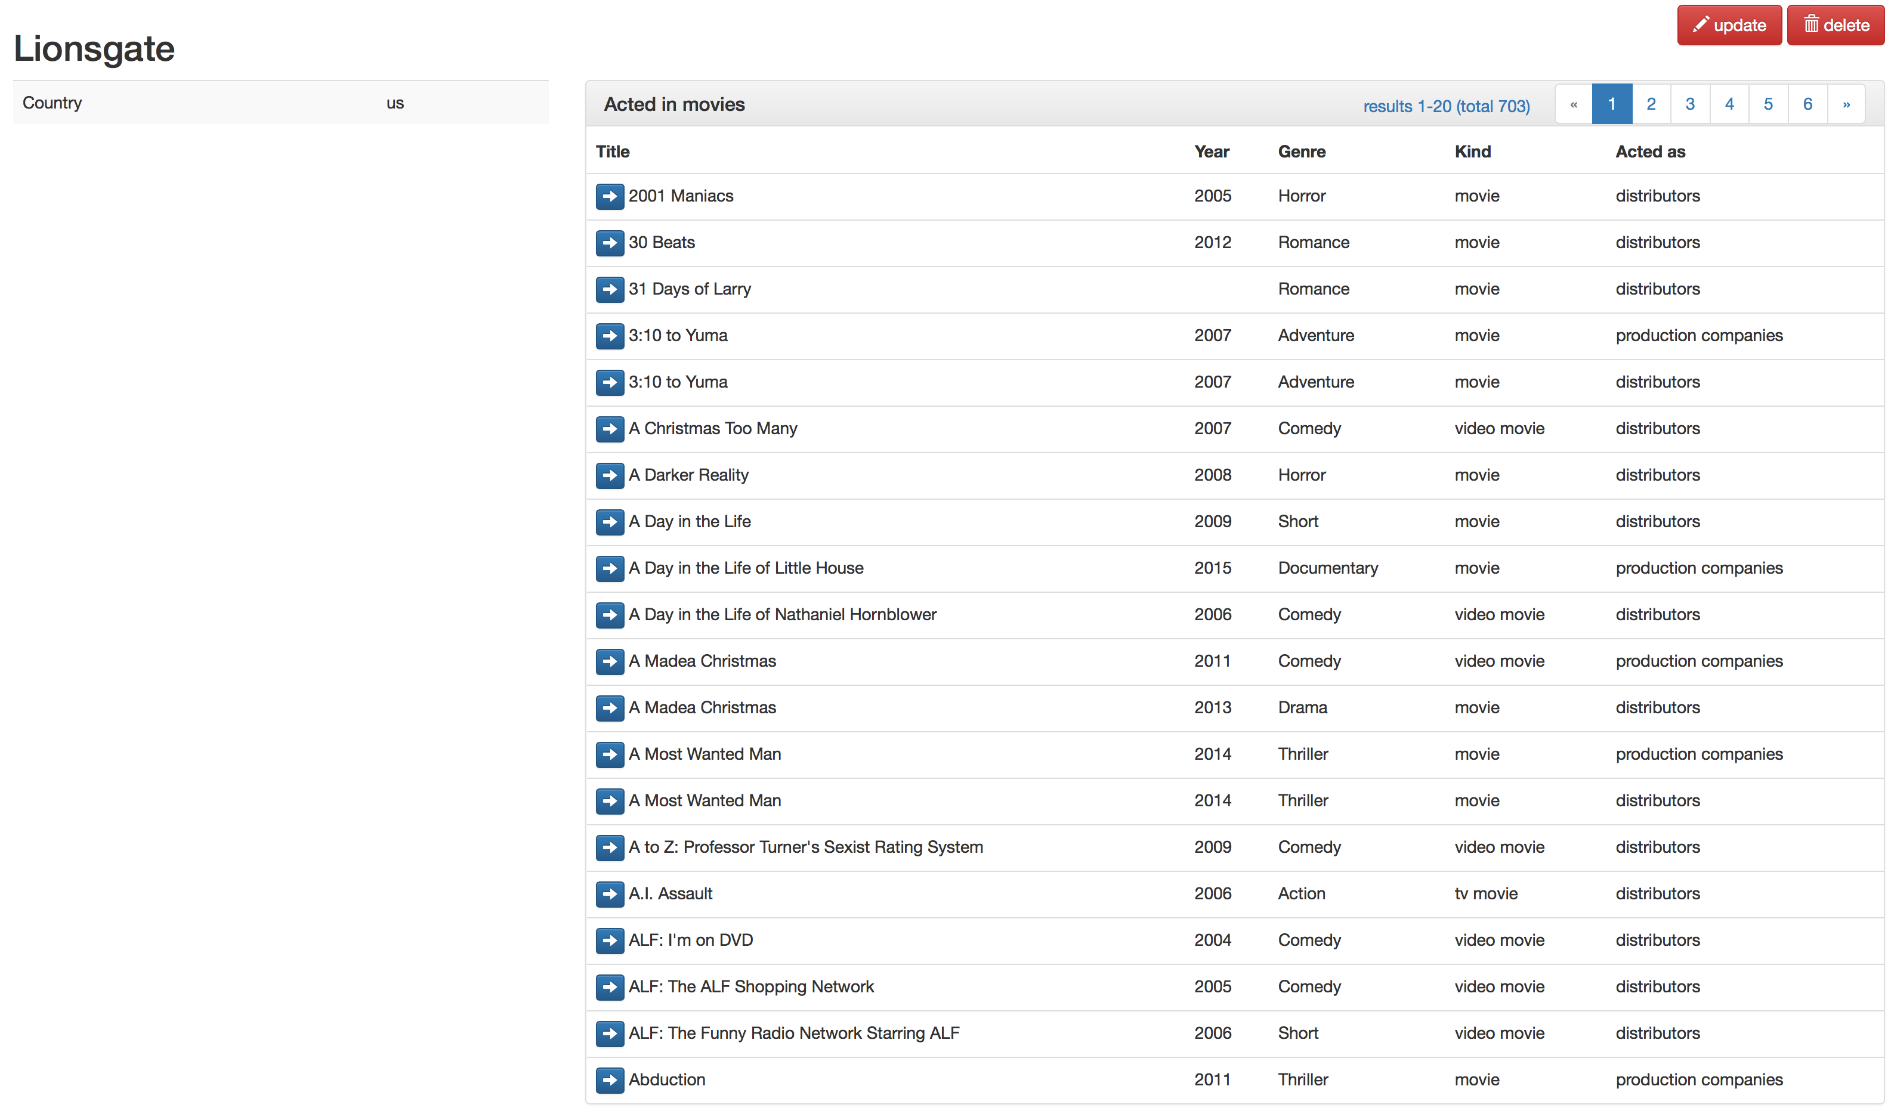

*Lionsgate main page, vertically truncated*

The above picture is truncated for practical reasons. The “Acted in movies” is 20 elements long, with pagination visible in the upper right corner. A similar list, with the explicit title “Acted in series” is present just below it, thus clearly separating these 2 kinds of elements. Episodes are implicitly included in the series, with modal windows to accessing corresponding lists.

The “Acted in movies” and “Acted in series” data arrays are AJAX-loaded.

Queries used to load this page’s data are given in Appendix B [§].

## Inserting, updating and deleting entities

In this chapter, we present the data management functionalities offered by the application. Full SQL queries are not given, mainly to save place on this document, but also because they are highly repeating and simple. Instead, we describe the procedures followed by application to insert complex things, including coherence verifications and error management.

Before any insertion is possible, we have to take a look to primary keys fields of the whole database. In chapter [§3.2.3] we discussed about the necessity of some primary keys to not be auto incremented during import phase, due to the fact that keys were already present in the CSV files.

Here is given the status of each primary key field in the database.

|  |  |
| --- | --- |
| Table.field | Status |
| casting.id | Already has AUTO_INCREMENT |
| character.id | Need to be defined as AUTO_INCREMENT |
| company.id | Need to be defined as AUTO_INCREMENT |
| country.id | Already has AUTO_INCREMENT |
| episode.id | Do not need AUTO_INCREMENT, references production.id (ISA) |
| gender.id | Already has AUTO_INCREMENT |
| kind.id | Already has AUTO_INCREMENT |
| name.id | Already has AUTO_INCREMENT |
| person.id | Need to be defined as AUTO_INCREMENT |
| production.id | Need to be defined as AUTO_INCREMENT |
| productioncompany.id | Need to be defined as AUTO_INCREMENT |
| role.id | Already has AUTO_INCREMENT |
| season.id | Already has AUTO_INCREMENT |
| serie.id | Do not need AUTO_INCREMENT, references production.id (ISA) |
| singleproduction.id | Do not need AUTO_INCREMENT, references production.id (ISA) |
| title.id | Already has AUTO_INCREMENT |
| type.id | Already has AUTO_INCREMENT |

The following script was used to apply changes on the database.

SET FOREIGN_KEY_CHECKS=0;

ALTER TABLE `character` CHANGE COLUMN `id` `id` INT UNSIGNED AUTO_INCREMENT;

ALTER TABLE `company` CHANGE COLUMN `id` `id` INT UNSIGNED AUTO_INCREMENT;

ALTER TABLE `person` CHANGE COLUMN `id` `id` INT UNSIGNED AUTO_INCREMENT;

ALTER TABLE `production` CHANGE COLUMN `id` `id` INT UNSIGNED AUTO_INCREMENT;

ALTER TABLE `productioncompany` CHANGE COLUMN `id` `id` INT UNSIGNED AUTO_INCREMENT;

SET FOREIGN_KEY_CHECKS=1;

The above script has to be run only as is when all data have been imported from the CSV files. Having these changes made on the original database before importing CSV files can lead to error, bad ID references and broken foreign keys.

### Persons

The persons have a statistics page, from which it is possible to insert a new person.

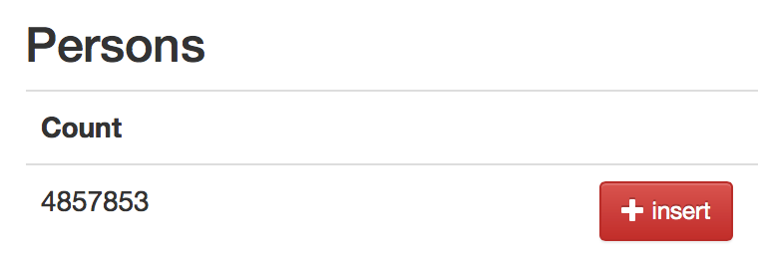

*Statistics page for the persons, with the insert button*

When inserting a person, a form is presented to the user to fill in the data.

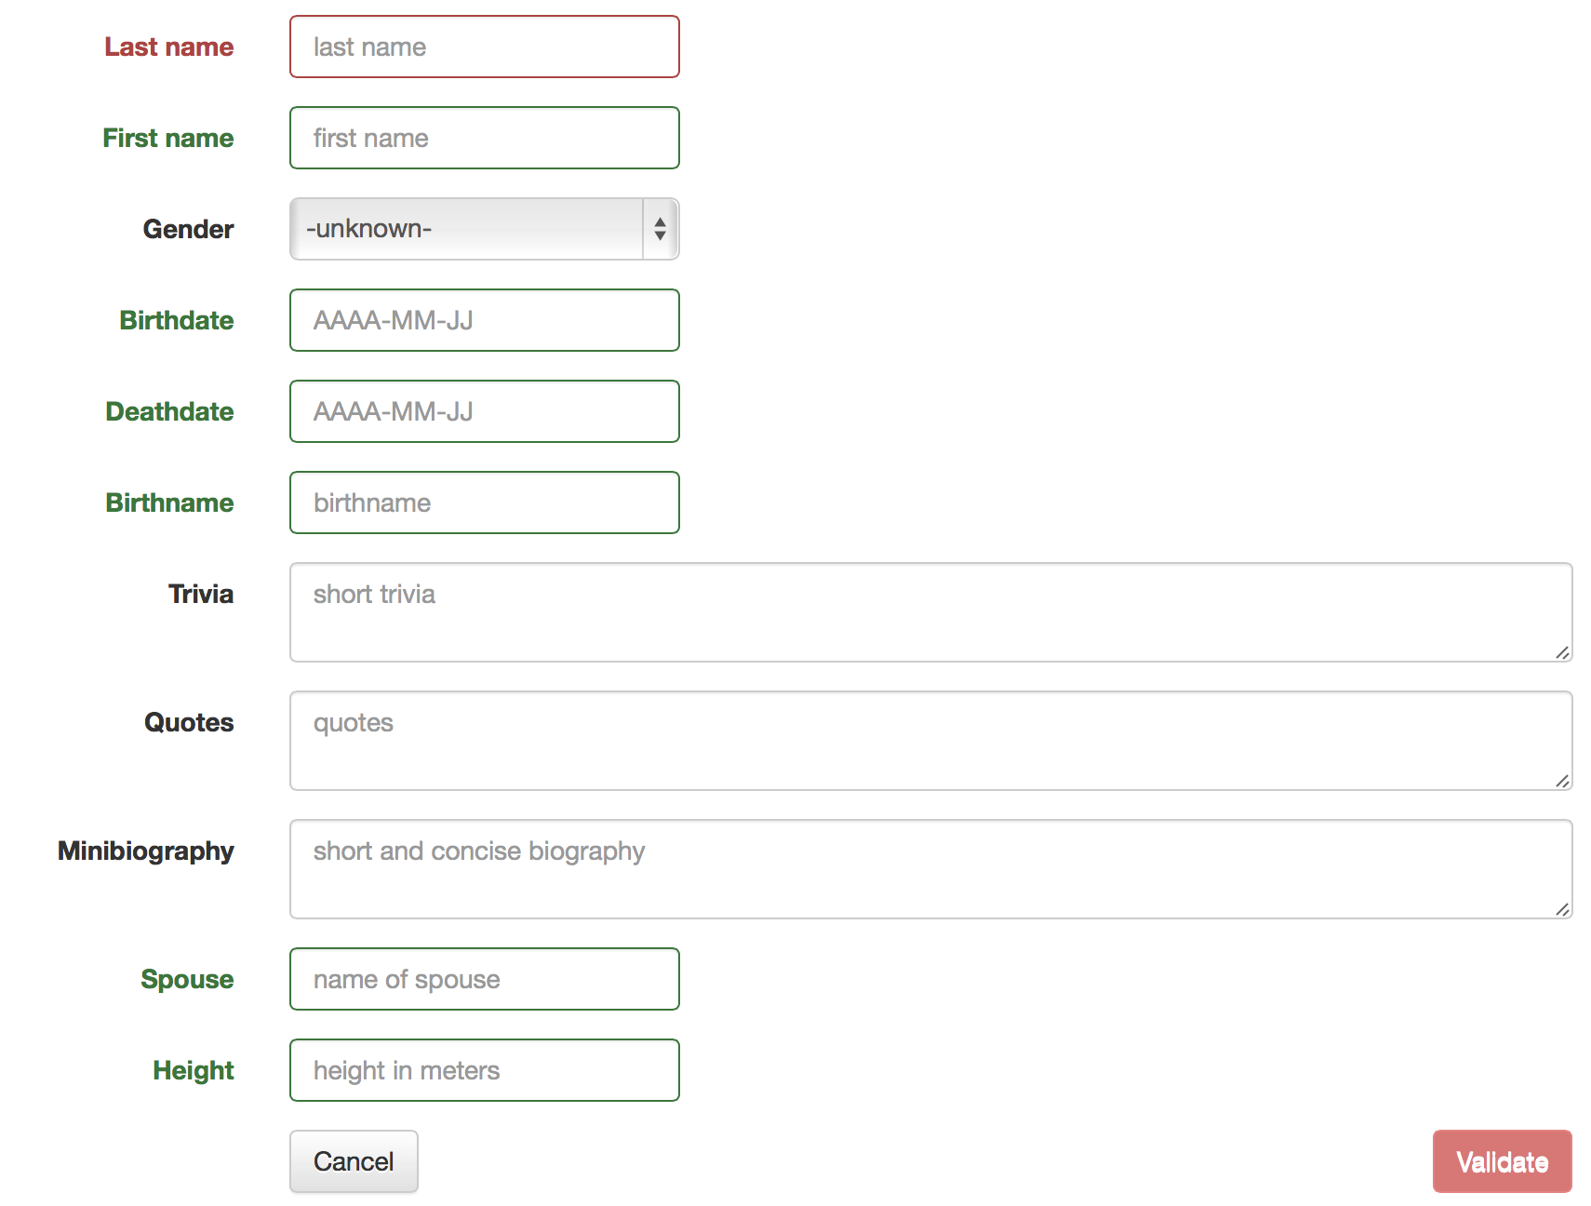

*Form for filling in a person’s details*

The update button is located in the upper right corner of the person’s main page. The form used for this update is exactly the same as the one used for the insertion. Fields are automatically populated by the ILARIA framework, using basic SELECT queries.

The delete button is located in the upper right corner of the person’s main page. It shows a modal window asking for the user to confirm what he wants to do.

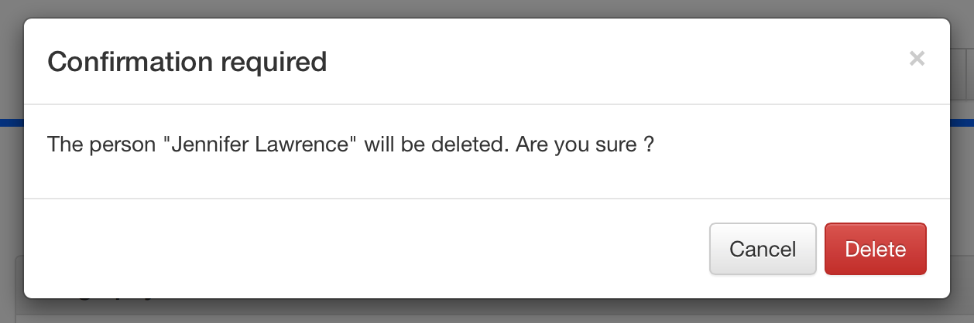

*Modal window asking for confirmation when trying to delete a person*

The insertion, update and deletion procedures can be found in Appendix B [§8.3.1].

### Alternative names

When located on a person’s main page, it is possible to manage the alternative names of this person.

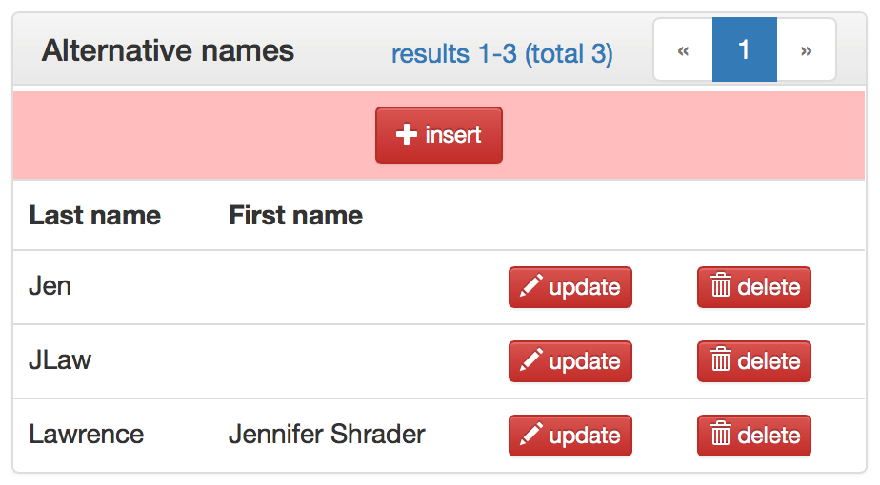

*The alternative names list on the Jennifer Lawrence’s main page*

When inserting an alternative name, a form is presented to the user to fill in data.

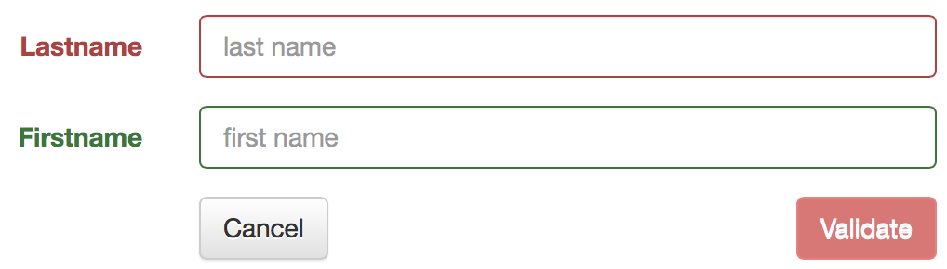

*Form for filling in an alternative name*

The form used for this update is exactly the same as the one used for the insertion. Fields are automatically populated by the ILARIA framework, using basic SELECT queries.

A modal window is used to ask for user confirmation.

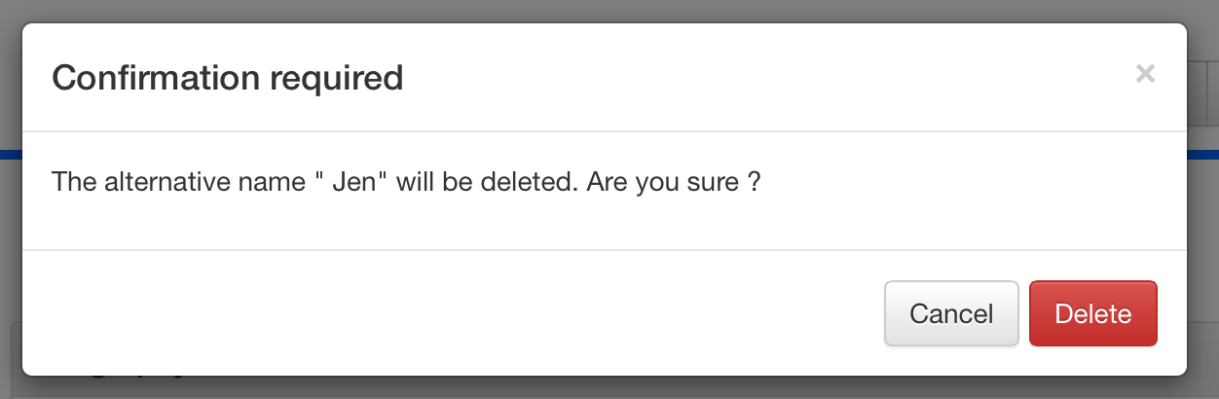

*Modal window asking for confirmation when trying to delete an alternative name*

The insertion, update and deletion procedures can be found in Appendix B [§8.3.2].

### Productions

The productions have a statistics page, from which it is possible to insert a new singleproduction or serie.

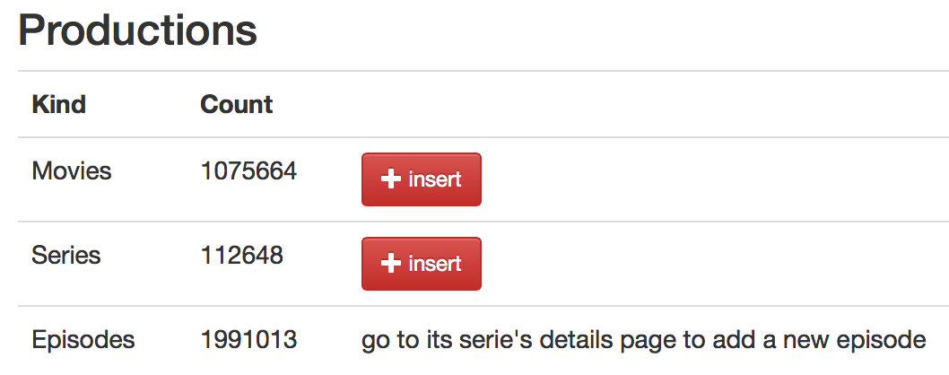

*Statistics page for the production, with the insert buttons for singleproductions (movies) and series*

When inserting a movie (singleproduction), the following form is presented to the user to fill in data.

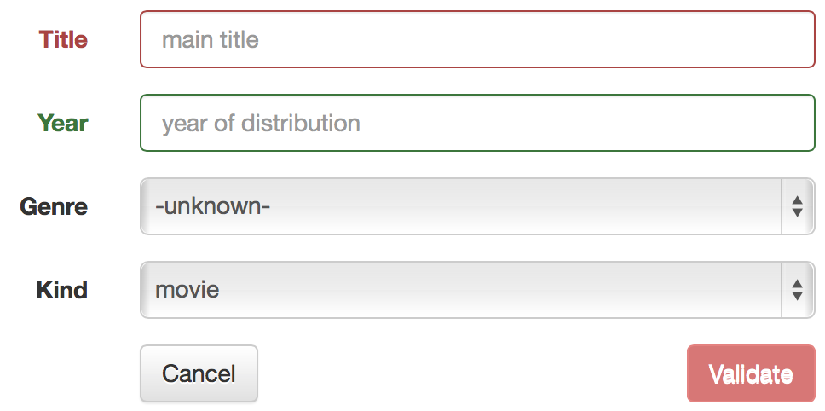

*Form for filling in the basic details of a singleproduction*

When inserting a serie, the following form is presented to the user to fill in data.

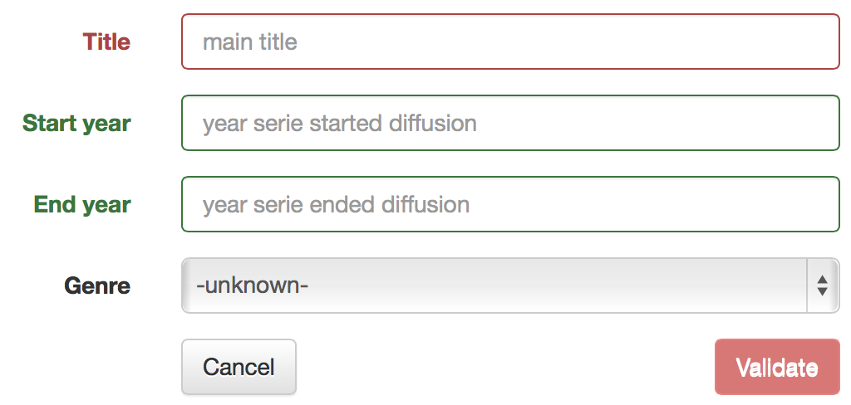

*Form for filling in the basic details of a serie*

The insertion button for an episode is located in the upper right corner of the serie main page. Thus, this inserts an episode in a pre-chosen serie. The following form is presented to the user to fill in data.

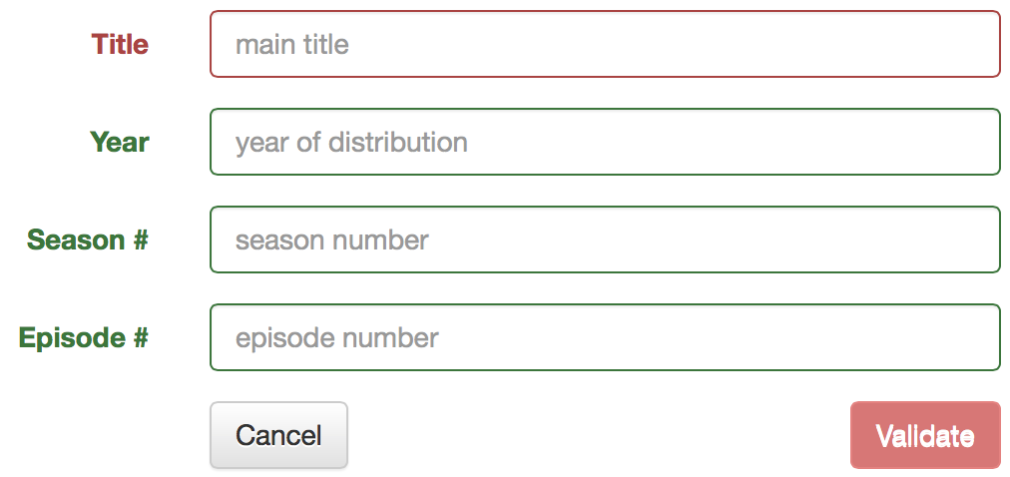

*Form for filling in the basic details of an episode*

The update button is located in the upper right corner of the production’s main page. The form used for this update is exactly the same as the one used for the insertion of the corresponding kind of production (movie, serie or episode). Fields are automatically populated by the ILARIA framework, using basic SELECT queries.

The delete button is located in the upper right corner of the production’s main page. It shows a modal window asking for the user to confirm what he wants to do.

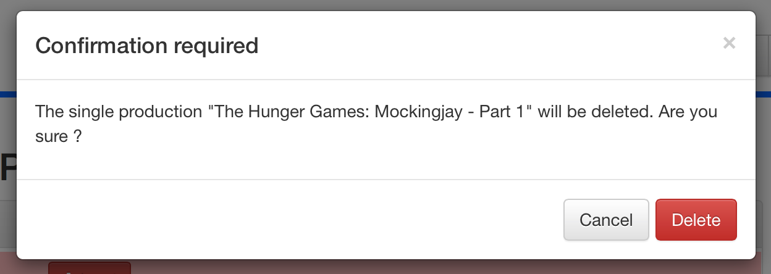

*Modal window asking for confirmation when trying to delete a singleproduction*

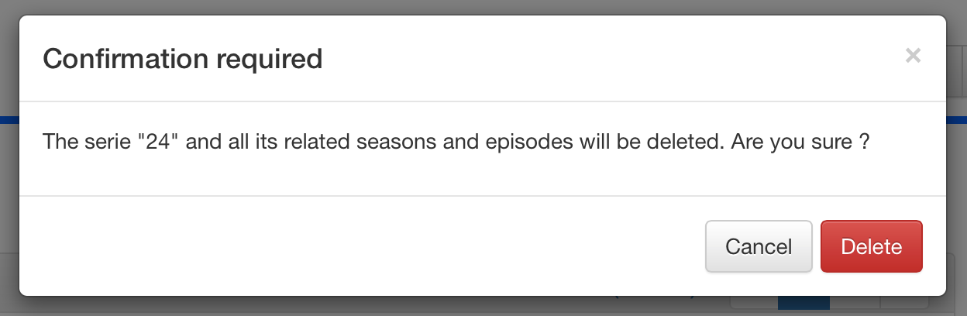

*Modal window asking for confirmation when trying to delete a serie*

The insertion, update and deletion procedures can be found in Appendix B [§8.3.3].

### Alternative titles

When located on a production’s main page, it is possible to manage the alternative titles of this production.

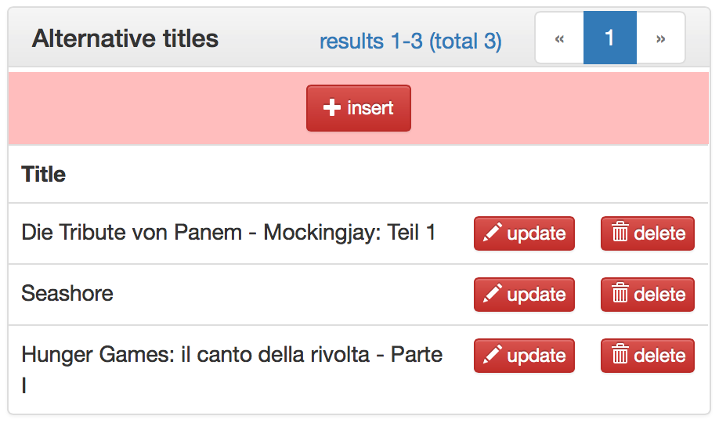

*The alternative titles list on the Hunger Games Mockingjay main page*

When inserting an alternative title, a form is presented to the user to fill in data.

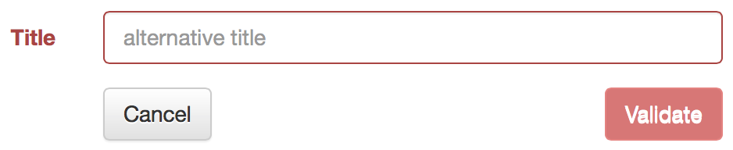

*Form for filling in an alternative title*

The form used for this update is exactly the same as the one used for the insertion. Fields are automatically populated by the ILARIA framework, using basic SELECT queries.

A modal window is used to ask for user confirmation.

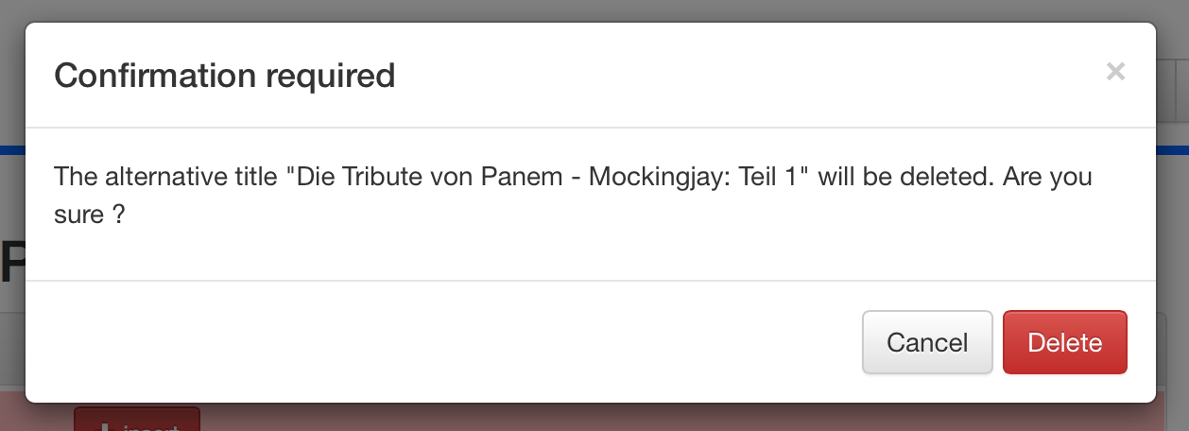

*Modal window asking for confirmation when trying to delete an alternative title*

The insertion, update and deletion procedures can be found in Appendix B [§8.3.4].

### Casting

When located on a production’s main page, it is possible to manage the casting of this production.

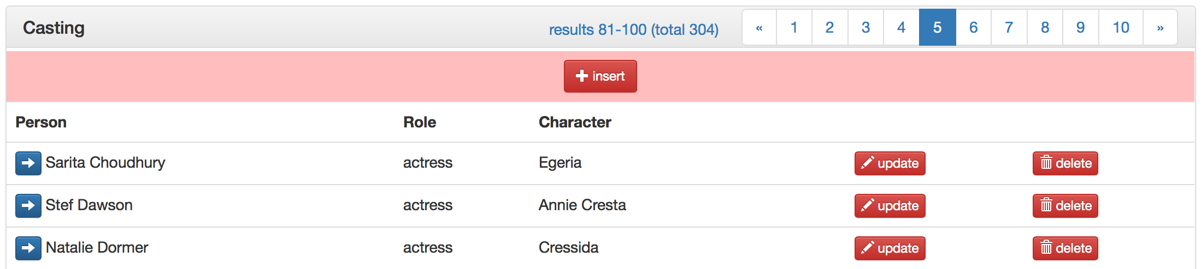

*A part of the casting array on the Hunger Games Mockingjay main page*

When inserting a casting record, a form is presented to the user to fill in data.

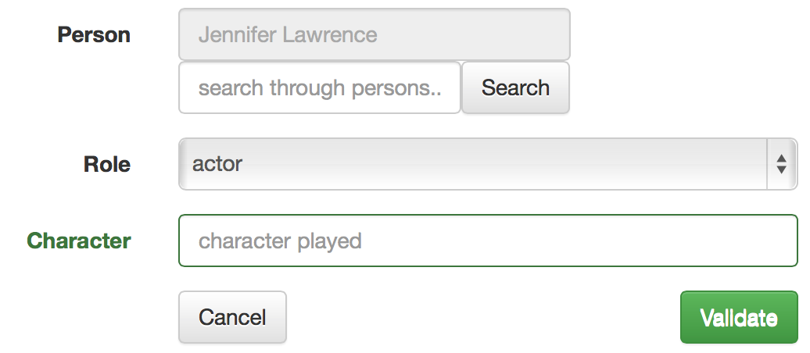

*Form for filling in a casting record*

The field “Person” is special. The upper read-only box indicates the currently selected person (here Jennifer Lawrence). The “search through persons…” box and its “Search” button are used to search another person for this role, and triggers a modal windows to present results.

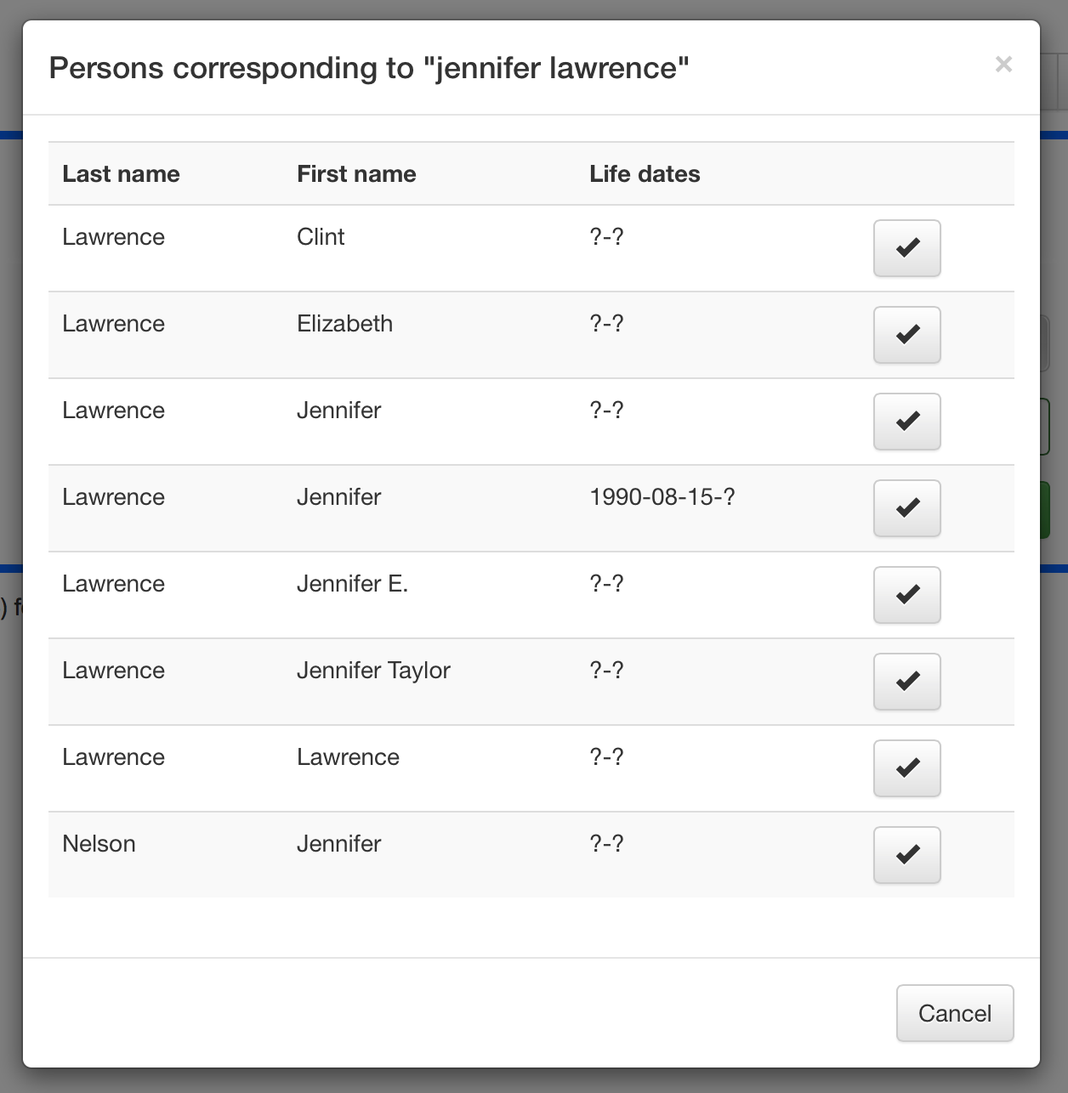

*Modal window showing persons corresponding to “jennifer lawrence"*

When clicking on a  button in this modal window, the corresponding person is loaded in the form and the modal window is closed. This globally works like an intelligent drop-down menu.

The form used for this update is exactly the same as the one used for the insertion. Fields are automatically populated by the ILARIA framework, using basic SELECT queries.

A modal window is used to ask for user confirmation.

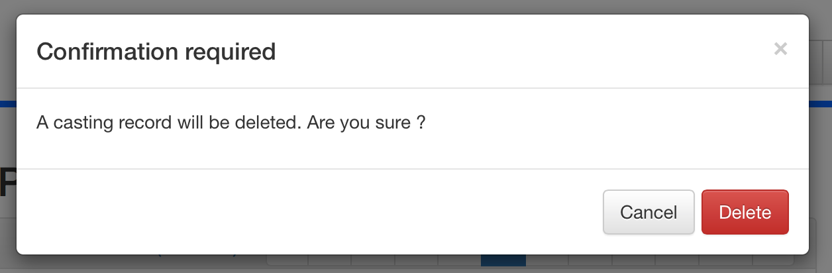

*Modal window asking for confirmation when trying to delete a casting record*

The insertion, update and deletion procedures can be found in Appendix B [§8.3.5].

### Companies involved in a production

When located on a production’s main page, it is possible to manage the companies involved in this production.

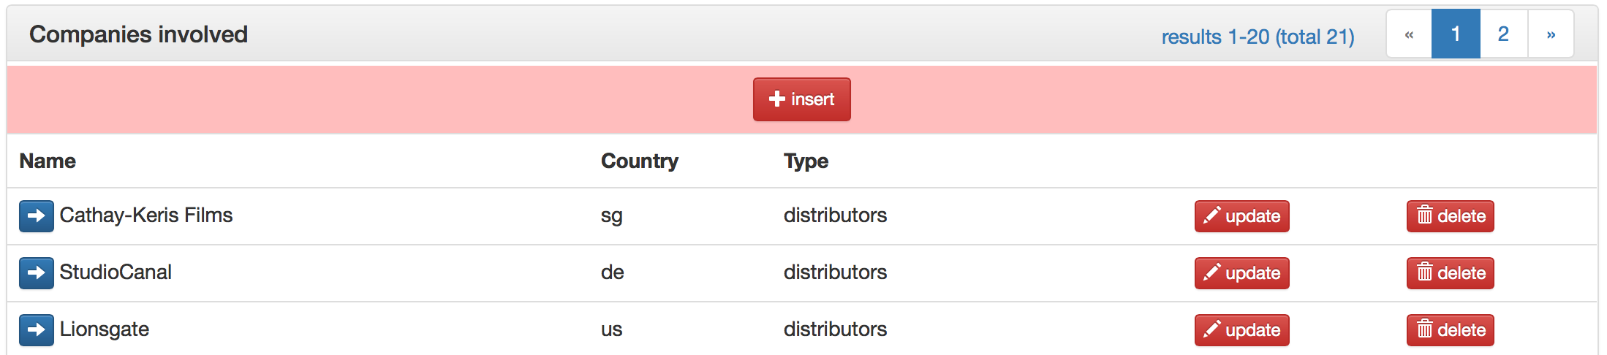

*A part of the companies array on the Hunger Games Mockingjay main page*

When inserting a productioncompany record, a form is presented to the user to fill in data.

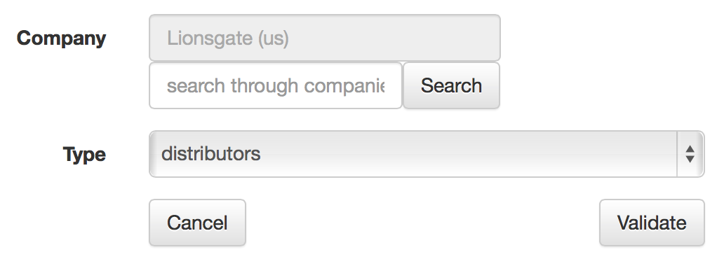

*Form for filling in a productioncompany record*

The field “Company” is special. The upper read-only box indicates the currently selected company (here Lionsgate located in the United States). The “search through companies…” box and its “Search” button are used to search another company, and triggers a modal windows to present results.

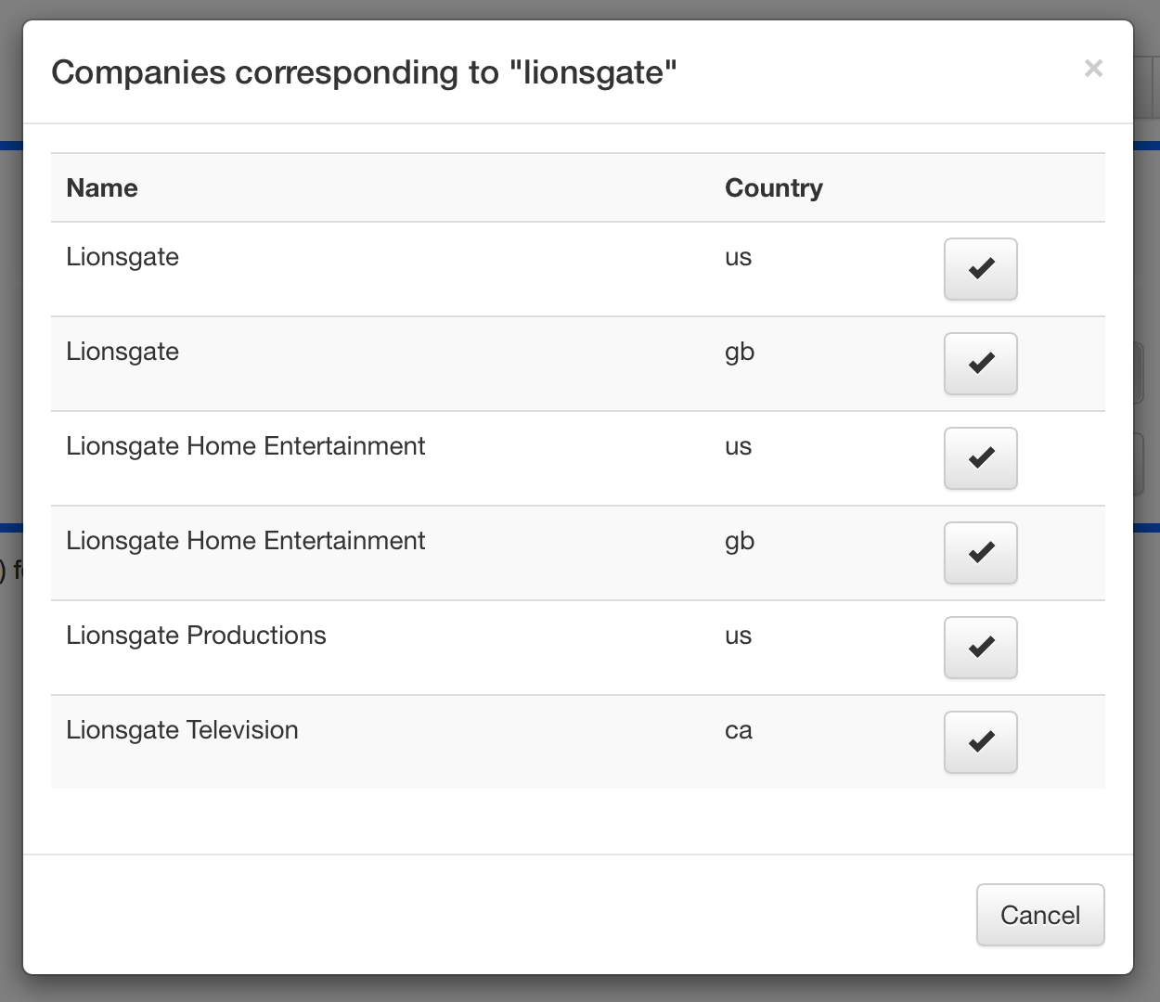

*Modal window showing companies corresponding to “lionsgate"*

When clicking on a  button in this modal window, the corresponding company is loaded in the form and the modal window is closed. This globally works like an intelligent drop-down menu.

The form used for this update is exactly the same as the one used for the insertion. Fields are automatically populated by the ILARIA framework, using basic SELECT queries.

A modal window is used to ask for user confirmation.

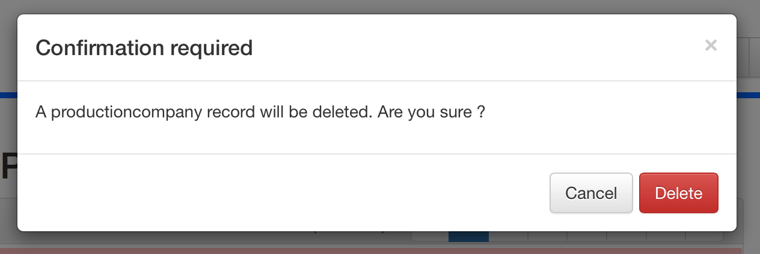

*Modal window asking for confirmation when trying to delete a productioncompany record*

The insertion, update and deletion procedures can be found in Appendix B [§8.3.6].

### Companies

The companies have a statistics page, from which it is possible to insert a new company.

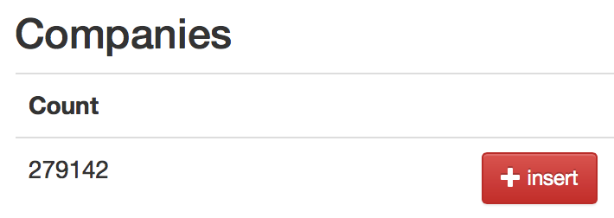

*Statistics page for the companies, with the insert button*

When inserting a company, a form is presented to the user to fill in the data.

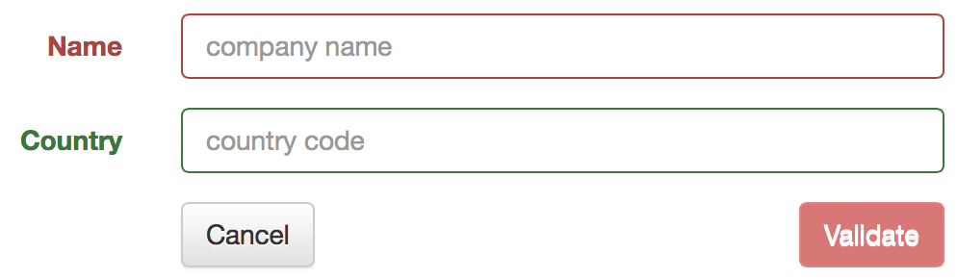

*Form for filling in a company’s details*

The update button is located in the upper right corner of the company’s main page. The form used for this update is exactly the same as the one used for the insertion. Fields are automatically populated by the ILARIA framework, using basic SELECT queries.

The delete button is located in the upper right corner of the company’s main page. It shows a modal window asking for the user to confirm what he wants to do.

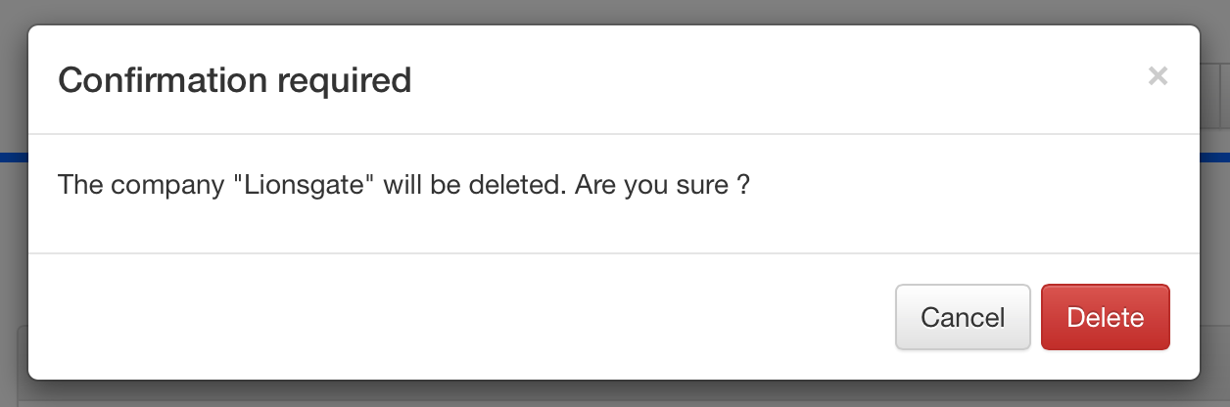

*Modal window asking for confirmation when trying to delete a company*

The insertion, update and deletion procedure can be found in Appendix B [§8.3.7].

### Miscellaneous

A specific page is dedicated to the management of miscellaneous entities : roles, genres, types and kinds.

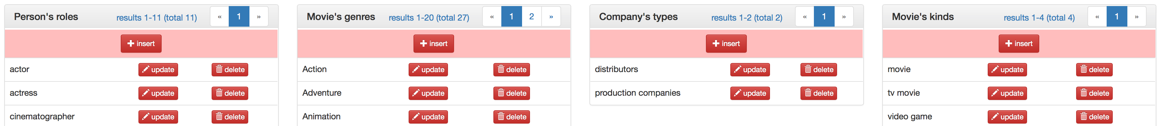

*Management page for miscellaneous entities*

As the corresponding forms are very simple (always one single field to fill in), the details are not shown here. It is basically forbidden by the database itself (“ON DELETE RESTRICT” constraints) to delete one of these miscellaneous entities record when it is used by other records. Application will show a modal deny message when trying to do so.

# Simple queries (milestone 2)

In this chapter, we present the SQL queries developed for the second milestone (called “simple querie”).

## SQL code

Here are the SQL codes for the simple queries.

### Query (a)

Original assignment was as follows.

*“Compute the number of movies per year. Make sure to include tv and video movies”*

Here is the corresponding SQL query we developed.

SELECT P.`year`, COUNT(P.`id`)

FROM `production` P

INNER JOIN `singleproduction` S ON P.`id` = S.`id`

WHERE S.`kind_id` IN (

SELECT K.`id`

FROM `kind` K

WHERE K.`name` IN ("tv movie","video movie","movie")

)

GROUP BY P.`year`;

### Query (b)

Original assignment was as follows.

*“Compute the ten countries with most production companies”*

Here is the corresponding SQL query we developed.

SELECT COU.`id`, COU.`code`, SUB.`number`

FROM (

SELECT COM.`country_id`, COUNT(DISTINCT COM.`id`) AS `number`

FROM `company` COM

INNER JOIN (

SELECT PC.`company_id`

FROM `productioncompany` PC

INNER JOIN `type` TY ON PC.`type_id` = TY.`id`

WHERE TY.`name` = "production companies"

) PC ON PC.`company_id` = COM.`id`

GROUP BY COM.`country_id`

HAVING COM.`country_id` IS NOT NULL

ORDER BY `number` DESC

LIMIT 10

) SUB

INNER JOIN `country` COU ON SUB.`country_id` = COU.`id`;

### Query (c)

Original assignment was as follows.

*“Compute the min, max and average career duration”*

We developed an all-in-one SQL query that used to work but was too slow (about 6-8 minutes on a modern laptop).

SELECT MIN(T.`careerDuration`) AS `min`, MAX(T.`careerDuration`) AS `max`,

AVG(T.`careerDuration`) AS `avg`

FROM (

SELECT (MAX(P.`year`) - MIN(P.`year`)) AS `careerDuration`

FROM (

SELECT DISTINCT C.`person_id`, C.`production_id`

FROM `casting` C

) C

INNER JOIN (

SELECT P.`id`, P.`year`

FROM `production` P

WHERE P.`year` IS NOT NULL

) P ON C.`production_id` = P.`id`

GROUP BY C.`person_id`

) T;

To improve performances, we chosed to design and exploit a materialized view. The following code is used to create the table.

CREATE TABLE m2c_careerduration (

person_id INT UNSIGNED,

careerDuration INT UNSIGNED,

PRIMARY KEY (`person_id`)

);

The following code is used to create the procedure that update this table.

DELIMITER $$

CREATE PROCEDURE refresh_m2c_careerduration ()

BEGIN

TRUNCATE TABLE m2c_careerduration;

INSERT INTO m2c_careerduration (`person_id`, `careerDuration`)

SELECT C.`person_id`, (MAX(P.`year`) - MIN(P.`year`)) AS `careerDuration`

FROM (

SELECT DISTINCT C.`person_id`, C.`production_id`

FROM `casting` C

) C

INNER JOIN (

SELECT P.`id`, P.`year`

FROM `production` P

WHERE P.`year` IS NOT NULL

) P ON C.`production_id` = P.`id`

GROUP BY C.`person_id`;

END;

$$

DELIMITER ;

Then, the following call has to be made every time we want the materialized view to be updated.

CALL refresh_m2c_careerduration;

Finally, here is the SQL query that has to be launched, and run in very little time (couple of seconds), when we want to obtain data.

SELECT MIN(T.`careerDuration`) AS `min`, MAX(T.`careerDuration`) AS `max`,

AVG(T.`careerDuration`) AS `avg`

FROM m2c_careerduration T;

### Query (d)

Original assignment was as follow.

*“Compute the min, max and average number of actors in a production”*

We developed an all-in-one SQL query that used to work but was too slow (about 2-3 minutes on a modern laptop).

SELECT MIN(T.`number`) AS `min`, MAX(T.`number`) AS `max`, AVG(T.`number`) AS `avg`

FROM (

SELECT COUNT(C.`id`) AS `number`

FROM `casting` C

INNER JOIN `role` R ON C.`role_id` = R.`id`

WHERE R.`name` = "actor"

GROUP BY C.`production_id`

) T;

To improve performances, we chosed to design and exploit a materialized view. The following code is used to create the table.

CREATE TABLE m2d_nbactorproduction (

production_id INT UNSIGNED,

nb_actor INT UNSIGNED,

PRIMARY KEY (`production_id`)

);

The following code is used to create the procedure that update this table.

DELIMITER $$

CREATE PROCEDURE refresh_m2d_nbactorproduction ()

BEGIN

TRUNCATE TABLE m2d_nbactorproduction;

INSERT INTO m2d_nbactorproduction (`production_id`, `nb_actor`)

SELECT C.`production_id`, COUNT(C.`id`) AS `number`

FROM `casting` C

INNER JOIN `role` R ON C.`role_id` = R.`id`

WHERE R.`name` = "actor"

GROUP BY C.`production_id`;

END;

$$

DELIMITER ;

Then, the following call has to be made every time we want the materialized view to be updated.

CALL refresh_m2d_ nbactorproduction;

Finally, here is the SQL query that has to be launched, and run in very little time (couple of seconds), when we want to obtain data.

SELECT MIN(T.`nb_actor`) AS `min`, MAX(T.`nb_actor`) AS `max`, AVG(T.`nb_actor`) AS `avg`

FROM m2d_nbactorproduction T;

### Query (e)

Original assignment was as follow.

*“Compute the min,max and average height of female persons”*

Here is the corresponding SQL query we developed.

SELECT MIN(P.`height`) AS `min`, MAX(P.`height`) AS `max`, AVG(P.`height`) AS `avg`

FROM `person` P

WHERE P.`height` IS NOT NULL

AND P.`gender` = "f";

### Query (f)

Original assignment was as follow.

*“List all pairs of persons and movies where the person has both directed the movie and acted in the movie. Do not include tv and video movies.”*

Here is the corresponding SQL query we developed.

SELECT DISTINCT C.person_id, C.production_id

FROM `casting` C

WHERE EXISTS

(

SELECT CC.id

FROM `casting` CC

INNER JOIN `role` R

ON CC.role_id = R.id

WHERE CC.person_id = C.person_id

AND CC.production_id = C.production_id

AND R.name = "director"

AND EXISTS

(

SELECT CC.id

FROM `casting` CC

INNER JOIN `role` R

ON CC.role_id = R.id

INNER JOIN `singleproduction` S

ON CC.production_id = S.id

INNER JOIN `kind` K ON S.`kind_id` = K.`id`

WHERE K.`name` = "movie"

AND CC.person_id = C.person_id

AND CC.production_id = C.production_id

AND R.name = "actor"

)

);

### Query (g)

Original assignment was as follow.

*“List the three most popular character names”*

Here is the corresponding SQL query we developed.

SELECT CH.`name`

FROM (

SELECT CA.`character_id`, COUNT(CA.`id`) AS `number`

FROM `casting` CA

WHERE CA.`character_id` IS NOT NULL

GROUP BY CA.`character_id`

ORDER BY `number` DESC

LIMIT 0,3

) T

INNER JOIN `character` CH ON T.`character_id` = CH.`id`;

## Application dedicated page

The web application offers a complete page dedicated to the execution and the results visualization of these 7 simple queries.

### Launch page

The launch page gives the original assignment linked to each query, and a button to launch it.

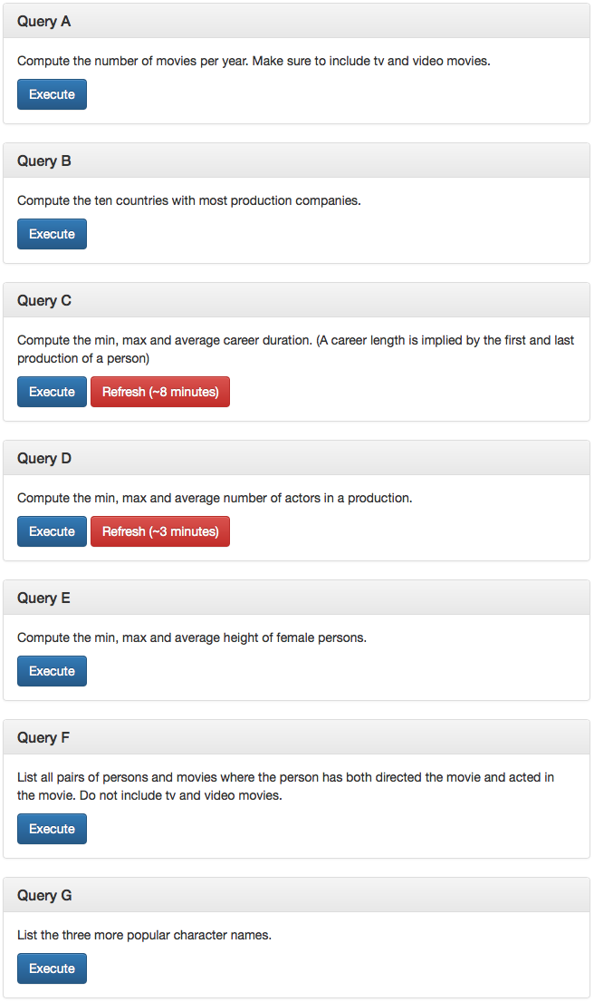

*Launch page for the simple queries of milestone 2*

### Queries results

The queries execution is asynchronous, using AJAX call to fill data arrays similar to those used in other parts of application (see [§5.1.1]).

The execution of query A leads to a result array with the following appearance.

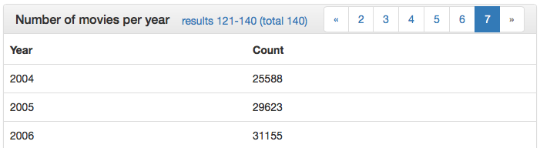

*Results array for the simple query A*

The execution of query B leads to a result array with the following appearance.

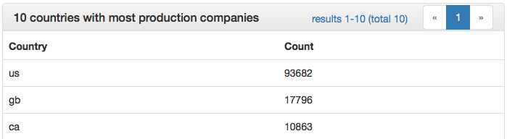

*Results array for the simple query B*

The execution of query C leads to a result array with the following appearance.

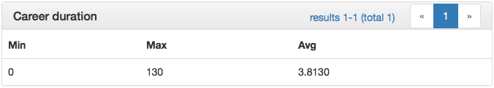

*Results array for the simple query C*

The execution of query D leads to a result array with the following appearance.

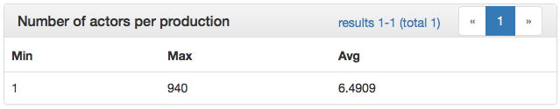

*Results array for the simple query D*

The execution of query E leads to a result array with the following appearance.

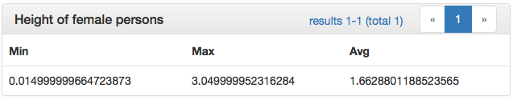

*Results array for the simple query E*

The execution of query F leads to a result array with the following appearance.

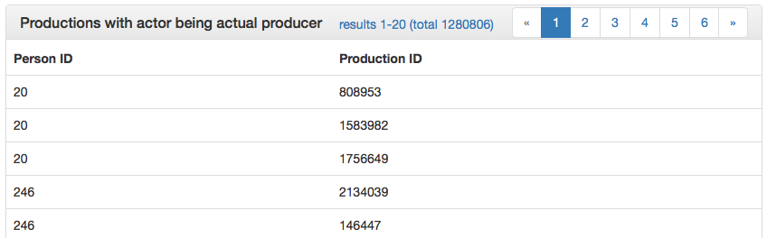

*Results array for the simple query F*

The execution of query G leads to a result array with the following appearance.

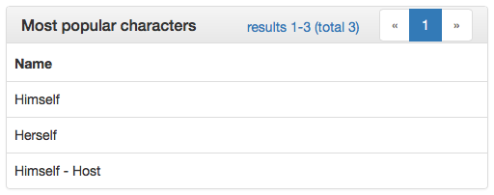

*Results array for the simple query G*

# Appendix A – Data import detailed report

This appendix presents complete information about the work we did to import CSV files into the database.

## Imported files

Each of the following chapter details the importation of a particular CSV file, the general ideas implemented in the corresponding PHP scripts, and the results obtained after the importation (number of imported rows, essential warnings, etc…).

Each script is build such that all lines subject to an error of parsing or data format during the import is written back in a separate CSV file. By doing this, only the failing lines of an import attempt have to be imported again after the errors have been corrected in the script.

### Persons

Persons are listed in the PERSONS.CSV file. For each row in this file, the script adds 2 records in database.

* A record is inserted in the table person, with all fields of CSV except the name.
* A record is inserted in the table name, representing the main name of the person. The ID of this record is generated by the AUTO_INCREMENT clause on this table.

Because the name and person tables are loop-linked by 2 foreign keys that cannot be NULL, we temporarily authorize the name_id attribute in table person to be NULL during the import, so we can import the person and set its name_id to NULL, then import the main name linked to the person, gather its ID and set it back as name_id in person. Instead of doing this, we could just have disabled the foreign keys check for the entire database, but it has the inconvenient that foreign keys values are not fully checked again when constraints are re-enabled.

Here is the numeric result of the first import attempt.

|  |  |  |  |
| --- | --- | --- | --- |
| Treated rows | Success | Success with warning | Errors |
| 4’857’852 | 4’857’845 | 0 | 7 |

The 7 errors have been identified as follows.

|  |  |  |
| --- | --- | --- |
| CSV line | ID | Manual operation |
| 819’536 | 824190 | removed (175 cm) from size |
| 2’571’426 | 2586222 | removed a space in birthdate between december and the year |
| 2’710’402 | 2726001 | replaced 1/2 by 0.5 in centimeters |
| 2’848’752 | 2865228 | rewritten 5'9 1/2 as 5' 9 1/2" |
| 3’068’990 | 3086716 | removed (160cm) from size |
| 3’708’910 | 3730653 | removed /98 in birthdate |
| 4’049’865 | 4073747 | replaced 6", 0' by 6' |

After being manually corrected, these 7 lines were successfully imported during the second attempt.

|  |  |  |  |
| --- | --- | --- | --- |
| Treated rows | Success | Success with warning | Errors |
| 7 | 7 | 0 | 0 |

### Alternative names

Alternative names of persons are listed in the ALTERNATIVE_NAME.CSV file. For each row in this file, the script adds 1 record in database.

* A record is inserted in the table name, representing the alternative name and directly linked to the person’s ID through the person_id field.

All rows were correctly imported at first attempt, with 10’109 duplicate entries that were deleted (some of them were colliding with another identical alternative name for the same person, others were colliding with their corresponding person’s main name).

|  |  |  |  |
| --- | --- | --- | --- |
| Treated rows | Success | Success with warning | Errors |
| 869’697 | 859’588 | 0 | 10’109 |

### Companies

Companies are listed in COMPANY.CSV file. For each row in this file, the script adds up to 2 records in database.

* If it doesn’t already exist due to previously imported companies, a record is inserted in the table country, representing the country in which the company is established.
* A record is inserted in the table company, representing the company.

All rows were correctly imported at first attempt, with no error nor warning ever.

|  |  |  |  |
| --- | --- | --- | --- |
| Treated rows | Success | Success with warning | Errors |
| 279’142 | 279’142 | 0 | 0 |

### Productions

Productions are listed in PRODUCTION.CSV file. For each row in this file, the script adds at least 3 records in database.

* A record is inserted in the table production, representing the parent element in the ISA hierarchy for productions.
* A record is inserted in one of the singleproduction, serie or episode table, depending on the kind of production, representing the child element in the ISA hierarchy.
* A record is inserted in the table title, representing the main title of the production.

In addition to this, records may be added in the following cases.

* When a row seems to be an alternative title for another episode (having same season and episode number in a given serie), it is not added like described above, but only generates a record in the table title, linked to the existing duplicate episode found as one of its alternative titles.
* When a singleproduction is added, a record may be added in the table kind if the corresponding kind does not already exist.
* When a production is added, a record may be added in the table gender if the corresponding gender does not already exist.
* When an episode is added, a record may be added in the table season if the corresponding season does not already exist in the given serie.

As for the persons import (see [§7.1.1]), the title_id field in the table production was temporarily NULL-authorized during the import operations.

Here is the result of the first import attempt.

|  |  |  |  |
| --- | --- | --- | --- |
| Treated rows | Success | Success with warning | Errors |
| 3’180’098 | 3’178’788 | 778 | 532 |

773 warning are generated for rows that generated an alternative title for an existing episode, as explained above. In addition to being added as alternative titles, these rows also generated an output line in a particular “duplicate ref” CSV file, to prevent other elements (productioncompany, casting) pointing to them from crashing when being imported. This CSV file thus contains association of their ID to the ID of episodes they are finally linked to as alternative titles.

The 5 remaining warnings are due to very long titles that have been truncated to 255 characters.

Despite investigation, no obvious reason was found for the 532 errors, so a second import attempt has been executed without changing anything to the script. During this second attempt, all these errors were eliminated. The final explanation is that they were episodes linked to series that appeared further in the CSV file, and were not already inserted during the first attempt.

|  |  |  |  |
| --- | --- | --- | --- |
| Treated rows | Success | Success with warning | Errors |
| 532 | 532 | 0 | 0 |

### Alternative titles

Alternative titles of productions are listed in the file ALTERNATIVE_TITLE.CSV. For each row in this file, the script adds 1 record in database.

* A record is added in the table title, representing the alternative title and directly linked to the production’s ID through the production_id field.

When importing a line, the script checks in the “duplicate ref” CSV file generated during productions import for alternative titles pointing to episodes that were originally converted themselves as alternative titles for other episodes, automatically correcting the production_id field when necessary so no row ever crash or is evicted.

All rows were correctly imported at first attempt, with 29’744 duplicate entries that were deleted (some of them were colliding with another identical alternative title for the same production, others were colliding with their corresponding production’s main title). 3 titles were truncated to 255 characters, and generated a warning for this reason.

|  |  |  |  |
| --- | --- | --- | --- |
| Treated rows | Success | Success with warning | Errors |
| 407’441 | 377’694 | 3 | 29’744 |

### Characters

The characters are listed in the file CHARACTER.CSV. For each row in this file, the script adds 1 record in database.

* A record is added in the table character, representing the character.

When a character being imported has the exact same name as another already imported character, it is not imported. Instead, a line is added in a separate “duplicate ref” CSV file, associating its ID to the ID of the already existing character, so that casting importation won’t fail and won’t miss any record.

All rows were correctly imported at first attempt, with 704 duplicate entries that were added to the “duplicate ref” CSV file instead of being imported into database. 5 names were truncated to 255 characters, and generated a warning for this reason.

|  |  |  |  |
| --- | --- | --- | --- |
| Treated rows | Success | Success with warning | Errors |
| 3’589’274 | 3’588’565 | 5 | 704 |

### Castings

The castings informations are listed in the file PRODUCTION_CAST.CSV. For each row in this file, the script adds up to 2 records in database.

* If it doesn’t already exist due to previously imported casting records, a record is inserted in the table role, representing the role played by the person in the production.
* A record is added in the table casting, representing the casting record.

When importing a line, the script checks in the “duplicate ref” CSV file generated during characters import for IDs pointing to other characters, automatically correcting the character_id field when necessary so no row ever crash or is evicted.

At first import attempt, 20’186 rows were corrected by the “duplicate ref” CSV file to point to the correct character.

|  |  |  |  |
| --- | --- | --- | --- |
| Treated rows | Success | Success with warning | Errors |
| 44’046’417 | 44’024’572 | 20’186 | 1’659 |

Some errors are due to an error in the script, not correcting production_id field according to its “duplicate ref” CSV file. After this script was corrected, the second import attempt generated the following result.

|  |  |  |  |
| --- | --- | --- | --- |
| Treated rows | Success | Success with warning | Errors |
| 1’659 | 0 | 1’272 | 387 |

The 1’272 warnings corresponds to the previously generated errors due to the leak of production_id field correction according to the “duplicate ref” CSV file. The remaining 387 errors are pure duplicate rows in the PRODUCTION_CAST.CSV file violating the unicity columns over the whole attributes set of the table casting, thus simply not imported.

### Association between production and company

The last CSV file, PRODUCTION_COMPANY.CSV, contains association between companies and productions, giving each tuple a particular type (distributor or production company). For each row in this file, the script adds up to 2 records in database.

* If it doesn’t already exist due to previously imported productioncompany records, a record is inserted in the table type, representing the type of association.
* A record is added in the table productioncompany, representing the association.

When importing a line, the script checks in the “duplicate ref” CSV file generated during productions import for alternative titles pointing to episodes that were originally converted themselves as alternative titles for other episodes, automatically correcting the production_id field when necessary so no row ever crash or is evicted.

At first import attempt, 20 rows were corrected as described right above, thus generating a warning. 80’261 rows were not imported at all, violating the unicity constraint over whole set of attributes of the table productioncompany.

|  |  |  |  |
| --- | --- | --- | --- |
| Treated rows | Success | Success with warning | Errors |
| 3’407’851 | 3’327’570 | 20 | 80’261 |

## SQL DDL code before milestone 2 modification

Below you can find the DDL SQL code for the database creation as it was before milestone 2 changes [§4.1] were executed.

**-- 1. Create tables with unlinked columns, primary keys, unique indexes and simple indexes on future foreign keys**

CREATE TABLE `name` (

`id` INT UNSIGNED AUTO_INCREMENT,

`firstname` VARCHAR(255) NULL,

`lastname` VARCHAR(255) NOT NULL,

`person_id` INT UNSIGNED NOT NULL,

PRIMARY KEY (`id`),

UNIQUE KEY `un_first_last_person` (`firstname`, `lastname`, `person_id`)

);

CREATE TABLE `person` (

`id` INT UNSIGNED,

`gender` VARCHAR(1) NULL,

`trivia` TEXT NULL,

`quotes` TEXT NULL,

`birthdate` DATE NULL,

`deathdate` DATE NULL,

`birthname` TEXT NULL,

`minibiography` TEXT NULL,

`spouse` VARCHAR(255) NULL,

`height` FLOAT NULL,

`name_id` INT UNSIGNED NOT NULL,

PRIMARY KEY (`id`),

UNIQUE KEY `un_main_name` (`name_id`)

);

CREATE TABLE `role` (

`id` INT UNSIGNED AUTO_INCREMENT,

`name` VARCHAR(255) NOT NULL,

PRIMARY KEY (`id`),

UNIQUE KEY `un_name` (`name`)

);

CREATE TABLE `character` (

`id` INT UNSIGNED,

`name` VARCHAR(255) NOT NULL,

PRIMARY KEY (`id`),

UNIQUE KEY `un_name` (`name`)

);

CREATE TABLE `production` (

`id` INT UNSIGNED,

`year` YEAR NULL,

`title_id` INT UNSIGNED NOT NULL,

`gender_id` INT UNSIGNED NULL,

PRIMARY KEY (`id`),

UNIQUE KEY `un_main_title` (`title_id`),

KEY `idx_gender` (`gender_id`)

);

CREATE TABLE `casting` (

`id` INT UNSIGNED AUTO_INCREMENT,

`person_id` INT UNSIGNED NOT NULL,

`production_id` INT UNSIGNED NOT NULL,

`role_id` INT UNSIGNED NOT NULL,

`character_id` INT UNSIGNED NULL,

PRIMARY KEY (`id`),

UNIQUE KEY `un_person_prod_role ` (`person_id`, `production_id`, `role_id`)

);

CREATE TABLE `title` (

`id` INT UNSIGNED AUTO_INCREMENT,

`title` VARCHAR(255) NOT NULL,

`production_id` INT UNSIGNED NOT NULL,

PRIMARY KEY (`id`),

UNIQUE KEY `un_title_production` (`title`, `production_id`)

);

CREATE TABLE `gender` (

`id` INT UNSIGNED AUTO_INCREMENT,

`name` VARCHAR(255) NOT NULL,

PRIMARY KEY (`id`),

UNIQUE KEY `un_name` (`name`)

);

CREATE TABLE `company` (

`id` INT UNSIGNED,

`name` VARCHAR(255) NOT NULL,

`country_id` INT UNSIGNED NULL,

PRIMARY KEY (`id`),

UNIQUE KEY `un_name_country` (`name`, `country_id`)

);

CREATE TABLE `country` (

`id` INT UNSIGNED AUTO_INCREMENT,

`code` VARCHAR(2) NOT NULL,

PRIMARY KEY (`id`),

UNIQUE KEY `un_code` (`code`)

);

CREATE TABLE `type` (

`id` INT UNSIGNED AUTO_INCREMENT,

`name` VARCHAR(255) NOT NULL,

PRIMARY KEY (`id`),

UNIQUE KEY `un_name` (`name`)

);

CREATE TABLE `singleproduction` (

`id` INT UNSIGNED,

`kind_id` INT UNSIGNED NOT NULL,

PRIMARY KEY (`id`),

KEY `idx_kind` (`kind_id`)

);

CREATE TABLE `kind` (

`id` INT UNSIGNED AUTO_INCREMENT,

`name` VARCHAR(255) NOT NULL,

PRIMARY KEY (`id`),

UNIQUE KEY `un_kind_name` (`name`)

);

CREATE TABLE `season` (

`id` INT UNSIGNED AUTO_INCREMENT,

`number` INT NULL,

`serie_id` INT UNSIGNED NOT NULL,

PRIMARY KEY (`id`),

UNIQUE KEY `un_serie_number` (`serie_id`, `number`)

);

CREATE TABLE `serie` (

`id` INT UNSIGNED,

`yearstart` YEAR NULL,

`yearend` YEAR NULL,

PRIMARY KEY (`id`)

);

CREATE TABLE `episode` (

`id` INT UNSIGNED,

`number` INT NULL,

`season_id` INT UNSIGNED NOT NULL,

PRIMARY KEY (`id`),

UNIQUE KEY `un_season_number` (`season_id`, `number`)

);

CREATE TABLE `productioncompany` (

`id` INT UNSIGNED,

`production_id` INT UNSIGNED NOT NULL,

`company_id` INT UNSIGNED NOT NULL,

`type_id` INT UNSIGNED NOT NULL,

PRIMARY KEY (`id`),

UNIQUE KEY `un_production_company` (`production_id`, `company_id`, `type_id`)

);

**-- 2. add all foreign keys constraints that are on schema**

ALTER TABLE `name`

ADD CONSTRAINT `fk_nametoperson` FOREIGN KEY (`person_id`) REFERENCES `person` (`id`)

ON DELETE CASCADE ON UPDATE CASCADE;

ALTER TABLE `person`

ADD CONSTRAINT `fk_mainname` FOREIGN KEY (`name_id`) REFERENCES `name` (`id`)

ON DELETE RESTRICT ON UPDATE CASCADE;

ALTER TABLE `production`

ADD CONSTRAINT `fk_maintitle` FOREIGN KEY (`title_id`) REFERENCES `title` (`id`)

ON DELETE RESTRICT ON UPDATE CASCADE,

ADD CONSTRAINT `fk_productionhasgender` FOREIGN KEY (`gender_id`)

REFERENCES `gender` (`id`) ON DELETE SET NULL ON UPDATE CASCADE;

ALTER TABLE `casting`

ADD CONSTRAINT `fk_casting_person` FOREIGN KEY (`person_id`) REFERENCES `person` (`id`)

ON DELETE CASCADE ON UPDATE CASCADE,

ADD CONSTRAINT `fk_casting_role` FOREIGN KEY (`role_id`) REFERENCES `role` (`id`)

ON DELETE RESTRICT ON UPDATE CASCADE,

ADD CONSTRAINT `fk_casting_production` FOREIGN KEY (`production_id`)

REFERENCES `production` (`id`) ON DELETE CASCADE ON UPDATE CASCADE,

ADD CONSTRAINT `fk_casting_character` FOREIGN KEY (`character_id`)

REFERENCES `character` (`id`) ON DELETE SET NULL ON UPDATE CASCADE;

ALTER TABLE `title`

ADD CONSTRAINT `fk_titletoproduction` FOREIGN KEY (`production_id`)

REFERENCES `production` (`id`) ON DELETE CASCADE ON UPDATE CASCADE;

ALTER TABLE `company`

ADD CONSTRAINT `fk_companyhascountry` FOREIGN KEY (`country_id`)

REFERENCES `country` (`id`) ON DELETE SET NULL ON UPDATE CASCADE;

ALTER TABLE `season`

ADD CONSTRAINT `fk_seasonhasserie` FOREIGN KEY (`serie_id`) REFERENCES `serie` (`id`)

ON DELETE CASCADE ON UPDATE CASCADE;

ALTER TABLE `episode`

ADD CONSTRAINT `fk_episodehasseason` FOREIGN KEY (`season_id`) REFERENCES `season` (`id`)

ON DELETE CASCADE ON UPDATE CASCADE;

ALTER TABLE `singleproduction`

ADD CONSTRAINT `fk_singleproduction_has_kind` FOREIGN KEY (`kind_id`)

REFERENCES `kind` (`id`) ON DELETE RESTRICT ON UPDATE CASCADE;

ALTER TABLE `productioncompany`

ADD CONSTRAINT `fk_productioncompany_production` FOREIGN KEY (`production_id`)

REFERENCES `production` (`id`) ON DELETE CASCADE ON UPDATE CASCADE,

ADD CONSTRAINT `fk_productioncompany_company` FOREIGN KEY (`company_id`)

REFERENCES `company` (`id`) ON DELETE CASCADE ON UPDATE CASCADE,

ADD CONSTRAINT `fk_productioncompany_type` FOREIGN KEY (`type_id`)

REFERENCES `type` (`id`) ON DELETE RESTRICT ON UPDATE CASCADE;

**-- 3. add foreign keys constraints relative to "ISA" architecture**

ALTER TABLE `serie`

ADD CONSTRAINT `fk_serie_isa_production` FOREIGN KEY (`id`) REFERENCES `production` (`id`)

ON DELETE CASCADE ON UPDATE CASCADE;

ALTER TABLE `episode`

ADD CONSTRAINT `fk_episode_isa_production` FOREIGN KEY (`id`)

REFERENCES `production` (`id`) ON DELETE CASCADE ON UPDATE CASCADE;

ALTER TABLE `singleproduction`

ADD CONSTRAINT `fk_singleproduction_isa_production` FOREIGN KEY (`id`)

REFERENCES `production` (`id`) ON DELETE CASCADE ON UPDATE CASCADE;

# Appendix B – Web application detailed

This appendix presents advanced and redundant information about the web application backbone and development process.

## Major components

In this chapter, we first describe the main automatic components proposed by the ILARIA framework that are used through the entire application to present data in a smart way, mostly using AJAX.

### AJAX-loaded data lists

Data lists are implemented in an AJAX-loading fashion that makes them beautiful, instantly displaying a “loading” GIF while queries are executed. Pagination is automatically managed, and buttons for inserting, updating and deleting rows are easily added by few lines of codes.

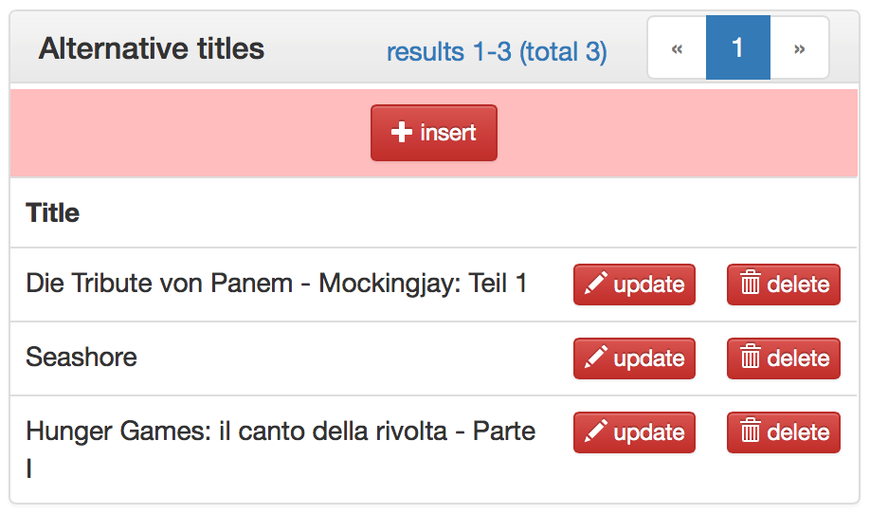

*An AJAX-loaded data list with 3 elements and management buttons*

Every data list having a similar header with paging buttons as the one here is AJAX loaded. The entire dataset is loaded once by AJAX after query was executed, and the pagination is done locally in Javascript, offering the user a more fluid experience.

### AJAX modal window

Using bootstrap generic functionality, a modal window is present in the HTML template code of the application and is actively used to display subpages in the application, like the “are you sure ?” windows when trying to delete an element, or result lists for subqueries when doing search.

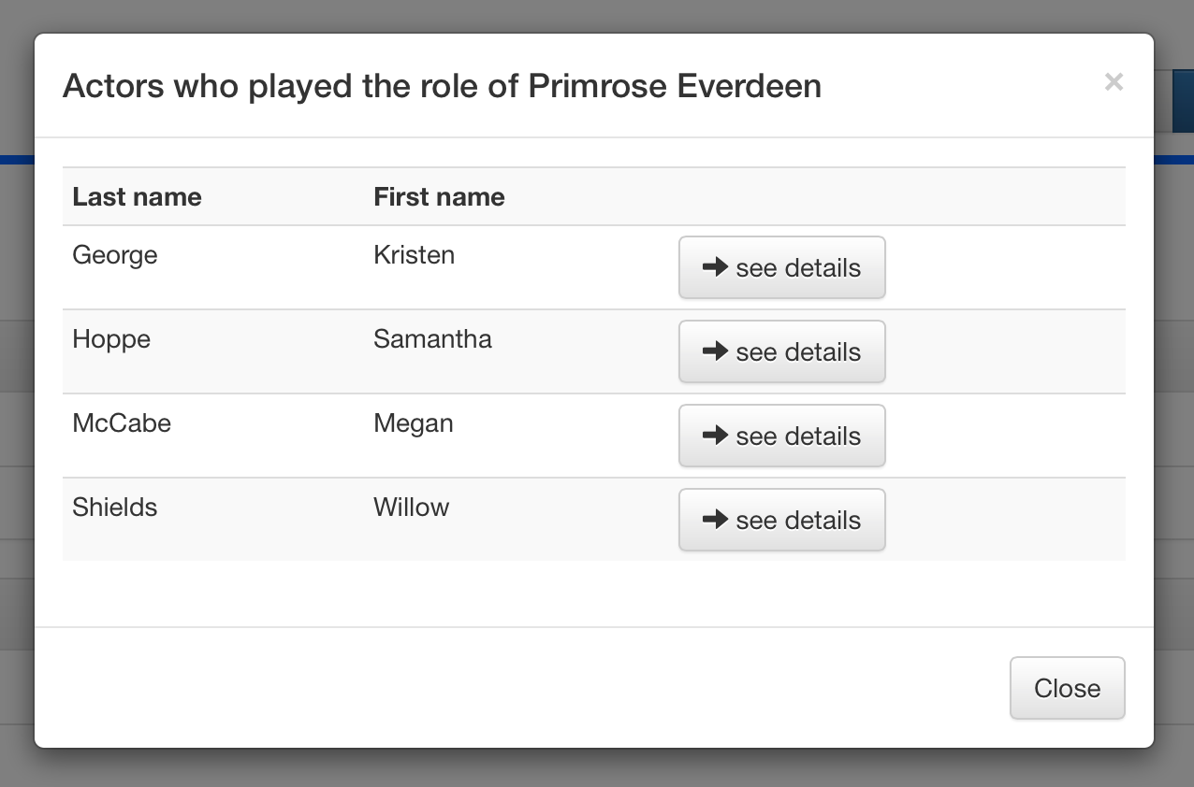

*The modal window filled with some actors playing the role of Primrose Everdeen in The Hunger Games saga*

The content of this modal window can (and actually *is*) loaded through AJAX requests. The request is issued when the window is called to be opened, and the window displays a “loading” GIF until the result becomes available to be displayed.

### Dynamic forms

Forms are graphically built using bootstrap components. Javascript bunches of code are automatically generated by the ILARIA framework to validate the content of the forms on the client side, checking things like “this field must not be empty” and “this field must have a unique value across all records”. When necessary, AJAX requests are issued to do live validation when editing things.

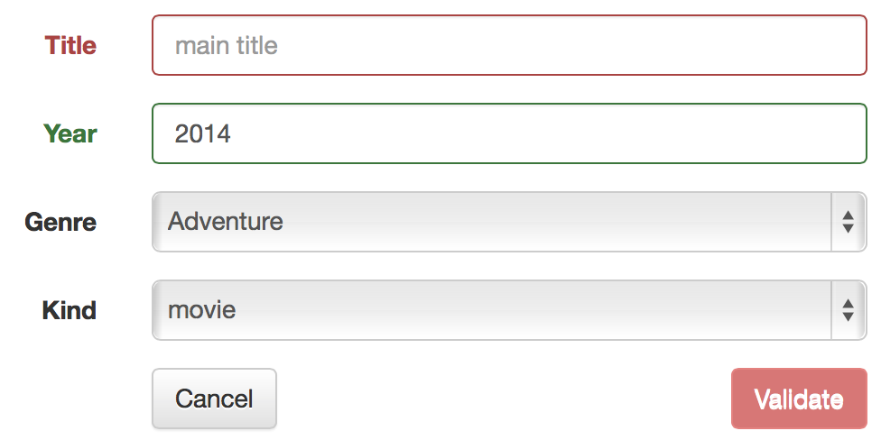

*A form with the “title” field in error state due to its emptiness*

Validation button of forms are automatically disabled and red-colored when a problem relative to the validation of a field is detected in the corresponding form. By using the ILARIA form component, all validations are automatically done on client and server sides for maximum security and problem prevention.

## Main pages queries

In the following chapters we give details about the exact SQL queries that are used through the application to display main pages of persons, productions and companies.

### Person’s main page

These queries are used to display the content of a person’s main page, as described in [§5.2.1].

The following query is used to load the main elements of the page (no-AJAX).

SELECT DISTINCT PE.`id`, PE.`gender`, PE.`trivia`, PE.`quotes`, PE.`birthdate`,

PE.`deathdate`, PE.`birthname`, PE.`minibiography`, PE.`spouse`, PE.`height`,

PE.`name_id`, NA.`lastname`, NA.`firstname`

FROM `person` PE

INNER JOIN `name` NA ON PE.`name_id` = NA.`id`

WHERE PE.`id` = 2682115;

The following query is used by AJAX loading to gather the alternative names.

SELECT DISTINCT NA.`id`, NA.`lastname`, NA.`firstname`

FROM `name` NA

WHERE NA.`person_id` = 2682115

AND NA.`id` != 2666765;

The final AND clause is used to evict the main name from the result set.

The following query is used by AJAX loading to gather the roles of a person in singleproductions.

SELECT DISTINCT SP.`id` AS `prod_id`, TI.`title` AS `prod_title`, KI.`name` AS `prod_kind`,

GE.`name` AS `prod_gender`, PR.`year` AS `prod_year`, CH.`name` AS `char_name`, RO.`name`

AS `role_name`

FROM `casting` CA

INNER JOIN `production` PR ON CA.`production_id` = PR.`id`

INNER JOIN `title` TI ON PR.`title_id` = TI.`id`

LEFT JOIN `gender` GE ON PR.`gender_id` = GE.`id`

INNER JOIN `singleproduction` SP ON PR.`id` = SP.`id`

INNER JOIN `kind` KI ON SP.`kind_id` = KI.`id`

LEFT JOIN `character` CH ON CA.`character_id` = CH.`id`

INNER JOIN `role` RO ON CA.`role_id` = RO.`id`

WHERE CA.`person_id` = 2682115

ORDER BY PR.`year` DESC, TI.`title` ASC;

The following query is used by AJAX loading to gather the roles of a person in series.

(

SELECT SER.`id` AS `prod_id`, TI.`title` AS `prod_title`, COUNT(DISTINCT EP.`id`) AS

`episode_count`, COUNT(DISTINCT SEA.`id`) AS `season_count`, SER.`yearstart` AS

`prod_yearstart`, SER.`yearend` AS `prod_yearend`, GE.`name` AS `prod_gender`, CH.`name`

AS `char_name`, RO.`name` AS `role_name`

FROM `casting` CA

INNER JOIN `production` PR ON CA.`production_id` = PR.`id`

INNER JOIN `title` TI ON PR.`title_id` = TI.`id`

LEFT JOIN `gender` GE ON PR.`gender_id` = GE.`id`

INNER JOIN `serie` SER ON PR.`id` = SER.`id`

INNER JOIN `season` SEA ON SER.`id` = SEA.`serie_id`

INNER JOIN `episode` EP ON SEA.`id` = EP.`season_id`

LEFT JOIN `character` CH ON CA.`character_id` = CH.`id`

INNER JOIN `role` RO ON CA.`role_id` = RO.`id`

WHERE CA.`person_id` = 1831321

GROUP BY PR.`id`, RO.`name`, CH.`name`

) UNION DISTINCT (

SELECT SER.`id` AS `prod_id`, TI.`title` AS `prod_title`, COUNT(DISTINCT EP.`id`) AS

`episode_count`, COUNT(DISTINCT SEA.`id`) AS `season_count`, SER.`yearstart` AS

`prod_yearstart`, SER.`yearend` AS `prod_yearend`, GE.`name` AS `prod_gender`, CH.`name`

AS `char_name`, RO.`name` AS `role_name`

FROM `casting` CA

INNER JOIN `production` PR_EP ON CA.`production_id` = PR_EP.`id`

INNER JOIN `episode` EP ON PR_EP.`id` = EP.`id`

INNER JOIN `season` SEA ON EP.`season_id` = SEA.`id`

INNER JOIN `serie` SER ON SEA.`serie_id` = SER.`id`

INNER JOIN `production` PR_SER ON SER.`id` = PR_SER.`id`

INNER JOIN `title` TI ON PR_SER.`title_id` = TI.`id`

LEFT JOIN `gender` GE ON PR_SER.`gender_id` = GE.`id`

LEFT JOIN `character` CH ON CA.`character_id` = CH.`id`

INNER JOIN `role` RO ON CA.`role_id` = RO.`id`

WHERE CA.`person_id` = 1831321

GROUP BY PR_SER.`id`, RO.`name`, CH.`name`

)

ORDER BY `prod_yearstart` DESC, `prod_title` ASC;

The first subquery searches for series in which the person is directly linked, while the second subquery is searching for series containing one or more episodes, with person linked to these episodes.

### Production’s main page

These queries are used to display the content of a production’s main page as described in [§5.2.2].

The following query helps to determine the kind of production in the ISA hierarchy (singleproduction, serie or episode).

(

SELECT SP.`id` AS `single`, NULL AS `serie`, NULL AS `episode`

FROM `singleproduction` SP

WHERE SP.`id`=2998449

) UNION (

SELECT NULL AS `single`, SE.`id` AS `serie`, NULL AS `episode`

FROM `serie` SE

WHERE SE.`id`=2998449

) UNION (

SELECT NULL AS `single`, NULL AS `serie`, EP.`id` AS `episode`

FROM `episode` EP

WHERE EP.`id`=2998449

);

Then, in the case of a singleproduction, the following query is used to gather general informations about it.

SELECT PR.`id` AS `prod_id`, TI.`title` AS `prod_title`, PR.`year` AS `prod_year`, KI.`name`

AS `prod_kind`, GE.`name` AS `prod_gender`, PR.`title_id` AS `maintitle_id`

FROM `production` PR

INNER JOIN `title` TI ON PR.`title_id` = TI.`id`

LEFT JOIN `gender` GE ON PR.`gender_id` = GE.`id`

INNER JOIN `singleproduction` SP ON PR.`id` = SP.`id`

INNER JOIN `kind` KI ON SP.`kind_id` = KI.`id`

WHERE PR.`id`=2998449;

In the case of a serie, the following query is used to gather general informations about it.

SELECT SER.`id` AS `prod_id`, TI.`title` AS `serie_title`, SER.`yearstart` AS

`serie_yearstart`, SER.`yearend` AS `serie_yearend`, GE.`name` AS `serie_gender`, TI.`id`

AS `maintitle_id`, COUNT(DISTINCT SEA.`id`) AS `season_count`, COUNT(DISTINCT EP.`id`) AS

`episode_count`

FROM `serie` SER

INNER JOIN `production` PR ON SER.`id` = PR.`id`

INNER JOIN `title` TI ON PR.`title_id` = TI.`id`

LEFT JOIN `gender` GE ON PR.`gender_id` = GE.`id`

LEFT JOIN `season` SEA ON SER.`id` = SEA.`serie_id`

LEFT JOIN `episode` EP ON SEA.`id` = EP.`season_id`

WHERE SER.`id`=11306

GROUP BY SER.`id`;

In the case of an episode, the following query is used to gather general informations about it.

SELECT EP.`id` AS `prod_id`, EP_TI.`title` AS `episode_title`, EP.`number` AS

`episode_number`, EP_PR.`year` AS `episode_year`, EP_TI.`id` AS `maintitle_id`,

SEA.`number` AS `season_number`, SER.`id` AS `serie_id`, SER_TI.`title` AS `serie_title`,

SER_GE.`name` AS `serie_gender`

FROM `episode` EP

INNER JOIN `production` EP_PR ON EP.`id` = EP_PR.`id`

INNER JOIN `title` EP_TI ON EP_PR.`title_id` = EP_TI.`id`

INNER JOIN `season` SEA ON EP.`season_id` = SEA.`id`

INNER JOIN `serie` SER ON SEA.`serie_id` = SER.`id`

INNER JOIN `production` SER_PR ON SER.`id` = SER_PR.`id`

INNER JOIN `title` SER_TI ON SER_PR.`title_id` = SER_TI.`id`

LEFT JOIN `gender` SER_GE ON SER_PR.`gender_id` = SER_GE.`id`

WHERE EP.`id`=11316;

In the case of a serie, the list of seasons it contains is loaded by the following query.

SELECT SEA.`id` AS `season_id`, SEA.`number` AS `season_number`, COUNT(DISTINCT EP.`id`) AS

`episode_count`

FROM `season` SEA

INNER JOIN `episode` EP ON SEA.`id` = EP.`season_id`

WHERE SEA.`serie_id`=11306

GROUP BY SEA.`id`

ORDER BY SEA.`number`;

In the case of a serie, when clicking on the “see episodes” button of a given season, the following query is used to load the content of the modal window.

SELECT EP.`id` AS `episode_id`, TI.`title` AS `episode_title`, EP.`number` AS `episode_number`

FROM `episode` EP

INNER JOIN `production` PR ON EP.`id` = PR.`id`

INNER JOIN `title` TI ON PR.`title_id` = TI.`id`

WHERE EP.`season_id`=920

ORDER BY EP.`number`;

In the case of an episode, the information about the related season and serie can be obtained via the following query.

SELECT EP.`id` AS `episode_id`, TI.`title` AS `episode_title`, EP.`number` AS `episode_number`

FROM `episode` EP

INNER JOIN `production` PR ON EP.`id` = PR.`id`

INNER JOIN `title` TI ON PR.`title_id` = TI.`id`

WHERE EP.`season_id`=920

ORDER BY EP.`number`;

For all kinds of productions, the following query is used to gather the casting.

SELECT PE.`id` AS `person_id`, NA.`lastname` AS `person_lastname`, NA.`firstname` AS

`person_firstname`, RO.`name` AS `role_name`, CH.`name` AS `char_name`

FROM `casting` CA

INNER JOIN `person` PE ON CA.`person_id` = PE.`id`

INNER JOIN `name` NA ON PE.`name_id` = NA.`id`

INNER JOIN `role` RO ON CA.`role_id` = RO.`id`

LEFT JOIN `character` CH ON CA.`character_id` = CH.`id`

WHERE CA.`production_id`=2998449;

For all kinds of productions, the following query is used to gather the companies involved in the production.

SELECT COM.`id` AS `id`, COM.`name` AS `name`, COU.`code` AS `country`, TY.`name` AS `type`

FROM `productioncompany` PC

INNER JOIN `company` COM ON PC.`company_id` = COM.`id`

INNER JOIN `country` COU ON COM.`country_id` = COU.`id`

INNER JOIN `type` TY ON PC.`type_id` = TY.`id`

WHERE PC.`production_id`=2998449;

For all kinds of productions, the following query is used to gather the alternative titles.

SELECT TI.`title`

FROM `title` TI

WHERE TI.`production_id`=2998449

AND TI.`id`!=2998451;

The final AND clause is used to evict the main title from the result set.

### Company’s main page

These queries are used to display the content of a company’s main page as described in [§5.2.3].

The following query is used to gather the general informations about a company.

SELECT TI.`title`

FROM `title` TI

WHERE TI.`production_id`=2998449

AND TI.`id`!=2998451;

The following query is used to gather the list of singleproductions in which the company is involved.

SELECT SP.`id` AS `id`, TI.`title` AS `title`, KI.`name` AS `kind`, PR.`year` AS `year`,

GE.`name` AS `gender`, TY.`name` AS `type`

FROM `productioncompany` PC

INNER JOIN `production` PR ON PC.`production_id` = PR.`id`

INNER JOIN `title` TI ON PR.`title_id` = TI.`id`

LEFT JOIN `gender` GE ON PR.`gender_id` = GE.`id`

INNER JOIN `singleproduction` SP ON PR.`id` = SP.`id`

INNER JOIN `kind` KI ON SP.`kind_id` = KI.`id`

INNER JOIN `type` TY ON PC.`type_id` = TY.`id`

WHERE PC.`company_id`=3293

ORDER BY TI.`title`, TY.`id`;

The following query is used to gather the list of series in which the company is involved.

(

SELECT SER.`id` AS `id`, TI.`title` AS `title`, COUNT(DISTINCT EP.`id`) AS `episode_count`,

COUNT(DISTINCT SEA.`id`) AS `season_count`, SER.`yearstart` AS `yearstart`, SER.`yearend`

AS `yearend`, GE.`name` AS `gender`, TY.`name` AS `type`

FROM `productioncompany` PC

INNER JOIN `production` PR ON PC.`production_id` = PR.`id`

INNER JOIN `title` TI ON PR.`title_id` = TI.`id`

LEFT JOIN `gender` GE ON PR.`gender_id` = GE.`id`

INNER JOIN `serie` SER ON PR.`id` = SER.`id`

INNER JOIN `season` SEA ON SER.`id` = SEA.`serie_id`

INNER JOIN `episode` EP ON SEA.`id` = EP.`season_id`

INNER JOIN `type` TY ON PC.`type_id` = TY.`id`

WHERE PC.`company_id`=3293

GROUP BY PR.`id`, TY.`id`

) UNION DISTINCT (

SELECT SER.`id` AS `id`, TI.`title` AS `title`, COUNT(DISTINCT EP.`id`) AS `episode_count`,

COUNT(DISTINCT SEA.`id`) AS `season_count`, SER.`yearstart` AS `yearstart`, SER.`yearend`

AS `yearend`, GE.`name` AS `gender`, TY.`name` AS `type`

FROM `productioncompany` PC

INNER JOIN `production` PR_EP ON PC.`production_id` = PR_EP.`id`

INNER JOIN `episode` EP ON PR_EP.`id` = EP.`id`

INNER JOIN `season` SEA ON EP.`season_id` = SEA.`id`

INNER JOIN `serie` SER ON SEA.`serie_id` = SER.`id`

INNER JOIN `production` PR_SER ON SER.`id` = PR_SER.`id`

INNER JOIN `title` TI ON PR_SER.`title_id` = TI.`id`

LEFT JOIN `gender` GE ON PR_SER.`gender_id` = GE.`id`

INNER JOIN `type` TY ON PC.`type_id` = TY.`id`

WHERE PC.`company_id`=3293

GROUP BY PR_SER.`id`, TY.`id`

)

ORDER BY `title`, `type`;

The first subquery searches for series in which the company is directly linked, while the second subquery is searching for series containing one or more episodes, with company linked to these episodes.

## Insert, update and delete procedures

The following chapters present the insert, update and delete procedure, written in pseudo-code to save time and space as they are all basic DML SQL queries.

### Persons

These are the procedures used to modify tables corresponding to a “Person”.

**Insertion**

At the form validation, the insertion procedure is triggered. During this procedure, the foreign key checks are disabled on the database (SET FOREIGN_KEY_CHECKS=0). They are re-enabled at the end of the procedure. It is no longer an option to authorize the NULL value on one of the foreign key fields as it was done during import (see [§4.1.1]), because executing the corresponding query takes about 10 seconds with millions of records already in the table.

The insertion procedure follows this schema.

1. Start a transaction
2. Insert a record in the person table, with value 0 as name_id
3. Insert a record in the name table, with the new person record ID as person_id
4. Update the person record to set name_id to the correct value
5. Commit the transaction

If anything fails during this procedure, a rollback is immediately triggered, guaranteeing that no inconsistent state of the database could be ever reached.

**Update**

Despite the insertion procedure needs it, the update one doesn’t necessitate any constraint to be wiped out.

The update procedure follows this schema.

1. Start a transaction
2. Update the corresponding record in the person table
3. Find the main name ID from this record
4. Update the corresponding record in the name table
5. Commit the transaction

If anything fails during this procedure, a rollback is immediately triggered, guaranteeing that no inconsistent state of the database could be ever reached.

**Deletion**

Like the insertion procedure, the deletion one temporarily disables the foreign keys constraints while deleting a person.

The delete procedure follows this schema.

1. Start a transaction
2. Delete the name records with matching person_id
3. Delete the person record
4. Delete the casting records with matching person_id
5. Commit the transaction

If anything fails during this procedure, a rollback is immediately triggered, guaranteeing that no inconsistent state of the database could be ever reached.

### Alternative names

These are the procedures used to modify tables corresponding to a “Alternative name”.

**Insertion**

The insertion procedure follows this schema.

1. Insert a record in the name table

No transaction is used because there is only one SQL query to execute, thus fully succeeding or failing by itself.

**Update**

The update procedure follows this schema.

1. Update the corresponding record in the name table

No transaction is used because there is only one SQL query to execute, thus fully succeeding or failing by itself.

**Deletion**

The delete procedure follows this schema.

1. Delete the corresponding record from the name table

No transaction is used because there is only one SQL query to execute, thus fully succeeding or failing by itself.

### Productions

These are the procedures used to modify tables corresponding to a “Production”.

**Insertion of a movie**

At the form validation, the insertion procedure is triggered. During this procedure, the foreign key checks are disabled on the database (SET FOREIGN_KEY_CHECKS=0). They are re-enabled at the end of the procedure. It is no longer an option to authorize the NULL value on one of the foreign key fields as it was done during import (see [§4.1.4]), because executing the corresponding query takes about 10 seconds with millions of records already in the table.

The insertion procedure follows this schema.

1. Start a transaction
2. Insert a record in the production table, with value 0 as title_id
3. Insert a record in the title table, with the new production record ID as production_id
4. Update the production record to set title_id to the correct value
5. Insert a record in the singleproduction table, thus completing the ISA hierarchy covering constraint
6. Commit the transaction

If anything fails during this procedure, a rollback is immediately triggered, guaranteeing that no inconsistent state of the database could be ever reached.

**Insertion of a serie**

Like for the insertion of a movie, the foreign keys constraints are temporarily disabled during insertion of a serie.

The insertion procedure follows this schema.

1. Start a transaction
2. Insert a record in the production table, with value 0 as title_id
3. Insert a record in the title table, with the new production record ID as production_id
4. Update the production record to set title_id to the correct value
5. Insert a record in the serie table, thus completing the ISA hierarchy covering constraint
6. Commit the transaction

If anything fails during this procedure, a rollback is immediately triggered, guaranteeing that no inconsistent state of the database could be ever reached.

**Insertion of an episode**

Like for the insertion of a movie, the foreign keys constraints are temporarily disabled during insertion of an episode.

The insertion procedure follows this schema.

1. Start a transaction
2. Insert a record in the production table, with value 0 as title_id
3. Insert a record in the title table, with the new production record ID as production_id
4. Update the production record to set title_id to the correct value
5. Search through the season table for the season having serie_id and number correctly set
6. If no season is found, insert it in the season table
7. Insert a record in the episode table, pointing to the (newly inserted) season, thus completing the ISA hierarchy covering constraint
8. Commit the transaction

If anything fails during this procedure, a rollback is immediately triggered, guaranteeing that no inconsistent state of the database could be ever reached.

**Updating a movie, a serie or an episode**

Despite the insertion procedures needs it, the update ones doesn’t necessitate any constraint to be wiped out.

The update procedures are similar and ordered like the insertion ones for each kind of production. Transactions are always used, and rollback is a systematic action in case of problem.

**Deleting a movie or an episode**

Like the insertion procedures, the deletion ones temporarily disables the foreign keys constraints while deleting a production.

The delete procedure follows this schema.

1. Start a transaction
2. Delete the title records with matching production_id
3. Delete the production record
4. Delete the singleproduction/episode record
5. Delete the casting records with matching production_id
6. Delete the productioncompany records with matching production_id
7. Commit the transaction

If anything fails during this procedure, a rollback is immediately triggered, guaranteeing that no inconsistent state of the database could be ever reached.

**Deleting a serie**

Like the insertion procedure, the deletion one temporarily disables the foreign keys constraints while deleting a production.

The delete procedure follows this schema.

1. Start the transaction
2. Delete the title records with matching production_id
3. Delete the production record
4. Delete the serie record
5. Delete the casting records with matching production_id
6. Delete the productioncompany records with matching production_id
7. Select and memorize the season records with matching serie_id
8. Delete these season records
9. Select and memorize the episode records linked to a season record previously memorized
10. Delete these episode records
11. Delete the production records matching any of the previously memorized episode
12. Delete the title records with matching production_id on any memorized episode
13. Delete the casting records with matching production_id on any memorized episode
14. Delete the productioncompany records with matching production_id on any memorized episode
15. Commit the transaction

If anything fails during this procedure, a rollback is immediately triggered, guaranteeing that no inconsistent state of the database could be ever reached.

### Alternative titles

These are the procedures used to modify tables corresponding to a “Alternative title”.

**Insertion**

The insertion procedure follows this schema.

1. Insert a record in the title table

No transaction is used because there is only one SQL query to execute, thus fully succeeding or failing by itself.

**Update**

The update procedure follows this schema.

1. Update the corresponding record in the title table

No transaction is used because there is only one SQL query to execute, thus fully succeeding or failing by itself.

**Deletion**

The delete procedure follows this schema.

1. Delete the corresponding record from the title table

No transaction is used because there is only one SQL query to execute, thus fully succeeding or failing by itself.

### Casting

These are the procedures used to modify tables corresponding to a “Casting”.

**Insertion**

The insertion procedure follows this schema.

1. Start a transaction
2. Search through the character table for character having name correctly set
3. If no character is found, insert it in the character table
4. Insert a record in the casting table, pointing to the (newly inserted) character
5. Commit the transaction

If anything fails during this procedure, a rollback is immediately triggered, guaranteeing that no inconsistent state of the database could be ever reached.

**Update**

The update procedure follows this schema.

1. Start a transaction
2. Search through the character table for character having name correctly set
3. If no character is found, insert it in the character table
4. Update the corresponding record in the casting table, pointing to the (newly inserted) character
5. Commit the transaction

If anything fails during this procedure, a rollback is immediately triggered, guaranteeing that no inconsistent state of the database could be ever reached.

**Deletion**

The deletion procedure follows this schema.

1. Delete the casting record

No transaction is used because there is only one SQL query to execute, thus fully succeeding or failing by itself.

### Companies involved in a production

These are the procedures used to modify tables corresponding to the participation of a company in a production.

**Insertion**

The insertion procedure follows this schema.

1. Insert a record in the productioncompany table

No transaction is used because there is only one SQL query to execute, thus fully succeeding or failing by itself.

**Update**

The update procedure follows this schema.

1. Update the productioncompany record

No transaction is used because there is only one SQL query to execute, thus fully succeeding or failing by itself.

**Deletion**

The deletion procedure follows this schema.

1. Delete the productioncompany record

No transaction is used because there is only one SQL query to execute, thus fully succeeding or failing by itself.

### Companies

These are the procedures used to modify tables corresponding to a “Company”.

**Insertion**

The insertion procedure follows this schema.

1. Start a transaction
2. Search through the country table for country having code correctly set
3. If no country is found, insert it in the country table
4. Insert a record in the company table
5. Commit the transaction

If anything fails during this procedure, a rollback is immediately triggered, guaranteeing that no inconsistent state of the database could be ever reached.

**Update**

The update procedure follows this schema.

1. Start a transaction
2. Search through the country table for country having code correctly set
3. If no country is found, insert it in the country table
4. Update the corresponding record in the company table
5. Commit the transaction

If anything fails during this procedure, a rollback is immediately triggered, guaranteeing that no inconsistent state of the database could be ever reached.

**Deletion**

The delete procedure follows this schema.

1. Delete the company record

No transaction is used because there is only one SQL query to execute, thus fully succeeding or failing by itself.

1. <http://www.imdb.com>
2. <http://www.oracle.com/fr/database/overview/index.html>
3. <http://dev.mysql.com/downloads/>
4. <http://dev.mysql.com/downloads/workbench/>
5. <http://httpd.apache.org>
6. <http://php.net>
7. <https://jquery.com>
8. <http://getbootstrap.com>
9. <http://fr.wikipedia.org/wiki/Ajax_(informatique)>
10. <http://dev.mysql.com/doc/refman/5.0/en/innodb-foreign-key-constraints.html>
11. <http://dev.mysql.com/doc/workbench/en/wb-reverse-engineer-live.html>