UNIVERSITY OF THE ARMED FORCES ESPE

**The Programmers - Group 5**

**Members:**

13 Guaman Jadan, Byron Vinicio

**Lider Group:** 14 Mena Realpe, Kevin Paul

15 Mortensen Franco, Eduardo Antonio

**Group 5**

**Project: Review - NullPointers**

**Inspector Team 4: Paul Mena - The Programmers**

**Proyect:** ApplianceStore

**Members:**

17 Portilla Andrade, Diego Alejandro

18 Salazar Encalada, Edwin Matthew

19 Solano Torres, Sebastian Ismael

20 Suquillo Gavilanes, Francisco Nicolas

21 Valdiviezo Condor, Darwin Roberto

Requirements 9.0/10 bad Structure,requirements are not easy find

Use Case D 9.0 /10 -1: It is necessary to establish a relationship between the variables

Class D 8.0/10 - there´s no some attributes that are in the Netbeans(class appliance: computer, class tv:color,kind class blender:size)

Code 7.5/10 unnecessary libraries, there´s variables in the visual that aren't in Netbeans,when you are calling CSV file it should be in another class that isn't where main function found.

Executable 8.5/10 Well structured, but a little confused

final grade : 42.0

* Requirements:
  + Structure a bit confusing
  + Some requirements not taken into account in the project
* Use Class Diagram:
  + A relationship between the variables remains to be established
  + Not in a folder
* Class Diagram:
  + There´s no some attributes that are in the Netbeans(class appliance: computer, class tv:color,kind class blender:size).
  + Ig some variables appear in the uml and are not found in the visual diagram

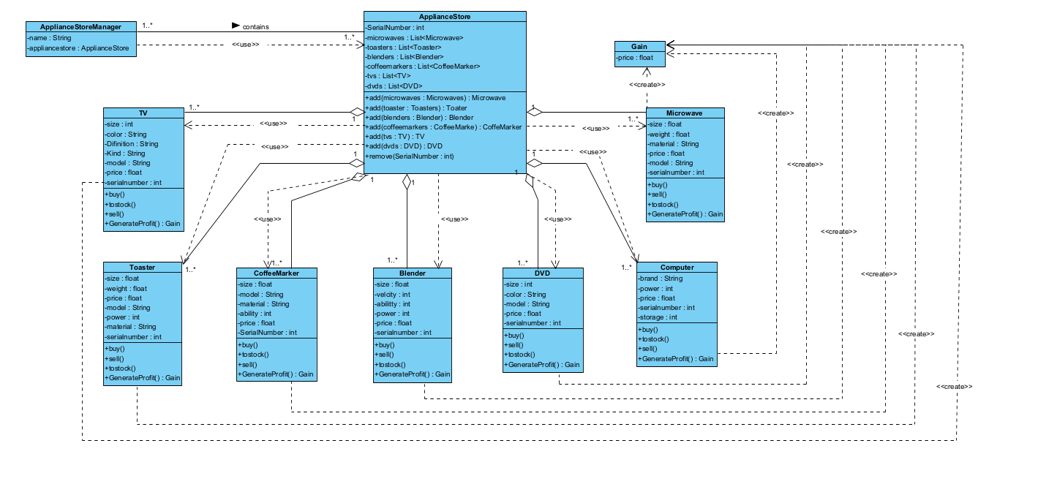

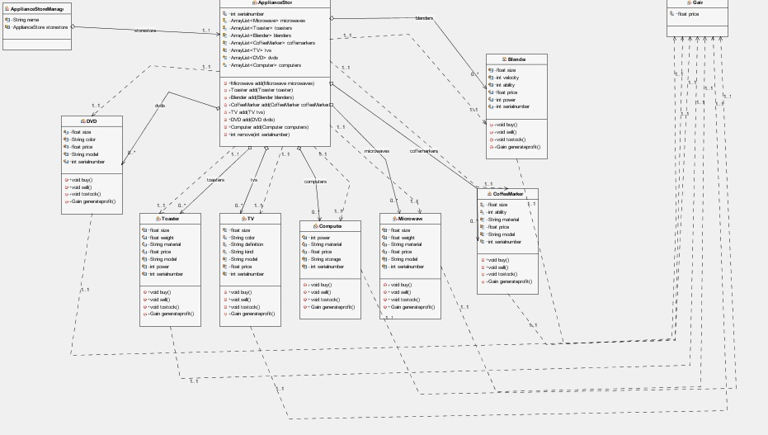

* Code:
  + Unnecessary libraries
  + There´s variables in the visual that aren't in Netbeans
  + When you are calling CSV file it should be in another class that isn't where main function found.
* Executable:
  + well structured, just a little confusing when executing