





**Activity 1**

* **Github team link:**

[**https://github.com/DiegoAndresMantilla/Team3DevSolutions**](https://github.com/DiegoAndresMantilla/Team3DevSolutions)

* **Link to the Youtube video with the interview with the client:**

[**https://youtu.be/95ccVoATMKM**](https://youtu.be/95ccVoATMKM)

* **Link to the video presentation of the project:**

[**https://youtu.be/yrsqwRnew68**](https://youtu.be/yrsqwRnew68)

**Screenshots of the evaluation parameters:**

1. **Github repository (Structure)**

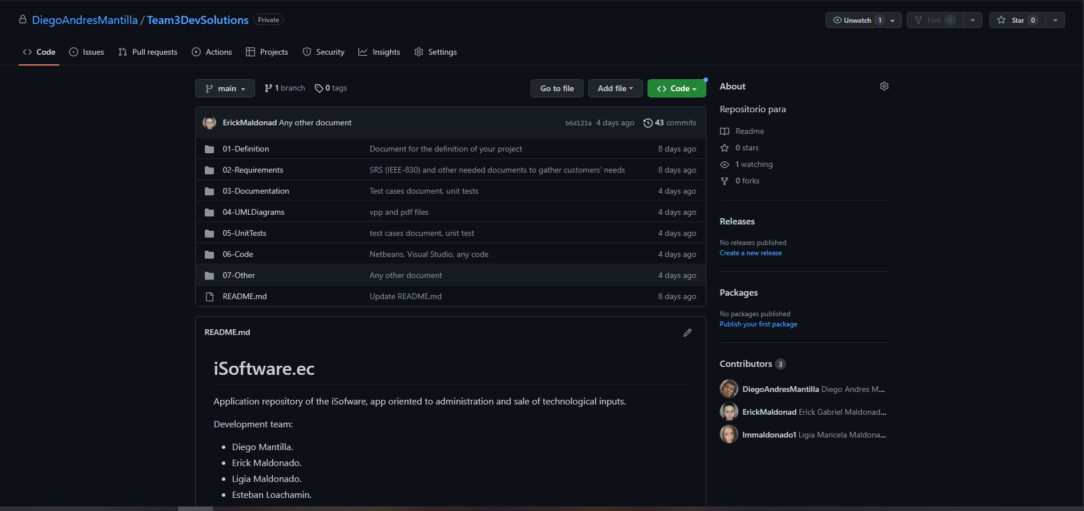

1. **Idea(Interview) and Feature List( Product BackLlog):**

The development of our project consists of implementing a client-server model web application. For this, we conducted an interview with Mr. Darwin Loachamin, owner of the company ISoftware.ec, who needs to improve his sales process through the implementation of eco-commerce in the city of Quito.

In the interview with the client, the functional and non-functional requirements that the application requires for its deployment have been determined. In the conversation, it is necessary to establish business policies, among them are: Calculate the distributed price, VAT calculation, unit profit calculation, total profit and discount percentage if you are a customer or have made previous purchases.

* **Interview Screenshots**



* **List the features(Products Backlog)**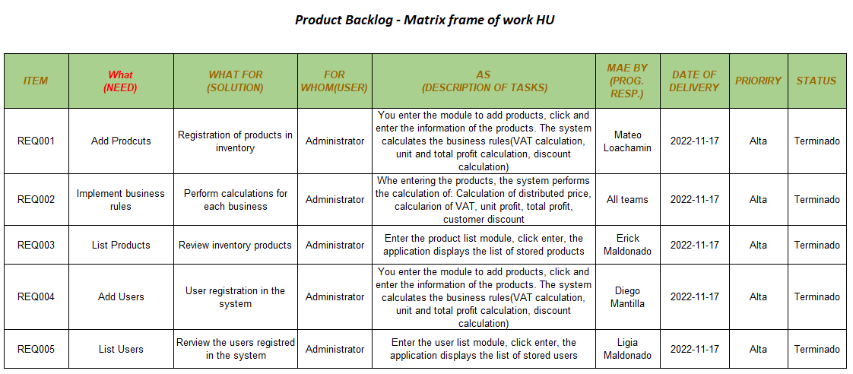

1. **Diagrams(Classes, Use Cases, Architecture):**

**Diagrams Classes**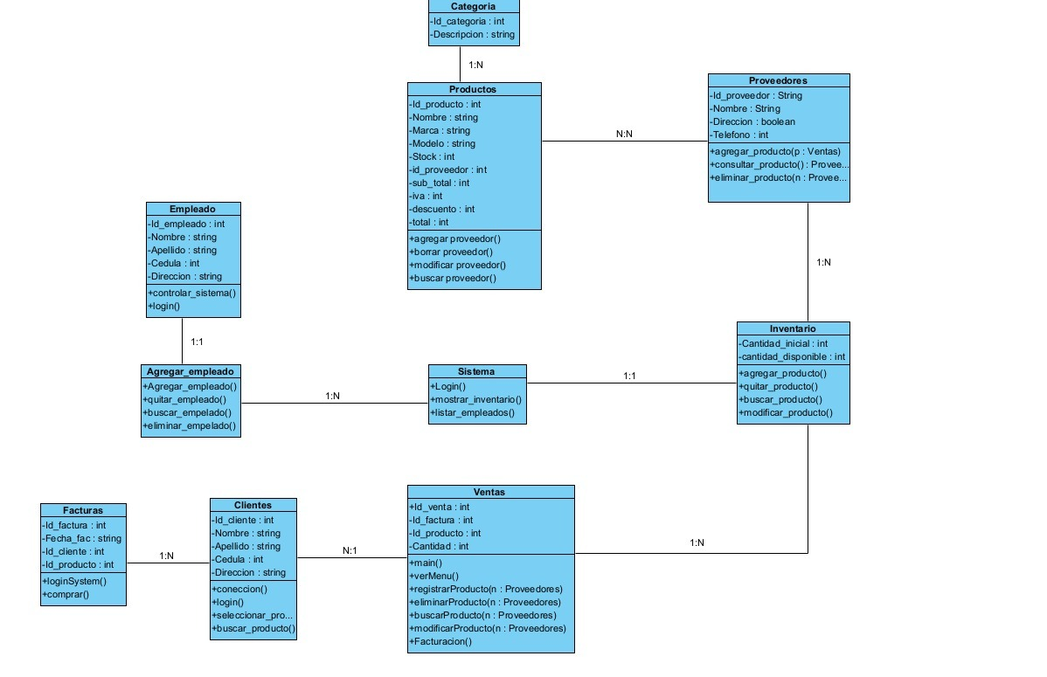

**Use Cases**

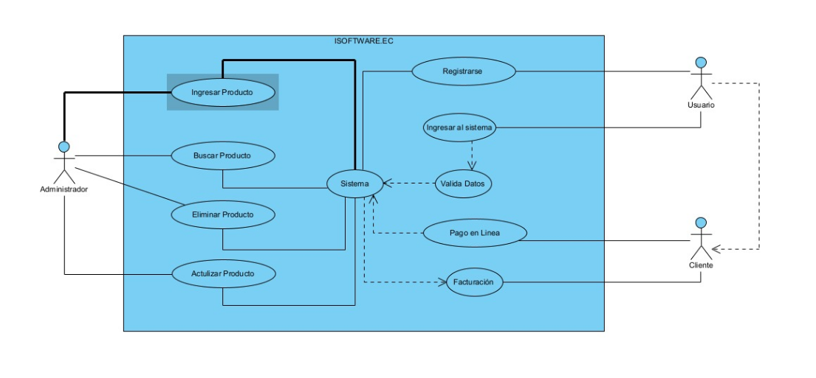

**Architecture ISoftware.ec**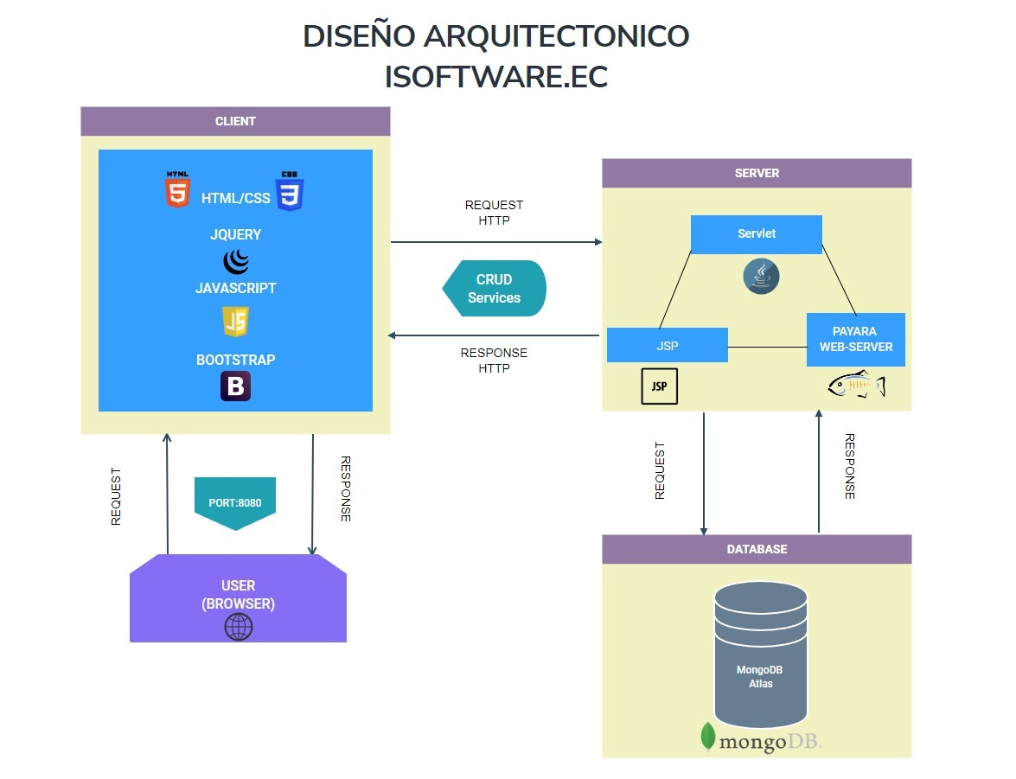

1. **MongoDB Atlas Database(In the cloud):**

**Link Database:**

**Compass:**

mongodb+srv://root:<password>@isoftware.ua3y4od.mongodb.net/test

**URI Java 3.7:**

mongodb+srv://root:<password>@isoftware.ua3y4od.mongodb.net/?retryWrites=true&w=majority

**Screenshots MongoDB Atlas**

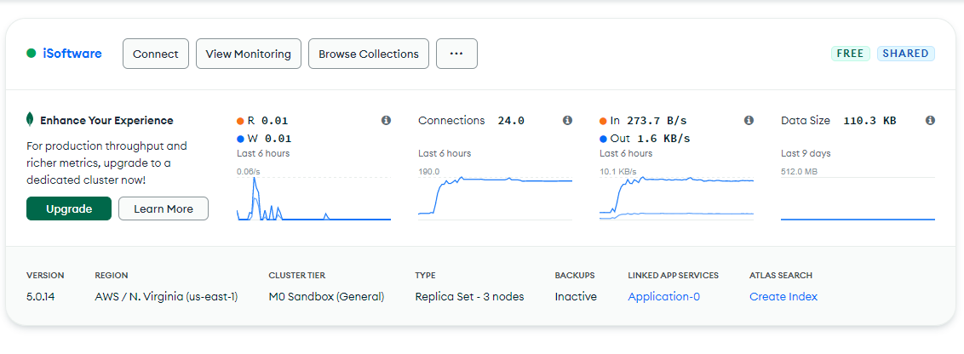

**Collection Products**

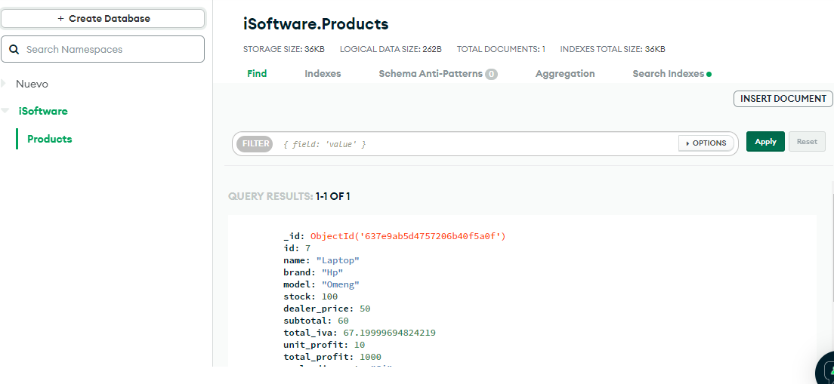

1. **Customer design and at least four business rules:**

**Homepage**

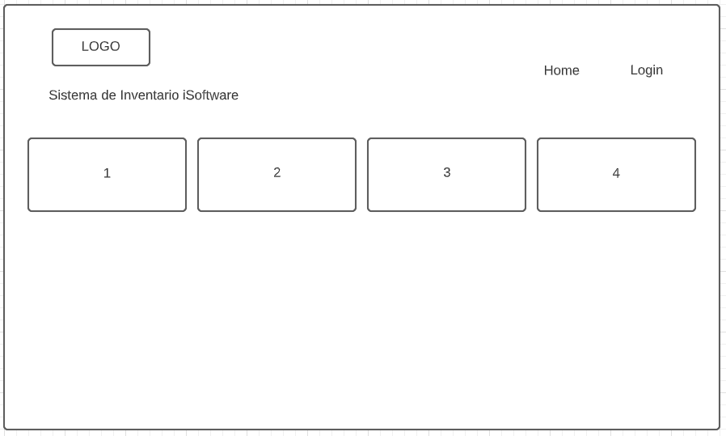

**Add Products VAT Calculation, Subtotal Calculation, Discount Price, Dealer Price**

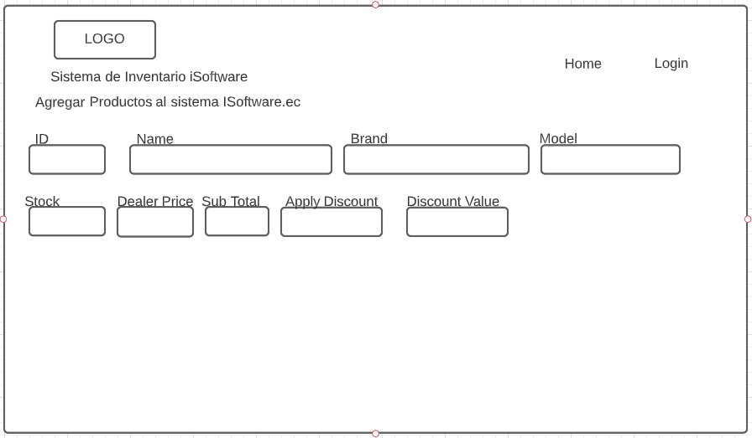

**List Products**

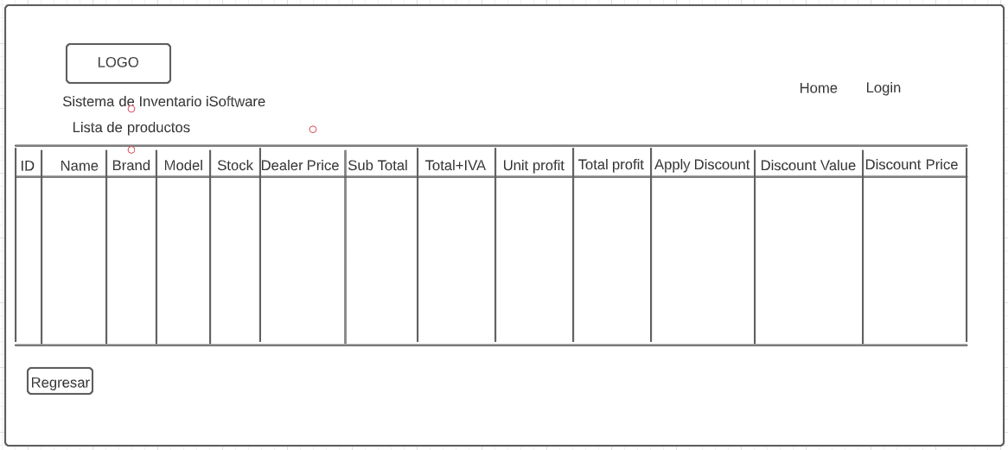

1. **Running the application in the cloud or hosting**

**Index**

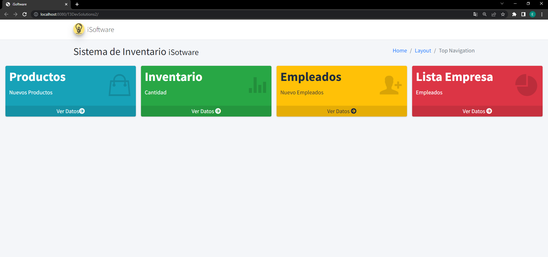

**Add Products**

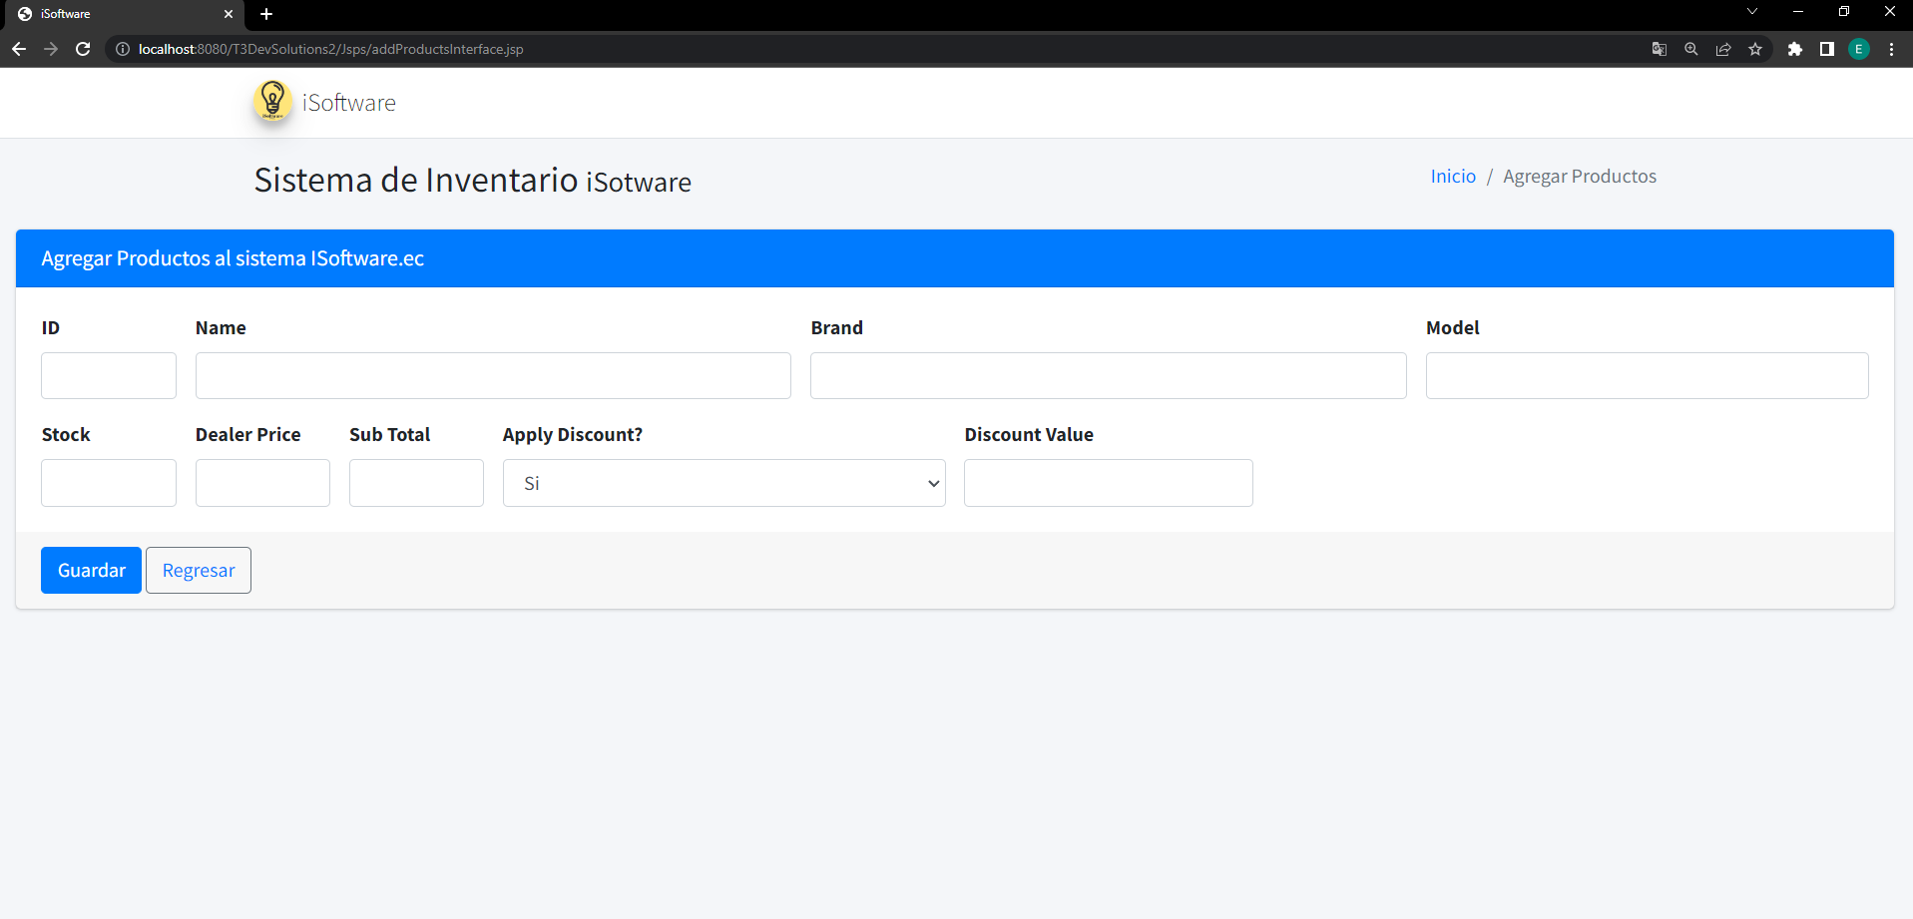

**List Products**

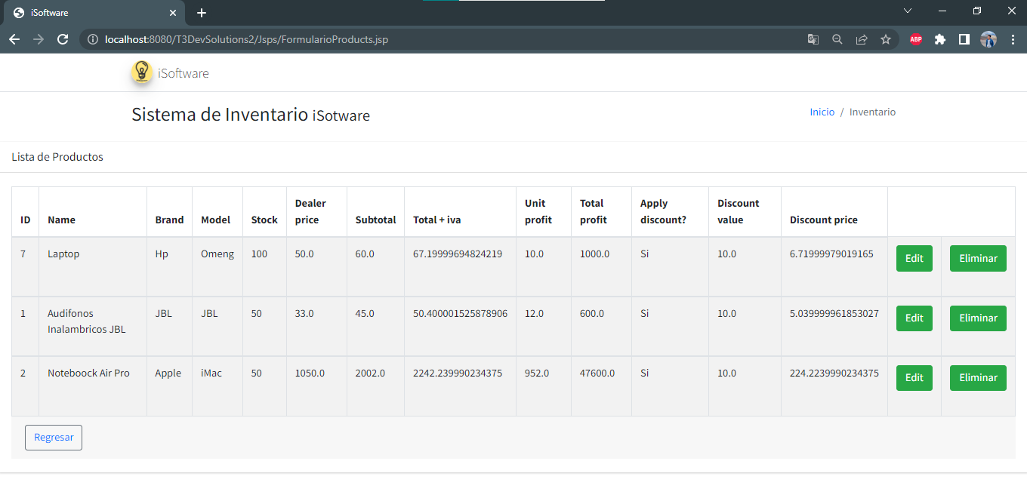

**Edit Products**

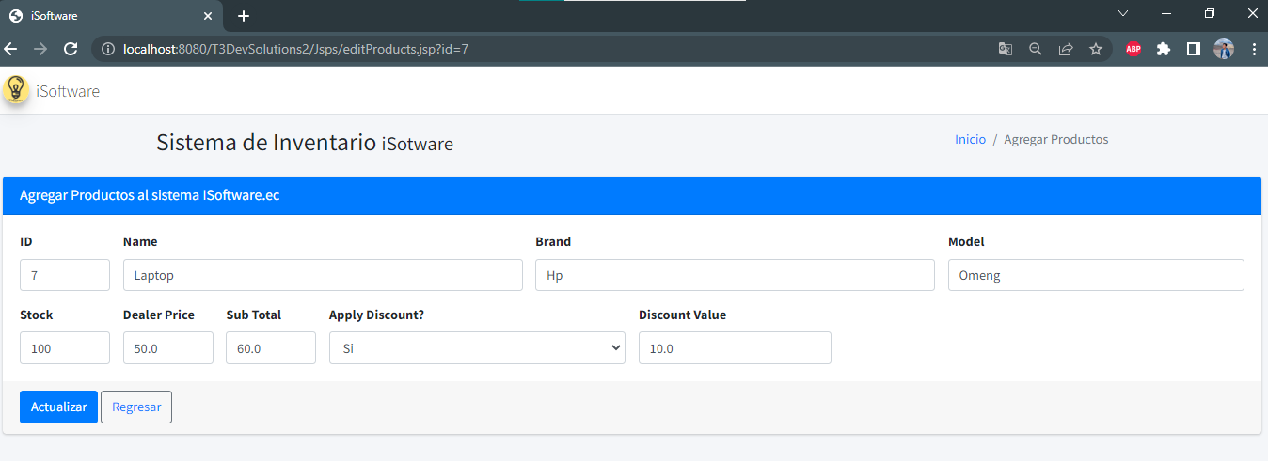

**DeleteProducts**

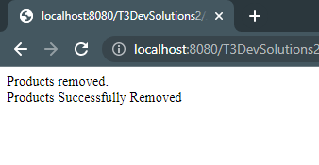

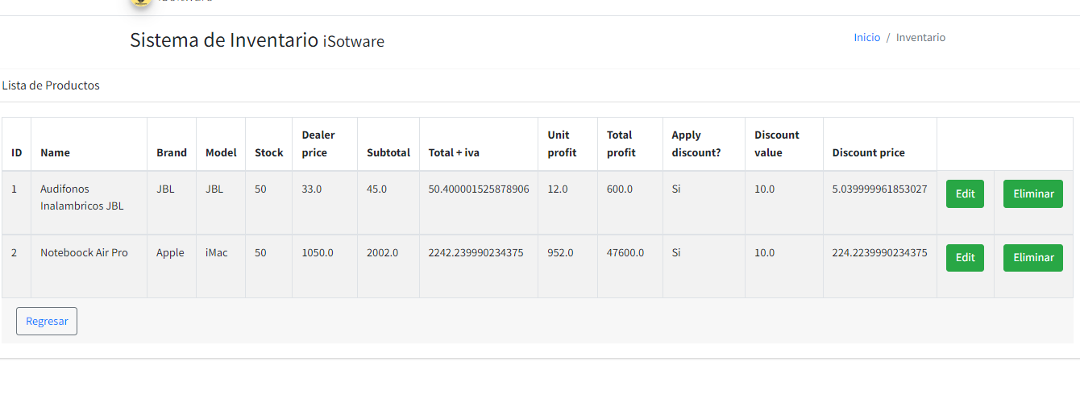

**Rubric**

-**GitHub Repository (Structure and Individual Collaboration) /1**

**-Idea (Interview) and feature List(Product Backlog) /1**

**-Diagrams (Classes, Use Cases, Architecture) /1**

**- MongoDB Atlas database (in the cloud) /1**

**-Customer design and at least four business rules /1**

**-Running the application in the cloud or hosting /1**

**Qualification /6**