





**Activity 2**

* **Github team link:**

[**https://github.com/DiegoAndresMantilla/Team3DevSolutions**](https://github.com/DiegoAndresMantilla/Team3DevSolutions)

* **Link to the video presentation of the project:**

[**https://youtu.be/UzSgbRWOyZI**](https://youtu.be/UzSgbRWOyZI)

**Screenshots of the evaluation parameters:**

1. **Github repository (Structure)** 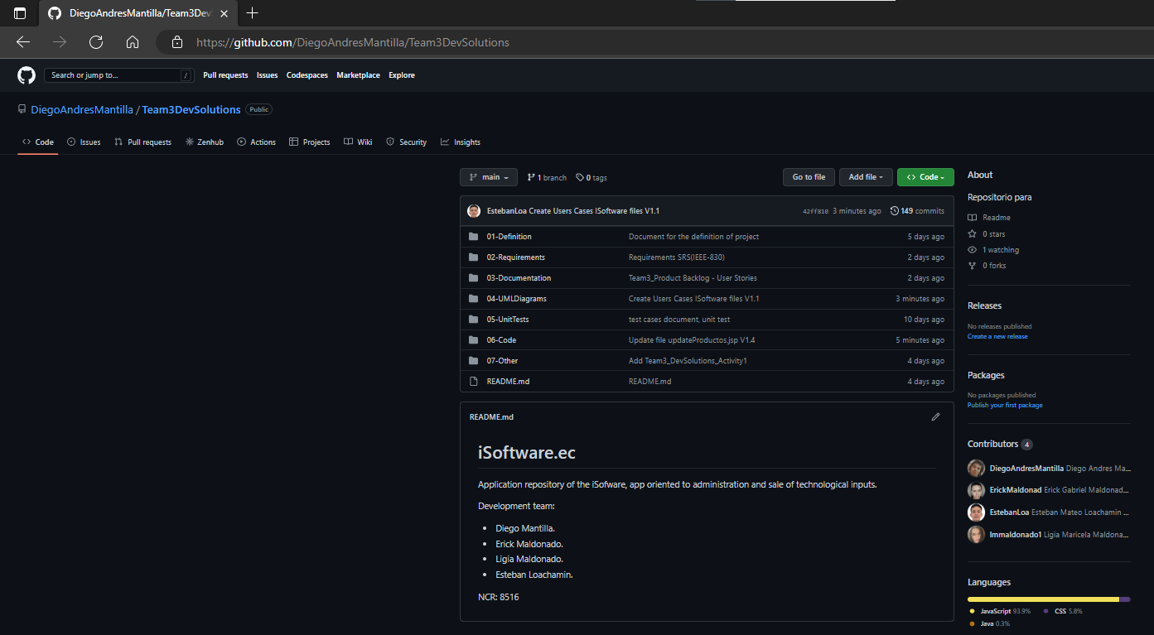

**1.1 Commits:**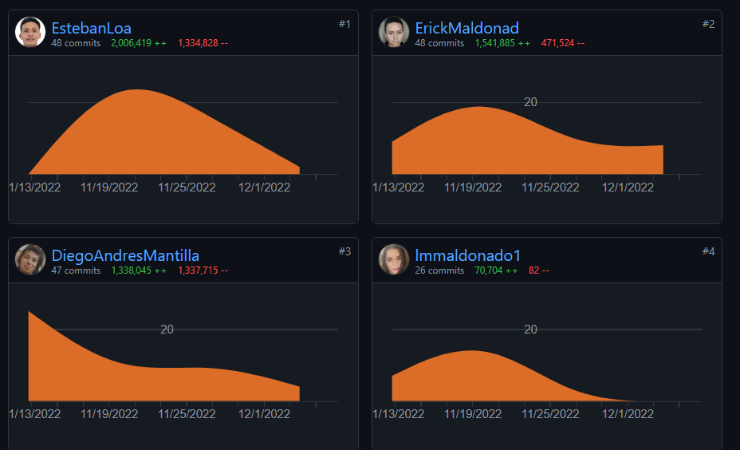

1. **List the features(Products Backlog)**

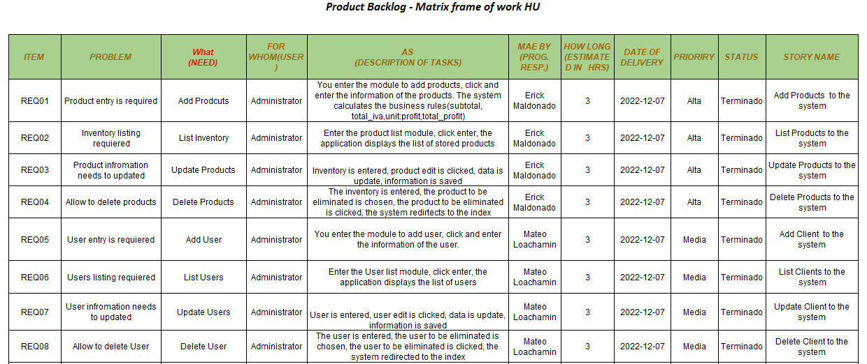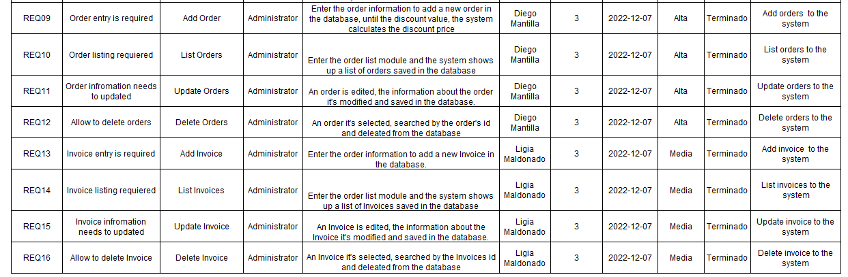

**2.2 Rest diagrams**

**2.2.1 Class diagrams**

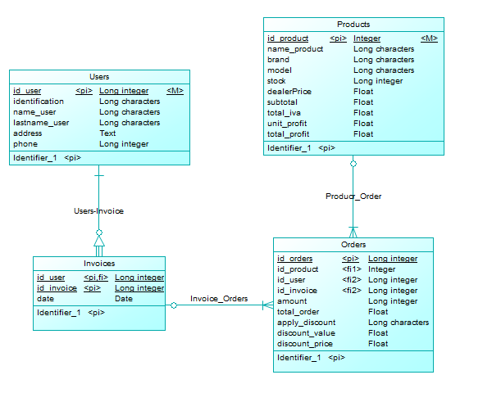

**2.2.2 Use cases diagrams**

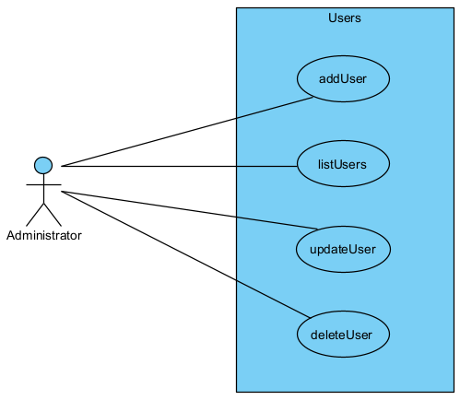

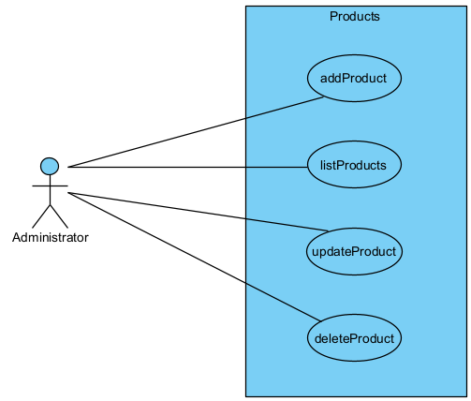

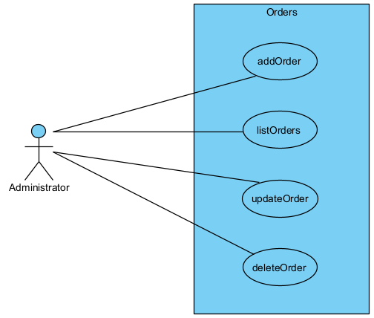

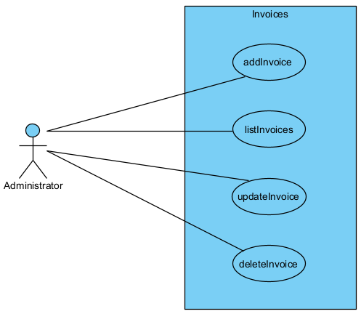

**2.2.3 Architecture**

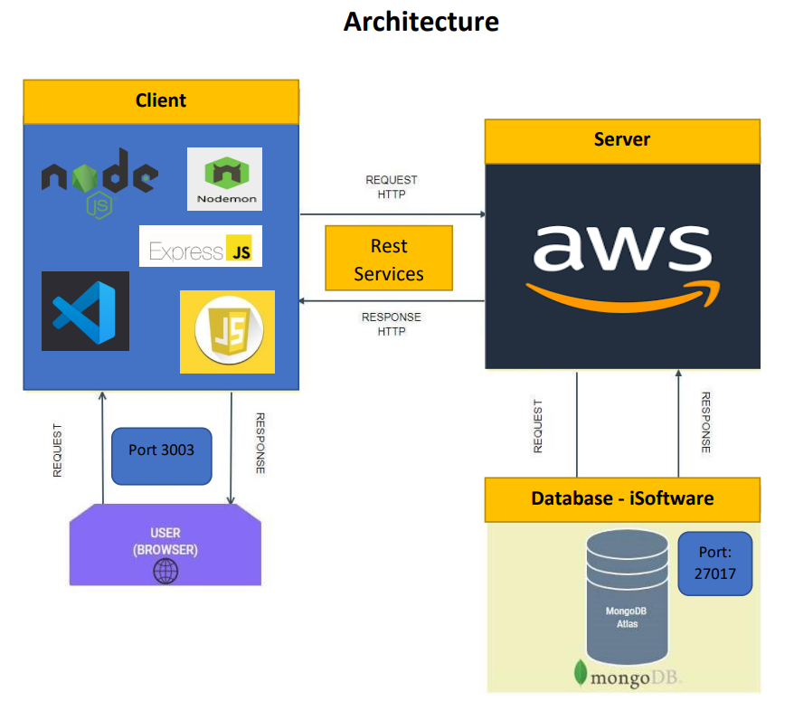

1. **URI designs**

**URI Layout**

**Product**

| **Method** | **post** |
| --- | --- |
| **URI** | <https://3.85.13.59:3003/iSoftware/addProduct> |
| **Body** |  |
| **Format** | **Json** |
| **Return** |  |

| **Method** | **get** |
| --- | --- |
| **URI** | <https://3.85.13.59:3003/iSoftware/listProducts> |
| **Body** |  |
| **Format** | **Json** |
| **Return** |  |

| **Method** | **put** |
| --- | --- |
| **URI** | <https://3.85.13.59:3003/iSoftware/updateProducts> |
| **Body** | id_product: { type: String } |
| **Format** | **Json** |
| **Return** |  |

| **Method** | **delete** |
| --- | --- |
| **URI** | <https://3.85.13.59:3003/iSoftware/deleteProduct> |
| **Body** | id_product: { type: String } |
| **Format** | **Json** |
| **Return** | **Deleted** |

**User**

| **Method** | **post** |
| --- | --- |
| **URI** | <https://3.85.13.59:3003/iSoftware/addUser> |
| **Body** |  |
| **Format** | **Json** |
| **Return** |  |

| **Method** | **get** |
| --- | --- |
| **URI** | <https://3.85.13.59:3003/iSoftware/listUsers> |
| **Body** |  |
| **Format** | **Json** |
| **Return** |  |

| **Method** | **put** |
| --- | --- |
| **URI** | <https://3.85.13.59:3003/iSoftware/lupdateUser> |
| **Body** | id_user: { type: String } |
| **Format** | **Json** |
| **Return** |  |

| **Method** | **delete** |
| --- | --- |
| **URI** | <https://3.85.13.59:3003/iSoftware/deleteUser> |
| **Body** | id_user: { type: String } |
| **Format** | **Json** |
| **Return** | **Deleted** |

**Order**

| **Method** | **post** |
| --- | --- |
| **URI** | https://3.85.13.59:3003/iSoftware/addOrder |
| **Body** |  |
| **Format** | **Json** |
| **Return** |  |

| **Method** | **get** |
| --- | --- |
| **URI** | https://3.85.13.59:3003/iSoftware/listOrders |
| **Body** |  |
| **Format** | **Json** |
| **Return** |  |

| **Method** | **put** |
| --- | --- |
| **URI** | https://3.85.13.59:3003/iSoftware/updateOrder |
| **Body** | id_order: { type: String } |
| **Format** | **Json** |
| **Return** |  |

| **Method** | **delete** |
| --- | --- |
| **URI** | https://3.85.13.59:3003/iSoftware/deleteOrder |
| **Body** | id_order: { type: String } |
| **Format** | **Json** |
| **Return** | **Deleted** |

**Invoice**

| **Method** | **post** |
| --- | --- |
| **URI** | https://3.85.13.59:3003/iSoftware/addInvoice |
| **Body** |  |
| **Format** | **Json** |
| **Return** |  |

| **Method** | **get** |
| --- | --- |
| **URI** | https://3.85.13.59:3003/iSoftware/listInvoices |
| **Body** |  |
| **Format** | **Json** |
| **Return** |  |

| **Method** | **put** |
| --- | --- |
| **URI** | https://3.85.13.59:3003/iSoftware/updateInvoice |
| **Body** | id_invoice: { type: String } |
| **Format** | **Json** |
| **Return** |  |

| **Method** | **delete** |
| --- | --- |
| **URI** | https://3.85.13.59:3003/iSoftware/deleteInvoice |
| **Body** | id_invoice: { type: String } |
| **Format** | **Json** |
| **Return** | **Deleted** |

1. **Web services, BDD, business rules in AWS**

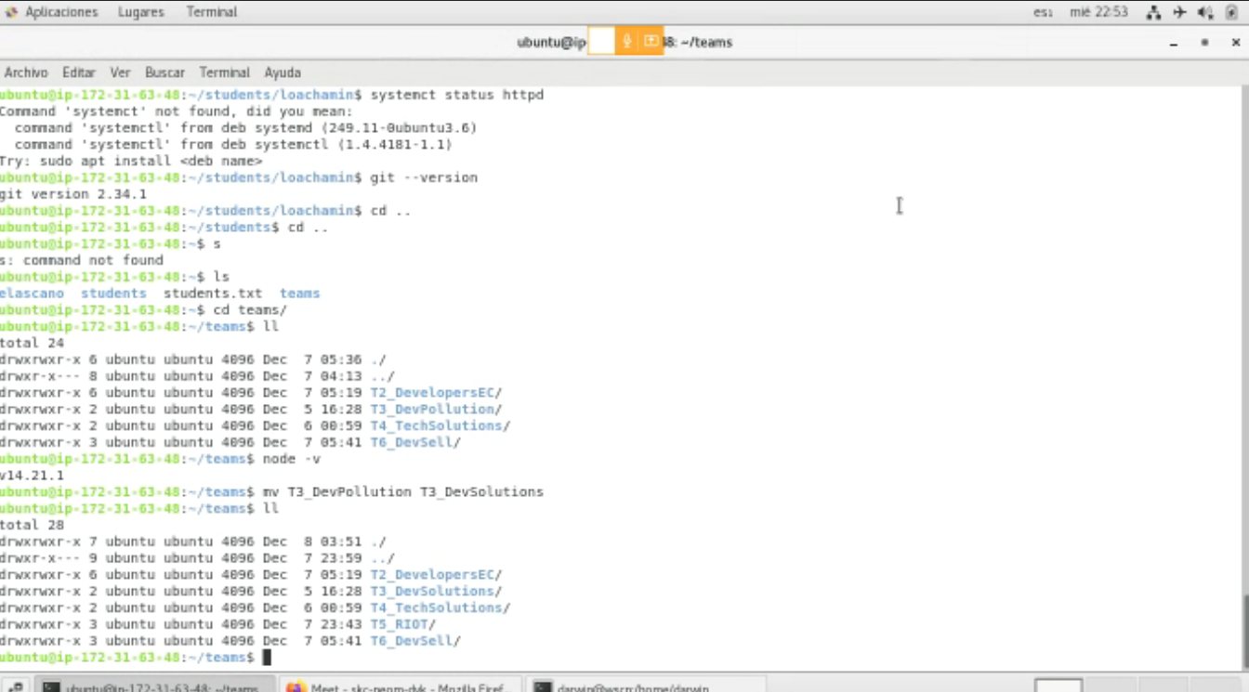

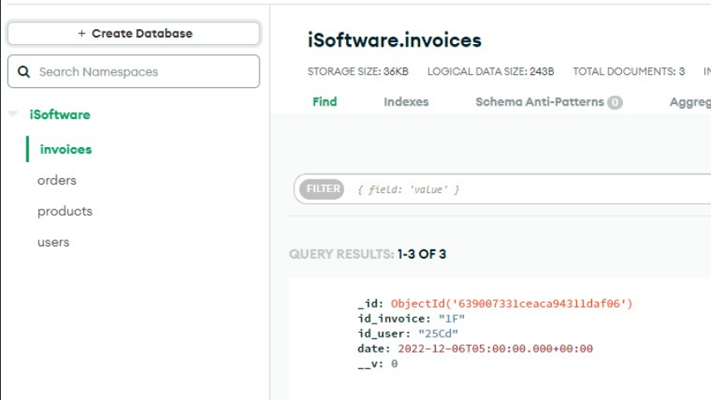

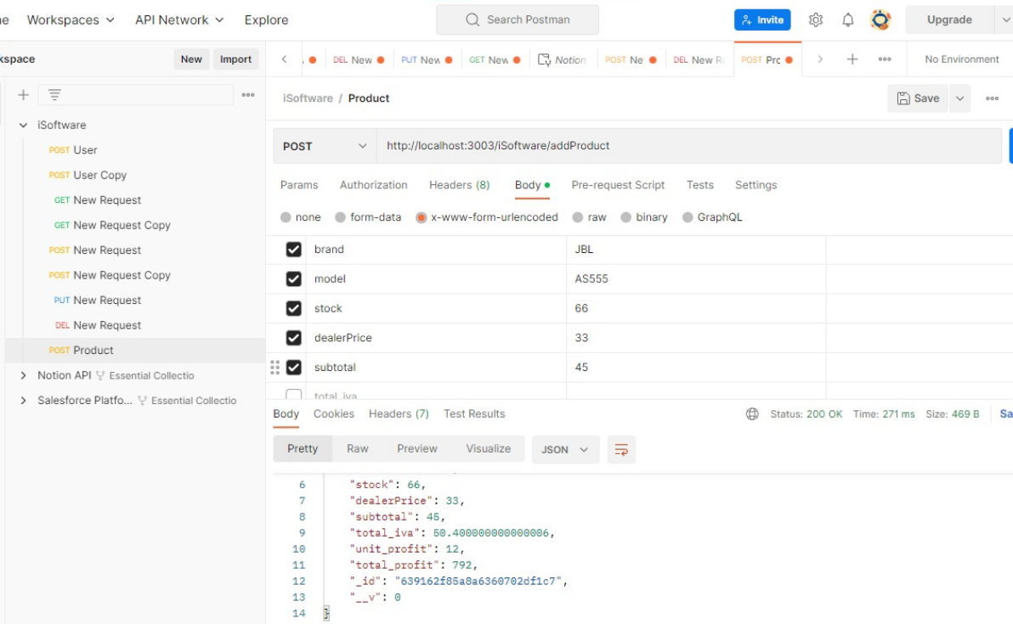

**Rubric**

1. GitHub repository (Structure and individual collaboration) /1
2. product Backlog + updated diagrams /1
3. Design of the URIs /1
4. Web Services + BDD + business rules in AWS or other Cloud /3

**Qualification /6**