Union Find – Percolation

**Purpose**

This lab was designed to teach you how to use an efficient data structure to solve a real-world problem.

**Percolation.** Given a composite system comprised of randomly distributed insulating and metallic materials: what fraction of the materials need to be metallic so that the composite system is an electrical conductor? Given a porous landscape with water on the surface (or oil below), under what conditions will the water be able to drain through to the bottom (or the oil to gush through to the surface)? Scientists have defined an abstract process known as *percolation* to model such situations.

**The model.** We model a percolation system using an *n*-by-*n* grid of *sites*. Each site is either *open* or *blocked*. A *full* site is an open site that can be connected to an open site in the top row via a chain of neighboring (left, right, up, down) open sites. We say the system *percolates* if there is a full site in the bottom row. In other words, a system percolates if we fill all open sites connected to the top row and that process fills some open site on the bottom row. (For the insulating/metallic materials example, the open sites correspond to metallic materials, so that a system that percolates has a metallic path from top to bottom, with full sites conducting. For the porous substance example, the open sites correspond to empty space through which water might flow, so that a system that percolates lets water fill open sites, flowing from top to bottom.)

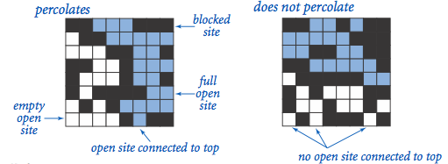

**The problem.** In a famous scientific problem, researchers are interested in the following question: if sites are independently set to be open with probability *p* (and therefore blocked with probability 1 − *p*), what is the probability that the system percolates? When *p* equals 0, the system does not percolate; when *p* equals 1, the system percolates. The plots below show the site vacancy probability *p* versus the percolation probability for 20-by-20 random grid (left) and 100-by-100 random grid (right).

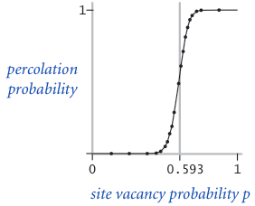               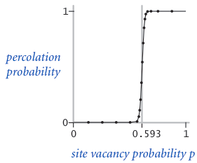

When *n* is sufficiently large, there is a *threshold* value *p*\* such that when *p* < *p*\* a random *n*-by-*n* grid almost never percolates, and when *p* > *p*\*, a random *n*-by-*n* grid almost always percolates. No mathematical solution for determining the percolation threshold *p*\* has yet been derived. Your task is to write a computer program to estimate *p*\*.

**Percolation.java is started for you.**

*Corner cases.* By convention, the row and column indices are integers between 1 and *n*, where (1, 1) is the upper-left site: Throw a java.lang.IndexOutOfBoundsException if any argument to open(), isOpen(), or isFull() is outside its prescribed range. The constructor should throw a java.lang.IllegalArgumentException if *n* ≤ 0.

*Performance requirements.* The constructor should take time proportional to *n*2; all methods should take constant time plus a constant number of calls to the union–find methods union(), find(), connected(), and count().

**Monte Carlo simulation.** To estimate the percolation threshold, consider the following computational experiment:

* Initialize all sites to be blocked.
* Repeat the following until the system percolates:
  + Choose a site uniformly at random among all blocked sites.
  + Open the site.
* The fraction of sites that are opened when the system percolates provides an estimate of the percolation threshold.

For example, if sites are opened in a 20-by-20 lattice according to the snapshots below, then our estimate of the percolation threshold is 204/400 = 0.51 because the system percolates when the 204th site is opened.

|  |  |  |  |  |
| --- | --- | --- | --- | --- |
|  | Percolation 50 sites  *50 open sites* | Percolation 100 sites  *100 open sites* | Percolation 150 sites  *150 open sites* | Percolation 204 sites  *204 open sites* |

By repeating this computation experiment *T* times and averaging the results, we obtain a more accurate estimate of the percolation threshold. Let *xt* be the fraction of open sites in computational experiment *t*. The sample mean $\overline{x}$ provides an estimate of the percolation threshold; the sample standard deviation *s*; measures the sharpness of the threshold.

$\overline{x}$ = $\frac{ x₁+x₂+…+xt}{T}$, $s^{2}$ = $\frac{ {(x₁ - \overline{x} )}^{2} + (x₂{ - \overline{x} )}^{2}+…+(xt{- \overline{x} )}^{2}}{T-1}$

Assuming *T* is sufficiently large (say, at least 30), the following provides a 95% confidence interval for the percolation threshold:

[ $\overline{x}$ − $\frac{1.96s}{√T}$, $\overline{x}$ + $\frac{1.96s}{√T}$]

To perform a series of computational experiments, create a data type PercolationStats with the following API.

**public class PercolationStats {**

**public PercolationStats(int n, int trials)**  // perform trials independent experiments on an n-by-n grid

**public double mean()**  // sample mean of percolation threshold

**public double stddev()**  // sample standard deviation of percolation threshold

**public double confidenceLo()**  // low endpoint of 95% confidence interval

**public double confidenceHi()**  // high endpoint of 95% confidence interval

**public static void main(String[] args)**  // test client (described below)

**}**

The constructor should throw a java.lang.IllegalArgumentException if either *n* ≤ 0 or *trials* ≤ 0.

Also, include a main() method that takes two *command-line arguments* *n* and *T*, performs *T* independent computational experiments (discussed above) on an *n*-by-*n* grid, and prints the mean, standard deviation, and the *95% confidence interval* for the percolation threshold. Use [StdRandom](http://algs4.cs.princeton.edu/code/javadoc/edu/princeton/cs/algs4/StdRandom.html) to generate random numbers; use [StdStats](http://algs4.cs.princeton.edu/code/javadoc/edu/princeton/cs/algs4/StdStats.html) to compute the sample mean and standard deviation.

% **java PercolationStats 200 100**

mean = 0.5929934999999997

stddev = 0.00876990421552567

95% confidence interval = 0.5912745987737567, 0.5947124012262428

% **java PercolationStats 200 100**

mean = 0.592877

stddev = 0.009990523717073799

95% confidence interval = 0.5909188573514536, 0.5948351426485464

% **java PercolationStats 2 10000**

mean = 0.666925

stddev = 0.11776536521033558

95% confidence interval = 0.6646167988418774, 0.6692332011581226

% **java PercolationStats 2 100000**

mean = 0.6669475

stddev = 0.11775205263262094

95% confidence interval = 0.666217665216461, 0.6676773347835391

**Program Files**

Percolation.java, PercolationVisualizer.java, InteractivePercolationVisualizer.java, and algs4.jar

**Command Prompt**

First go to the directory to where your java file is located by using cd and dir if needed or just copy and paste the directory from the properties option under location.

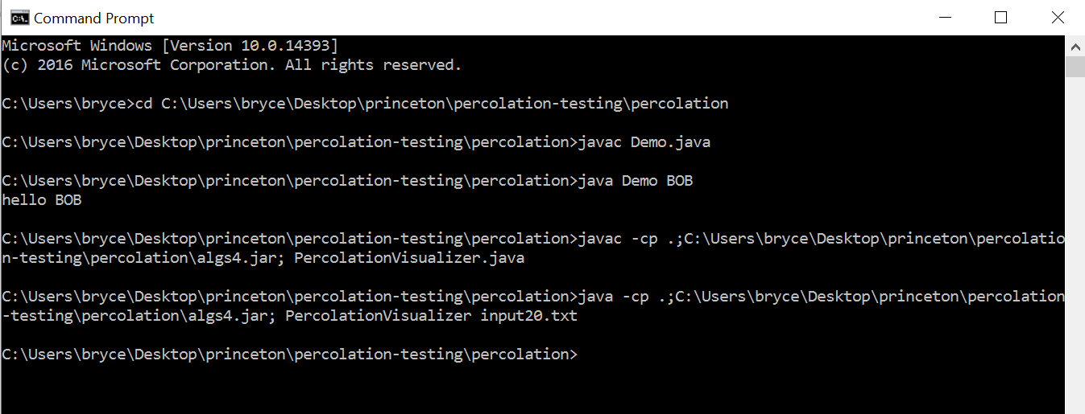

javac <classname.java> will compile

java <classname> will run

-cp .;“the file directory to the jar”; will add a jar file. Please notice the period and semicolon at the beginning and the semicolon at the end

In JCreator you can add a jar file by Configure, Options, JDK Profiles, double click jdk version, then add archive(in Netbeans – right click on project, properties, libraries, add jar/folder)