Computer Science Graphs – BFS-Part 2 Lab Value - 100

Lab Goal : This lab was designed to teach you how to implement a graph with an adjacency list and matrix.

Lab Description : In part two you will implement Dijkstra’s algorithm and A*. Do not modify any of the other classes but you will need to modify some of the classes that you designed in part one. Remember that Dijkstra’s algorithm finds the shortest path on a weighted graph and A* search will do the same but likely in fewer steps. Each time you pop a node bump up the count and when you reach the goal print out the number of steps that it took. It’s permissable if your count if off by one.

The test data is represented pictorially below with the shortest weighted path in yellow:
Files Needed ::
mapGraph.java

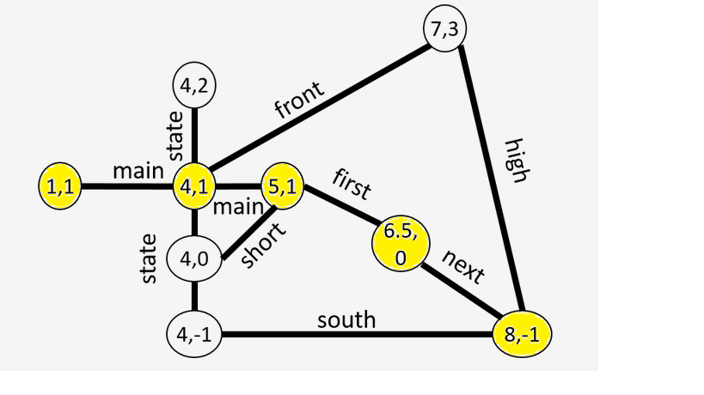

Sample Output :

Making a new map...DONE.
Loading the map...DONE.
Num nodes: 9
Num edges: 22
[Lat: 1.0, Lon: 1.0, Lat: 4.0, Lon: 1.0, Lat: 7.0, Lon: 3.0, Lat: 8.0, Lon: -1.0]
Dijkstra count: 9
[Lat: 1.0, Lon: 1.0, Lat: 4.0, Lon: 1.0, Lat: 5.0, Lon: 1.0, Lat: 6.5, Lon: 0.0, Lat: 8.0, Lon: -1.0]
AStar count: 5
[Lat: 1.0, Lon: 1.0, Lat: 4.0, Lon: 1.0, Lat: 5.0, Lon: 1.0, Lat: 6.5, Lon: 0.0, Lat: 8.0, Lon: -1.0]

// and afterwards run DijkstraGrader

Dijkstra count: 10
Dijkstra count: 7
Dijkstra count: 6
Dijkstra count: 29
Score: 1.0
Feedback: All tests passed. Great job!

MAP: Straight line (-3 <- -2 <- -1 <- 0 -> 1 -> 2-> 3 ->...)
** Test #1: Running Dijkstra's algorithm from (0.0, 0.0) to (6.0, 6.0)...PASSED.

MAP: Example map from the writeup
** Test #2: Running Dijkstra's algorithm from (7.0, 3.0) to (4.0, -1.0)...PASSED.

MAP: Right triangle (with a little detour)
** Test #3: Running Dijkstra's algorithm from (0.0, 0.0) to (0.0, 4.0)...PASSED.

UCSD MAP: Intersections around UCSD
** Test #4: Running Dijkstra's algorithm from (32.8709815, -117.2434254) to (32.8742087, -117.2381344)...PASSED.

// and afterwards run AStarGrader

AStar count: 7
AStar count: 4
AStar count: 6
AStar count: 12
Score: 1.0
Feedback: All tests passed. Great job!

MAP: Straight line (-3 <- -2 <- -1 <- 0 -> 1 -> 2-> 3 ->...)
** Test #1: Running A* from (0.0, 0.0) to (6.0, 6.0)...PASSED.

MAP: Example map from the writeup
** Test #2: Running A* from (7.0, 3.0) to (4.0, -1.0)...PASSED.

MAP: Right triangle (with a little detour)
** Test #3: Running A* from (0.0, 0.0) to (0.0, 4.0)...PASSED.

UCSD MAP: Intersections around UCSD
** Test #4: Running A* from (32.8709815, -117.2434254) to (32.8742087, -117.2381344)...PASSED.

