Group 2 – Session 2

**MILOSPORT INVENTORY MANAGEMENT**

**MGMT- 582 Management of Organizational Data Final Project**

**Group Members:**

Ryan Egbert, Diego Carlos Chavez, Zainab Aljaroudi

Chayadeepsai Cherukpalli, Bidrupa Sinha,Tamaralayefa Timiyan.

# Background

MILOSPORT is Utah's premier specialty retailer for skateboard, snowboard, and lifestyle products. It operates from three physical locations , has an online shopping platform and phone ordering service. It is a medium scale business with apparent seasonal sales trends. During the peak months (September – February) MILOSPORT averages around 1000-2000 orders per month. It has a wide customer spread from different regions of the US.

The dataset provided by the company offers information for the following areas:

* Products, categories, and suppliers
* Order information for the month of October 2021
* Promotion/discounts on products
* Customer specifics (name, address, etc.)
* Order fulfillment and channel information

# Dataset Description

The entire dataset is grouped into 8 categories containing information ranging from product, shipping, order and customer information. The list below shows the description of each dataset group in detail:

1. Products - The product dataset contains information on SKUID, title, price and cost of purchase. It also contains inventory levels, the supplier ID and promotions ID of each unique product.
2. Supplier – The supplier dataset contains information on the supplier ID, supplier name, manufacturing location and contact information.
3. Category – The category dataset contains information on the category ID and the category name of each product category currently offered by the company.
4. Orders – The orders dataset contains information of the order ID, basket value and date of each order. It also contains information on the customer and channel corresponding to the order.
5. Promotion – The promotion dataset contains information on the promotion ID as well as the corresponding Start and End date for each promotion type.
6. Fulfillment – The fulfillment dataset contains information on the shipping ID for each order, as well as the tracking ID, shipping date and courier information.
7. Channel – The channel dataset contains information on the different channels currently used by the company which includes the channel ID and channel name.
8. Customer – The customer dataset contains information on each customer including the Customer ID, Name, Address – Street, City, State and Zip Code, as well as the contact phone number for each customer.

# Introduction - Project Summary/objectives

Due to the nature of running an omnichannel retail store, good inventory management is key to reducing unnecessary costs and improving inventory turnaround. This project covers the creation of an efficient inventory management database system with the following entities: product, vendor, category, orders, promotion, fulfillment, channel, and customer.

Retail inventory management works by creating systems to log products, receive them into inventory, track changes when sales occur, manage the flow of goods from purchasing to final sale and check stock counts. An efficient inventory management system helps retailers maximize profits and minimize expenses by preventing stock-outs and overstocking. We aim to achieve the following business objectives by creating a database solution for MILOSPORT:

**Decreases Inventory Costs**

When retailers understand the quantities to stock, they can pinpoint inventory levels more accurately, thereby reducing storage and carrying costs for excess merchandise.

**Minimizes Out-of-Stocks**

Inventory management helps prevent missed sales by preventing stock outs. Retailers can use inventory management tools to determine the “just right” stocking quantities to have on hand. Another advantage of real-time information on sales and stock helps retailers to react quickly by reordering, transferring stock from another location or drop shipping to the customer.

**Improves Profit Margins**

Lower inventory costs and the right supply to fill every order improves profitability.

**Prevents Spoilage and Obsolescence**

Inventory management helps retailers address costly inefficiencies that occur when products expire or become obsolete. For example, seasonal collections or holiday-specific packaging may face plummeting demands.

**Improves Multi-Channel and Omnichannel Performance and Order Fulfillment**

It is often very difficult to keep track of correct inventory counts across all channels that a retailer uses. Having accurate inventory data across selling channels helps improve inventory utilization and ultimately gets the product to consumers faster.

**Simplifies Processes and Facilitates Growth**

Strong inventory management also reduces friction in system as sales grow. Shipping, receiving and order fulfillment run more smoothly which minimizes error, customer complaint and staff stress.

**Improves Customers Satisfaction**

When customers get the product they want faster with fewer mistakes or out-of-stocks, it increases customer loyalty.

**Improves Forecasting**

Retailers can use data such as historical sales results and available inventory to project future sales, growth and capital needs. These forecasts are vital to budgeting and helps guide spending for marketing, product development and staffing.

# Conceptual Data Modelling

**Entity Relational Diagram**

To begin the conceptual modelling of the database, we decided the attributes necessary for each dataset. In addition, we further broke down several entities into associative entities, thus removing the need for many to many relationships in our model.

# Relational Data Model

|  |  |  |
| --- | --- | --- |
|  | Primary Keys | Foreign Keys |
| Supplier | SupplierID |  |
| Product | SKUID | SupplierID, PromotionID |
| Promotion | PromotionID |  |
| Category | CategoryID |  |
| Product_Category | SKUID, CategoryID | SKUID, CategoryID |
| Channel | ChannelID |  |
| Customer | CustID |  |
| Order | OrderID | CustID, ChannelID |
| Product_Order | SKUID, OrderID | SKUID, OrderID |
| Fulfillment | ShippingID | OrderID |

Having finished our conceptual design, we moved on to creating connections between the different entities. We identified primary and foreign keys, other attributes, and relationships between the entities.

# Normalization analysis

The pre-cleaned data received from the company was in 0 Normal Form. It contained Null Values, multivalued attributes, and composite attributes which led to the presence of update, delete and insert anomalies . Normalization was implemented in order to

1. Maintain thematic separation in the database
2. Avoid redundant data
3. Avoid anomalies (insert, delete, update)
4. Maintain data integrity

To get the data to 3NF and eliminate these anomalies, we followed the following steps:

1. Ensured that each tuple contained exactly one value for each attribute. We eliminated multi-valued and composite attributes mainly from the address and name columns.
2. Ensured that there were no partial dependencies. All MILOSPORT relations had one attribute as their primary key, and therefore no partial dependencies existed.
3. Ensured that there were no transitive dependencies.
4. Ensured that there were no null values and duplicates in the primary key attributes.

## Pre-Normalization

Before normalization, MILOSPORT provided three datasets, Product, Order, and Transaction with 49, 78, and 9 columns, respectively.

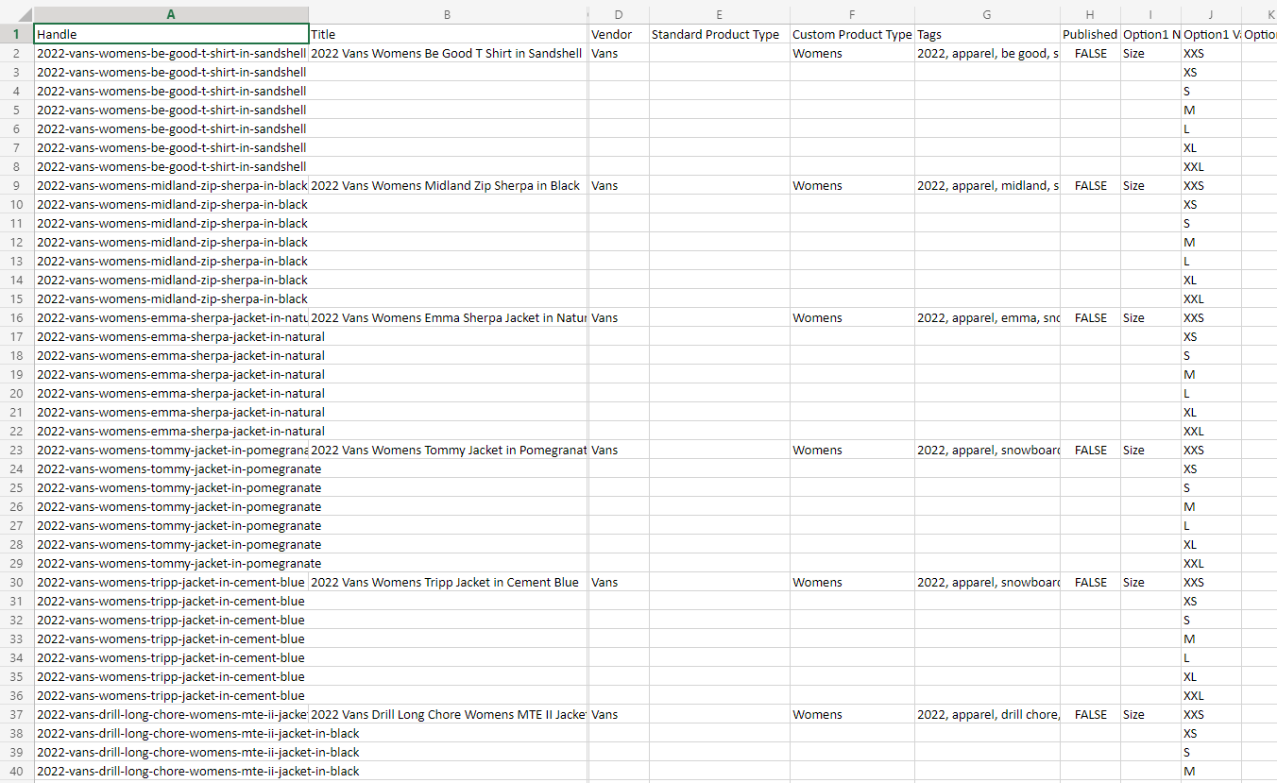

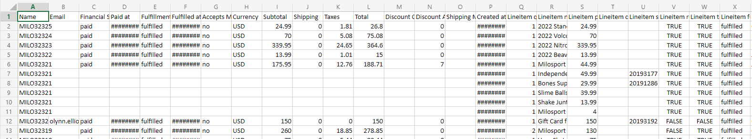

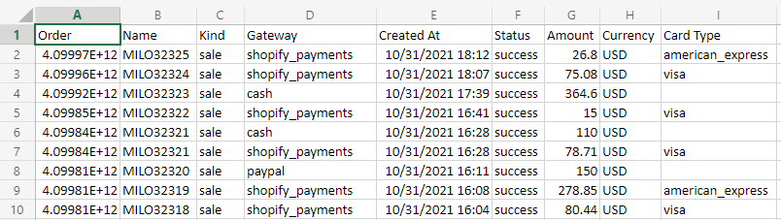

## Post-Normalization

|  |  |
| --- | --- |
| Product | Promotion |
| Supplier | Fulfillment |
| Category | Channel |
| Order | Customer |

# Database Implementation

The queries used in this study aim to solve several business problems by achieving the following:

1. Identifying out of stock items by category
2. Archiving products that are no longer sold(from previous years)
3. Possible expansion of business – Identifying the most profitable city
4. Identifying the most sold items for the month
5. Identifying what channels are preferable by the customer
6. Identifying the top 5 profitable categories
7. Identifying the bottom 5 profitable categories
8. Identifying the most profitable business partners
9. Identifying the high-end products
10. Binning the cart value to identify possible promotion strategies
11. Identifying the most used fulfillment channel to negotiate better terms

## SQL QUERIES AND RESULTS

1. The first query aims to retrieve old products that have high inventory quantities in stock. Based on the output, we recommend applying a discount on these products to reduce inventory costs and potential obsolescence and spoilage.

1. The second query calculates the average profit per supplier by subtracting the cost of purchase for each product from the selling price. This helps in identifying the company’s most profitable partners to target possible expansion of business with these suppliers.

1. The third query aims to identify the cities with the highest number of orders in order to recommend areas of possible expansion for the business. The results show that Waldorf, Maryland will be a good city for possible expansion as it contains the highest number of orders.

1. The fourth query aims to identify the most frequently used courier company in order to propose a long term contract as well as negotiation for reduced delivery rates. The results show that USPS is the most frequently used courier service and therefore we recommend it as a good candidate for a prolonged contract.

1. The fifth query aims to identify the top selling products in order to plan inventory both seasonally as well as annually. It will also help to prevent stock outs for top selling products and provide insights into the top selling category. The results of the below query highlights the top 10 selling products including specific suspenders, skate shoes, snow boards and skateboards among others.Graphical user interface, text, application, email

   Description automatically generated
2. The sixth query aims to identify the volumes sold per channel. This helps identify the channel that is most frequented by customers. The result from the query shows that the in-store channel is the most frequented. We understand that in-spite of having a website, it is under-utilized and we can run a few promotional programs to drive more traffic to online customers.

1. The seventh query aims to identify the most profitable categories so that the company can introduce similar products that are more likely to become a success in terms of earnings. Furthermore, MiloSport needs to know in which categories the company should have an adequate amount of inventory to avoid lost sales. The results show that Gift Cards, Consignments, Custom Bundles, Jackets and Women are the most profitable categories. In the case of Gift Cards, we recommend that the company directs its marketing efforts to increase the number of gift cards bought by customers.

1. The eighth query aims to identify the least profitable categories so that the company can focus on increasing their demand. The results show that Magazines, Bearings, Stances, Beanies and Shirts are the least profitable categories and therefore we recommend that the company do some research regarding the quantity sold for each category. If the number of items sold in those categories is low, then Milosport should probably decide to bundle them with other categories through promotions to increase demand.

1. The ninth query aims to extract the stock out items by categories. This query helps to understand and prioritize the most stocked out items and prepare for replenishment. An important item to consider is that ‘snow’ and ‘skate’ items will often be out of stock due to the seasonal nature of snowboarding and skateboarding.

1. The tenth query aims to see the distribution of orders in different basket values. This helps us to gain valuable insights about spread of orders. This query resulted in placing the basket values for the orders in 5 different buckets. By viewing the information this way, we can easily see that a vast majority of the orders were under $250. Furthermore, we can investigate the basket value distributions of promoted and non-promoted items and use targeted promotions to nudge consumers into purchasing more.

1. The eleventh query aims to provide the low inventory by category for non-promotion items. This view helps us to identify the SKU’s that need replenishment. Also, by tracking the change in the inventory we can understand the velocity and throughputs of different categories.

# Business Recommendations – Summary.

* With the information for top selling products, it is recommended that the inventory for these products should be planned both seasonally and annually to avoid stockouts.
* Optimization of the website  is highly recommended to drive more traffic and create an omni-channel experience. Milosport can run promotions on its website and provide  differential discounts on total basket value. This will help bring in new customers and will help increase basket value.
* The city Waldorf in Maryland contains the highest number of orders. Therefore, we suggest possible expansion of the business in this city in terms of an outlet center or a new branch of the store.
* Currently, most of the orders are fulfilled through USPS. With that, it is recommended to negotiate reduced delivery rates with USPS as a preferred fulfillment service provider.