Ejercicio_Tarea.R

Usuario

2023-09-05

# Diego David Flores Cadena  
# 05/09/2023  
# Matricula: 2070509  
  
  
# Importar ----------------------------------------------------------------  
  
setwd("C:/Repositorio_GIT_DiegoFlores/Met.ES/Codigos")  
Tarea<-read.csv("Tarea.csv",header = T)  
  
  
# Descriptivas ------------------------------------------------------------  
  
library(dplyr)

##   
## Attaching package: 'dplyr'

## The following objects are masked from 'package:stats':  
##   
## filter, lag

## The following objects are masked from 'package:base':  
##   
## intersect, setdiff, setequal, union

A<-Tarea %>%   
 filter(Tratamiento == "A")  
  
B<-Tarea %>%  
 filter(Tratamiento == "B")  
  
mean(A$Diametro)

## [1] 39.76467

mean(B$Diametro)

## [1] 45.89167

Descriptor<-Tarea %>%   
 group_by(Tratamiento) %>%   
 summarise(  
 n=n(),  
 media=mean(Diametro),  
 mediana=median(Diametro),  
 sd=sd(Diametro),  
 var=var(Diametro)  
 )  
  
Descriptor

## # A tibble: 2 × 6  
## Tratamiento n media mediana sd var  
## <chr> <int> <dbl> <dbl> <dbl> <dbl>  
## 1 A 30 39.8 39.6 4.90 24.1  
## 2 B 30 45.9 45.2 4.17 17.4

# Gráfica -----------------------------------------------------------------  
  
boxplot(Tarea$Diametro~Tarea$Tratamiento,  
 xlab = "Tratamiento",  
 ylab = "Diametro",  
 main = "Árboles Diego",  
 col = "gold")

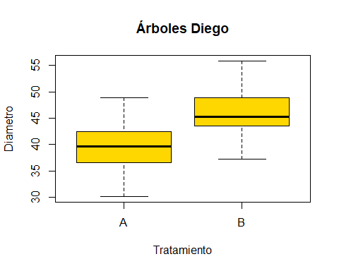

t.test(Tarea$Diametro~Tarea$Tratamiento,var.equal=T)

##   
## Two Sample t-test  
##   
## data: Tarea$Diametro by Tarea$Tratamiento  
## t = -5.2103, df = 58, p-value = 2.61e-06  
## alternative hypothesis: true difference in means between group A and group B is not equal to 0  
## 95 percent confidence interval:  
## -8.480898 -3.773102  
## sample estimates:  
## mean in group A mean in group B   
## 39.76467 45.89167

# Conclusiones ------------------------------------------------------------  
  
#En conclusión los árboles tratados con el fertilizante resultaron perjudicados, ya que,  
#su diametro es menor que los árboles que no utilizaron fertilizante.