**Kraenau Rodríguez, Diego Armando**

**diegokraenau@gmail.com | +51 958480647 | https://www.linkedin.com/in/diegokraenau/**

**Location: Perú(Lima)-Surco-Condominios Parque de Surco 2**

**Software Engineer Student (ninth cycle,20 years old)**

I consider myself and extremely punctual and hones person at the work level, adding that I have great techniques for teamwork and I also consider myself a self-taught person with current issues.

# SKILLS

|  |  |  |  |  |  |  |  |  |  |  |  |
| --- | --- | --- | --- | --- | --- | --- | --- | --- | --- | --- | --- |
| **Platforms** | | | | | | | | | | | |
| Windows | AWS | | | IntelliJ IDEA | Microsoft Azure | | | | Spring Boot | Visual Studio Code | |
| Visual Studio | Sharepoitn with |  | | | |  | |  | | |
|  | PowerApps | |  | | | |
|  |  |  | | | |  | |  | | |
| **Technologies** | | | | | | | | | | | |
| Java | C# | | | C++ | Flutter(Dart) | | | | Android | Python | |
| Angular | ReactJs-Redux | | | Typescript | Kotlin | | | | Html ,CSS,SASS | Firebase | |
| Json | APIs | | | .Net | REST Services | | | | NodeJs(Express) | Docker | |
|  |  | | |  |  | | | |  |  | |
| **Databases** | | | | | | | | | | | |
| SQLServer | MySql | | | PostgreSQL | MongoDB | | | | Oracle(Basic) |  | |
| **Others** | | | | | | | | | | | |
| GitHub | AdobeXD | | | FTP(WINSCP) | Swagger | | | | Postman | Git | |
| Knowledge | Agile | | |  |  | | | |  |  | |
| About Software | Development | | | Trello | Selenium | | | | Office 365 | MVC and no | |
| Architecture |  | | |  |  | | | |  | Traditional web app | |
|  |  | | |  |  | | | |  | apps | |
| **Soft Skills** | | | | | | | | | | | |
| |  |  |  |  |  | | --- | --- | --- | --- | --- | | Team Work | Communication skills | Self-taught person | Decision-making | Conflict resolution | | | | | | | | | | | | |

# WORK EXPERIENCE

|  |  |
| --- | --- |
| **WHIZ | Brand & Tech Partner**  **Functional Analyst** | **Lima, Peru**  **(28/01/2021–Now)** |

* **Monitoring and analysis of software projects(28/01/2021– Now)**

During my stay in this company I was integrated into like 6 or 7 software projects where in some I did functional documents for the next functional systems and I also followed up on various software projects in which I was also involved.

|  |  |
| --- | --- |
| **FORCECLOSE**  **Developer Junior** | **Lima, Peru**  **(3/10/2020– 31/12/2020)** |

* **Documentation and Unit Tests for Niubiz (3/10/2020– 30/10/2020)**

I made an improvement to the documentation of Niubiz API´s with some Unit Tests because they wanted to change his previous documentation and need it will be more readable for the users would use. During my stay in FORCECLOSE , I could learn more about agile practices.

Technologies:

-Postman

-Spring

* **Budget Management Module for a mining (30/10/2020– 31/12/2020)**

I created a budget management module for a mining, which is called “San Martin Contratistas Generales”, it was made with Sharepoint and PowerApps to manage the flows. The main function of this module is to allow the budgeting area to manage their budgets ,also to be able to communicate with the other areas for a request.

Technologies:

-Sharepoint

-PowerApps

|  |  |
| --- | --- |
| **Software y Consultoría Proemsa S.A**  **Web Developer Junior** | **Lima, Peru**  **(10/03/2020– 30/08/2020)** |

### Peruvian company with more than 15 years of experience in the development of business software solutions and facing technological changes with web development and mobile solutions.

### During this time I participated in the following projects:

* **PergilGX (17/03/2020– 30/08/2020)**

It is a software that manages and controls the personnel of your company, as well as the processes of the organizational structure and all the administration of human capital. In addition, it automates the processes of selection, hiring, remuneration, attendance control, training, performance evaluation and talent management.

Main tasks executed in the project:

* Maintenance of diversity of payment slips to clients
* Search data or make queries to extract data from database
* Maintenance of attendance control and employee compensation

One of my greatest contributions during my stay in Proemsa was that I created a function to reformulate the pay slip because at the beginning of the pandemic a problem arose with the Pension Fund Administrator and other clients wanted to reformulate the formula to calculate compensation for service time.

Technologies:

-GeneXus(Software to make Software, is a software created with artificial intelligence)

-MySql

-PostgreSQL

-EC2 (AWS)

-Winscp

* **ProcontGX (17/03/2020– 30/08/2020)**

It is an accounting and finance solution that provides optimal budget monitoring as well as automation of the accounting area to improve decision making. It is aimed at industrial, agricultural, commercial, services, financial, shipping companies, construction companies, mining companies. It allows you to keep accounting in real time and obtain managerial, analytical, operational and tax information about your company,

Main tasks executed in the project:

* Maintenance of checking accounts for employees
* Maintenance of payment of deductions ,accounting books

Creation of a function that basically tries to pass information from an accounting book in txt or excel format to the Procont system for later saving in the database.

Technologies:

-GeneXus(Software to make Software, is a software created with artificial intelligence)

-MySql

-PostgreSQL

-EC2 (AWS)

-Winscp

# EDUCATION

|  |  |  |
| --- | --- | --- |
| March/2013 – December/2016 | High-school education | Trilce schools |
| March/2017 – Now | Software Engineer Student | Universidad Peruana de Ciencias Aplicadas(UPC) |
| January/2012 – Jun/2016 | Advanced Certificate in English | Asociación Cultural Peruano Británico |

# LANGUAGES

|  |  |  |
| --- | --- | --- |
| **Spanish:** Native | **English:** Advanced | **Other Language:** ---- |

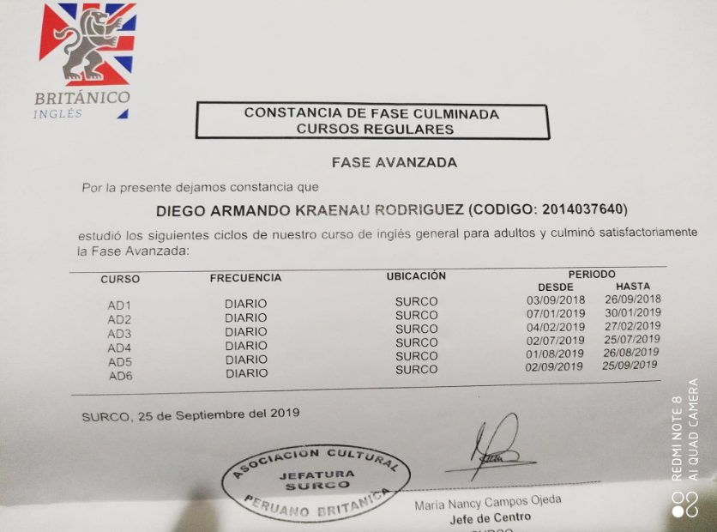

# Most Important Projects

These are few projects that I consider that are the most important and completes, but also you can find other projects on my GitHub: ***https://github.com/DiegoKraenau***

* CLI for Nodejs : **npx create-backend-ddd**

Description: A CLI built in Node.js, to automate the process of creating a rest api with DDD architecture

-GitHub: [***https://github.com/DiegoKraenau/create-backend-DDD***](https://github.com/DiegoKraenau/create-backend-DDD)

-Npmjs: ***https://www.npmjs.com/package/create-backend-ddd***

Features:

✓ Support for MySql and PostgreSQL ✓ Sequelize(Mysql, Postgresql) Support

✓ Express Ready for Promises (Async / Await) ✓ Example Endpoint

✓ Fully configured environment variables ✓ Scaffolding

✓ DDD architecture ✓ Docker compose

✓ JWT ✓ Awilix

✓ IOC (Inversion of Control)

* A package for react applications : **npm loading-screen-kraenau**

Description: A simple component created for the only reason of providing a responsive loading screen customable for applications made in ReactJs.

-GitHub: ***https://github.com/DiegoKraenau/Loding-Screen***

-Npmjs: [***https://www.npmjs.com/package/loading-screen-kraenau***](https://www.npmjs.com/package/loading-screen-kraenau)

* Frontend Challenges :

Description: In this section, I will show some frontend challenges that I did in the web Frontend Mentor (<https://www.frontendmentor.io>).

* Manage Landing Page:

Web deployed: ***https://diegokraenau.github.io/landing/***

GitHub: ***https://github.com/DiegoKraenau/landing***