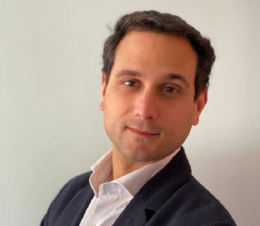

Diego | 61867982 | diego@cosermo.com

# About me

I'm a passionate of structural engineering

# Work experience

**LosBlancos** *2015-2021*I'm in charge of a group of ten steel detailer

**COsermo** *2021-present*Stress analysis for piping system

# Hard skills

* Tekla
* CYPE
* IdeaStatica