It’s a simple Web Api project that contains the 4 controllers

GetOnCurrentFloor/{floor}

This end point takes an integer and process the request of get elevator on current floor.

BroughtToFloor/{floor}

This end point takes an integer and process the request of brining the person on requested floor.

elevatorRequestsAll

This end point takes and list of integers and process the request from elevator car to move on list of floors.

elevatorRequestsNext/{direction}

This end point takes a direction from user and move the user one floor up or down according to the direction.  
  
currently application is running on port 5147, I have attached the screen short blow.

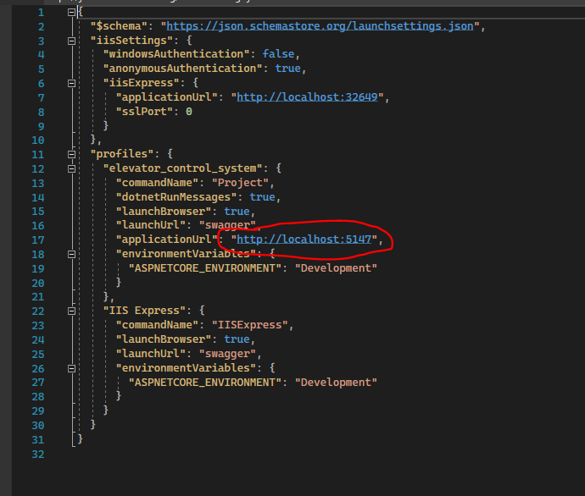

We can change the port to 8080 here in properties/ launchSettings.json.