Llistes de Distribució
- Instal·lació
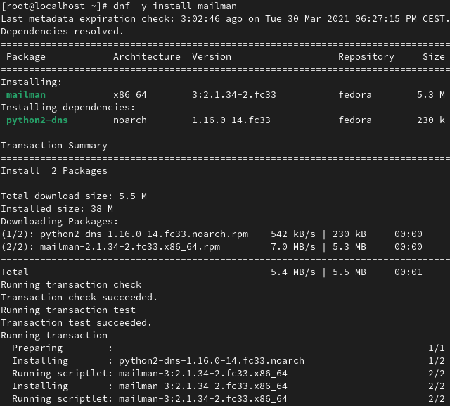
- Configuració
  - as
  - as
  - as
  - as
  - as
  - as
  - as
  - as
  - as
  - as
  - as
  - as
- Comprovació
  - as
  - as
  - as
  - as
  - as
  - as
  - as
  - as
  - as
  - as
  - as
  - as
  - as
  - as
  - as
  - a

