Prices and Chart of SPY Graph

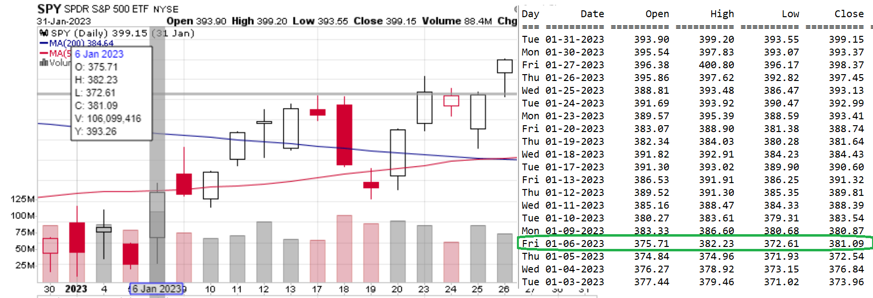

**Problem Statement:** Given a Date Range, and a list of Prices for the respective Stock Symbol as shown above, determine how the following strategy would pan-out.  
Assume Date Range: 1/1/2023 -> 2/28/2023  
Note “Open” price the first day of Date Range (e.g. 377.44 on 1/3/2023)  
Determine which arrives first 30 days, 6% rise or 8% drop in price (8% drop from $377.44 = 377.44 x 0.92 = **$347.21**), (6% rise from $377.44 = 377.44 x 1.06 = **$400.09**)  
To determine whether 8% drop Price was reached, you need to examine the “Low” price of the respective date.  
In above example, from 1/3/2023 until 1/31/2023, Low price always stayed above $347.21)

To determine whether 6% rise Price was reached, you need to examine the “High” price of the respective date.  
In above screenshot, High price on 1/27/2023 reached 400.80, which was above $400.09.

The Stock/ETF Symbol, % drop, % rise and number of days should be inputs for the program.  
Enter Stock/ETF Symbol (e.g. SPY):  
Enter % Drop (e.g 8):   
Enter % Rise (e.g 6):   
Enter Number of Days to Alert (e.g. 30):  
  
Once either of above is reached, start over on the subsequent date.  
  
Program should output:  
When % rise Alert is reached  
HIGH ALERT REACHED - Fri Jan 27 2023  
DAYS PASSED: 23  
Start Date: Tue Jan 03 2023  
Cur High: 400.80  
  
When % drop Alert is reached  
LOW ALERT REACHED – [Day Mon DD YYYY]  
DAYS PASSED: [##]  
Start Date: [Day Mon DD YYYY]  
Cur Low: ###.##

When Number of Days Alert is reached  
## DAYS ALERT REACHED – [Day Mon DD YYYY]  
Start Date: [Day Mon DD YYYY]  
  
  
**Phase # 2:** Find % drop which works 80% of the time.  
Given a Stock/ETF Symbol and Number of Days to Alert, find the best lowest % drop which would work 80% of the time.  
% Drop should be a round Integer Number Minimum of 6 and maximum of 14 (e.g. 6, 8, 10, 12 or 14).  
Note: % rise is calculated as follows: % rise = (% drop x 3 ) / 4. (e.g. if % drop = 10 => % rise = 10 x 3 / 4 = 7.5%)  
  
Only two inputs will be needed in Phase # 2  
Enter Stock/ETF Symbol (e.g. SPY):  
Enter Number of Days to Alert (e.g. 30):  
  
  
**Phase # 3:** Allow the use of “Close” price of previous day, instead of “Open” price of current day, when starting over on the subsequent date.  
  
Inputs for Phase # 3  
Enter Price to Start Calculation (e.g. 1 -> Open today or 2 -> Close Prev)  
Enter Stock/ETF Symbol (e.g. SPY):  
Enter Number of Days to Alert (e.g. 30):