Diego Goncalves Eliseu
Prf. Benton
ENC1101-26 Fall 0026

League of Legends is a 5v5 MOBA video game that came out in 2009 which for a video game it’s a miracle for a game that lasts this long in popularity, the game has 5 roles for each team. The roles are Top, Jungle, Mid, Bot, and Support. The goal of the game is to the destroy the enemy base with each role staring the game against the enemy with the same role they gain gold to buy items which upgrade your champion and later in the game they team fight over neutral objectives to decide who will win the game.
League of Legends is a game that has a unique discourse community as it is a very long Stading game compared to most. “We needed these specialized terms—this musician’s lexis—to make sure we were all playing together effectively” (Melzer 105). ” Like how they needed specialized terms like musician’s lexis League needs their own like Ganking,CC,Item economy, wave freezing. Also “A discourse community [is] a community of people who share the same goals, the same methods of communicating, the same genres, and the same lexis” (Melzer 102).” Which this quotes shows that league is a discourse community by having the same goals which is to win and the same method of communication which is by typing or pings like the “Enemy missing” ping which can be used if an enemy is missing from lane or when you do a bad play or when you do a good play.

In League of Legends, it’s a unique game with many things that you need to know to play competitive games. The community of League of Legends creates many lingo for specific things that if don’t know these thing you would be considered a noob .As examples there is ganking which is when a jungler goes to ambush one the laners to kill them , Csing is when you kill the minions with the last hit to get gold , jg/top/mid/bot/sup diff which is as LoL 5v5 game and everyone has one role they type in the chat top diff if they think that it was the enemy top lane was much better then their top laner which caused them to lose game, and Inter which is what you call someone when you think that they are intentionally trying to lose the game. The competitive and communicative value of the League of Legends community by creating terms to help communicate in game to work together like “be careful the jungler might gank top”, and terms like inter to call out the teammates who are performing sub optimally.

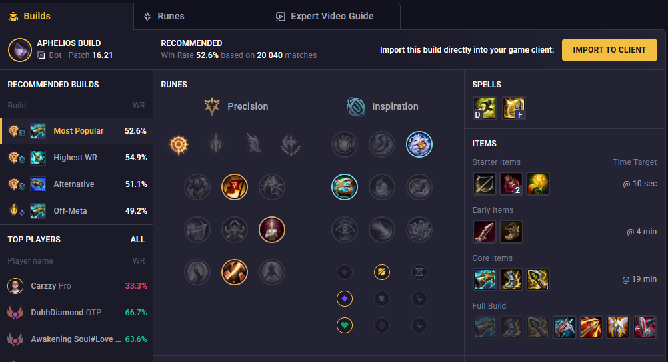
With the complicated nature of League of Legends, the community needed a way for help to figure it out that’s where websites/apps like mobalytics. To show some context for the game there are 173 different champions you can control with 5 different ability for each one and 200 different items where you can buy over 6 items a game, 375 different rune page combinations, 60 different summoner spell combinations. With mobalytics they allow you to search up a champion and they give you the most optimal runes,items to build on your character every game for every champion.They also have expert video guides explaing the abilitys and combos to do with the champion you searched up.With a lot of the community using this or similar aaps it shows the dedication to being the best in a competitive envitoment.

Concluding the League of Legends community is a discorse community that due to the circumesence of how the game is they create their own lingo to help communite things in game in a short and consise way.Also they create artifact like Mobalytics to help with how complex their game is to become the best they could be in the game.

