Simulations and implementation of magnetic interactions of microrobots designed for pollulant removal in wastewater caused by textile industry

D. Martinez1 , Asesor: J.F. Osma2

1 df.martinezv @uniandes.edu.co, 2 jf.osma43@uniandes.edu.co,

November 2020

Resume – "Lorem ipsum dolor sit amet, consectetur adipiscing elit, sed do eiusmod tempor incididunt ut labore et dolore magna aliqua. Ut enim ad minim veniam, quis nostrud exercitation ullamco laboris nisi ut aliquip ex ea commodo consequat. Duis aute irure dolor in reprehenderit in voluptate velit esse cillum dolore eu fugiat nulla pariatur. Excepteur sint occaecat cupidatat non proident, sunt in culpa qui officia deserunt mollit anim id est laborum. esse cillum dolore eu fugiat nulla pariatur. Excepteur sint occaecat cupidatat non proident, sunt in culpa qui officia deserunt mollit anim id est laborum "

Keywords *–.microrobots, pollulant, magnetics, dyes, fenols, wastewater,*

1. INTRODUCTION

The treatment of wastewater is essential because many of these are discharged directly into bodies of water such as rivers without any type of pretreatment, this causes great damage not only to the water source itself, but also affects different ecosystems present around it. from these sources altering the balance of both the biotic and abiotic environments [1]. These wastewaters present chemical, biological, organic pollutants, among others. Which generates great difficulty in its treatment and decontamination [2].

In industrial wastewater, there is contamination due to synthetic dyes or azo-type dyes, because these are produced in large quantities for use in different areas and their production can reach up to 75 tons per year [1] [3]. These azo-type dyes can affect the development of aquatic life once it enters different types of water, since they generate depletion of dissolved oxygen and interfere with photosynthetic processes [4]. Additionally, azo-type dyes cause damage to human health if there is a long exposure due to the different biotransformations that they can present, one of them is the release of aromatic amines which are absorbed by the skin causing mutations. and developing diseases such as cancer or neurological disorders [1] [5] [6].

In addition, one of the industries that most use this type of dye is the textile industry and because the fixation of the dye with the fibers is not complete, the use of these is very high, producing 200 billion liters per year of wastewater effluents. the textile industry [7]. Currently, there are more than 9000 types of dyes of which the chemical structure of 896 azo dyes incorporated in the industry is known and only 426 have main compounds of 22 regulated amines, the rest present an exclusive metabolization with unregulated amines [5]. For this reason, different dye treatments have been developed in which physical and chemical methods have been applied, such as coagulation/flocculation, precipitation, ion-pair extraction, photocatalysis, ozonation, ultrasonic mineralization, among others [1]. The problem with these treatments is that they are expensive and given the wide range of dyes, they are not always effective. On the other hand, due to their low biodegradability, treatment of contaminated water with dyes different from conventional biological treatments such as membrane filtration or treatment with flocculants should be sought [1] [8].

Due to this, there is a need to propose a solution for the removal of azo dyes. Carrying out a dye removal approach in phenolic synthetic wastewater, this solution proposes the manufacture of microrobots. These micro robots are small machines that can reach places that are difficult to access and carry out different functions in different environments and areas of science [9] [10]. Additionally, these microrobots work with enzymatic components such as the laccase enzyme, which oxidizes phenolic compounds present in water [1]. These enzymes are part of the family of blue copper oxidoreductases found in fungi, which are capable of degrading aromatic amines [11] [12]. On the other hand, the microrobots will be composed of ferrous magnets and nickel. These magnets are floating on the sheet or surface of the phenolic water in direct contact with the laccases and thus carry out the process of oxidation of phenols and reduction of concentrations of azo-type dyes.

Finally, it is sought that, with the help of electromagnetism, once the laccases reach an inflection point and their oxidative efficiency is reduced, it is proposed to fold these microrobots with the help of an external magnetic field changes and in this way to be able to sediment them to subsequently remove them from the phenolic water.

1. MATERIALS AND METHODS

Before physical implementation of the microrobots. It is highly important to understand the behavior of the system and how it will act in uncontrolled scenarios and applications, regardless of the situation the microrobots will be put on, they should work the way they need, this is because a little change in the mechanism and the response could end in an even worst case of contamination. Some simulations have to be done in order to have a clear response of how the mechanism will work. In addition to that, simulations can help with the exact measurements and geometries to have an optimal response in the real-world implementation.

The materials and methods are divided into several stages. First, there is a need to design a structure for the microrobots this general shape will give the initial taught of the model and it will open the path for future work.

1. General structure

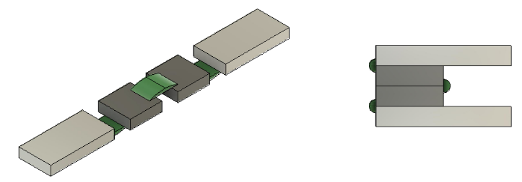

Figure1. General structure microrobot. (Left) fullstrusture open, where light-gray rectangles correspond to the nikel pallets and darker gray squares represent the magnets. All structure is attached with polymerer strips. (Right) Folded microrobots.

Having a general structure, we can analyze some aspects and the right way to start with the simulation. First of all, here we have an array of ferromagnetic components. So there is a need of using some key theories about magnetic interactions. Also, in order to achieve the folded form due to an external change, that could be a magnetic field, a change of pH or temperature we have to analyze the intrinsic magnetic haviours of the general system.

1. COMSOL Mulsiphysics simulations

Multiphysics simulations and analysis of this type of structure are highly important in a way that it can show the physical interactions of the objects. Is this case we are using the AC/DC module from COMSOL multiphysics with the study of current free magnetic interactions between two different ferromagnetic materials such as iron oxiyde and nickel. In this type of current free simulations, we know that.

$$∇×H = 0$$

And it is possible to define the scalar magnetic potential, Vm, from the relation.

$$H=-∇V_{M}$$

This is analogous to the definition of the electric potential for static electric fields.Using the constitutive relation between the magnetic flux density and magnetic field.

$$B=μ_{0}\left(H+M\right)$$

Together with the equation

$$∇⋅B = 0$$

We can derive an equation for Vm

$$-∇⋅\left(μ_{0}∇V_{M}-μ_{0}M_{0}\right)=0$$

The model uses this equation by selecting the Magnetic Fields, No Currents interface from the AC/DC Module. And this will give us the interaction of the system by estuding its scalar magnetiic potential.

1. MATLAB Simulations

With studies developed a few years ago Janssen et al. (2009), Yonnet and Allag (2009). We know that it is possible to calculate the force between any two cuboid magnets with arbitrary magnetization directions. However, since the model produced by the research ended up having great results, it represents a huge amount of time to implement and analyze by hand. So because if that, we used the public framework of verified

and tested Matlab code to calculate the forces between arbitrarily magnetized magnets. With a set of convenient functions are provided to easily calculate the forces between arbitrary multipole arrays of magnets. Anyone may download this code to use it, modify it, and re-distribute it freely.

This model is based on the theory for the study of an array of magnets interacting with each other that consist in a fixed ferromagnetic material and a floating one, just as can be seen in figure2. 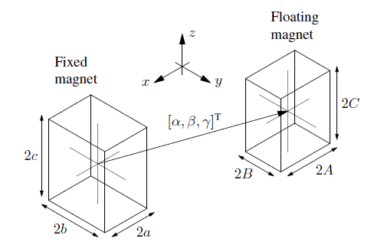

Figure2. Depiction of the geometry for the two-magnet system

The geometry of the two-magnet system is shown in Figure 2, in which the magnets have side lengths s = [2a, 2b, 2c] T and S = [2A, 2B, 2C] T respectively and the distance between their centers is given by d = [\alpha, \beta,\gamma]T.

The calculations always assume that the first magnet is fixed, and force is acting on the second magnet. The signs must be reversed to obtain the forces acting on the first magnet. Akoun and Yonnet provide the force expressions for magnets with vertical magnetization. This force is denoted herein as $F_{\left(z,z\right)}=\left(S,s,d,J_{1},J_{2}\right)$ as a function of the magnet sizes, the distance between them, and their magnetization magnitudes J1 and J2. Allag, Yonnet, and Latreche provide the force expressions for the first magnet with vertical magnetization and the second magnet with magnetization in the horizontal y direction. This force is denoted herein as $F_{\left(z,y\right)}=\left(S,s,d,J_{1},J_{2}\right)$ The force between a vertically magnetized magnet and one with magnetization in the horizontal x-direction can be calculated by applying a rotational transformation to $F_{\left(z,y\right)}$ around the z-axis. That is

$$F_{\left(z,x\right)}=\left(S,s,d,J_{1},J_{2}\right)=R_{z}\left(-\frac{π}{2}\right)F_{\left(z,y\right)}\left(S_{\left(z,x\right)},s_{\left(z,x\right)},d_{\left(z,x\right)},J_{1},J_{2}\right)$$

Where $S_{\left(z,x\right)}=abs\left(R_{z}\left(\frac{π}{2}\right)S\right),s_{\left(z,x\right)}=abs\left(R_{z}\left(\frac{π}{2}\right)s\right)$ and $d_{\left(z,x\right)}=R_{z}\left(\frac{π}{2}\right)d$. Using the force expressions $F_{\left(z,x\right)}$, $F_{\left(z,y\right)}$ and $F_{\left(z,z\right)}$ in superposition allows the force to be calculated between a vertically magnetised magnet and another magnet with arbitrary magnetisation direction. By applying coordinate system transformations to these expressions, arbitrary magnetisation directions can be achieved for the first magnet as well. Achiving that the force between two magnets of arbitrary magnetisation can be written as follows

$$F=\left(S,s,d,J_{1},J_{2}\right)=\sum_{\left(i,j∈{\left(x,y,z\right)}^{2}\right)}{F_{\left(i,j\right)}\left(S,s,d,J_{1},J_{2}\right)}$$

Where:

$J_{1}={\left[J_{1_{x}},J_{1_{y}},J_{1_{z}}\right]}^{T}$ and $J_{2}={\left[J_{2_{x}},J_{2_{y}},J_{2_{z}}\right]}^{T}$

The theory presented in the equation above was implemented in the matlab code wich perform the simlation of the magnetic force bewteen the two magnets.

1. RESULTS
2. COMSOL Results

First, we have the main implementation of the microrobot. A general structure with four main parts. Two rectangles representing the nickel pallets and two square parts noted as iron pallets. We defined the materials in the COMSOL console and established all the studies needed.

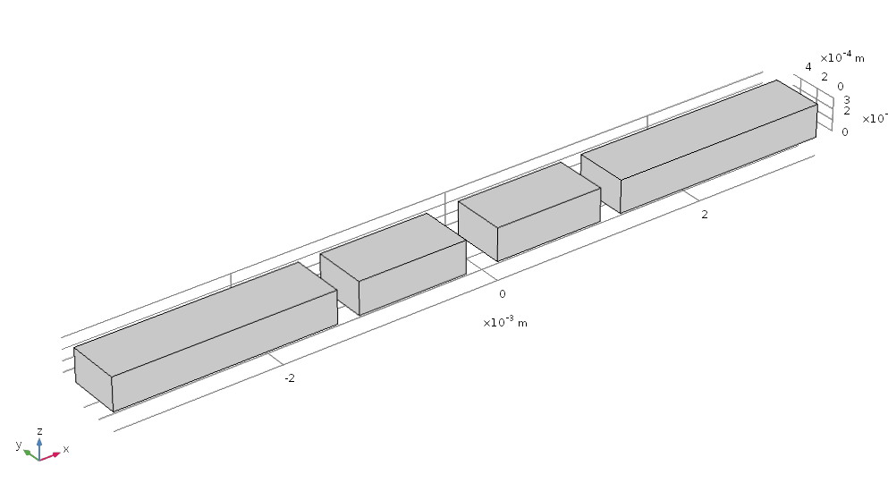

Figure 3 General strusture

The first result is shown in figure 4. Represents the interaction between the two magnets and the magnetization curves with the magnetic flux density.

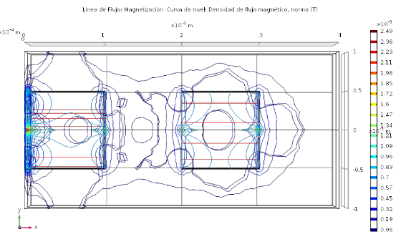

Figure 4 Magnetic flux density lines and magnetization density curves

The study of the interaction of the magnetic field in the magnets and between them was made. The importance of this study is to analyze if the magnetic interactions are present and how those kind of responses would change in certain situations. For example a variation of the distance between the two magnets or some external force. 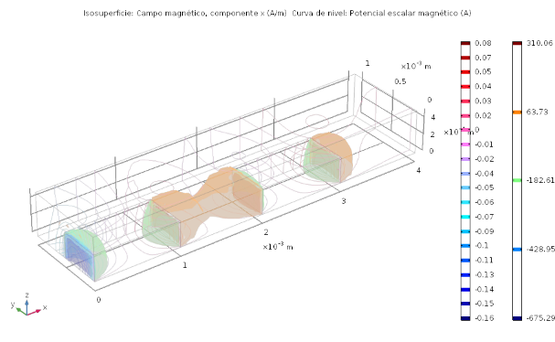

Figure 5 Magneticfield magntiude and lines of magnetic scalar potencial

In addition to the analysis of the interaction between the two magnets. The second part of the simulation was the study of the interaction between a single magnet and a single plate of nickel. In that order, we would be able to understand how the entire microrobot is changing when an interaction is placed. In this case, we wanted to study the response of the magnetic field and the magnetic flux density lines of the nickel will change when the iron is present. Also, the study of the magnetization can be computed, in order to see if the nickel will interact as mented with in the final structure..

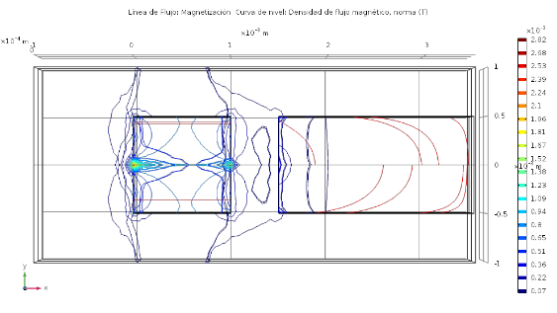

Figure 6 Magnetic flux density lines and ,agmetization curves of the systm magnet-nickel

Moreover, some analysis of the magnetic field related to the magnetic flux density is shown in figure 7. These interactions between the magnet and nickel will help with further analysis of torque and magnetic repulsion forces..

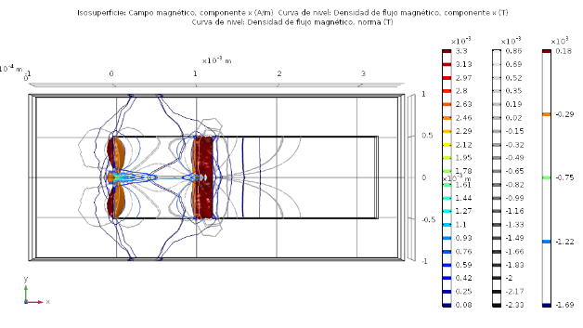

Figure 7. Magnetic field magnitude and magnetic flux density curves

Finally, in order to achieve a better understanding of the behaviors or the microrobot. We simulated in Comsol the entire structure. In that way, we could analyze the overall distribution of magnetic interactions and how real robots respond to several external interactions. In figure 8, we can see the magnetization curves present in the stucture, as well as the magnetic flux density in the entire structure.

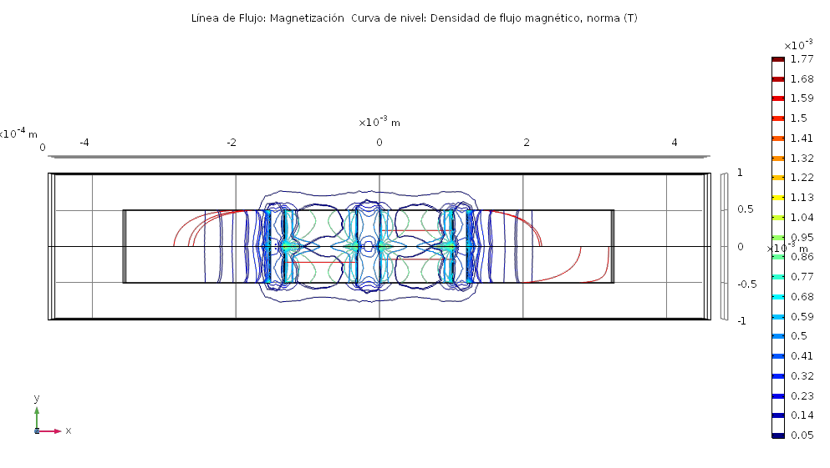

Figure 8 magnetic flux density curves and magnetization flux lines

On the other hand. While in figure 8 we see the interaction of the whole structure. In figure 9 it is possible to see how the magnetic field in behaving at the boundaries of the pallets. This result computed with the idea of analyzing the behaviors of the magnetic field with the distance between the pallets is changed. After some other results and calculations, we will be showing the relation of the magnetic field and the repulsive and attractive force between the magnets and the nickel pallets. 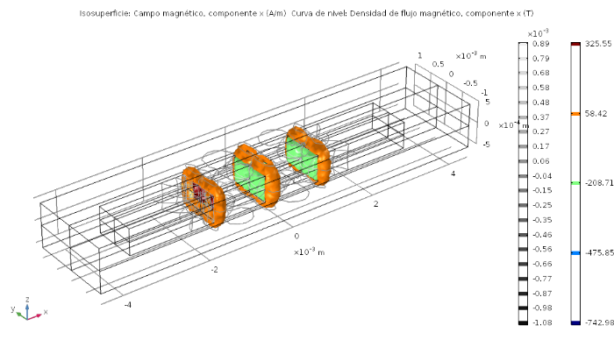

Figure 9 Surface representing the norm of the magnetic field between the pallets. And the curves representinf the magnetic flux density.

1. MATLAB Results

Small and thin magnets can be difficult to obtain and hard to work with. While multiple smaller magnets can be stacked together to approximate a single large magnet, greater forces can be achieved by varying the magnetization pattern between adjacent magnets in the stack(Cite).

Having said that, we wanted to study the interactions between those smalls parts in separate conditions. First, we started with the simulation of the repulsive force between the two magnets in the middle of the microrobots. An overview of the schema for the simulation is shown in figure 10.

The magnets are aside from each other, with a magnetization applied in the x-axis.

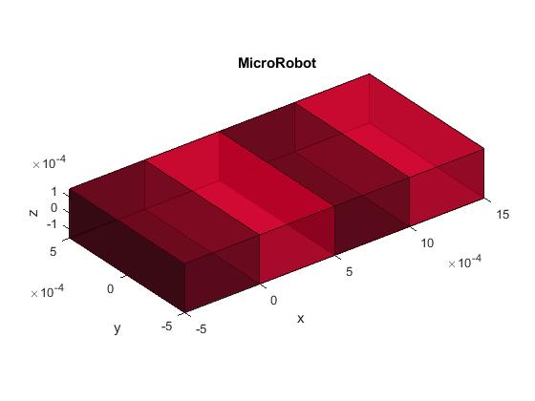

Figure 10 Magnets with x-axis magnetization and polarized. Initial distance of 0mm, simulation of N38 Neodimiun magnets.

We plotted the repulsion force of the magnets as a function of the separation in the x-axis from 0mm up to 3mm. The results are shown in figure 11.

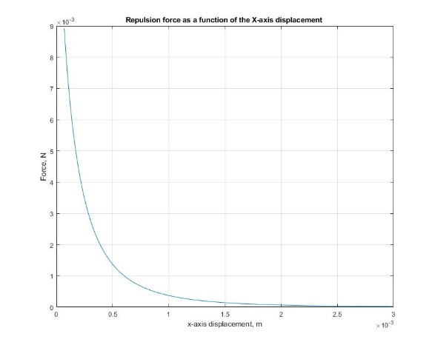

Figure 11 Repusion force as a fuction of the x-axis displacement of an array of 2 neodimiun N38 magnets with the same characteristics.

Next, we wanted to study the interactions between the magnets within each other, but in this case with a 90-degree inclination in the floating magnet. For this setup the magnets were the same as the ones shown in fig 10.

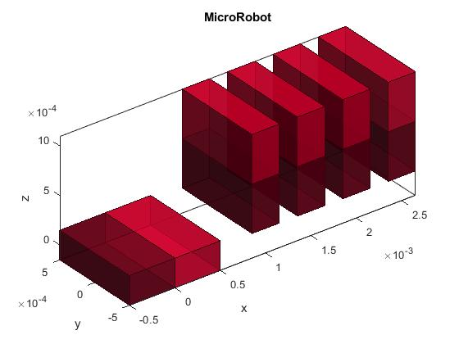

Figure 12 Magnets with x-axis magnetization and polarized. Initial distance of 0mm, simulation of N38 Neodimiun magnets.Floating magnet with 90 degree inclination.

The results of all the repulsion forces for the set up in figure 12 are shown in figure 13.

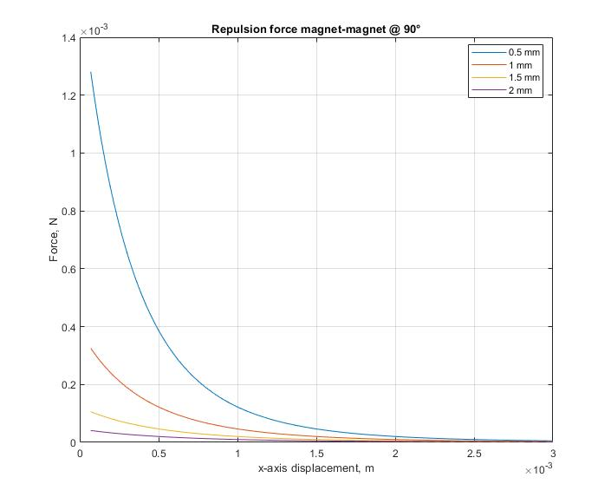

Figure 13 Repusion force as a fuction of the x-axis displacement of an array of 2 neodimiun N38 magnets with the same characteristics and shifted 90 degrees.

Next, we wanted to study the interactions between one magnet and a pallet of nickel within each other, with a 90 degree inclination in the nickel pallet.

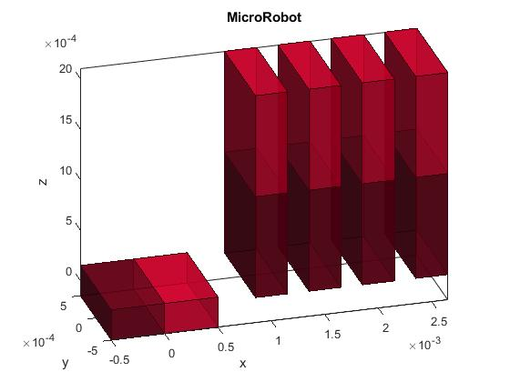

Figure 14 Magnet amd nickel setup with x-axis magnetization and polarized. Initial distance of 0.5mm, simulation of N38 Neodimiun magnets and soft nickel pallet..

The results of all the repulsion forces for the set up in figure 14 are shown in figure 15.

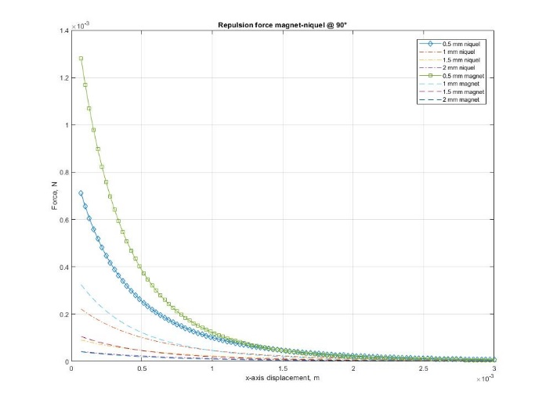

Figure 15 Repusion force as a fuction of the x-axis displacement of an array of 2 neodimiun N38 magnet and nickel pallets with the same characteristics and shifted 90 degrees.

Finally, we made a simulation for the interaction of 9 0 degrees rotated magnet and nickel pallet. In order to find an optimal distance in which the folding process can be achieved.

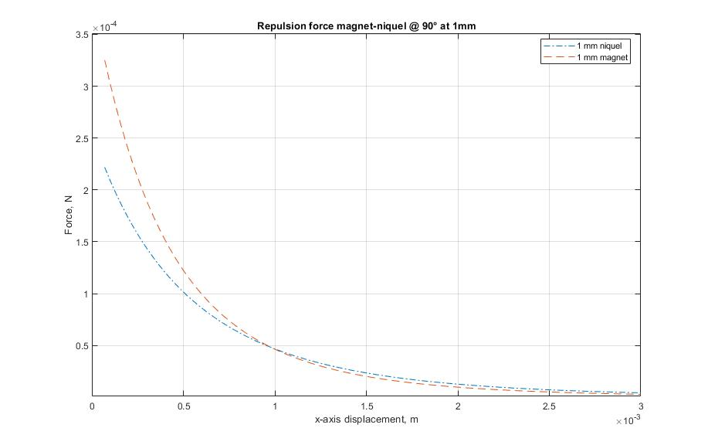

Figure 3 Repulsion force as a function of the x-axis displacement in the configuration of magnet-magnet and magnet-nickel. At starting distance of 1mm form each other and 90 degrees shiftted.

**hasta aquí van los resultados de Tesis 1. Para poder hacer análisis y conclusiones buenas es necesario seguir con el trabajo. El análisis hasta ahora corresponde a las gráficas que se ubtuvieron de comsol y matlab, pero estas pueden o no ser las finales.**

III. REFERENCIAS

[1] S. Lee *et al.*, “済無No Title No Title,” *J. Chem. Inf. Model.*, vol. 53, no. 9, pp. 1689–1699, 2012, doi: 10.1017/CBO9781107415324.004.

[2] H. Abu Hasan, M. H. Muhammad, and N. I. Ismail, “A review of biological drinking water treatment technologies for contaminants removal from polluted water resources,” *J. Water Process Eng.*, vol. 33, no. May 2019, p. 101035, 2020, doi: 10.1016/j.jwpe.2019.101035.

[3] A. Tkaczyk, K. Mitrowska, and A. Posyniak, “Synthetic organic dyes as contaminants of the aquatic environment and their implications for ecosystems: A review,” *Sci. Total Environ.*, vol. 717, p. 137222, 2020, doi: 10.1016/j.scitotenv.2020.137222.

[4] R. D. G. Franca *et al.*, “Oerskovia paurometabola can efficiently decolorize azo dye Acid Red 14 and remove its recalcitrant metabolite,” *Ecotoxicol. Environ. Saf.*, vol. 191, no. August 2019, p. 110007, 2020, doi: 10.1016/j.ecoenv.2019.110007.

[5] B. J. Brüschweiler and C. Merlot, “Azo dyes in clothing textiles can be cleaved into a series of mutagenic aromatic amines which are not regulated yet,” *Regul. Toxicol. Pharmacol.*, vol. 88, pp. 214–226, 2017, doi: 10.1016/j.yrtph.2017.06.012.

[6] A. Das and A. Dey, “P-Nitrophenol -Bioremediation using potent Pseudomonas strain from the textile dye industry effluent,” *J. Environ. Chem. Eng.*, vol. 8, no. 4, p. 103830, 2020, doi: 10.1016/j.jece.2020.103830.

[7] V. S. G. Garcia, J. M. Rosa, and S. I. Borrely, “Toxicity and color reduction of a textile effluent containing reactive red 239 dye by electron beam irradiation,” *Radiat. Phys. Chem.*, vol. 172, no. February, p. 108765, 2020, doi: 10.1016/j.radphyschem.2020.108765.

[8] N. Saravanan and K. S. K. Sasikumar, “Waste water treatment process using Nano TiO2,” *Mater. Today Proc.*, no. xxxx, pp. 10–12, 2020, doi: 10.1016/j.matpr.2019.12.143.

[9] A. Halder and Y. Sun, “Biocompatible propulsion for biomedical micro/nano robotics,” *Biosens. Bioelectron.*, vol. 139, no. February, p. 111334, 2019, doi: 10.1016/j.bios.2019.111334.

[10] Y. Wang, Y. Jiang, H. Wu, and Y. Yang, “Floating robotic insects to obtain electric energy from water surface for realizing some self-powered functions,” *Nano Energy*, vol. 63, no. April, p. 103810, 2019, doi: 10.1016/j.nanoen.2019.06.006.

[11] X. Qiu, Y. Wang, Y. Xue, W. Li, and Y. Hu, “Laccase immobilized on magnetic nanoparticles modified by amino-functionalized ionic liquid via dialdehyde starch for phenolic compounds biodegradation,” *Chem. Eng. J.*, no. September, 2019, doi: 10.1016/j.cej.2019.123564.

[12] V. M. de Aguiar, R. Esquinelato Silva, R. A. C. Leão, R. O. M. A. de Souza, R. S. B. Gonçalves, and L. S. de Mariz e Miranda, “Studies on the laccases catalyzed oxidation of norbelladine like acetamides,” *Mol. Catal.*, vol. 485, no. February, p. 110788, 2020, doi: 10.1016/j.mcat.2020.110788.