REPORT FOR COMPUTATIONAL INTELLIGENCE COURSE

CONTENTS:
- Introduction
- Laboratory 1
  - Description
  - Code
  - Reviews received
  - Reviews done
    - MattColu
    - sidharrth2022
- Laboratory 2
  - Description
  - Code
  - Reviews received
  - Reviews done
    - FrancescoSorrentino
    - Critaek
    - dfm88
    - MatteMagnaldi
    - EnricoMagliano
    - Eliafontana
    - Zohrelhj
- Laboratory 3
  - Description
  - Code
  - Reviews received
  - Reviews done
    - giogenna16
    - rogierz
- Personal experiments
- Final project: Quarto agent
  - Introduction, collaborations and thanks
  - The best strategy: Hardcoded rules
    - Description
    - Code
    - Results
  - An alternative tree search method: MonteCarlo Tree Search (MCTS)
    - Description
    - Code
    - Results
  - Let’s try to mix: Genetic Algorithm
    - Description
    - Code
    - Results
  - A disappointing strategy: Reinforcement Learning
    - Description
    - Code
    - Results
  - Final considerations

INTRODUCTION:

Hello everyone, I’m Diego Gasco (studentID: 296762) and I’m attending the Computational Intelligence course by Professor Giovanni Squillero.
In this document I report all the information about the work done by me during this course. In particular I insert the laboratories with my code and the reviews received and done, some experiments and the final project description.
All of the main topics are named and linked to the related document section in the Contents index. For the code sections I put screenshots for a better understanding of the concepts.
For the other students’ s code reviewed by me, I take only the main important parts of the student’s code that I reviewed, in a way that my work should be clear for the reader (I avoid for examples the typical files “lib.py” in case they are only a repetition of what Professor provided us as support code).
I’m sorry if sometimes the if-statements or for-loops are cut divided on two photos, but I think that using pictures is clearer than copying and pasting the code row-by-row for the reader understandability.

If you want to go back to the index page, you can see the link in the lower right part of each page (“Contents”).

My GitHub repository for the labs: https://github.com/Diegomangasco/Computational_Intelligence
My GitHub repository for the final project: https://github.com/Diegomangasco/Quarto

LABORATORY 1:

Description:

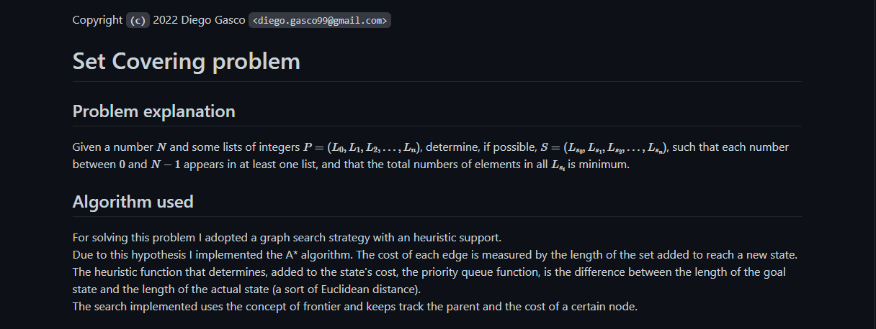

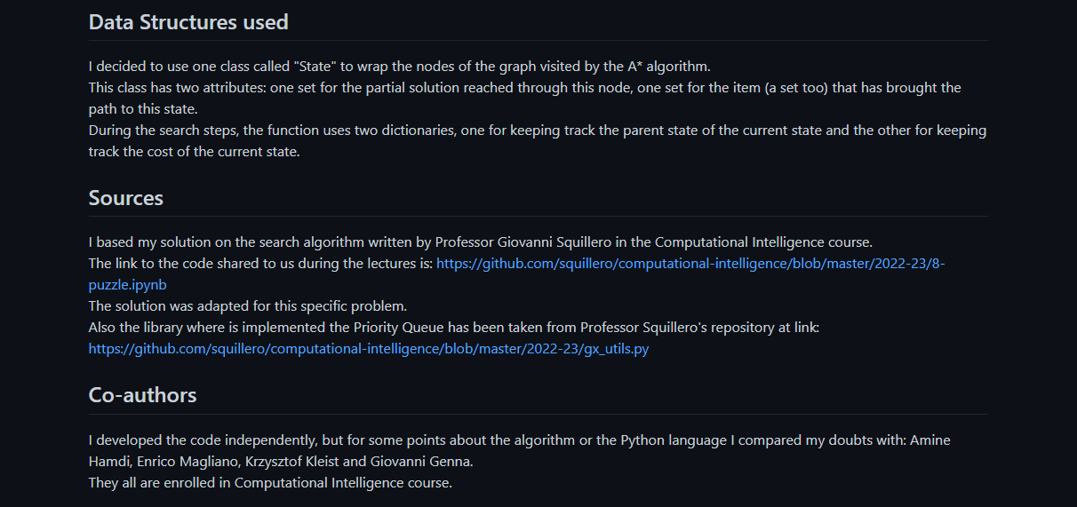
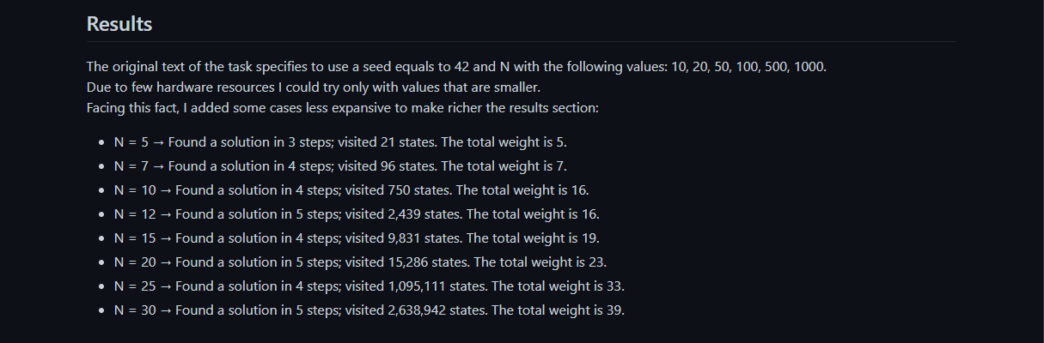
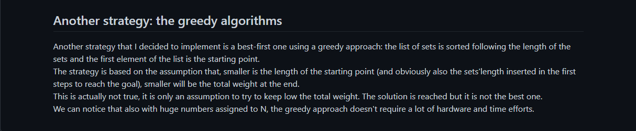

Code:

File: lib.py

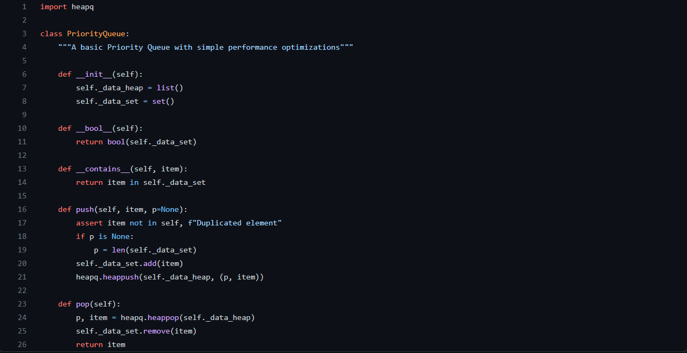
File: lab1.ipynb

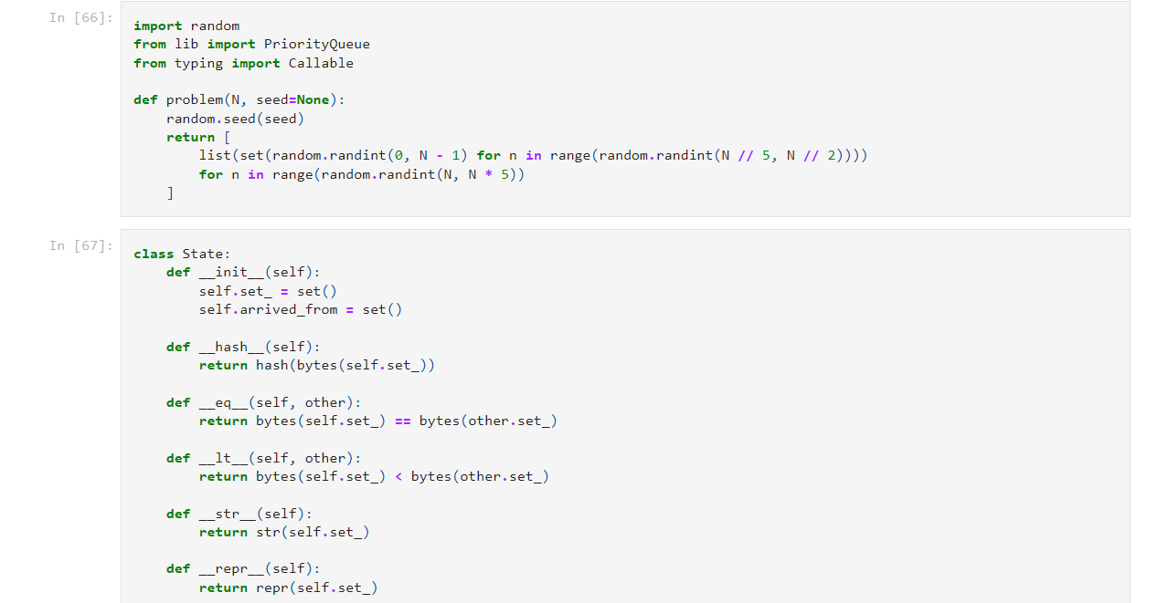

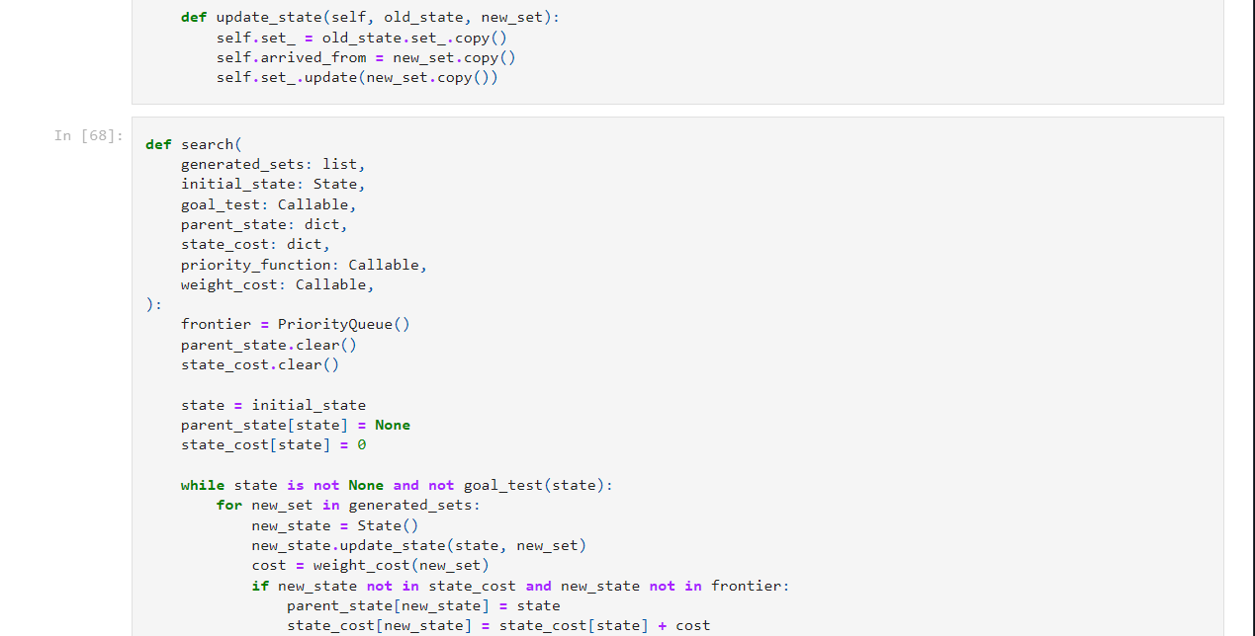
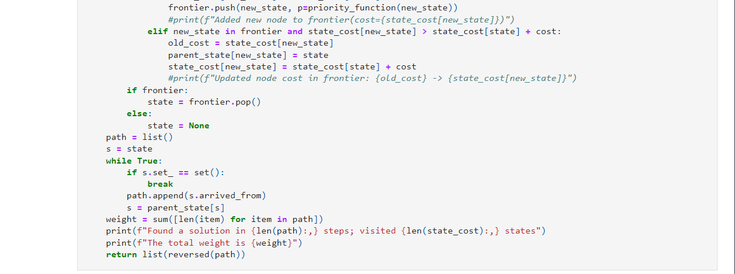
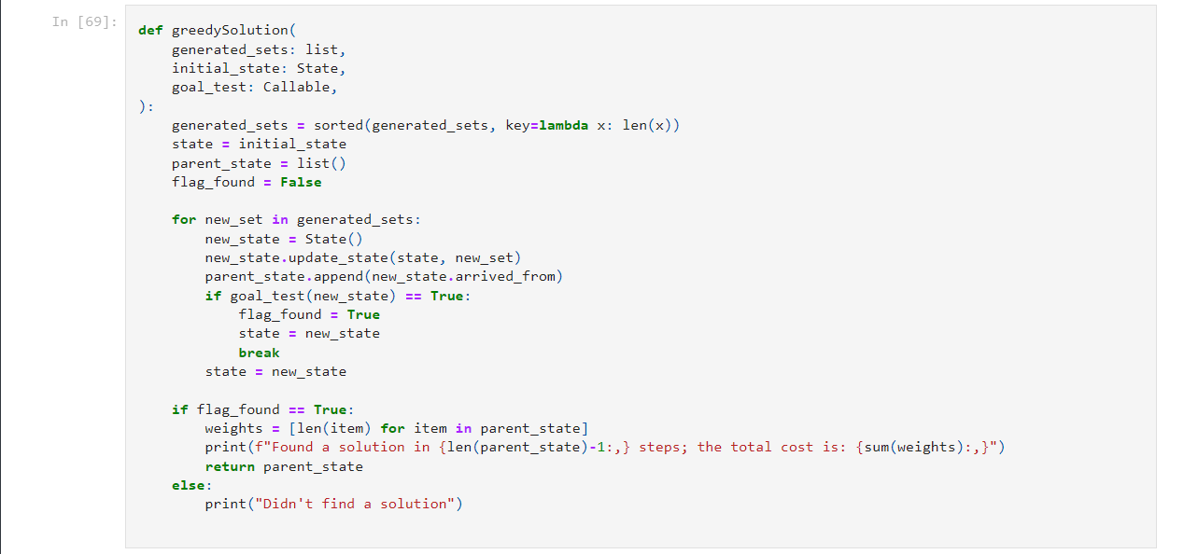
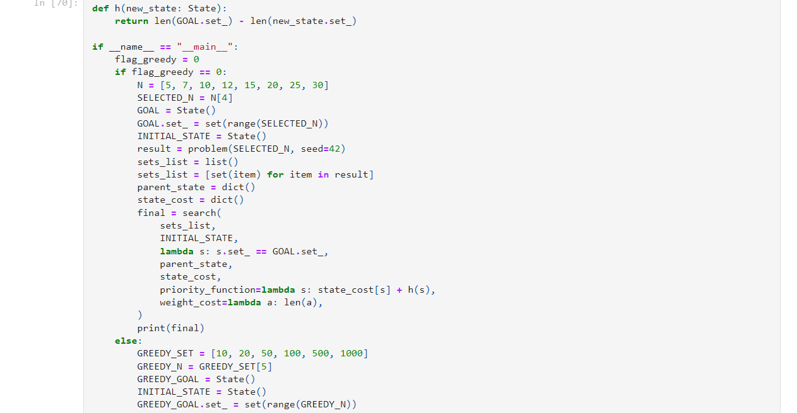


Reviews received:

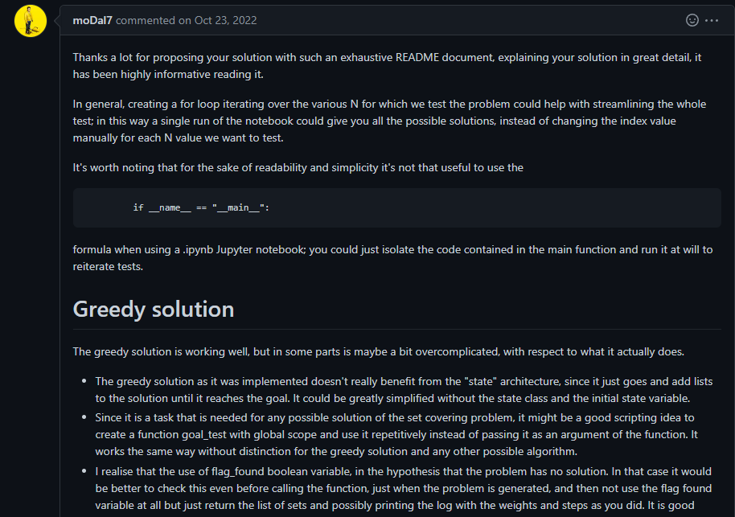
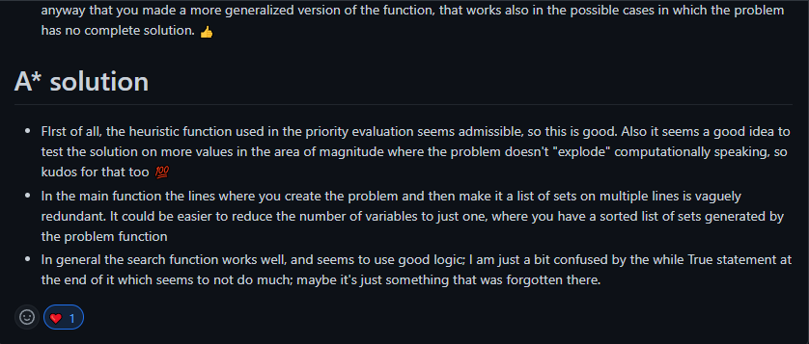
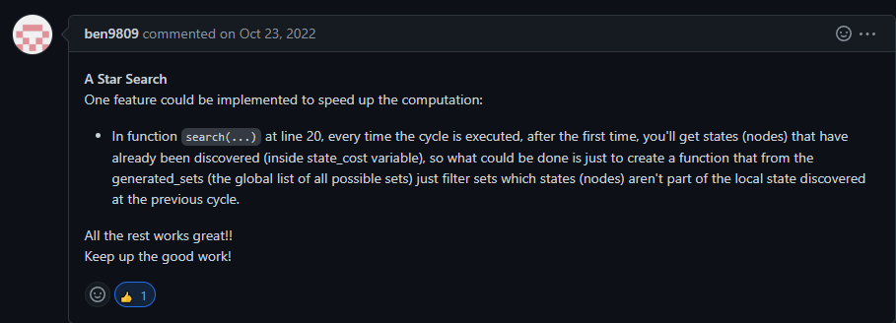
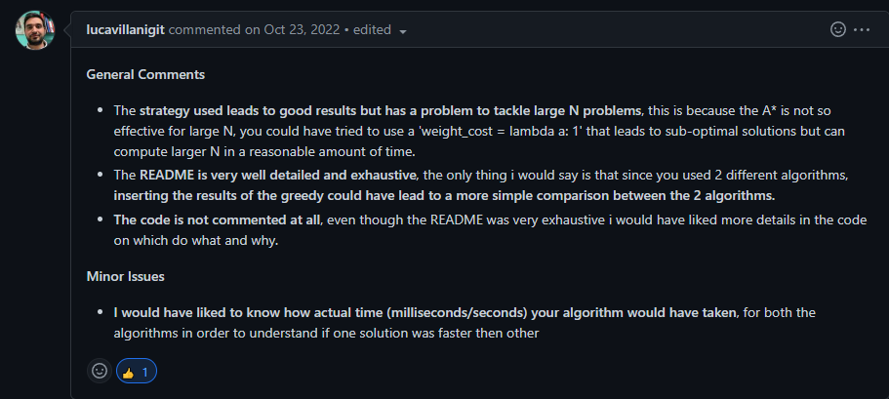

Reviews done:

MattColu/Comp_Int

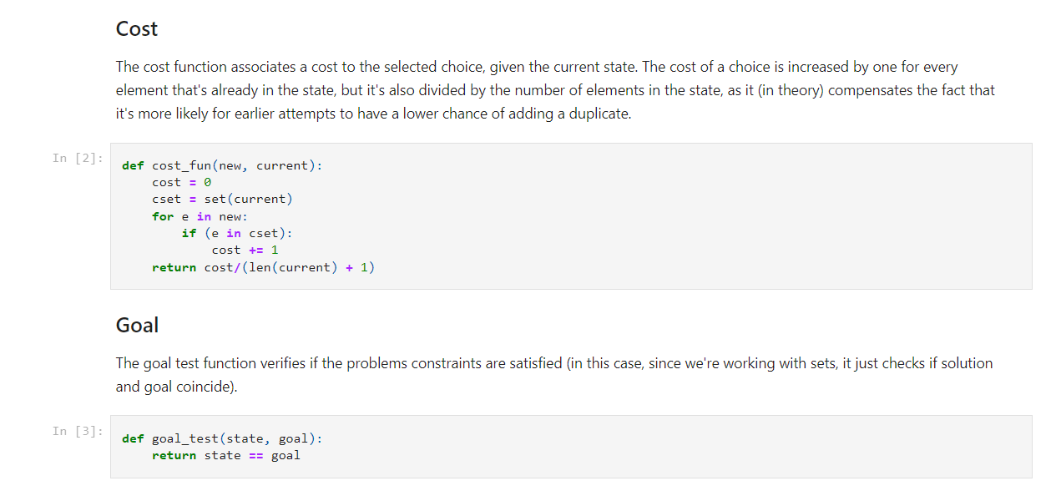

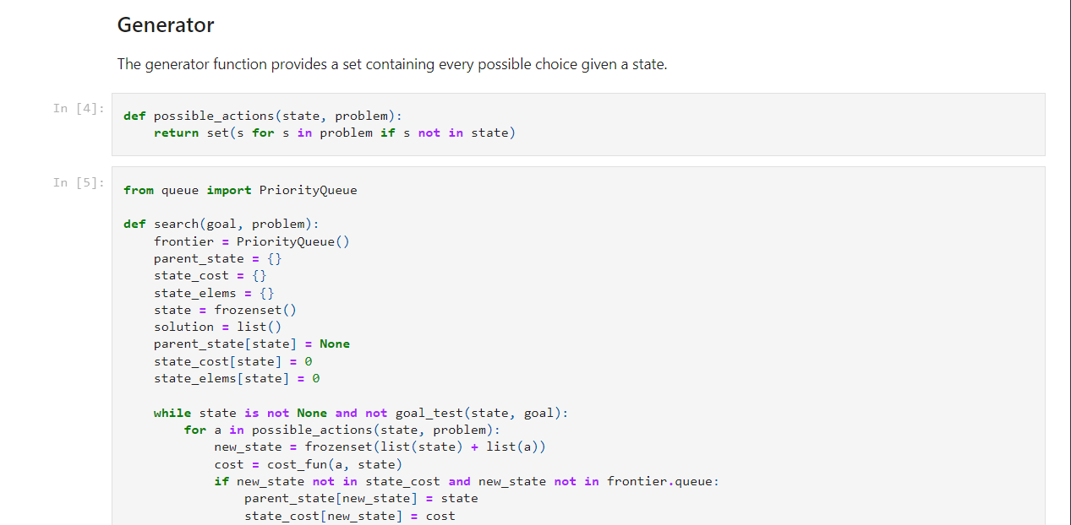
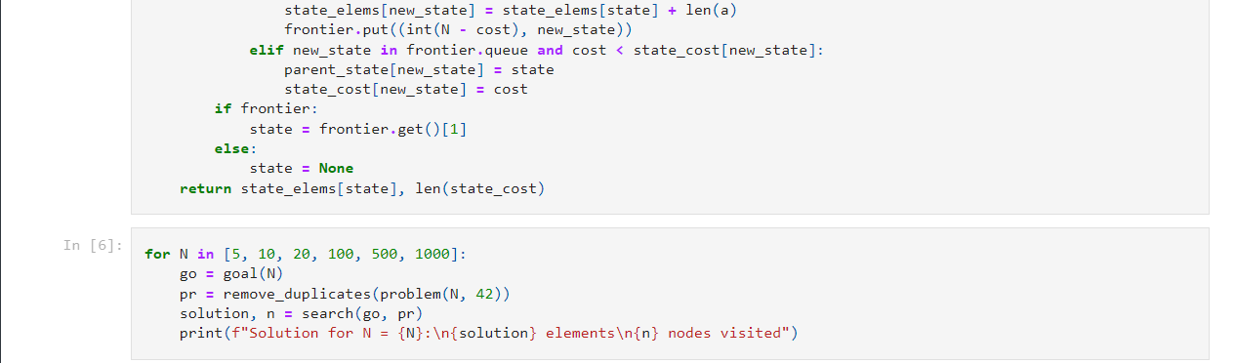
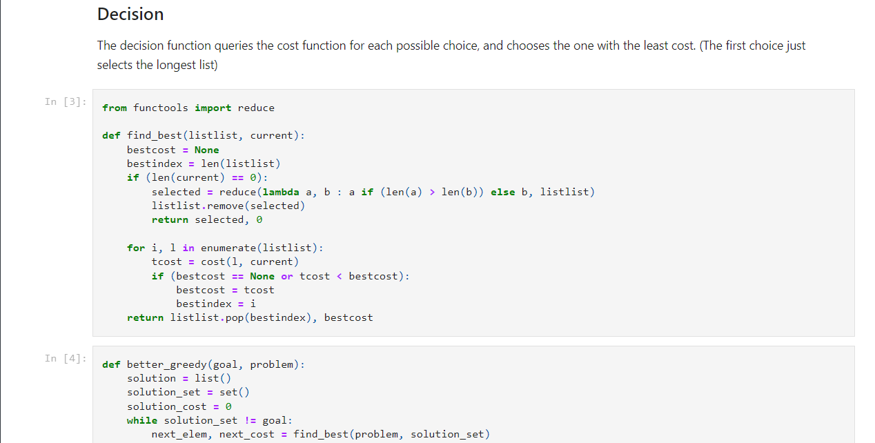
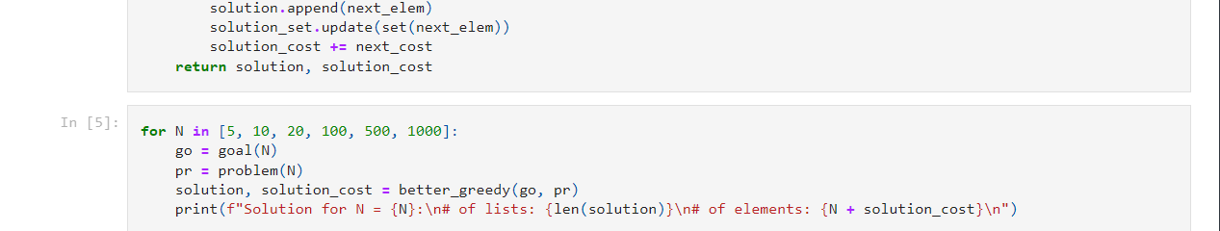
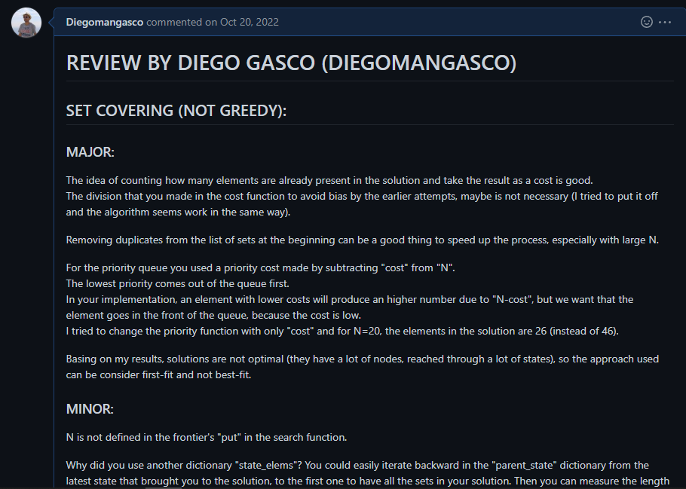
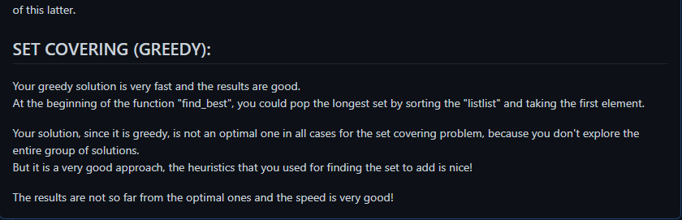

sidharrth2022/sid-computational-intelligence

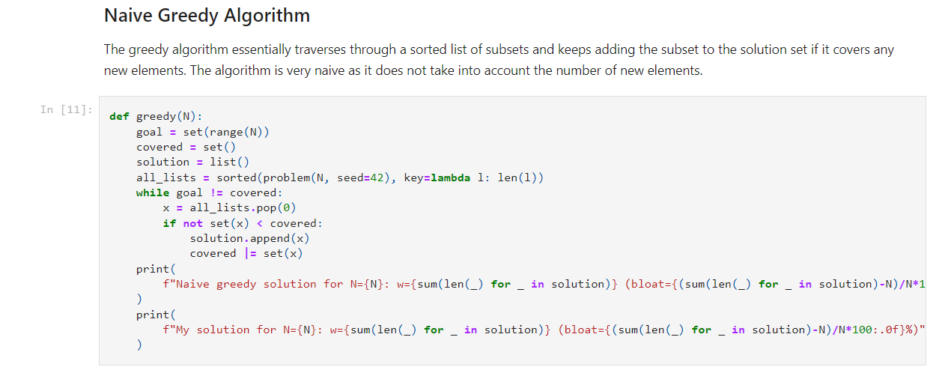

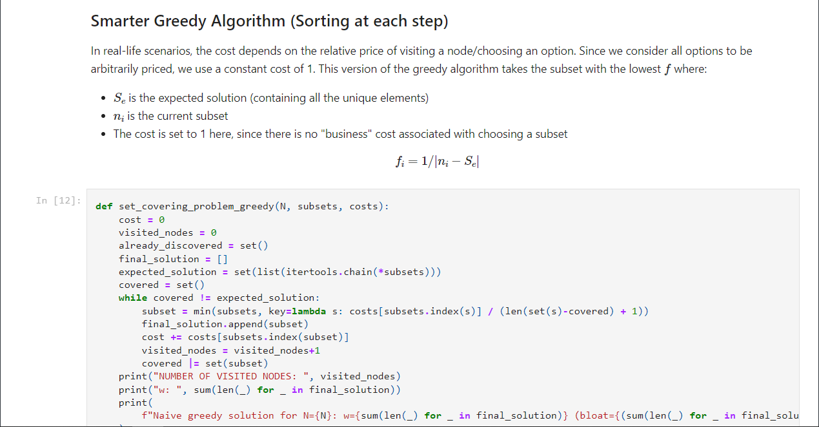

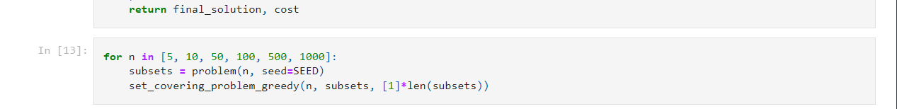

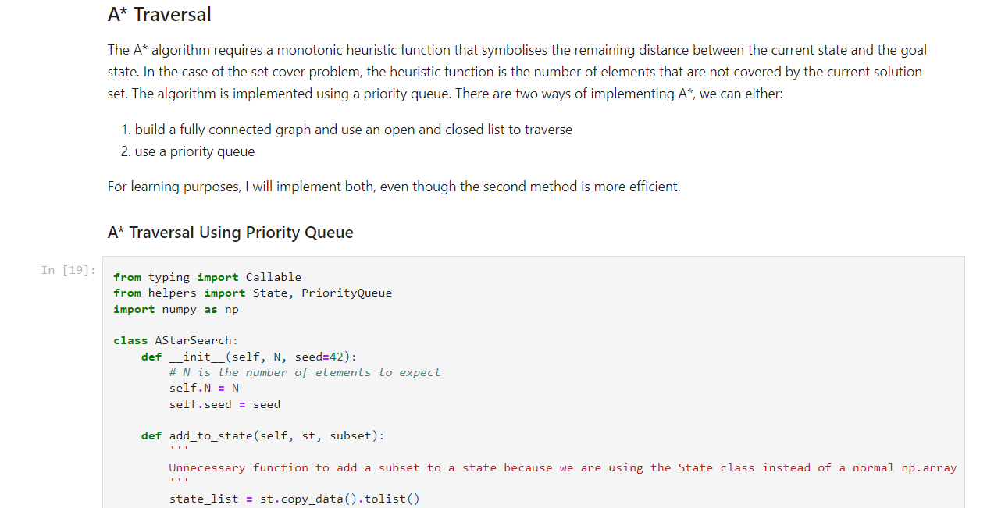
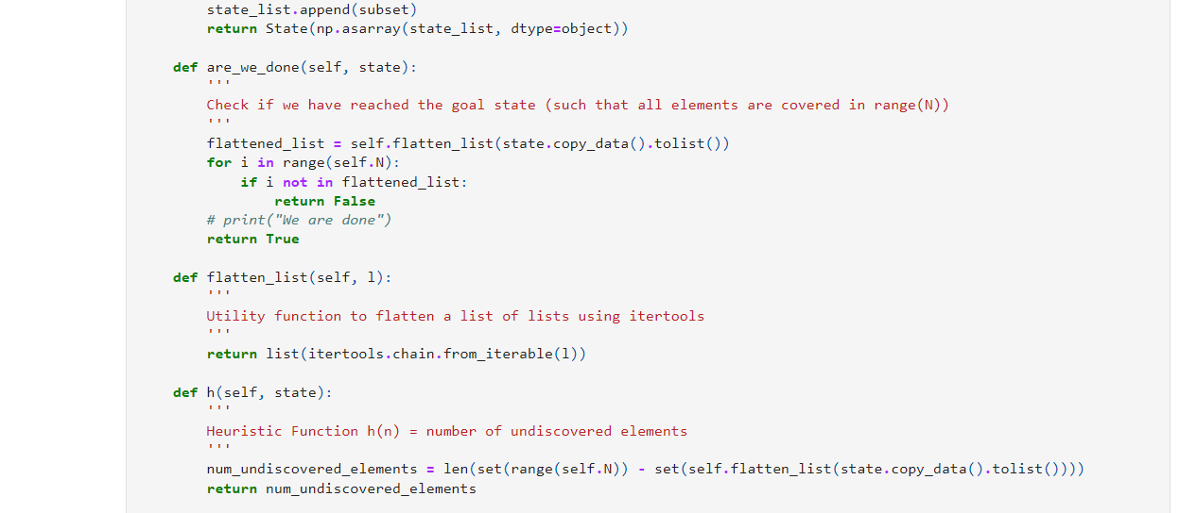
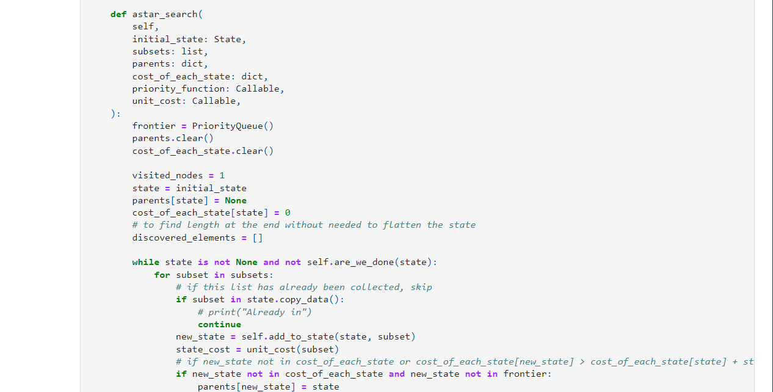
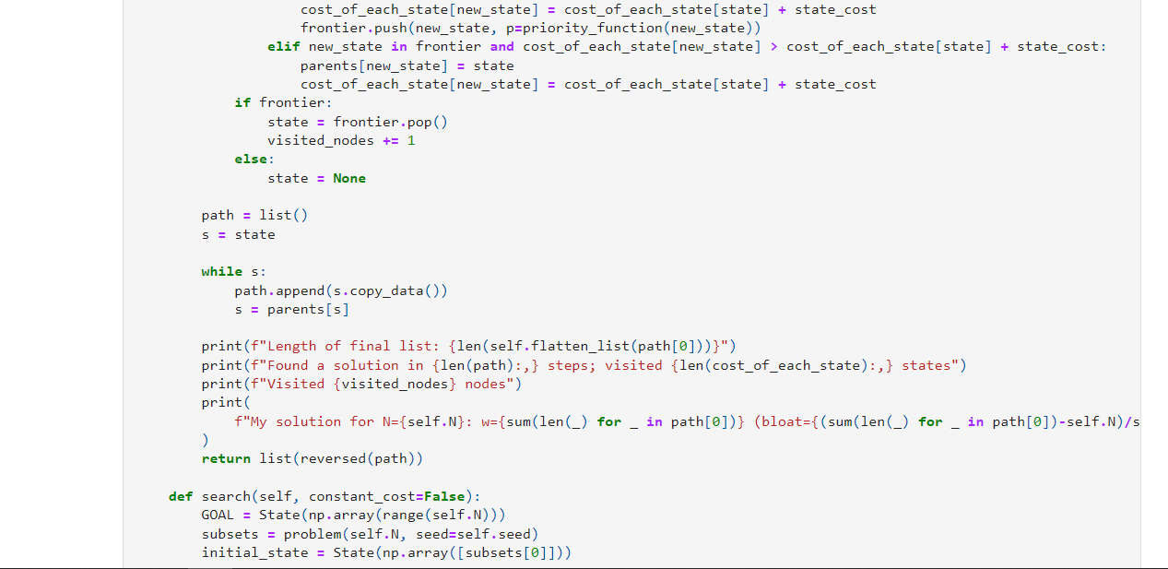
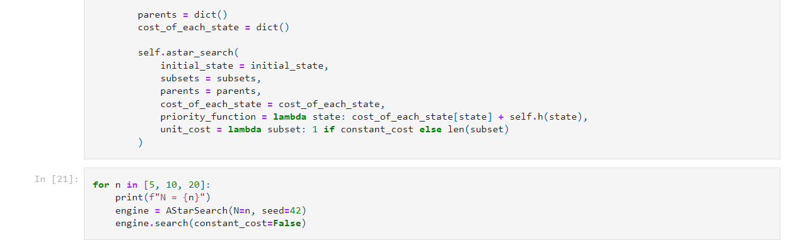

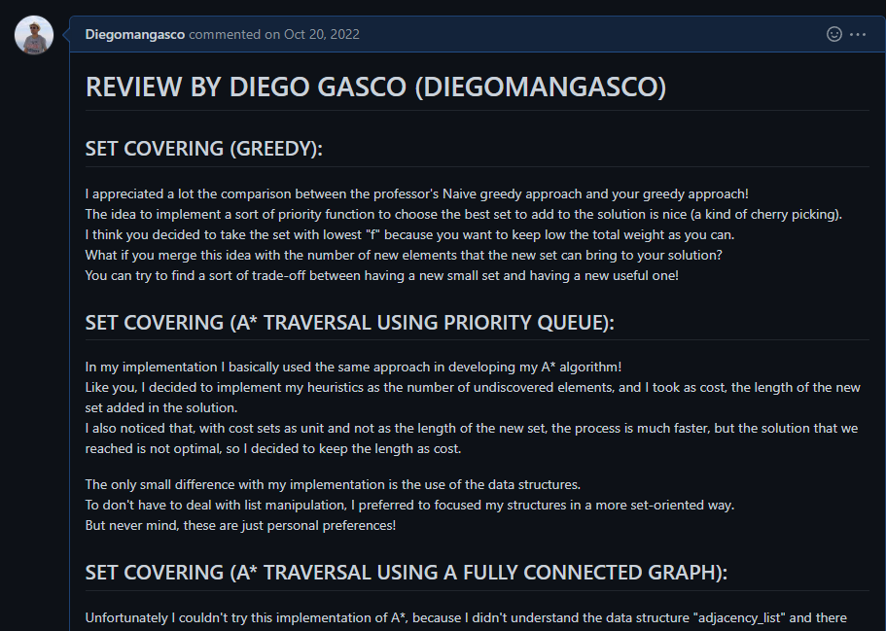
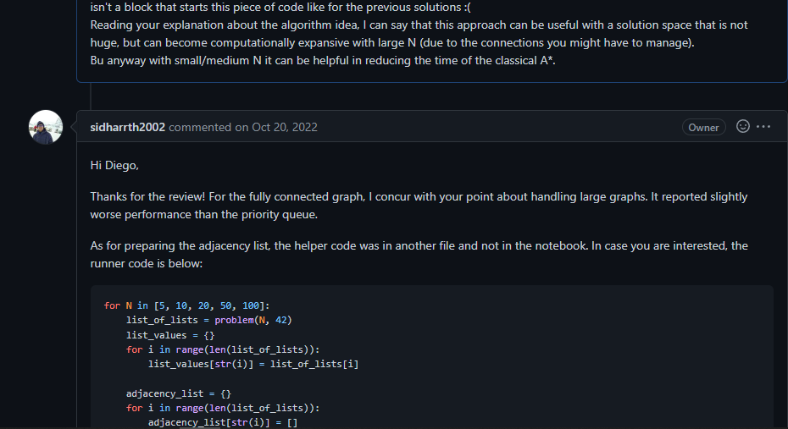
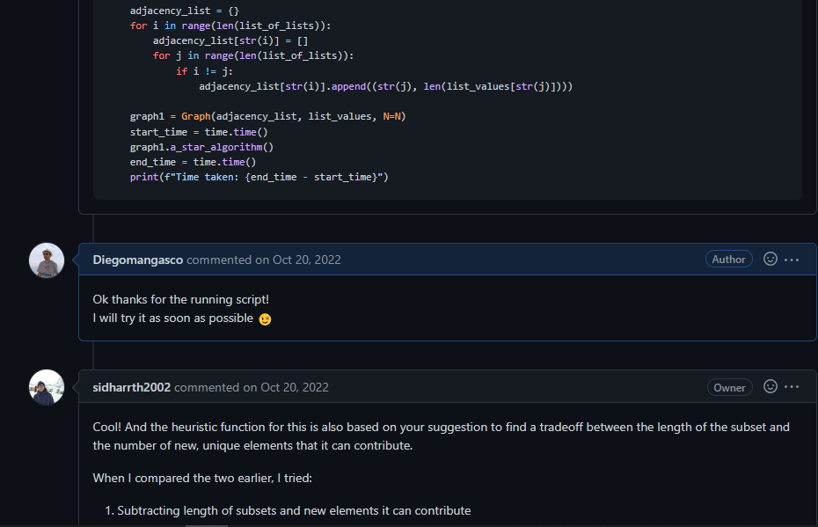

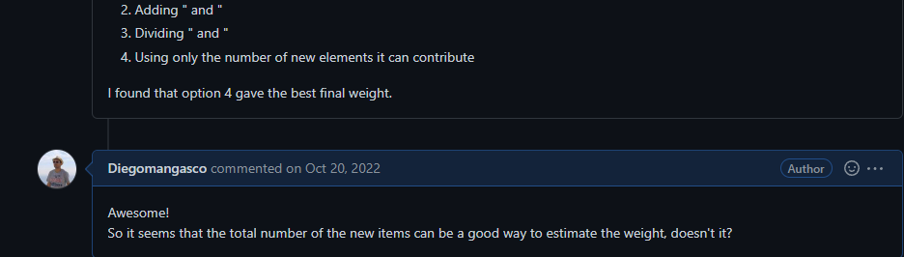

LABORATORY 2:

Description:

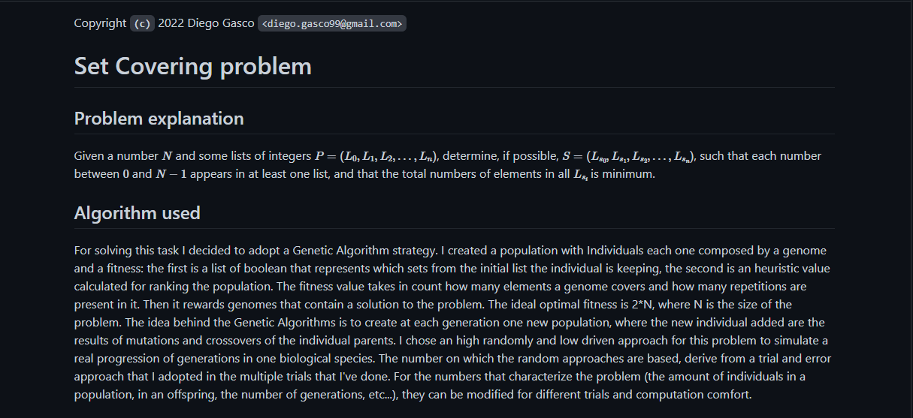
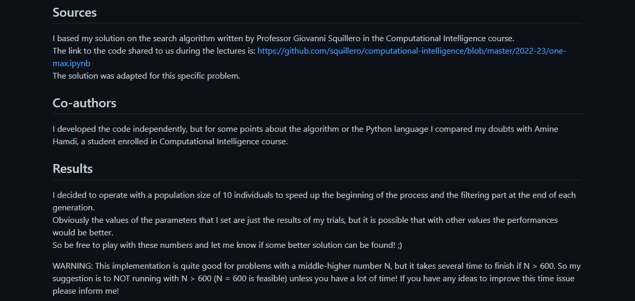
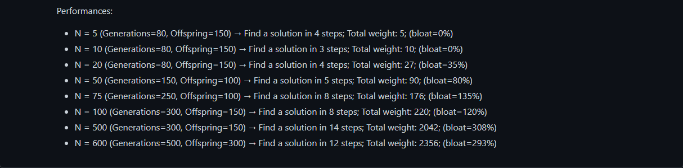

Code:

File: lab2.ipynb

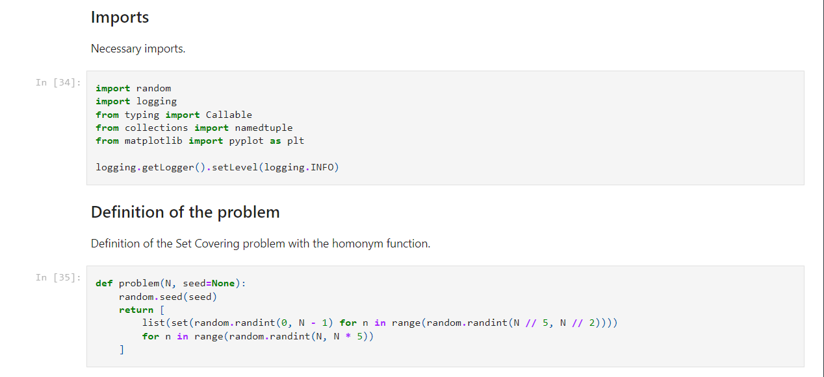
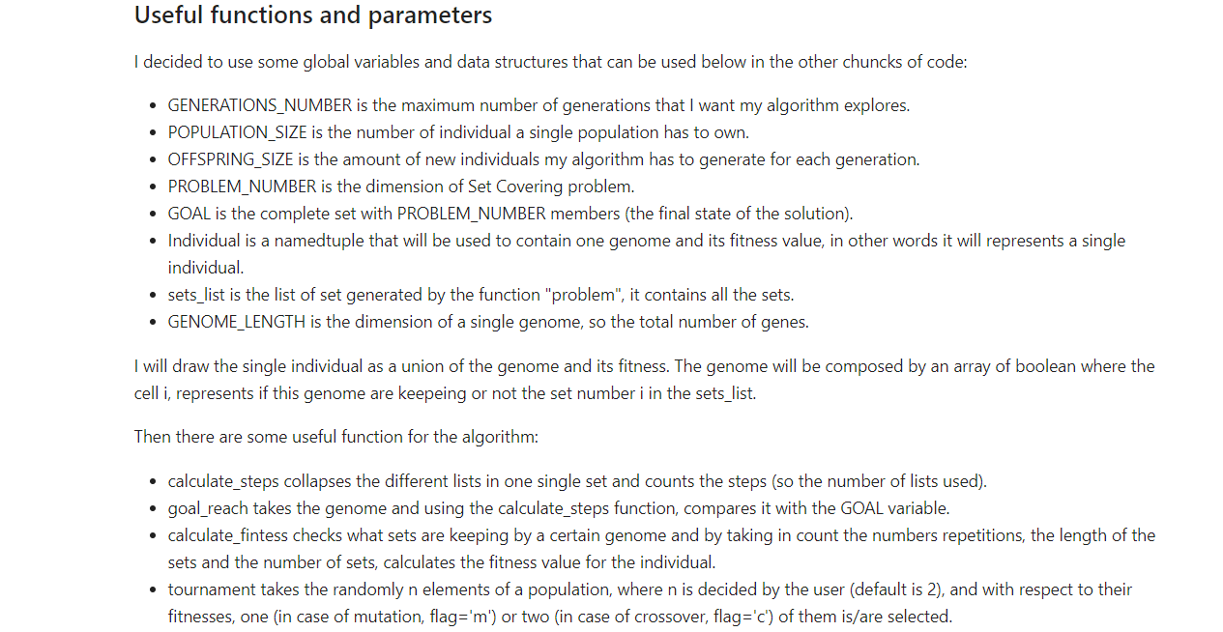
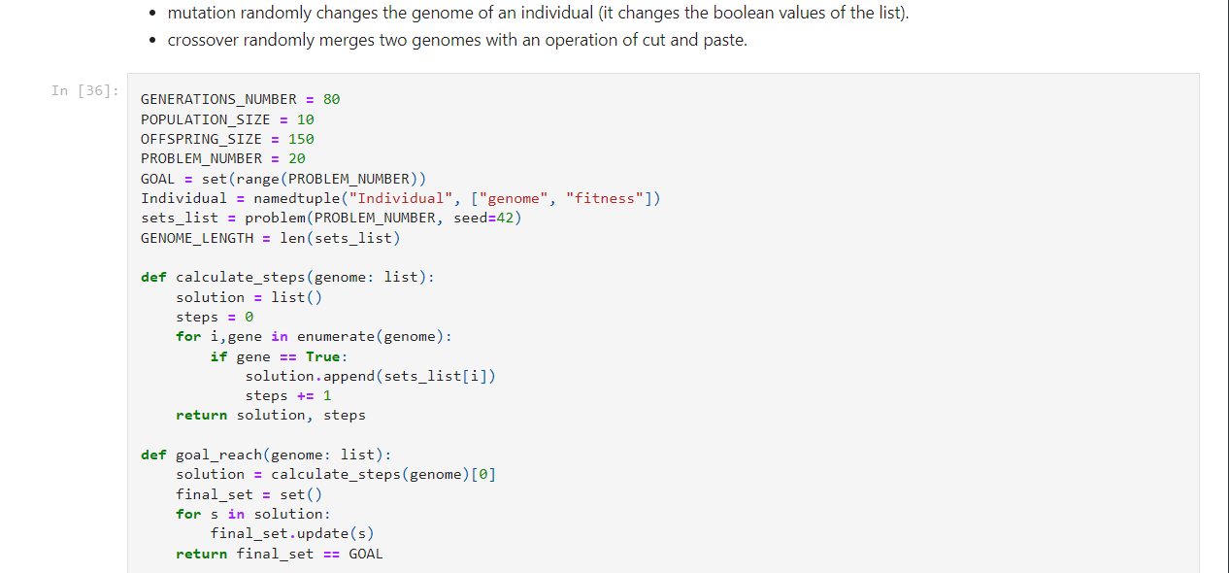
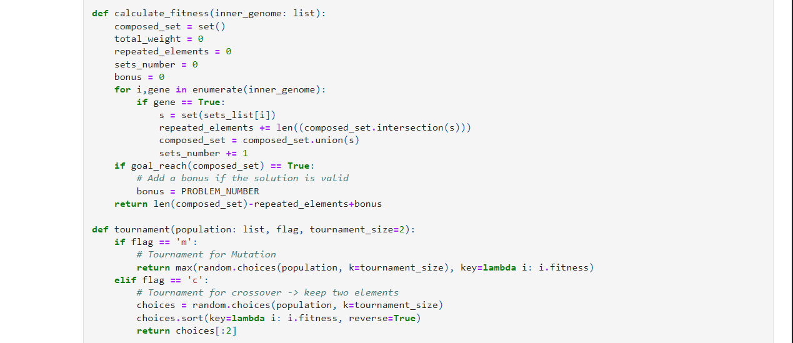
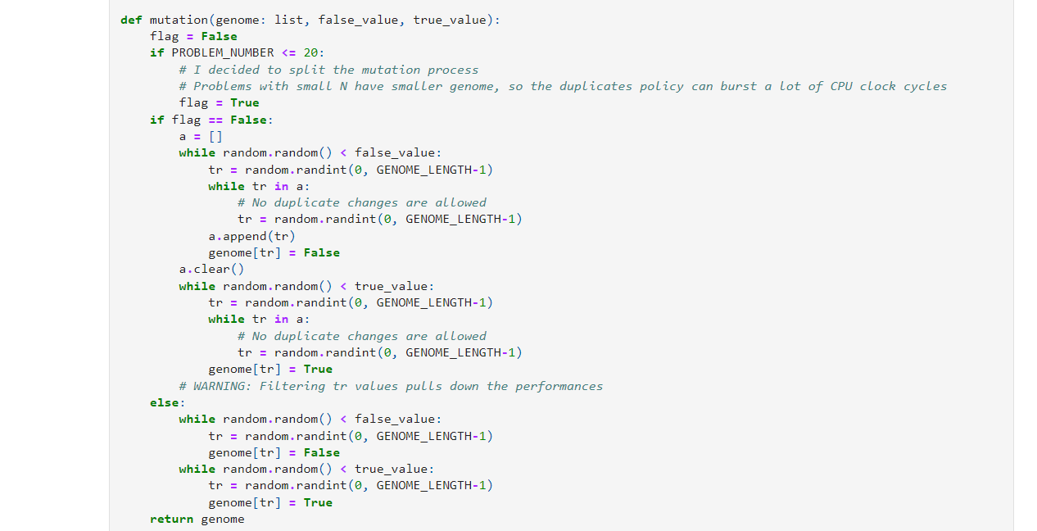

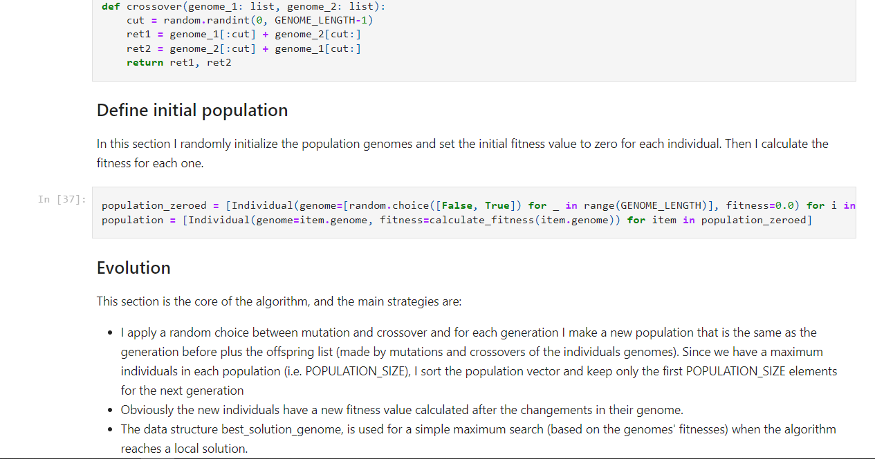
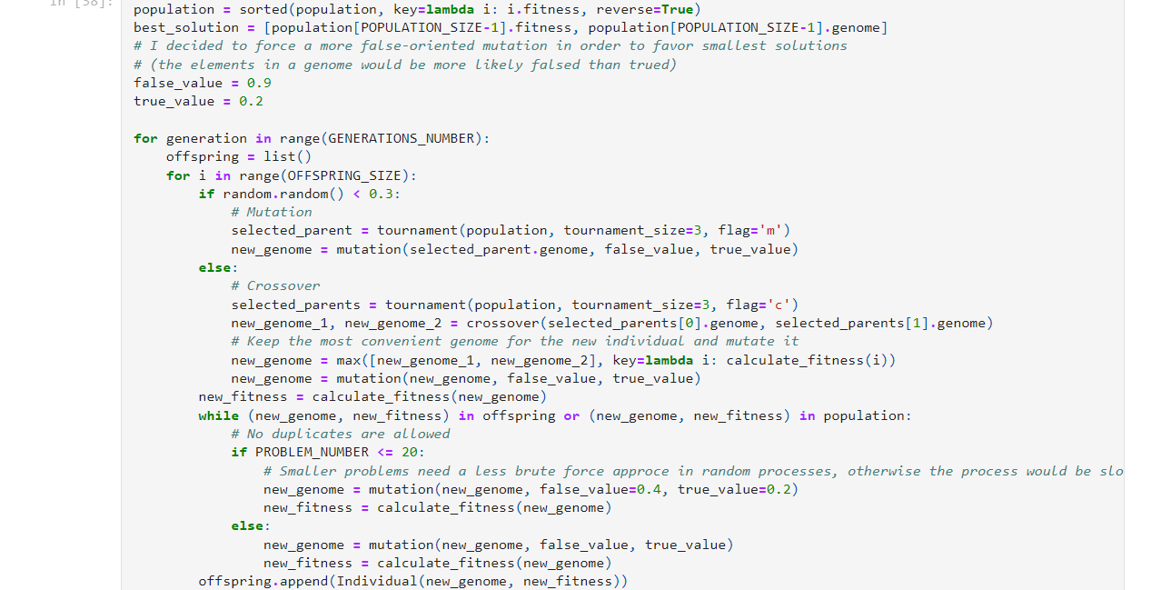
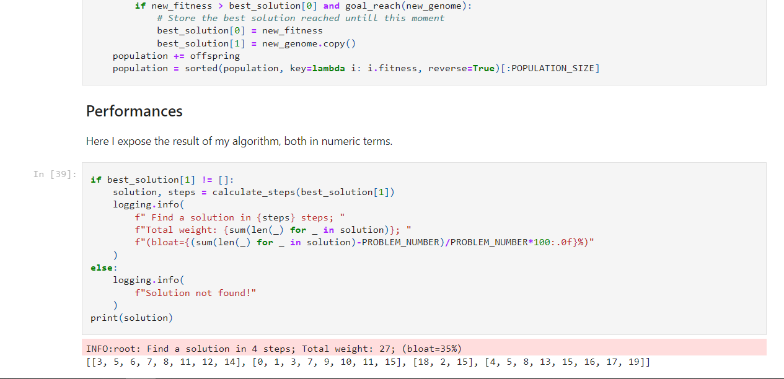

Reviews received:

Unfortunately I didn’t receive any review for this lab :(

Reviews done:

FrancescoSorrentino/Computational-Intelligence---22-23

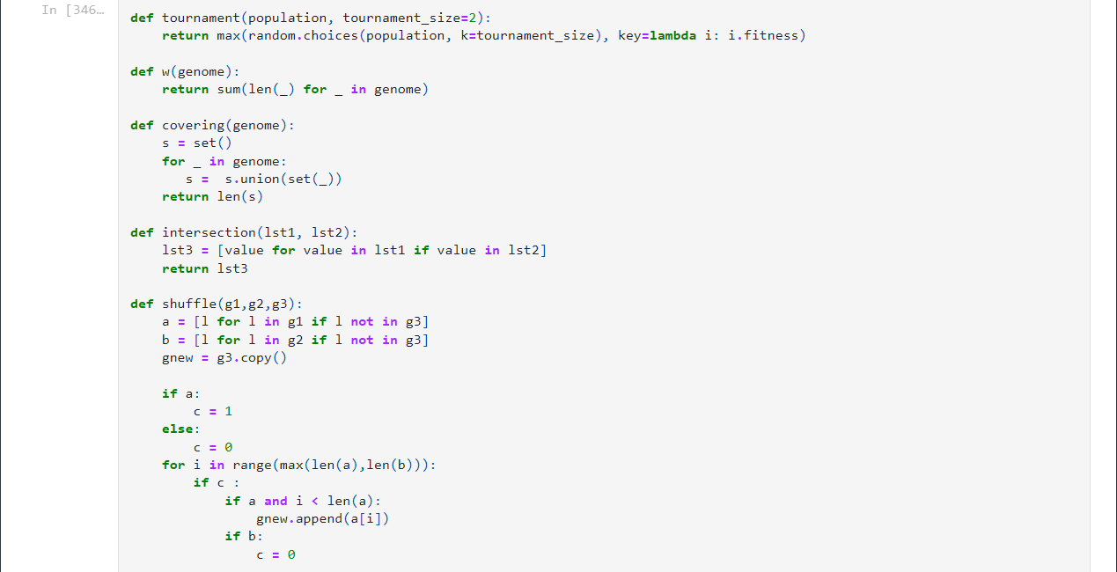

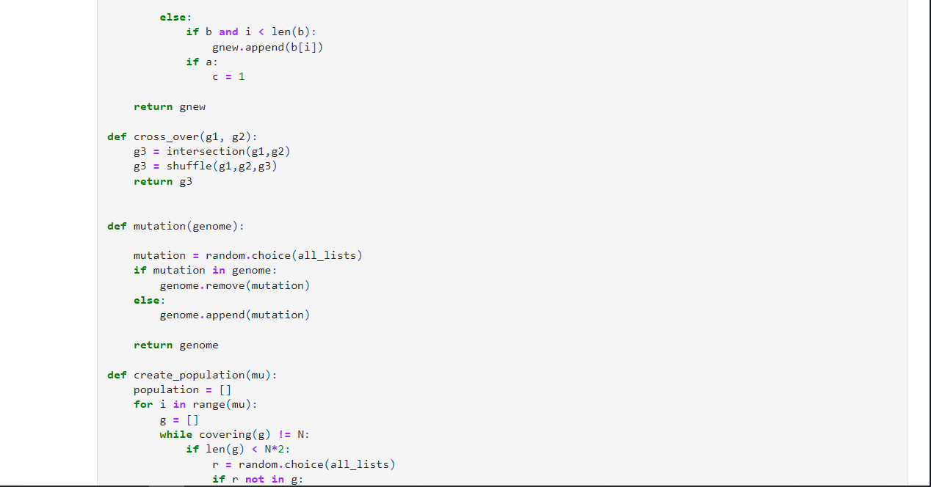
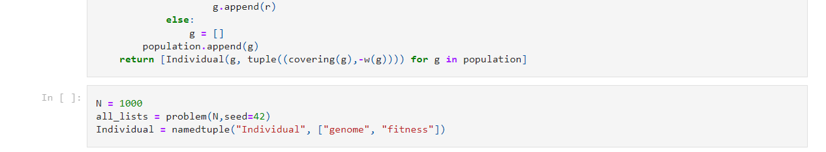
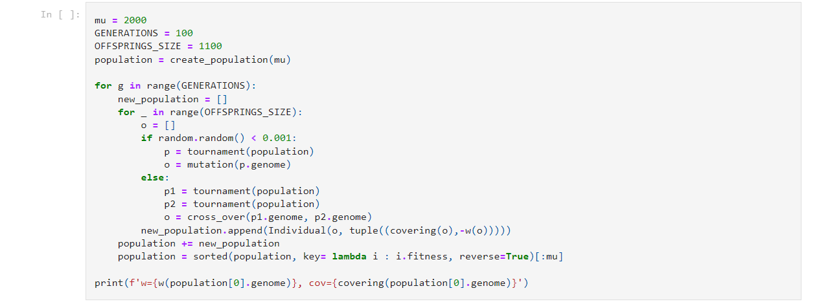
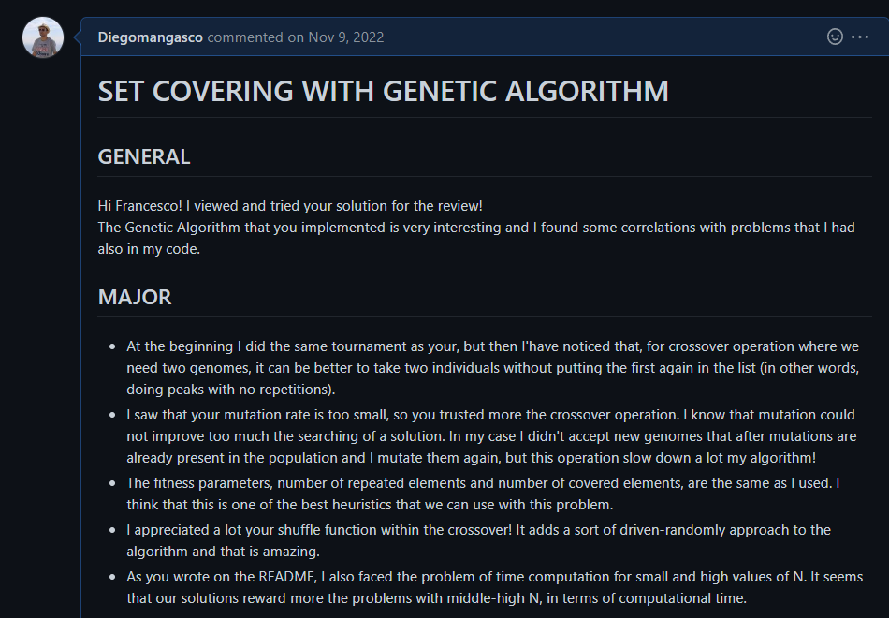
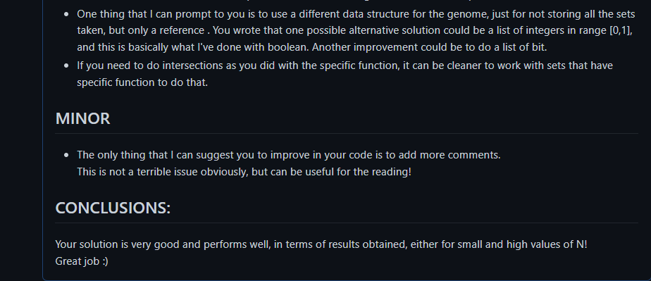

Critaek/Computational_Intelligence_22

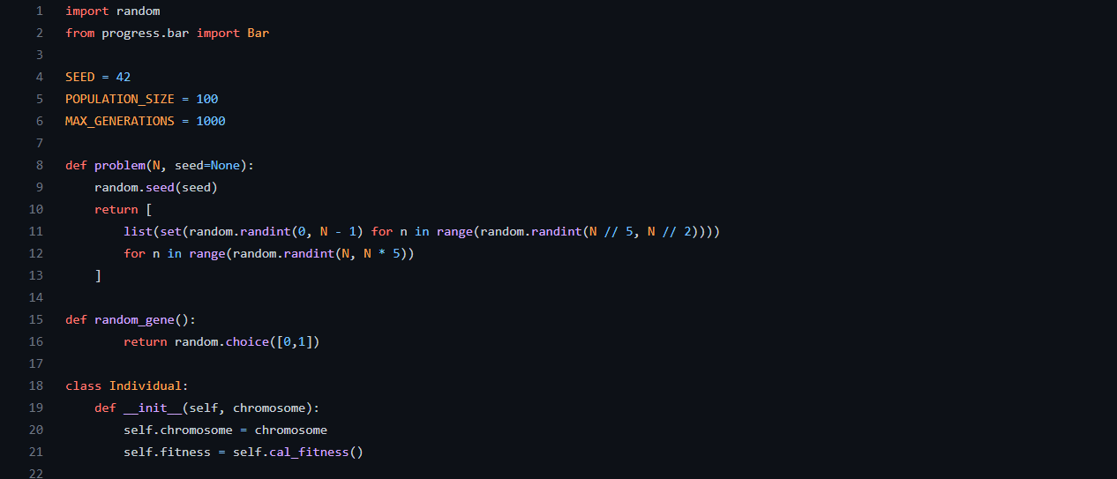
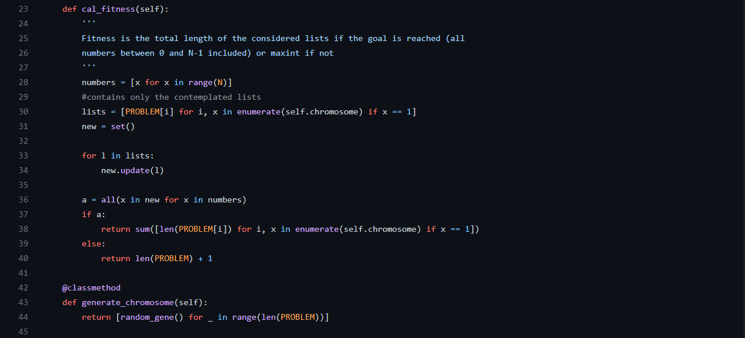
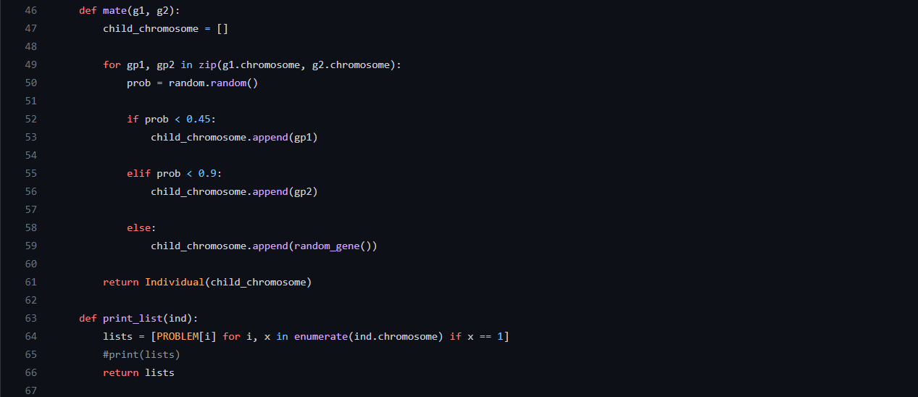
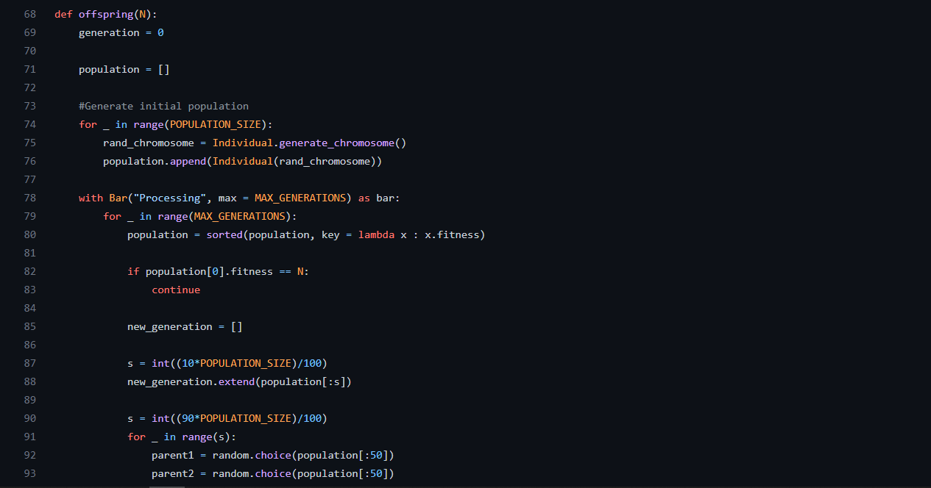
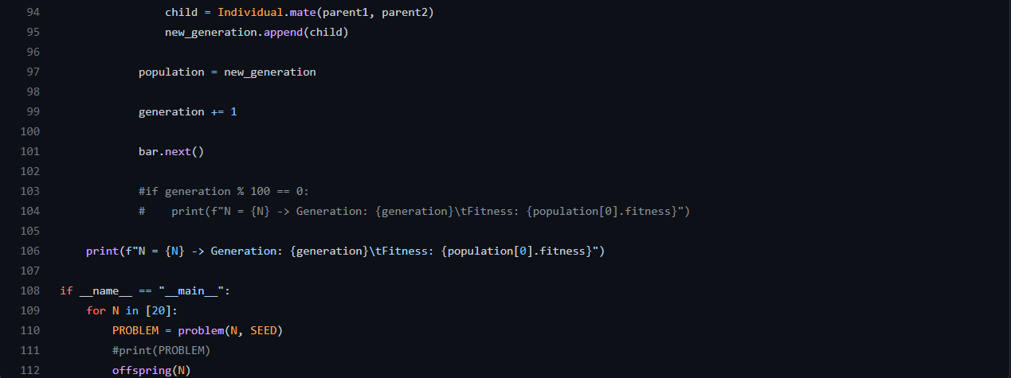
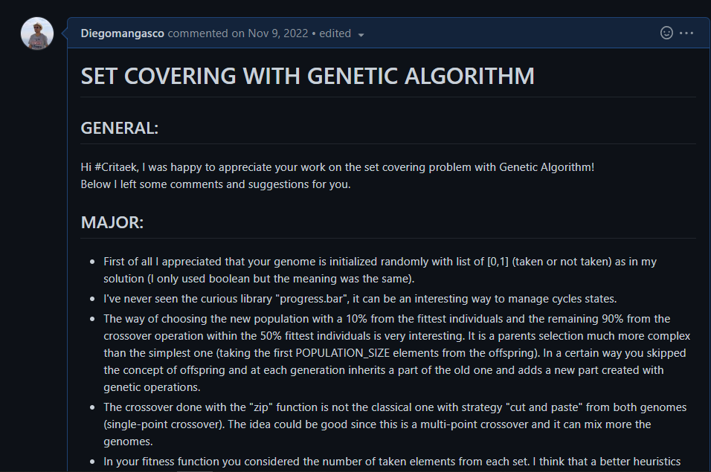
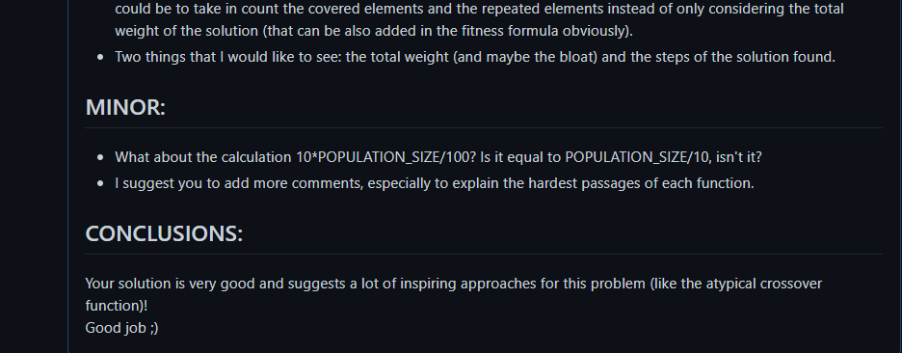

dfm88/computational_intelligence_2022

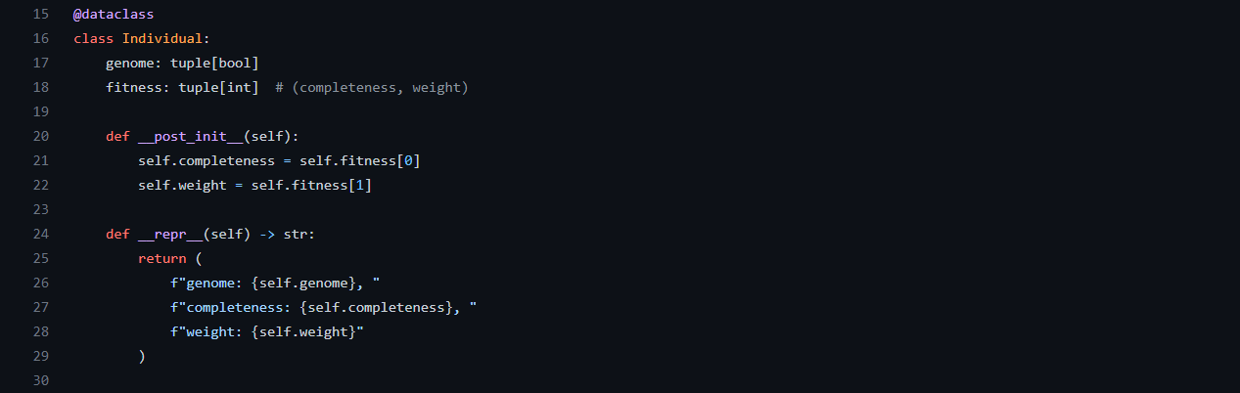

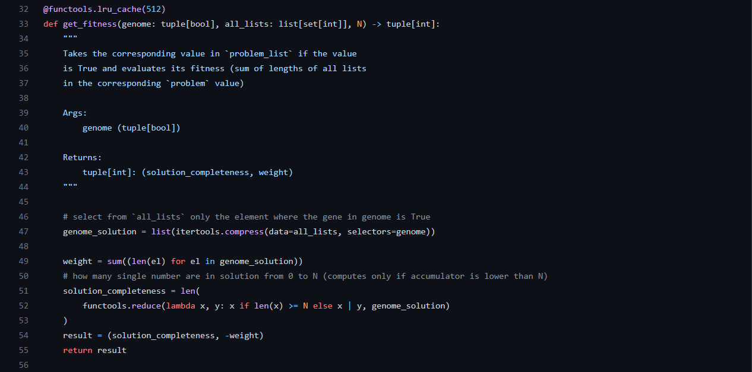
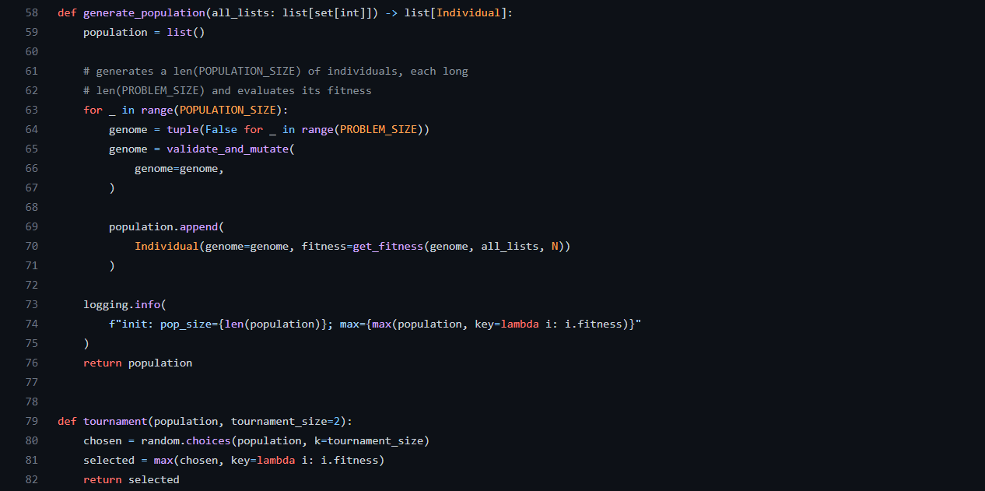
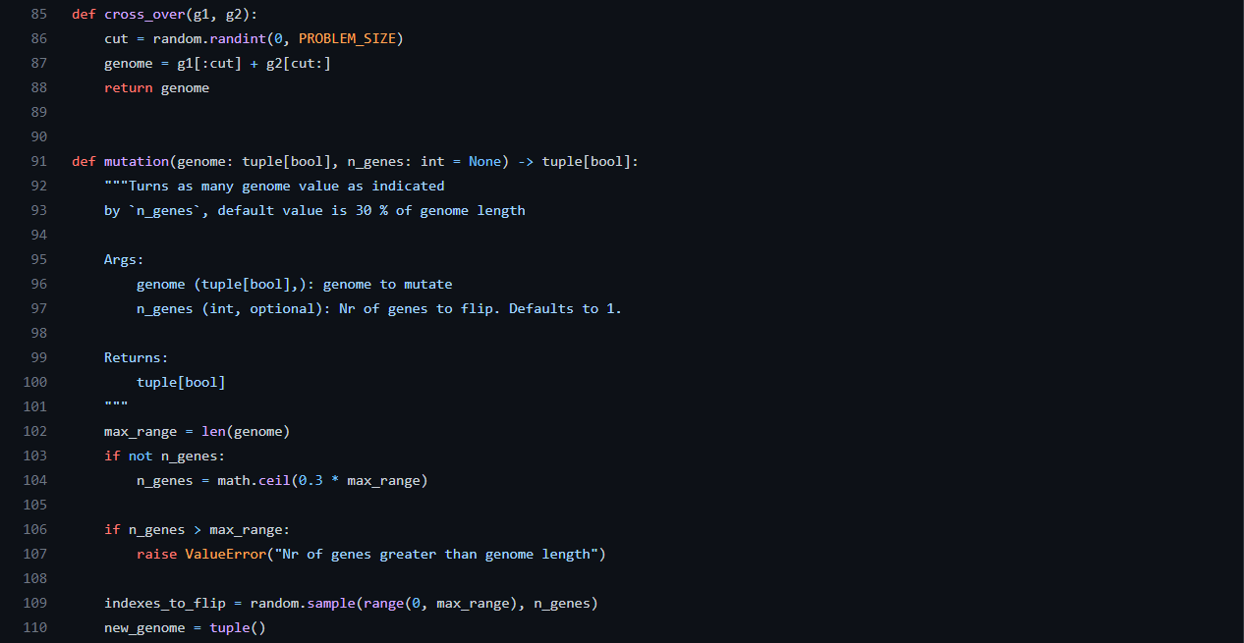
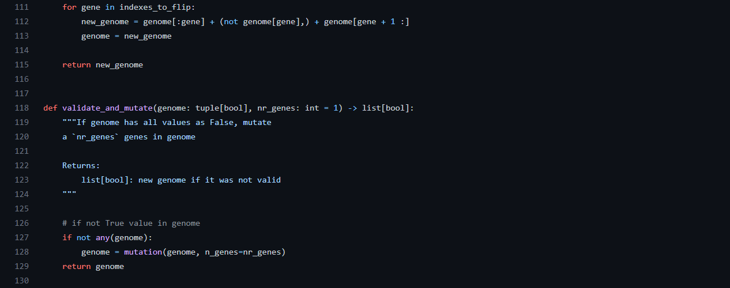

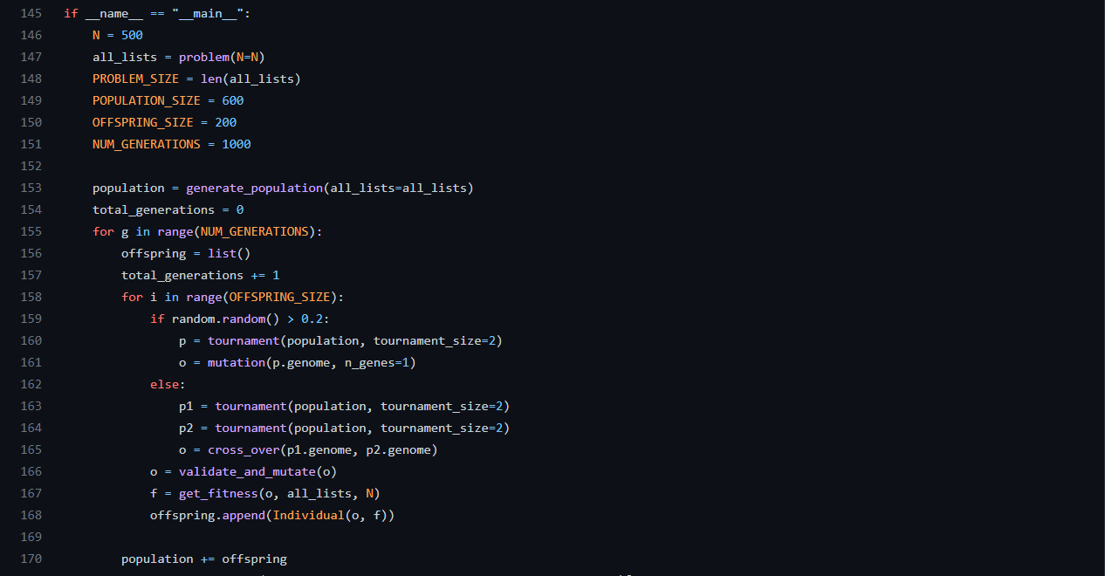
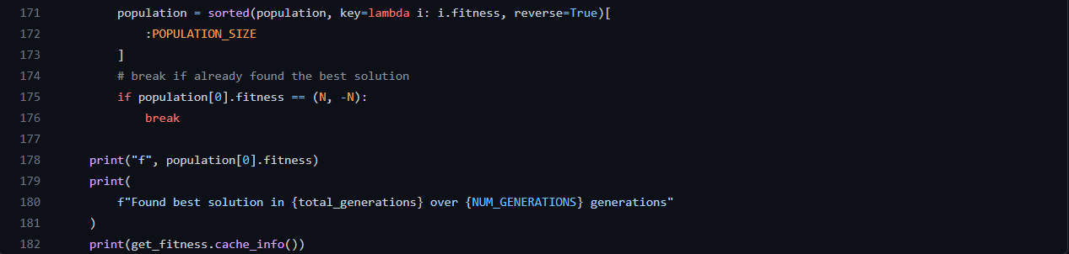
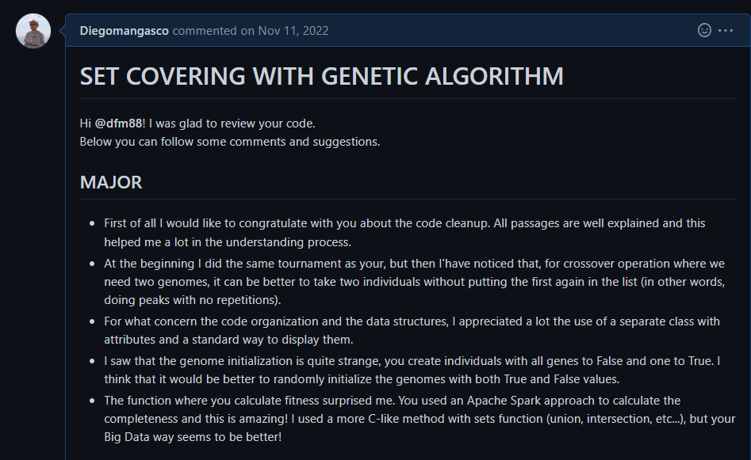
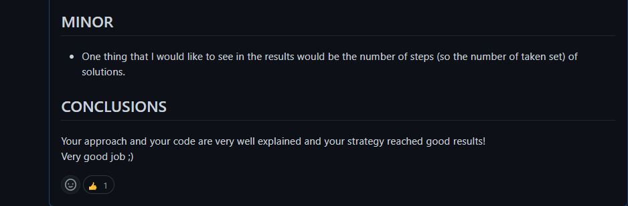

MatteMagnaldi/Computational_intelligence2022

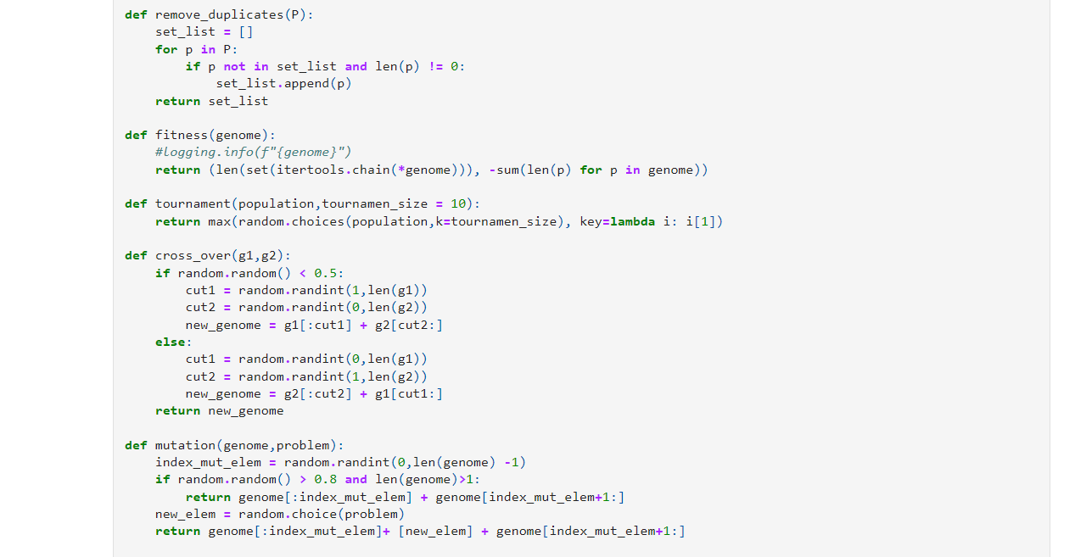
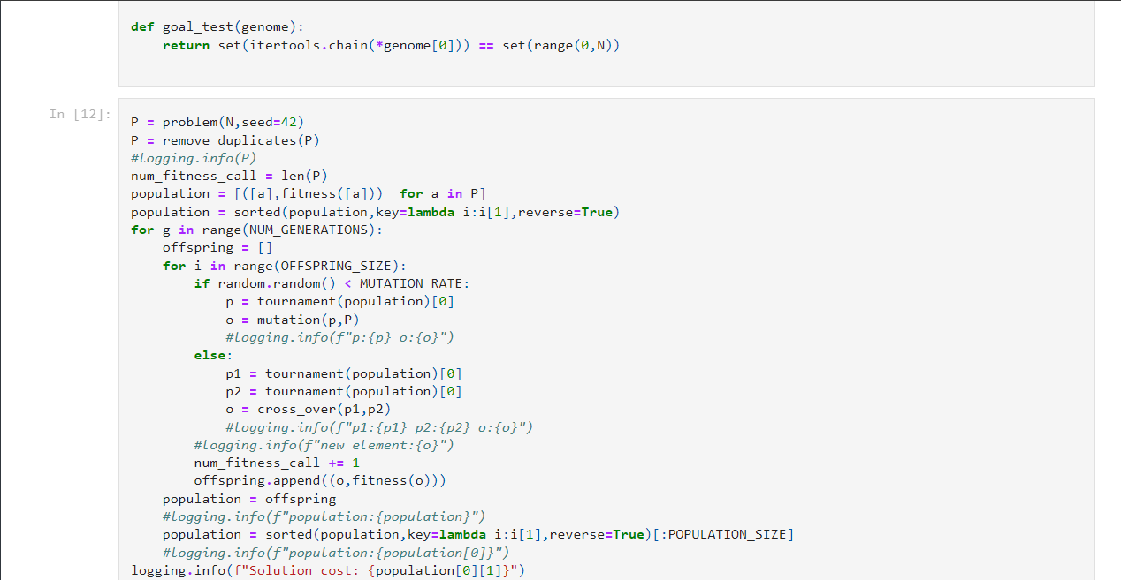

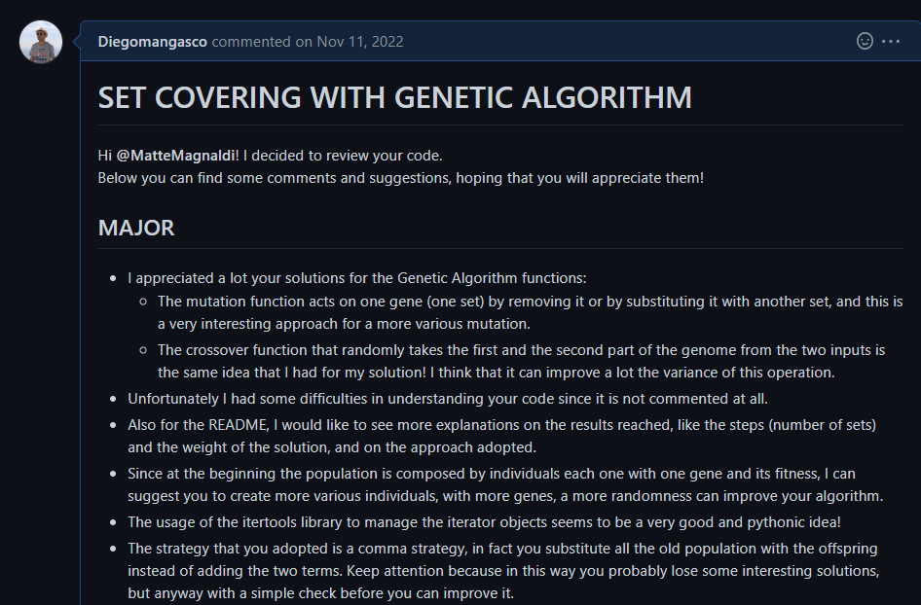
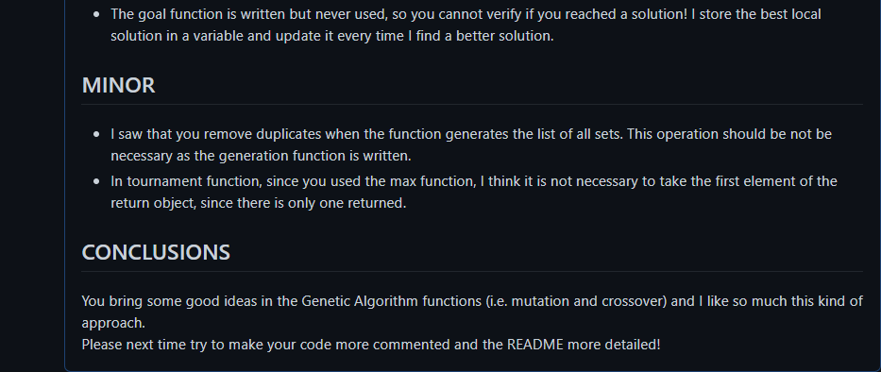

EnricoMagliano/computational-intelligence

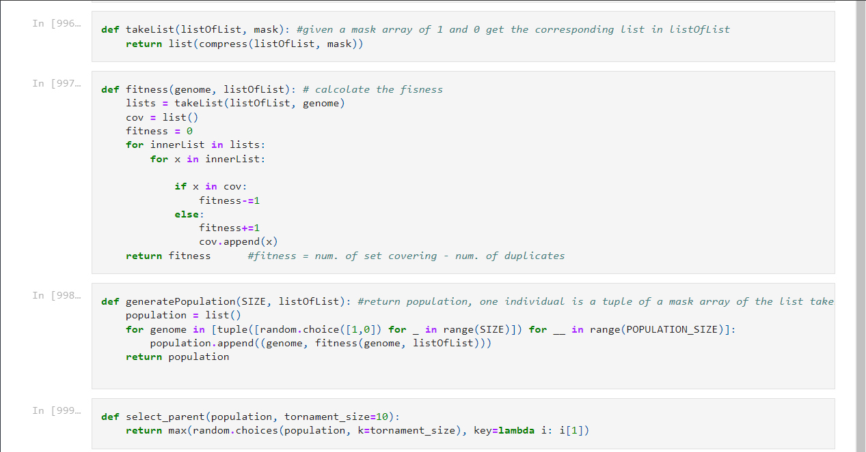
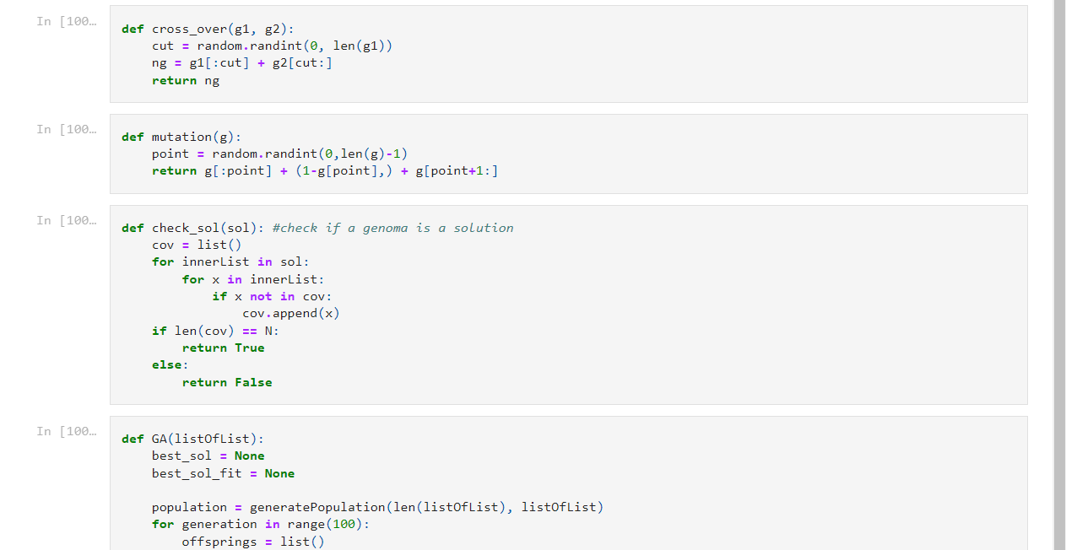
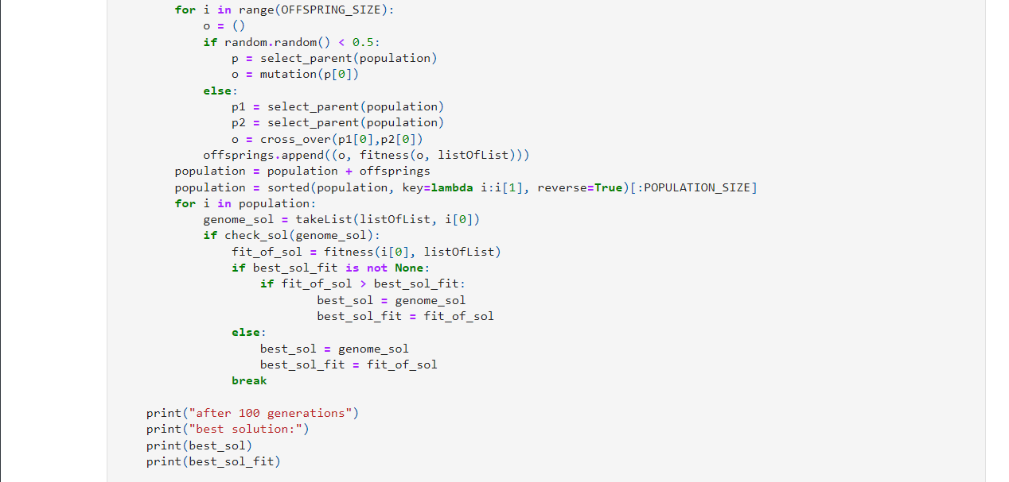

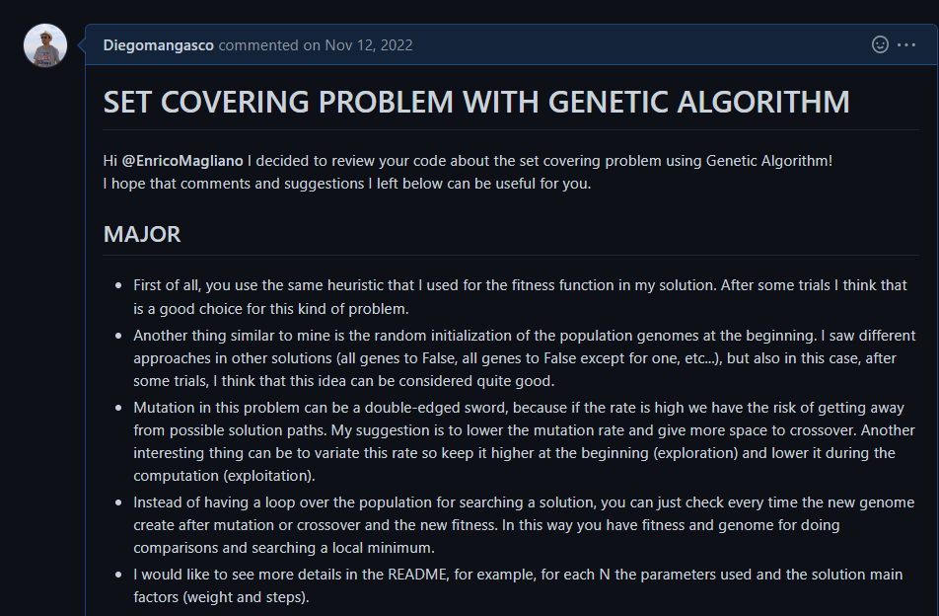
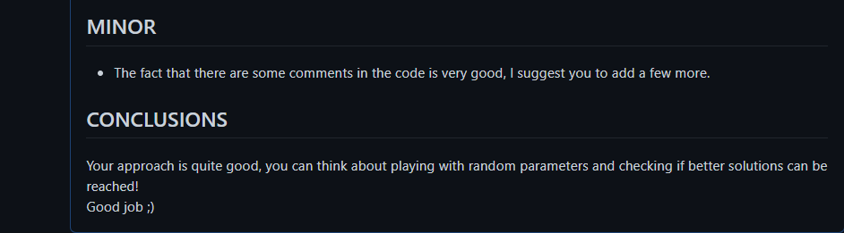

Eliafontana/Computational_Intelligence_2022-23_S290188

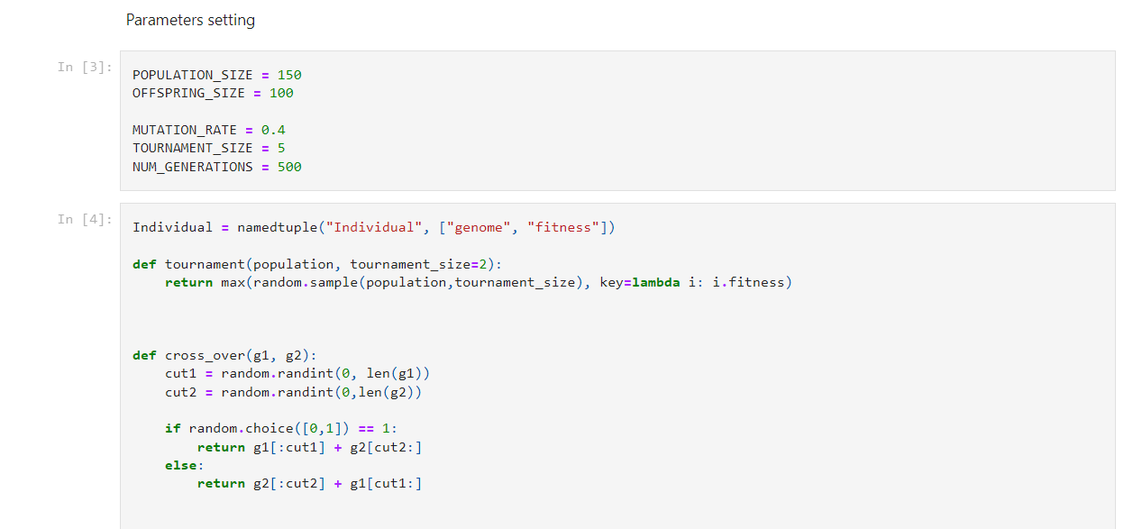
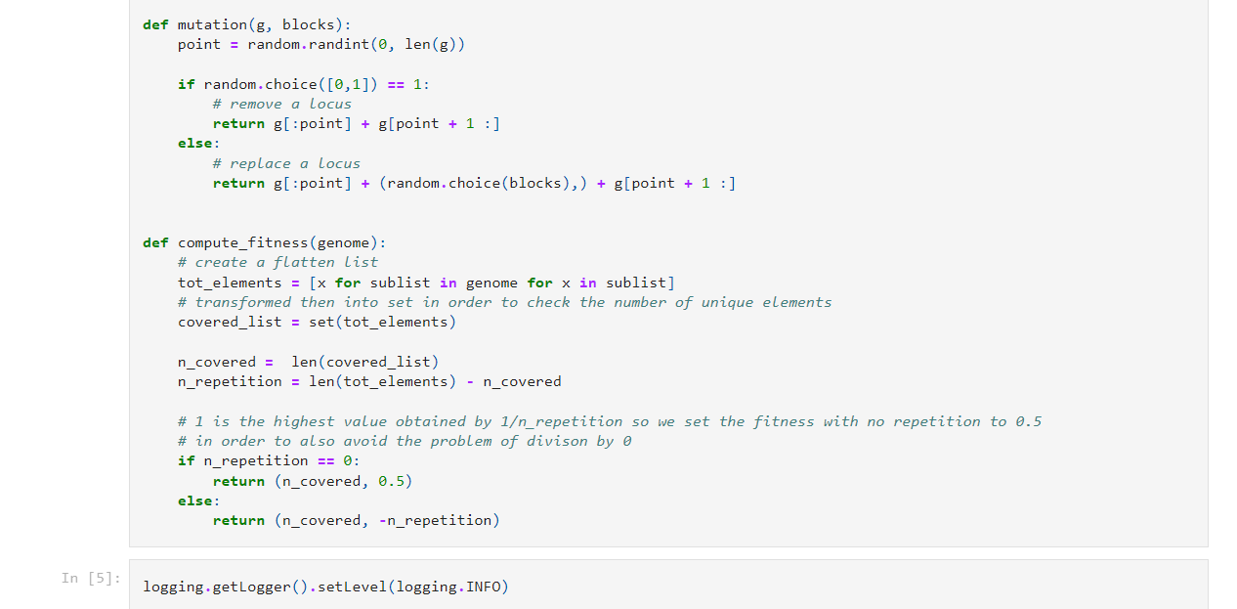
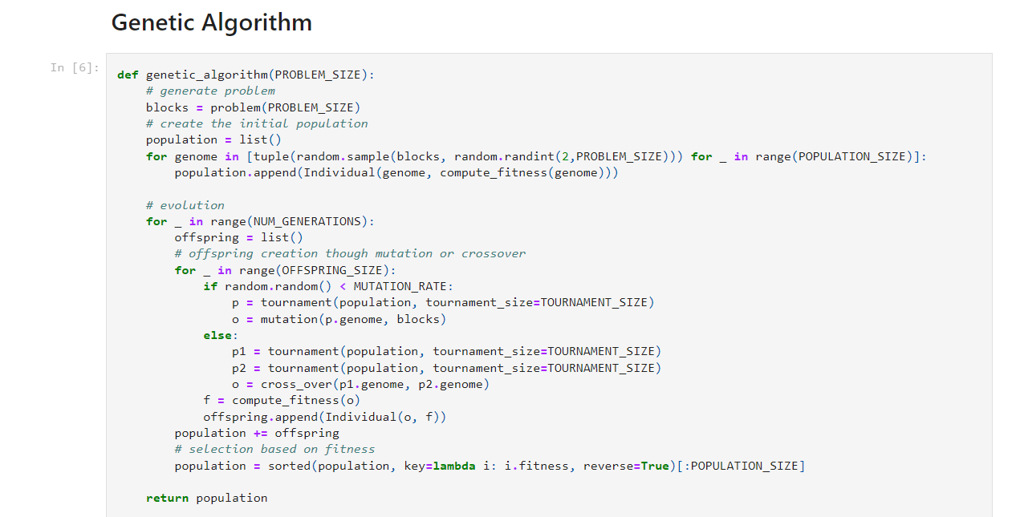
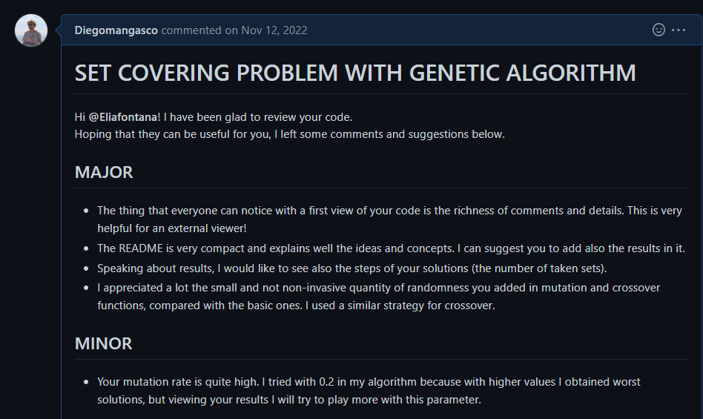
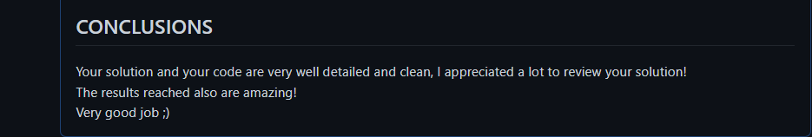

Zohrelhj/Computational_Intelligence---Polito-

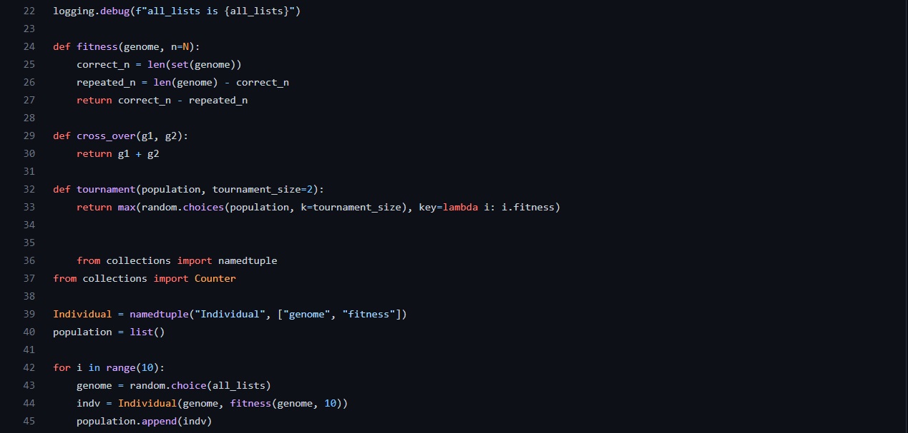
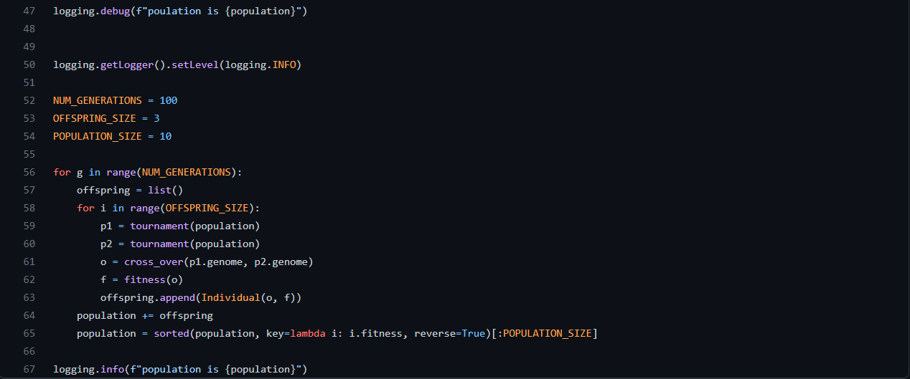

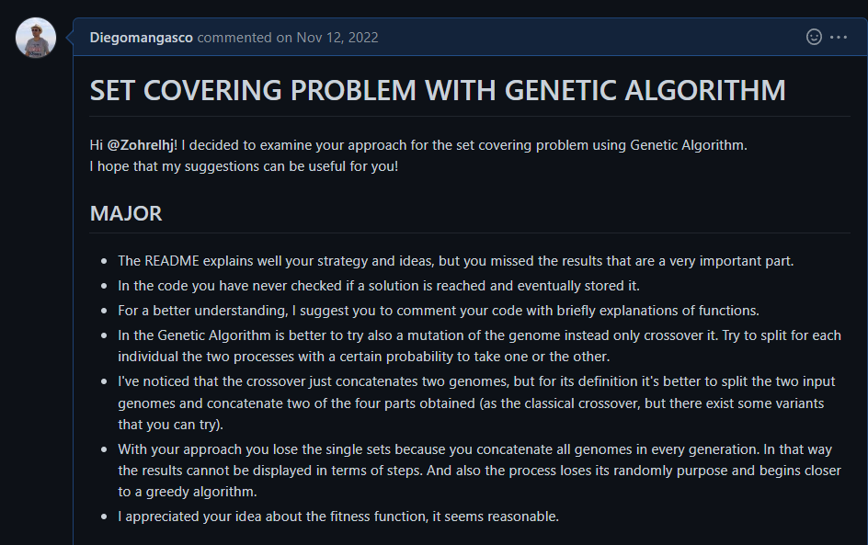
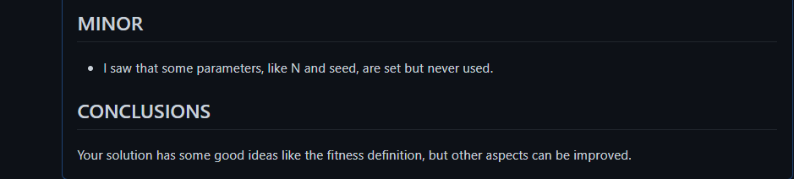

LABORATORY 3:

Description:

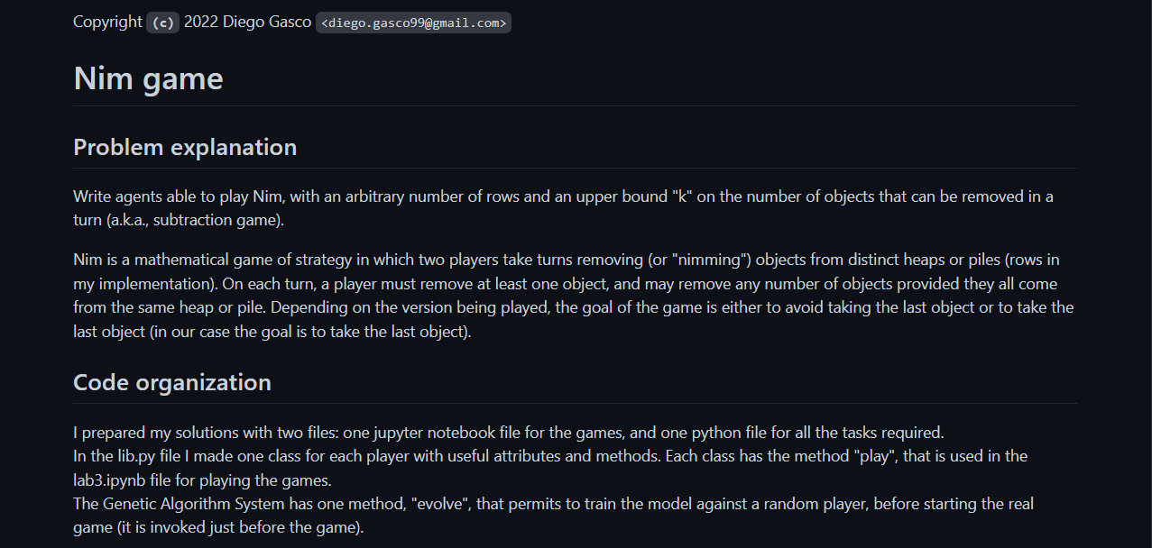
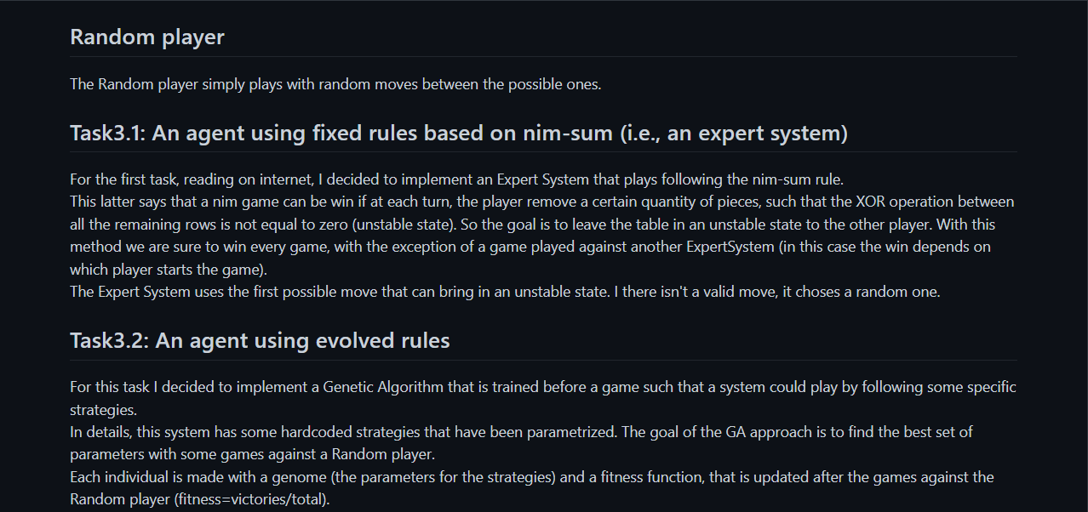
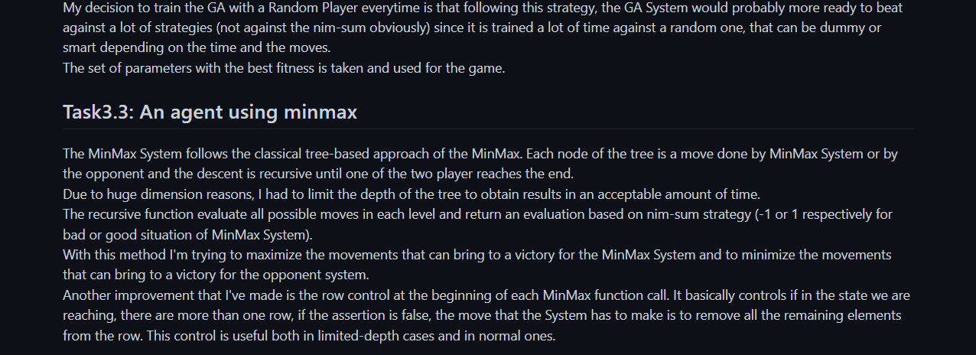
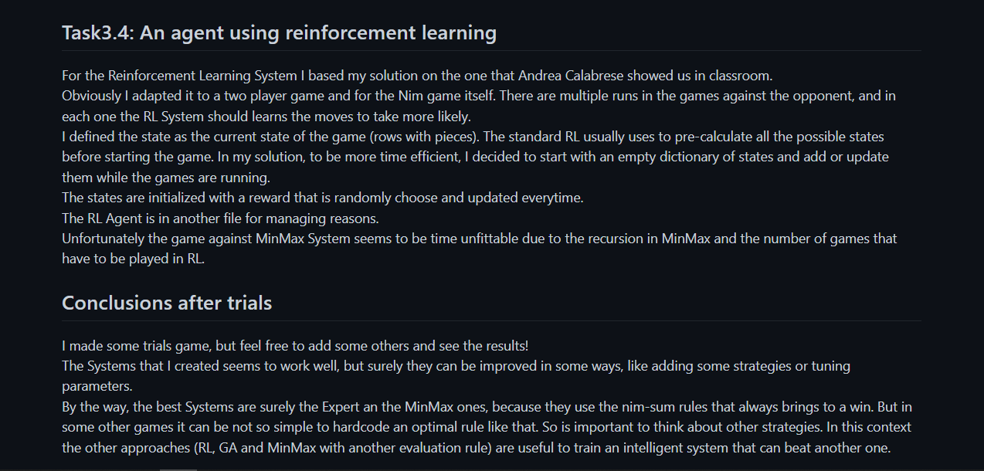

Code:

File: lib.py

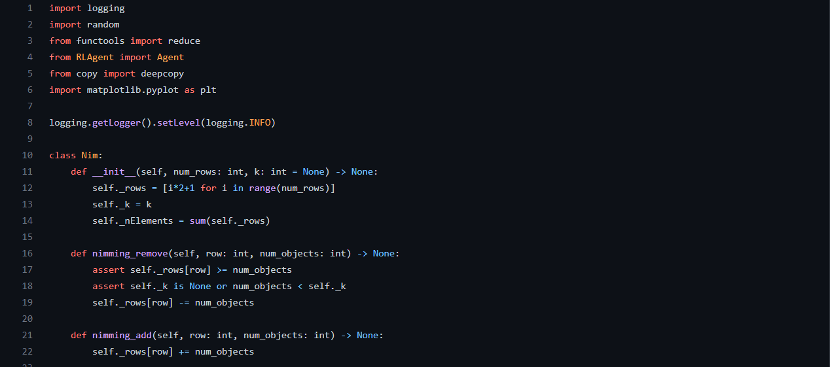

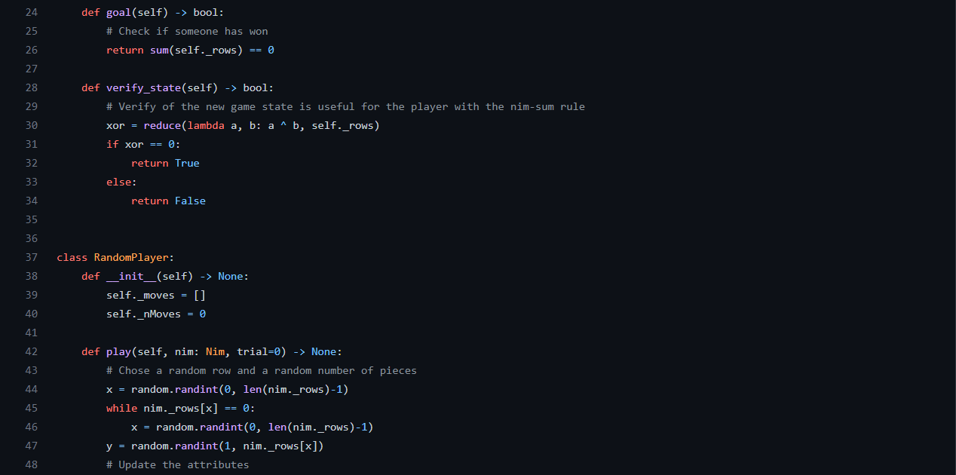
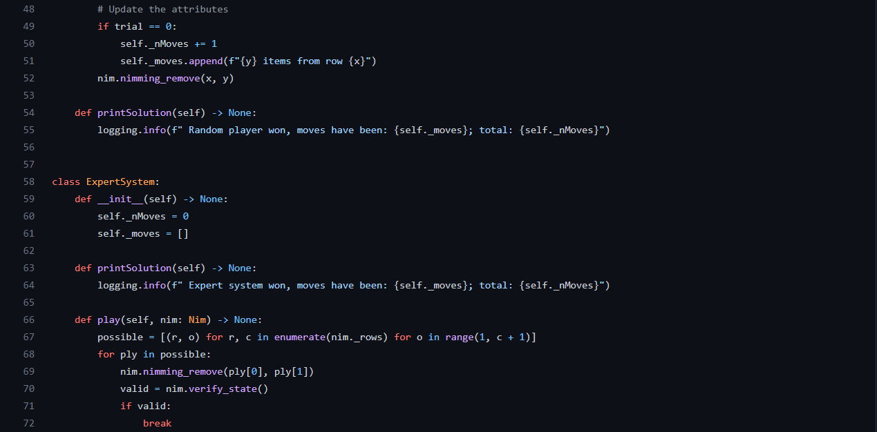

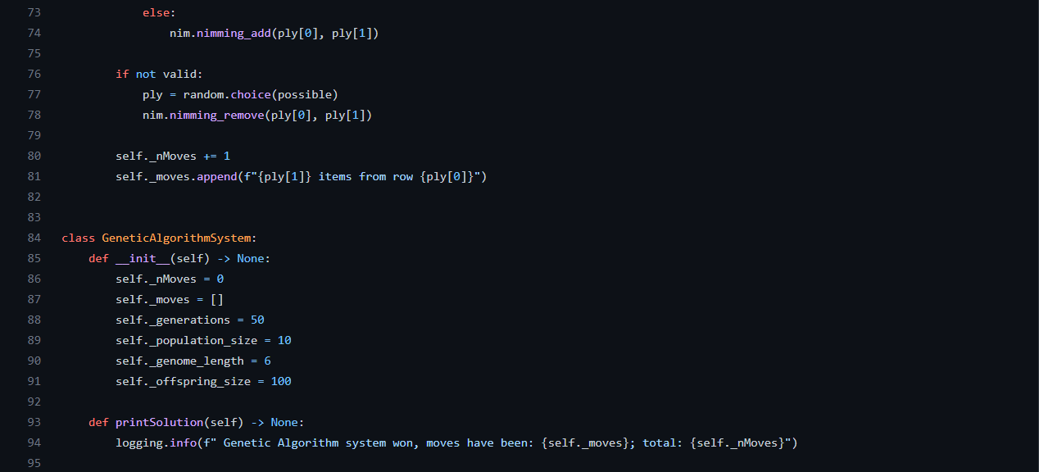
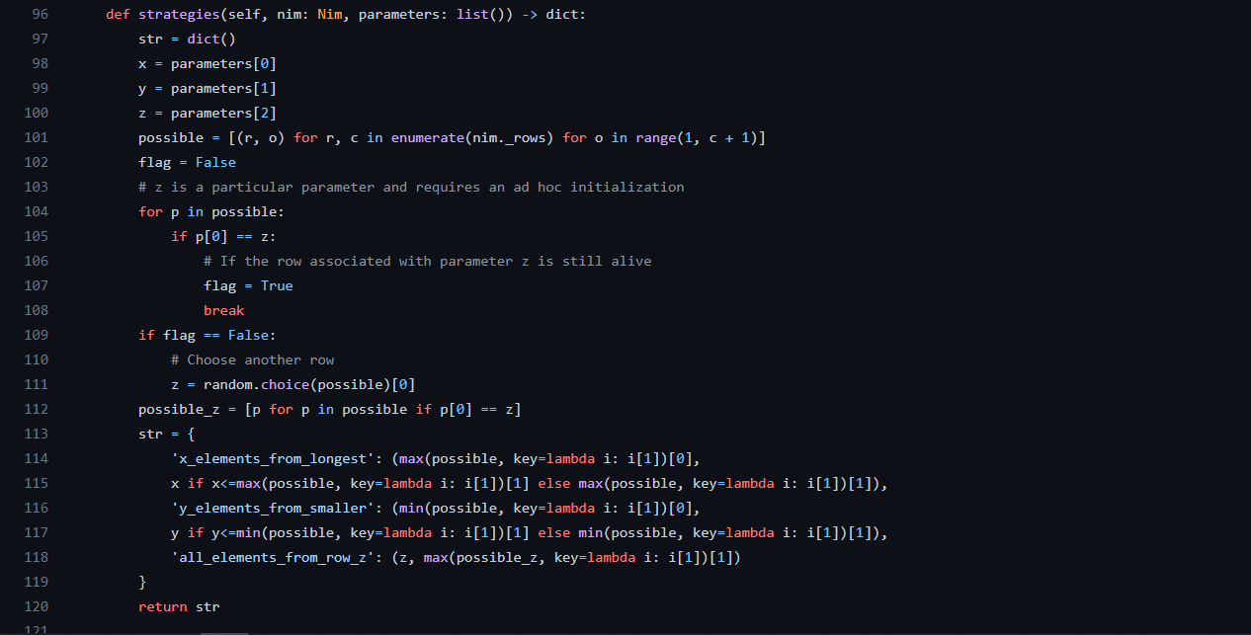
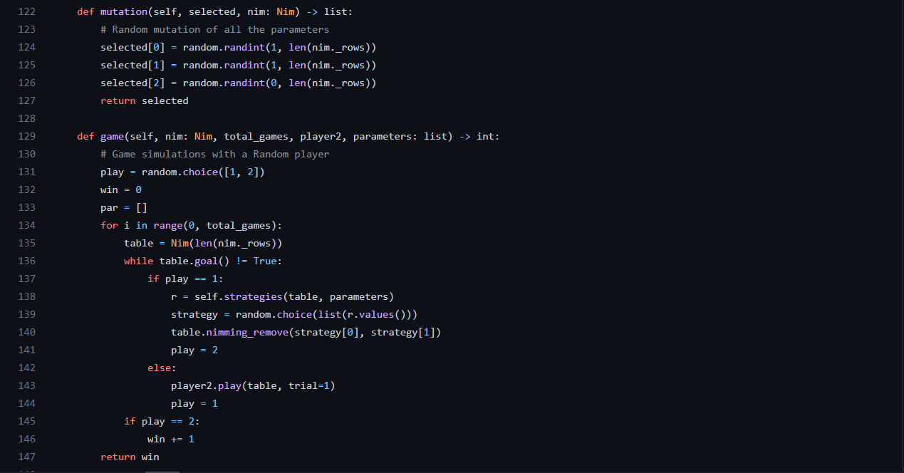
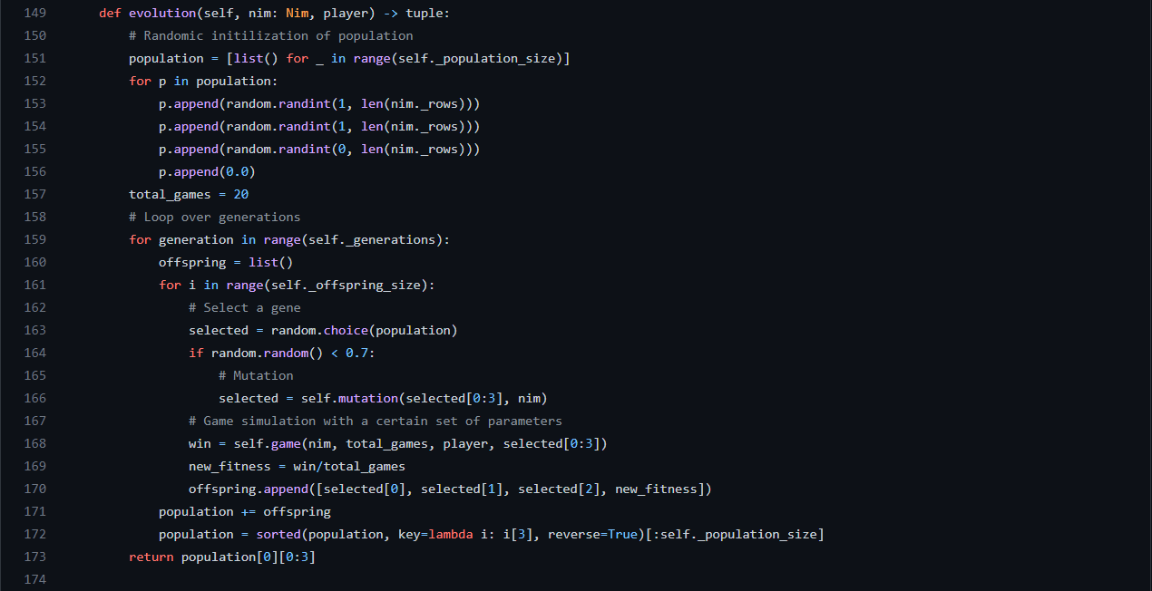
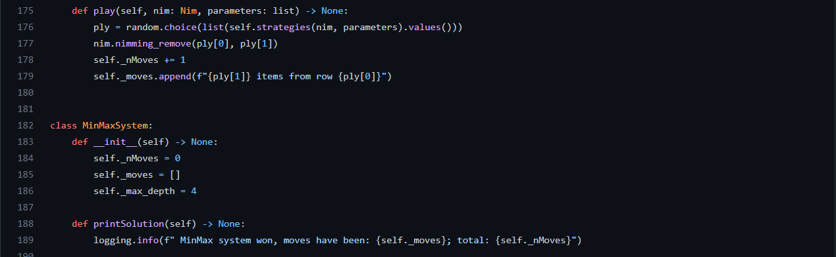
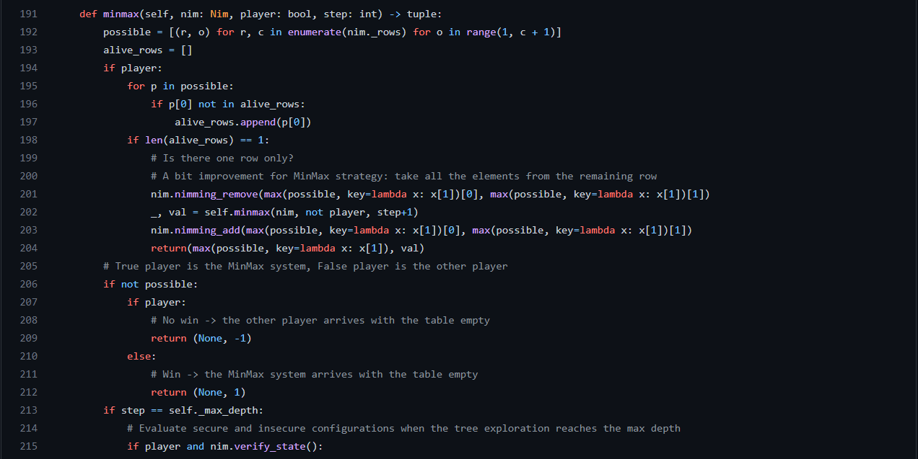
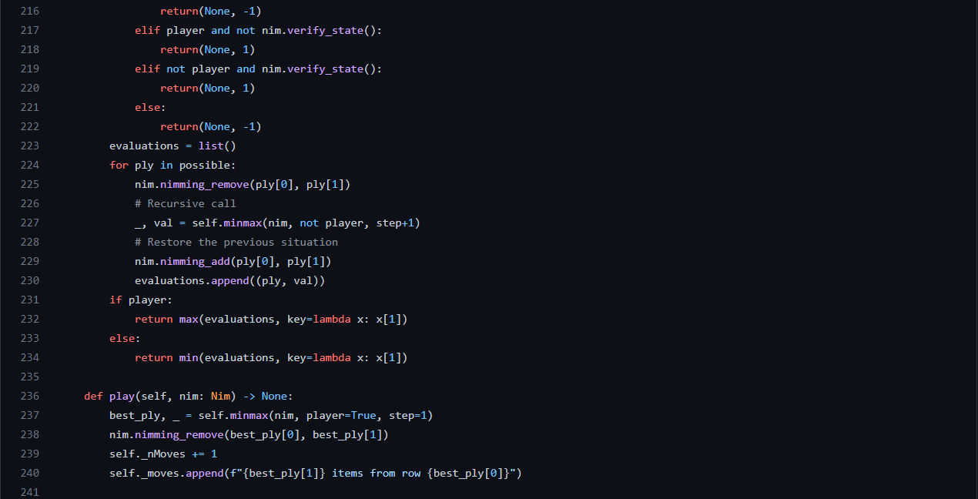
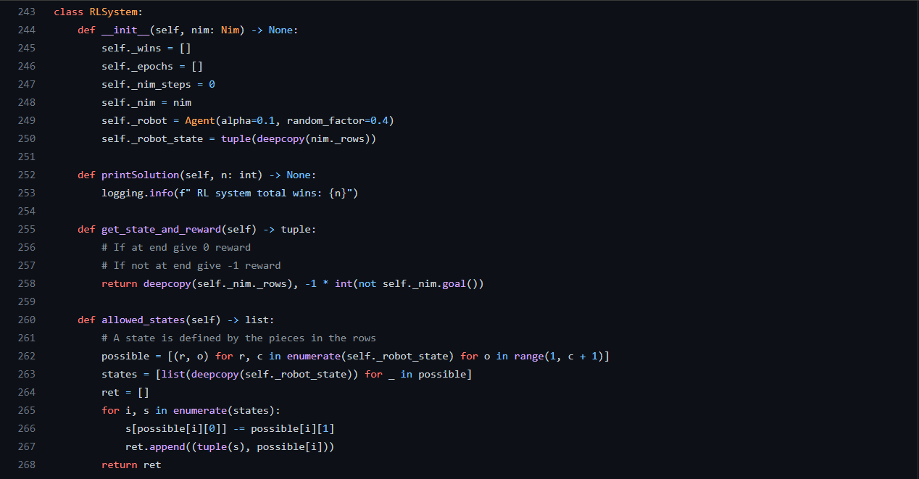
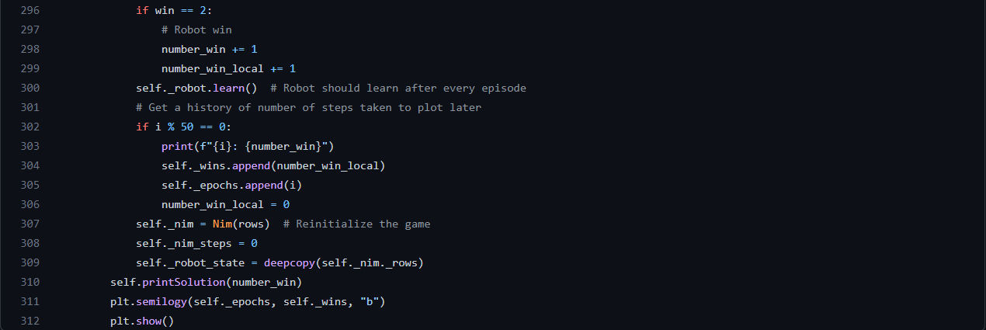
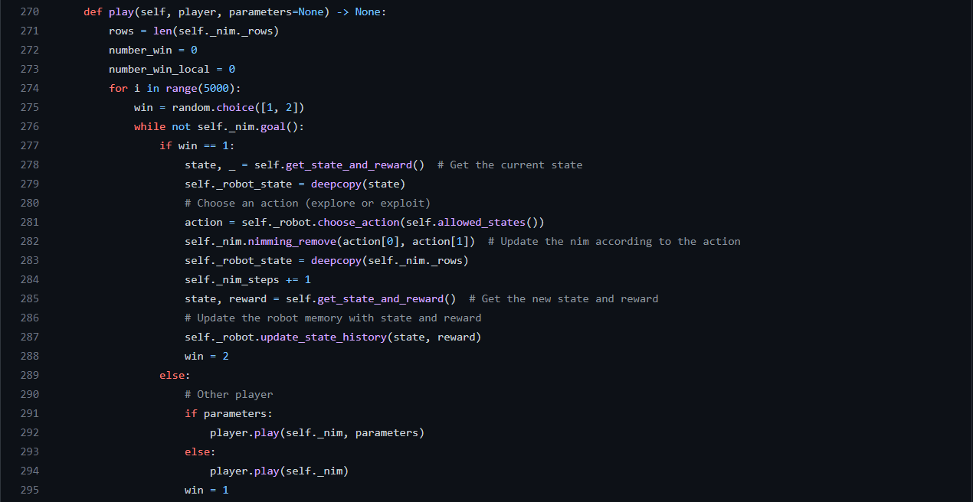

File: RLAgent.py

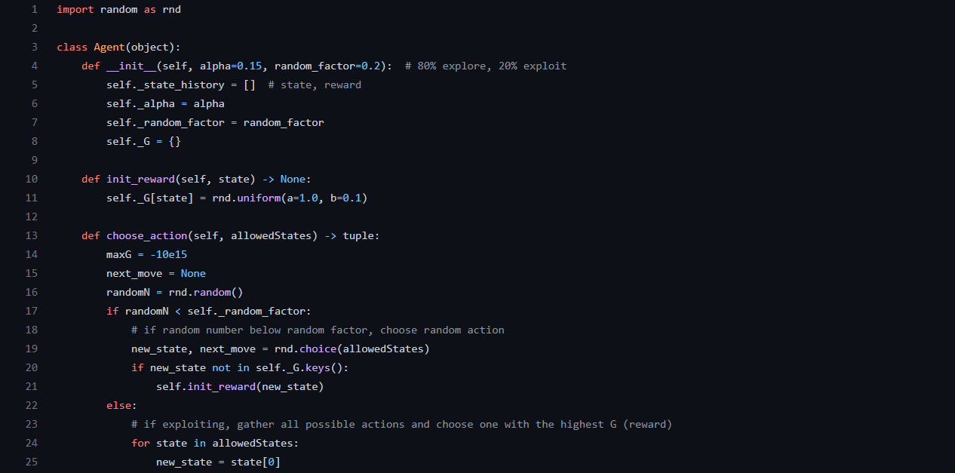
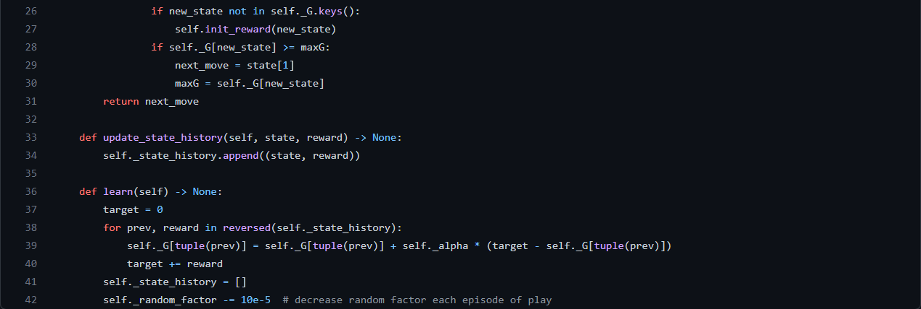
File: lab3.ipynb

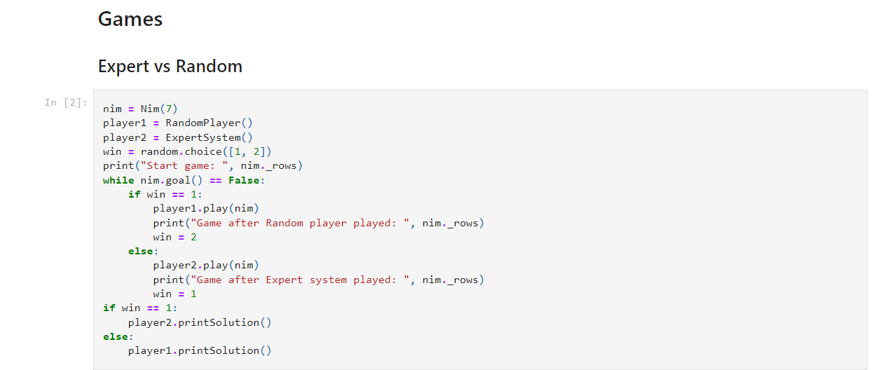

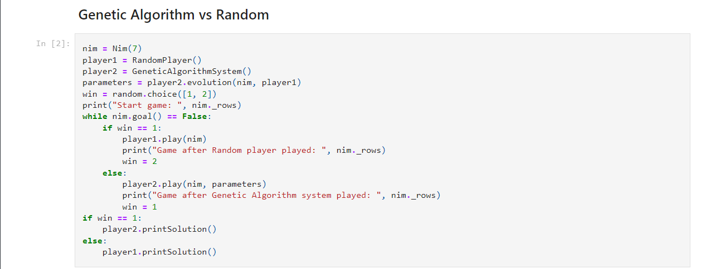
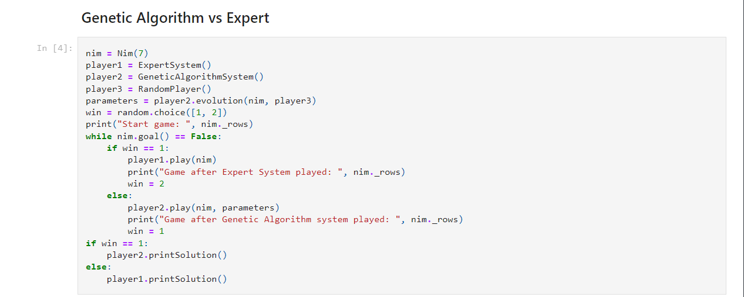
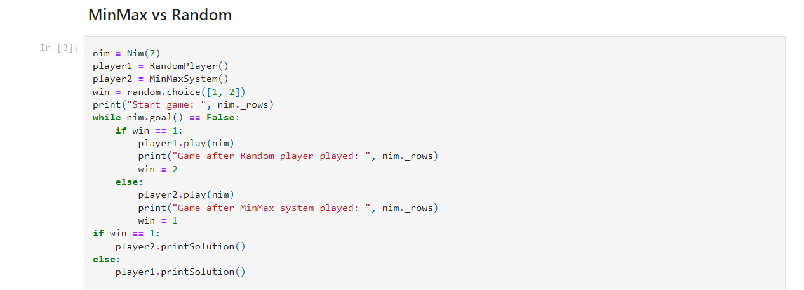

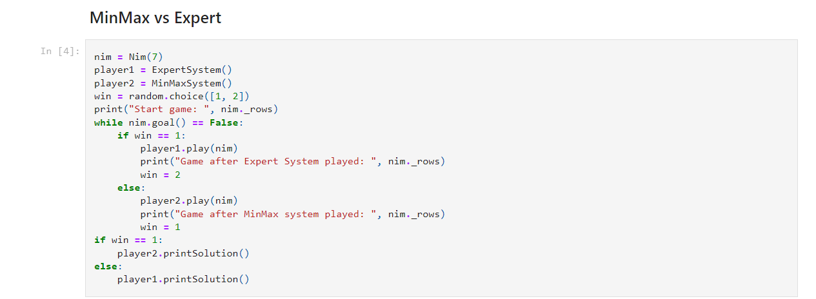

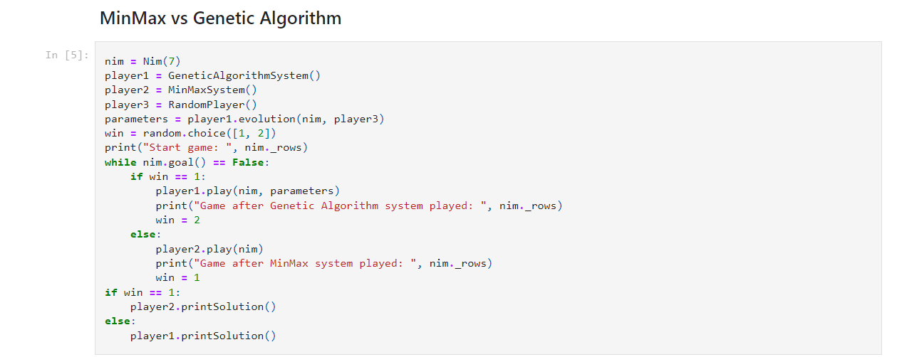

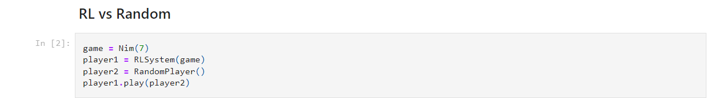

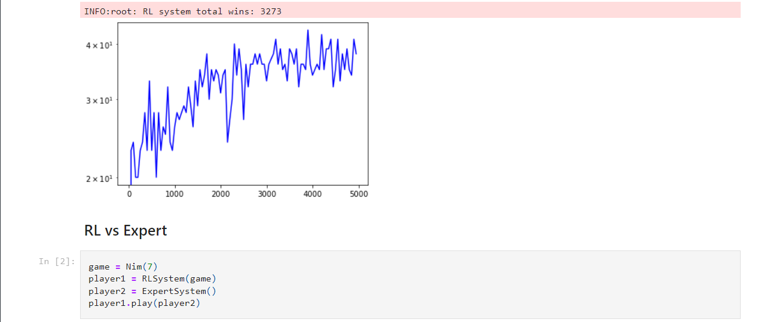

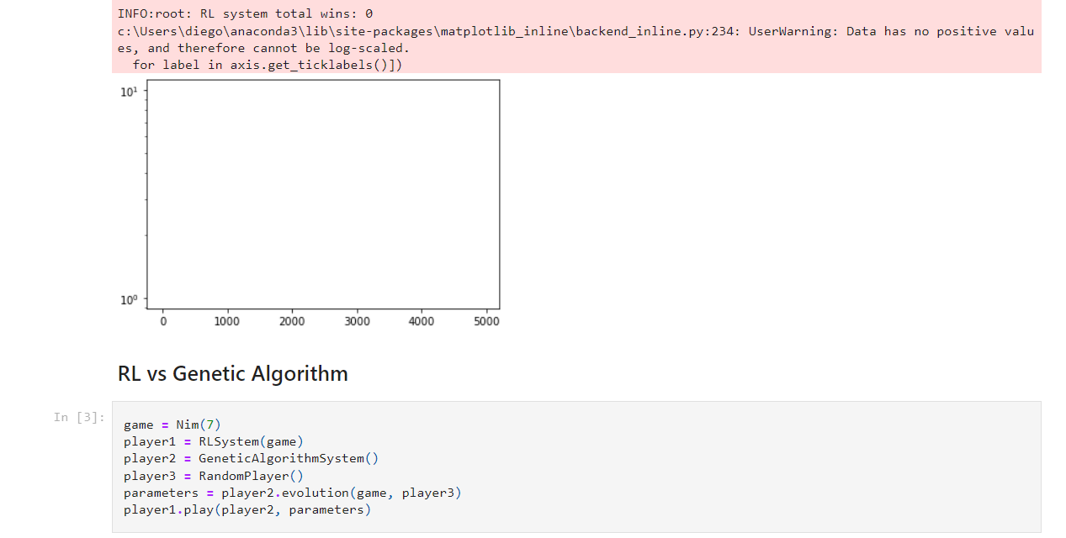

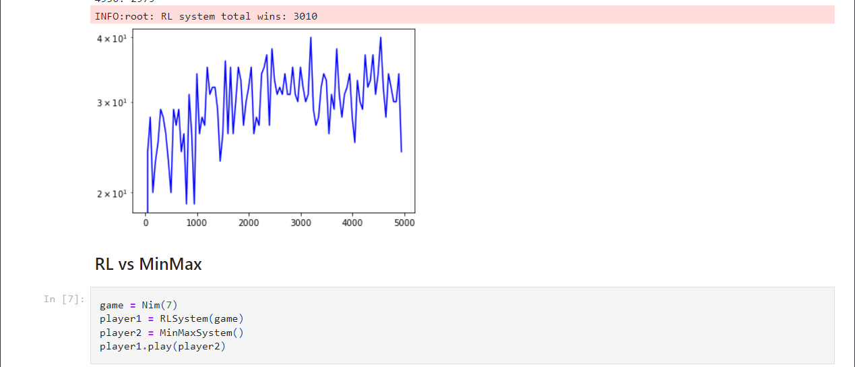

Reviews received:

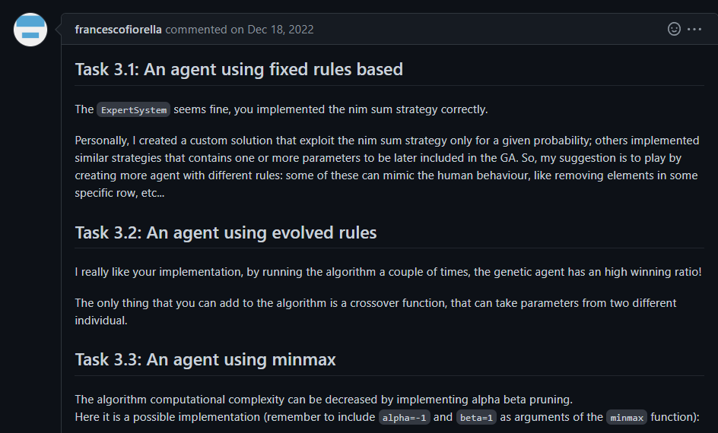
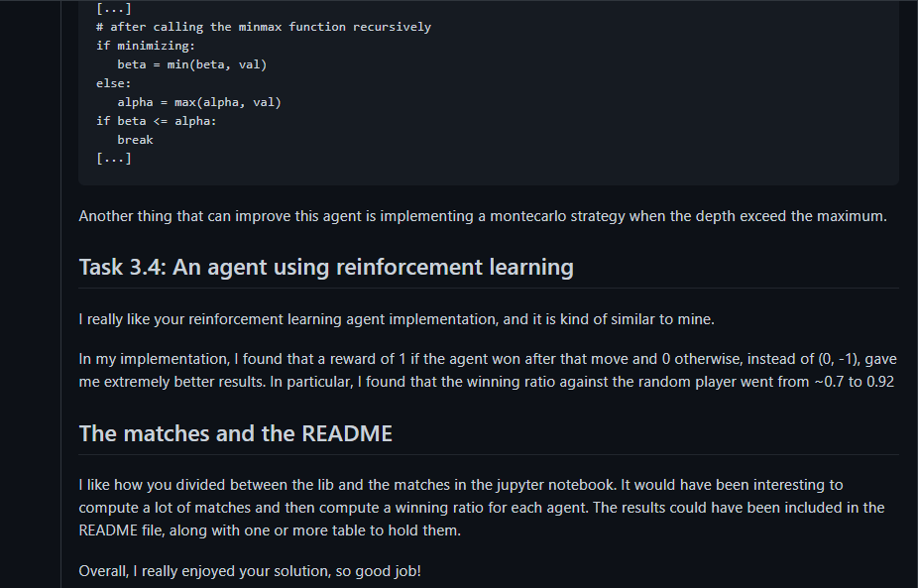
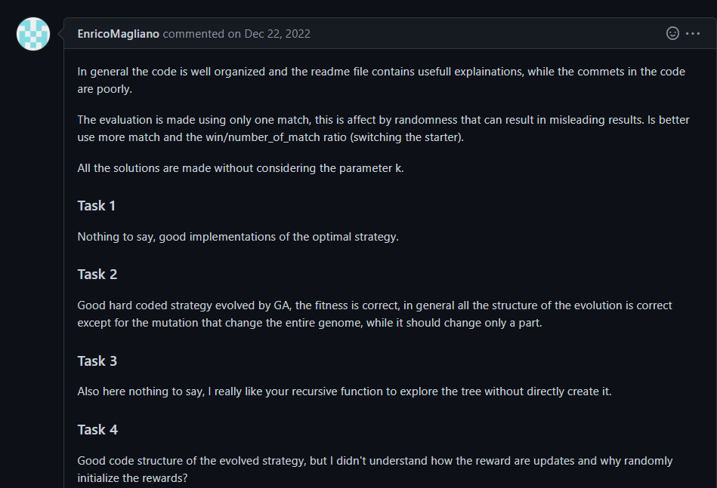


Reviews done:

giogenna16/ComputationalIntelligence_2022_2023_s304684

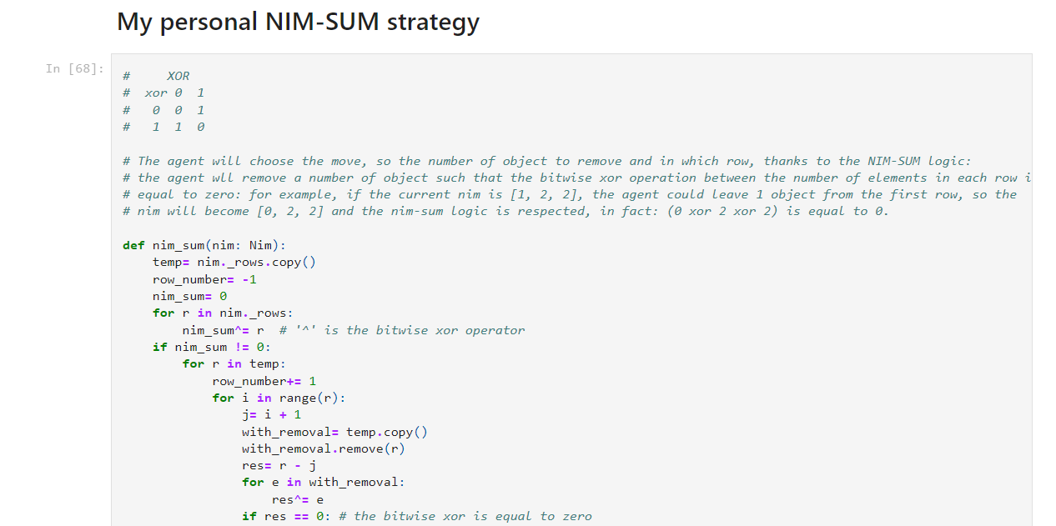
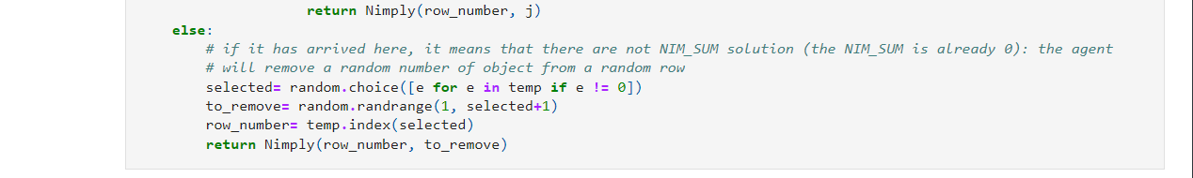
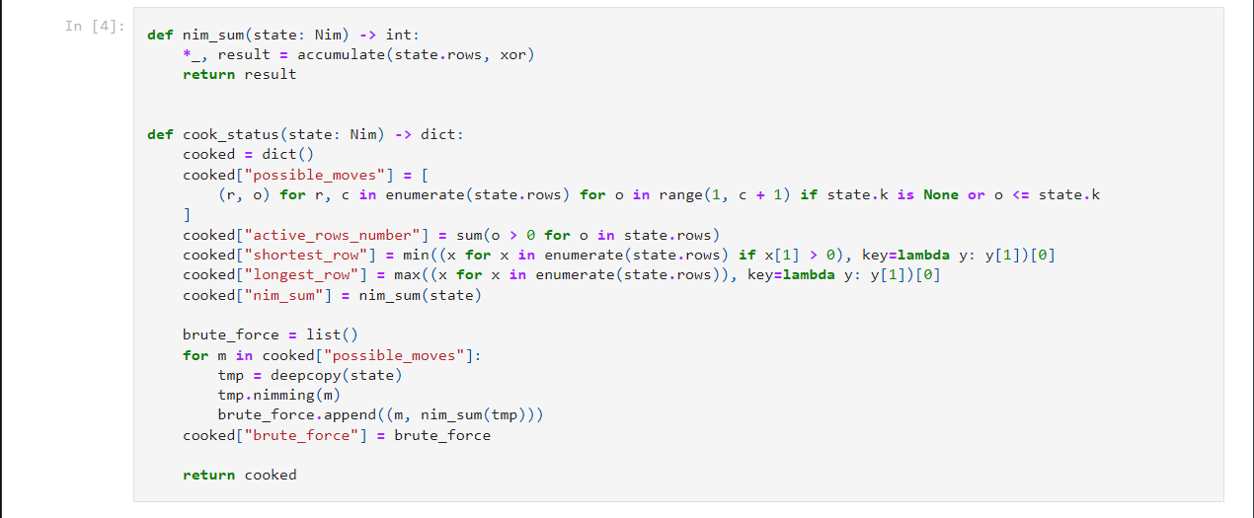

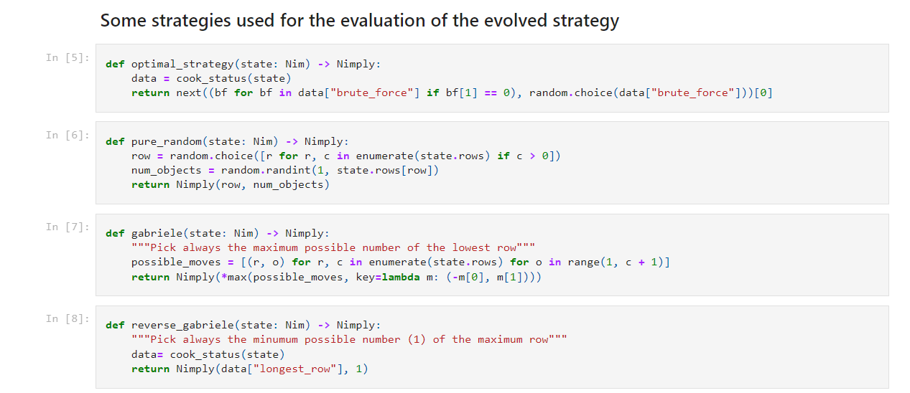

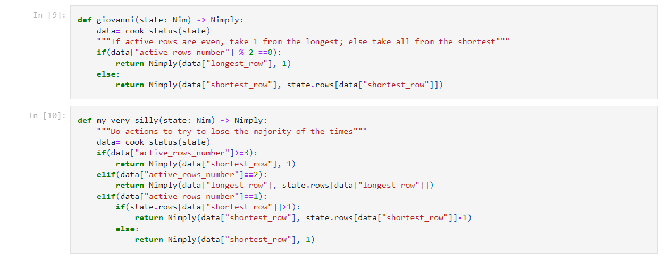

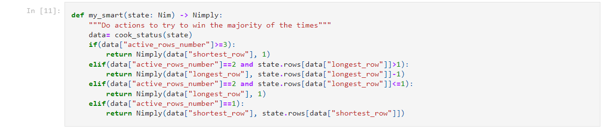

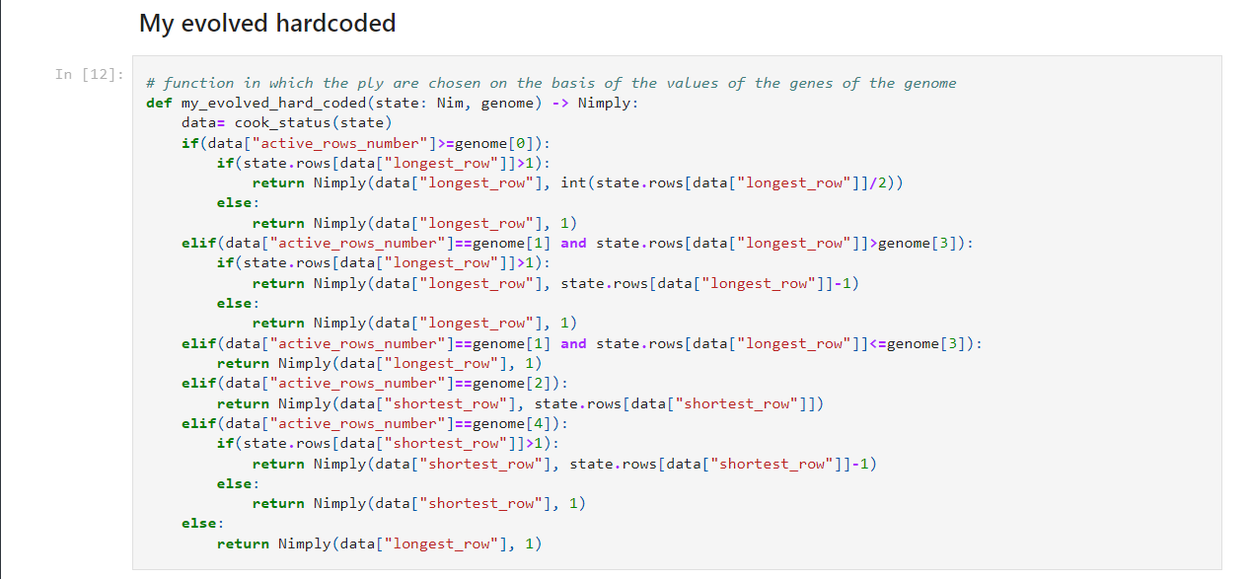

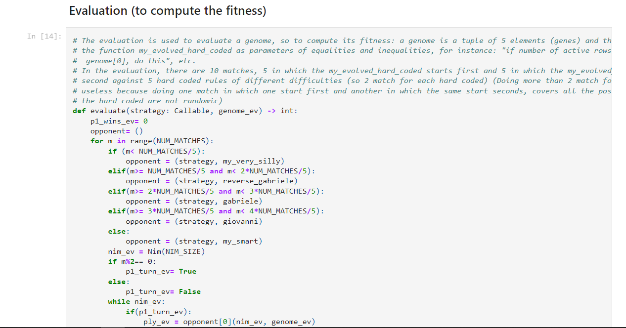

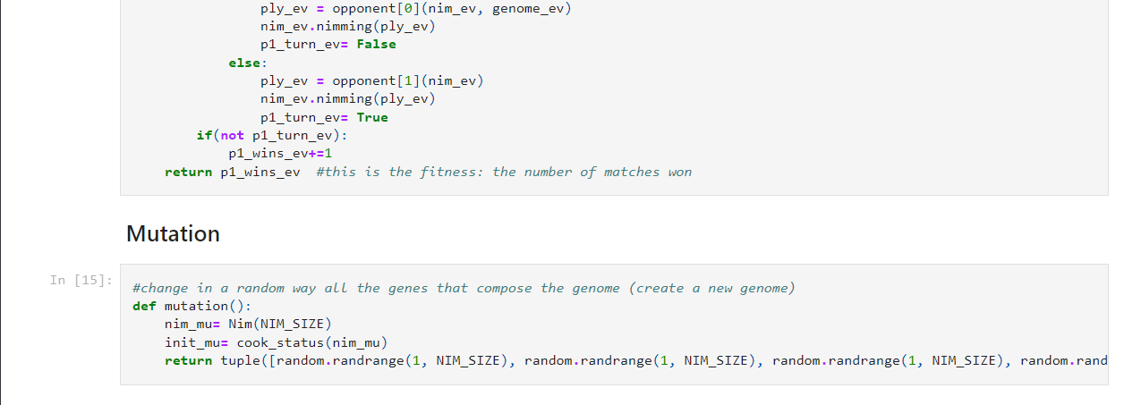

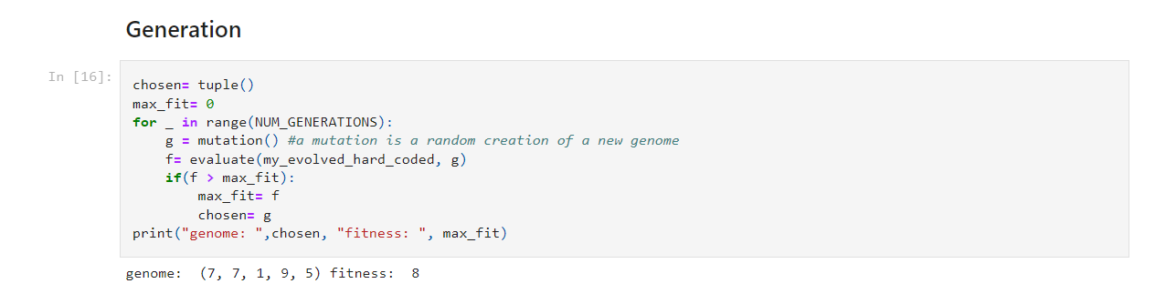

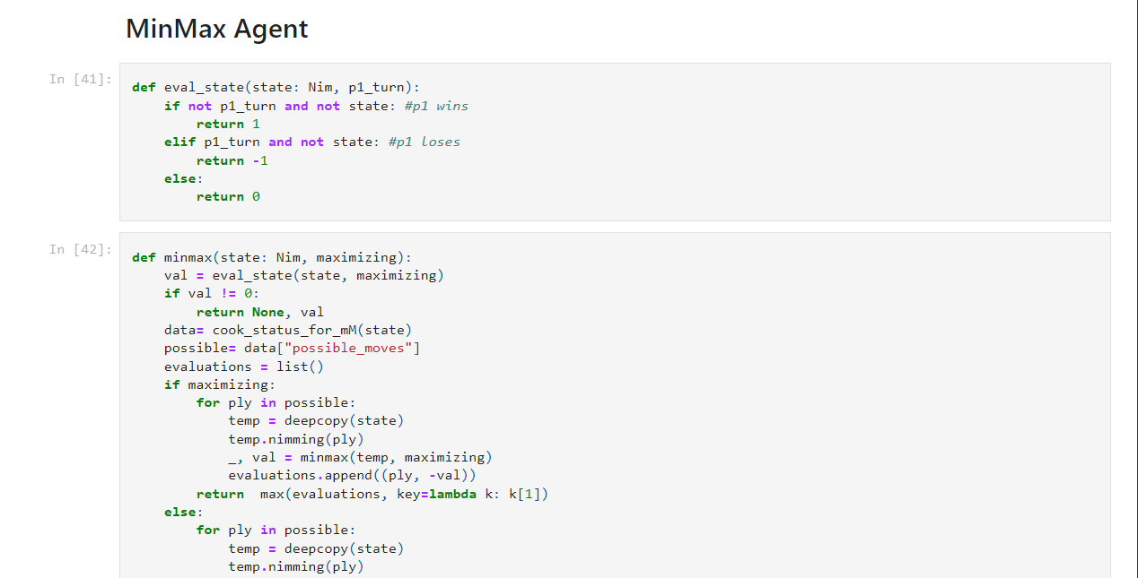

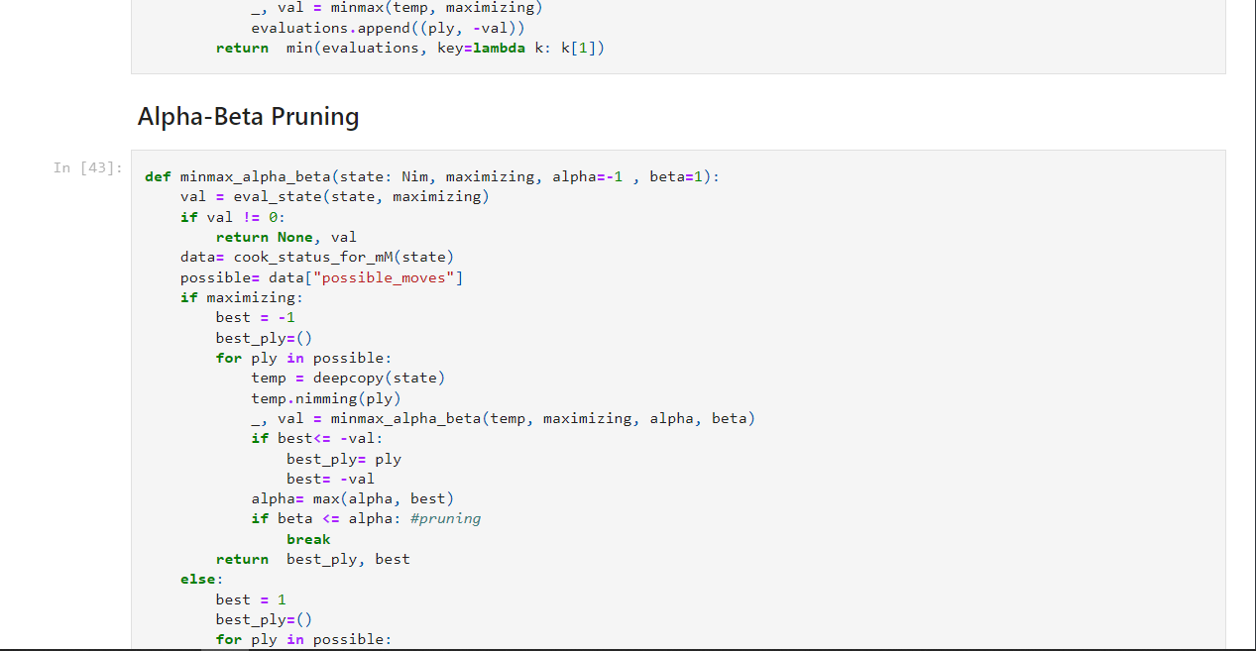



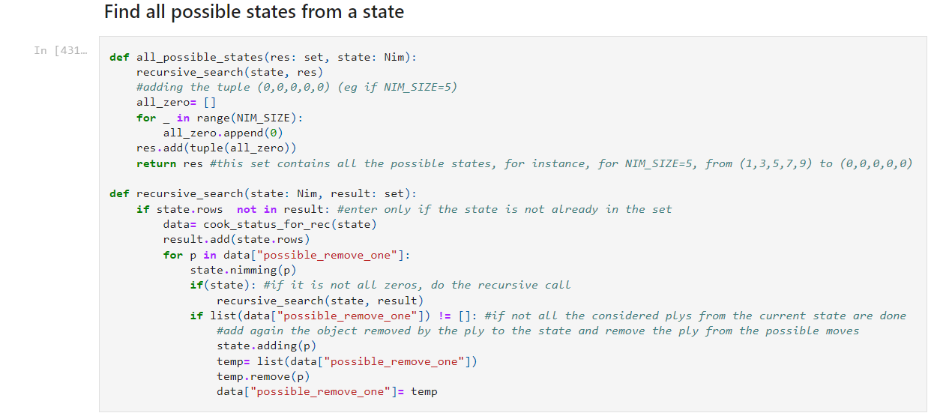

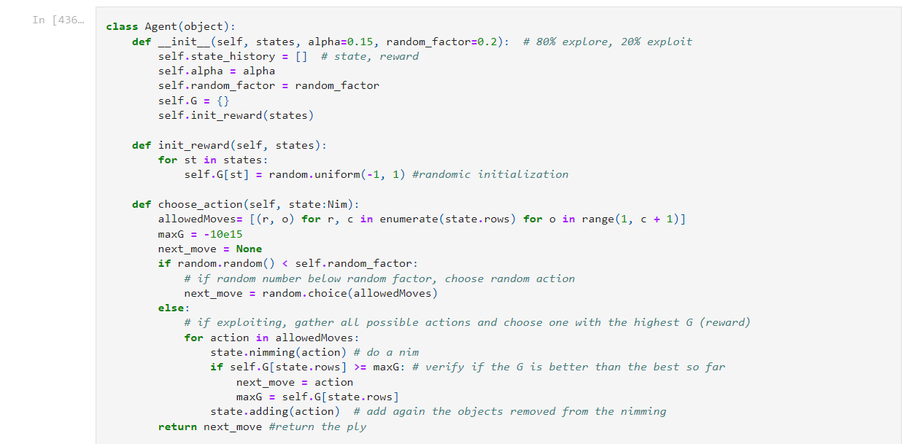

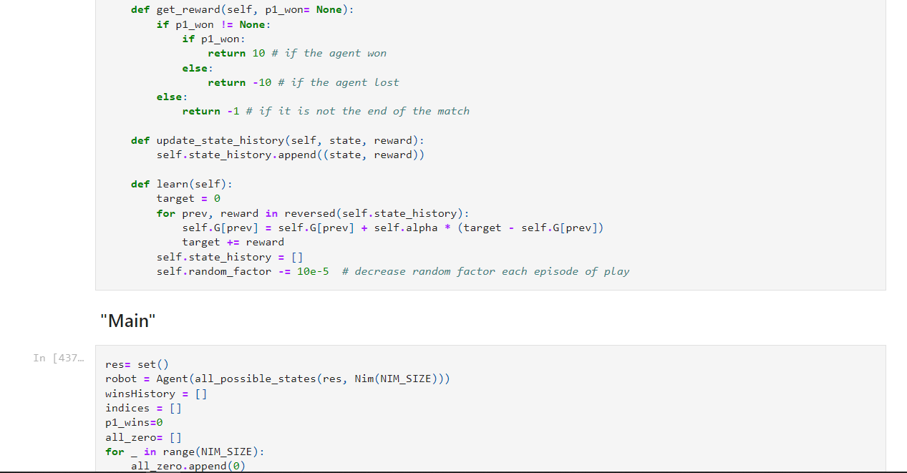

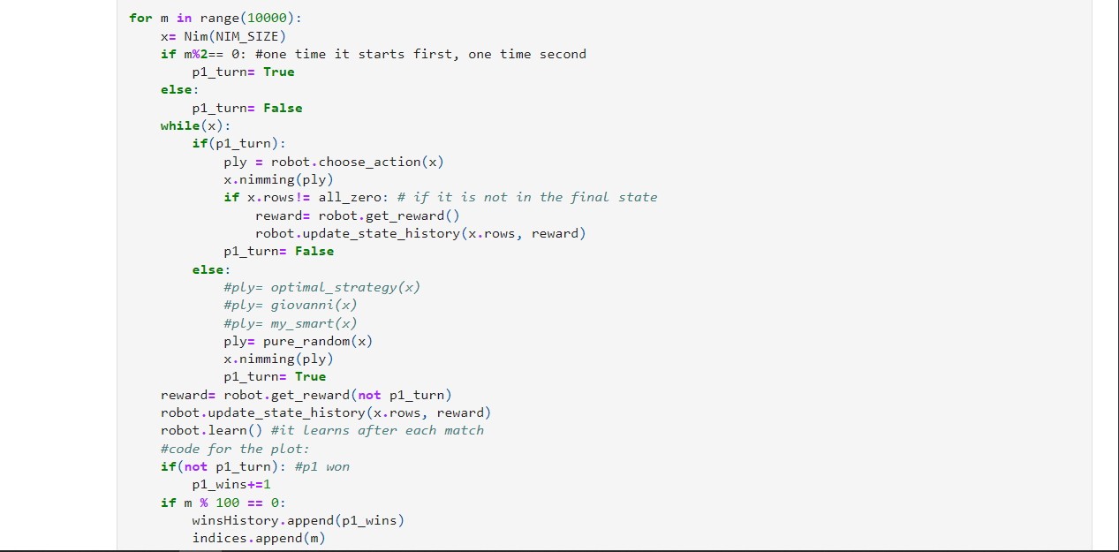

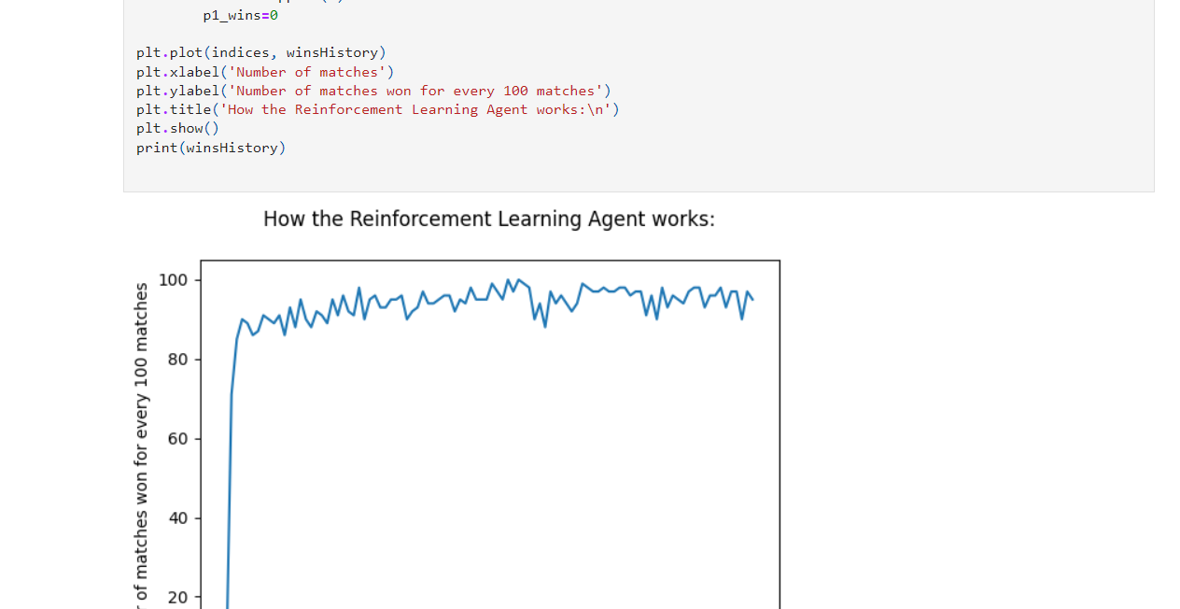

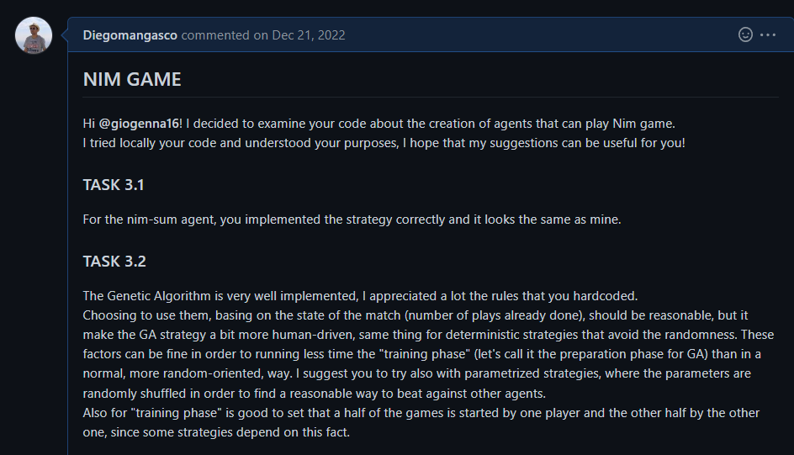
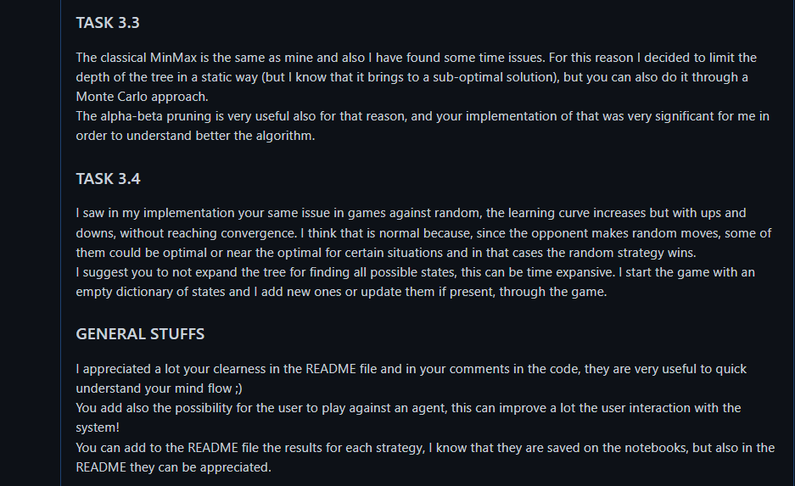


rogierz/ComputationalIntelligence2022

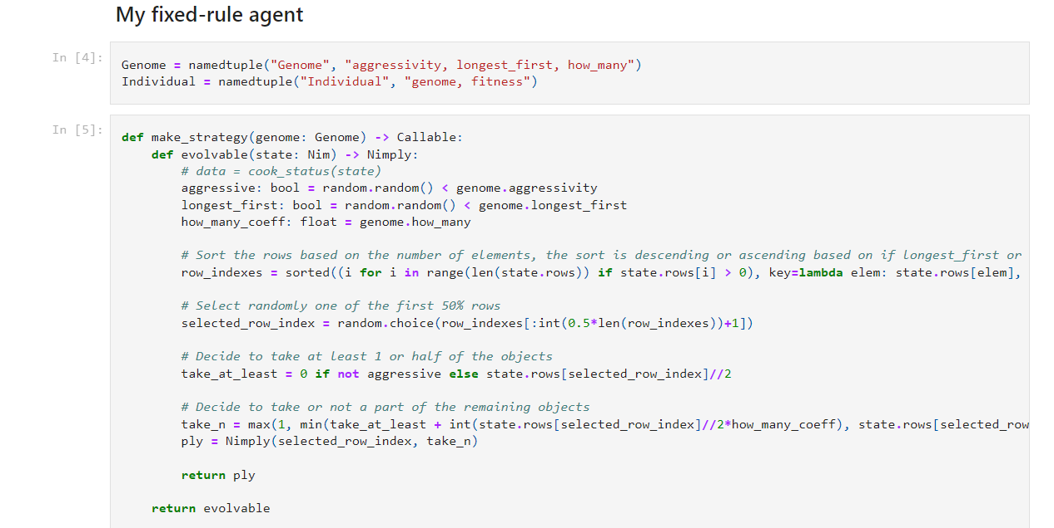

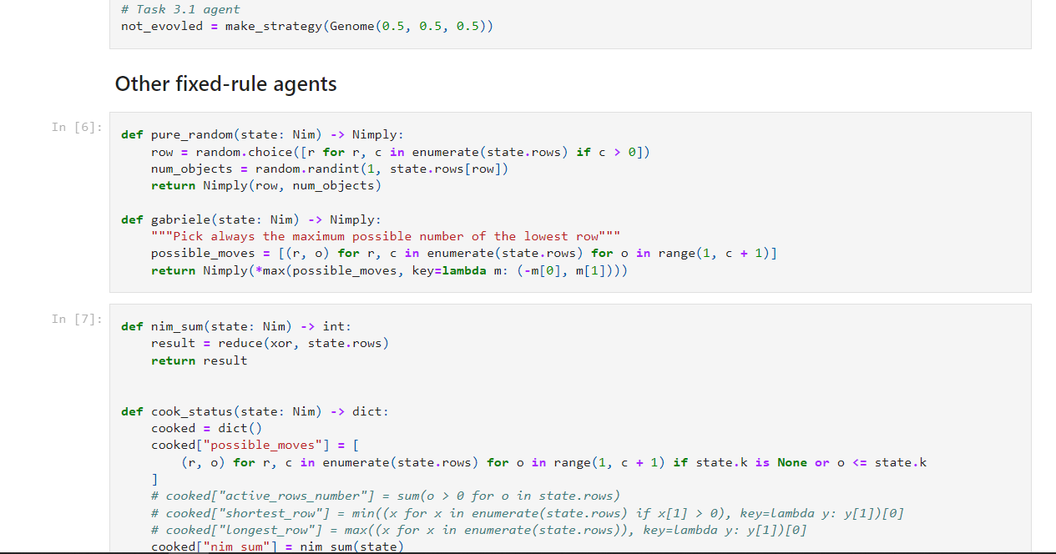
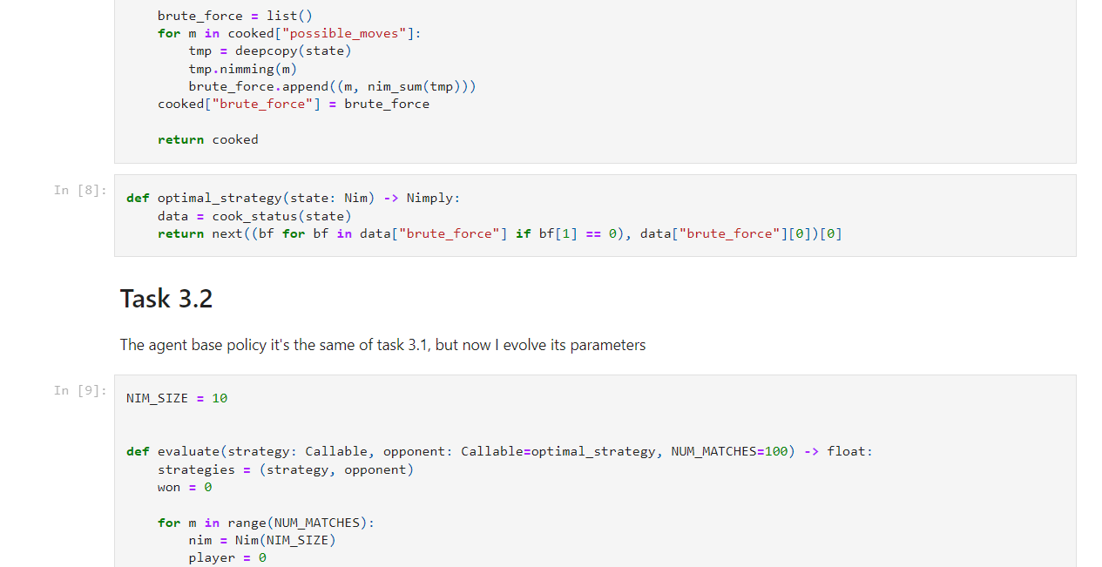
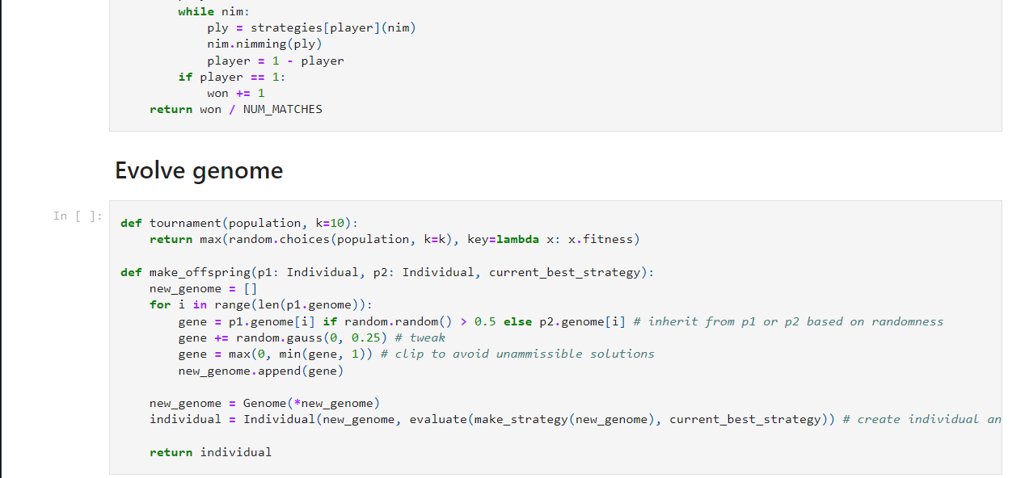
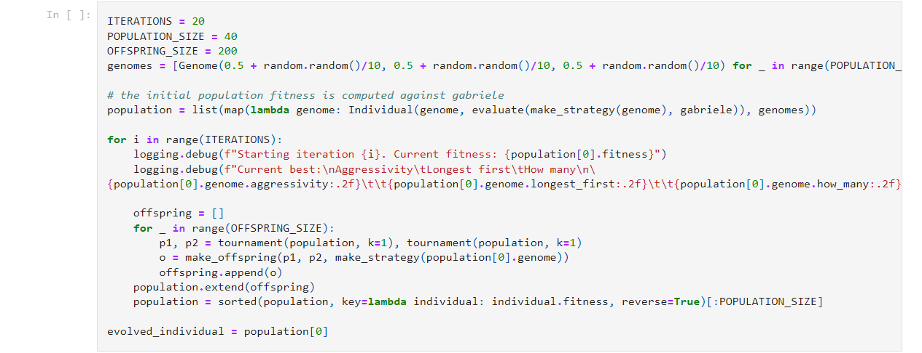
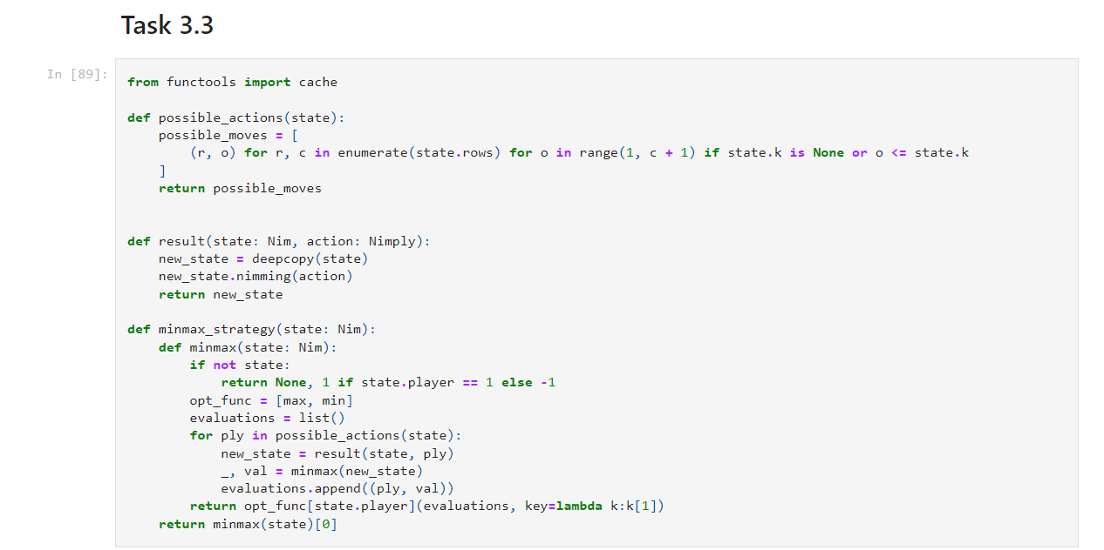

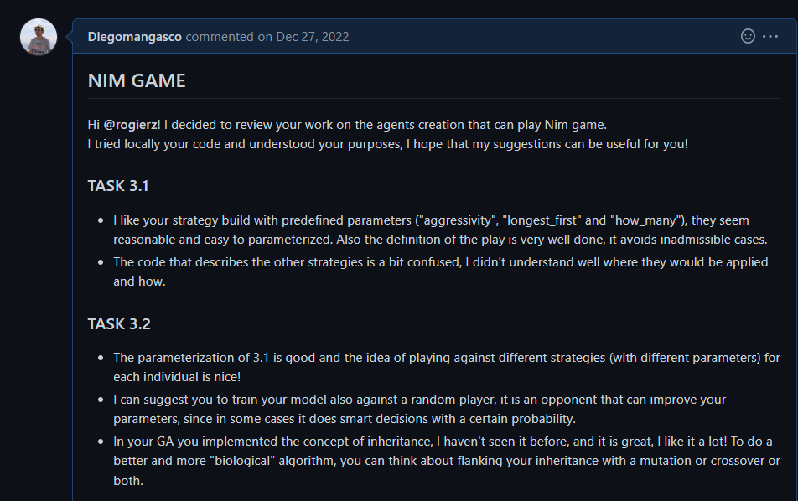
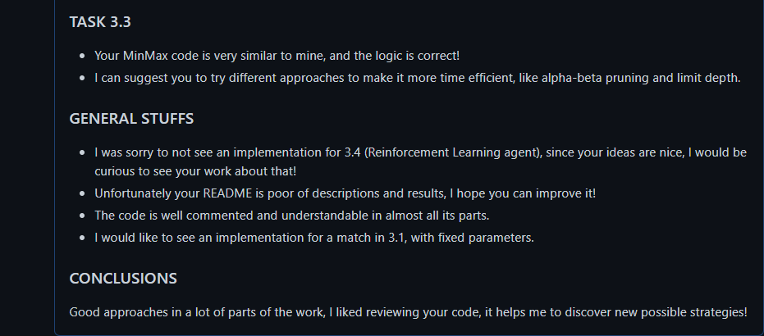

PERSONAL EXPERIMENTS:

When Professor Squillero explained us some methods about Single State Methods, I would try to adapt some of them to the Set Covering problem, so I decided to do it in a separate folder in my repository.
Not all the implementation showed good results, but I’m happy to have tried them!

Here is the code that I developed:

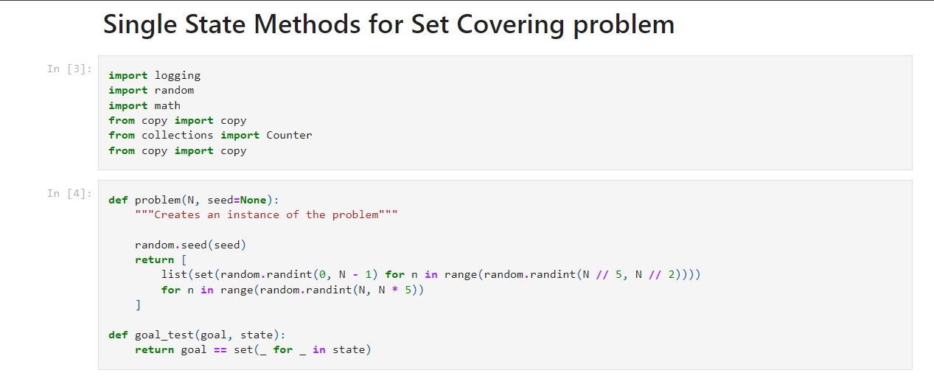
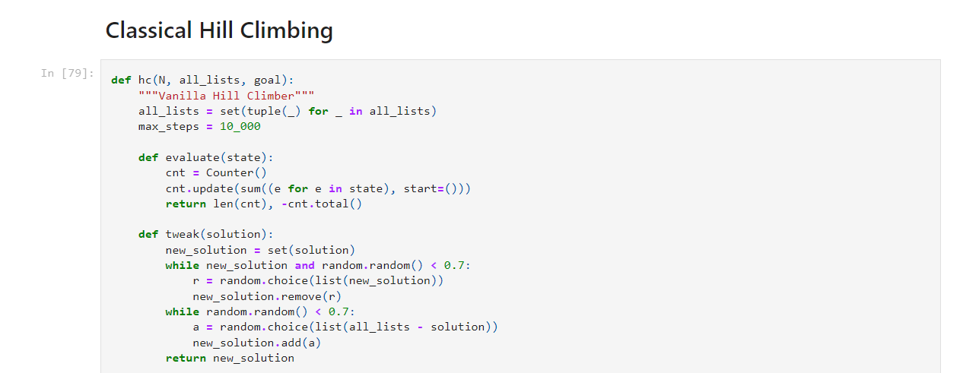
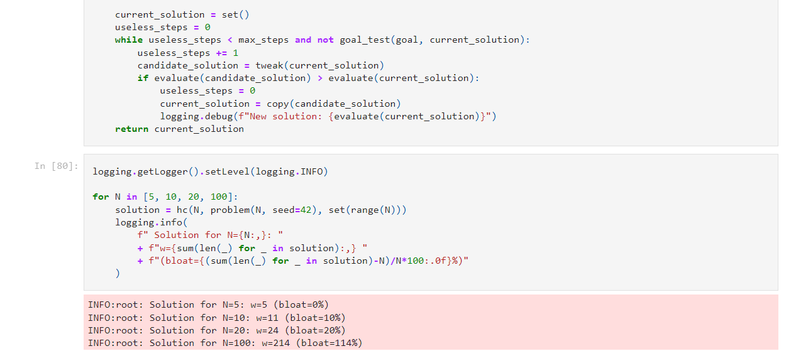
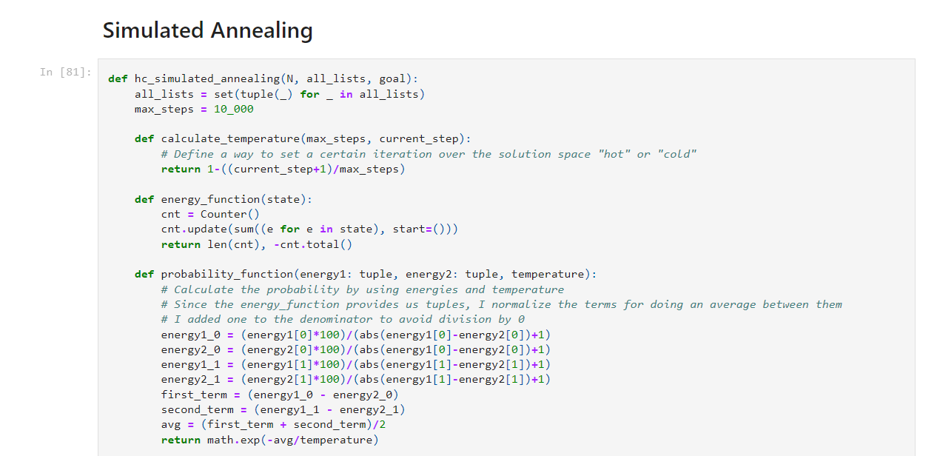
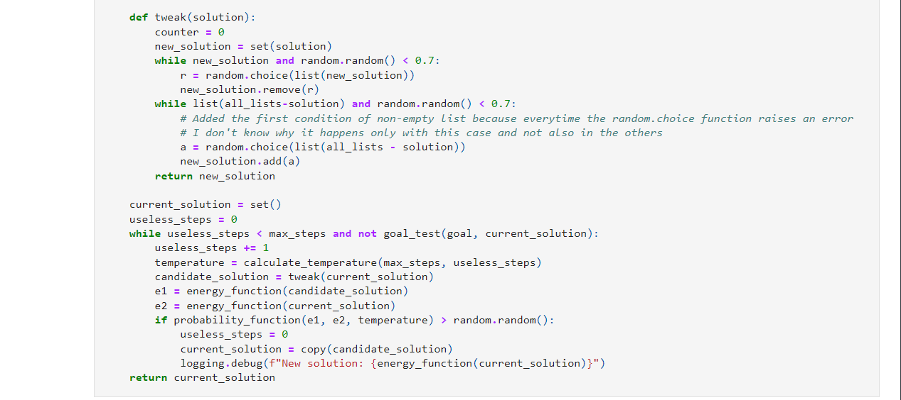
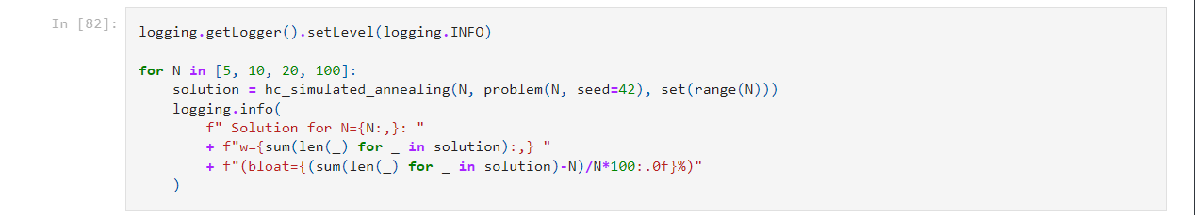
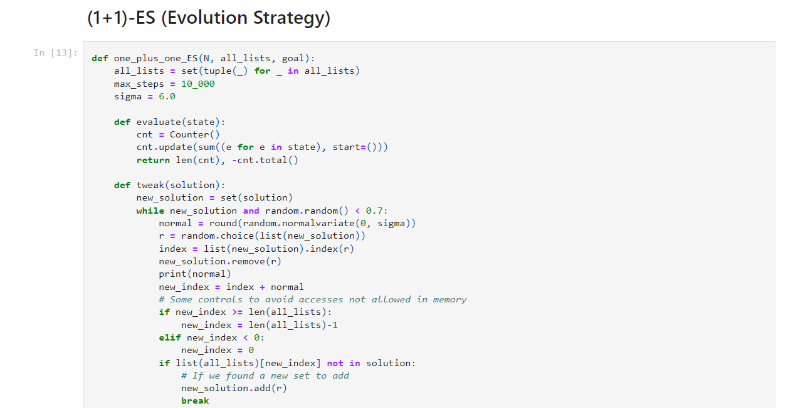
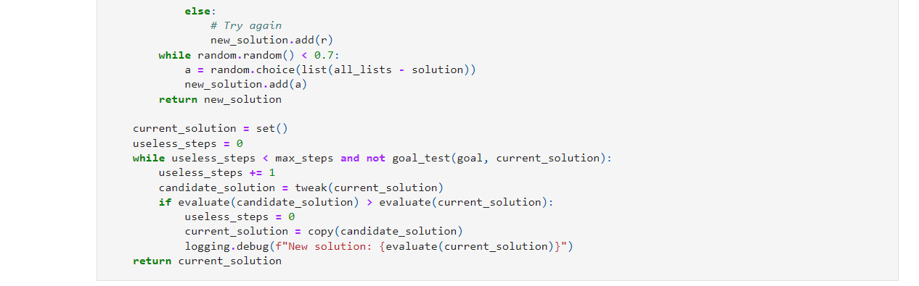
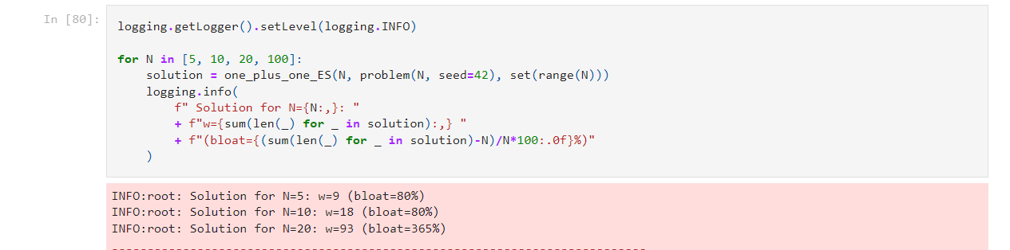
FINAL PROJECT: QUARTO AGENT

Introduction, collaborations and thanks:

For the final project of the course, we had to develop an/multiple agent/s that are able to play the board game Quarto. This one is a two player game and our strategies would be able to beat a Random Player (i.e. a player that performs random moves) with a certain regularity.
For the ideas about the strategies, I collaborated with a student that I met thanks to the reviews: Sidharrth Nagappan (that will be referred as “Sid”, his social nickname, in the next pages).
Sid is a Malaysian student that is spending his Erasmus experience in Politecnico di Torino and we became friend after my review to his lab.
We developed the most of the code independently, but we exchanged a lot of ideas for the approaches adopted and for the results comparisons. I will report in details all the contributions that each one of us did to this project.
For the Quarto agent, we have chosen different strategies and for each agent I build a chapter to describe it, both the ideas and the code.
All the functions I implemented are documented with the special Python functionality (put the information like this: ‘’’Description’’’), in this way I explained all the logic inside. In addiction, I also wrote comments in the code for the understanding of the main steps.
Each file present in the repository will be reported with the relative path in the repository.

I would saying thank you to Sid, for all the work done together, a great colleague with which the mind is always stimulated!

The best strategy: Hardcoded rules

Description:

The agent that demonstrated the best performances against the Random Player is, without any doubt, the Hardcoded Player.
The rules that it follows are not so complex, basically every time an action is required to it (so ‘choose_piece’ or ‘place_piece’) it scans all the rows, columns and diagonals in the board to find the best move to do.
Also the time performances are very good! I tried to play against the Random Player for 1000 games and they took no more than 5 minutes.

Code:

File: HardcodedPlayer/utils.py

The function ‘find_piece’ is used as support for the ‘choose_piece’ function of the Player.

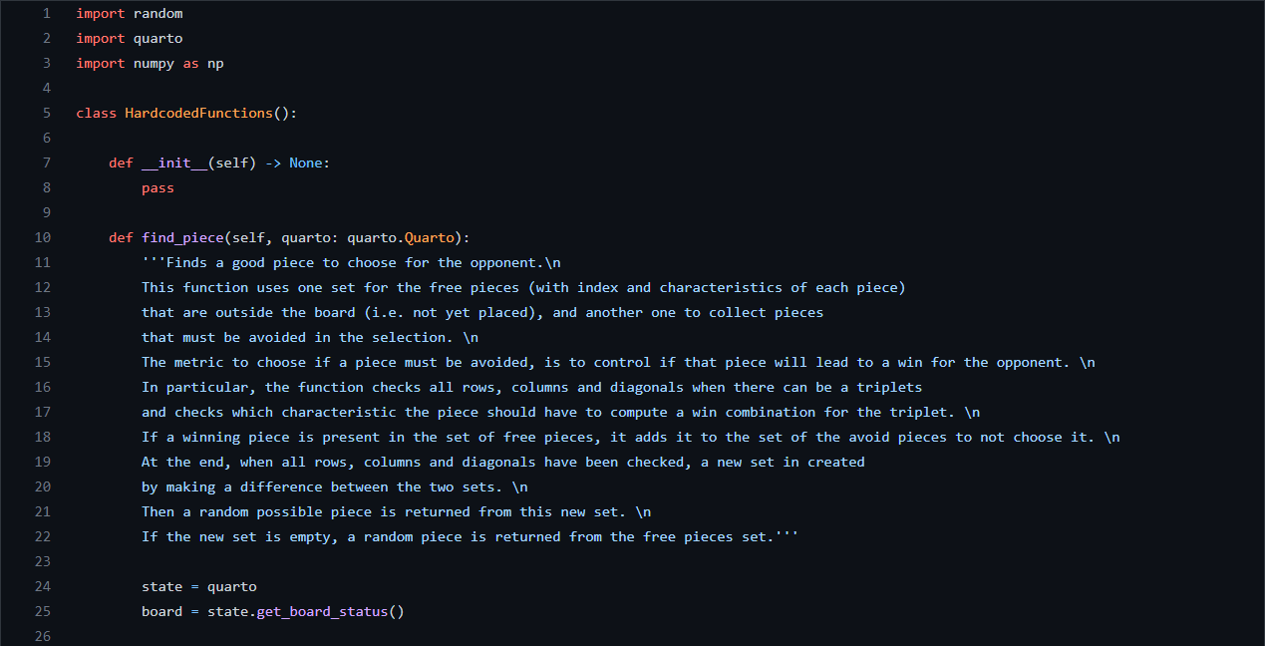
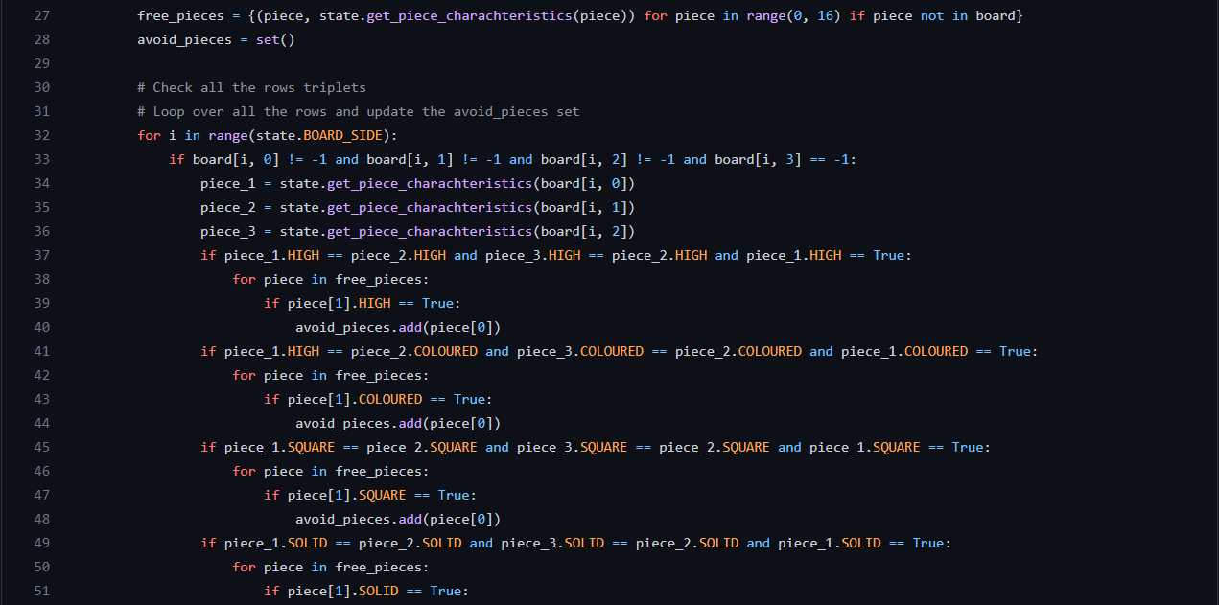
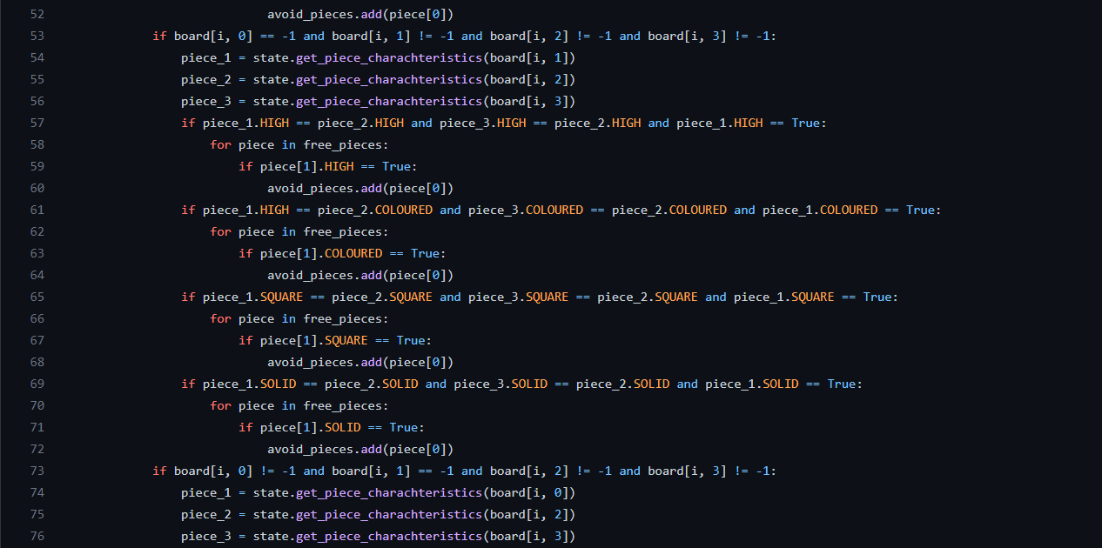
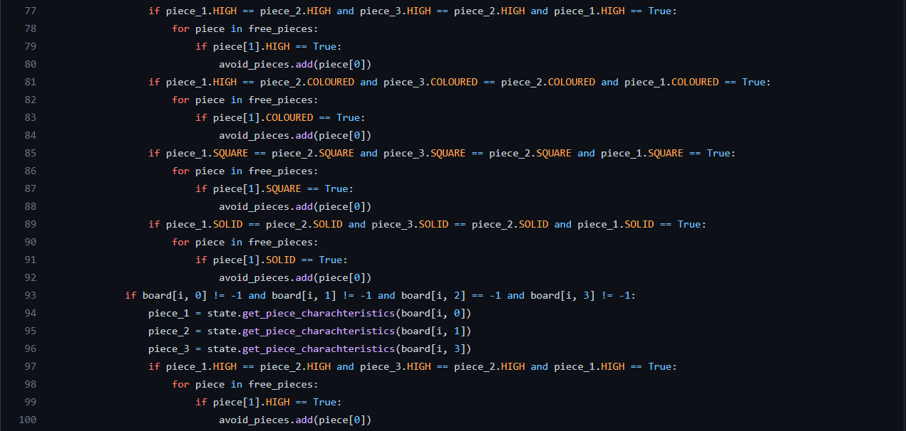
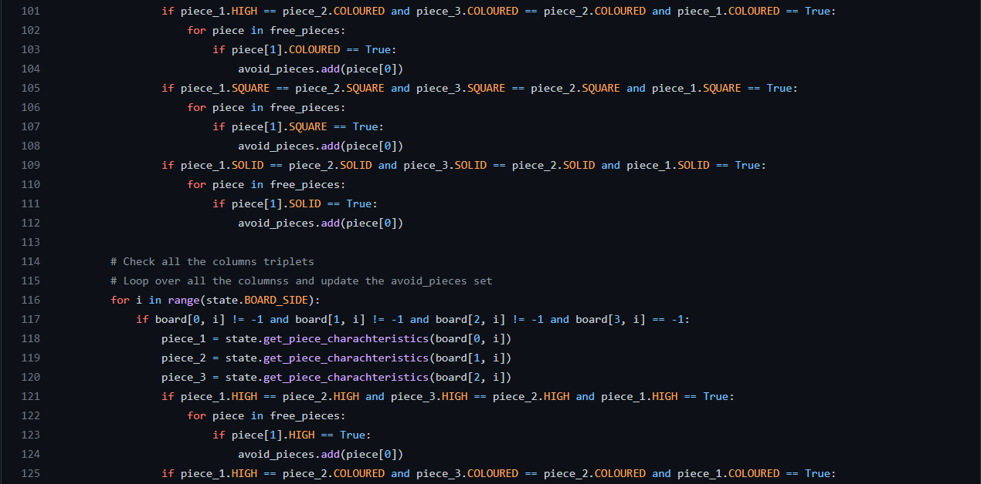
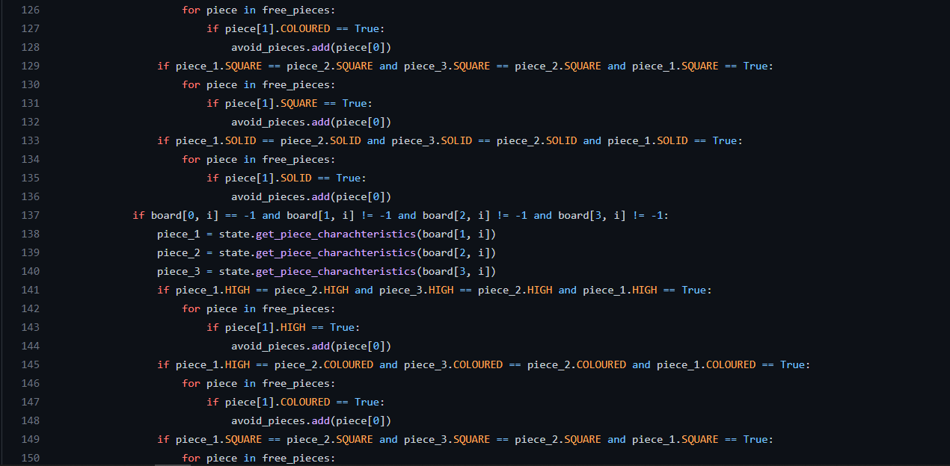
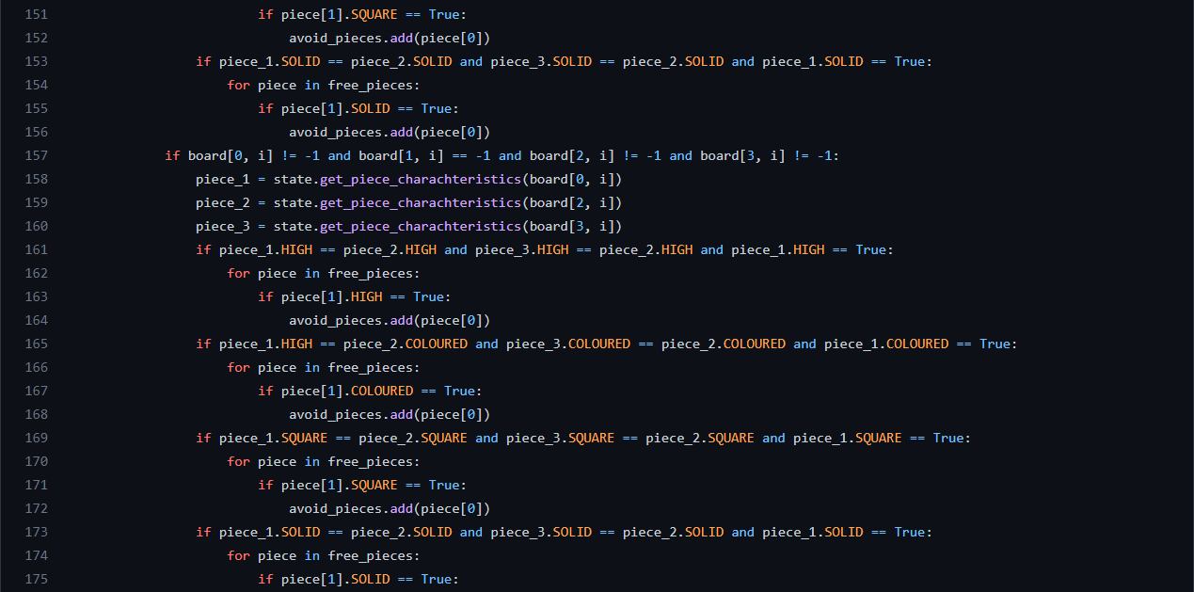
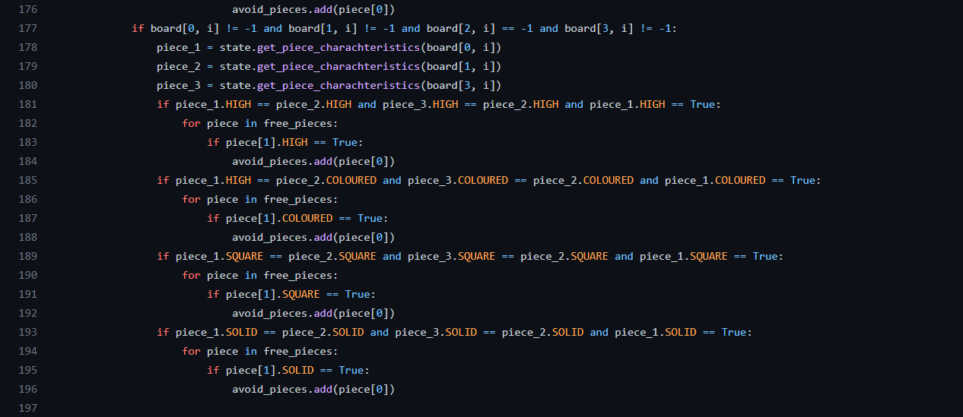
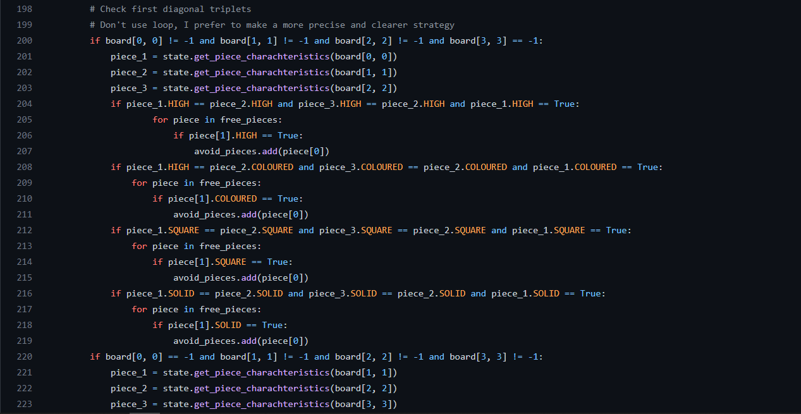
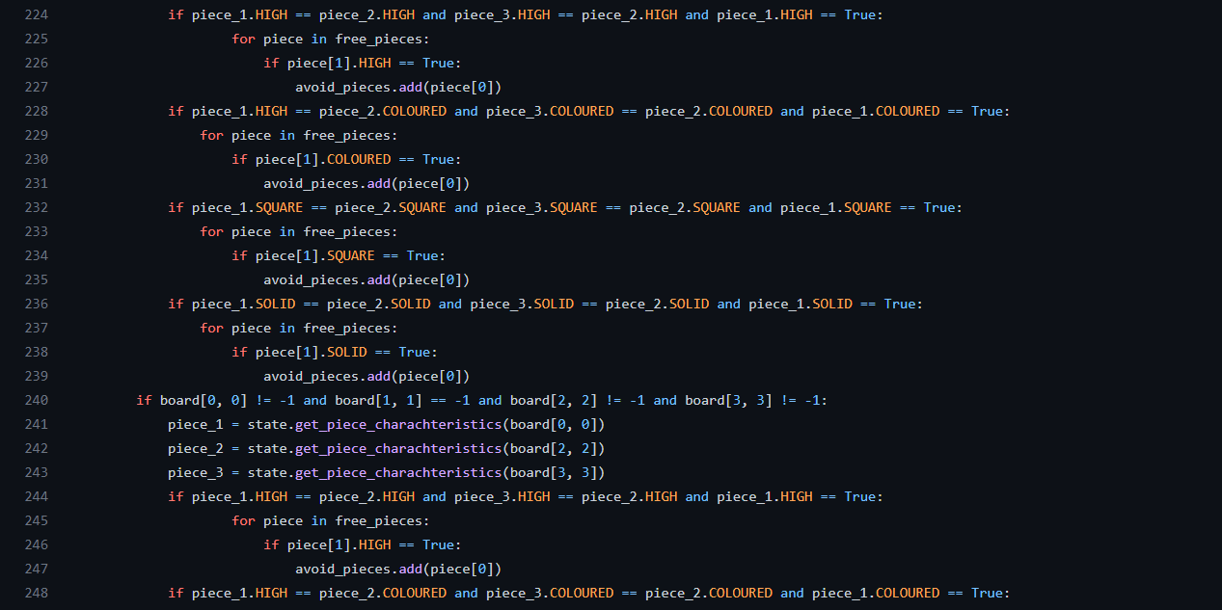
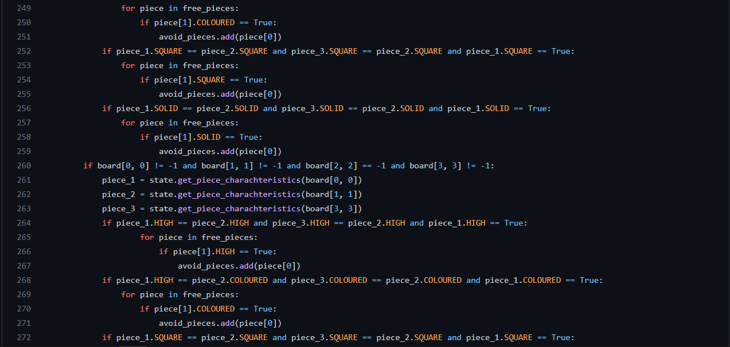
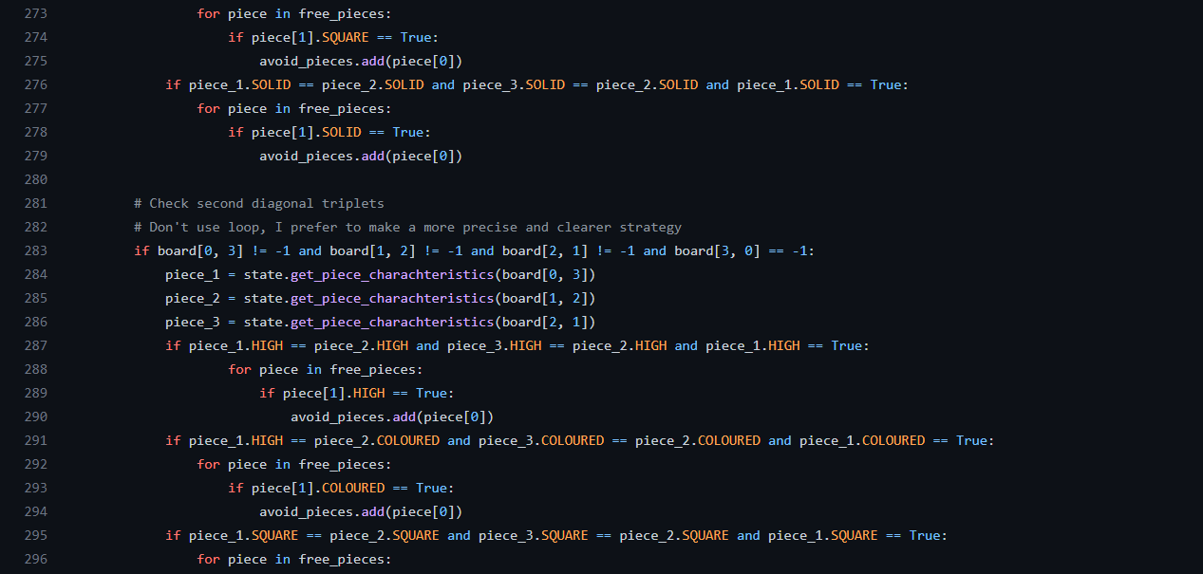
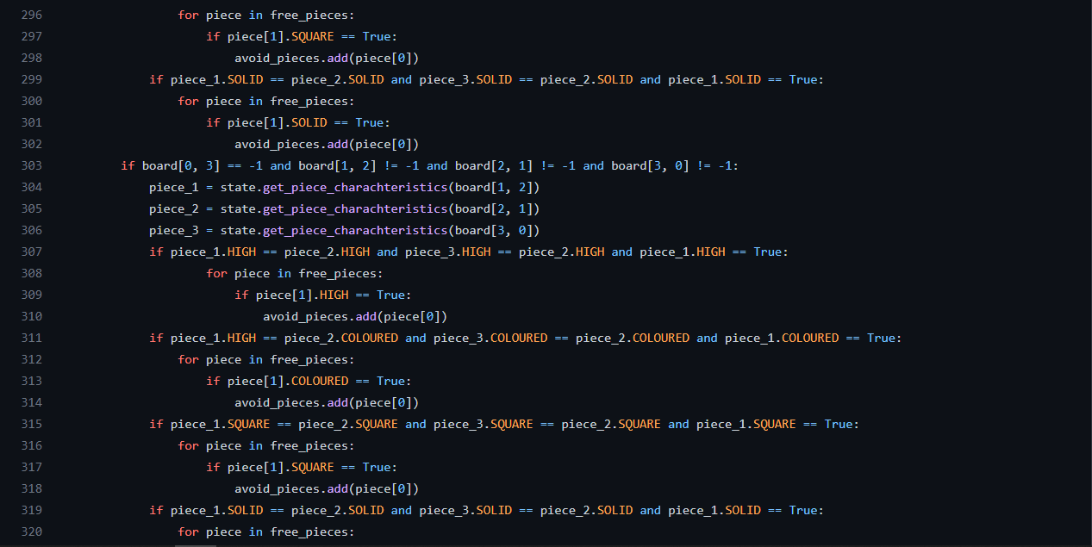
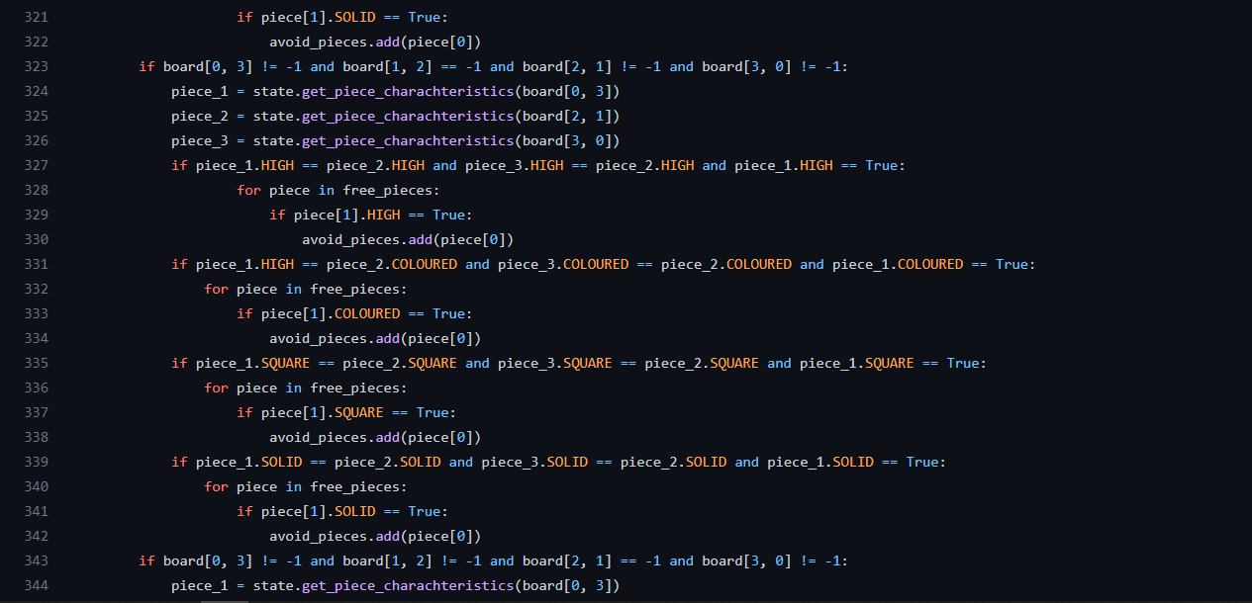
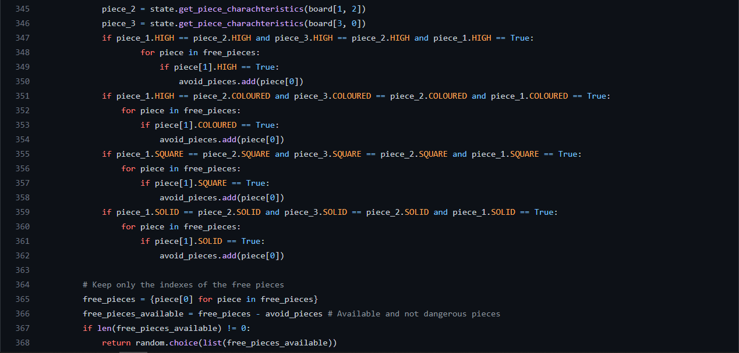

The function ‘find_position’ is used as support for ‘place_piece’ function of the Player.

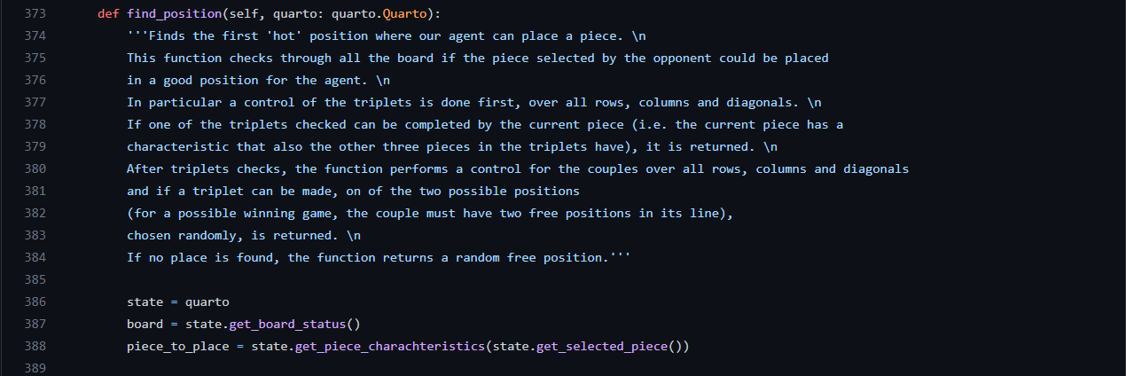
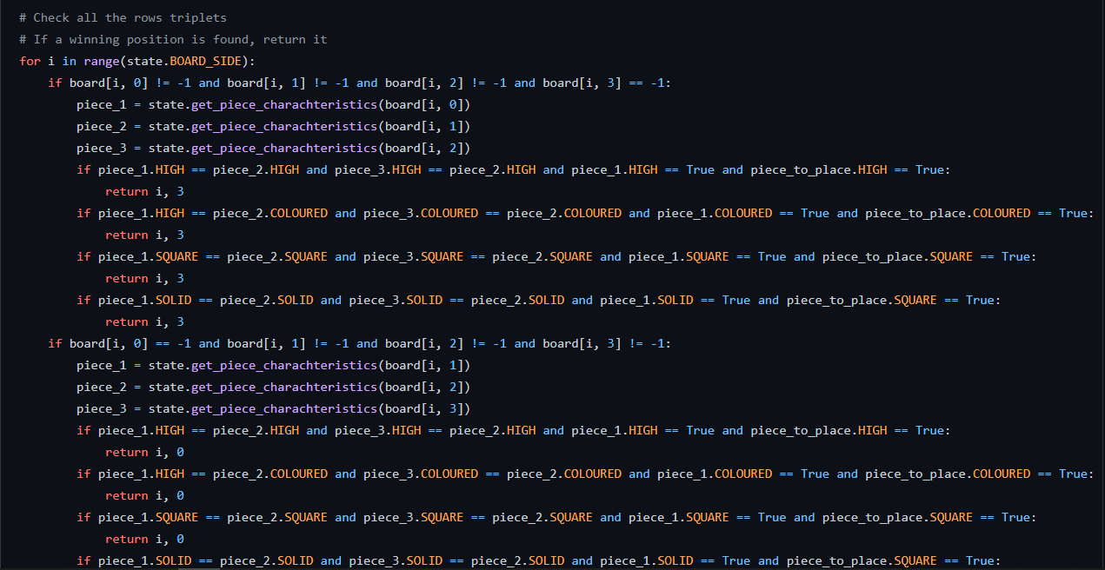
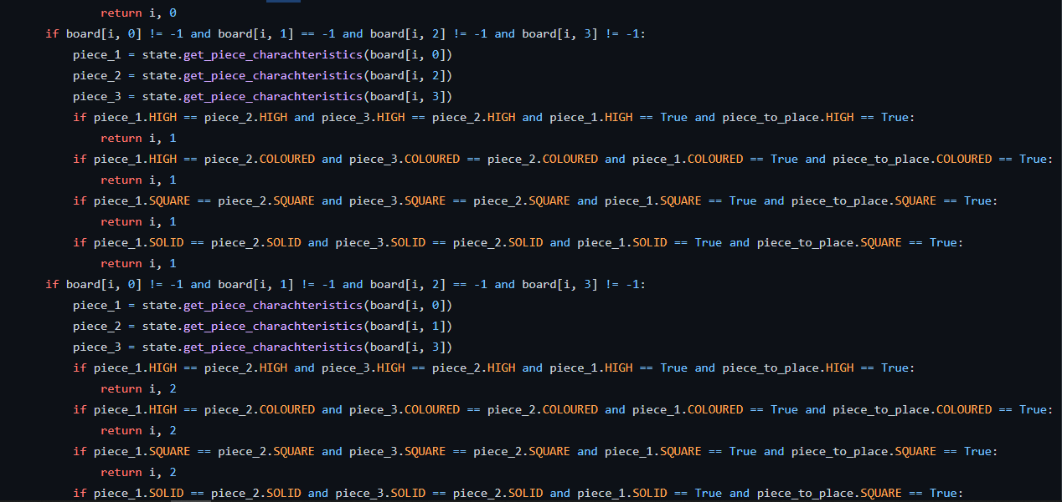
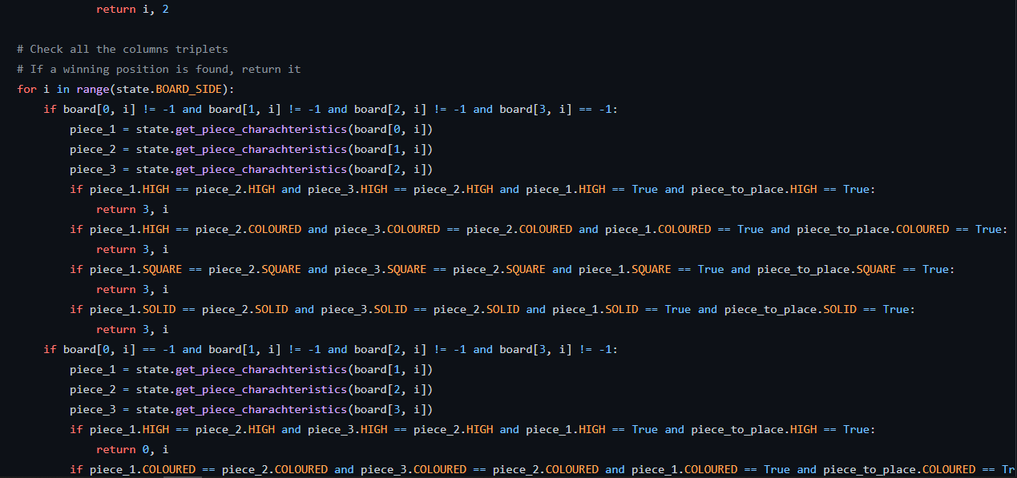
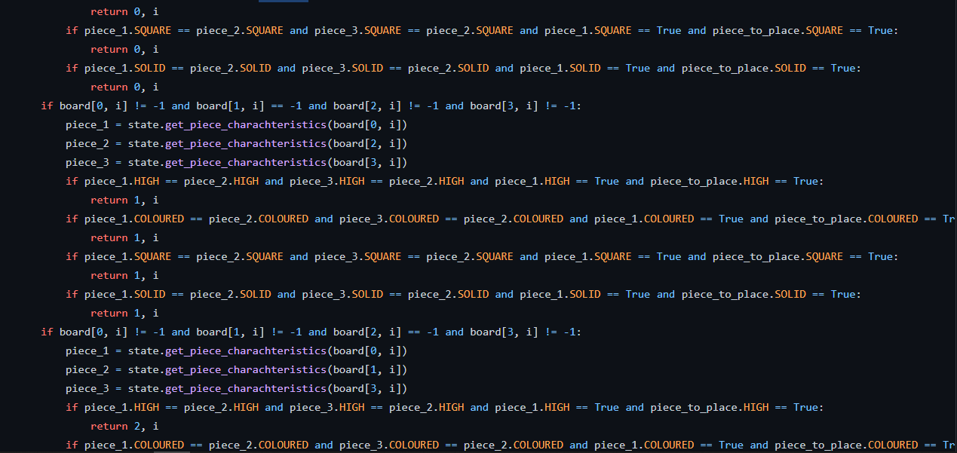
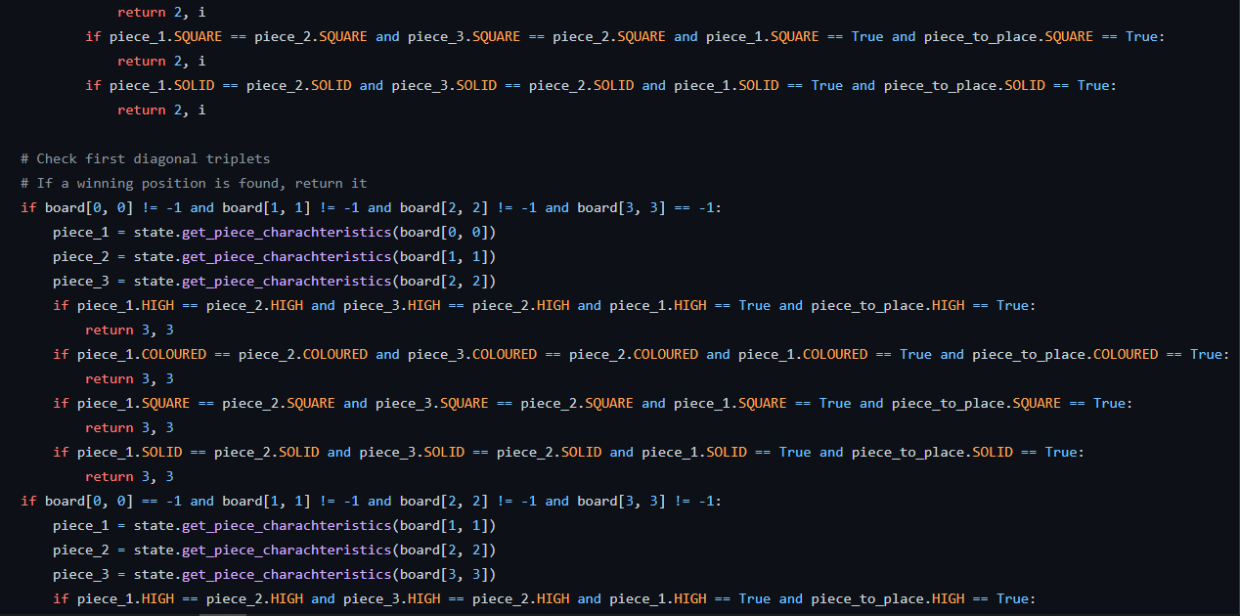
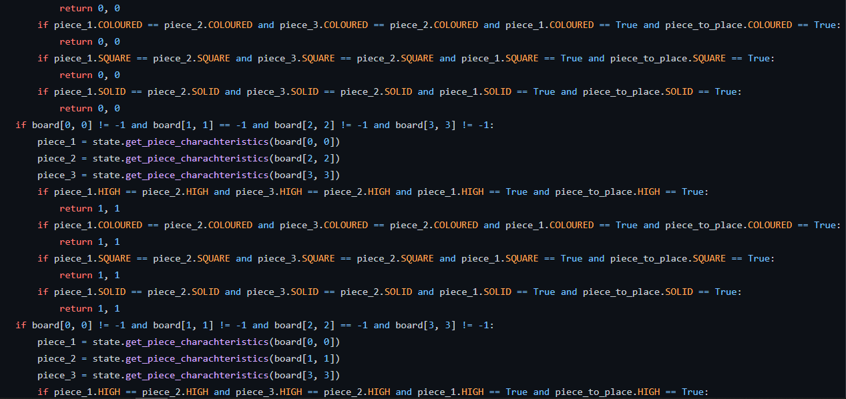
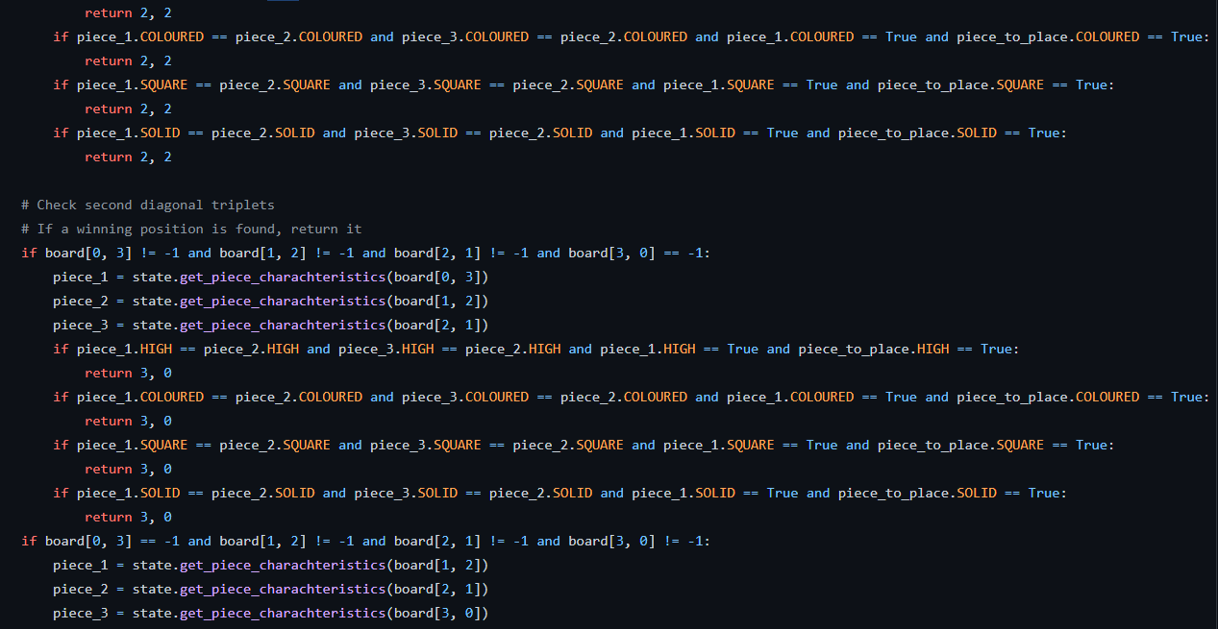
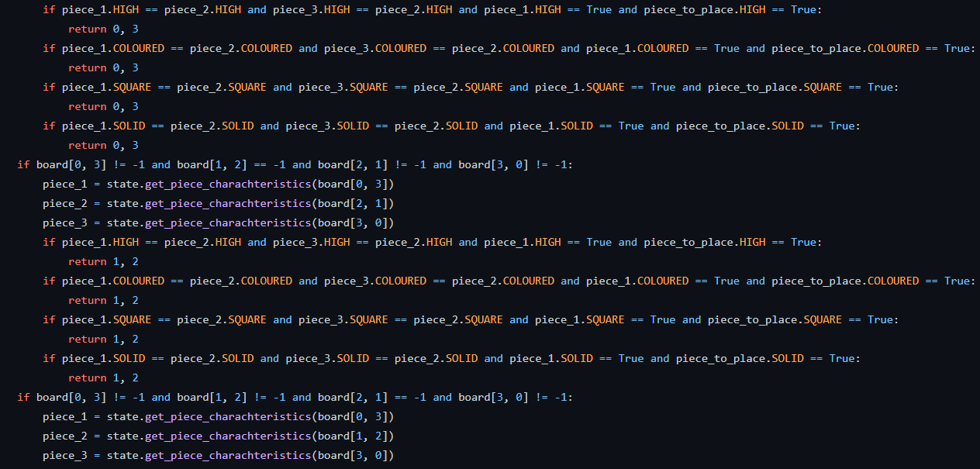
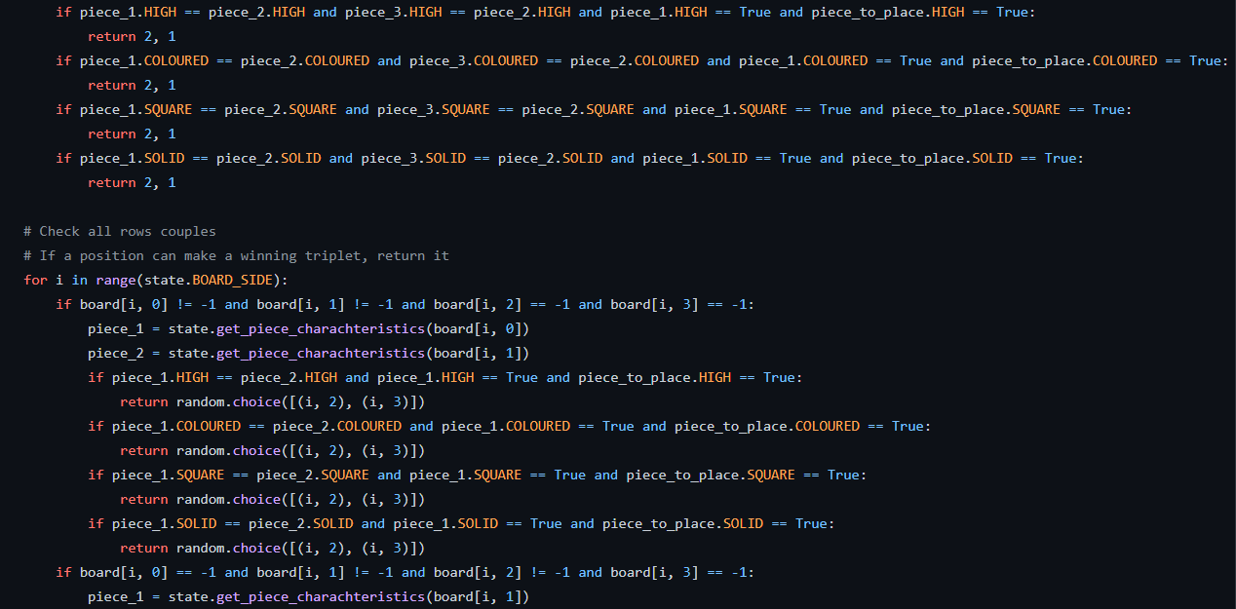
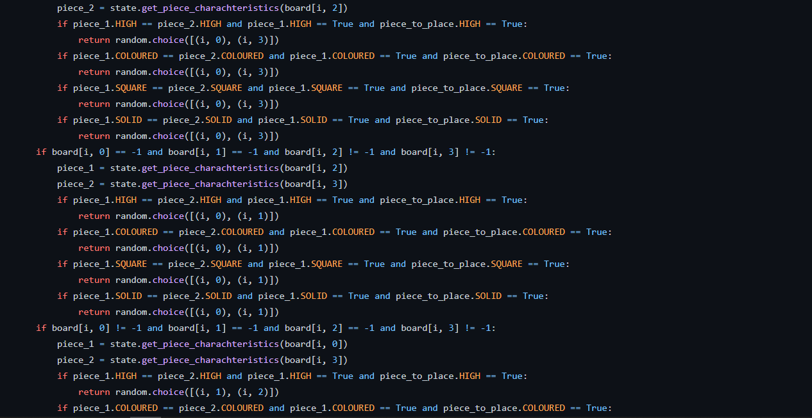
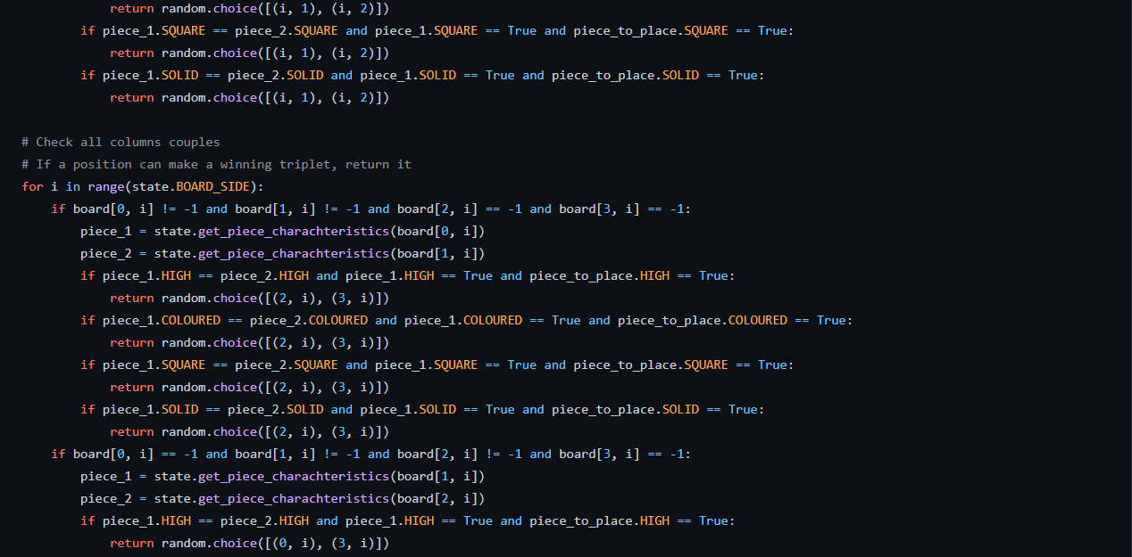
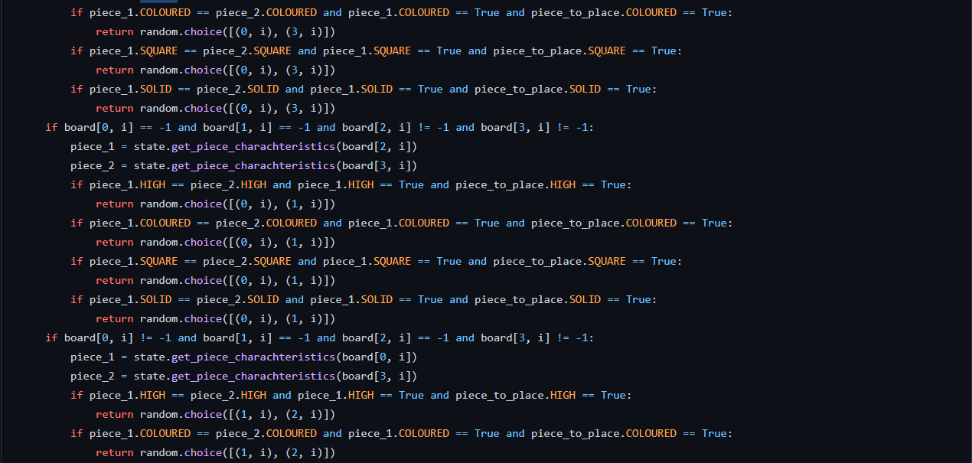
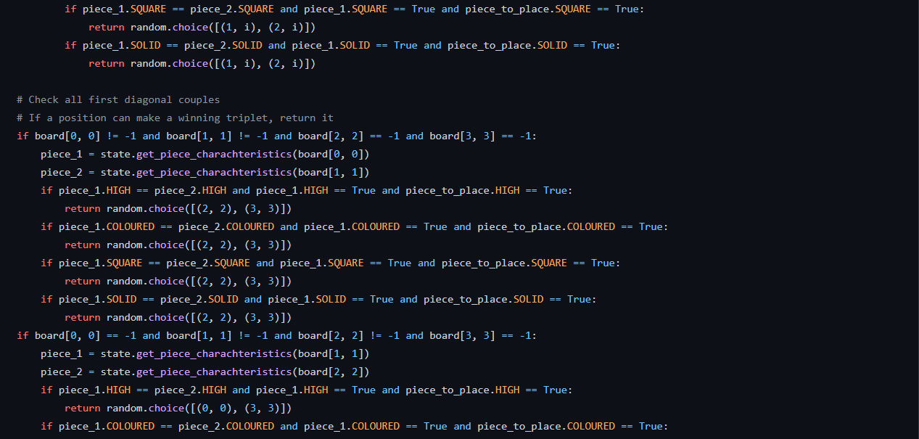
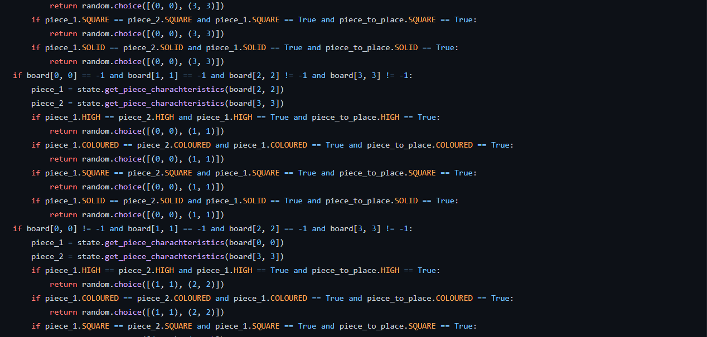
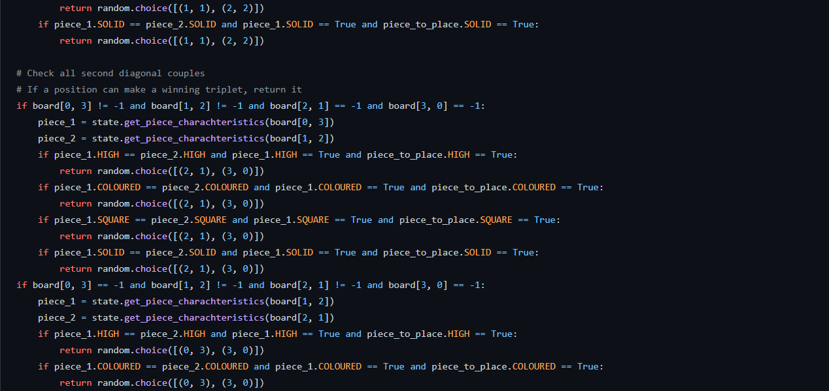
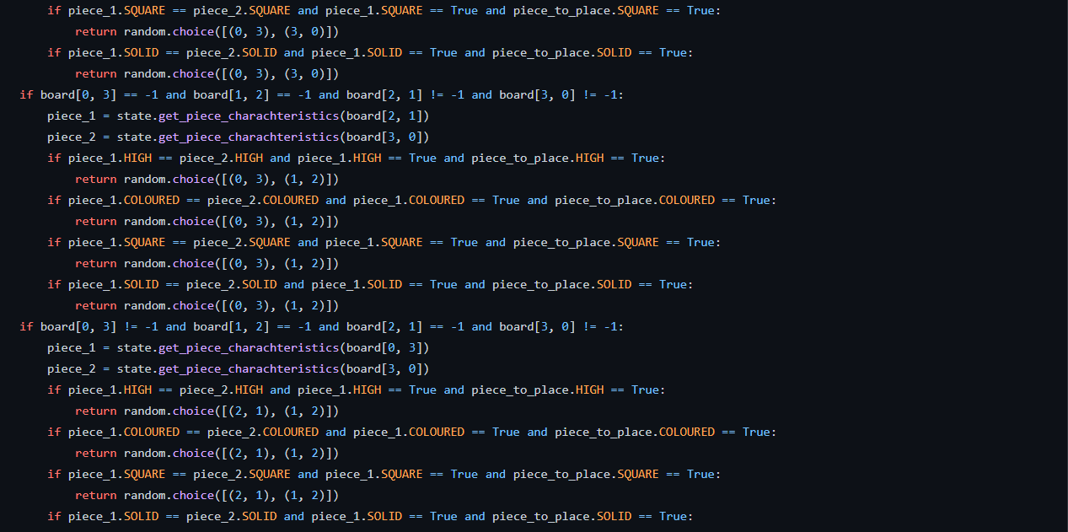

File: HardcodedPlayer/HardcodedPlayer.py

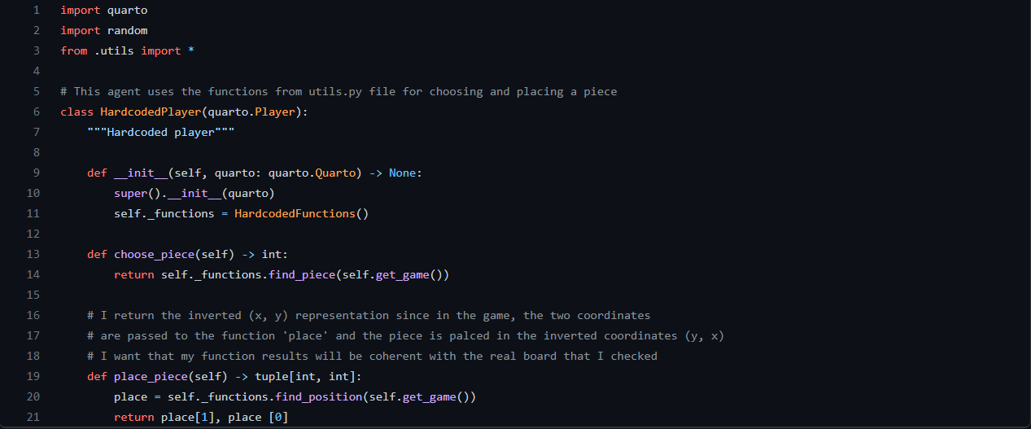

Results:

The Hardcoded Player is very fast and performs well against random, it basically has inside the strategies to follow at each step, hardcoded inside it.
After 1000 games against Random Player the win rate is always between 86% and 88%.
An alternative tree search method: MonteCarlo Tree Search (MCTS)

Description:

Me and Sid were wondering when Professor Squillero told us about MonteCarlo methods in one of his lectures.
When we started the project, we were searching an alternative approach to MinMax, because we known that it basically always wins, but we wanted to explore something new.
So we decided to implement this algorithm, the MonteCarlo Tree Search (also called MCTS).
For a better understanding of the method, we explore the Wikipedia page of the algorithm and we saw that it is composed by four steps:

- Selection: explore the tree with certain rules (see UCB later) and select a node that is not yet fully expanded.
- Expansion: expand the node found with a random child and add it to the tree.
- Simulation: simulate a game from the node expanded until the end, with random moves.
- Backpropagation: update the values stored in each node (the reward and the number of visits) of the path done, from the new node created, to the root.

In the Selection phase we used the Upper Confidence Bound (UCB) formula to find the best child of a node and go on with the tree exploration.
The UCB formula is:

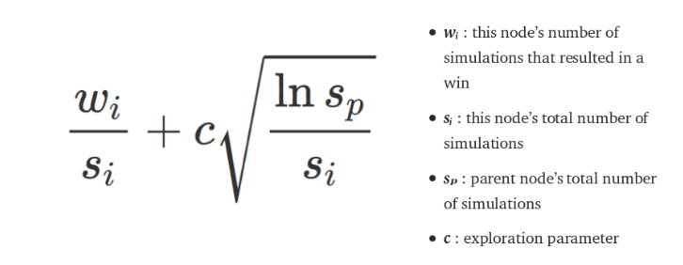

For the “c” parameter we choose 1.41 (so the square root of 2) that is, according to Wikipedia a good trade-off between exploration and exploitation.

Unfortunately, the MCTS requires a lot of iterations from 1 to 4 in order to have a good tree (and this problem will be explored more when I will talk about Reinforcement Learning). So we decide to have not a lot of iterations (between 30 and 50) but do them at each turn. In this way we basically expand a new tree from the current state of the game (that becomes the root node) every time.
Then, another improvement is to expand not only a single child per Expansion, but instead, creating all possible children of the considered node. This idea comes from a GitHub work that we found here, and we implement it and see a high improvement in performances.

Code:

File: MCTSPlayer/quartoTrain.py

The “QuartoTrain” class is almost equal to the one provided for the project, but I built it in order to set some variables as I need in a certain state of the game, since a new “QuartoTrain” object can be created also in the middle of the game. For this purpose I have to set the current board, piece selected and player.
I report only the parts that changes with respect to the original one, so only the initialization.

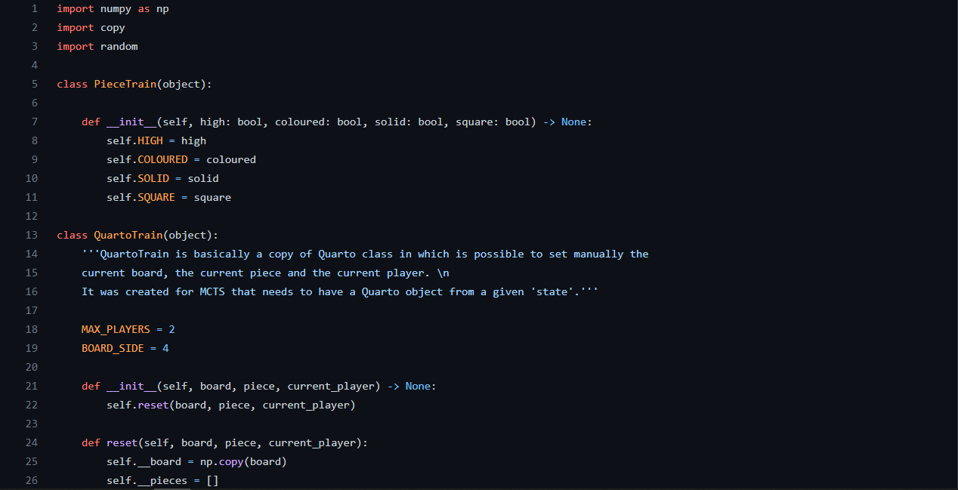
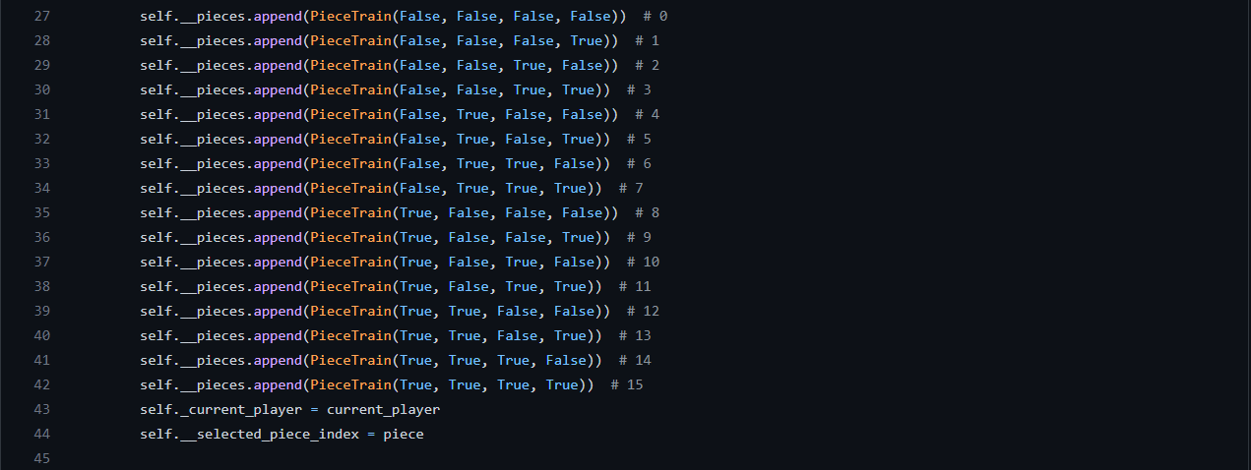

File: MCTSPlayer/utils.py

In this file I wrote some useful functions for the MCTS environment.

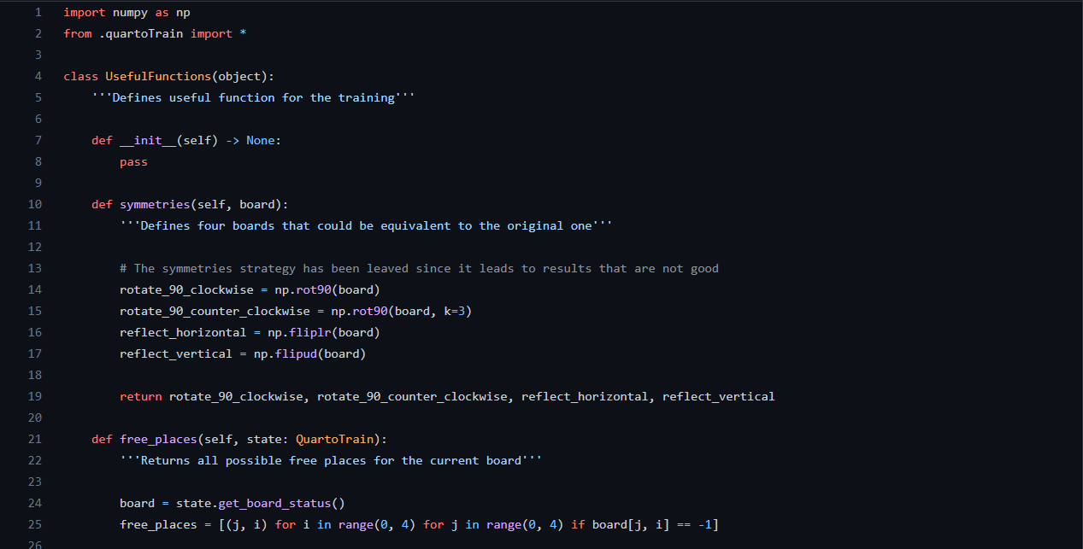
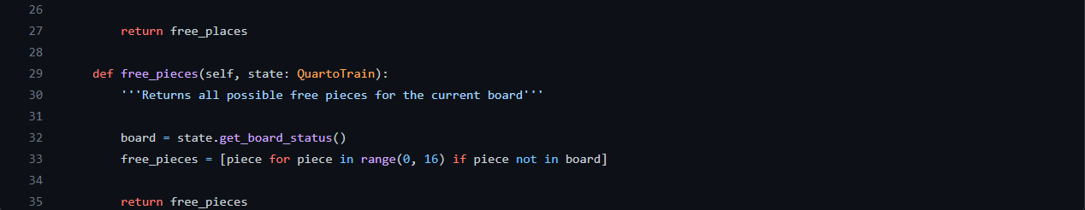

File: MCTSPlayer/MCTSTools.py

In this file I put all the logic to train the tree, that is used by the player.

The class Node represents a certain state of the game with some useful information.
The idea of adding the “end_node” boolean flag was mine, with which it is simpler to manage the leaf node of the tree.
Sid thought about putting the place where move the piece (“place_where_move_current”) and not to store also the piece itself, since it is wrapped in the “state” object.

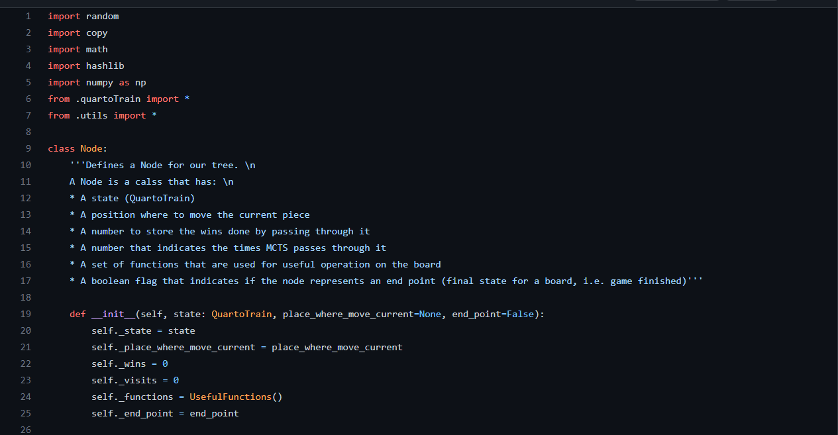

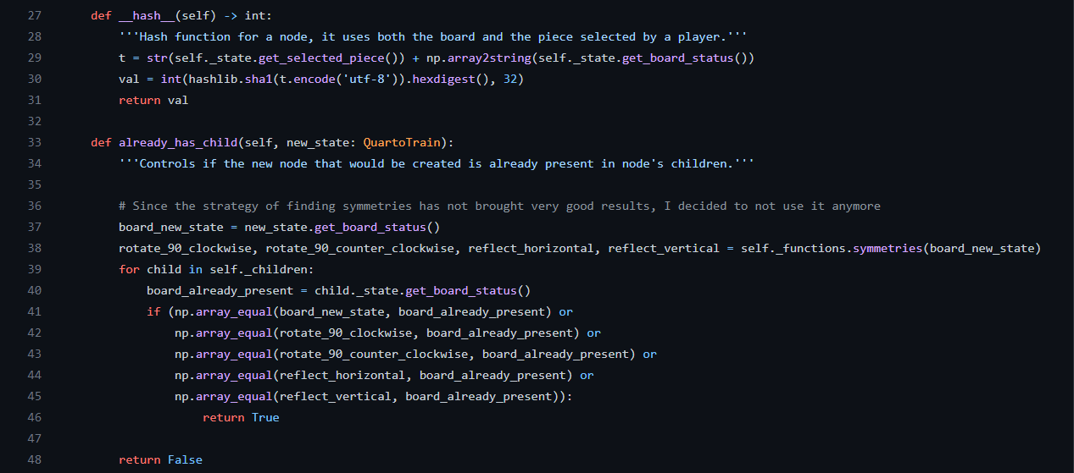
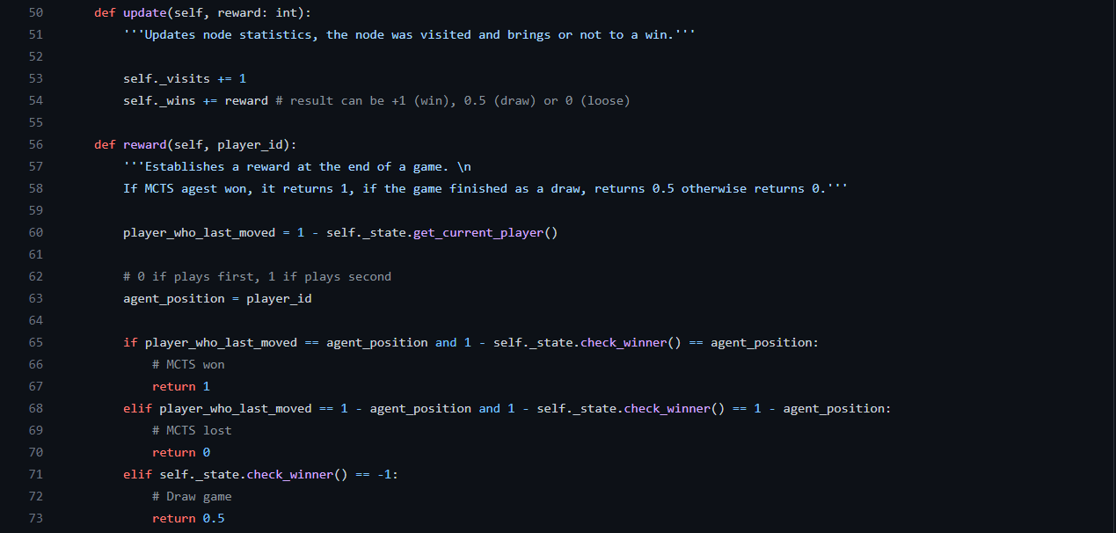
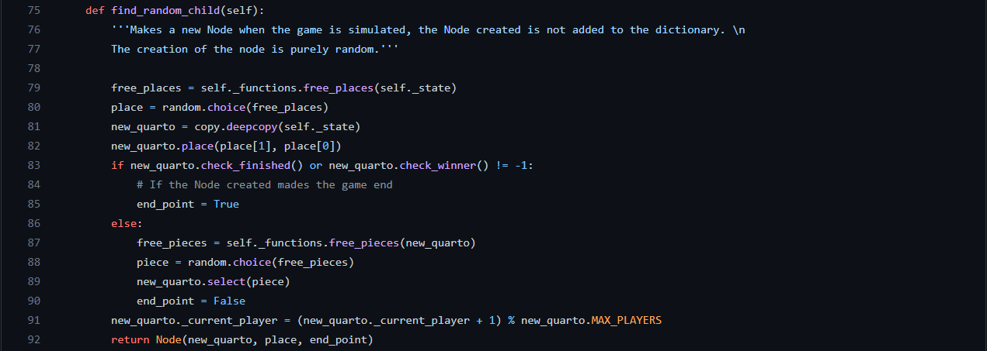

The class MCTS contains all the functions to implement the tree search

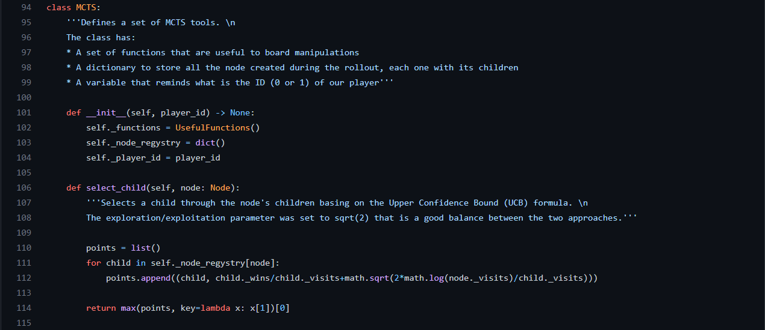
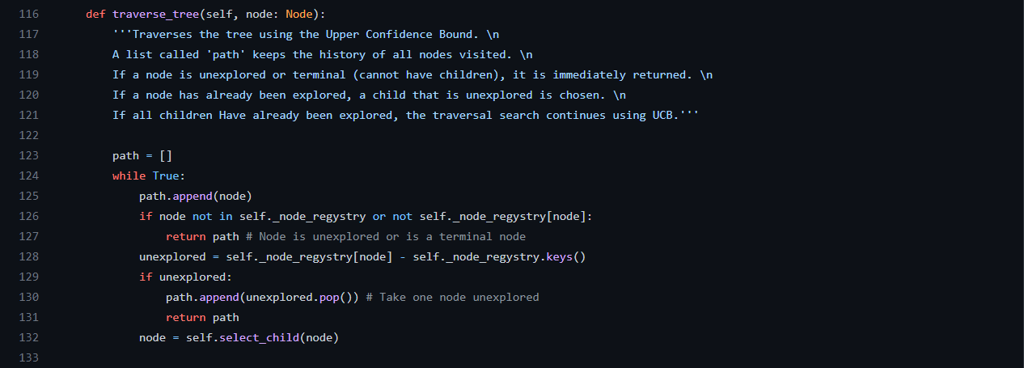
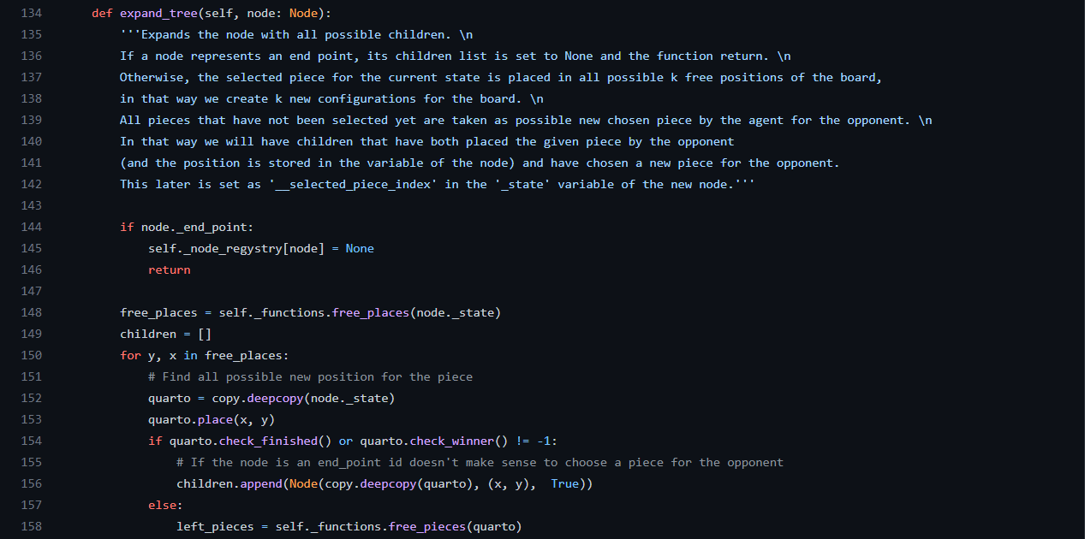
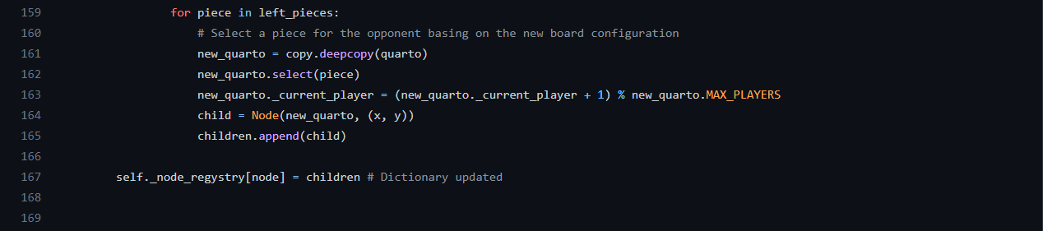
The reward inversion was also taken by the repository mentioned in the Description

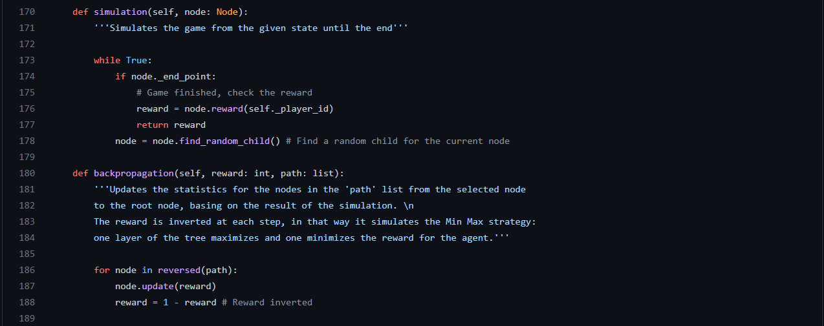

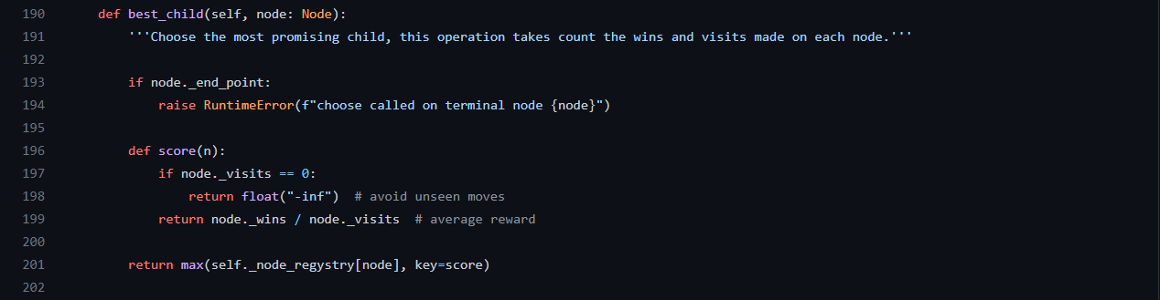
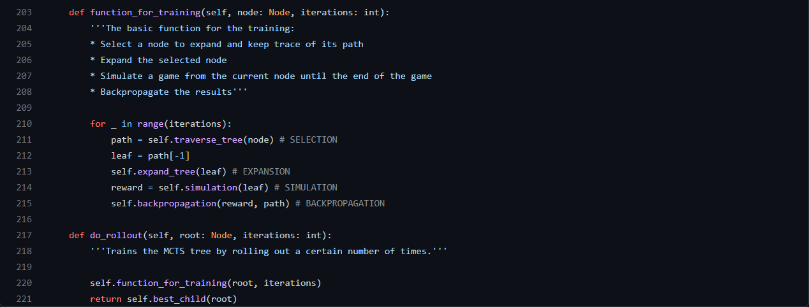

File MCTSPlayer/MCTSPlayer.py

In this file I implement the Player that uses MCTS as background strategy.

The Player is created with a parameter, “iterations”, that is set to 30 by default. It represents the number of rollouts that each tree search must do. 30 is good for making the Player not too slow, but obviously it brings to a less detailed exploration of the tree (50 can be also a good compromise).

The variable “_last_state” represents the selected child after the rollout, which contains both a place where put the current piece, and the information about the next piece to select with “choose_piece” (this later information is wrapper in the child’s “state” variable).

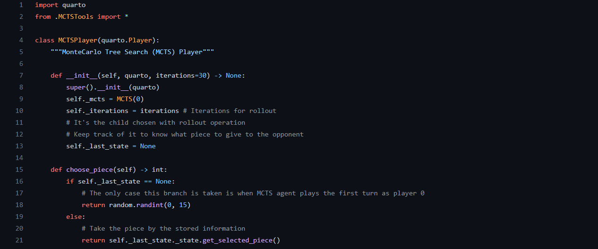
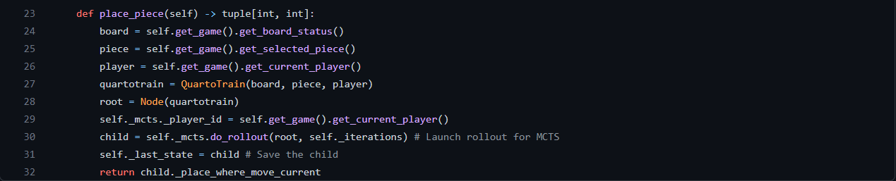

File: MCTSPlayer/API.py

This file was created as a support for Reinforcement Learning agent, but, since that agent didn’t bring good results, I left it for working with Genetic Algorithm. So basically this file refers to an old idea that didn’t have success, but I have decided to report this idea anyway, since it represents a part of the job that we did.
The file “database.json” that is referred inside, was a file with a pre-trained MonteCarlo tree, with a lot of iterations (on GitHub there is the one with 10000 nodes, but we tried also with 1 million nodes).

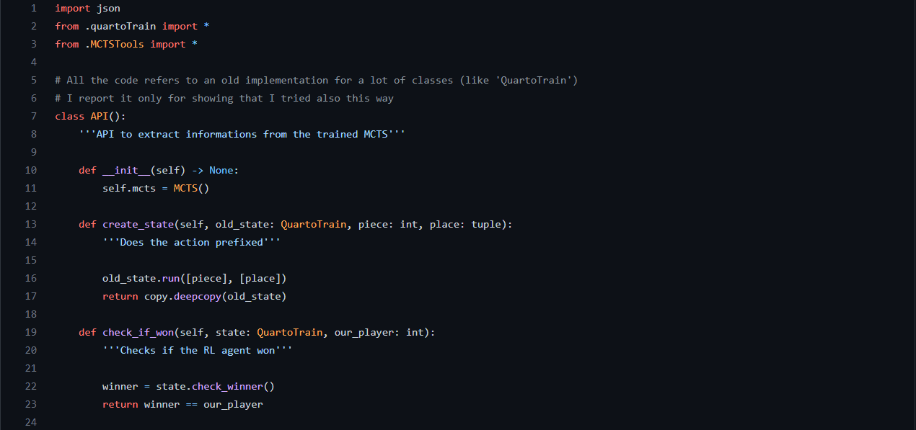
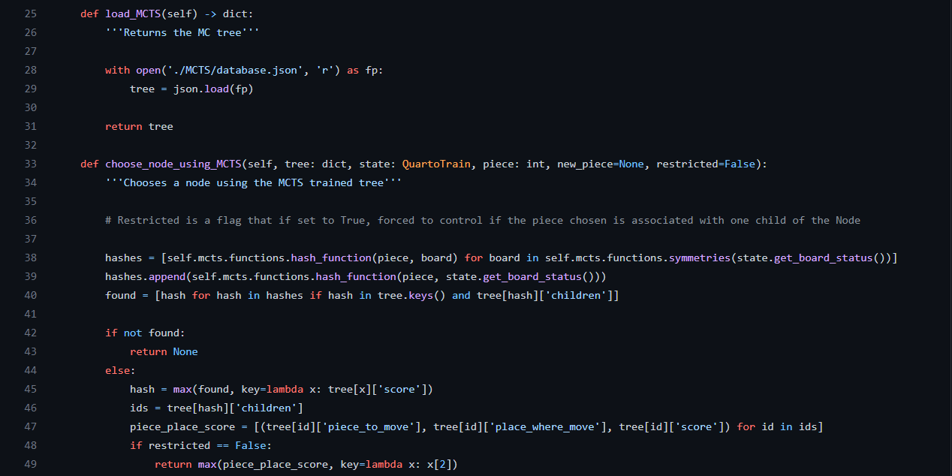

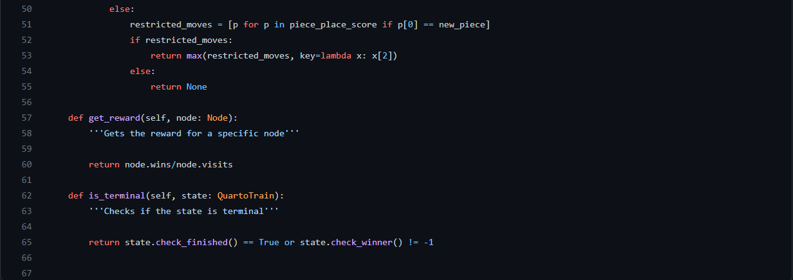

Results:

MCTS was a very stimulating study for us. We was wondering about the implementation that includes also a phase of updating of the states (the Backpropagation), since we both study subjects that include Machine Learning, we have an overview also about the path followed to arrive at the State-of-the-art.
The Tree search, in a way similar to MinMax, needs a lot of iterations to be efficient, but this results in a slower performance.
At the beginning we also tried to have an almost fully expanded tree, but this idea was a hole in the water (see Reinforcement Learning Player for details).
Then we decided to expand a part of the tree (30 or 50 iterations) at each new step of the game with some improvements as I told in the description.

The time taken by each rollout (when a “place_piece” happens) is 3 or 4 seconds with 30 iterations, that can be considered acceptable. Obviously, when iterations number is set to higher values, the win rate increases, but each “place_piece” move can require more than 7 seconds (it depends on the number of iterations).

The results achieved against the Random Player are positive, but they are not fixed, since a random move could be optimal in some cases, and our tree is not fully expanded.
The win rate is always between 60% and 80%, a lot of times it stays in the middle value, 70%.

Let’s try to mix: Genetic Algorithm

Description:

When someone wants to use MCTS, the time problems are very important, especially in situations where the resources are not so huge and the games to play are a lot. For that reason me and Sid thought about a mix of strategy. In particular we want to have three of them: Random, Hardcoded, MCTS.

Sid suggests to force the mix strategy to play in that way: the first turns are less important, so the system can play randomly, the middle turns must drive the game in our favour so we can play with hardcoded rules, at the end, when also a detailed expansion should be feasible, we can play with MCTS and arrive to the end.

But we needed a way to select when one of the three strategy must be selected and I proposed an idea that can trace the current state of the game: make a score for the board associated to its current state.
The score of the board must tell us if a board is “hot” (a lot of couples and triplets) or not. If there are a lot of good possibilities to win, our system must play in a smart way (hardcoded or tree search).

The Genetic Algorithm is used for searching the three parameters, one for each strategy, that determine the situations in which the Player has to switch its way to play.
For that decision, I thought about making a difference function (“compute_diff”): the current score of the board is compared with the three parameters and the strategy that will take for that turn is the one whit the numerically closer parameter to the current score.

Each individual in the algorithm has a set of three parameters (its genome) and a fitness value that is the result of a certain number of games (wins divided by total games).

Code:

File: GAPlayer/ScoreFunction.py

This files contains the logic behind the scoring of the board. It looks similar to the code of Hardcoded Player, but there are some differences explained in the documentation and comments.

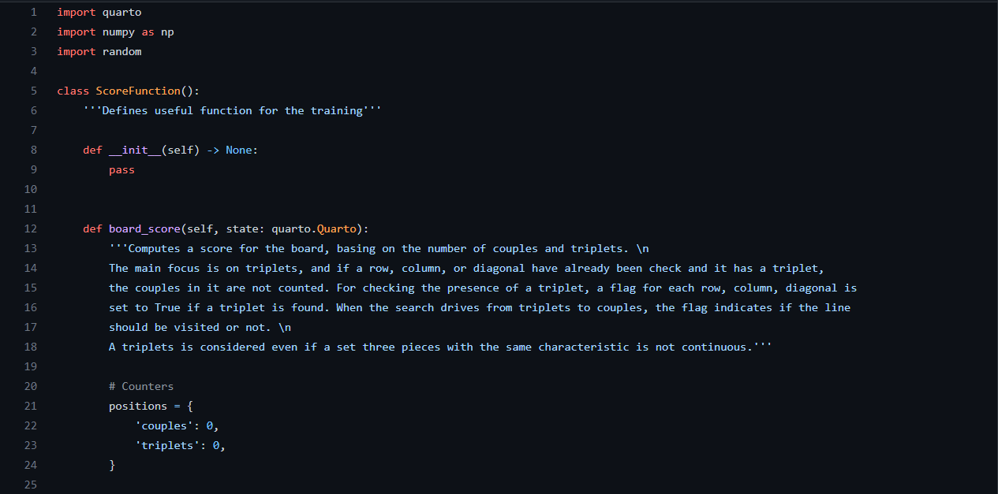
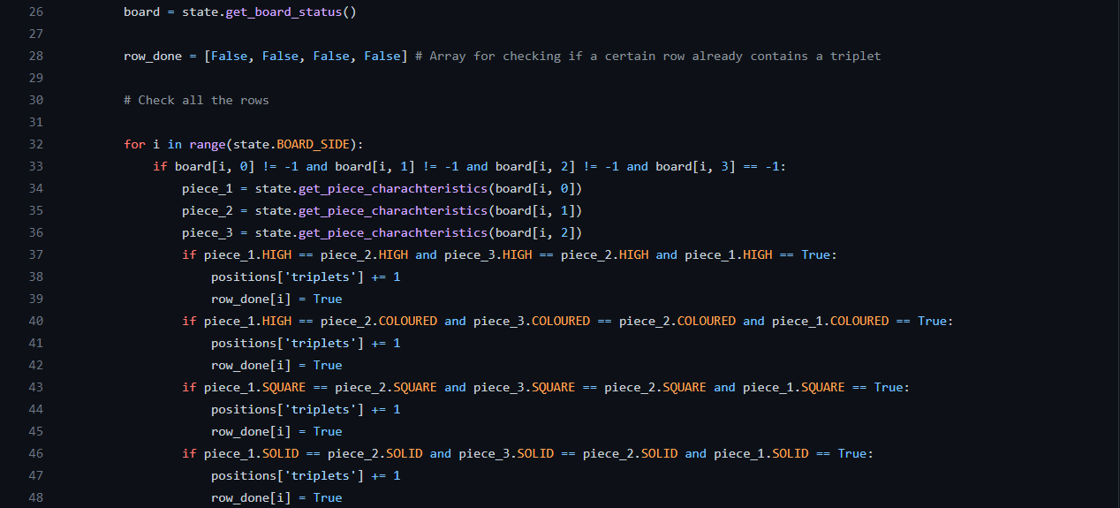
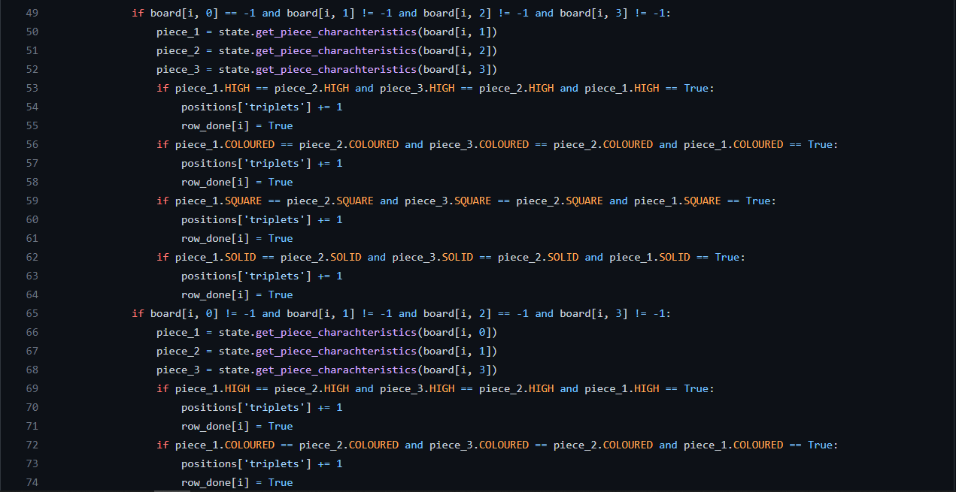
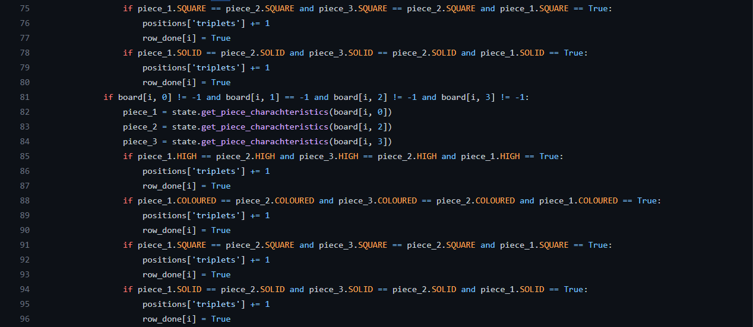
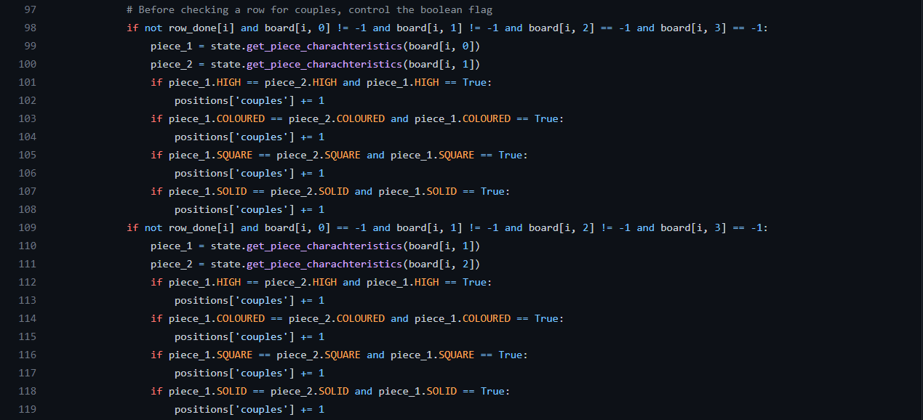
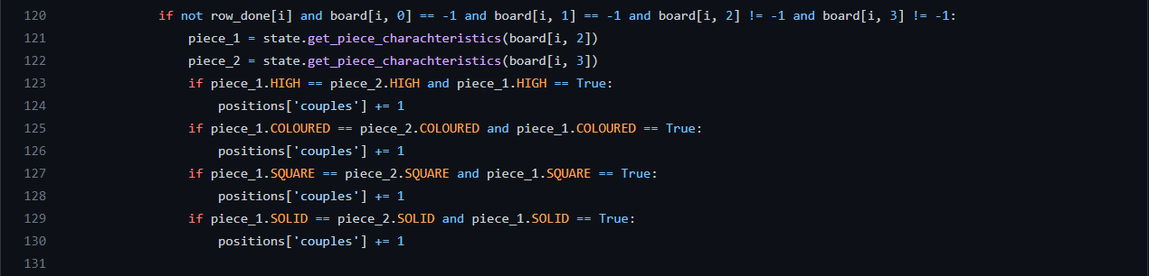

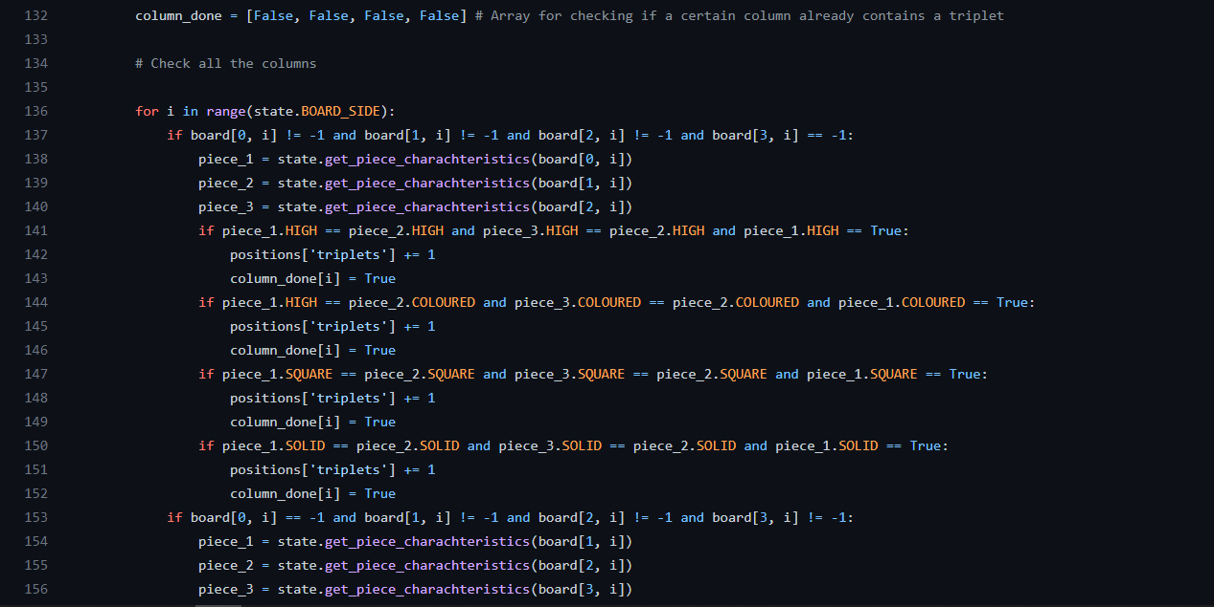
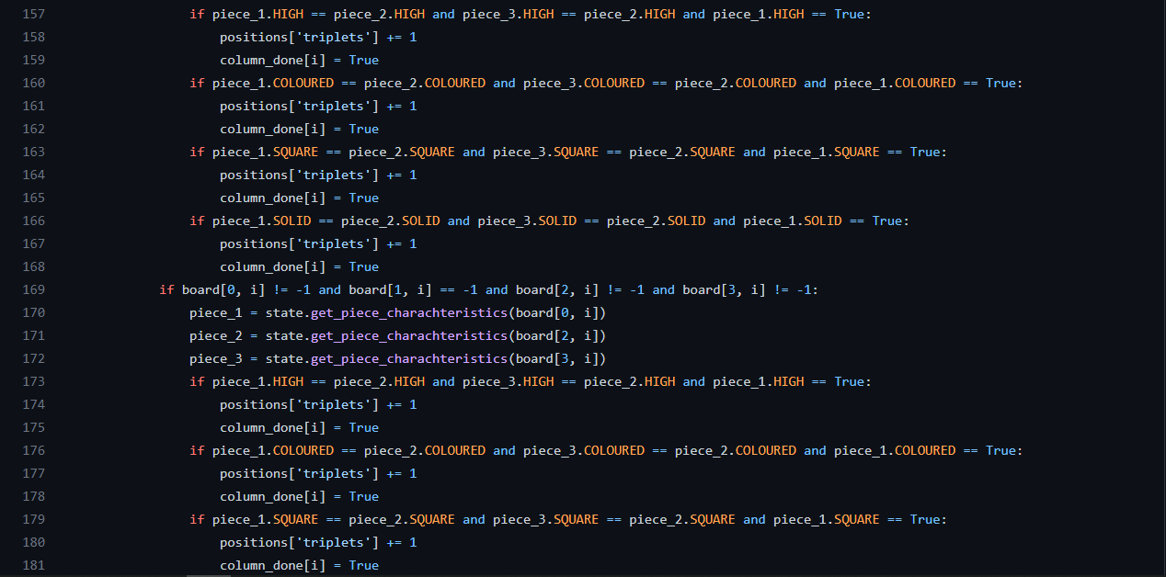
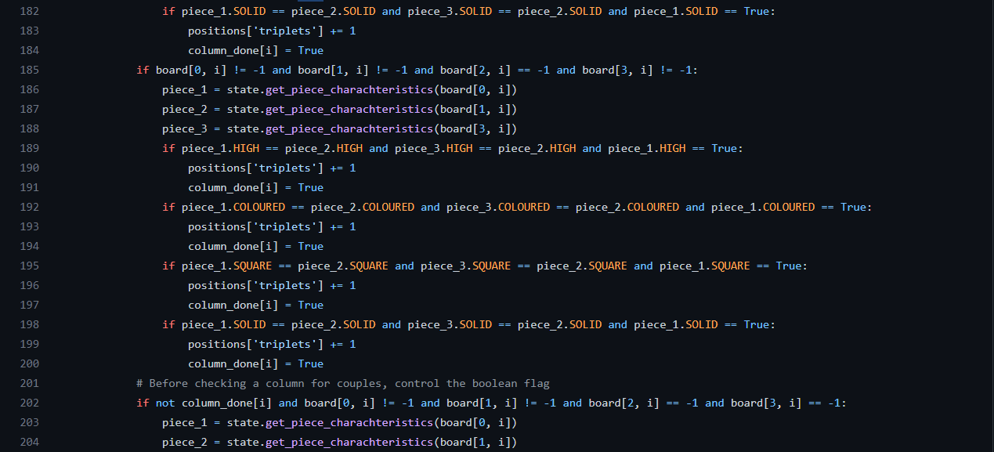
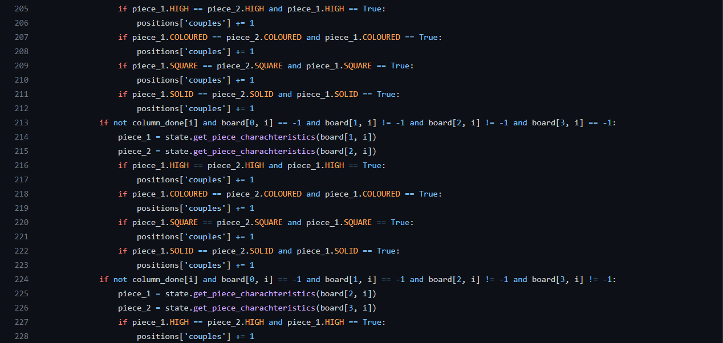
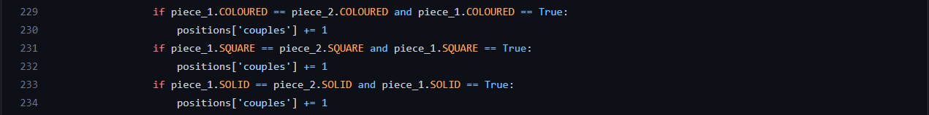

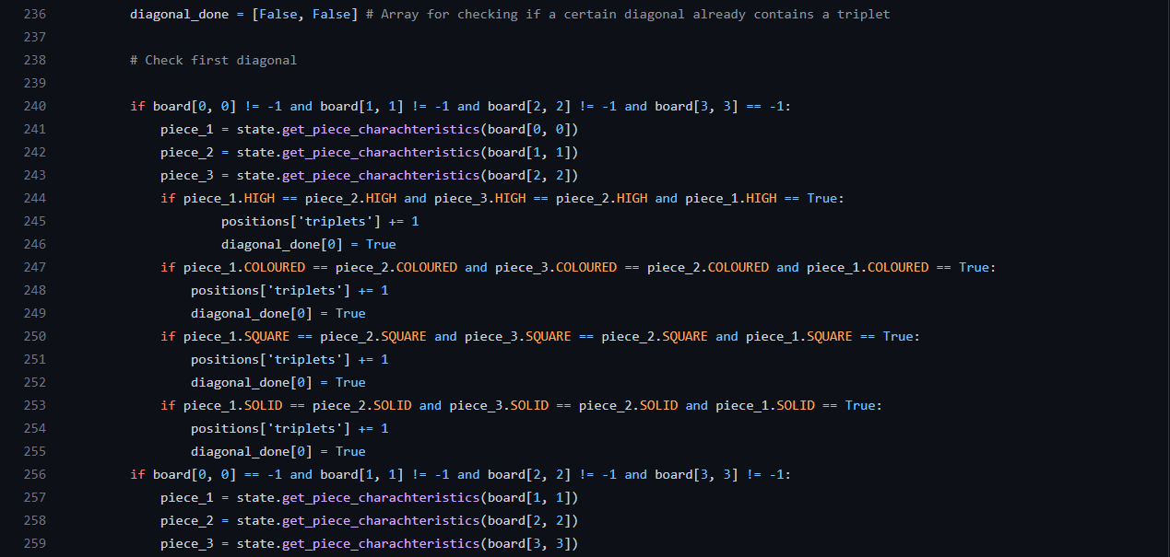
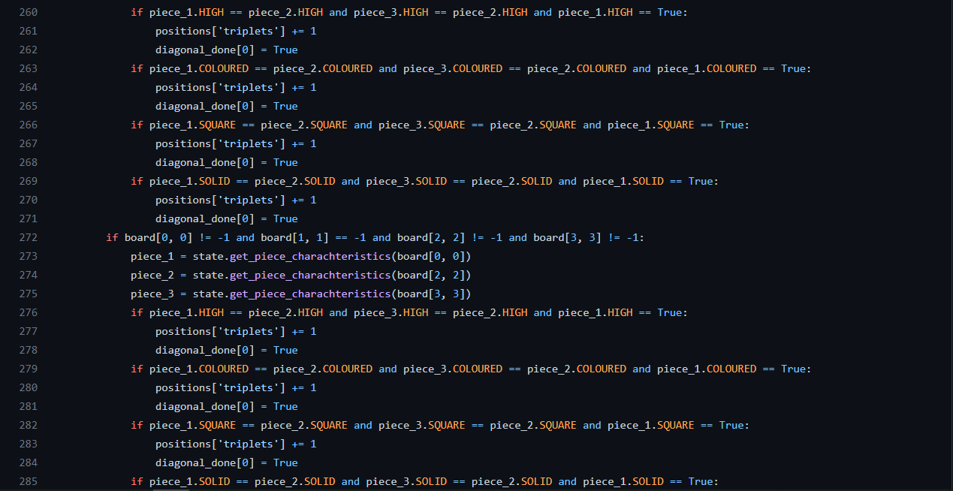

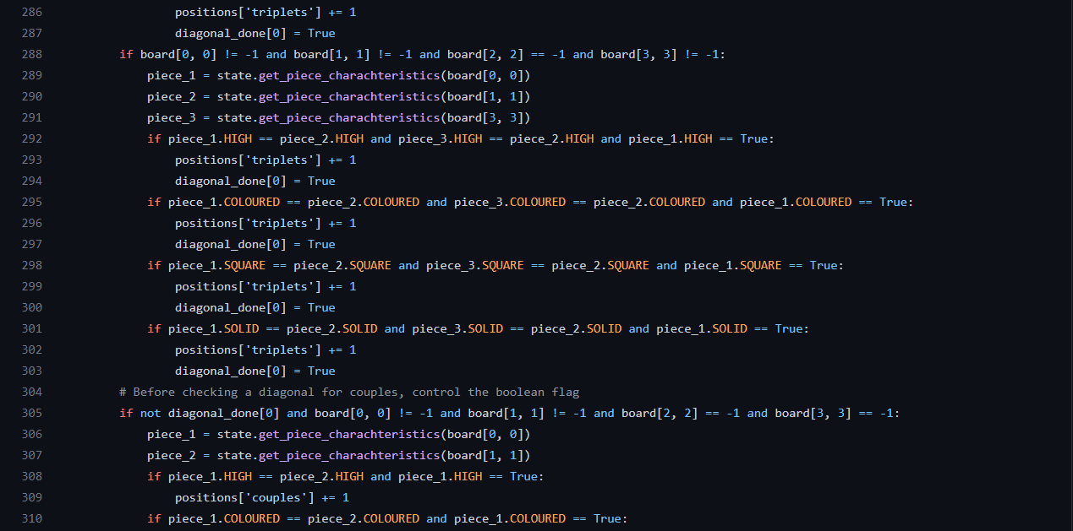
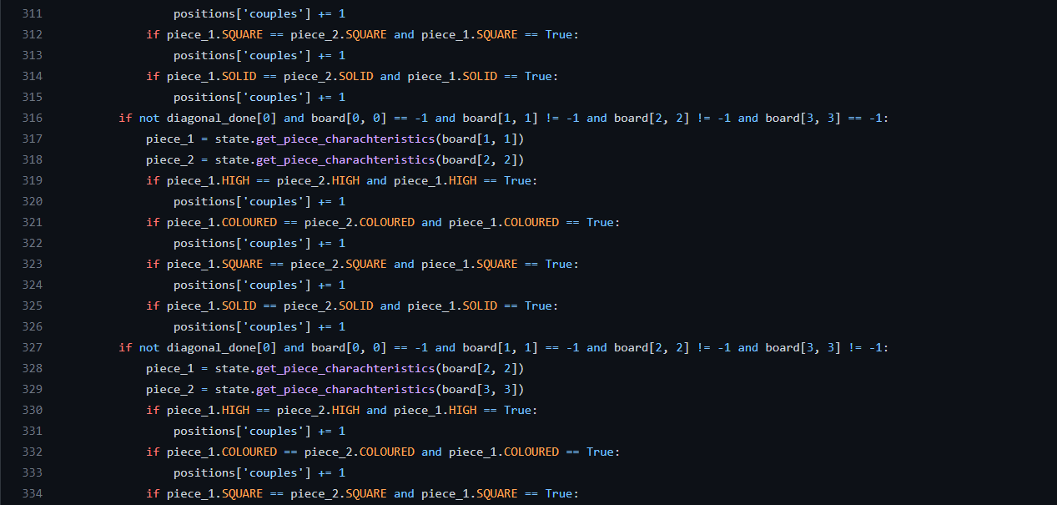

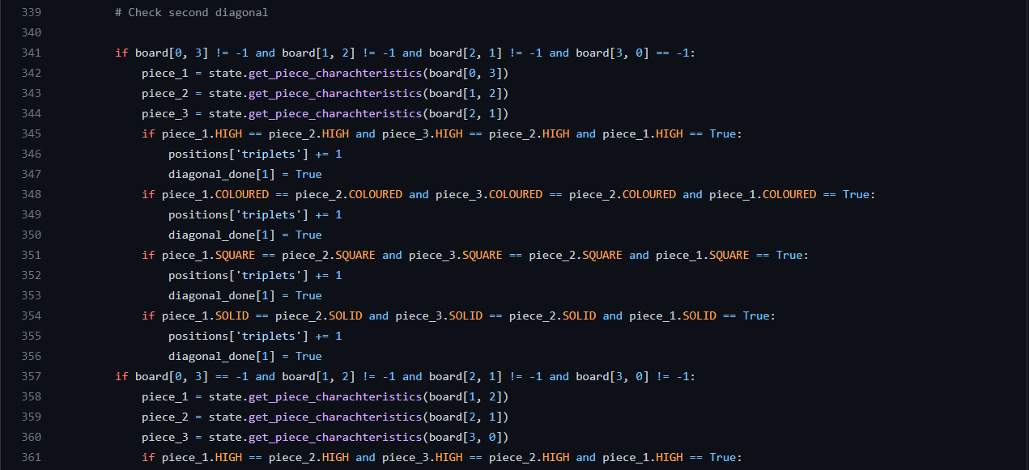
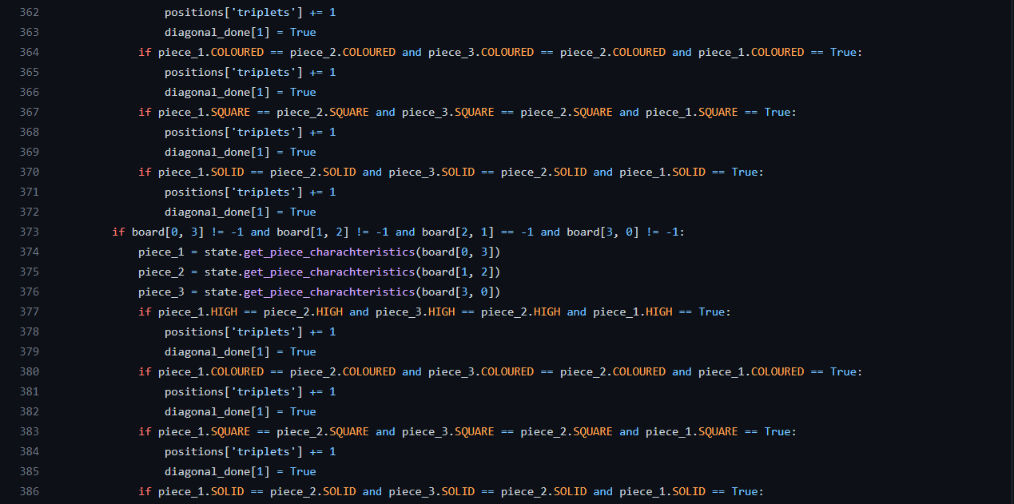
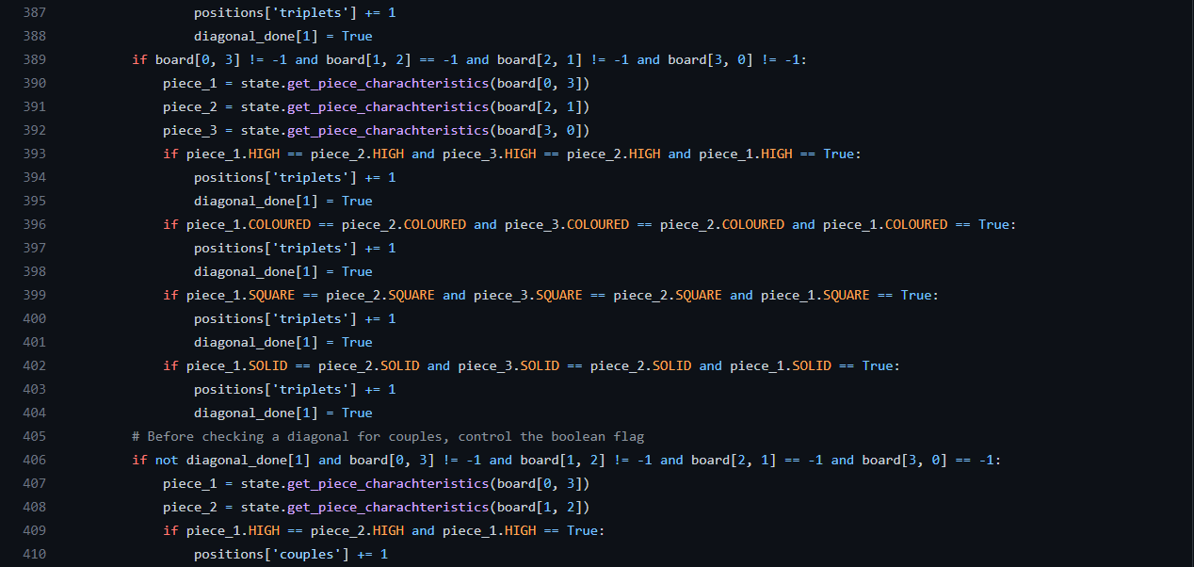
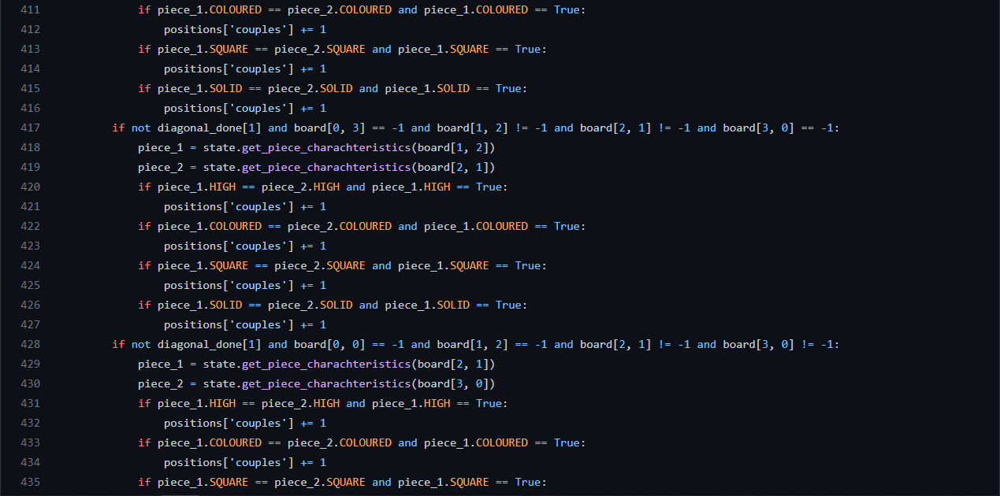


We found that the maximum score that a board can have is almost always, 17.
We need this value for one next settings in the code.

File: GAPlayer/quartoTrain.py

In this file we have the same content of the previous “MCTSPlayer/quartoTrain.py”, so I decided to not add it a second time.

File: GAPlayer/GATools.py

This file contains all the logic for the training phase of the Genetic Algorithm, which goal is to find the set of the best three parameters related to the points (i.e. board scores) when the Player must switch its strategy.
The global variable “GENOME_VAL_UPPER_BOUND” was derived from the number 17 treated before (the maximum score of the board), after some trials we discover that the best results were achieved if 10 was the maximum value for the three parameters (better parameters for swapping within strategies have been found).

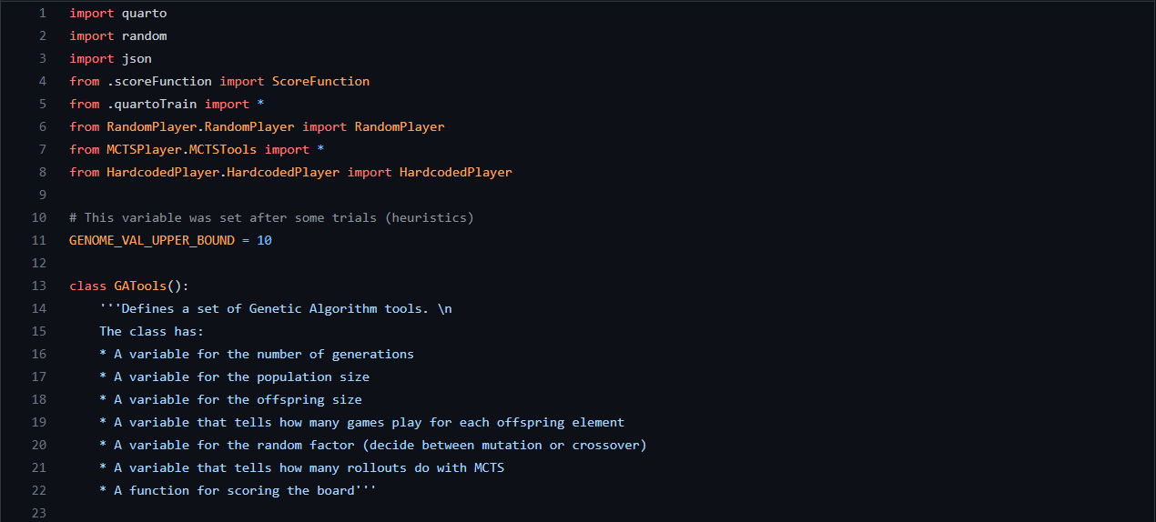
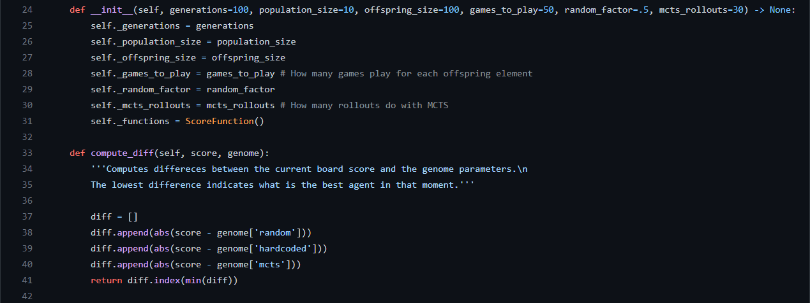
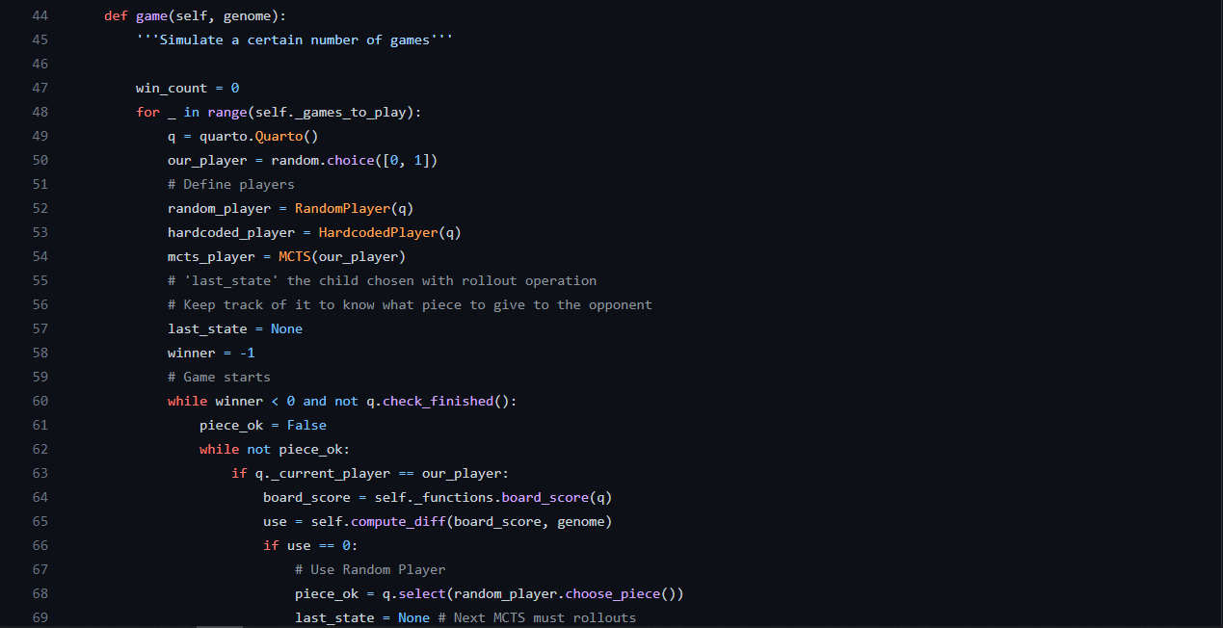
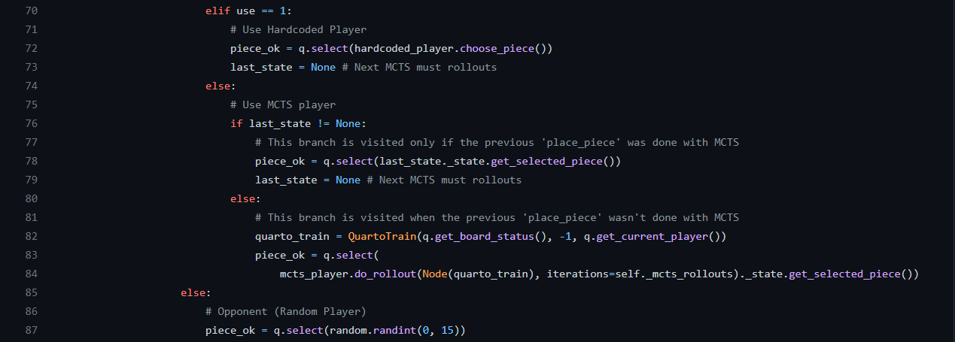
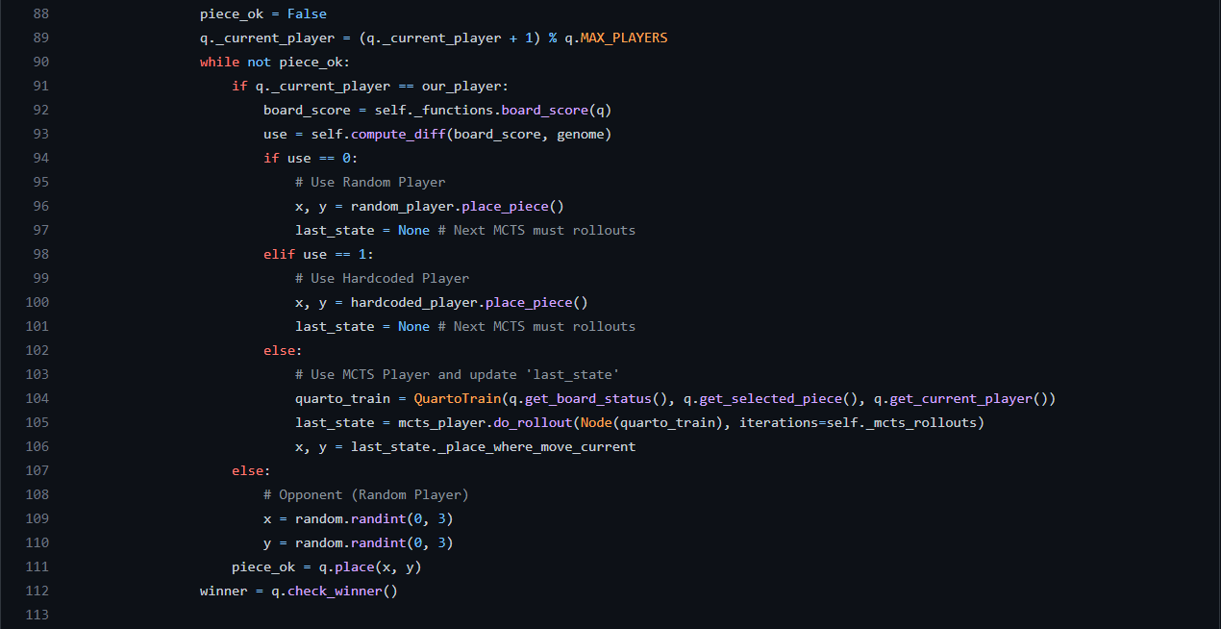
Sid had the idea to implement this function to maintain the pre order established by us

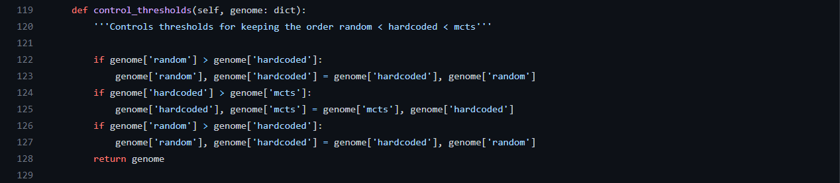

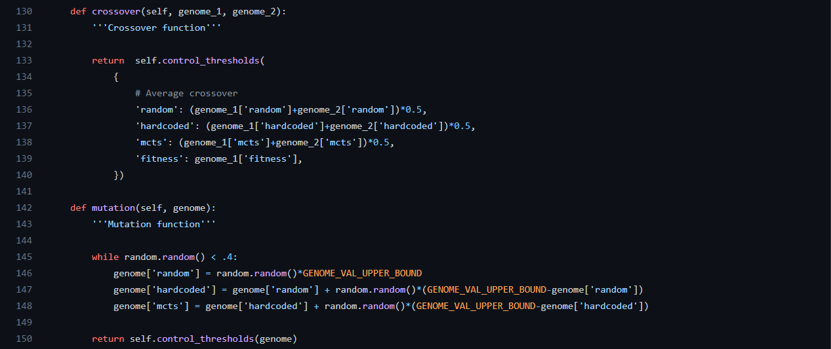
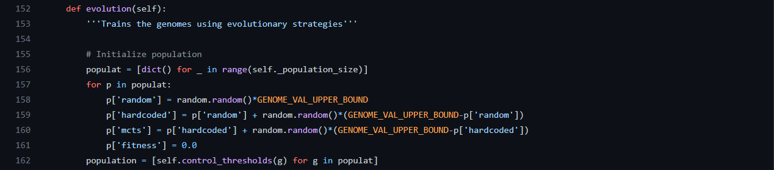
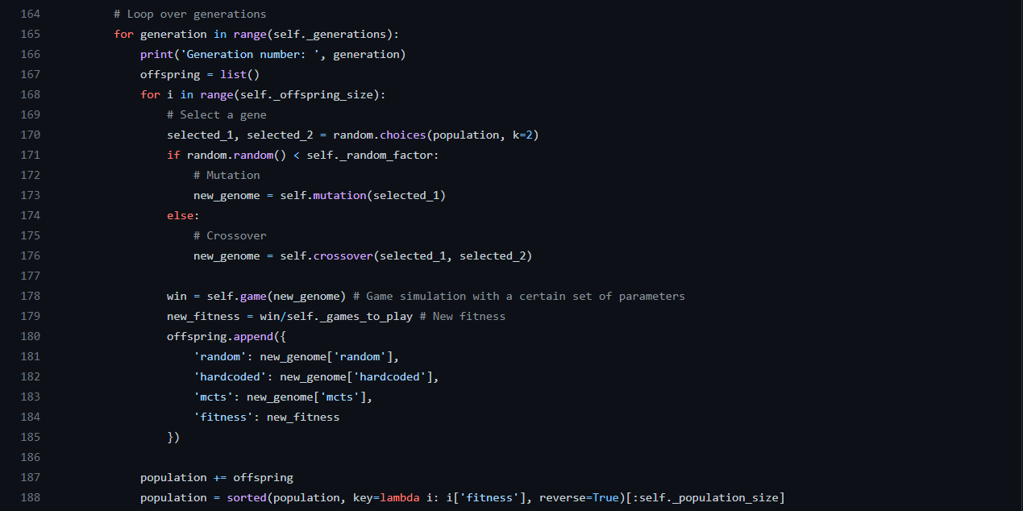

File: GAPlayer/parameters.json

I this file I stored the three best parameters found with Genetic Algorithm (the best genome), for now they are 2.09077 for random, 3.79032 for hardcoded and 7.25199 for MCTS.

File: GAPlayer/GAPlayer.py

Here I implement the Player that uses the three parameters for playing Quarto with different strategies.
The function “compute_diff” is the same as in file “GAPlayer/GATools.py”, so I don’t report it another time.
The implementations of functions “choose_piece” and “place_piece” is very similar to the one made for the game simulation in the training phase of the Genetic Algorithm.

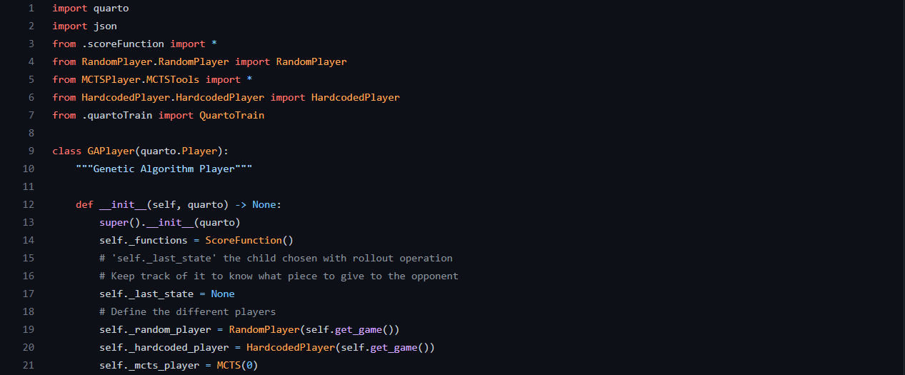
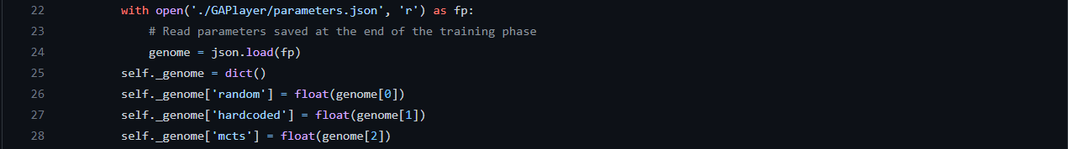
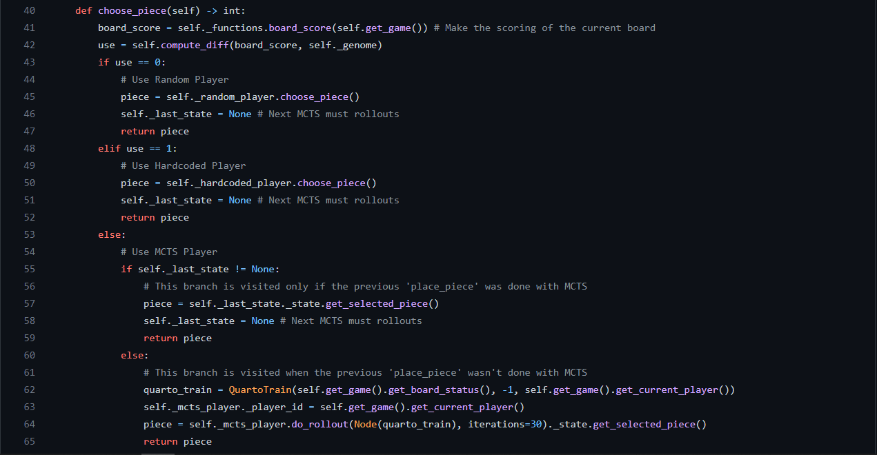
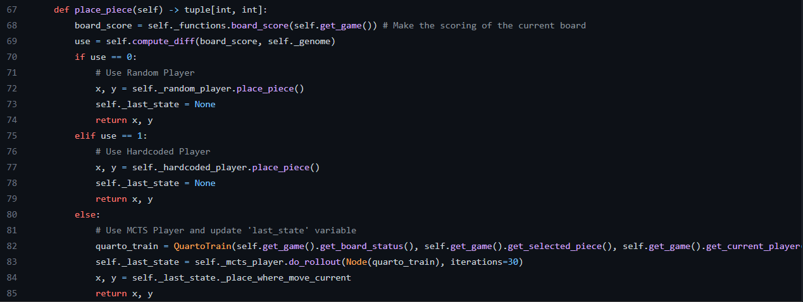

Results:

The results reached by the Player are so good, both in terms of win rate and time performances.
By decreasing the number of times that MCTS acts in the game, the speed is increased.
I mean, MCTS isn’t so slow, 4/5 seconds for each turn plyed by the agent, but here we have an improvement if we think to play a lot of games.
The win rate against Random Player is between 60% and 80% and also in this case, the most of the games are around 70%.

One of the weaknesses of GA training is the number of games for each offspring element, we set it to 6, but if we increase it also by few units, the training phase becomes so slow. With a powerful machine the training could be done with more games and the results would be more accurate.

A disappointing strategy: Reinforcement Learning

Description:

Before start thinking about Genetic Algorithm, we would try to integrate MCTS with the Reinforcement Learning.
We stored a very well trained tree with MonteCarlo strategy (in the file “MCTSPlayer/database.json there is the version with 10k nodes but we arrived also to a 1 million nodes) and we want to use it as a background to the RL.
The main idea was to first search the current state into the database and if found, use the information from it (place where put the piece and piece to select after), if no state is found, play with a random move.
In all cases, after the current state is treated, store it with its reward in the state path.
This later was used at the end of each game for the learning phase, in that way the dictionary of states-rewards would be updated and the Player would learn something.

This strategy demonstrates that, even if a database of 1 million node, Quarto game has a too much huge state space. Only the 22% of the states were found from the MCTS, the others time the turn was played randomly.

At the end of the learning phase of RL (5000 iterations), the learning curve didn’t present any improvement sign as we can see below:

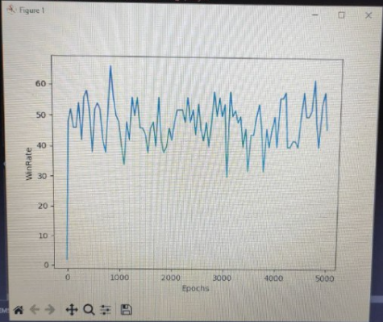

So we decided to left this idea and try to implement other stuffs, but we decided to keep it as an example to a strategy that, for what concern our implementation, must be avoided.

Also the Player was not implemented for this strategy.

Code:

File: RLPlayer/RLPlayer.py

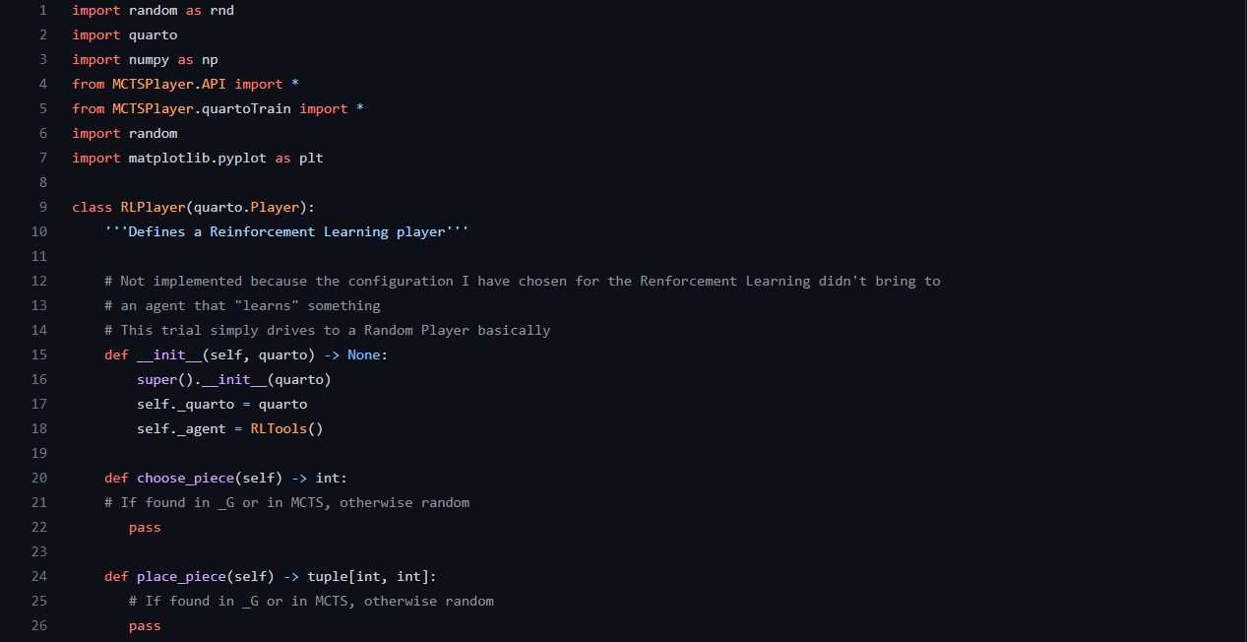
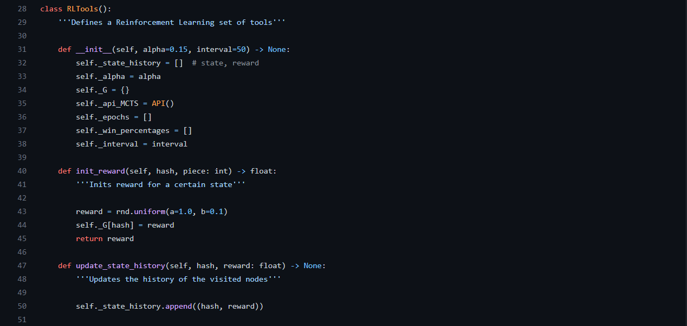
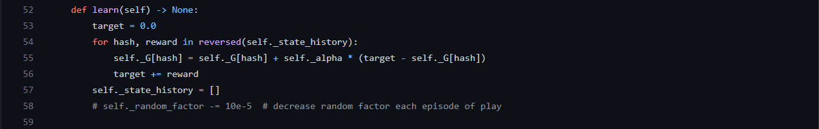
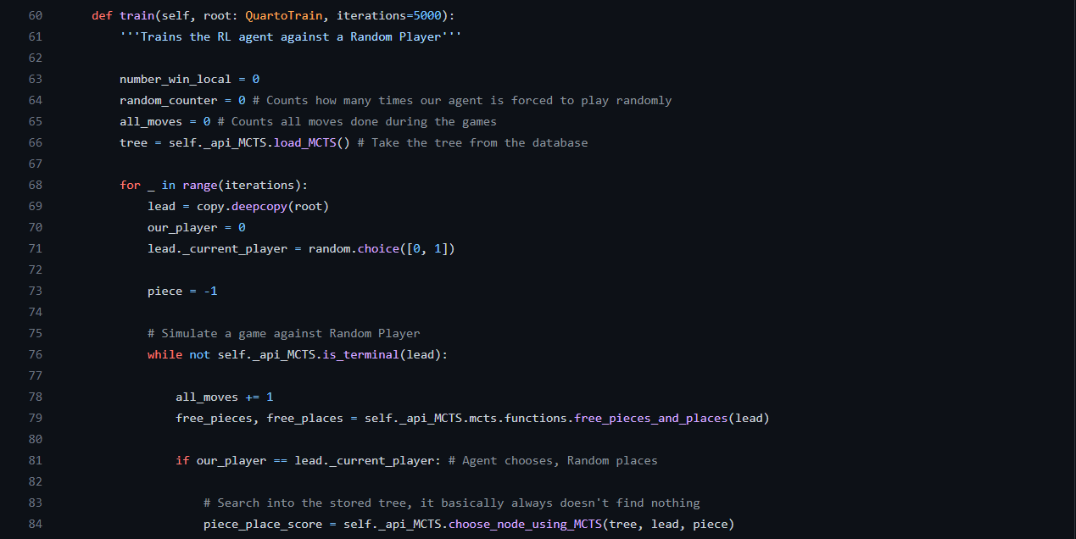
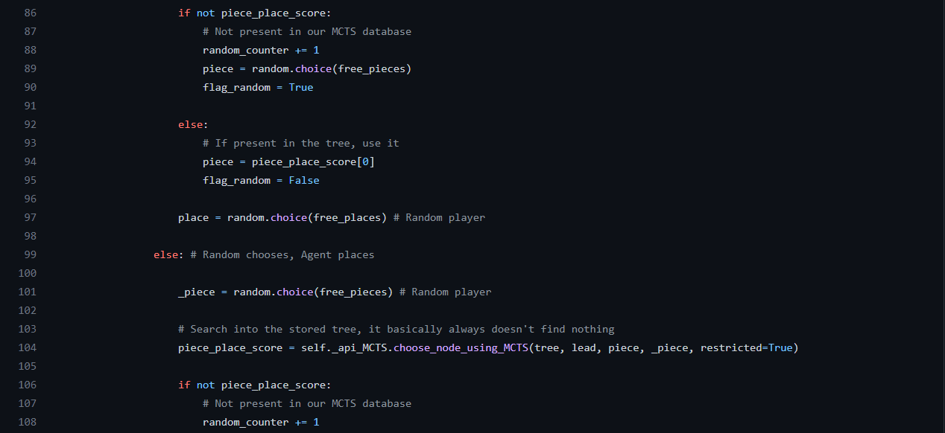
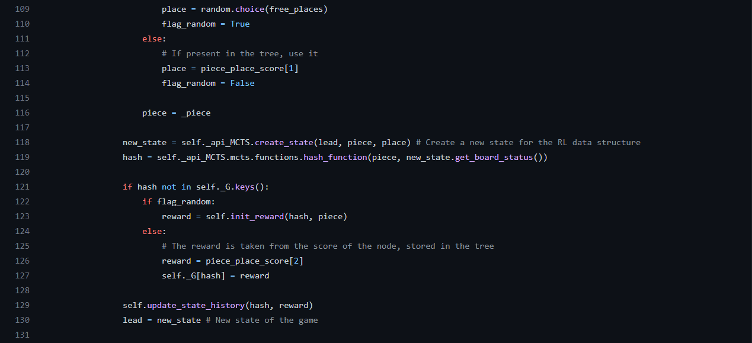
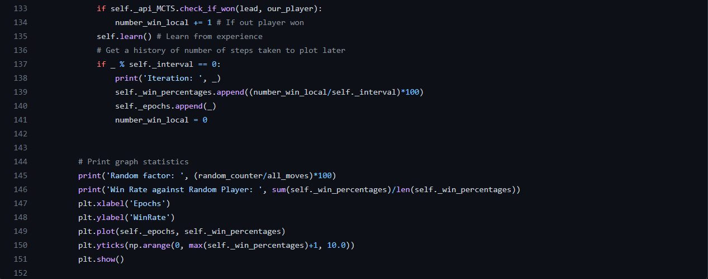

Results:

As I told before, this strategy didn’t bring interesting results, the training phase didn’t show a rising learning curve, and the player win rate basically was around 50%, like the random one (and this is understandable since the majority of plays have been done randomly).

Final considerations:

This project allowed us to explore a lot of interesting methods for building smart systems.
One of the main interesting things, after learning how these systems work, is to learn how to adapt them in a real scenario like Quarto’s one.

Since the Gradient Descent technique is not always a passable road in Artificial Intelligence, it is so important to learn how to make intelligent systems in other ways.

I hope that this report and the code wrapped inside, were readable and well detailed.

