Fork Mode

tasklist /fi "imagename eq node.exe"

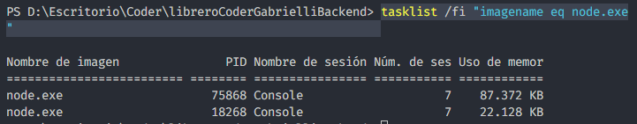

Cluster Mode

tasklist /fi "imagename eq node.exe"

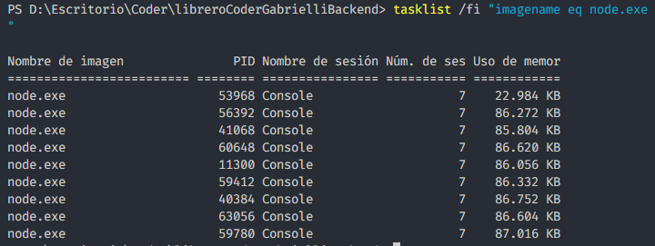

Forever

forever start --minUptime 100000 --spinSleepTime 100000 -w index.js -p 8080

forever start --minUptime 100000 --spinSleepTime 100000 -w index.js -p 8081

forever start --minUptime 100000 --spinSleepTime 100000 -w index.js -p 8082

tasklist /fi "imagename eq node.exe"

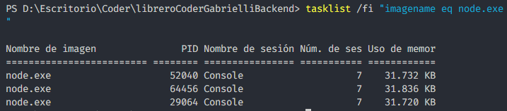

forever list

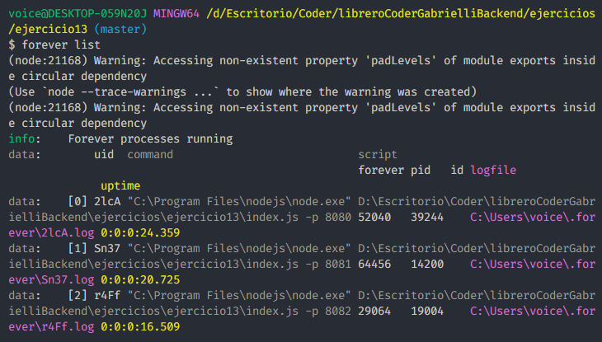

Pm2

pm2 start index.js --name="Server1" --watch -- 8080

pm2 start index.js --name="Server2" --watch -- 8081

pm2 start index.js --name="Server3" --watch -- 8082

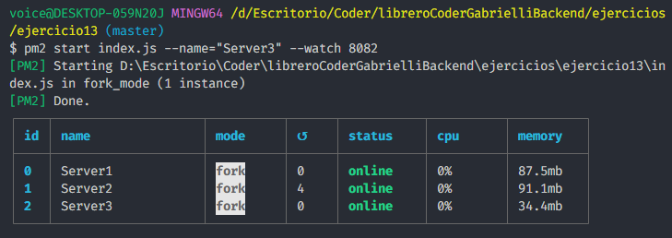

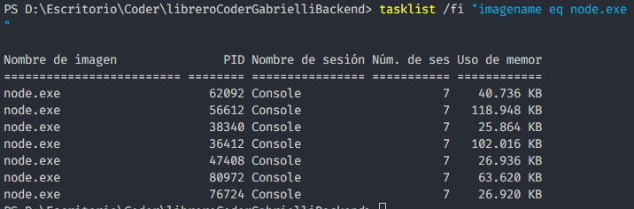

pm2 start index.js –name=”Server0” –watch -I max -- 8080

