**Personality Test Website**

Group 6 Project Proposal for CIT 313

February 2017

**Personality Test Website**

Group 6 Project Proposal for CIT 313

1. **PROJECT DESCRIPTION**

The purpose of the website is to provide an app that presents a series of 20 questions, where the user sorts the order of options for each question in order of most describes them to least describes them. Once the user completes the 20 questions, the application processed a result and provides the user with a report indicating their dominant traits as per the DISC personality profile scale. The user will be presented with the opportunity to share the result to Facebook which will include an invitation for friends to also take the assessment.

The business case for this application is that it has the potential to become viral, and in so doing, market the organization.

1. **MOCKUPS**

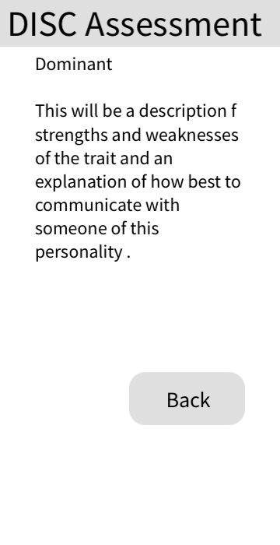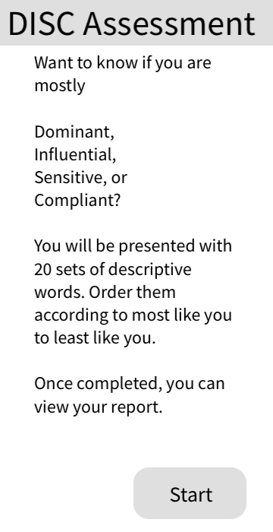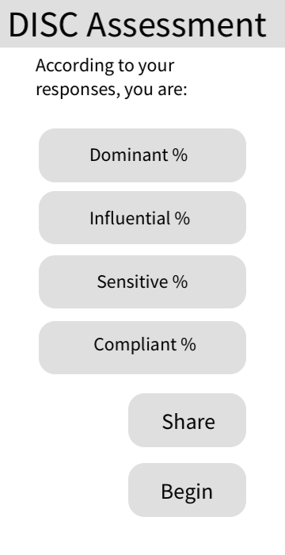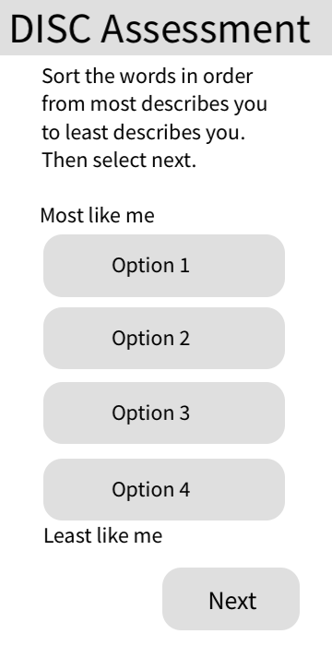

1. **THIRD PARTY APIs**

We will be using the Facebook API in our project. Specifically, the plugins that make it easier to share content from our website. We will also use the API to help drive more users to our website.

1. **DATABASE**

The database for the Personality Test Website will have the following entities: Table, Table, Table.

**Assessment_questions:**

*Type of Data:* text

*Relationships:* Will have foreign keys in the Lists & Children entities

*Columns:* Question, dOption, iOption, sOption, cOption

1. **MILESTONES**
   1. **Week 10: Milestone 1-**
      1. *Create the necessary database tables*
      2. *Create required classes*
      3. *Create required JSP’s*
   2. **Week 11: Milestone 2-**
      1. *Implement Facebook API*
      2. *Work on responsiveness*
      3. *Work on styling*
   3. **Week 12: Milestone 3-**
      1. *Troubleshoot and test*
      2. *Upload to Heroku*
   4. **Week 13: Project Demo, App Store Submission**
      1. *Complete final touches to the project to prepare for Project Demo*