Follow this step:

1. Open Project structure in File -> Project structure  
   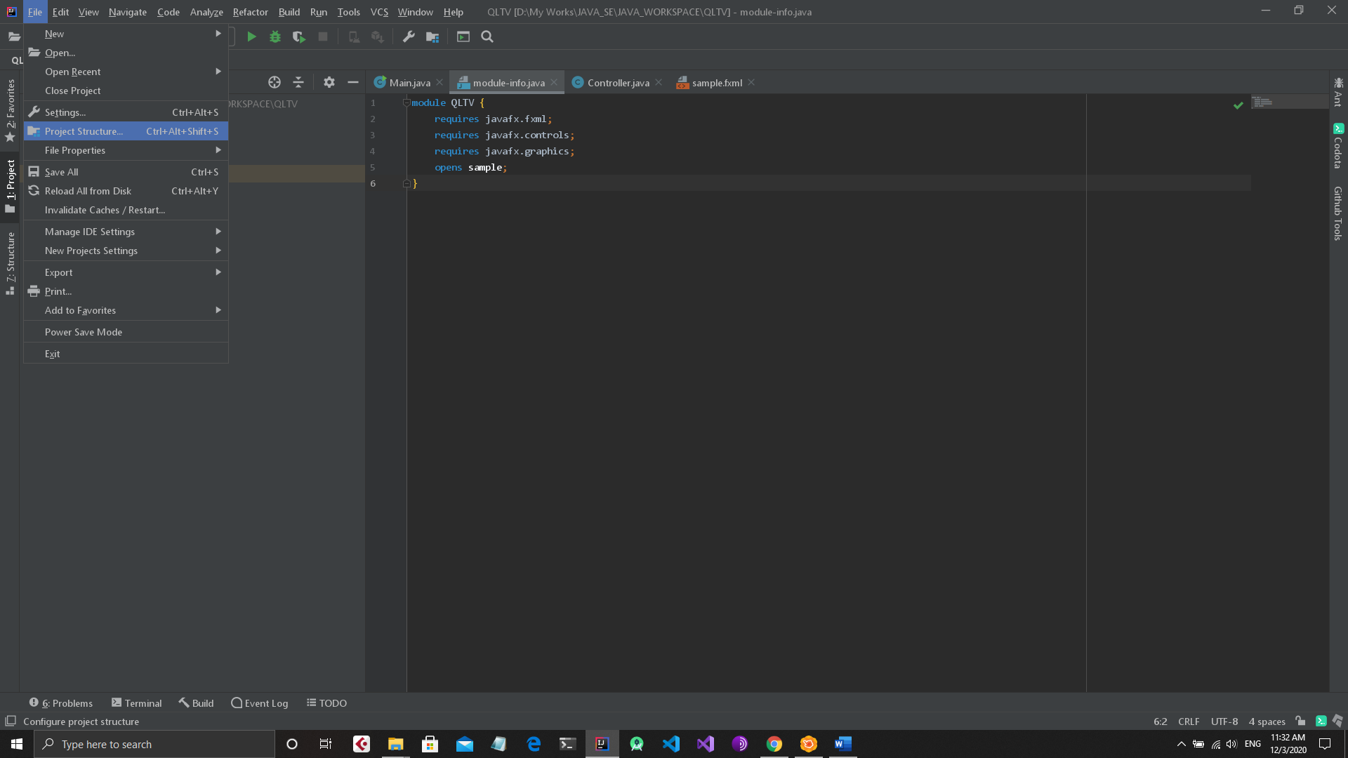
2. Click on Global Library  
   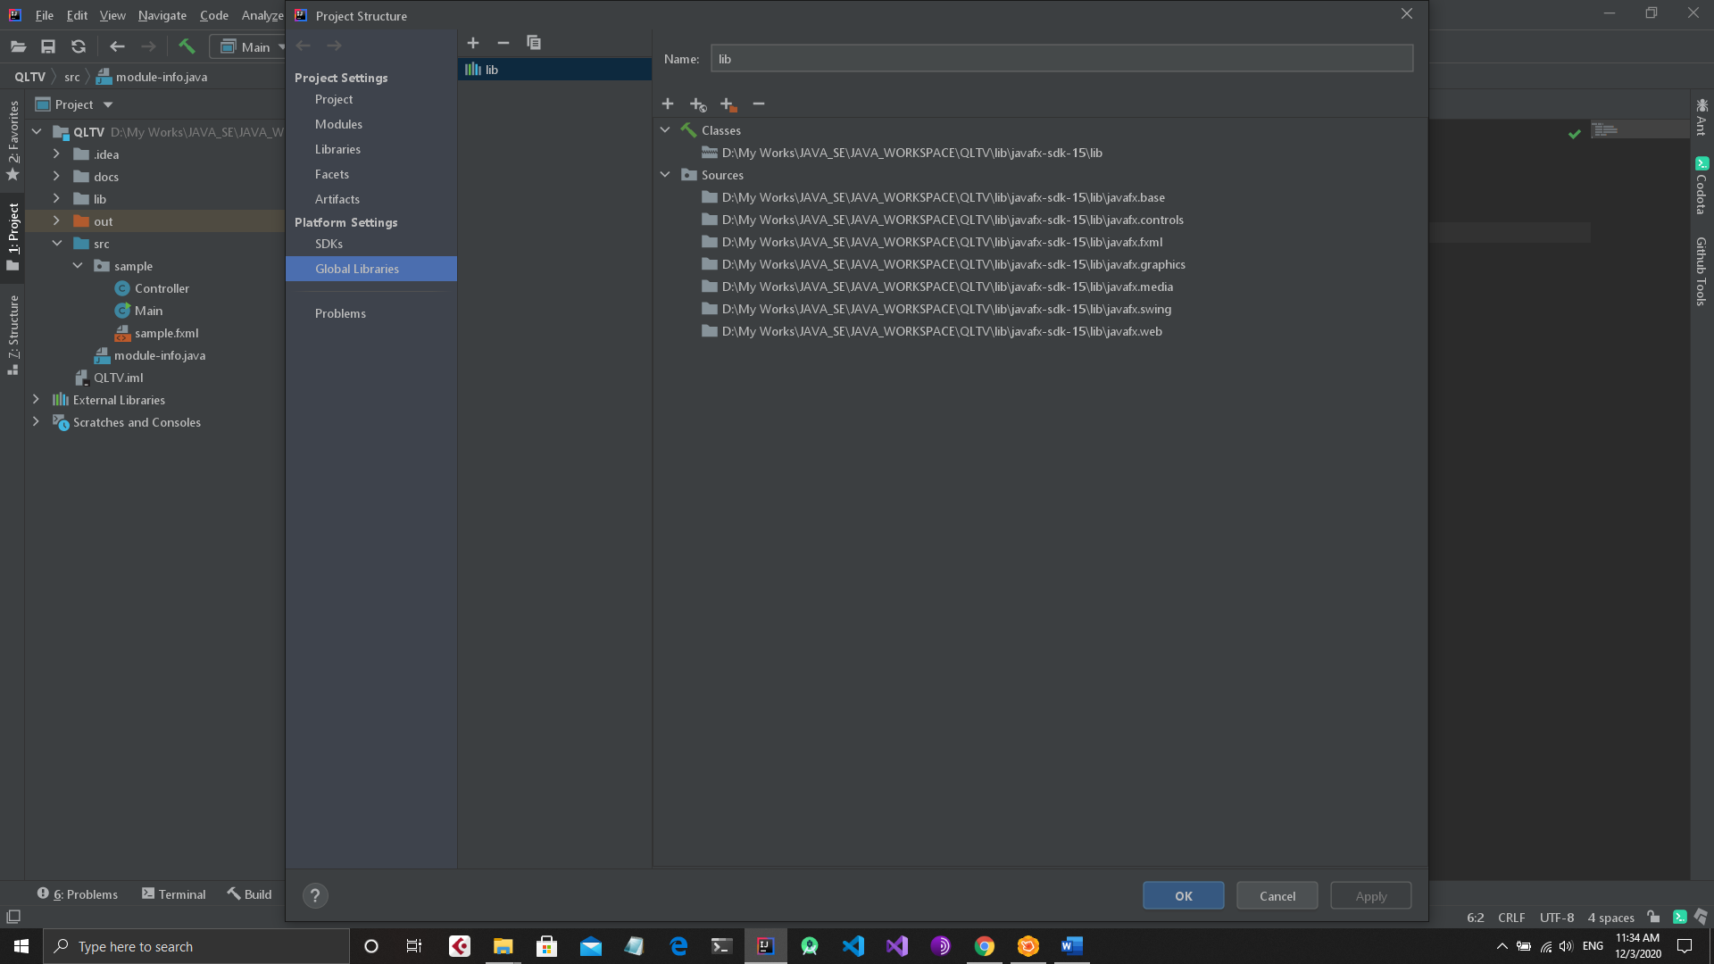  
     
   Select library in this path: something like : ..\QLTV\lib\javafx-sdk-15\lib
3. Check Java JDK and select Java JDK 11
4. Apply and Run the Project