1. Go to project structure  
   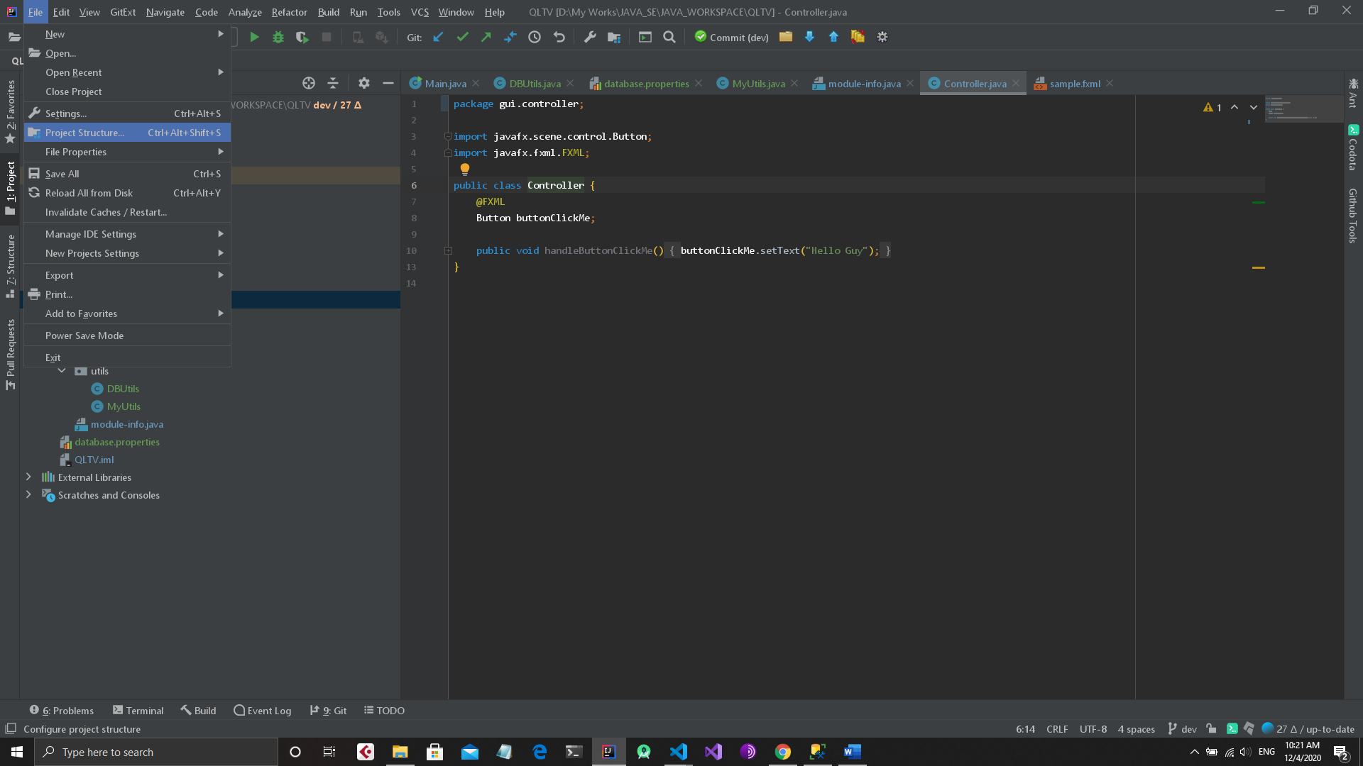
2. On Global library add jdbc jar file  
   Path is something like this: ..\QLTV\lib\mssql-jdbc-8.4.1\mssql-jdbc-8.4.1.jre11.jar
3. Apply and Run