Homework DayWeek2Day1 screenshots

-removing the navigation label bullets
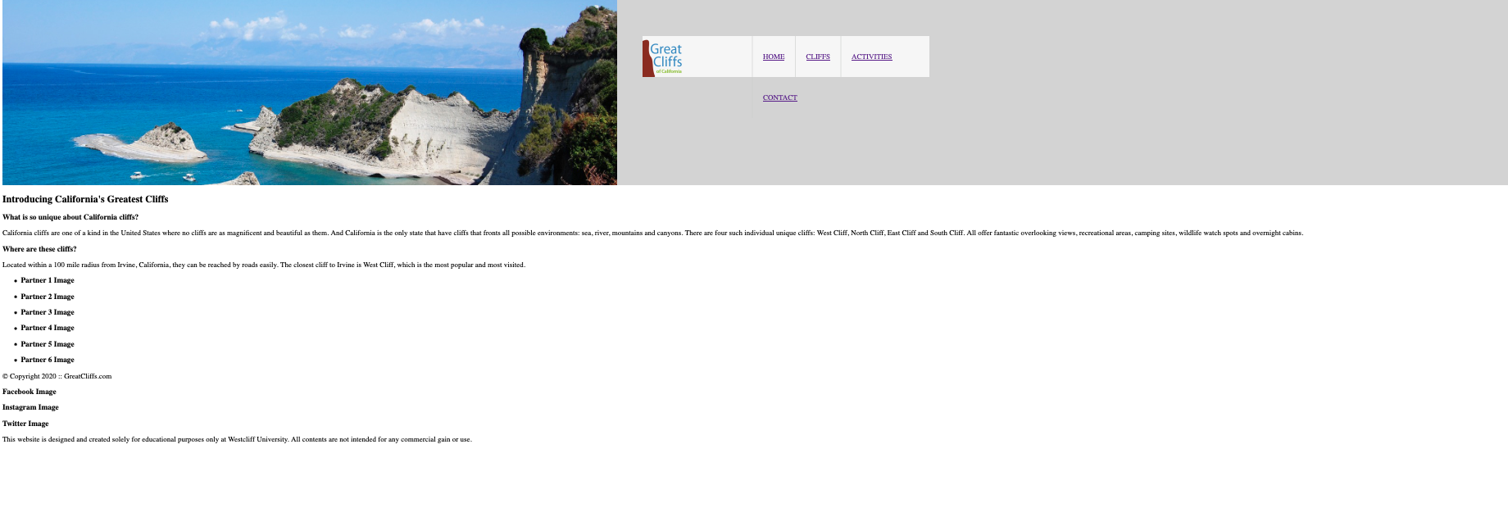
-getting rid of the underlines, changing color, and creating mouse hovering
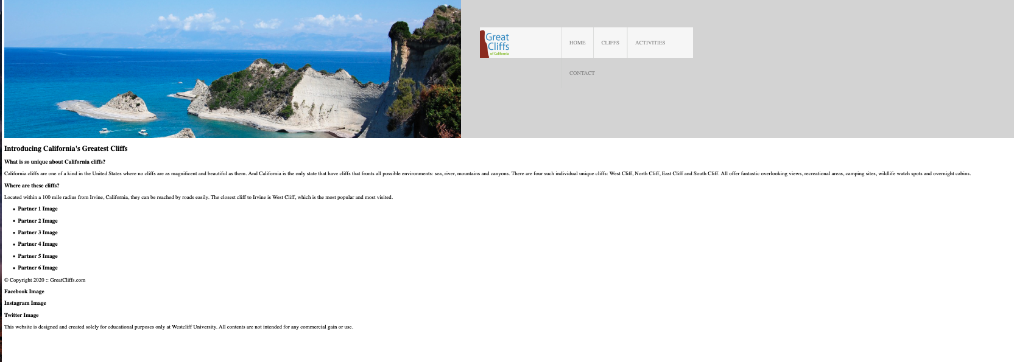
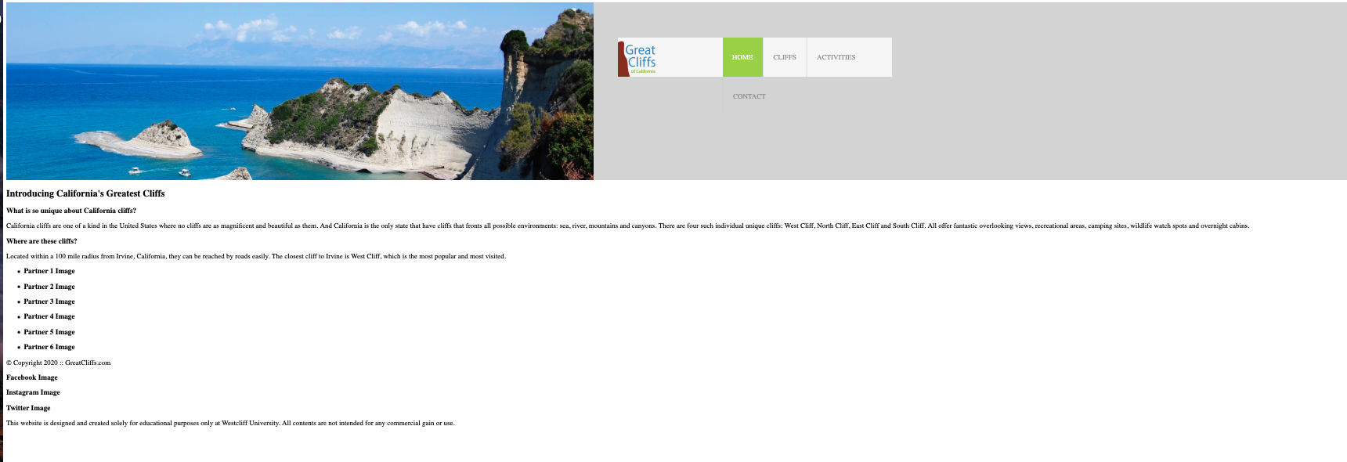
-updated main area using css$
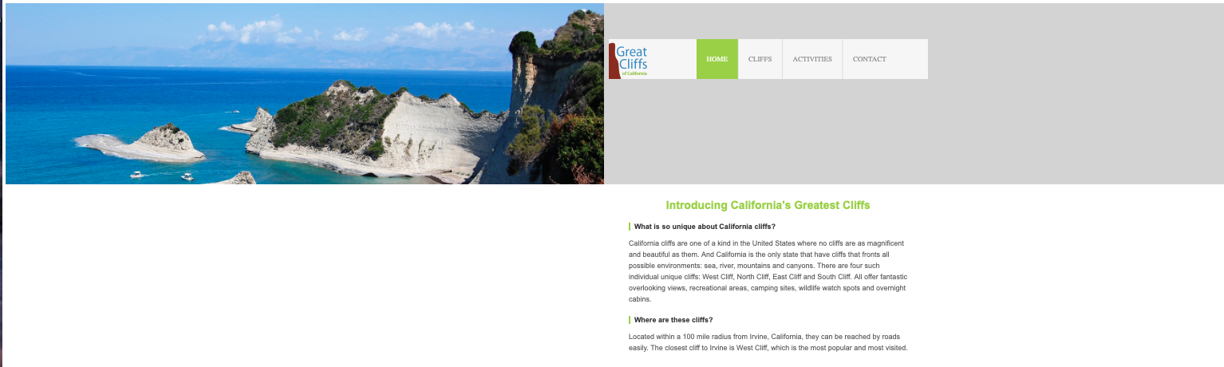
Adding partners images
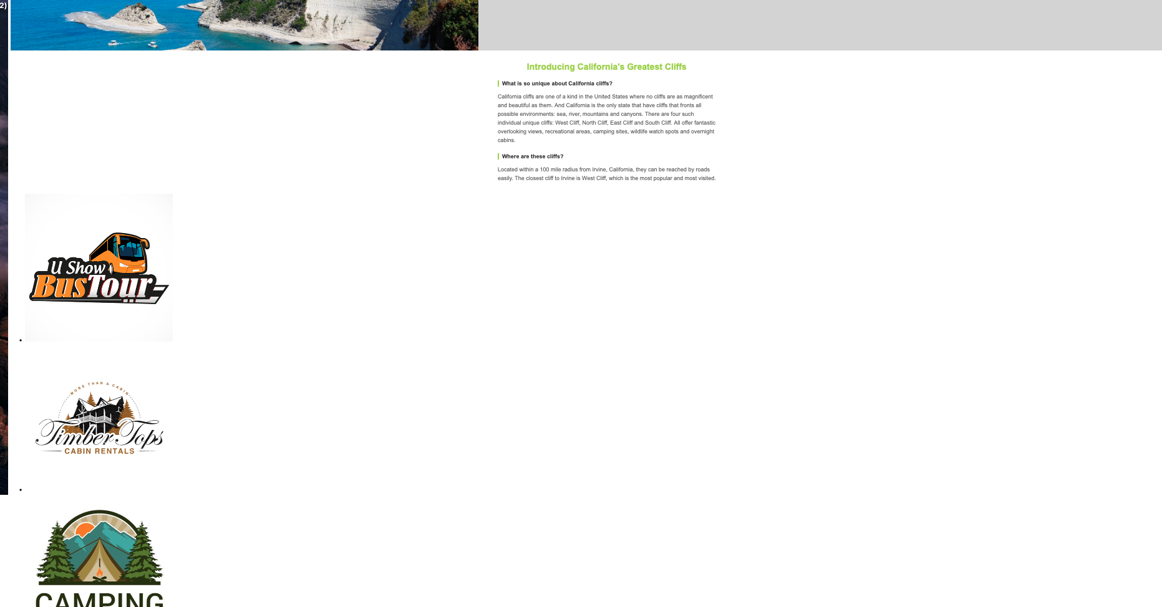
Rearranging the partners logo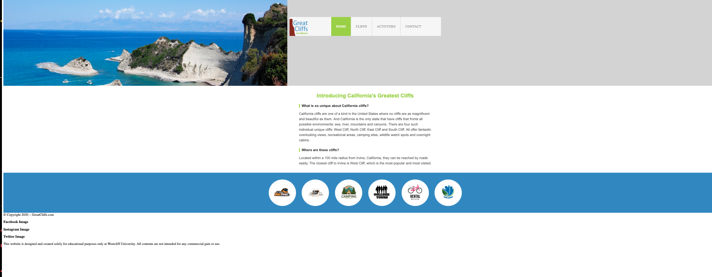

Fixing footer and social media links for final look
