Github URL: https://github.com/Dieneba1/m1-assignment
Website: Local Pet Adoption center
Screenshots showing CSS3 Styling applied to the mini site
1.Home Page after styling paragraphs
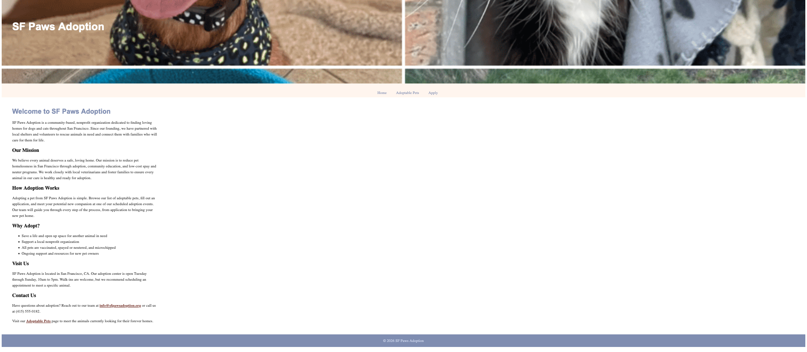
2. Refining table styling

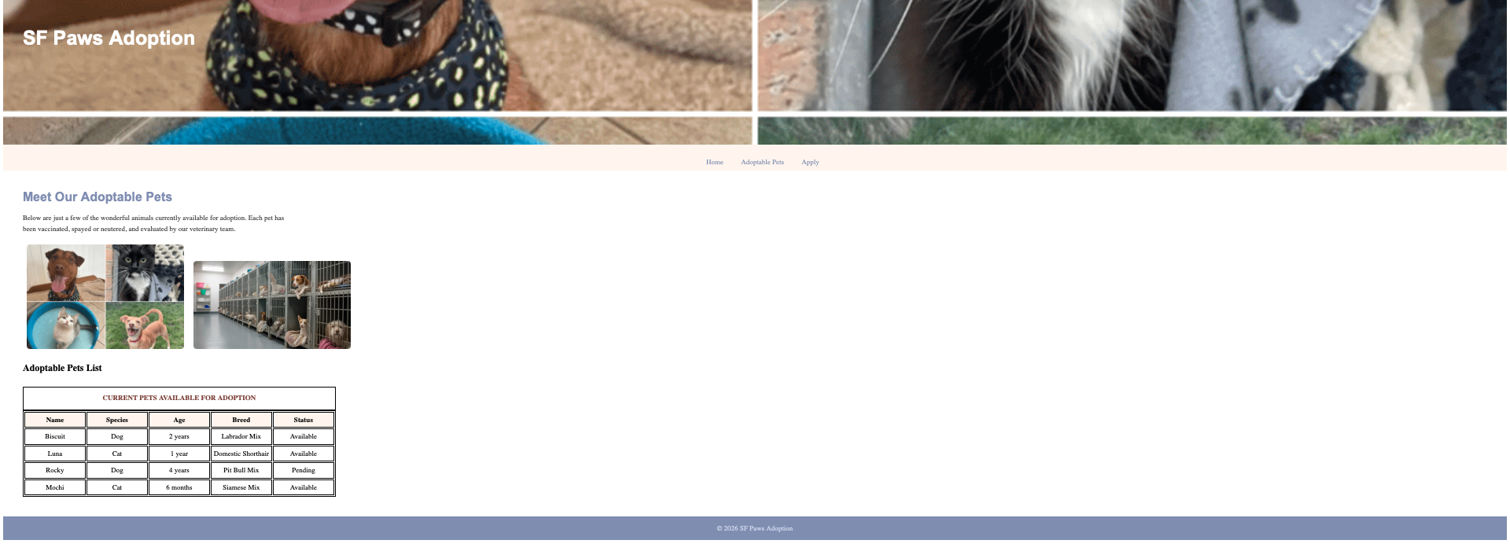

3.adding form styling on application page
