**Network and Servers**

**IGW_schematic**

**DITS-NETSRV - Configure for internet access of internal private network**

**ICT50715**

Diploma of Information Technology (Software Development)

Intermediate Programming

**Assessment**

**Task 3 By** DIEGO HENRIQUE GONCALVES

**Student No:** CTI2017271

**For CTI Info.**

**Tech. Date:** 09/04/2018

1. **ABSTRACT**

This document discuss about the internal network and NAT server plan, structure and model security to obtain access at external address without lost the internal identified IP.

**Summary**

**1.Abstract**2

**2.Introduction**4

**3.Plan**5

**5. Conclusions**6

**6. Recommendations**6

**7. References**6

1. **INTRODUCTION**

The plan of structure is based in a distributed and share environment, that have  many people working on same link to access the external network, but not directly ever with a common point as a NAT server.

1. **PLAN**

* Switches: Share connection to all devices and obtain a class of IP getting and disrupt diferents points about company.
* Common_line: Everybody access the same link and get the external contents, not permit others address like Link_server to access external contents.
* NAT_server: Read all diferents access and convert to provide external links and permit internal users navigate on Internet.

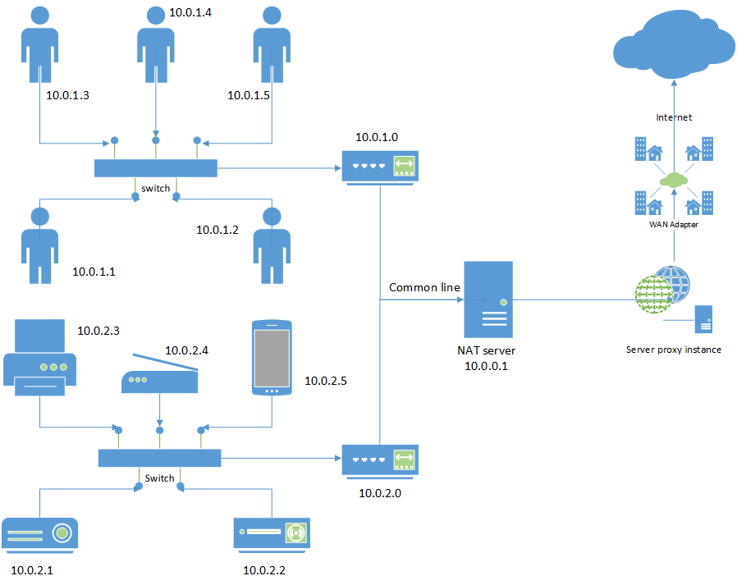

**1** - Represent the plan NAT structure

**SRC Sample:**

SRC 10.0.2.10 port 2020 -> SRC 159.165.3.10 port 1020

1. **CONCLUSIONS**

A discuss about if this is necessary, we have two points that will be describe, first the security in your internal environment and who access the machines, the firewall helps us, but identify each access make a double check, second the  quantity of address to get external access need a balance like NAT.

1. **RECOMMENDATIONS**

This level of security depends on the company size, but if we need have all control about the contents evolved enterprise informations, maybe a good way and recommendable practice is use a NAT server.

1. **REFERENCES**