**Network and Servers**

**LpaNetServerPlan**

**DITS-NETSRV - Plan and design network server to meet business requirements**

**ICT50715**

Diploma of Information Technology (Software Development)

Intermediate Programming

**Assessment**

**Task 1(a) By** DIEGO HENRIQUE GONCALVES

**Student No:** CTI2017271

**For CTI Info.**

**Tech. Date:** 09/04/2018

1. **ABSTRACT**

This document discuss about the network servers plan and how configure, structure and model architecture to get performance and enables end-points all the time.

**Summary**

**1.Abstract**2

**2.Introduction**4

**3.Plan**5

**5. Conclusions**6

**6. Recommendations**6

**7. References**6

1. **INTRODUCTION**

The plan of structure and network servers is important, because contain metrics and rules about links, access and security around the repositor and applications.

1. **PLAN**

* **Gateway**: with internal IP's, all users can access the servers configurations.
* **Firewall**: A filter about machines and rule that who can access each server.
* **Link_server**: End-point with parameters and conditions to receive requests and check availability to call others servers.
* **Link_server & DataBase (homologation)**: Same plan but a server with address to provide tests, contain a DataBase to tests.
* **Web_server**: Repository of codes and tools of deploy.
* **App_server_cluster**: Initial with two links to provide the application and availability to many access.
* **DB_server_cluster**: three Links to provide the DataBase address and the redundancy maintenance.

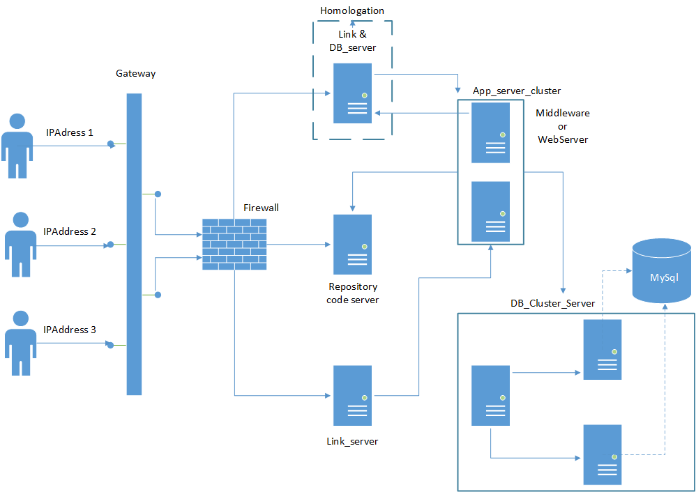

**1** - Represent the plan of Netowrk and Servers

1. **CONCLUSIONS**

The central point is the availability application to work all the time and the advertisement is when receive many requests in the same time, this is critical because the structure need support the traffic.

1. **RECOMMENDATIONS**

Recommend this plan to apply in a simple structure server to attend a small company with small resources and need availability.

1. **REFERENCES**