Graham Pomfret

0595995

3400 Assignment 1

Question 1:

“1- Write a query that alphabetizes the first names in ascending order.”

Query Needed: ALTER TABLE `table 1` ORDER BY `COL 2` ASC;

Output

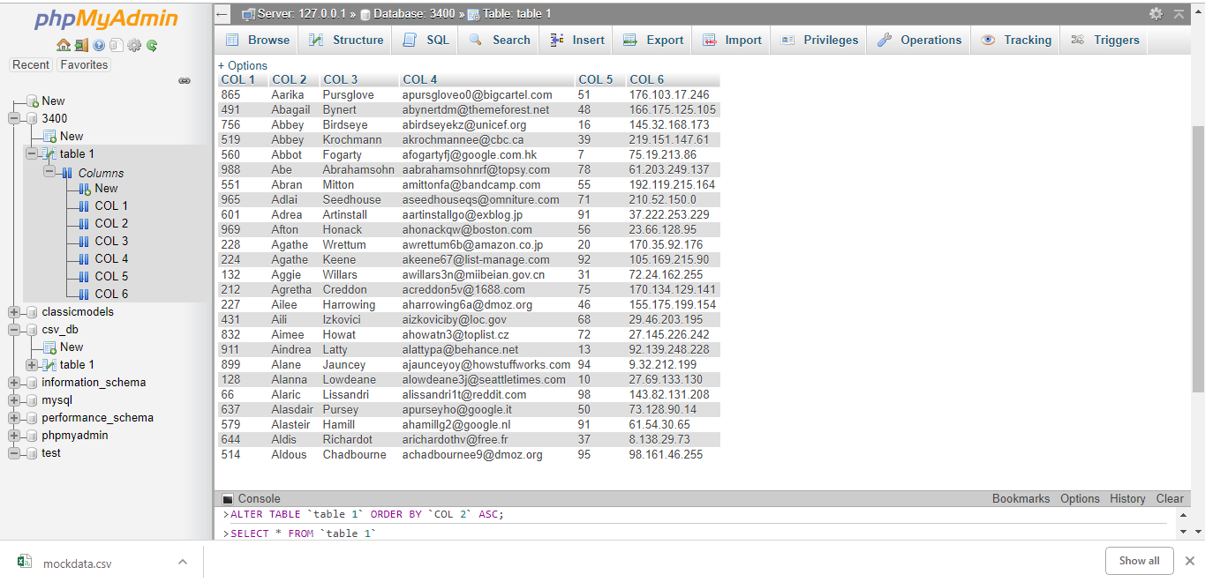

Question 2

“2- Write a query that outputs every student whose first name starts with an A”

Query Needed:

SELECT `COL 2` FROM `table 1` WHERE `COL 2` LIKE 'A%'

Output:

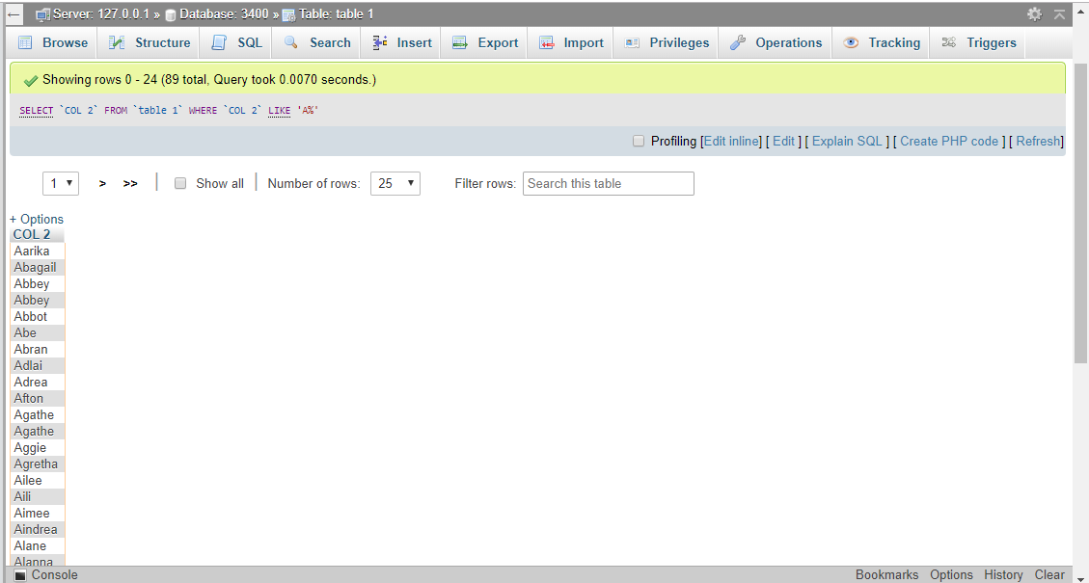

Question 3:

“3- Write a query that outputs every student who has a ‘ch’ anywhere in their name (first or last).”

Query Needed:

SELECT `COL 2`, `COL 3` FROM `table 1` WHERE `COL 2` LIKE '%ch%' OR `COL 3` LIKE '%ch%';

Output:

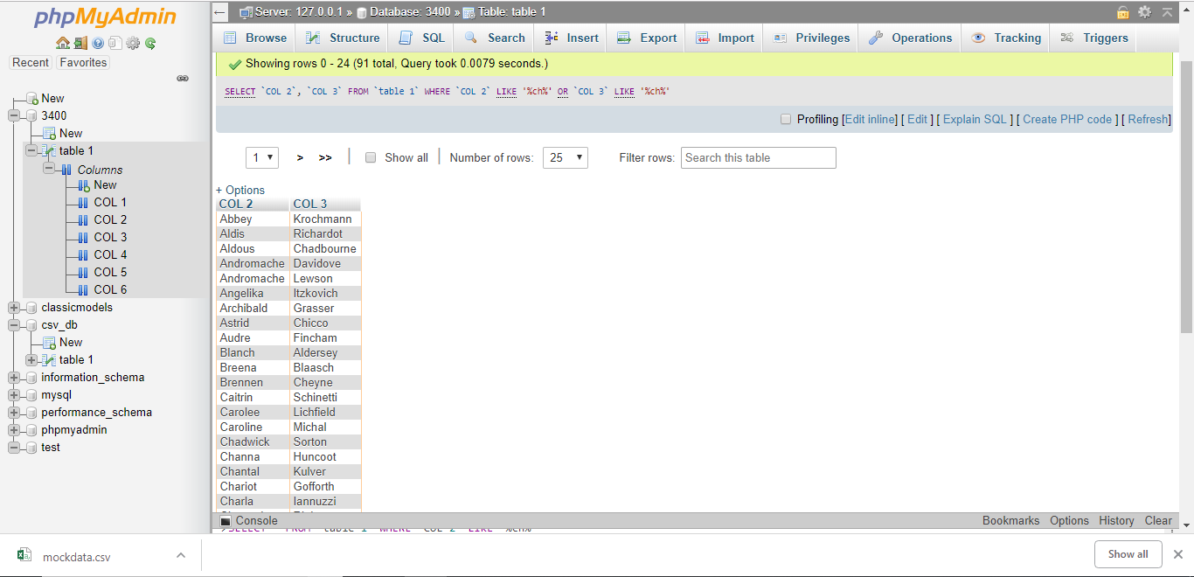

Question 4:

4- Write a query that selects the first name, last name, and IP address, for every IP address that starts with ‘100’ or less.

Query Needed:

SELECT `COL 2`, `COL 3`, `COL 6` FROM `table 1` WHERE `COL 6` LIKE '100%' OR `COL 6` LIKE '__.%' OR `COL 6`LIKE '_.%'

Output:

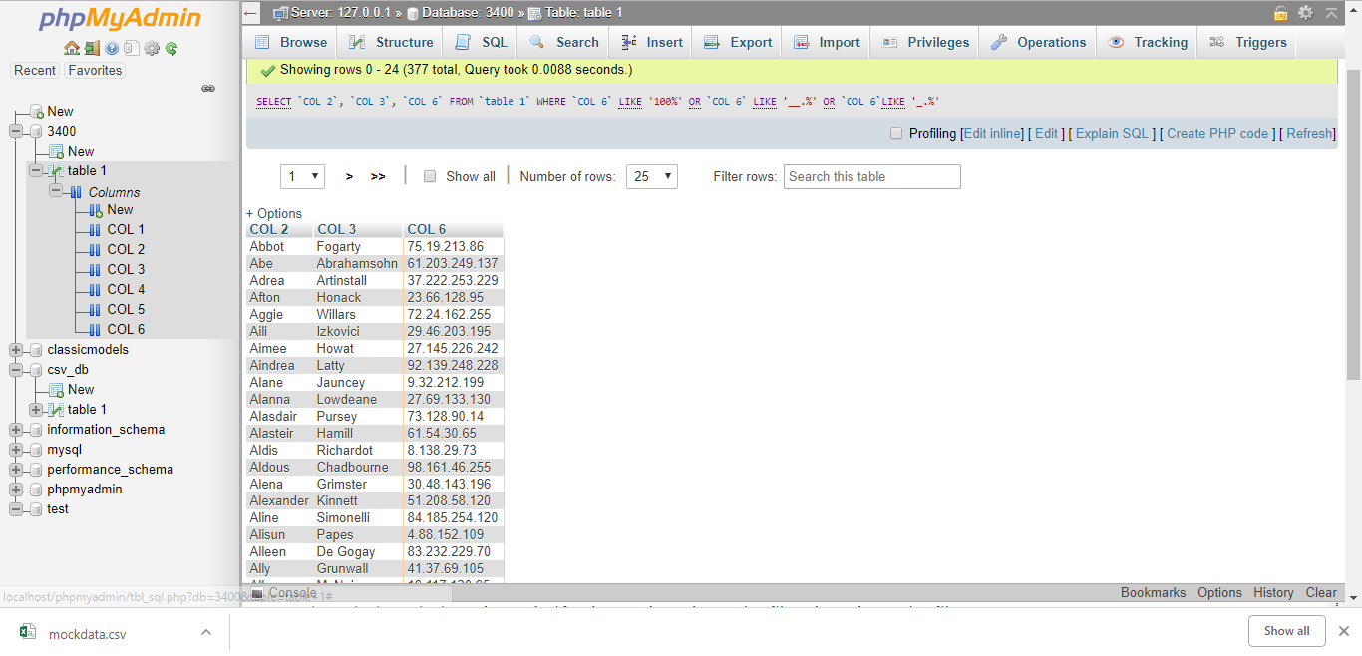

Question 5:

5- Write a regular expression using the LIKE operation and wildcards/placeholders that searches for any email address registered with the reddit.com domain (i.e., @reddit.com).

Needed Query:

SELECT * FROM `table 1` where `COL 4` LIKE '%@reddit.com'

Output:

