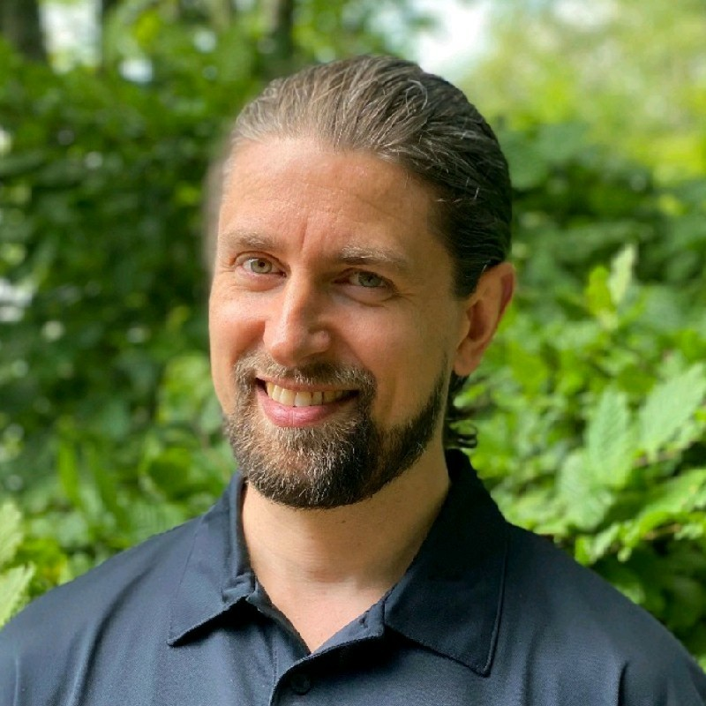
Bo Holch Ogdal

✉ boholch@gmail.com
☎ +45 29 29 41 71

I’m an accomplished entrepreneur and strategist, advisor, and data scientist (Fin-tech) and I have expertise in digital technology platforms and business transformation using innovative and disruptive technologies with a specific focus in Finance and E-commerce (investing, advertising).

Furthermore, I’ve got extensive expertise at project board level, in money management, e-commerce scaling, industry 4.0, and retail sectors, helping businesses create clear visions with concrete goals to deliver achievable value and results on time. I’ve worked for notable companies such as Grundfos and LEGO.

Core Competences

execute | data science | full stack developer | saas | marketing expert | financial services | fin-tech | trading | advertising | social media strategy | leadership | project management | educator & trainer

Professional Experience

CTO & Project Manager & Full Stack Lead Developer
TradeFundrr LLC (www.tradefundrr.com)
Jan 2022 – Present

Main responsibilities
- Deliver SaaS platform to host biggest online magnet to find trading talent to get funded by main partner T3 Trading (www.t3trading.com).
- Full stack architect and developer of entire platform to support Frontend App
- Setup support processes
- Execute support tickets at all levels

Latest Key Achievements
- Built, setup, and maintaining all backend services at www.tradefundrr.com including all business logic handling account management at third party vendors with rules services, based on executed order history on exchanges.
- Implemented all business logic and math required to run a financial trading platform utilizing 3 external vendors through APIs (Rithmic, Sterling, Tradovate) on AWS.

CTO - Business Development
Ninjacators LLC (www.ninjacators.com)
April 2020 – Present

Main responsibilities
- Backoffice accountable to support all online business operations
- Business modeling and Product Mangement
- Full stack developer of back office CRM
- Ensure 99% operational system uptime
- Supported building support CRM back office custom industry requirements for running modern online sales platform activities within the retail finance industry.

Lastest Key Achievements
- Setup and implement product development processes for entire company.
- Helped scale company +300% since 2021
- Developed full stack platform for licensing of more than 400 products in the hands of 100,000+ customers, implemented in existing products as well as new.

Crypto Advisor & Data Scientist
Nordix Systems
Feb 2018 – August 2019

Main responsibilities
- SaaS Team Lead
- PR/Social Media Advisor
- Developed Blackbox strategies for entering/exiting trades

ICO Advisor & CMO (l-pesa.com)
L-Pesa Group
Jan 2017 – Apr 2018

Main responsibilities
- Scaling Microloans to Africa via Social Media Advertising
- PR/Social Media Advisor on Kripton ICO
- Telegram Community Manager
- Social Exchange Bot
- Web + Advertising

Digital Strategist | Social Media Expert & ICO Advisor
Bodigi
Aug 2016 – Present
- Owner
- Worked with many clients around the world scaling their businesses on Facebook, spending more than $100k/month in ad spend.
- Top Rated Facebook Marketing Freelancer on Upwork
- External contractor

Digital Platform Business Lead
LEGO Systems A/S
July 2015 – July 2016
Responsible for digital business development in LEGO Education

Main responsibilities
- Build new digital channels in core markets
- Drive and lead innovation funnel exploration for digital product opportunities
- Develop portfolio of digital products and establish digital program management
- Drive and lead change management regarding digitization and agile mindset

Global Program Manager, Program Management
Grundfos Management A/S
January 2014 – June 2015
Responsible for the digital product strategy and represent business wishes on development of new mobile Apps and other digital products in Grundfos.

- Delivered, in 5 weeks - working as a ’Startup’ through 3 external suppliers, Grundfos GO Balance App prototype + ALPHA Reader 3D mockup including working hardware prototype to ISH fair in Frankfurt, Germany 14th of March 2015. The App became one of the three must-see things at ISH.

Main Responsibilities
- Pricing and product profitability including P/L
- Overall optimization of products
- Development and execution of product strategies
- Specification of new products
- Participate in development projects
- Managing product roadmaps
- Building up and maintaining product knowledge within the group
- Participate in product launches and promotion

Latest Key Achievements
- Launched the Grundfos Installer Companion to successful launch August 2014
external suppliers and cross company stakeholders using agile development processes. My responsibilities included Program Management and leading the Project Decision Board. See https://itunes.apple.com/dk/app/grundfos-installer-companion/id897500836?mt=8 for more info
- Successfully established Digital Products product portfolio into the matrix organization.

Global Program Development Manager, Global D&E Projects
Grundfos Management A/S
February 2012 – December 2013 (1 years 11 months) Bjerringbro
Key Achievements
- Led the Grundfos GO project, the first Grundfos mobile product platform, from idea to launch through 5 external suppliers and cross company stakeholders using agile development processes. See https://itunes.apple.com/dk/app/grundfos-go-remote/id524685121?mt=8&ls=1 or www.grundfos.com. The App won the Danish Design Awards in the Business & Finance category 2012.
- Successfully delivered 3 mobile interface box products enabling the App to communicate with more than 60 pumps and products.
- Successfully anchored the Mobile OS platform project deliverable into the line organization - going from box product development to continuous integration and delivery (life cycle ownership)
- Change leader for organizational change to use visual management (PRINCE2) - Going from resource management to delivery management

Project Manager in Development & Engineering
Grundfos Management A/S
January 2011 – February 2012 (1 year 2 months)
Key Achievements
- Led numerous hardware/software projects. One project was a BACNET enabling product for the London Olympics and the other SMS/GPRS gateway for connecting our products to SCADA systems & Cloud solutions.

Project Manager in Research & Technology, Grundfos Management A/S
Grundfos Management A/S
January 2008 – December 2010(3 years)
Key Achievements
- Led a team of motor control specialists, responsible for the global motor driver platform for all our synchronous and asynchronous motors for pumps and delivered to several projects that are today successful working products.
- Executed as the first project in Grundfos according to a Grundfos IBM ClearCase and ClearQuest configuration management implementation strategy

Software Development Manager, R&D
Nordic ID OY
Finland, Salo/Turku December 2004 - December 2007 (3 years 1 month)
Led software team to launch new embedded BSP including SDK and other product features that added innovative value to a new product.
Main Responsibilities
- Managed budgets and supplier contracts including the Nordic ID Turku Office
- Managed outsourced resources and off-shore software projects
- Lead the software teams including off-shore test teams

Key Achievements
- Launched Windows CE 4.2 in our PL product line
- Implemented Configuration Management and Quality Assurance processes
- Implemented agile development and operation
- Organized customer requirement acquisition strategy to improve customer solutions and internal cost efficiency
- Improved staff morale and quality by creating a self-organized team

Software Engineer, R&D
Nordic ID OY
Finland, Salo February 2001 - December 2004 (3 years 11 months)
- Software lead on the Windows CE based PL product line
- Implemented agile development methods for the team
- Responsible for customization of drivers and applications
- Assisted Global Customer Support

Vocational profile

Change Leader 12 years of experience as a change leader through projects.

Educator & Trainer Educator at the Poul Due Jensens Academy

Project Management 12 years of experience in project leadership across entire value chain and several external suppliers
Management 12 years of experience in middle management

System development 12 years of professional experience
in driver and application development
using UML, SQL, HTML,
PHP, Python, JavaScript

Education, Courses & Training
2013 Grundfos The Trainer
2013 ITIL Foundation certification
2012 Visual Management Training
2010-2011 International Project Management course
2005 Course in team management
2004-2005 Course in self organized teams

1998 - 2004 M.Sc. in Computer Science, Åbo Akademi
University (Thesis: VoIP)
1998 Q2/Q3 Turun AKK, Learning the finish language
1996 -1997 Practical experience abroad
(Germany, Finland).
1993 -1996 Student at Aalborg Business College.
Majors: Mathematics, accounting and business economics.
1984-1993 Elementary school, Mou Skole

Languages
Danish, mother tongue
English, fluently
Finnish, fluently
Swedish, very good
German, good

Hobbies
Musician, Hunting, Family fun

