CPM-65 DEBUG.COM Documentation
Program description
DEBUG.COM is a debugging tool with these features:
- Memory handling (dump, change, move, fill memory area, search in memory)
- Controlled program execution (start execution, breakpoints, single stepping, status register display and change)
- Support functions (load and save files, disassemble program, multiple commands per line)
DEBUG is written for a 64 chr per line screen. It needs 5 kB RAM at the top of memory.
DEBUG is controlled by a command line interface. All addresses and bytes are in hex (nnnn, mmmm,jjjj, bb, cc). Leading zeroes may be omitted. Numbers which are part of a command
are decimal (d, dd). The maximum number or characters in the input line is 126.
Usage
DEBUG [d:filename.ext]
When started, DEBUG moves itself to its location in the upper memory and changes the BDOS vector at $FE/$FF to its start to protect itself from code looking for the highest available RAM location.
Filename.ext can be any program or other file. By default, the file is loaded to the start of the TPA. In case of the Junior ][ this is $2000. With the M(ove) command the code can be moved to any desired location, if needed.
After startup, DEBUG will display its command line prompt.
A help screen with all available commands can be displayed with ?.
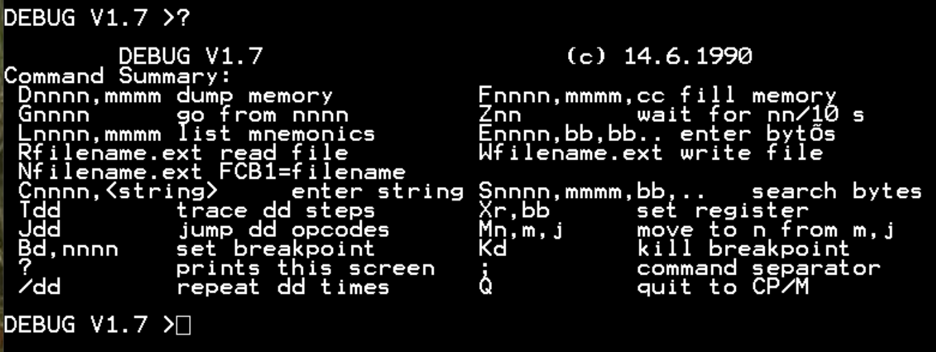
Commands
Dnnnn,mmmm dump memory from nnnn to mmmm
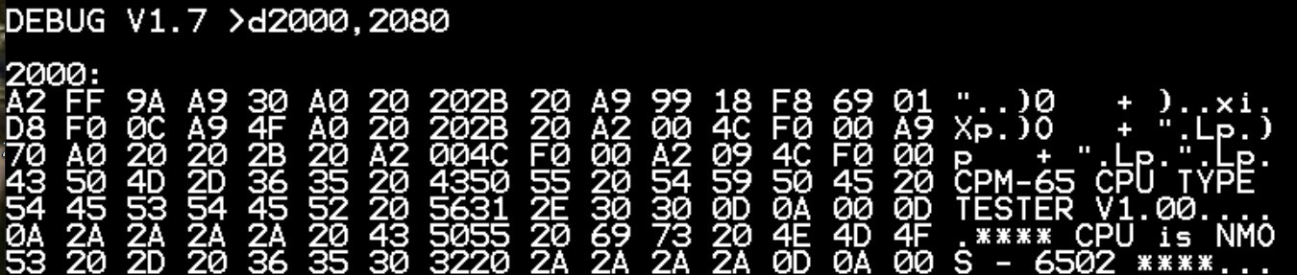
Fnnnn,mmmm,cc fill memory from nnnn to mmmm with bytes cc
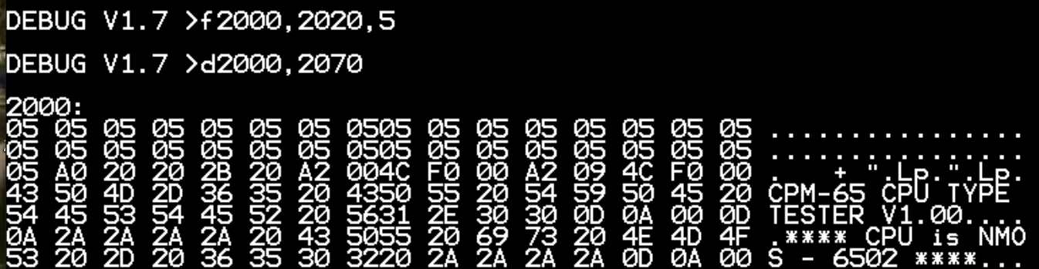
Gnnnn go from nnnn start execution of program at nnnn
Znn wait for nn/10 s
Lnnnn,mmmm list mnemonics from nnnn to mmmm
If mmmm is omitted, 14 lines are displayed by default
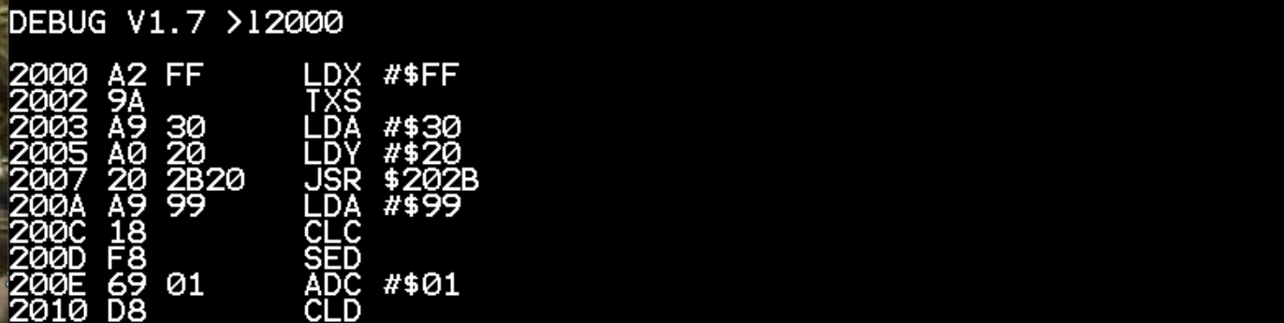
Ennnn,bb,bb.. enter bytes bb, … from nnnn
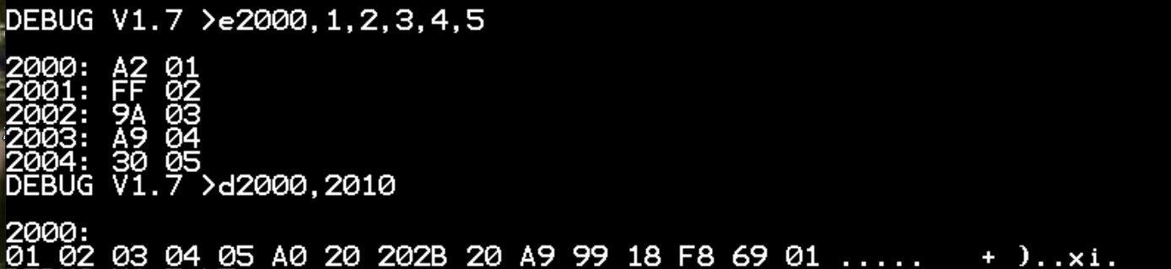
Rfilename.ext read file to memory beginning at $2000
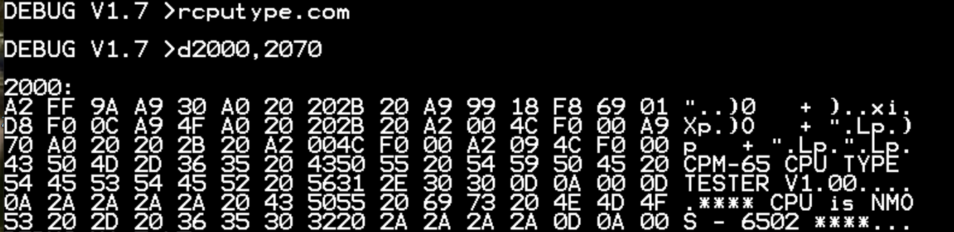
Wfilename.ext write file from $2000, length equal to the file previously loaded
Nfilename.ext fill FCB1 with filename.ext
If Ext is omitted, it will be filled with blanks. This command can place a filename or command string in the FCB1, which is then used by the program to be debugged. Standard memory location for FCB1 is $D003.
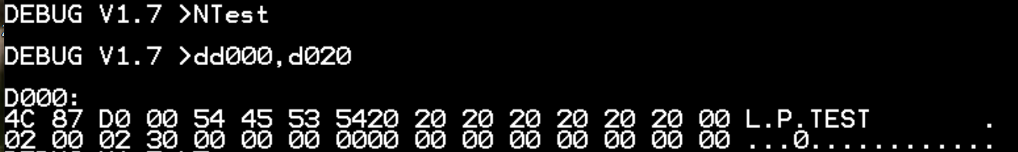
Cnnnn,<string> enter string
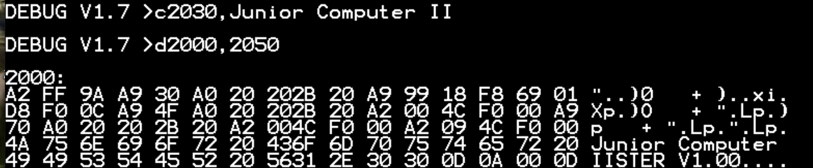
Snnnn,mmmm,bb,.. search bytes bb, …
Tdd trace program execution from actual PC for dd steps
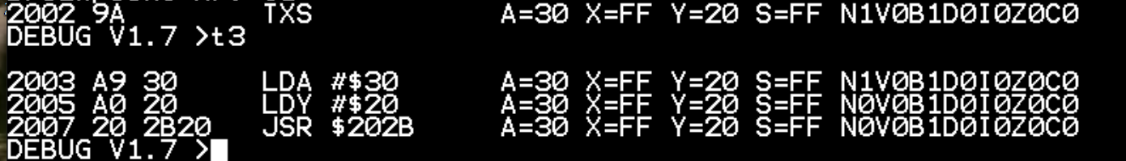
If dd is omitted, 1 step will be done
Xr,bb set register r to bb
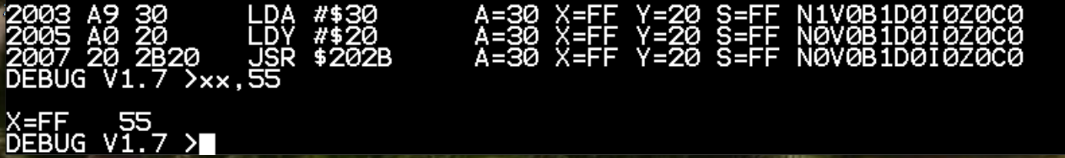
R can be A Accu, X X register, Y Y-Register, S Stack pointer or flags c Carry, Z Zero, I Interrupt, D Decimal, B Break, V Overflow, N Negative
Old content of the register as well as the new one are displayed
Jdd jump dd opcodes without branching
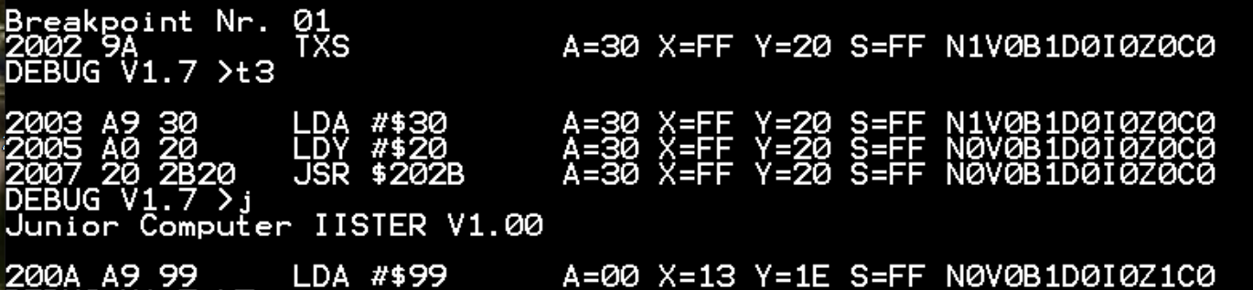
This command sets a breakpoint at the next command in memory. It therefor allows to skip stepping through subroutines or loops. Be aware: if the breakpoint after the instruction you jump from is never reached, because the program continues elsewhere, the stepping may not occur and DEBUG may crash.
Mn,m,j move memory to n from m,j
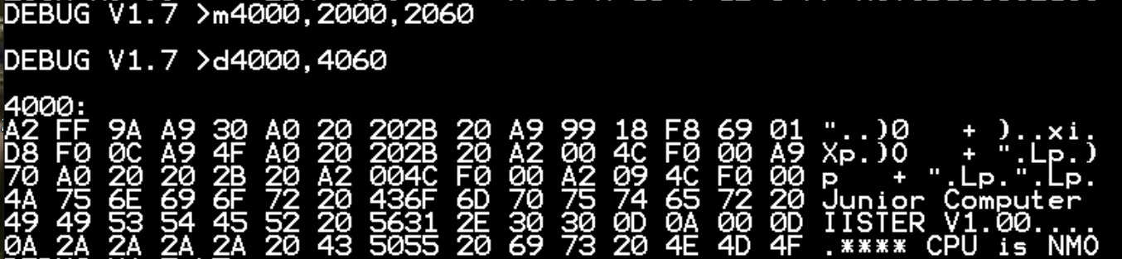
Bd,nnnn set breakpoint
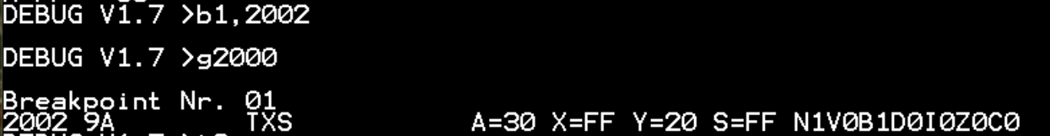
The command B without parameters will print a list of all breakpoints.
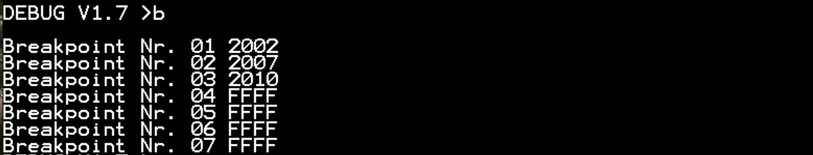
Kd kill breakpoint d
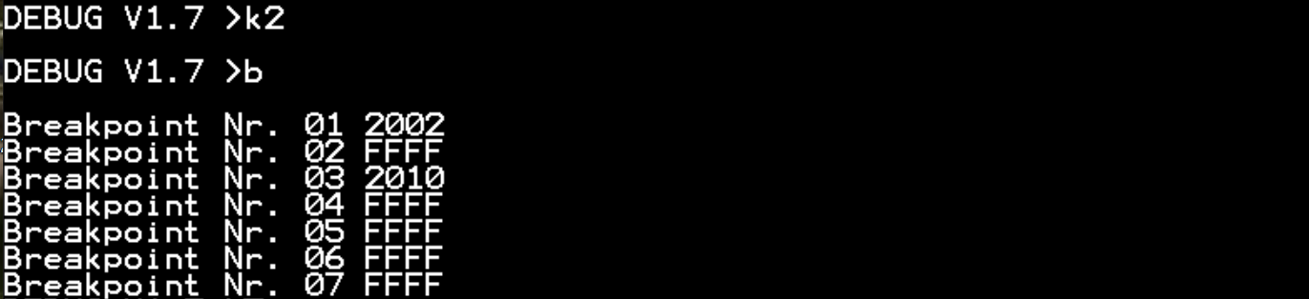
If d is omitted, all breakpoints are killed
; command separator
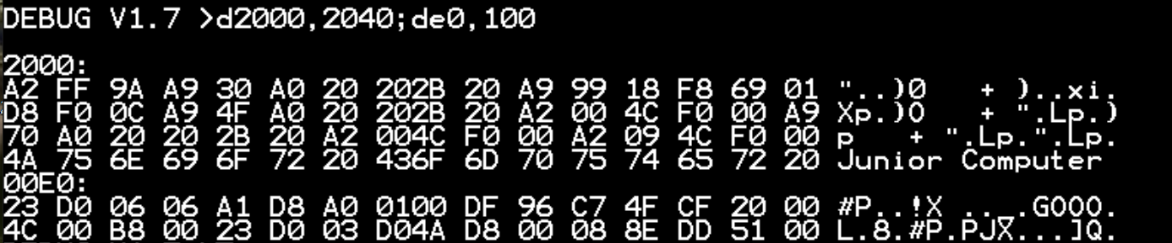
Allows to enter multiple commands in 1 line
/dd repeat dd times
Not really useful at this time
Q quit to CP/M
When all is said and done …
Happy bug hunting
Dietrich

