**Washington State University Everett**

**COUGHACKS 2023**

**Aaron Gibson, Dietrick Kooyman, Jonathan Osterhus, Sky Butlay, William Worthy**

The hardware used for this project is shown in Table (1).

**Table 1**

|  |  |
| --- | --- |
| Item | Quantity |
| Liquid Crystal Display | 2 |
| Arduino UNO R3 | 2 |
| Ultimate GPS Breakout v3 | 1 |
| DHT11 Temp and Humidity Module | 1 |
| BMP 180 | 1 |
| Ultrasonic Sensor | 1 |
| Button | 4 |
| Thermistor | 1 |
| Tilt Ball Switch | 1 |

**Step Counter:**

A tilt ball switch is used with Arduino interface to record the number of steps a person has taken. The tilt ball switch detects motion through orientation. When the tilt ball switch is shifted a metal ball makes or breaks contact with internal conductors. Each time this occurs will be recorded as one step.

**GPS multi-function tracking and display:**

The ultimate GPS breakout v3 is a stand-alone module that communicates with satellites and gathers timing data. The data is then imported into open source Arduino library software where it is then parsed. The parsed data is returned as latitude, longitude, and elevation. With repeated recordings the speed and distance a person travels is obtained and displayed for the user. The elevation gain and loss are calculated and recorded.

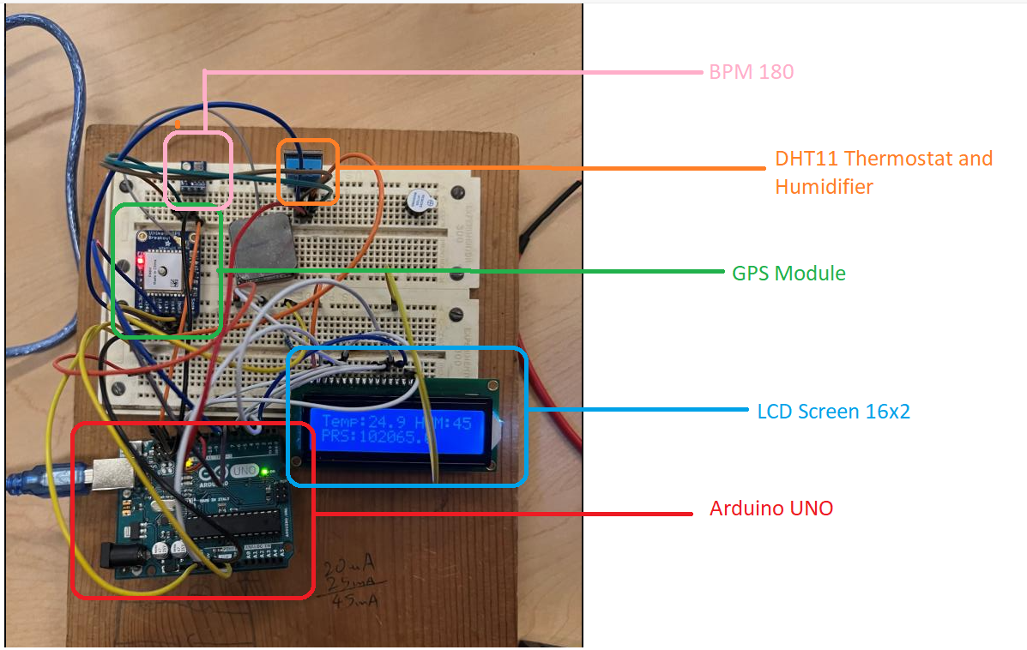

**Portable Weather Station:**

A BMP 180 is used to measure barometric pressure, and dry bulb temperature. A DHT11 temperature and humidity module is used to measure humidity and the wet bulb temperature. The dry bulb temperature in Celsius, barometric pressure in Pascals, and humidity are displayed to the LCD screen.

**Push Up Counter and display:**

An ultrasonic sensor connected to an Arduino UNO R3 is used to detect when a person’s body comes within 10 cm of the sensor and when they pull further away than the 10 cm. Each time this occurs a counter is incremented and then displayed to an LCD screen. A red LED is programmed to flash when the current record for pushups is obtained.

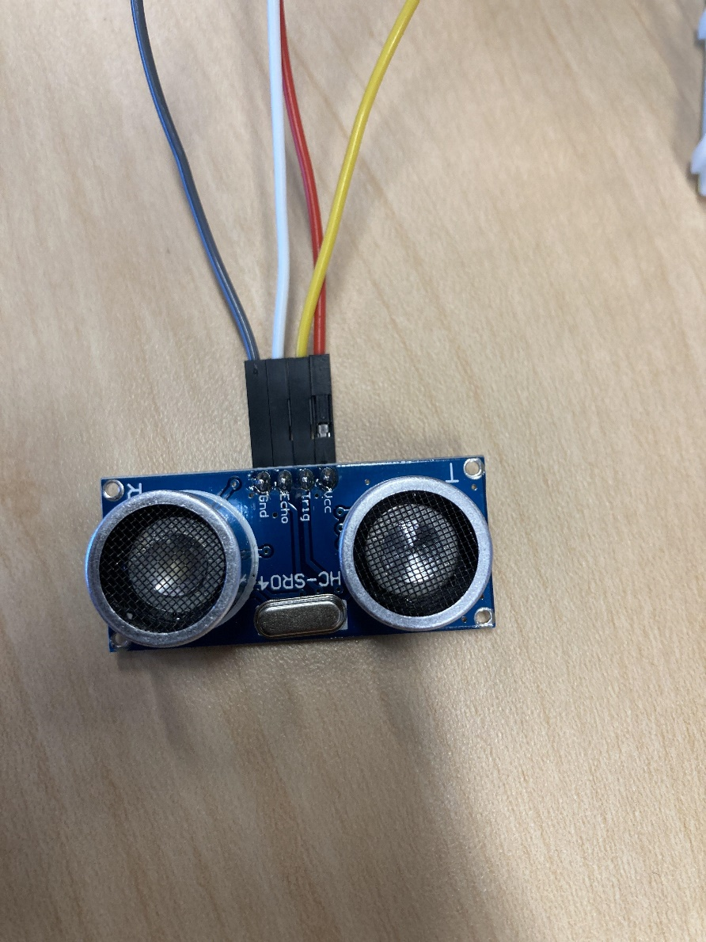

Ultra Sensor used for the Push-Up Counter

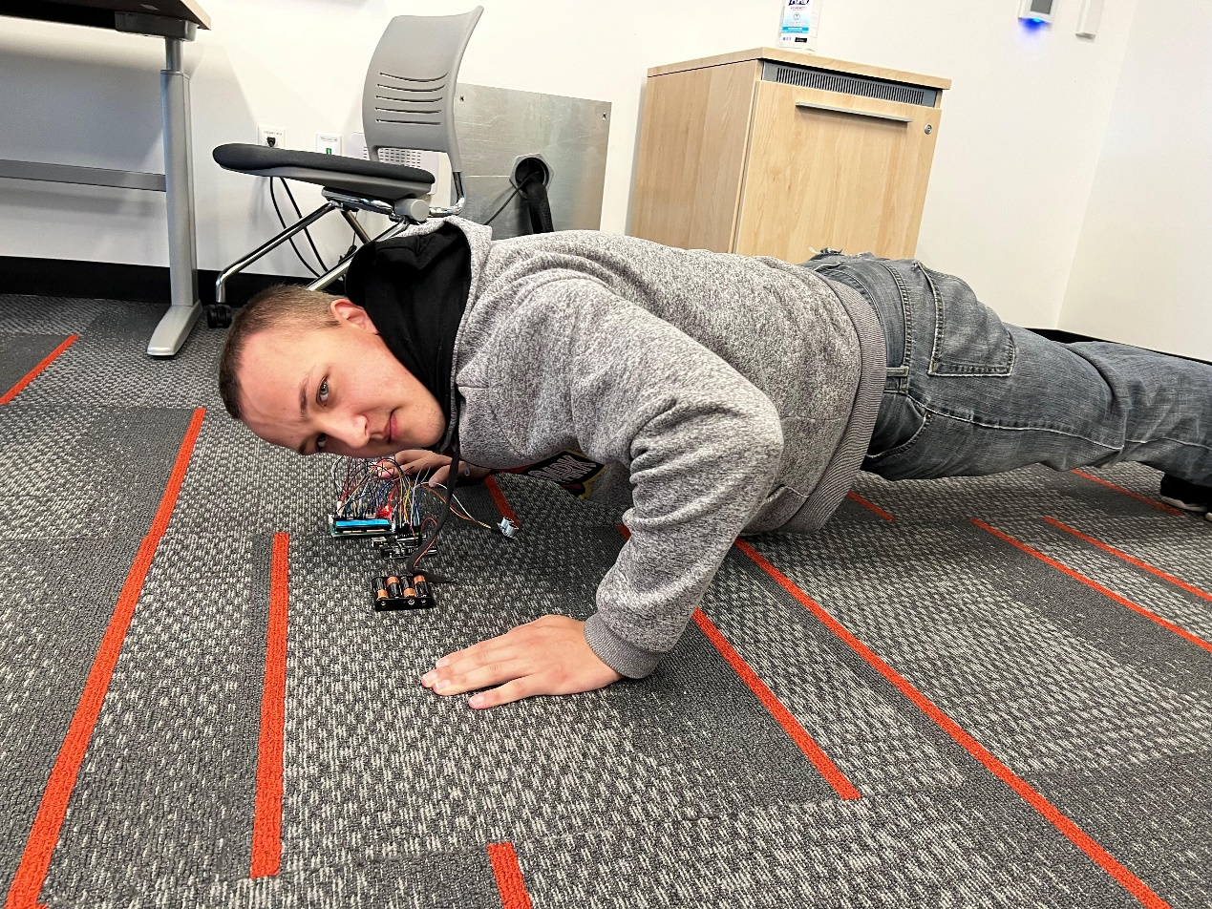

Demonstration: Jonathan testing the Push up Counter