Linking Loader | Linkage Editor
Performs all linking and relocation operations, including automatic library search, and loads the linked program into memory for execution. | Produces a Linked version of the program, which is normally written to a file or library for later execution.
Suitable when a program is reassembled for nearly every execution. | Suitable when a program is executed many times without being reassembled.
Resolution of external reference and library searching is performed more than once. | Resolution of external reference and library searching is performed only once.
Linking loaders perform linking operations at load time. | Linkage editors perform linking operations before the program is loaded for execution
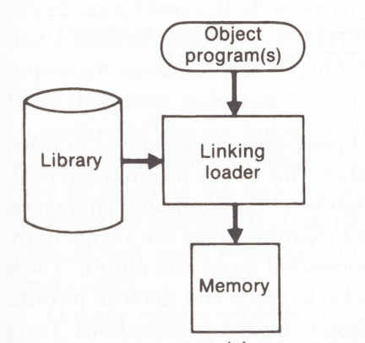 | 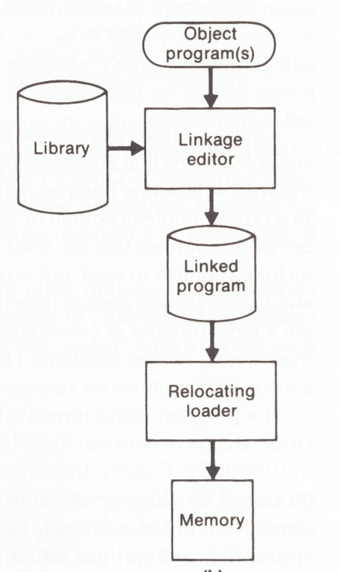
There is no need of relocating loader. | The relocating loader loads the load module into the memory
The Loading may requires two passes. | The Loading can be accomplished in one pass.
When program is in development stage then at that time the linking loader can be used. | When the program development is finished or when the library is built then linkage editor can be used.

