Basis | Line | Line and Staff | Matrix
Meaning | The organization in which the authority and responsibility moves downward, and accountability flows upward. | The organization structure in which specialist are added to the line managers to provide guidance and support | People with similar skills are pooled for work assignments
Decision Making |  |  | Totally Decentralized
Appropriate for | Small Organization | Large Organization | Organization with rapidly changing external environment
Discipline | Strict | Loose | Moderate
Example Figure | 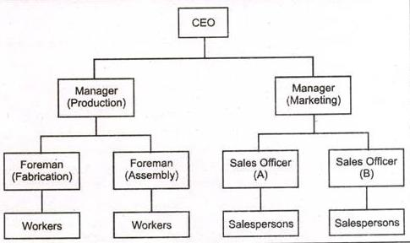 | 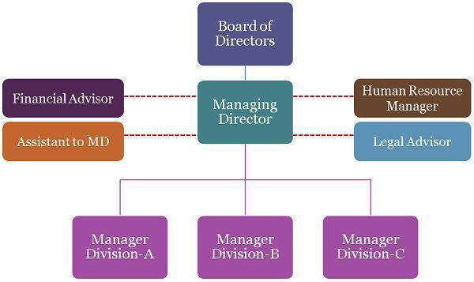 | 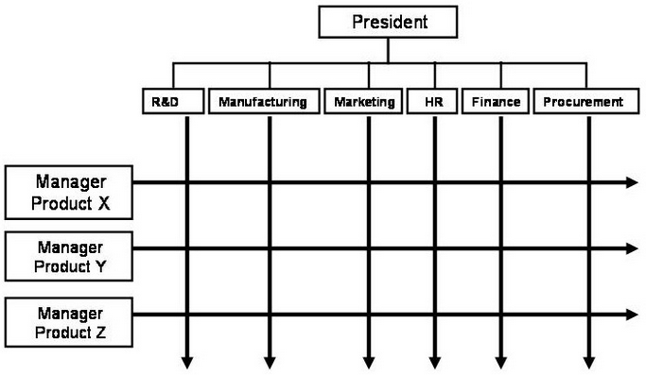
Authority | Command | Command and Advice | Command from different departments
Response to Change | Slow | Moderate | Fast
Use of Resource | Low | Moderate | Optimum
Cost | Economical | Expensive as two sets of employee are to be hired | Expensive if more managers are to be created through individual project team
Duplication of Effort | No | No | Possible
Confusion of functions | No | Unless the duties and responsibilities are clearly mentioned | A single staff have to work for different department
Reporting Channel | Clear | Clear | Unclear

