**Info 6205 Assignment 5 (Binary Search Tree) Difu Chen**

**Ⅰ.Data Graph**

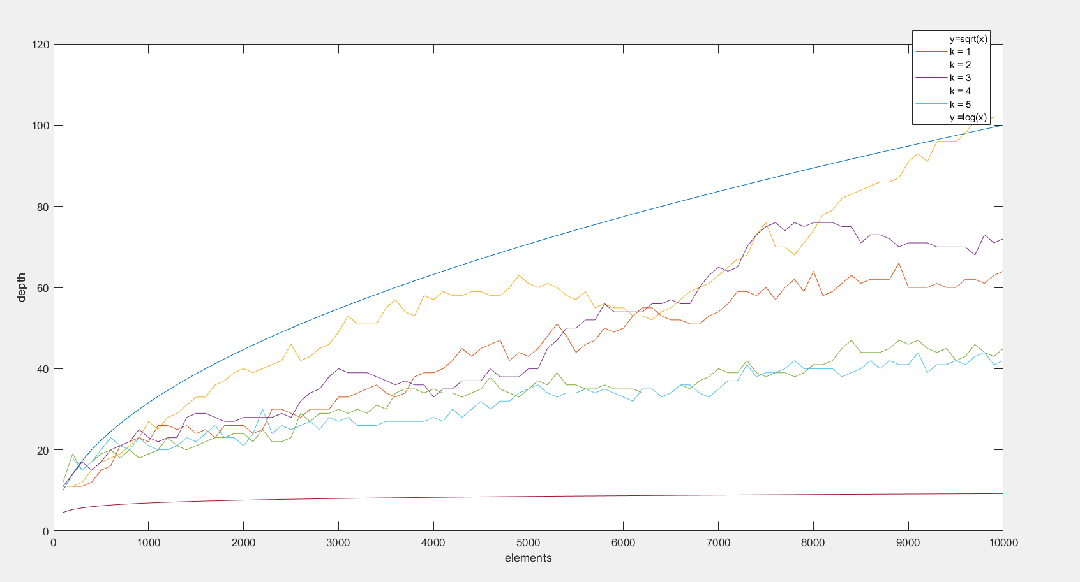

Graph 1

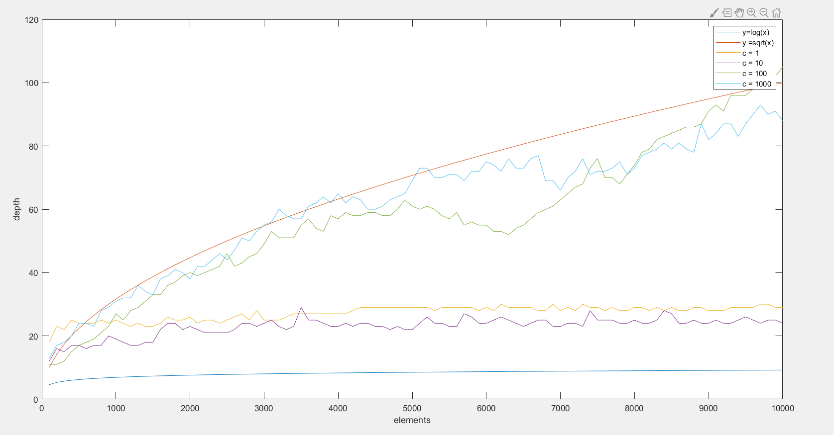

Graph 2

**Ⅱ. Data Analysis**

In the graph 1, the x-axis represents the number of elements, and I set them from 100 to 10000, increasing by 100 per step. The y-axis represents the depth of BST. In addition, the coefficient k determines the bound of key that is proportional to the number of elements.

In the graph 2, the x-axis and y-axis represent same thing. However, in this graph, the coefficient c determines the number of randomly deletion and insertion that is proportional of the number of elements.

In the graph 1, I set the coefficient c equal to 100 and test the boundary from one time of the number of elements to five times. From this graph, we can see that the depth of all BSTs are almost between the O(lg(N)) and O(N^1/2), however, when the k equals to 2, the depth of the BST is mostly closed to the O(N^1/2). And when the key grows up, the depth of BST keeps in a stable tendency and does not vary too much.

In the graph 2, I set the coefficient k equal to 2 that is the ideal coefficient for the bound of k. From this graph, we can see that the depth of all BSTs are almost between O(lg(N)) and O(N^1/2), however, when the coefficient c grows up, the depth of BST gets more closed to O(N^1/2) and the variance decrease with the growth.

**Ⅲ. Conclusion**

In conclusion, with the larger number of randomly deletion and insertion, when the bound of key is twice of the number of elements, the depth of BST can be more closed to O(N^1/2).