Data Tree Instructions

Startup and Settings

Download
Download DataTree from the OACSIMBEA website: http://silverbulletinc.com/oacsimbea
Self Extracting Data Tree Package

Installation
Run DataTreeFull.exe to install DataTree. By default it will be created at C:/Program Files/DataTree

Open DataTree
Open C:/Program Files/DataTree/DataTree.exe
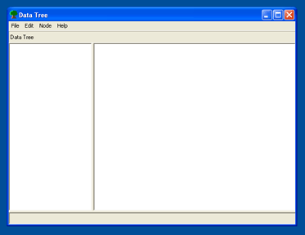

Opening Database Connections
Click: File > Open Database Connection > MS Access or SQL Server
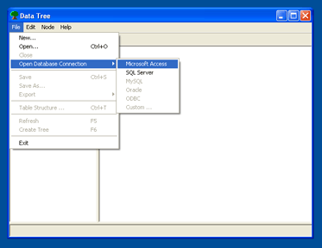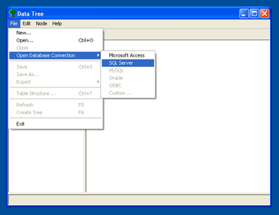

Open MS Access Database or Connect to SQL Server Database
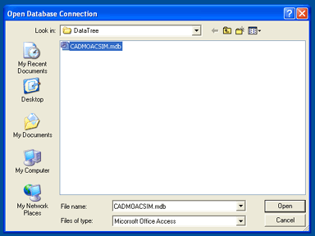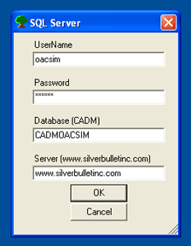

You are now connected to the database. Next Step: Set Table Structure

Setting Table Structure
Click: File > Set Table Structure
Choose Child Table and Fields
Choose Parent Table and Fields
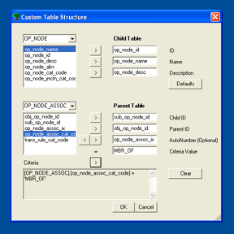

Important:
- Child.ID, Parent.ChildID, and Parent.ParentID must be the same type (i.e. Number)
- Category Code is often a required field. Please choose a proper Category Code and add it to the Table Structure settings.

Category Code
- Choose Category Code (op_node_assoc_cat_code) from the Parent Field Listbox.
- Enter Criteria Value in the textbox to the right of the ‘=’ sign (MBR_OF)
- Click the arrow below the ‘=’ sign to add this Criteria to the Custom Table Structure settings.
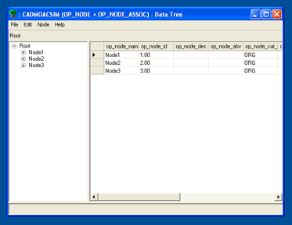

You are now ready to navigate the tree structure. Next Step: Save Configuration File.

Configuration Files

Save Configuration File
Click File > Save
Configuration Files save all settings in DataTree:
- Database Connection
- Table Structure (Child, Parent, Criteria)
- Visible Columns
- Column Widths
- Row Height

Open Configuration File
Click File > Open
Open a configuration file automatically sets the database connection and table structure to easily allow you to navigate the tree structure.

You have been provided configuration files for the most frequently used data elements. By default you will see these files when you click File > Open.
- Activity
- Data
- Event
- Function
- Information
- Node
- Performance
- Physical
- Standard
- System
- Technology

Viewing and Navigating Data Trees

Tree Navigation
- Navigate the tree using the ‘+’ and ‘-’ signs to expand/collapse the tree.
- Right click on an individual Node for more detailed options including Find, Cut, Copy, and Paste

List Customization
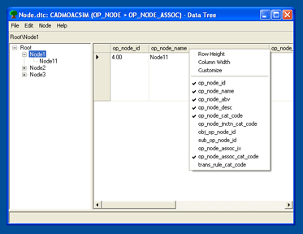

Right Click the Column Headings on the right side Data List
- Change Column Widths, Row Heights
- Check / Uncheck individual fields to display / hide columns
- Customize Column Orders and Column Visibility by choosing Customize from the drop down list
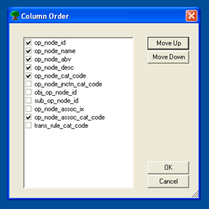

Editing Data Trees

Add, Edit, Delete
- To add a new node, click Node > New Node or click Ctrl+N. This creates a root node called ‘New Item’. Change the name.
- To insert a new node, select the parent node and then click Node > New Node or select the parent node and click Ins (the Insert key)
- To edit a node, select the node and click: Node > Edit Node. You can also rename nodes by selecting the node and then clicking it again. This will allow you to directly edit the name. Edit the description by selecting the node then double clicking the textbox at the bottom of DataTree.
- There are two types of Deletion. Because there may be multiple mappings between child and parent nodes, there must be a distinction between simply removing a node from that mapping and completely deleting the node from the database. It is important to understand the difference between Remove and Delete.
  - To remove a node, select the node and click Node > Remove Node or select the node and click Ctrl+Del. This only removes the node from its parent. The node will appear as a root node when the tree is recreated. Any subtrees will remain in tack.
  - To delete a node, select the node and click Node > Delete Node. This will COMPLETELY delete that node and ALL of its subtrees. This can not be undone!

Cut, Copy, Paste
Use the edit menu, shortcut keys, or right click to Cut, Copy, and Paste.
- Cut / Paste removes a node from one parent and attaches it to another parent node. Select node, click Ctrl+X, select new parent node, click Ctrl+V.
- Copy / Paste creates a new node (including a copy of its subtree) that mirrors the original node, but these nodes are not the same and will not be associated with each other. Changing one node will not change the other node. It is important to note the difference between Copying and Duplicating. Select node, click Ctrl+C, select new parent node, click Ctrl+V.
- Copy / Paste As Duplicate creates a duplicate node. This does not create a new node just a new child parent mapping. Any changes to one node will affect the other node … it’s the same node. It is important to note the difference between Copying and Duplicating. Select node, click Ctrl+C, select new parent node, click Ctrl+D.
- Cut or Copy / Paste To Root creates a new root node. The only difference from above is there is no new parent. Select node, click Ctrl+C or Ctrl+X, click Ctrl+R.
Note: although the above steps use the shortcut keys, please use which ever method is easiest for you … menu commands or right click will also work.

Drag and Drop
Use drag and drop as a shortcut to Cut / Paste and Cut / Paste To Root. Select node, drag to new parent node or drag to blank white space to create a root node.

Exporting

Organization Chart (Visio)
Click File > Export > Organization Chart (Visio .xls)
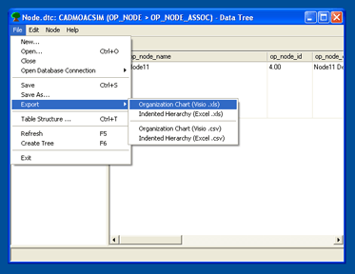

This creates an Excel file that Visio can import

Indented Hierarchy (Excel)
Click File > Export > Indented Hierarch (Excel .xls)
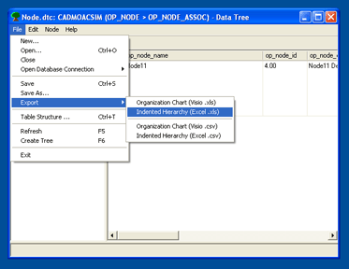

This creates an Excel file with levels in indented columns.

Note: Some older versions of Microsoft Office will not create an Excel file. If you have problems, please use the .csv alternatives.

Security and Privacy

Sharing Information

Examples

