** Song Suggestion Application **

Introduction:

* This is a java-based song suggestion application which uses spotify API in the background.
* To use this application, you need to have a spotify account.
* You can apply for a free spotify account just by following this link: <https://www.spotify.com/in/signup/>
* Once you are logged in or made an account, java application will ask the permission to access your account’s content.
* Click on agree and you are good to go.

Tools used in this application:

1. Java (SWING).
2. Node JS Server to receive TOKEN.
3. Spotify API.
4. Gradle for building the application.
5. Basic Architecture:

Server

Sends access token

Response

Ajax call

Spotify Server

Java App

1. Basic Working:
   1. When java application is launched it establishes a web socket connection between server.
   2. So, when spotify API is called from java application it sends ACCESS_TOKEN to the server.
   3. And then server sends this ACCESS_TOKEN to the application.
   4. From this point java application can make ajax call to the spotify server and load the content from it.
2. Guide:
   1. From the source code : If you want to run this application through gradle follow these steps :
      1. Open the command line and change the working directory to project directory (cd song-suggestor)
      2. gradle build OR gradlew build (does not require gradle installation)
      3. gradle run OR gradlew run (does not require gradle installation)
   2. if you want to run this application through a jar file or send this application through a jar file then :
      1. gradlew fatJar (‘J’ capital)
      2. java -jar ‘build/libs/song-suggestor-all.jar’
3. How to use this application :
   1. You have a text box and a button on the top right corner.
   2. Select the appropriate radio button.
   3. A. song B. artist C. album
   4. After selecting the radio button type in the content you want to search
   5. 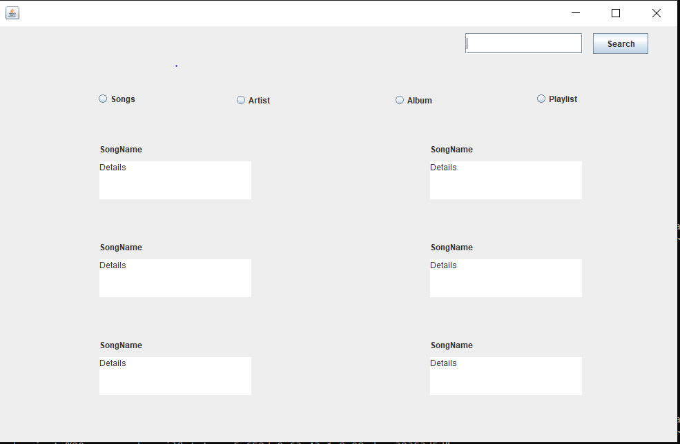

Result Panel

Radio Buttons to switch between content

Search panel

* 1. Currently playlist is not working but that can be the future scope for the application.